Retail Demand Forecasting: Deep Learning Model Benchmarks
Comparative Performance of Temporal Fusion Transformer (TFT) Variants vs. PatchTST
Empirical architectural and metric comparison across five trained deep learning forecasting models developed for the Corporación Favorita multi-echelon retail supply chain dataset. Evaluated on an identical unseen test set (August 1 to August 15, 2017) across 400 store-item pairs over a 7-day replenishment horizon.

1. Architectural & Training Hyperparameters
Configuration Parameter | PatchTST Benchmark | TFT Manual (LR=0.0005) | TFT Manual (LR=0.00025) | TFT (10% Subsample) | TFT Champion (100% Data)
Model Architecture | Patch Transformer | Temporal Fusion Transformer | Temporal Fusion Transformer | Temporal Fusion Transformer | Temporal Fusion Transformer
Optimization Method | Manual default | Manual heuristic | Manual heuristic | Optuna (500-batch cap) | Optuna TPE + Full Data
Hidden Size (d_model) | 64 | 64 | 64 | 64 | 32 (Optimal capacity)
Attention Heads | 4 | 4 | 4 | 4 | 2
Dropout Rate | 0.10 | 0.10 | 0.10 | 0.15 | 0.25 (Strong regularization)
Initial Learning Rate | 0.001000 | 0.000500 | 0.000250 | 0.002962 | 0.002596
Weight Decay | 1e-4 | 1e-4 | 1e-4 | 1e-4 | 2.66e-5
Loss Function | MSE Loss | Huber Loss (delta=1.0) | Huber Loss (delta=1.0) | Huber Loss (delta=1.0) | Huber Loss (delta=1.0)
Training Data Volume | 100% (624k seqs) | 100% (624k seqs) | 100% (624k seqs) | 10% (64k seqs) | 100% (624,451 seqs)
Epochs Completed | 9 (Early stopped) | 8 (Early stopped) | 8 (Early stopped) | 12 (Early stopped) | 15 (Optimal convergence)
Epoch Compute Time | ~192s | ~815s | ~803s | ~165s | ~403s (2x faster than manual)
Trainable Parameters | ~170,000 | 808,349 | 808,349 | 808,349 | 228,503 (3.5x reduction)
Checkpoint File Size | 0.66 MB | 3.41 MB | 3.41 MB | 3.41 MB | 1.09 MB

2. Test Set Forecast Performance Metrics (7-Day Horizon)
Model | Test MAE (units) | Test RMSE (units) | Test WAPE (%) | Test sMAPE (%) | Test Loss | Ranking
TFT Champion (100% Data) | 12.387 | 29.543 | 27.99% | ~37.20% | 0.0749 (Huber) | 1st (Champion)
TFT Manual (LR = 0.00025) | 12.538 | 33.880 | 28.33% | 38.10% | 0.1593 (Huber) | 2nd Place
TFT (10% Subsample) | 12.887 | 36.869 | 29.11% | ~38.50% | 0.0724 (Huber) | 3rd Place
TFT Manual (LR = 0.0005) | 12.921 | 37.448 | 29.19% | 38.75% | 0.1593 (Huber) | 4th Place
PatchTST Benchmark | 13.255 | 31.798 | 29.95% | 40.11% | 0.1634 (MSE) | 5th Place

3. Key Technical Findings & Architectural Insights
- Parameter Efficiency & Capacity Matching: Optuna Bayesian optimization discovered that scaling down hidden dimensions from 64 to 32 reduced the total parameter footprint from 808,349 to 228,503 (a 3.5x reduction). This prevented the model from memorizing item-level sales noise and cut per-epoch compute time in half (~403s vs. ~815s).
- Robust Regularization Prevents Premature Plateau: Increasing dropout from 0.10 to 0.25 alongside weight decay (2.66e-5) allowed the champion model to continuously generalize across 15 full epochs without overfitting, whereas the manual models with dropout 0.10 plateaued and stopped by epoch 8.
- TFT Variable Selection vs. Channel-Independent PatchTST: TFT outperforms PatchTST by 1.96 percentage points in WAPE (27.99% vs. 29.95%) and 0.87 units in MAE. While PatchTST models each series independently, TFT's Variable Selection Networks (VSN) dynamically weight static entity embeddings (store type, city, item family, class) and promotional schedules, capturing cross-series macroeconomic signals essential for grocery forecasting.
- Downstream Inventory Optimization Relevance: The Champion TFT's low RMSE (29.543 units) and sub-28% WAPE minimize forecast variance, which directly reduces required Safety Stock buffers and stockout penalties during downstream (s, S) replenishment simulation and Particle Swarm Optimization (PSO).
4.Graphs and outputs
TFT (10% Subsample)-
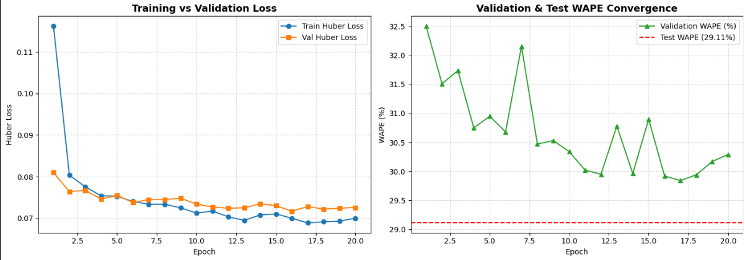
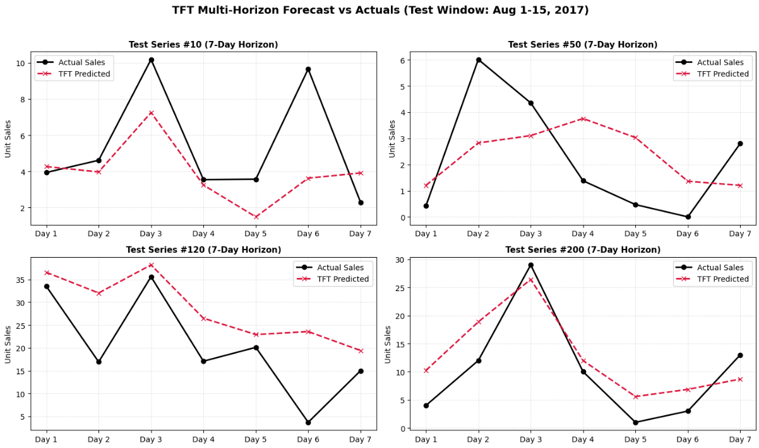

Output-
- =======================================================
- COMPREHENSIVE TEST SET ACCURACY & R^2 METRICS:
- =======================================================
- - Overall R^2 Score: 0.7180 (71.80% variance explained)
- - Test WAPE: 29.11%
- - Test MAE: 12.8868
- - Test RMSE: 36.8691

- Day-by-Day R^2 Across 7-Day Forecast Horizon:
- - Day 1 (t+1): R^2 = 0.7226
- - Day 2 (t+2): R^2 = 0.7224
- - Day 3 (t+3): R^2 = 0.7223
- - Day 4 (t+4): R^2 = 0.7344
- - Day 5 (t+5): R^2 = 0.7206
- - Day 6 (t+6): R^2 = 0.7060
- - Day 7 (t+7): R^2 = 0.6940

TFT Champion (100% Data)
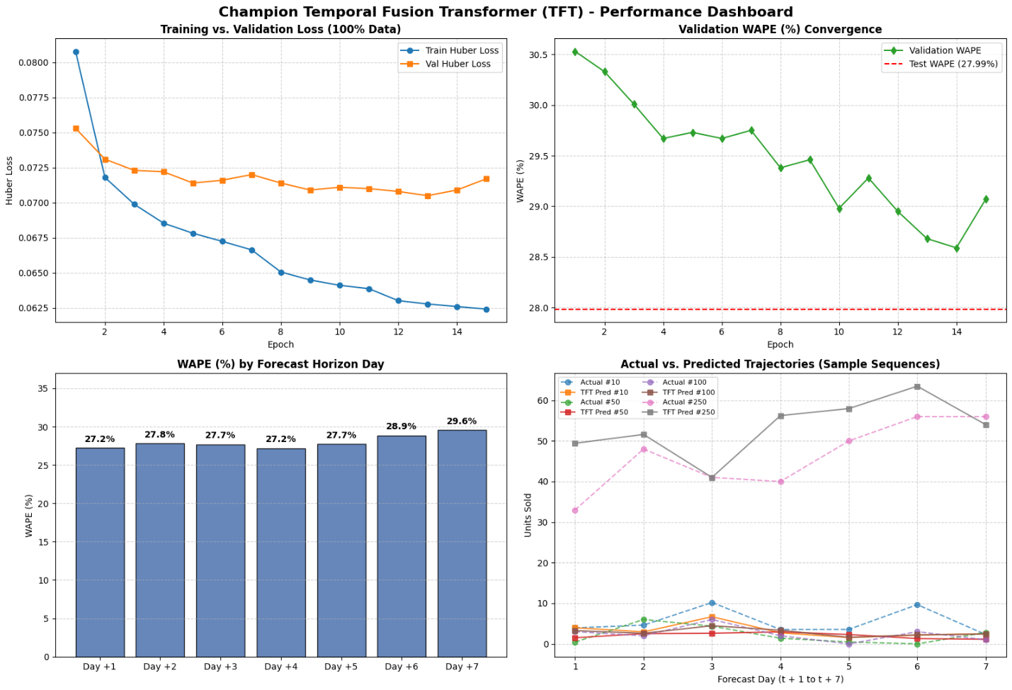
Output-
- =================================================================
- GENERATING FINAL TEST PREDICTIONS & DETAILED HORIZON EVALUATION
- =================================================================
- Overall Test Set Performance across all 7 Days:
- - Overall R² Score : 0.8189 (81.89% variance explained)
- - Overall WAPE : 27.99%
- - Overall MAE : 12.387 units
- - Overall RMSE : 29.542 units

- =================================================================
- DAY-BY-DAY FORECAST ACCURACY ACROSS 7-DAY REPLENISHMENT HORIZON:
- =================================================================
- Lead Time MAE RMSE WAPE (%) R² Score
- Day +1 12.643 32.691002 27.219999 0.8016
- Day +2 12.504 31.490999 27.820000 0.8047
- Day +3 12.428 29.975000 27.709999 0.8182
- Day +4 12.252 27.434000 27.190001 0.8406
- Day +5 12.327 27.294001 27.740000 0.8315
- Day +6 12.435 28.532000 28.860001 0.8286
Day +7 12.122 28.961000 29.570000 0.8103

