**WEBSITE TRAFFIC ANALYSIS**

**PHASE-2**

**INNOVATION**

**AIM**:

The aim of building a machine learning model for website traffic analysis is to gain insights into user behavior, optimize website performance, and make data-driven decisions to improve user experience and achieve business goals.

**INTRODFUCTION:**

Innovations in website traffic analysis have evolved rapidly over the years to provide businesses and website owners with deeper insights into user behavior, performance optimization, and more.

Here are some notable innovations in website traffic analysis:

**1. REAL-TIME ANALYTICS:**

• Real-time analytics tools allow website owners to monitor visitor activity as it happens. This provides immediate feedback on the impact of marketing campaigns, website changes, or events.

**2. AI AND MACHINE LEARNING:**

• AI and machine learning algorithms can analyze large volumes of data to uncover patterns and insights that might be difficult to discover using traditional methods. They can predict user behavior, segment audiences, and personalize content.

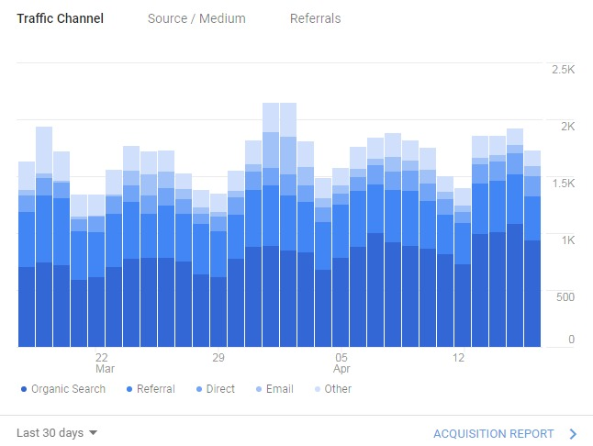

**3. PREDICTIVE ANALYTICS:**

• Predictive analytics models can forecast future website traffic trends based on historical data. This helps businesses plan for peak traffic periods, optimize resources, and improve user experiences.

**4. USER JOURNEY MAPPING:**

• Advanced analytics tools allow businesses to map the entire user journey, from the first interaction to conversion. This provides a holistic view of user behavior and helps identify bottlenecks or opportunities for improvement.

**5. CROSS-DEVICE TRACKING:**

• With the proliferation of smartphones and tablets, cross-device tracking is essential. Advanced tools can connect user interactions across different devices, providing a more accurate view of user engagement.

**6. VOICE AND VISUAL SEARCH ANALYSIS:**

• As voice and visual search become more common, analyzing how users interact with your website through these methods can help businesses optimize for these emerging trends.

**7. CONTENT ANALYTICS:**

• Content analytics tools use natural language processing (NLP) and sentiment analysis to understand how users engage with written and visual content. This can inform content creation and optimization strategies.

**8. CONVERSION ATTRIBUTION MODELING:**

• Attribution modeling helps businesses understand which marketing channels and touchpoints contribute most to conversions. Advanced models can incorporate multi-touch attribution and provide more accurate insights.

**9. BEHAVIORAL SEGMENTATION:**

• Behavioral segmentation divides website visitors into segments based on their actions and interactions. This allows for highly targeted marketing and content strategies.

**10. A/B TESTING AND MULTIVARIATE TESTING:**

• Innovations in A/B testing and multivariate testing tools provide more sophisticated and automated testing capabilities. They can optimize websites for different user segments and behaviors.

**11. CUSTOMER DATA PLATFORMS (CDPs):**

• CDPs unify customer data from various sources, including website interactions, to create comprehensive customer profiles. This enables businesses to provide personalized experiences and targeted marketing.

**12. PRIVACY-COMPLIANT ANALYTICS:**

• With increasing concerns about data privacy, analytics tools are innovating to provide insights while adhering to privacy regulations like GDPR and CCPA. This includes anonymizing data and providing opt-out mechanisms.

**13. INTEGRATION WITH BUSINESS INTELLIGENCE (BI) TOOLS:**

• Integrating website traffic data with BI tools allows for more in-depth analysis and visualization. Businesses can create custom dashboards and reports to gain actionable insights.

**14. MOBILE APP ANALYTICS:**

• As mobile app usage grows, analytics tools are adapting to track user behavior within mobile applications, providing insights into user engagement and app performance.

**15. AUGMENTED AND VIRTUAL REALITY ANALYTICS:**

• For websites and applications utilizing AR and VR technologies, specialized analytics tools can track user interactions within immersive environments.

**MACHINE LEARNING MODEL FOR WEBSITE TRAFFIC ANALYSIS:**

Machine learning models can be used for website traffic analysis to gain insights into user behavior, improve user experience, and make data-driven decisions.

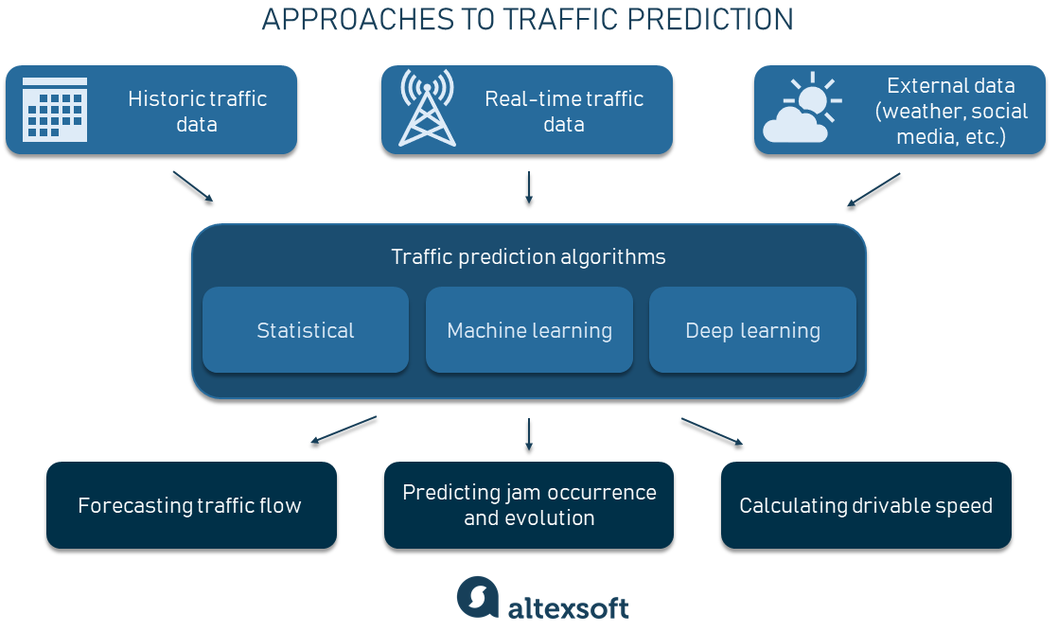

The example is related to Machine learning for website traffic analysis. Here are the primary objectives and steps to achieve this aim:

Step 1: Data Collection

- Gather data from various sources such as web server logs, Google Analytics, user interactions, and other relevant sources.

- Ensure data quality, consistency, and security.

Step 2: Data Preprocessing

- Clean and preprocess the data to handle missing values, outliers, and noise.

- Transform and format the data for machine learning, including feature engineering.

Step 3: Define Objectives

- Determine the specific objectives and key performance indicators (KPIs) for website traffic analysis.

- Decide what aspects of user behavior you want to understand, such as traffic patterns, user segmentation, conversion rates, or bounce rates.

Step 4: Feature Selection

- Identify relevant features (variables) that can influence website traffic and user behavior.

- Use techniques like feature selection or dimensionality reduction to optimize the feature set.

Step 5: Model Selection

- Choose appropriate machine learning algorithms for your analysis, depending on your objectives.

- Common algorithms for website traffic analysis include regression, classification, time series analysis, and clustering.

Step 6: Data Splitting

- Split the data into training, validation, and test sets to evaluate model performance accurately.

Step 7: Model Training

- Train the selected machine learning model(s) on the training data.

- Tune hyperparameters and optimize the model's performance.

Step 8: Model Evaluation

- Assess the model's performance using appropriate metrics like accuracy, F1-score, RMSE (Root Mean Square Error), etc., depending on the task.

- Consider using cross-validation for more robust evaluations.

Step 9: Interpretability and Insights

- Ensure that the model provides interpretable results, allowing you to understand the factors affecting website traffic.

- Use techniques like feature importance, SHAP values, or visualization to gain insights into user behavior.

Step 10: Deployment

- Deploy the trained model in a production environment to continuously monitor website traffic.

- Automate the data pipeline for regular updates and retraining.

Step 11: Monitoring and Maintenance

- Continuously monitor model performance and retrain it as needed.

- Stay updated with changing user behaviors and adapt the model accordingly.

Step 12: Actionable Recommendations

- Translate insights gained from the model into actionable recommendations for improving the website's content, layout, marketing strategies, etc.

Step 13: Iteration

- Iterate on the model and analysis based on the feedback and results obtained over time.

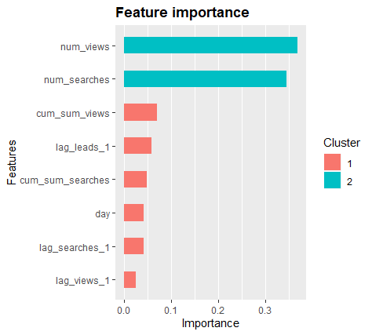

**CONCLUSION:**

It's important to note that the choice of machine learning models and techniques for website traffic analysis depends on the specific goals and data available. Additionally, data preprocessing, feature engineering, and continuous model evaluation and refinement are crucial aspects of building effective machine learning systems for website traffic analysis.The few of above mention ideas are going to implimented in this project.