# **Website Traffic Analysis**

**PHASE** **3 : DEVELOPMENT PART -1**

**(Loading And Preprocessing** **The Dataset)**

AIM:

Loading and preprocessing a dataset for website traffic analysis is a crucial step in any web analytics project. It involves gathering data from various sources, cleaning and transforming it for analysis.

Here's a step-by-step guide on how to approach this task:

CREATE PYTHON FILE:

A python files contain various libraries and features for machine learning and data analysis. I have created a python file for this project.

IMPORTING LIBRARIES:

To perform machine learning and website traffic analysis in Python, you can use a combination of various libraries. Here are some commonly used libraries for each of these tasks:

Numpy:

It can also be used to handle numerical operations related to website traffic analysis. We can use it for tasks like calculating averages, standard deviations, and performing mathematical operations on data.

Sklearn:

It provides functionality for unsupervised and supervised neighbors-based learning methods. Unsupervised nearest neighbors is the foundation of many other learning methods, notably manifold learning and spectral clustering.

Matplotlib.pyplot:

That specific import line merely imports the module "matplotlib. pyplot" and binds that to the name "plt".

Pandas:

Importing pandas as pd: an essential Python library for data scientists. Once you import it, you can take your data analysis to a whole new level. As a general purpose programming language, Python has all the features necessary to analyze and gain insights from data

CODES:

Just some imports for usecase:

import math, time, datetime

import random as rd

Data Manipulation

import numpy as np

import pandas as pd

Visualization

import matplotlib.pyplot as plt

import seaborn as sns

import geopandas as gpd

plt.style.use('seaborn-whitegrid')

Preprocessing

from sklearn.preprocessing import OneHotEncoder, LabelEncoder, label_binarize

Machine learning models:

from sklearn.model_selection import train_test_split

from sklearn.svm import LinearSVC

MATPLOTLIB DEFAULTS:

*# matplotlib defaults*  
*plt*.style.use('seaborn-whitegrid')  
plt.rc('figure', autolayout = True, figsize = (15,4), titlesize = 10, titleweight ='bold')  
plt.rc('axes', labelweight = 'bold', labelsize = 10, titlesize = 10, titleweight = 'bold', titlepad = 10)

MATPLOTLIB CONFIGURATION FOR HIGHER IMAGES**:**

*# matplotlib configuration fro higer images*  
*%*matplotlib inline  
%config InlineBackend.figure_formats = 'retina'

LOADING AND UNZIPPING THE DATASET:

The head() method returns a specified number of rows, string from the top. The head() method returns the first 5 rows if a number is not specified.

*# load the dataset*  
  
df = pd.read_csv(data_dir / "train_1.csv.zip")  
df.head()

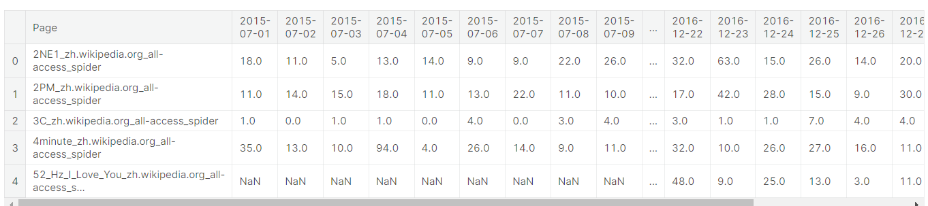

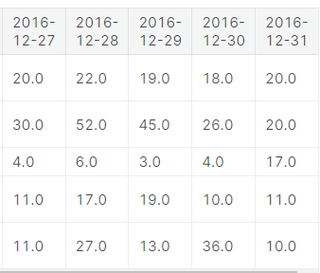

CHECKING FOR MISSING VALUES:  
 Returns the number of missing values in the dataset.

*# checking for missing values*  
*missing_values* = df.isnull().sum()  
missing_values

Page 0  
2015-07-01 20740  
2015-07-02 20816  
2015-07-03 20544  
2015-07-04 20654  
 ...   
2016-12-27 3701  
2016-12-28 3822  
2016-12-29 3826  
2016-12-30 3635  
2016-12-31 3465  
Length: 551, dtype: int64

missing_values[missing_values > 0]

2015-07-01 20740  
2015-07-02 20816  
2015-07-03 20544  
2015-07-04 20654  
2015-07-05 20659  
 ...   
2016-12-27 3701  
2016-12-28 3822  
2016-12-29 3826  
2016-12-30 3635  
2016-12-31 3465  
Length: 550, dtype: int64

total_missing_values = missing_values.sum()  
total_missing_values

SHAPE OF THE DATAFRAME:  
*# shape of the dataframe*  
*df*.shape

total_data = np.product(df.shape)  
total_data

MISSING PERCENT:

*# calculating the total percent of missing values*  
*missing_percent* = (total_missing_values / total_data) * 100

CHECKING NULL VALUES:

df.isna().sum()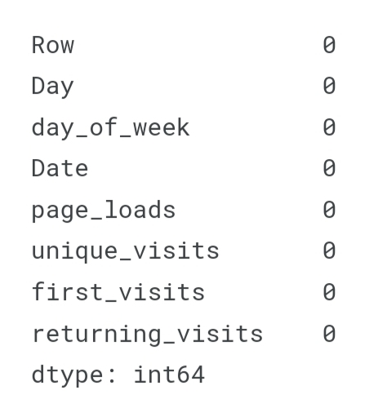

FILLING NULL COULUMNS AND ROWS:

*df_fill* = df.copy()  
df_fill = df_fill.fillna(0)  
df_fill.head()

Below is the filled null values and cleaned dataset:

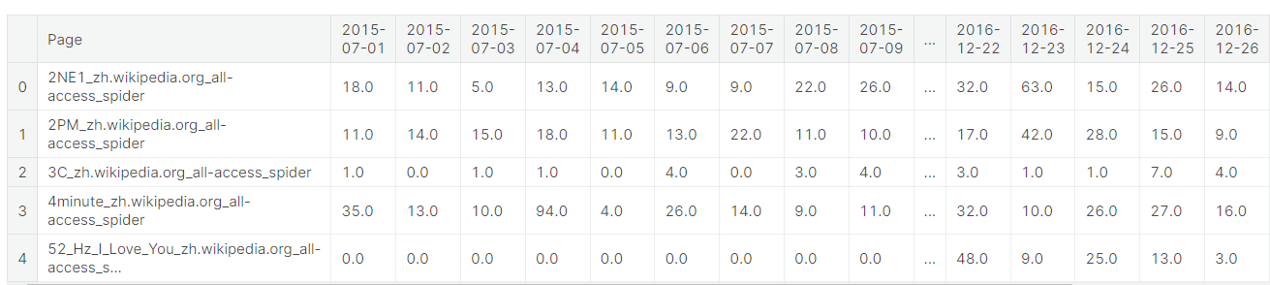

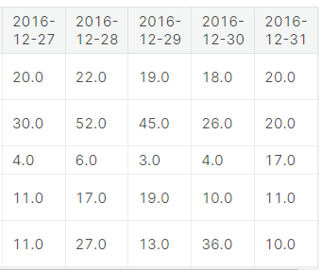

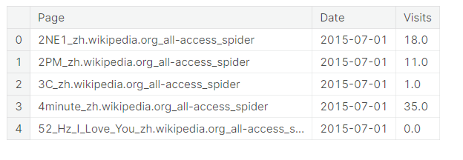

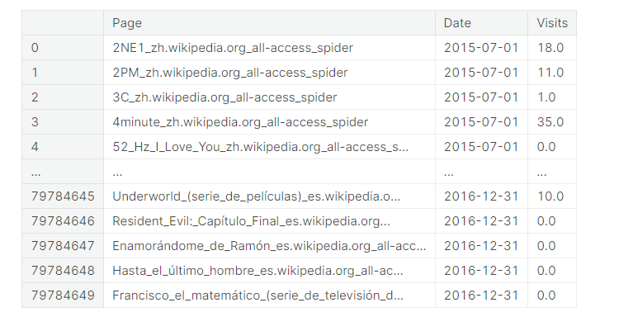

**DATASET DESCRIPTION:**

**df.info()**

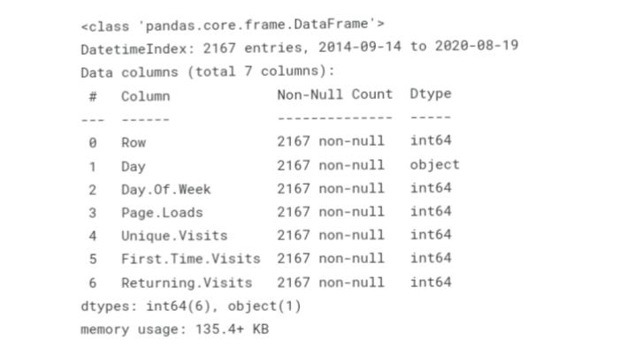

VISUALISING :

Visual representation of the given website traffic dataset which represents the Average number of views per day.

*# Visualising for Mean*  
*temp* = train_data.groupby('Date')['Visits'].mean()  
plt.xlabel('Date')  
plt.ylabel('Visits')  
plt.title('Average number of views per day')  
plt.plot(temp, label='Visits')  
plt.legend()  
plt.show()

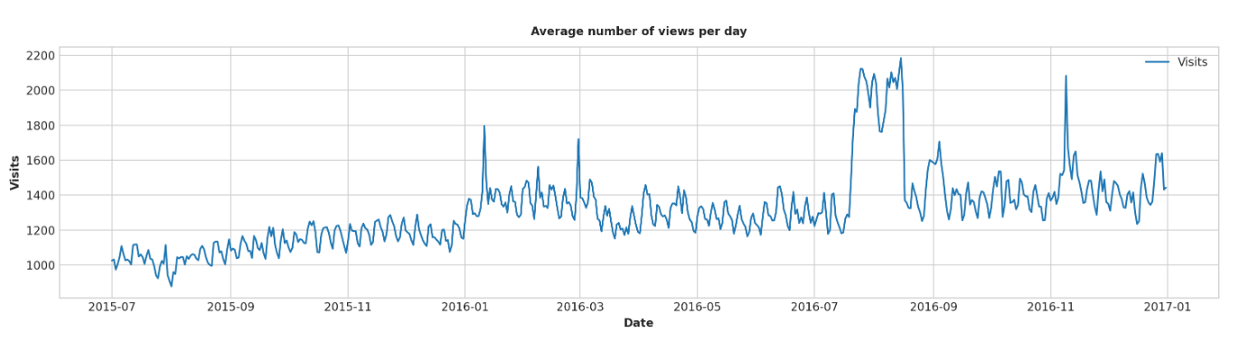

Visual representation of the given website traffic dataset which represents the Median number of views per day.

*# Visualising for Median Number of Data*  
*temp* = train_data.groupby('Date')['Visits'].median()  
plt.xlabel('Date')  
plt.ylabel('Median')  
plt.title('Median number of views per day')  
plt.plot(temp, label='Visits')  
plt.legend()

plt.show()

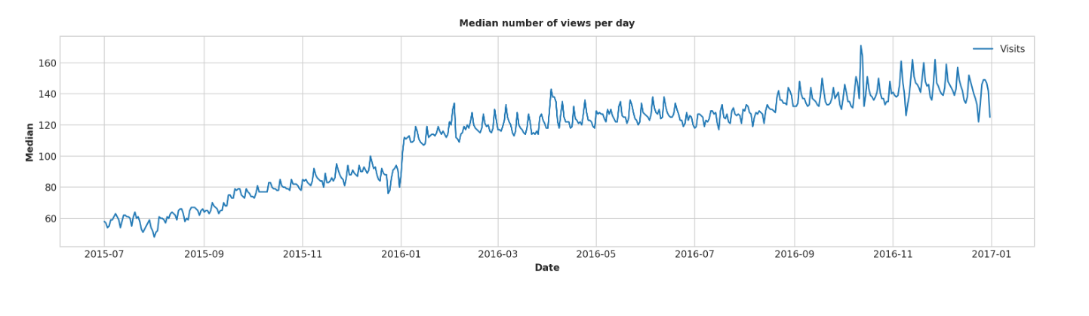

CONCLUSION:

Thus, this general process should provide a solid framework for loading and preprocessing of website traffic analysis dataset. It involves visual representation which can be more effective understanding the analysis of website traffics. Help to improve business and in many fields of virtual life. This cleaned dataset can now be used for further analysis, machine learning models and interpretation.