MLC_C4_Assignment_Tanush Dey

Steps

- Creation of EMR CLUSTER – We created a emr clusted with m4.2xlarge and also two core of same configuration.
We also installed the jupyter hub and spark in the emr cluster
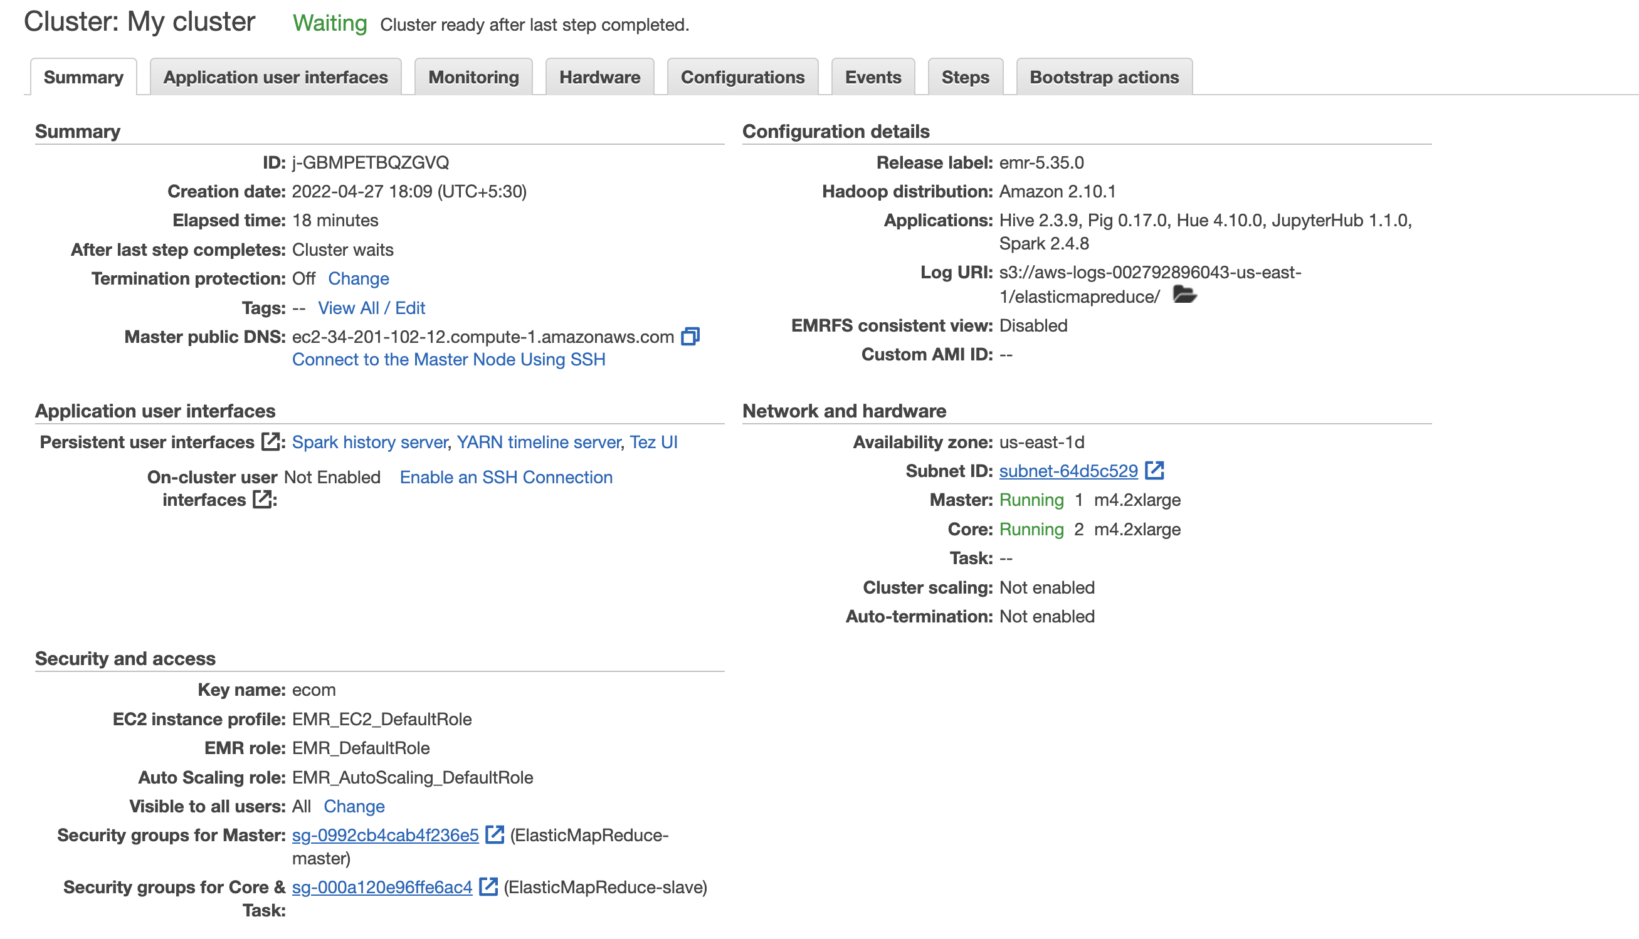

For the 9433 port for access of jupyterhub we edited the inbound rule in master security group , we created a customtcp rule with 9433 port and 0.0.0.0/0 cidr

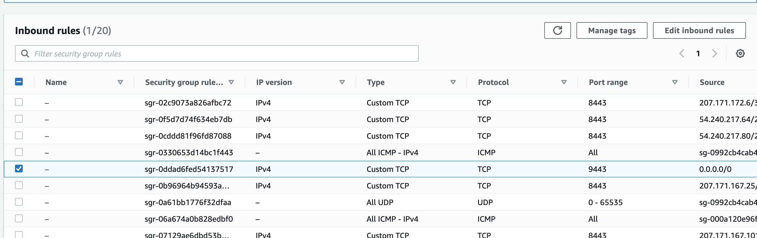

- Files Stored in s3 – I used my s3 bucket to upload the 2 files and gave necessary permission to be queried upon.
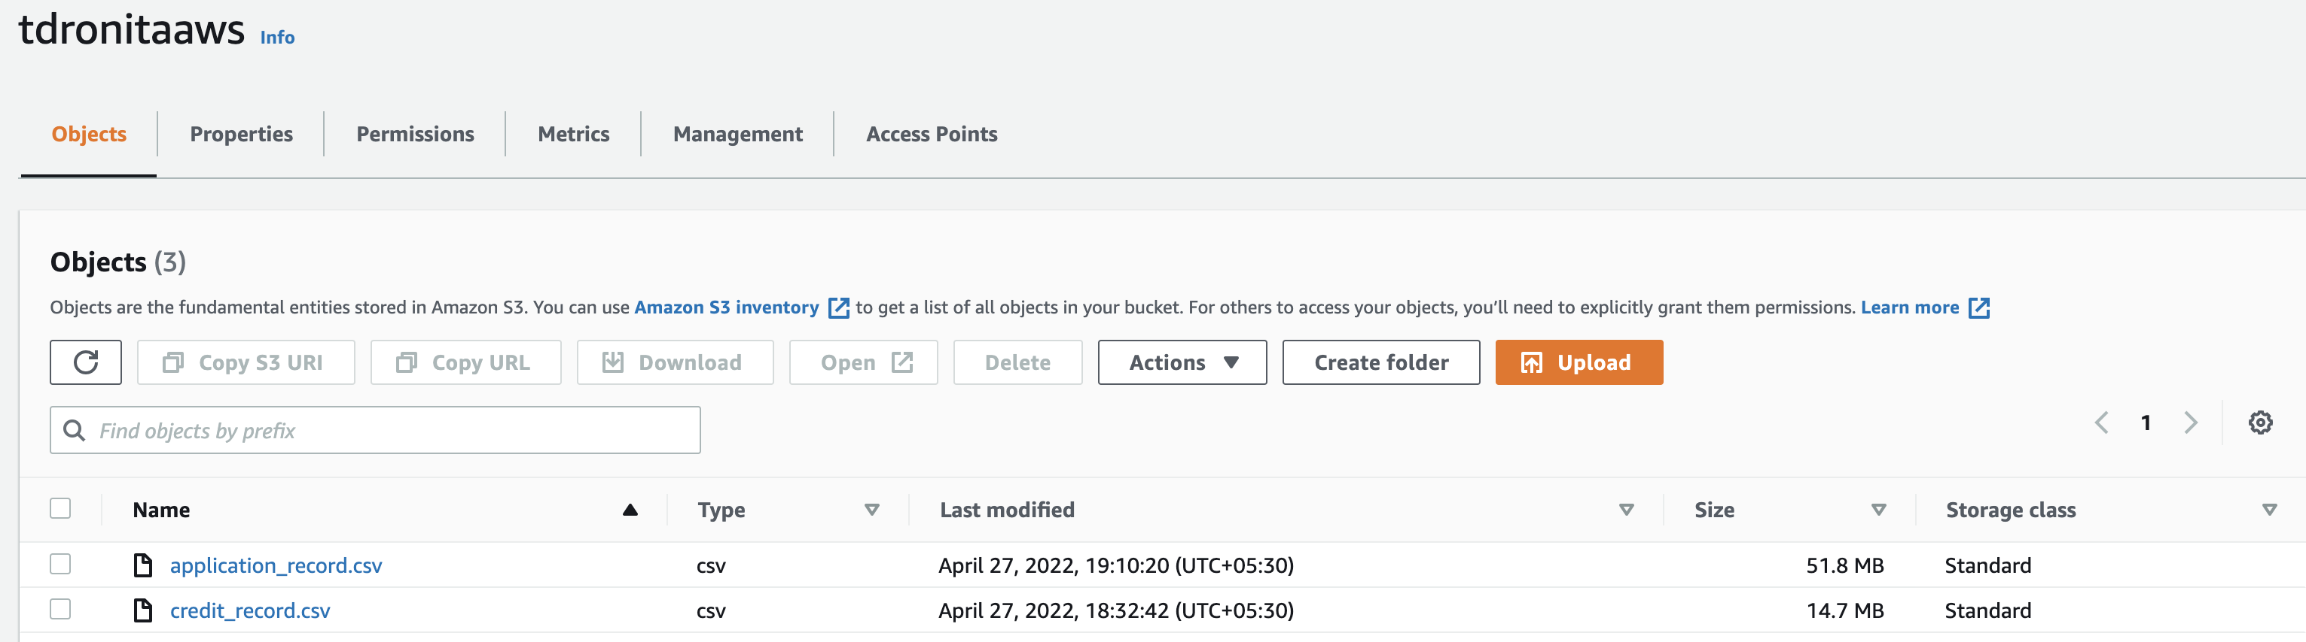

- As I was using python kernel I installed the necessary libraries used

- We had some issues with broadcast Timeout during model training

So in the code we did increase the timeout to a very high
spark = SparkSession.builder.appName("test").config("spark.sql.broadcastTimeout", "3600000000").getOrCreate()

- In the exercise we read files from the s3 bucket and solved the eda questions, The verbiage is present in jupyter notebook attached

- We created the logistic regression using the woe class

- We also calculated the probability for the test data

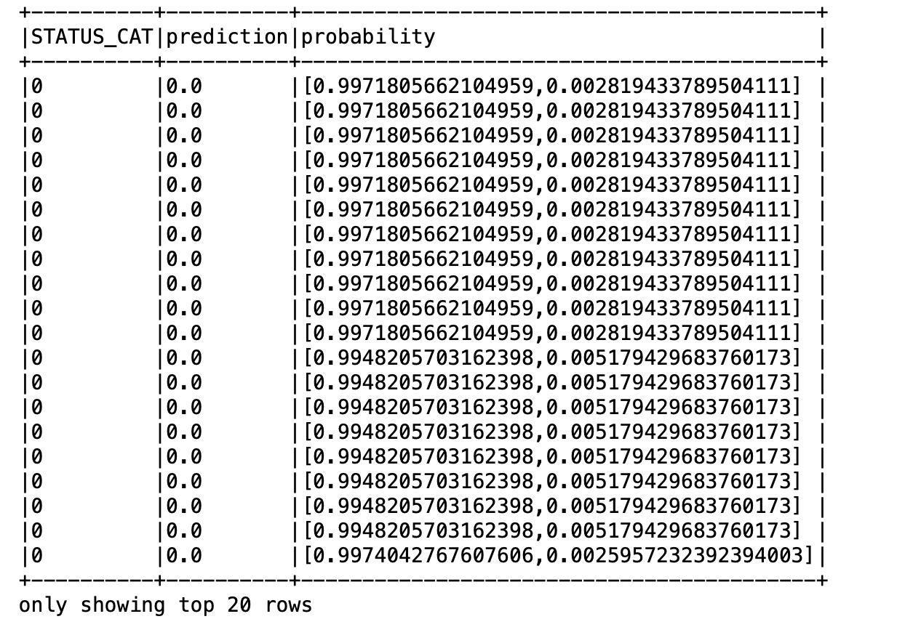
- We also checked area under roc
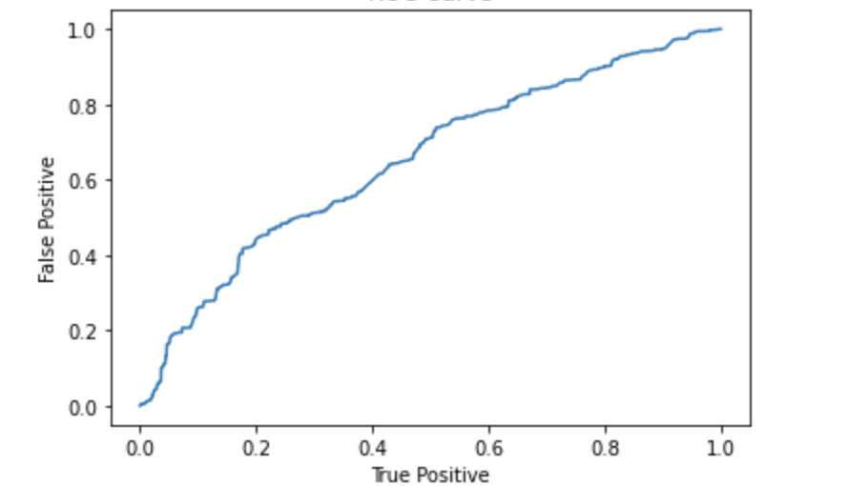
- We also calculated the below metrics

