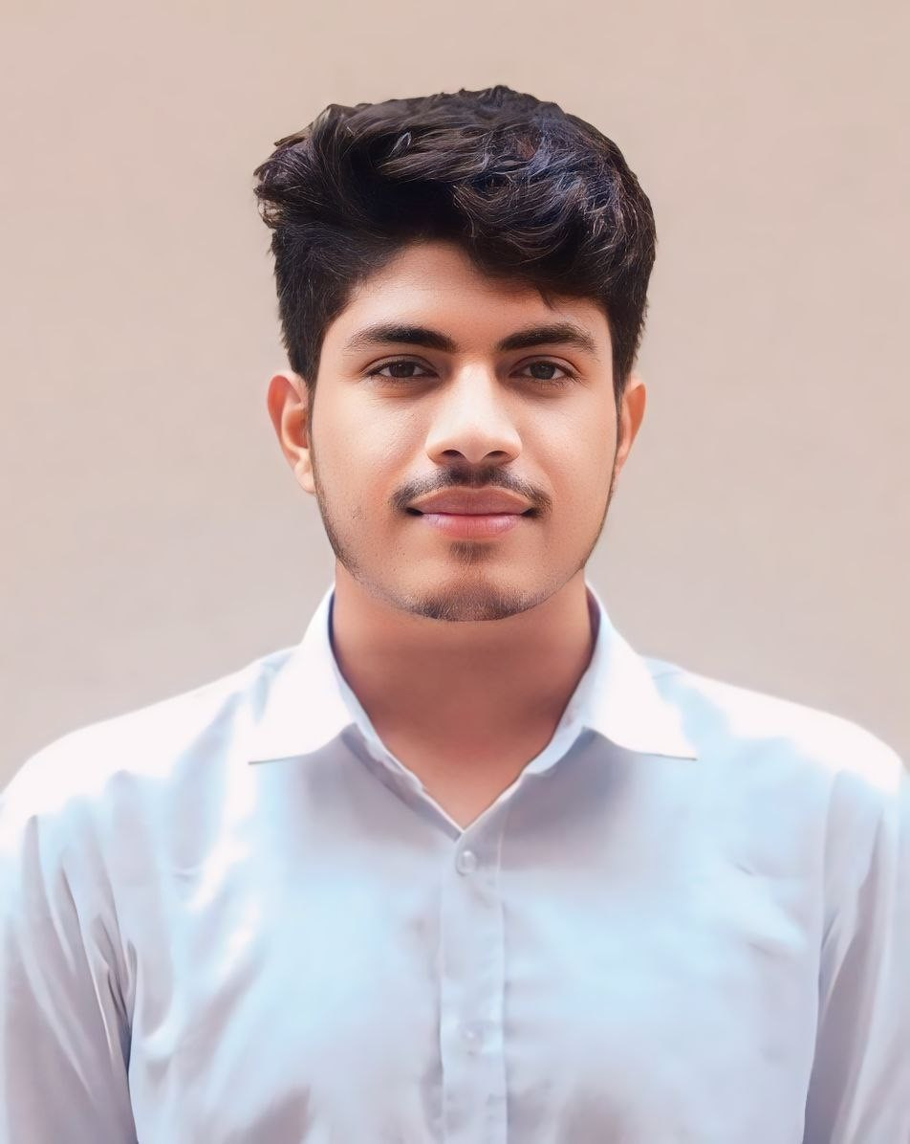

# MD.Tanvir Islam

**Full-stack Development**

* Phone Number:

+8801639125012

* WhatsApp Number:

+8801639125012

* Email:

(tanvirislam3912@gamil.com)

* Present Address:

H-260,R-03,Block-D,

Mirpur-12, Dhaka

# Hard Skills:

* JavaScript
* HTML
* CSS.
* React.js
* Node.js
* MongoDB
* Express.js
* MongoDB
* Next.js

# Sof t Skills:

* Communication.
* Team-building

•Time Management

* Organizing

# Co-Curricular Activities

* Personal Projects
* Travelling.
* Singing.
* Sports.

# Career Objective

I am Looking for a career with an equal opportunity for growth and development and a challenging environment where I can show a strong sense of responsibility, the dignity of work, and devotion to building a bright career and developing the organization.

# Experience

**Creative IT Institute**

16.08.23 - Present

**Intern/Jr :** Full-stack Development-(MERN)

# Job Responsibilities:

* Writing clean, eﬃcient, and well-documented code using JavaScript & Node.js Language.
* Building and maintaining web applications using modern web development tools and technologies.
* Collaborating with other team members to design and implement new features and functionality.
* Troubleshooting and de bugging code to ensure optimal performance and reliability.
* Participating in code reviews to ensure code quality and adherence to coding standards.

# Achievement:

* Achieved KPI target from Team.
* Got “0” late attendance award.

# Educational Qualiﬁcation

* Diploma in Engineering in Computer Science from “CPI Management & Technology” in 2023 with a CGPA of 3.68 out of 4.00.
* SSC in Science studies group from “Chaitonkanda Golam Mohammad High School” in 2019 with a GPA of 4.00 out of 5.00

# Training /Certiﬁcation

**Name:** Full-stack Development-(MERN) 16.08.23-09.11.23(0.3 months)

# Creative IT institute

**Topics covered:** React.js & Next.js(framework) , JavaScript , Tailwind(framework) , Node.js , MongoDB, Express.js , jwt

, redux toolkit, Firebase, React Awesome

**Country**: Dhaka, Bangladesh Got Certiﬁcate

# Achievements/Academic publications/Portfolio

**Achievements:** 2nd Winner in Engineering Cricket Tournament.

1st Winner in Engineering Cricket Tournament.

# LinkedIn: linkedin.com/in/tanvir-islam-3b7883284

**Portfolio(GitHub):**[https://www](http://www.linkedin.com/in/md-tanvir-3b).[linkedin.com/in/md-](http://www.linkedin.com/in/md-tanvir-3b)tanvir[-3b](http://www.linkedin.com/in/md-tanvir-3b) 7883284

# Reference

Name:Din Islam Tahsan Company:CreativeIT Designation:Sr.Faculty& Software Developer Email : [tahsan.cit.bd@gmail.com](mailto:tahsan.cit.bd@gmail.com) Phone Number: 01777308777

**Name**:Colonel Wahida Rahman Institute:Armed Forces Medical Collage **Designation**:Lieutenant, MBBS,MPhil.Asociate

Phone Number: 01716456206

# Language Proﬁciency

* + **English:** Reading- Beginner, Writing- Intermediate, Listening- Beginner, Speaking: Intermediate.
  + **Bangla:** Reading- Native, Writing- Advance, Listening- Native, Speaking- Native.

# Extra-Curricular Activities

**PresidentofCPIManagement&TechnologyDevelopment Club**

01.01.22–01.12.23

# President

**Responsibilities:**

•ConnectingupwithmanydiferentCompatibledevelopers.

•Formed Development Alumni Association with 25+ active members.

# Personal Information

* + Date of Birth: 28.04.2003
  + Nationality: Bangladesh
  + NID: 51173133296
  + Marital Status: Unmarried