**DCakeShop**

|  |  |  |
| --- | --- | --- |
| **Supervisor:** | ***Sir Kousar Raza*** | |
| **Batch:** | ***2112D*** | |
| **Group:** | **2** | |
| **Serial No:** | Enrollment No: | Student Name: |
| **1.** | **1353144** | ***Wahib Hussain*** |
| **2.** | **1351365** | ***M.Hassan*** |
| **3.** | **1364177** | ***Zaqir Ahmed*** |

**Acknowledgement**

***“We would like to express my special thanks of gratitude to Sir Kousar Raza. Thank you for being an amazing mentor. You’re great in every way!* *You inspire us to work hard and dream big. We ‘re truly thankful to have a genius mentor like you. Thank you mentor! It’s honorable for us to be under your supervision. We learned a lot from you.***

***We would also like to thanks the e-project team at Aptech Head Office, who gave as the opportunity to do this interesting and wonderful project about DCakeShop.***

**Following are the benefit of E-Project**

* ***improve productivity and quality of work***
* ***increase customer satisfaction***
* ***Gain a competitive advantage and boost your bottom line”.***

**Synopsis**

E-commerce is fast gaining ground as an accepted and used business paradigm. More

and more business houses are implementing web site providing functionality for

performing commercial transactions over the web. It is reasonable to say that the

process of shopping on the web is becoming commonplace.

Shopping Cart feature allows online shopping customers to “place” items in the

cart. Upon “checkout” the software calculates as total for the order including shipping

and handling postage, packing and taxes, if applicable. The Shopping Cart is very

important feature used in e-commerce to assist people making purchases products

online. It provides the user a catalog of different products available in the system. In

order to purchase a shopping cart is provided to the user. The shopping cart application

has been developed to allow business grows larger and faster. This site will let

customers to view and order products online from any part of the world.

E-commerce is fast gaining ground as an accepted and used business paradigm. More

and more business houses are implementing web site providing functionality for

performing commercial transactions over the web. It is reasonable to say that the

process of shopping on the web is becoming commonplace.

Shopping Cart feature allows online shopping customers to “place” items in the

cart. Upon “checkout” the software calculates as total for the order including shipping

and handling postage, packing and taxes, if applicable. The Shopping Cart is very

important feature used in e-commerce to assist people making purchases products

online. It provides the user a catalog of different products available in the system. In

order to purchase a shopping cart is provided to the user. The shopping cart application

has been developed to allow business grows larger and faster. This site will let

customers to view and order products online from any part of the world.

E-commerce is fast gaining ground as an accepted and used business paradigm. More

and more business houses are implementing web site providing functionality for

performing commercial transactions over the web. It is reasonable to say that the

process of shopping on the web is becoming commonplace.

Shopping Cart feature allows online shopping customers to “place” items in the

cart. Upon “checkout” the software calculates as total for the order including shipping

and handling postage, packing and taxes, if applicable. The Shopping Cart is very

important feature used in e-commerce to assist people making purchases products

online. It provides the user a catalog of different products available in the system. In

order to purchase a shopping cart is provided to the user. The shopping cart application

has been developed to allow business grows larger and faster. This site will let

customers to view and order products online from any part of the world.

E-commerce is fast gaining ground as an accepted and used business paradigm. More

and more business houses are implementing web site providing functionality for

performing commercial transactions over the web. It is reasonable to say that the

process of shopping on the web is becoming commonplace.

Shopping Cart feature allows online shopping customers to “place” items in the

cart. Upon “checkout” the software calculates as total for the order including shipping

and handling postage, packing and taxes, if applicable. The Shopping Cart is very

important feature used in e-commerce to assist people making purchases products

online. It provides the user a catalog of different products available in the system. In

order to purchase a shopping cart is provided to the user. The shopping cart application

has been developed to allow business grows larger and faster. This site will let

customers to view and order products online from any part of the world.

E-commerce is fast gaining ground as an accepted and used business paradigm. More

and more business houses are implementing web site providing functionality for

performing commercial transactions over the web. It is reasonable to say that the

process of shopping on the web is becoming commonplace.

Shopping Cart feature allows online shopping customers to “place” items in the

cart. Upon “checkout” the software calculates as total for the order including shipping

and handling postage, packing and taxes, if applicable. The Shopping Cart is very

important feature used in e-commerce to assist people making purchases products

online. It provides the user a catalog of different products available in the system. In

order to purchase a shopping cart is provided to the user. The shopping cart application

has been developed to allow business grows larger and faster. This site will let

customers to view and order products online from any part of the world.

E-commerce is fast gaining ground as an accepted and used business paradigm. More

and more business houses are implementing web site providing functionality for

performing commercial transactions over the web. It is reasonable to say that the

process of shopping on the web is becoming commonplace.

Shopping Cart feature allows online shopping customers to “place” items in the

cart. Upon “checkout” the software calculates as total for the order including shipping

and handling postage, packing and taxes, if applicable. The Shopping Cart is very

important feature used in e-commerce to assist people making purchases products

online. It provides the user a catalog of different products available in the system. In

order to purchase a shopping cart is provided to the user. The shopping cart application

has been developed to allow business grows larger and faster. This site will let

customers to view and order products online from any part of the world.

E-commerce is fast gaining ground as an accepted and used business paradigm. More

and more business houses are implementing web site providing functionality for

performing commercial transactions over the web. It is reasonable to say that the

process of shopping on the web is becoming commonplace.

Shopping Cart feature allows online shopping customers to “place” items in the

cart. Upon “checkout” the software calculates as total for the order including shipping

and handling postage, packing and taxes, if applicable. The Shopping Cart is very

important feature used in e-commerce to assist people making purchases products

online. It provides the user a catalog of different products available in the system. In

order to purchase a shopping cart is provided to the user. The shopping cart application

has been developed to allow business grows larger and faster. This site will let

customers to view and order products online from any part of the world.

E-commerce is fast gaining ground as an accepted and used business paradigm. More

and more business houses are implementing web site providing functionality for

performing commercial transactions over the web. It is reasonable to say that the

process of shopping on the web is becoming commonplace.

Shopping Cart feature allows online shopping customers to “place” items in the

cart. Upon “checkout” the software calculates as total for the order including shipping

and handling postage, packing and taxes, if applicable. The Shopping Cart is very

important feature used in e-commerce to assist people making purchases products

online. It provides the user a catalog of different products available in the system. In

order to purchase a shopping cart is provided to the user. The shopping cart application

has been developed to allow business grows larger and faster. This site will let

customers to view and order products online from any part of the world.

E-commerce is fast gaining ground as an accepted and used business paradigm. More

and more business houses are implementing web site providing functionality for

performing commercial transactions over the web. It is reasonable to say that the

process of shopping on the web is becoming commonplace.

Shopping Cart feature allows online shopping customers to “place” items in the

cart. Upon “checkout” the software calculates as total for the order including shipping

and handling postage, packing and taxes, if applicable. The Shopping Cart is very

important feature used in e-commerce to assist people making purchases products

online. It provides the user a catalog of different products available in the system. In

order to purchase a shopping cart is provided to the user. The shopping cart application

has been developed to allow business grows larger and faster. This site will let

customers to view and order products online from any part of the world.

E-commerce is fast gaining ground as an accepted and used business paradigm. More

and more business houses are implementing web site providing functionality for

performing commercial transactions over the web. It is reasonable to say that the

process of shopping on the web is becoming commonplace.

Shopping Cart feature allows online shopping customers to “place” items in the

cart. Upon “checkout” the software calculates as total for the order including shipping

and handling postage, packing and taxes, if applicable. The Shopping Cart is very

important feature used in e-commerce to assist people making purchases products

online. It provides the user a catalog of different products available in the system. In

order to purchase a shopping cart is provided to the user. The shopping cart application

has been developed to allow business grows larger and faster. This site will let

customers to view and order products online from any part of the world.

E-commerce is fast gaining ground as an accepted and used business paradigm. More

and more business houses are implementing web site providing functionality for

performing commercial transactions over the web. It is reasonable to say that the

process of shopping on the web is becoming commonplace.

Shopping Cart feature allows online shopping customers to “place” items in the

cart. Upon “checkout” the software calculates as total for the order including shipping

and handling postage, packing and taxes, if applicable. The Shopping Cart is very

important feature used in e-commerce to assist people making purchases products

online. It provides the user a catalog of different products available in the system. In

order to purchase a shopping cart is provided to the user. The shopping cart application

has been developed to allow business grows larger and faster. This site will let

customers to view and order products online from any part of the world.

**E-commerce is fast gaining ground as an accepted and used business paradigm. Moreand more business houses are implementing web site providing functionality for performing commercial transactions over the web. It is reasonable to say that the process of shopping on the web is becoming commonplace.**

**Shopping Cart feature allows online shopping customers to “place” items in the cart. Upon “checkout” the software calculates as total for the order including shipping and handling postage, packing and taxes, if applicable. The Shopping Cart is very important feature used in e-commerce to assist people making purchases products online. It provides the user a catalog of different products available in the system. In order to purchase a shopping cart is provided to the user. The shopping cart application has been developed to allow business grows larger and faster.**

**This site will let customers to view and order products online from any part of the world.**

**Problems Definition**

**Mr. “Wahib , Hassan & Zaqir” are the founder of the DCakeShop. The starting of them journey is from**  **their red velvet cakes which became iconic and people lined up around the block for our banana pudding. There was even talk of New York pretzel guys becoming cupcake guys. DCakeShop was a destination for locals and tourists alike.**

**It was time for them to open the cupboards and share their magic with the world. There neighborhood bakery found its way into new neighborhoods near and far, They wrote cookbooks and helped people all over celebrate their most important moments.**

**They have also give an opportunity to the customers is that if customers orders two items in one day we will give him special discount coupon.** **.Those customers who had registered in the web site are able to see the entire list. For unregistered user the page will have following Link access but the premium products will not be activated . Now they wishes to sell their products online through their website .** **And while they have grown, a few things will always remain: open early and close late, a dollop of buttercream makes everything better, and our mission: make today sweeter than yesterday.**

**Customer Requirement Specification**

**To popularize their Cake shop, Mr. “Wahib , Hassan & Zaqir ” has listed out**

**the few points which they want to be their in website.**

**Here are list to be design in the project;**

1. **Home page: should contain Menus like home, login, free recipe available, contact us, feedback, adding recipe FAQ’s, Order the books of the recipe.**
2. **• For Register page the customer can register with the site provided he/she .**

**Once the users get registered he/she must be allowed to login with their user name and password.**

**• Cake can be ordered by both Registered and Un-Registered Users. They are suppose to provide the authenticate details.**

**3) Feedback form (to take the feedback from both registered users and Unregistered Users.)**

**4) Online Order: Here the list of the Cake must be added with its image and little description. There should be link mentioned for buying the Cake, once the links gets clicked then the users is supposed to provide the authenticate details like;**

**• Name**

**• Email ID**

**• Contact Details**

**• Address (where the Cake will get delivered)**

**(validation must be provided)**

**• Submit**

**Once the transaction is complete the message must be prompted to the user whether the transaction is completed or not.**

**4) About Us: Describe about the Cake shopr and the owner.**

**5) Contact Us: Should display the Contact details.**

**Admin: Admin will have its own Login Page where the following functions will be taken care of:**

**• Details of the Cake will be added and updated.**

**• Checking the List of the registered users.**

**• Checking the list of the Cake being ordered and the updating the status like if the Cake is send then the order processes, once reached the status will be completed.**

**Scope of the work**

**(Briefly)**

**The name of the project is DCakeShop the software provides the customer various facilities in this project we can easily maintain DCakeShop sales details. It’s gives complete information of DCakeShopit’s name, price, and category etc. we can see the Cake details before purchasing the particular Cake and view for our requirements satisfying item detailDCakeShop automation system provides ability to view any Cake of different category available in the shop.**

**Admin can perform login by entering Username and Password and register to purchasing . Users allotted to him and can view the feedback submitted bye Users. That means a person which has the system which provides the facility to the customer of the shop to purchase complexity.**

**For example any customer wants to purchase any cupcake from the shop than first customer has to login in the website and then just choose the category of the cupcake than he/she can see the more then one type of cupcake there and then he/she can choose the specific cake from there.**

**WHY SHOP WITH US?**

**We are the leading cake experts in the**

**Pakistan.**

**• FREE Click & Collect service in all Pakistan’s**

**stores.**

**• Fantastic savings across 100s of top brands all**

**year round.**

**• FREE Gift wrap service available in store.**

**• The most generous loyalty card membership on**

**the high street.**

**• FREE Standard delivery available online.**

**Site Map**



**About Us**

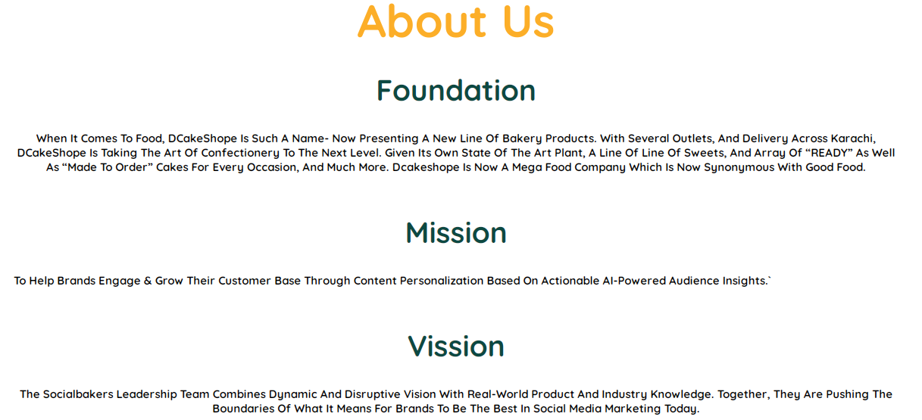

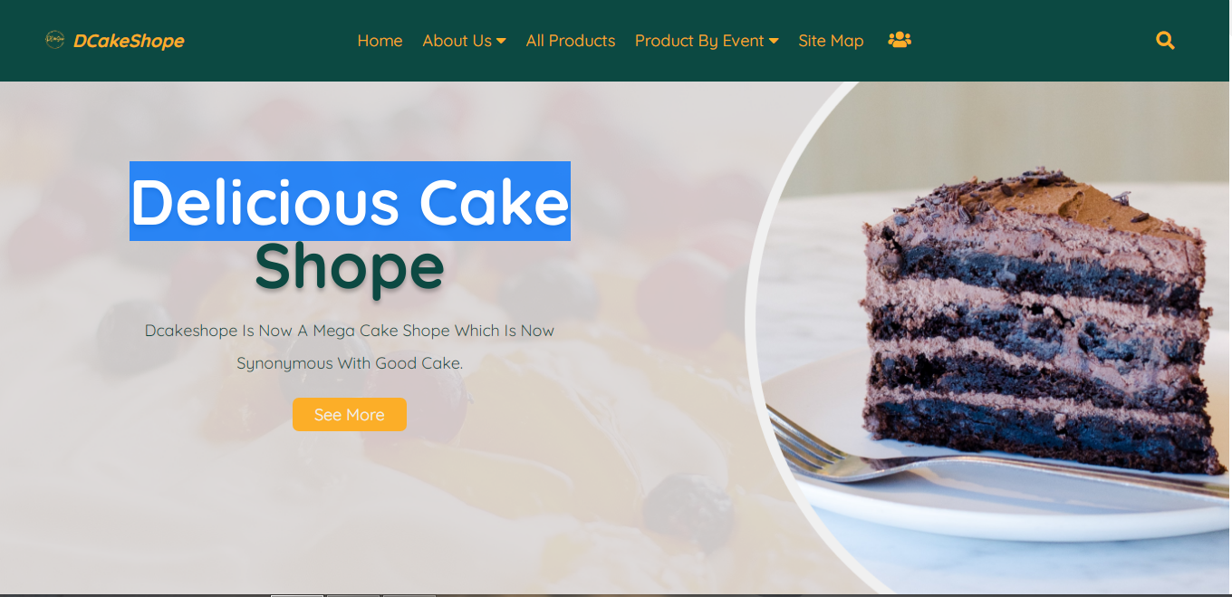

**Top Layout**

**Product Page**

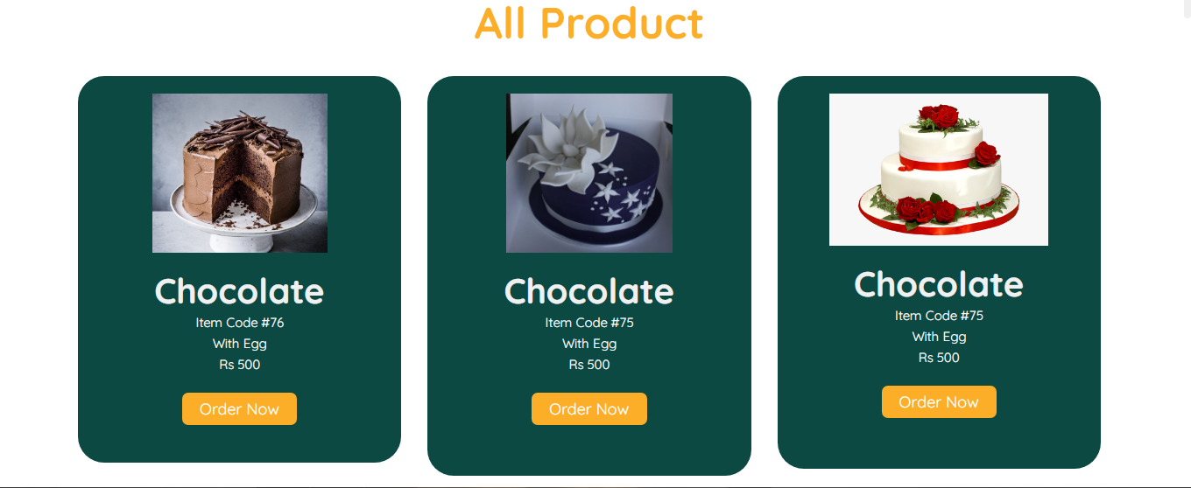

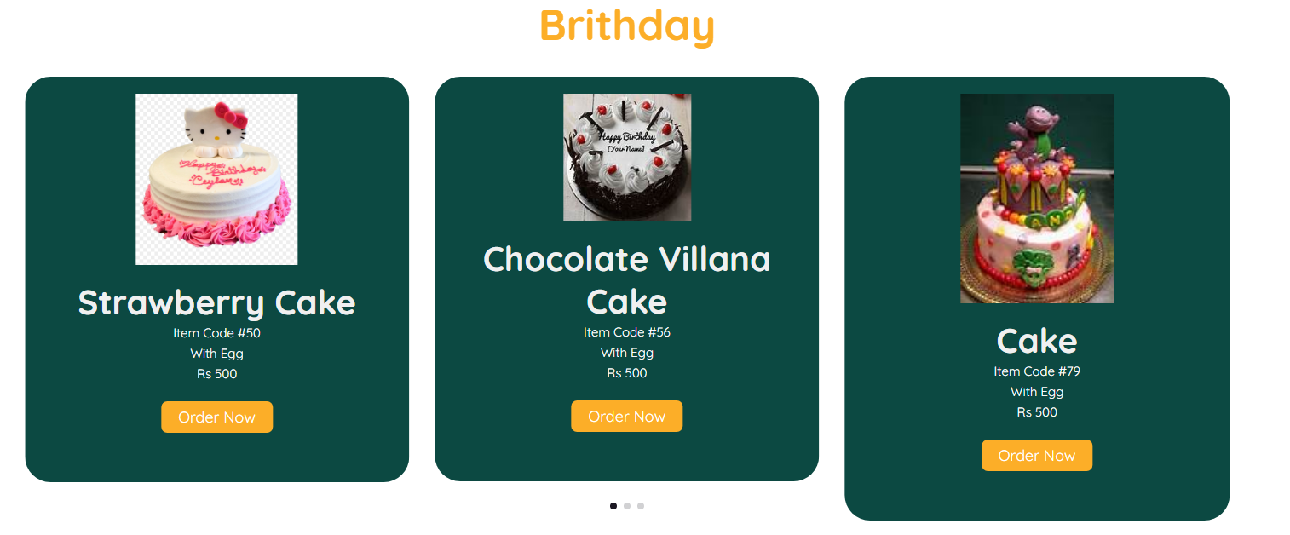 **Birthday**

**Product by Event**

**Anniversary**

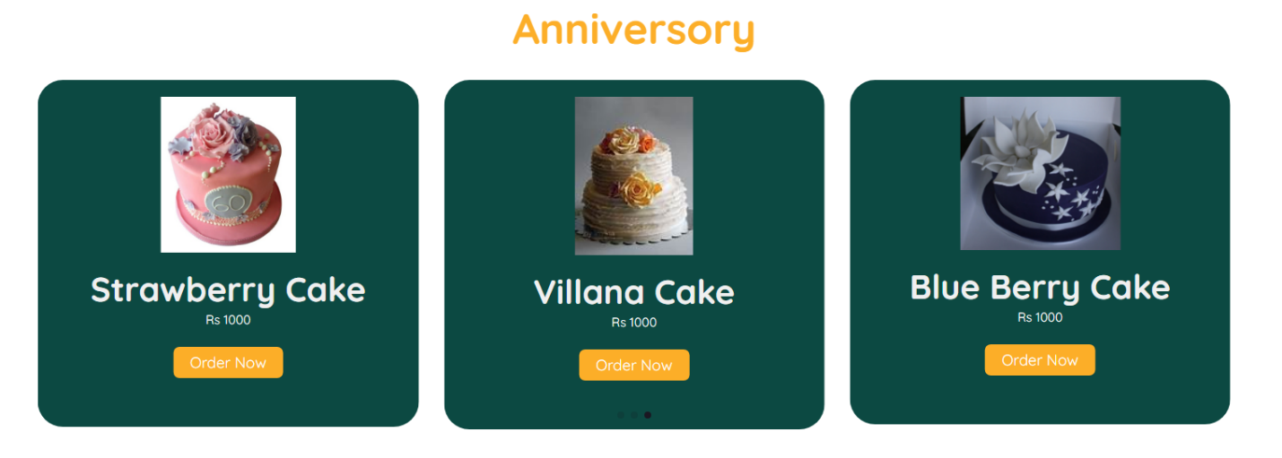

**Engagement**

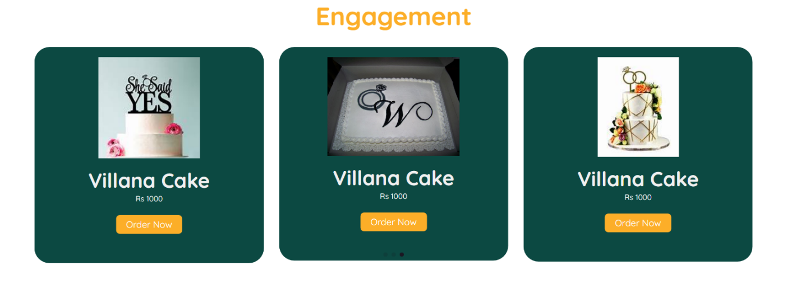

**Registration Page**

**Sign In Sign Up**

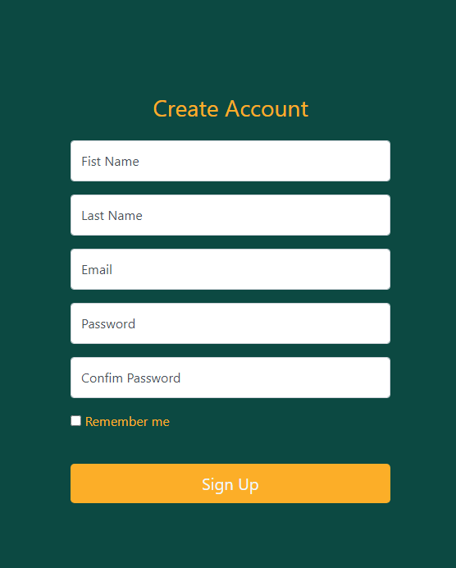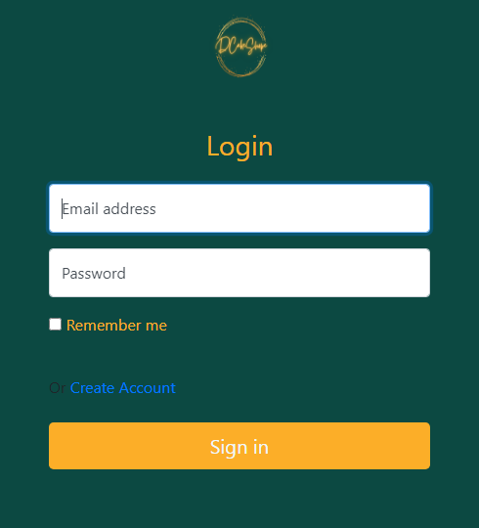

**Order Page**

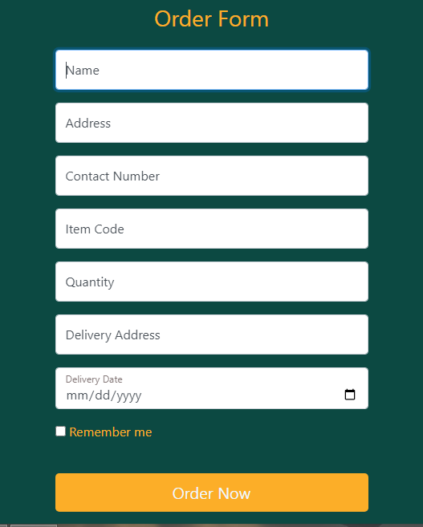

**THANK YOU**

**FOR READING**

**OUR DOCUMENTATION**