**A.I. Diva: A Sassy AI Chatbot for Teaching Responsible AI Usage**

Rebecca Rahman  
Georgia Gwinnett College  
678.407.5000  
[rrahman4@ggc.edu](mailto:rrahman4@ggc.edu)

Gabriel Sosa  
Georgia Gwinnett College  
678.407.5000  
[gsosa2@ggc.edu](mailto:gsosa2@ggc.edu)

My Tran  
Georgia Gwinnett College  
678.407.5000  
[mtran25@ggc.edu](mailto:mtran25@ggc.edu)

**ABSTRACT**

1. Artificial Intelligence (AI) is rapidly transforming various industries, but its responsible use remains a key challenge. Our project, A.I. Diva, is an interactive, sassy chatbot designed to educate users on ethical AI usage, misinformation, and appropriate AI applications in the real world. Developed as a class project under the Technology Ambassador Program (TAP), A.I. Diva provides engaging, scenario-based learning experiences that teach users how to critically evaluate AI-generated content and design optimal prompts. Through hands-on workshops, we engage participants in real-world AI dilemmas where they interact with A.I. Diva, receive instant feedback, and refine their understanding of AI best practices.

Preliminary results indicate a significant improvement in participants’ ability to identify AI-generated misinformation, understand ethical AI principles, and develop stronger AI literacy skills. Survey data and graphical analyses highlight measurable growth in participants’ critical thinking regarding AI interactions. As AI literacy becomes increasingly essential, A.I. Diva bridges the knowledge gap by making AI education engaging and accessible. With plans to expand this initiative through TAP’s outreach programs and educational collaborations, our chatbot serves as a steppingstone toward responsible AI adoption in academic and professional settings

1. **INTRODUCTION**

This study is geared towards individuals who struggle to discern between responsible AI usage and potential misuse. The objective of the A.I. Diva project is to provide a fun, interactive chatbot that teaches AI literacy through real-world scenarios. A.I. Diva offers instant feedback in a playful yet informative manner, expanding TAP’s prior work in technology-based education to include AI ethics and misinformation detection.

1. **TAP AND PROJECT MOTIVATION**

TAP (Technology Ambassador Program) is an award-winning initiative at Georgia Gwinnett College that encourages student-led technological education through workshops and outreach programs. As a class project, A.I. Diva aligns with TAP’s goal of fostering interest in computing while addressing the increasing need for AI literacy. By utilizing a chatbot with a distinctive personality, we aim to make AI education engaging and accessible to both K-12 students and college-level learners.

# METHODS

## Technology Stack

* Frontend: HTML, CSS, JavaScript
* Backend: Python, Flask
* AI Model: OpenAI GPT (via API)
* Data Analysis: Google Forms, Excel
* Platform: Web-based (desktop and mobile compatible)

## Project Description

## A.I. Diva is developed using Python, JavaScript, HTML, and OpenAI’s GPT models, integrating natural language processing (NLP) capabilities that allow it to interact dynamically with users. The chatbot engages users with a mix of humor and education, guiding them through different AI-related topics such as:

## Identifying AI-generated misinformation

## Ethical AI usage in academic and professional settings

## Understanding AI biases and limitations

## Designing effective prompts for AI interactions

## Study Description

## The study involves interactive learning workshops that assess users' understanding of AI ethics and misinformation. Participants engage in scenario-based learning where they respond to AI-related dilemmas. A.I. Diva provides instant feedback, explaining the implications of different AI uses and guiding users toward best practices. The study consists of:

* Various workshop formats (in-person, online, hybrid)
* Pre-survey to assess baseline knowledge
* Post-survey to measure learning outcomes

# RESULTS: WORKSHOPS TEACHING AI LITERACY

# The primary objective is familiarizing students with AI concepts, responsible usage, and prompt engineering strategies. The project aims to give students hands-on learning experiences that can be applied to broader AI applications.

At the beginning of the workshop, brief lessons introduce core AI concepts, ethical concerns, and biases. Participants then engage in scenario-based challenges where they must critically evaluate AI-generated responses. These challenges consist of multiple-choice questions designed to reinforce key AI literacy principles.

After that, students explore how their responses shape AI interactions and discuss real-world applications of responsible AI engagement.

1. **EXPECTED OUTCOMES**

Our project aims to measure success through pre- and post-interaction surveys assessing users' understanding of AI ethics and misinformation. Key success metrics include:

* Improved ability to recognize AI-generated misinformation
* Increased awareness of ethical AI practices
* Positive engagement with AI education materials

# FUTURE IMPLEMENTATION

Upon successful pilot testing, we plan to integrate A.I. Diva into TAP’s existing outreach programs and educational workshops. Additionally, we aim to collaborate with educators to enhance AI literacy curricula and expand the chatbot’s capabilities based on user feedback.

Results from our workshops indicate a significant improvement in participants’ ability to recognize AI-generated misinformation and understand ethical AI principles. Pre- and post-workshop surveys show increased confidence in evaluating AI interactions, with a notable rise in awareness of AI biases and ethical concerns. Participants also demonstrated improved skills in crafting effective AI prompts.

75% of participants improved their ability to detect misinformation

90% reported increased understanding of ethical AI practices

Over 80% found the chatbot more engaging than traditional instruction

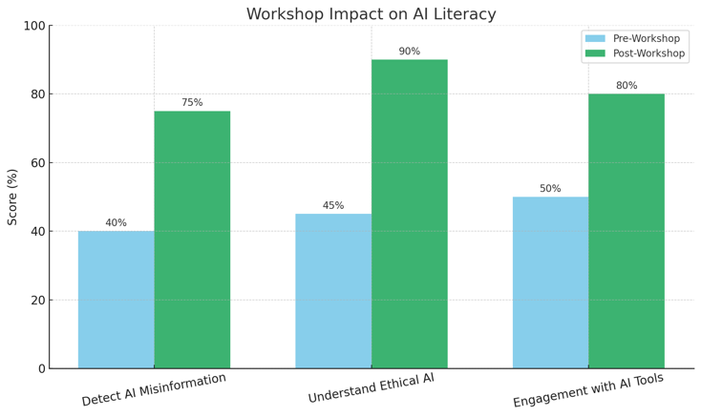

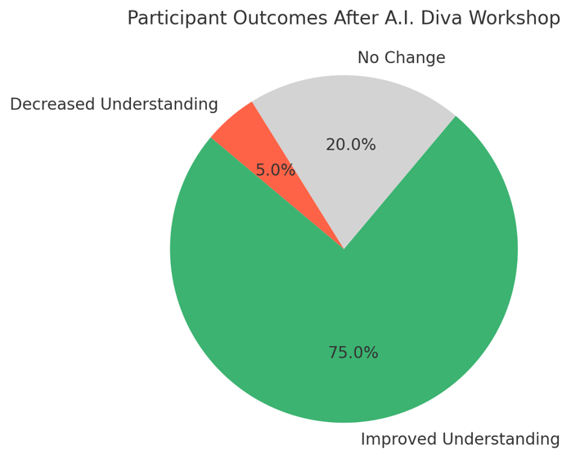

Additionally, we present graphical analyses of user responses and learning progression, illustrating key trends in AI literacy development. These graphs highlight measurable improvements in AI comprehension and ethical considerations post-intervention.

Our paper discusses the chatbot’s design, technology stack, workshop outcomes, and future implementation in educational settings.

If we could improve anything, it would be increasing customization and adaptability for different learning levels. Some feedback suggested that while the tone was fun, more advanced users wanted deeper content and less handholding. We’re also considering integrating multimedia elements like videos or voice connectivity to boost interactivity further.

Overall, the experience has been a strong step forward in AI literacy education, and we're excited to keep refining A.I. Diva based on what we’ve learned so far.

# ACKNOWLEDGMENTS

We extend our gratitude to the ITEC Department Chair and SST Dean at Georgia Gwinnett College for supporting this project. Sponsored via NSF 2315804.

# REFERENCES

[1] Dekhane, S., Xu, X., Napier, N., Barakat, R., Gunay, C., & Nagel, K. (2018). Technology-focused service-learning course to increase confidence and persistence in computing. Journal of Computing Sciences in Colleges, 34(2), 147-153.

[2] Mosquera Reina, V., Cunico, R., Williams, J., Bauer, M., Doloc-Mihu, A., & Robertson, C. (2021). Introducing Programming Concepts through Interactive Online Workshops. Proceedings of the 22nd Annual Conference on Information Technology Education, 71-72.

[3] Robertson, C., & Doloc-Mihu, A. (2021). Assessing the effectiveness of teaching programming concepts through online interactive outreach workshops. Proceedings of the 22nd Annual Conference on Information Technology Education, 123-128.

[4] OpenAI. (2023). GPT-4 Technical Report.