1. Open search engine
2. Search Processing in browser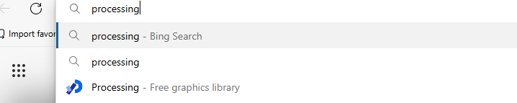
3. Select download processing 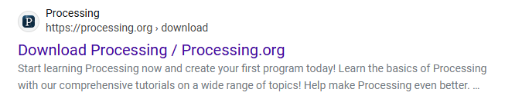
4. Open file 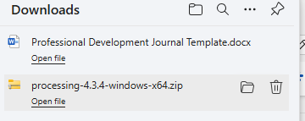
5. Select file
6. Click extract all
7. Extract

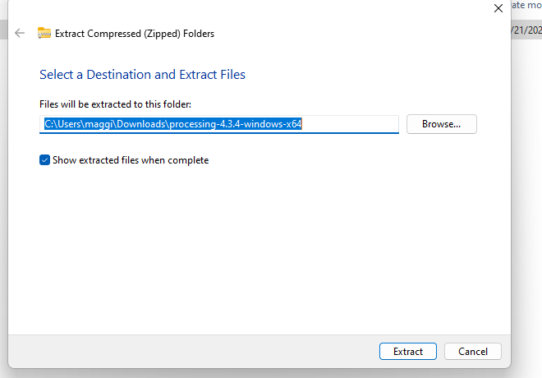

8.Open Search Engine

9. Search GitHub 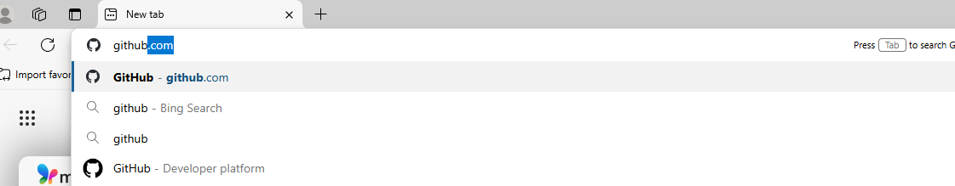

10.Create an Account/ Sign In to your Account

11. Type “repo:TAP-GGC/ArtifyAI” into search bar

12. Open Artify AI Repo

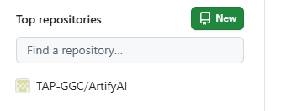

12. Select Green Code Button

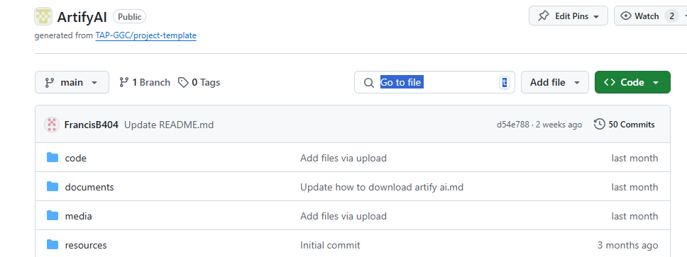

13. Select Download Zip

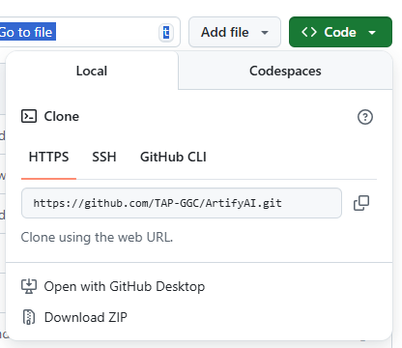

14. Open Files

15. Go to Home

16. Select Downloads

17. Open ArtifyAI-main file

18. Select File

19. Select Extract All

20. Select Extract

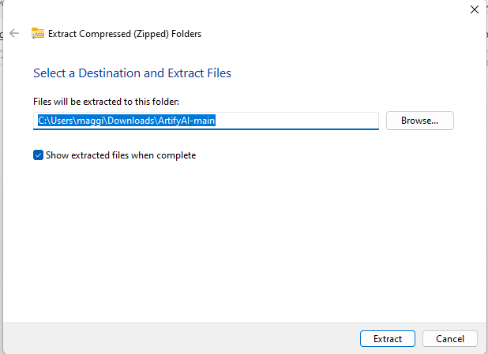

21. Open Search Processing in apps

22.Open Processing

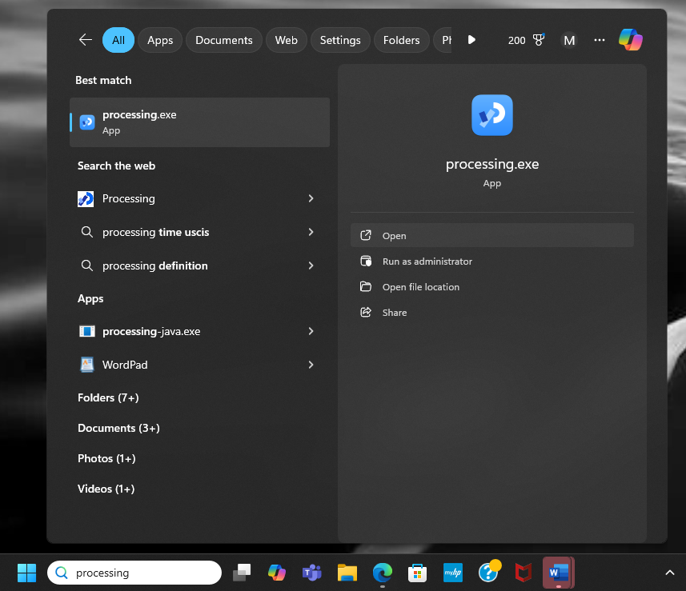

23. Click File

24. Click Open

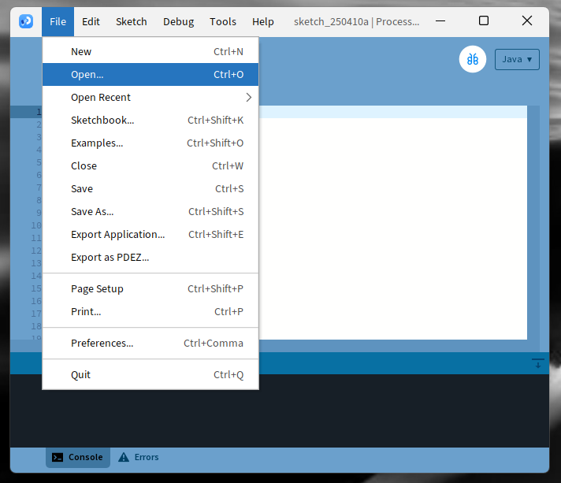

25. Select Prompt Screen then open.

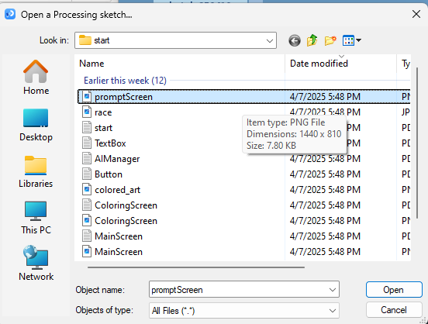

26. Select the Play button on the top left corner.

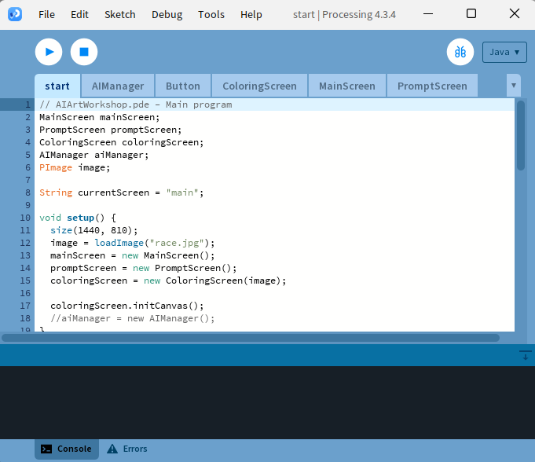

27. Select start

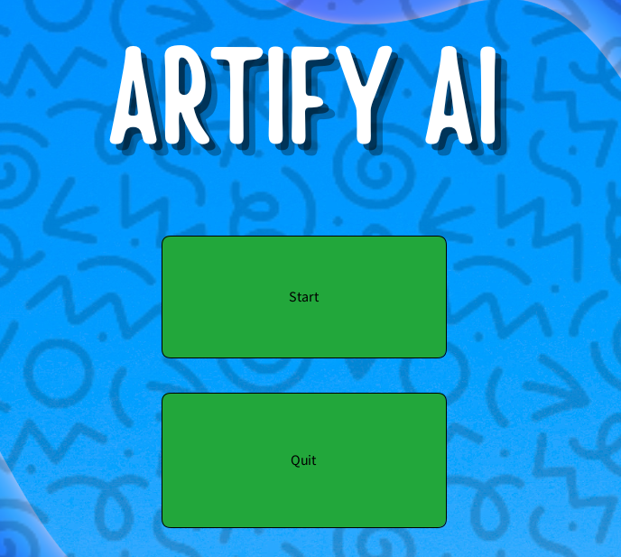

28. Enter prompt of desired image in box then press generate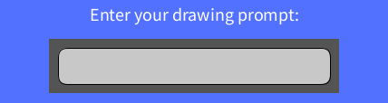

29.Use color pallet by selecting a color and RGB feature by adjusting values from 0-255 then selecting generate to color image. 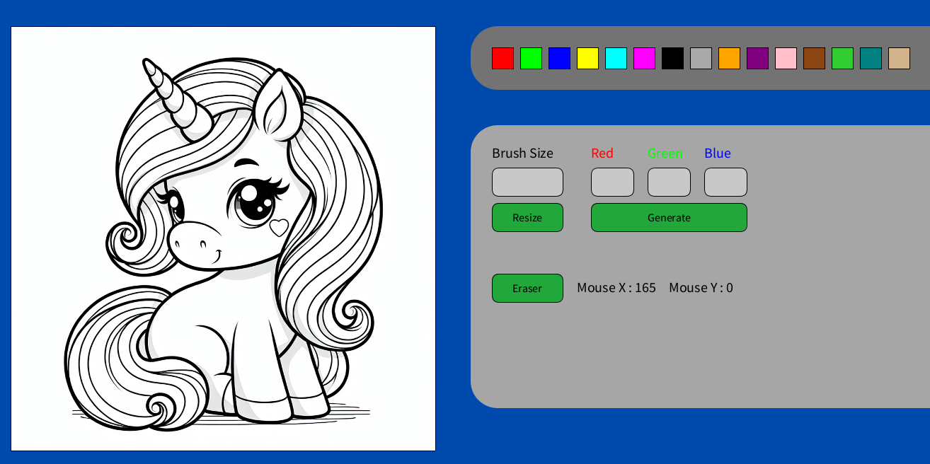

30. Adjust brush size by entering numbers 1-100 then click resize. Use the eraser button to eliminate undesired color.

31. HAVE FUN!