Teaching 3D Modeling via an Engaging TinkerCAD Project

Peter Davis, Ato Koomson, Huyen Pham

Instructors: Dr. Cindy Robertson, Dr. Anca Doloc Mihu

**Introduction**

Our project aims to engage all ages to learn more about 3D modeling and 3D printing. Researchers found a positive relationship between frequent exposure to TinkerCAD [1] and computational thinking. For example, Eryilmaz and Deniz [2] published a study that explored the effects of TinkerCAD education on 583 students in Ankara Province. Another study on TinkerCAD [3] used TinkerCAD with middle school students to work on their spatial reasoning skills. This study found a correlation between students that had been exposed to TinkerCAD and improved spatial reasoning ability.

We are developing our project during our Technology Ambassador Program (TAP) course during Fall 2023. The TAP program at Georgia Gwinnett College (GGC) aims to get all ages interested in technology via student projects and outreach. TAP's main goal is to inspire students to explore and be creative with technology. When students join TAP, they not only learn how to use technology but also use what they learn to make interesting projects. These projects are meant to be enjoyed by people of all ages in our community. By showing how useful and fun technology can be, TAP hopes to get everyone excited about the digital world, no matter how old they are.

**Methods**

In our project, we use TinkerCAD, which is a user-friendly, web-based 3D modeling software accessible through a standard web browser. Additionally, we employ 3D printers to bring digital designs to life. TinkerCAD provides an excellent platform for beginners to grasp the fundamentals of 3D modeling because it eliminates some of the common pain points associated with 3D modeling software. It is an ideal tool for our educational objectives because it is free, accessible from any browser, browser-based to avoid downloading software, and allows users to express their creativity in a safe space without the complexity of other modeling software.

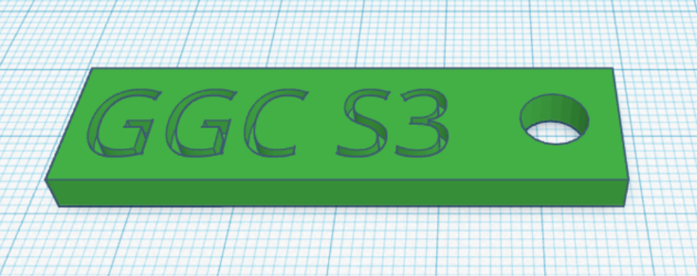

Figure 1. Example of a keychain featuring the GGC logo designed with TinkerCAD.

Through TinkerCAD, we empower participants to design personalized keychains featuring the GGC logo (Figure 1), making the 3D modeling and printing process accessible and engaging, even to those without advanced technical knowledge. Our project is a work in progress at the time of this submission.

**Results**

We will present our project at three outreach events. First, through the TAP Expo, a school-wide event featuring TAP students' projects and presentations where attending students can try out and play with the provided material. Second, the Super Saturday Series, an event where TAP projects are presented to middle school students to grow and drive interest in STEM and remove some of the initial intimidation associated with the field and its difficulty. Finally, through classroom workshops at our institution, we will present our project before students of varying concentrations to foster the idea that STEM does not necessarily have to be intimidating but can be fun and simple.

We will measure the success of our efforts and the effectiveness of our project through pre and post-surveys which will be given to all participants at these events. By comparing the pre and post-survey results, we can track and measure the success of our efforts and acquire feedback from those who partook in the activity. We will present our project and our findings at the conference.

**Discussion and Conclusion**

Our project focuses on introducing individuals of all ages to the world of 3D modeling and printing. Through TinkerCAD, a user-friendly web-based 3D modeling software, we empower participants to design personalized keychains featuring the GGC logo, making the 3D modeling and printing process accessible and engaging, even to those without advanced technical knowledge. This project serves as a hands-on, practical introduction to technology, aiming to ignite interest and curiosity across various demographics, including college students, middle and high school students, professionals, and the GGC community. Our mission is to inspire a lasting fascination with technology, bridge the gap between technology and the community, and promote STEM involvement for all. Our poster will introduce the audience to our project and present the results of our outreach workshops.

# References

1. Tinkercad (2021). “Tinkercad: Create 3D digital designs with online CAD”. <https://www.tinkercad.com/>
2. Selami ERYILMAZ, Gülhanım DENİZ. “Effect of Tinkercad on Students' Computational Thinking Skills and Perceptions: A Case of Ankara Province”. *TOJET: The Turkish Online Journal of Educational Technology*, 20(1): 2021.
3. Srinjita Bhaduri, Quentin L Biddy, Jeffrey Bush, Abhijit Suresh, and Tamara Sumner (2021). “3DnST: A Framework Towards Understanding Children’s Interaction with Tinkercad and Enhancing Spatial Thinking Skills”. *In Proceedings of the 20th Annual ACM Interaction Design and Children Conference (IDC '21). Association for Computing Machinery*, New York, NY, USA, 257–267. <https://doi.org/10.1145/3459990.3460717>

# Acknowledgements

Georgia Gwinnett College - Technology Ambassadors Program

Georgia Gwinnett College - School of Science and Technology

Georgia Gwinnett College – Digital Media Lab