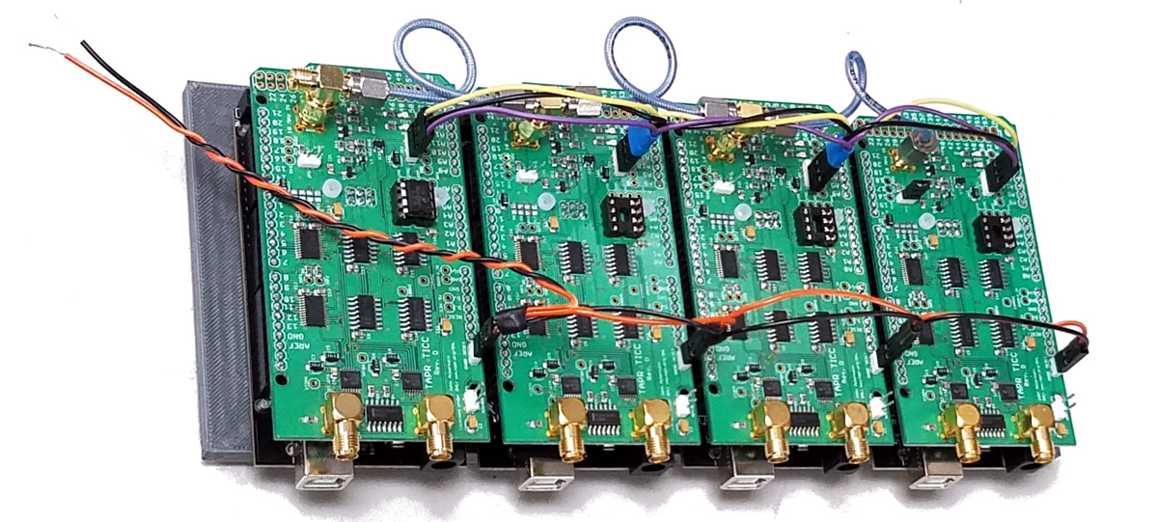
TAPR TICC Application Note 2019-01

multi-TICC:
A Multi-Channel Timestamping Counter
based on the TAPR TICC

Introduction

The TAPR TICC (https://tapr.org/kits_ticc.html) is a two-channel “timestamping” counter with a resolution of <60 picoseconds. It is a “shield” that mounts on an Arduino Mega 2560 processor board, and it communicates via the Arduino’s USB port.

A timestamping counter is one that maintains an internal timescale (i.e., a counter clocked by an external 10 MHz reference that starts at power-on and runs continuously) that marks the occurrence time of external events against that timescale. Every time a pulse appears on one of the TICC’s two input channels (called “chA” and “chB”), the TICC outputs the timestamp of that event and the channel on which it occurred.

A timestamp is a basic measurement that can be used directly to compare the phase of the input signal compared to the reference clock. You can also compare timestamps from channel to channel. For example, if separate pulse-per-second signals are applied to chA and chB, the time interval between the signals can be calculated simply by subtracting the timestamps. Timestamps are very useful building blocks.

While the TICC is a two-channel device, it provides on-board headers that allow multiple TICCs to be driven by a common external reference and share a single timescale. In this way 4-, 6-, 8- channel or even larger counters can be assembled, with direct comparison possibl across all those channels. This application note describes how to build and use a “multi-TICC”.

Hardware Configuration

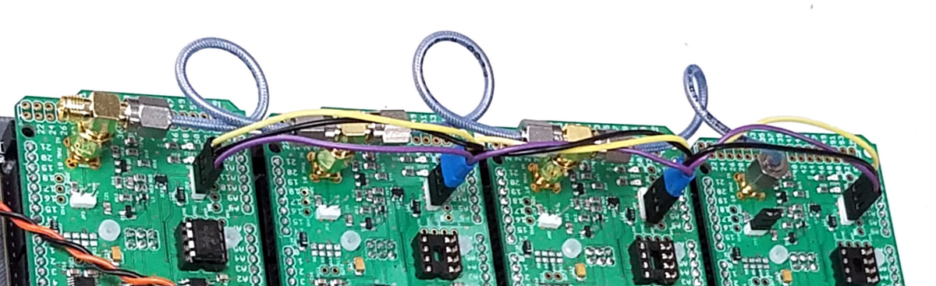
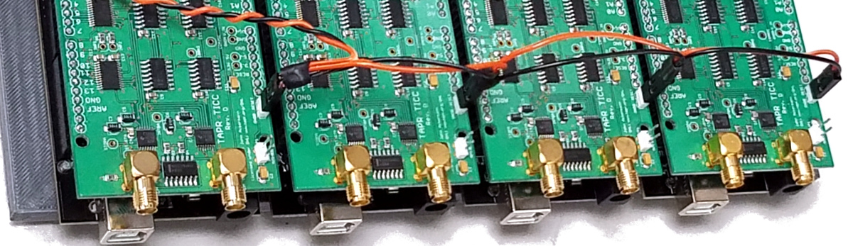
In the multi-TICC, one board is configured as the “master” and provides clock and synchronization signals to the other “slave” boards. All boards run off a common 10 MHz reference clock. To ease assembly, I created (with a lot of help from Mike, W8RKO) a 3-D printed carrier that will align and secure 4 boards. The FreeCAD design files and .stl file are available from the TICC github repository (https://github.com/TAPR/TICC).

Typically, the boards are interconnected this way:

1. As shown in the photo above, the 10 MHz clock is applied to all boards through short coax cables and “tee” connectors. The “TERM” termination jumper should be installed only on the last board in the chain.

2. Also as shown, the three pins of the JP2 header are also connected in a daisy-chain fashion across all the boards. While the photo shows a hand-made cable using 3 pin plugs, it is probably easier to make the cable using 6 pin 0.1 inch spaced IDC ribbon cable connectors – just make sure you plug the same row of the connector onto each JP2!. If you use the 4-board frame described below, the nominal spacing between JP2 headers is 2.25 inches.

3. Note that on the slave boards, IC10 (the 12F675 PIC) is removed. This is because the coarse clock signal generated by the PIC on the master board is routed via JP2 to the slave boards.

4. It’s not mandatory, but I think it’s highly desirable, to connect the RESET lines of all the boards in parallel so that they can be reset simultaneously. To do that, as shown in the picture above I soldered a 2 pin header in the holes marked “GNDB” and “RESET” located on the right front of the board, and made a daisy-chained connector tying them together. Momentarily connecting the two flying leads will cause all boards to reset. Again, this could more easily be done with a 4 pin ribbon cable. One note: with the reset lines in parallel, if one of the TICCs is powered down, it will pull the reset line of the others low with the result that they will not start. Make sure all the TICCs are powered up when the reset daisychain is connected.

5. Again, it is not mandatory but it is highly desirable to install jumpers on the “DISABLE AUTO-RESET” header (JP1) on each board (unlike as shown in the picture). If this is not done, each time a connection is made to the Arduino serial port, that TICC will reset and that will cause synchronization problems. Remember, though, that with this jumper installed the Arduino IDE will not be able to upload new firmware to the board. You need to remove the jumper before programming!

With these changes, your string of boards is ready to emerge as a multi-TICC!

Firmware Configuration

The firmware shipped on recent TICC units (version 20170309.1) has basic multi-TICC capability included. A newer version is available (currently in the “multi_ticc” branch of the github.com/TAPR/TICC repository) that adds two helpful features for multi-TICC use:

(a) the ability to assign channel IDs other than A and B; and

(b) a “PROP_DELAY” variable to set the offset (in picoseconds) between channels. This allows you to compensate for the length of the interconnect cables and other sources of board-to-board delay. (PROP_DELAY serves the same purpose as the existing “FUDGE0” variable, but I’ve been requested to make two delay settings available. The PROP_DELAY and FUDGE0 settings are additive.)

To enable multi-TICC operation, use the configuration “Y” command to set the master board as “M”aster, and to set the slave boards to “S”lave mode. Optionally, use the “N” command to change the channel ID to any single printable ASCII character. Since the master board by default has channels A and B, it’s sensible to set the second board to “C D”, the third to “E F” and so on. Finally, if desired use the PROP_DELAY or FUDGE0 variables to set the offset in picoseconds (more on that below).

Data Interface

If you have 4 TICCs configured configured in master/slave mode, you also have 4 USB ports carrying serial data. It would be nice to consolidate those data streams, and maybe even make them available via Ethernet. To accomplish that, I’ve written a simple Python program intended to run on a Raspberry Pi, which conveniently has 4 USB ports so can serve as an aggregator for four TICCs; if you use more than that, you’ll need to add a USB hub to the mix.

