1.**Introduction**

In today's world, access to real-time weather information has become essential for individuals to plan their day-to-day activities, whether it be deciding what to wear, planning outdoor events, or making travel decisions. With the rapid growth of mobile and web applications, weather forecasting services have become more readily available through APIs. This project aims to create a simple yet efficient weather application that provides users with real-time weather data based on their city input, utilizing a AI powered model developed to be used for weather prediction .

**Problem Statement**

**Goal**: The goal of this project is to develop a user-friendly, functional weather application. The application will allow users to input a city name and retrieve relevant weather information for that location. The app will display the data in a well-structured, interactive manner with an intuitive user interface. It will help the user get the accurate weather results of city .

**Weather apps are useful in a wide range of scenarios, including:**

- Traveling: Knowing the weather conditions of a destination can help travelers pack appropriately and plan their journey.

- Outdoor Activities: Whether for hiking, cycling, or sports, knowing the weather conditions is critical to ensuring safety and preparedness.

- Daily Planning: A weather app helps individuals determine the ideal time for outdoor tasks like running errands, exercising, or gardening.

-Industries : Many farmers can get a heads up of how the weather is going to be in future and they can plan accordingly .

**Problem Description**

The problem lies in the lack of simple, accessible tools for quickly checking weather conditions. Many users today rely on multiple resources to gather weather information—checking weather websites, looking at smartphone applications, or relying on weather updates via social media. However, these resources may not provide quick, accurate, or easy access to relevant information in one place.This project aims to solve that problem by building a straightforward weather application where the user can quickly get the temperature and weather conditions of any city in just a few steps. The app will not only provide weather details but also present the data in an interactive format, allowing users to understand it clearly without the need for navigation across multiple screens.

**2. Tools and Environment Used**

1. **OpenWeatherMap API :** It will be used for fetching the live and historic weather data that will be used for testing , training and predicting the weather by the model .

**2.MERN stack :** It will be used for developing the application for mobile and desktop users both .

· MongoDB (Database)

· NoSQL database for storing and retrieving data in JSON-like documents.

Used for persisting application data (e.g., user profiles, weather forecasts).

· Express.js (Backend Framework)

· Lightweight framework for building server-side applications.

Handles API requests, routing, and middleware functions.

· React (Frontend Framework)

· Library for building user interfaces, especially single-page applications (SPAs).

Responsible for rendering data dynamically and providing a responsive user experience.

· Node.js (Runtime Environment)

· JavaScript runtime environment for executing server-side code.

Used to run Express.js and handle backend logic.

**3.Python:**  It will be used for the analysis and managing the model as well the datasets . It provide many libraries that will be used for visualizing and doing mathematical operations .

Using python we will be making api calls to call the data for predictions .

Building the model uses Machine Learning and python provides many libraries that provide many machines and algorithms that can be imported .

For testing the performance python will be used like f1 score etc .

**4.Google COLAB :**  It is a platform that provide the user to preform data collection and user can perform analysis to develop model .

Google Colab is an excellent tool for developing, testing, and refining your weather prediction model. It provides a cloud-based environment for running Python code, which is particularly useful for machine learning and data science tasks.

1. **Analysis Document** 
   1. **E-R diagrams**

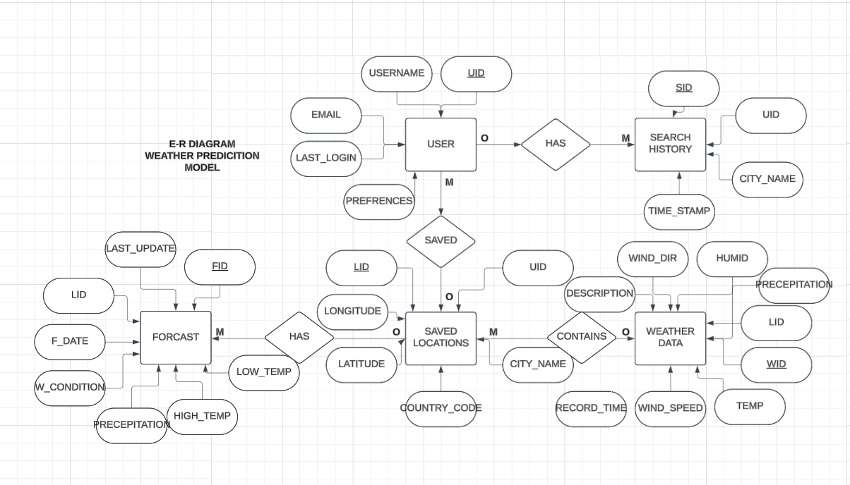

* 1. **Data Flow diagram**

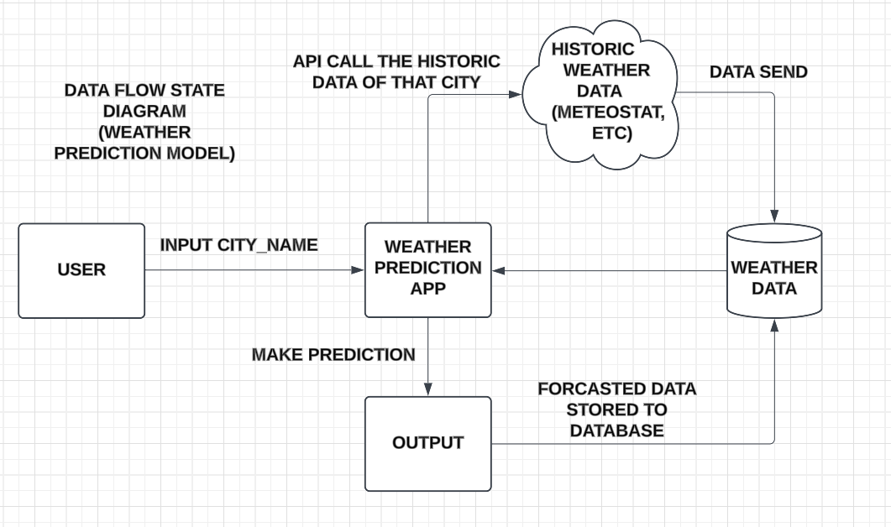

**4.Limitations of the project**

1. Dependency on External API (OpenWeatherMap)

- Since the app relies on an external API, any downtime or issues on the OpenWeatherMap server can result in the weather data not being retrieved, causing the app to fail or display incorrect information. The app's performance is entirely dependent on the API's availability and reliability.

2 Basic Error Handling and User Interface

- Limited Error Handling:

- While the app handles basic errors (like when a user enters an invalid city name or encounters network issues), the error messages are relatively simple. The app doesn't provide more advanced error handling or feedback mechanisms (like a retry option, more detailed troubleshooting steps, or user-specific suggestions).

- No Advanced Weather Alerts:

- The app does not support advanced weather alerts or notifications (e.g., alerts for storms, heavy rain, temperature extremes). These kinds of notifications could be very useful for users who want to stay prepared for sudden weather changes, but they would require integration with a notification system or a more complex backend service.

3. Scalability Concerns

- The app's current architecture is designed for light to moderate use. However, if the application were to scale up (for instance, by handling thousands of simultaneous users), it would likely encounter performance issues. The API rate limits could become a bottleneck, and the front-end React app might need optimizations to handle high levels of concurrency (e.g., by implementing throttling, debouncing, or caching).

4. Limited Weather Data Coverage

- While OpenWeatherMap provides accurate data for most major cities, there may be discrepancies in data accuracy, particularly for smaller cities or remote areas. For instance, small towns or rural areas might have less precise weather data or limited forecast information.

**5. Results**

The main objective of this project was to build a user-friendly, responsive web application that can deliver real-time weather data with minimal interaction. The result is an intuitive weather app that allows users to check weather conditions for any city globally, utilizing the free tier of the OpenWeatherMap API.

Key Features :

* City Search Functionality: Users can input any city name into a search bar and receive real-time weather data for that location.
* Real-Time Weather Data: The app fetches and displays up-to-date weather information, including:
* Temperature (in Celsius or Fahrenheit).
* Weather Description (e.g., Clear, Cloudy, Rainy).
* Humidity (percentage).
* Wind Speed (in meters per second).
* Chart displaying the variation in temperature .

The user interface (UI) of the Weather Application is designed to be clean, simple, and intuitive. The layout follows a minimalist design, focusing only on essential elements for user interaction. Below are some details:

* Input Field: A search bar where users can type the name of the city they want to search for.
* Weather Information: Displays the weather details (temperature, humidity, wind speed, description) in a visually appealing and organized manner.
* Error Feedback: If an invalid city is entered, an error message appears to guide the user to correct their input.

Future Scope :

* A map like visual for the user to locate the city of which he wants the weather report .
* Recent visited places report for the user that he can look in future if he wants to know the cities he visited .
* A voice search chat bot feature for the disabled people , to make the use of app easy for them and get results through voice search .