COACHING TEST
MANAGEMENT SYSTEM
PostgreSQL Database Project
Problem Statement Submission
Student Name | Lakshya Purohit
Database | coaching_test_db
Technology | PostgreSQL
Interface | pgAdmin 4

1. Problem Statement
Design and implement a relational database for a Coaching Test Management System. The system maintains student records, test details, test sections, student attempts and section-wise scores. It also generates performance reports and demonstrates query optimization using indexes and EXPLAIN ANALYZE.

2. Objectives
- Store student, test and section information.
- Record student test attempts and section-wise marks.
- Calculate total scores, averages and percentages.
- Identify students scoring below 40%.
- Generate performance rankings and section-wise reports.
- Use indexes to improve query performance.
- Analyze execution plans using EXPLAIN ANALYZE.

3. Database Design
The database contains six related tables. Primary keys uniquely identify records and foreign keys maintain relationships.
Table | Important Columns | Keys / Relationship | Purpose
students | student_id, student_name, email, batch, enrollment_date | student_id PK | Student details
tests | test_id, test_name, test_date, total_marks | test_id PK | Test details
attempts | attempt_id, student_id, test_id, attempt_date | PK; FKs to students/tests | Student test attempts
sections | section_id, section_name | section_id PK | Subjects/sections
test_sections | test_id, section_id, max_marks | FKs to tests/sections | Maps sections to tests
scores | score_id, attempt_id, section_id, marks_obtained | PK; FKs to attempts/sections | Section-wise marks

4. Entity Relationships
- One student can have many attempts.
- One test can have many attempts.
- One test can contain many sections through test_sections.
- One attempt can contain many score records.
- Each score belongs to one attempt and one section.
students → attempts → scores ← sections
↓
tests → test_sections → sections

5. SQL Queries and Reports

5.1 Count Test Sections
SELECT COUNT(*) AS total_test_sections
FROM test_sections;

5.2 Count Scores
SELECT COUNT(*) AS total_scores
FROM scores;

5.3 Student-wise Test Scores
SELECT s.student_id, s.student_name,
t.test_id, t.test_name, t.test_date,
ROUND(SUM(sc.marks_obtained), 2) AS total_score
FROM students s
JOIN attempts a ON s.student_id = a.student_id
JOIN tests t ON a.test_id = t.test_id
JOIN scores sc ON a.attempt_id = sc.attempt_id
GROUP BY s.student_id, s.student_name,
t.test_id, t.test_name, t.test_date
ORDER BY s.student_id, t.test_id;

5.4 Average Score by Section
SELECT t.test_id, t.test_name, sec.section_name,
ROUND(AVG(sc.marks_obtained), 2) AS average_score
FROM tests t
JOIN test_sections ts ON t.test_id = ts.test_id
JOIN sections sec ON ts.section_id = sec.section_id
JOIN attempts a ON t.test_id = a.test_id
JOIN scores sc ON a.attempt_id = sc.attempt_id
AND sec.section_id = sc.section_id
GROUP BY t.test_id, t.test_name,
sec.section_id, sec.section_name
ORDER BY t.test_id, sec.section_id;

5.5 Students Below 40 Percent
SELECT s.student_id, s.student_name, t.test_name,
ROUND(SUM(sc.marks_obtained), 2) AS total_score,
t.total_marks,
ROUND((SUM(sc.marks_obtained)/t.total_marks)*100, 2) AS percentage
FROM students s
JOIN attempts a ON s.student_id = a.student_id
JOIN tests t ON a.test_id = t.test_id
JOIN scores sc ON a.attempt_id = sc.attempt_id
GROUP BY s.student_id, s.student_name,
t.test_id, t.test_name, t.total_marks
HAVING SUM(sc.marks_obtained) < t.total_marks * 0.40
ORDER BY percentage;

6. SQL Concepts Used
Concept | Use
INNER JOIN | Combines matching records between related tables.
GROUP BY | Groups rows for aggregate calculations.
SUM() | Calculates total marks.
AVG() | Calculates average performance.
ROUND() | Rounds calculated values.
HAVING | Filters grouped results.
ORDER BY | Sorts the output.
LIMIT | Restricts returned rows.

7. Query Optimization
An index was created on attempts.attempt_date and EXPLAIN ANALYZE was used to inspect execution plans for date-based and combined filters.
CREATE INDEX idx_attempts_attempt_date
ON attempts(attempt_date);

EXPLAIN ANALYZE
SELECT *
FROM attempts
WHERE attempt_date = DATE '2026-01-04';

EXPLAIN ANALYZE
SELECT *
FROM attempts
WHERE student_id = 500
AND attempt_date = DATE '2026-01-04';

The execution plans demonstrate index-assisted execution for suitable filters. PostgreSQL may choose different plans depending on table size, statistics and data distribution.

8. System Workflow
- Store students in students.
- Create tests in tests.
- Define subjects in sections.
- Map subjects to tests using test_sections.
- Record student attempts in attempts.
- Store section-wise marks in scores.
- Run SQL reports for totals, averages and percentages.
- Use indexes and EXPLAIN ANALYZE for performance analysis.

9. Demonstrated Results
- 60 test-section records were present in the demonstrated dataset.
- 60,000 score records were present in the demonstrated dataset.
- The student/test report generated total scores for each student and test.
- The section-average report generated test-section results.
- The below-40% report identified students below the required threshold.
- The performance query ranked students by average score.
- EXPLAIN ANALYZE demonstrated index-assisted execution for suitable filters.

10. Conclusion
The Coaching Test Management System successfully implements a relational PostgreSQL database for managing students, tests, sections, attempts and scores. SQL joins and aggregate functions provide meaningful reports, while indexing and EXPLAIN ANALYZE demonstrate practical database query optimization.

Appendix A — Project Screenshots
Screenshots below provide evidence of the database structure, SQL execution, results and indexing work completed in pgAdmin 4.
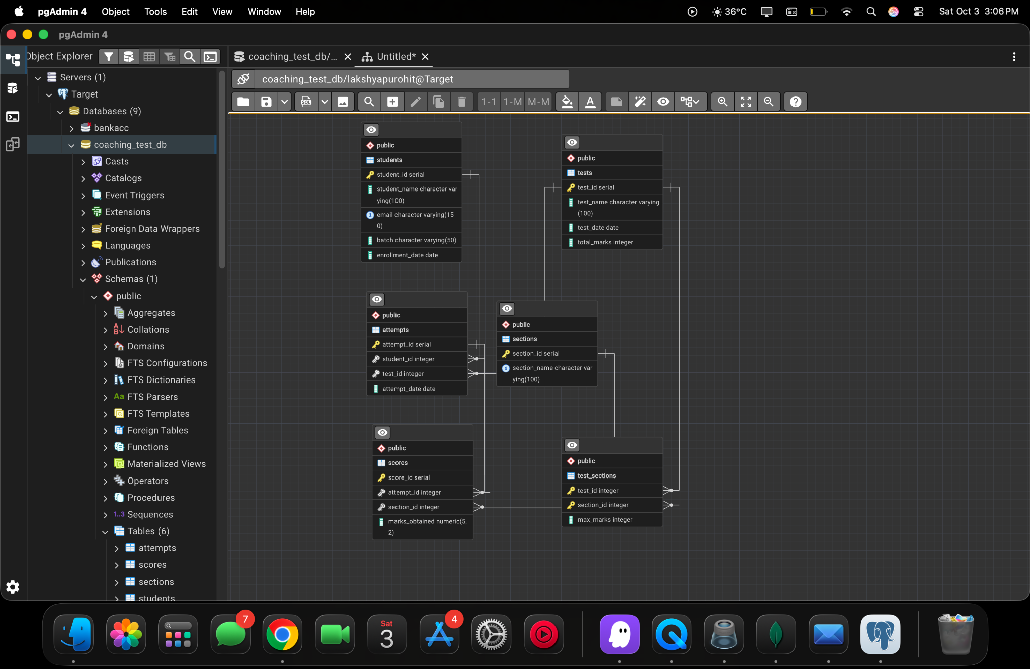
ER diagram / database structure.
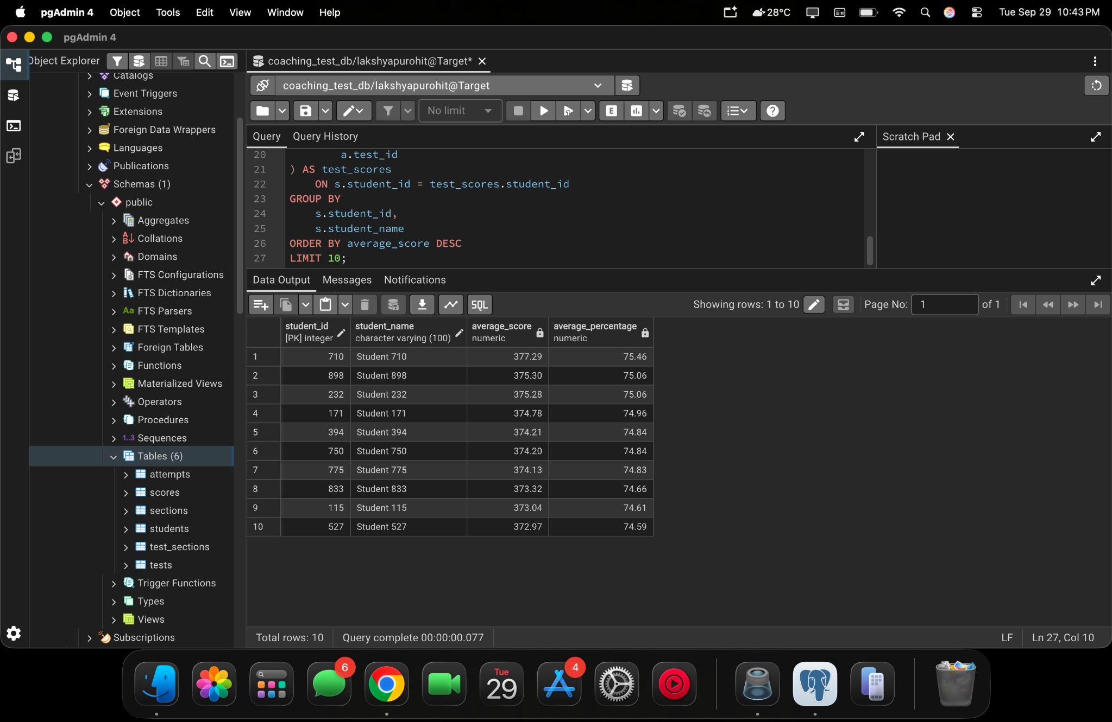
pgAdmin 4 project screenshot — 1779261e-f9db-42ab-9fa1-6c2074d5b0a5

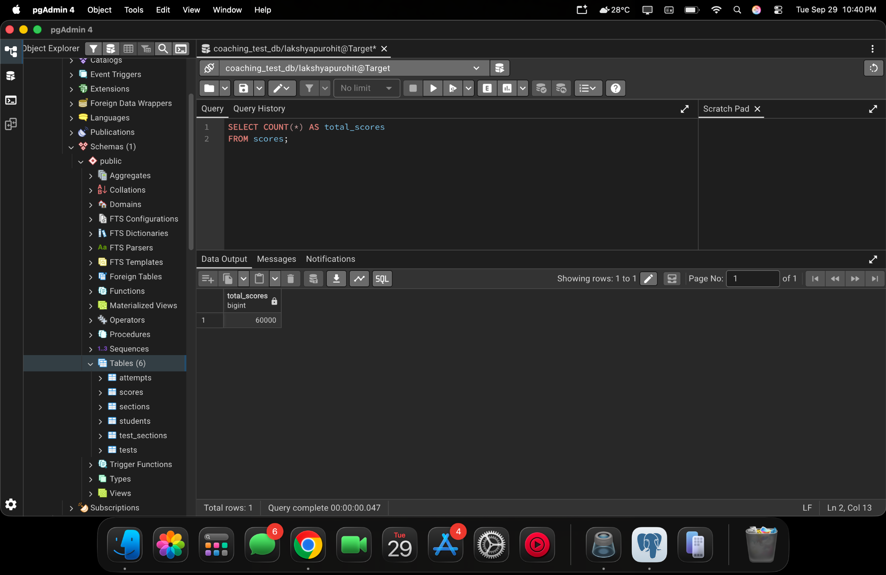
pgAdmin 4 project screenshot — 5904340f-747d-4d24-926e-a0bcf977e1aa
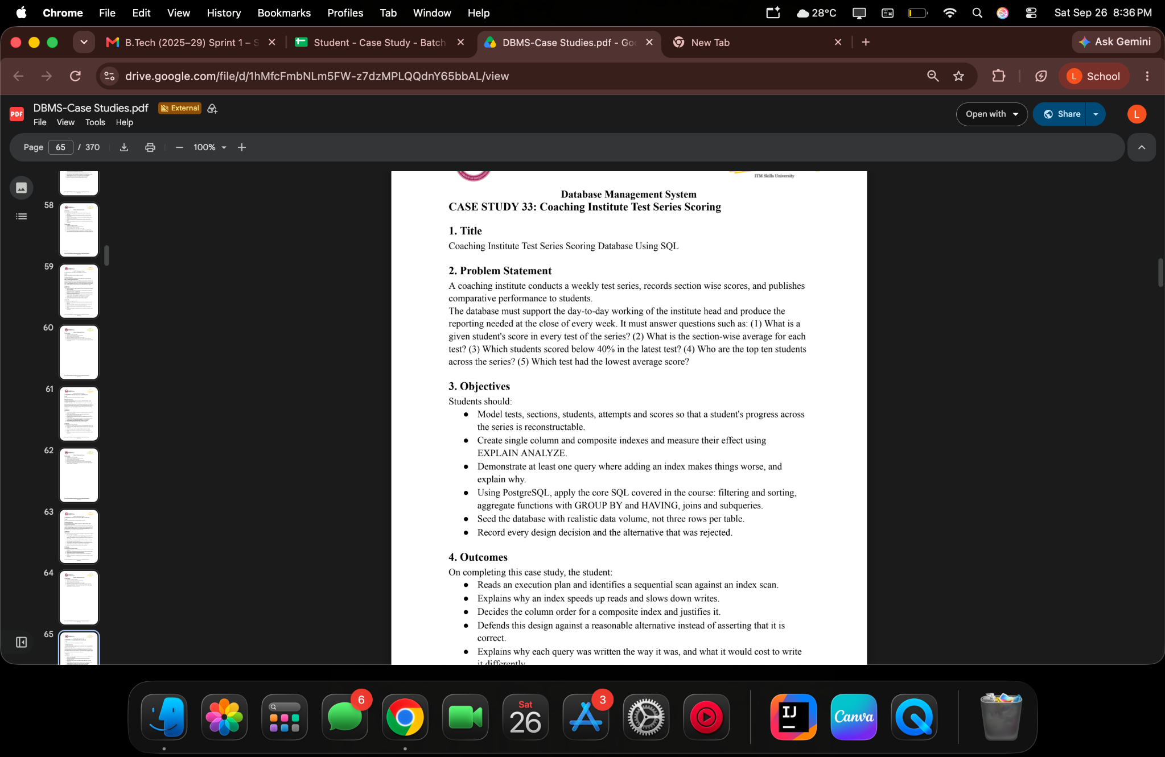
pgAdmin 4 project screenshot — bfc11c47-0e67-44f3-9615-27f7afe2fd99

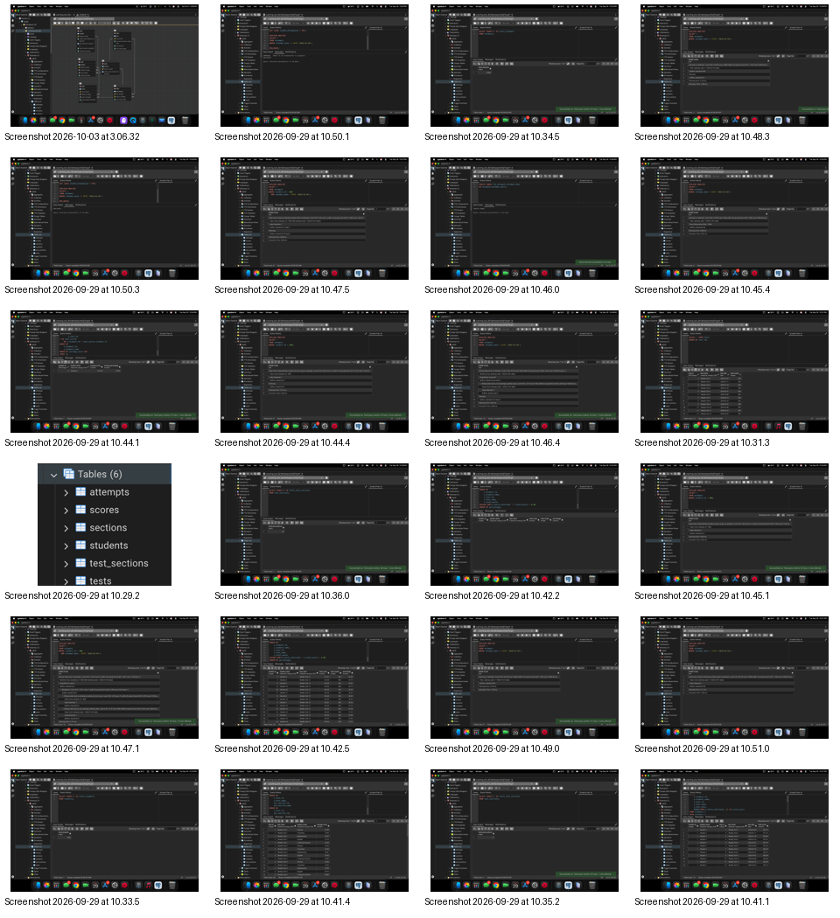
pgAdmin 4 project screenshot — contact
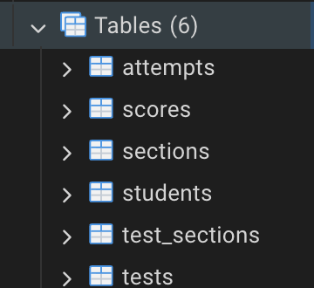
pgAdmin 4 project screenshot — 2026-09-29 at 10.29.25 PM

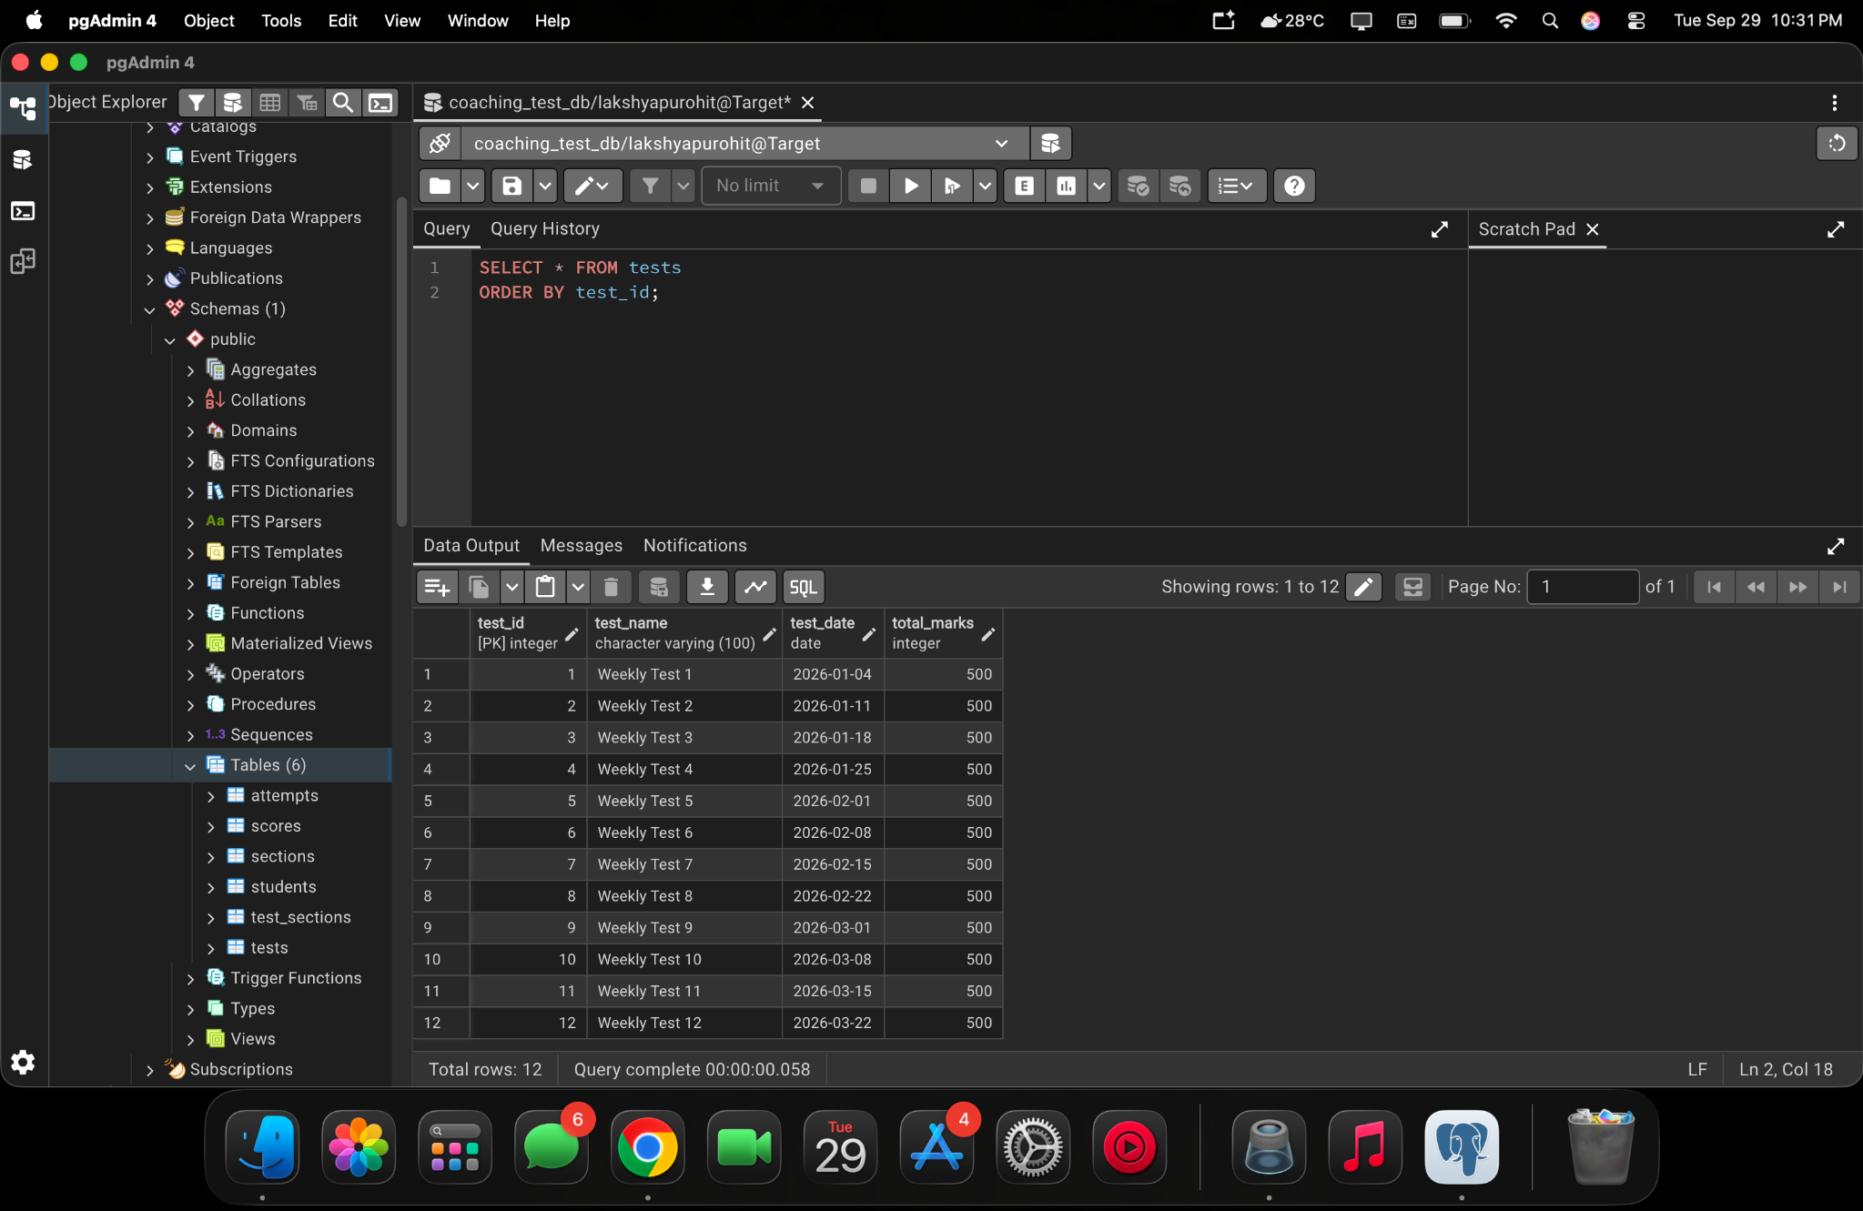
pgAdmin 4 project screenshot — 2026-09-29 at 10.31.35 PM
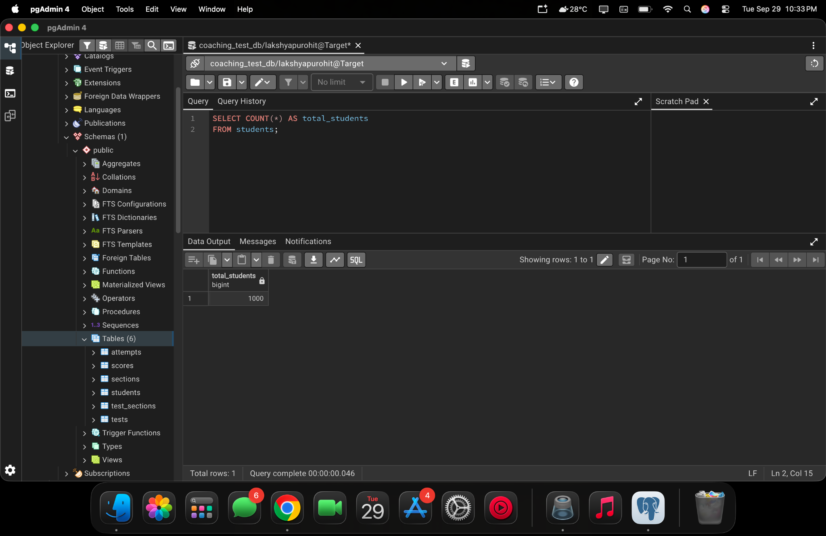
pgAdmin 4 project screenshot — 2026-09-29 at 10.33.52 PM

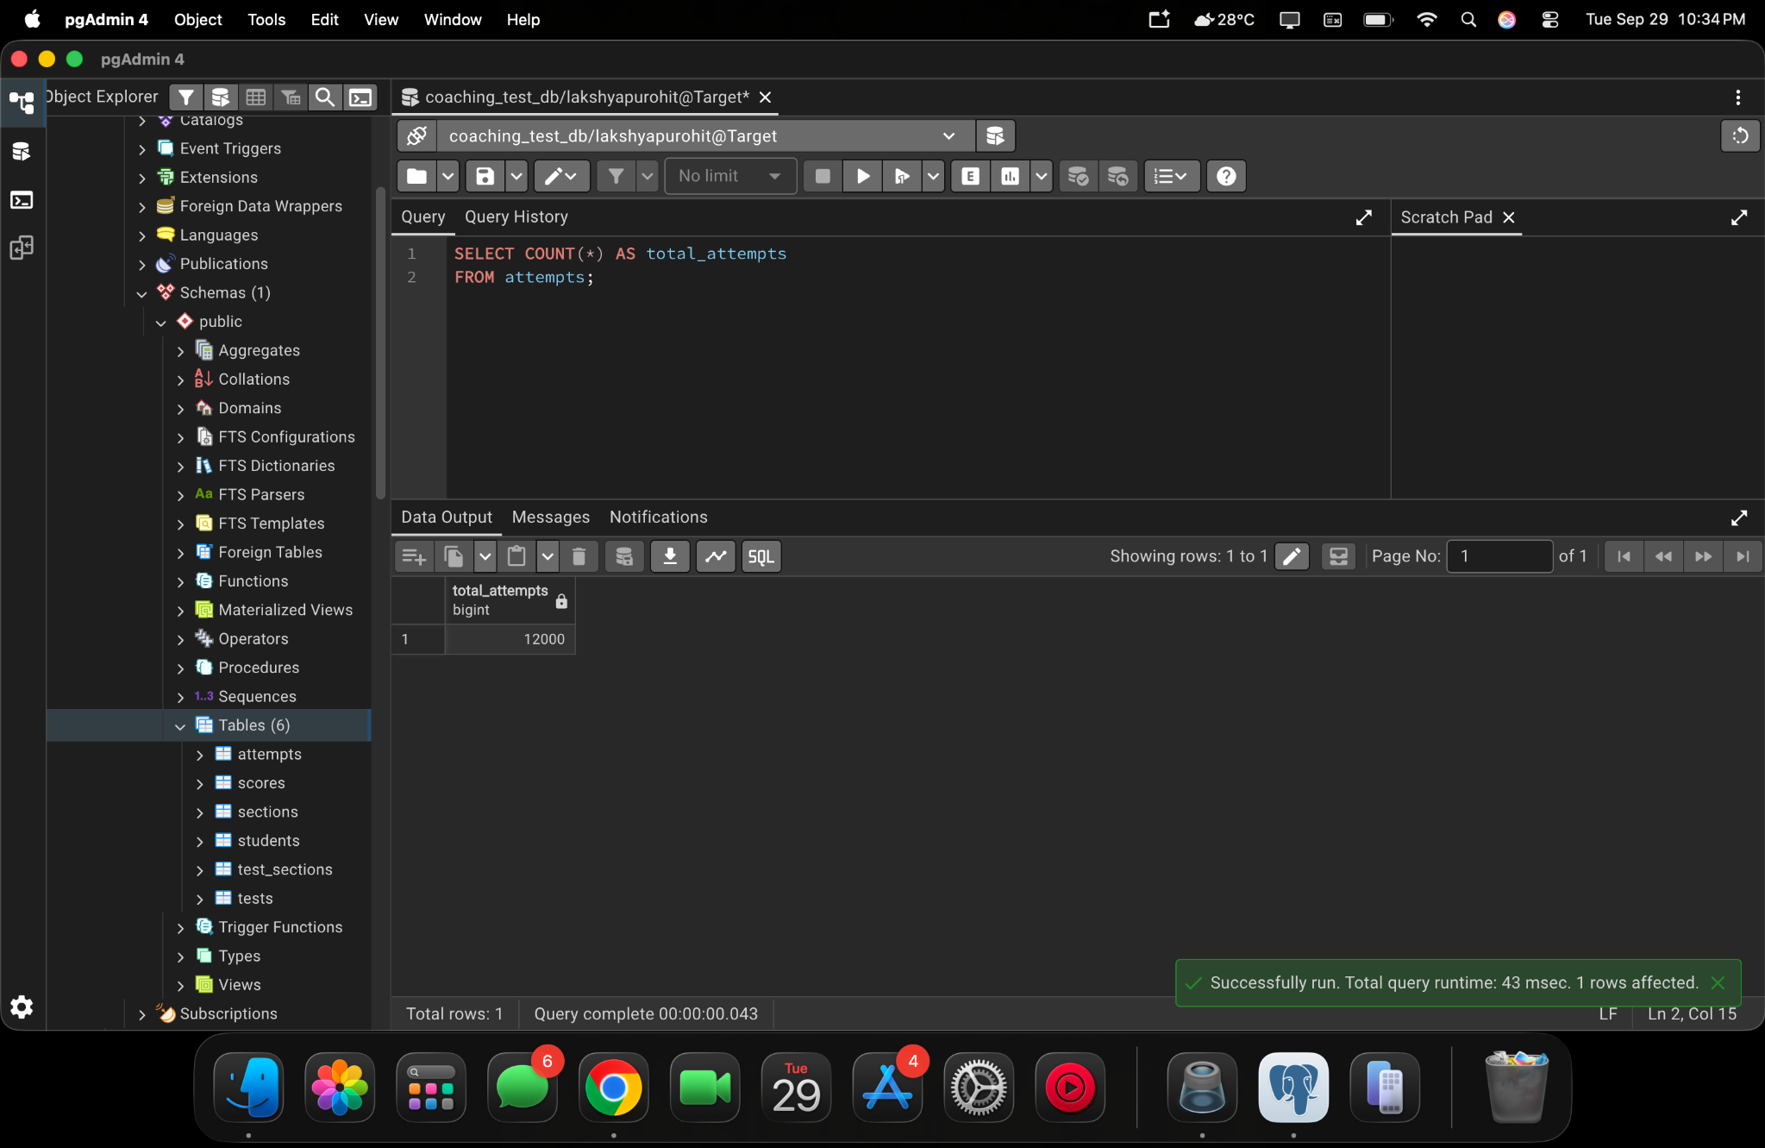
pgAdmin 4 project screenshot — 2026-09-29 at 10.34.57 PM
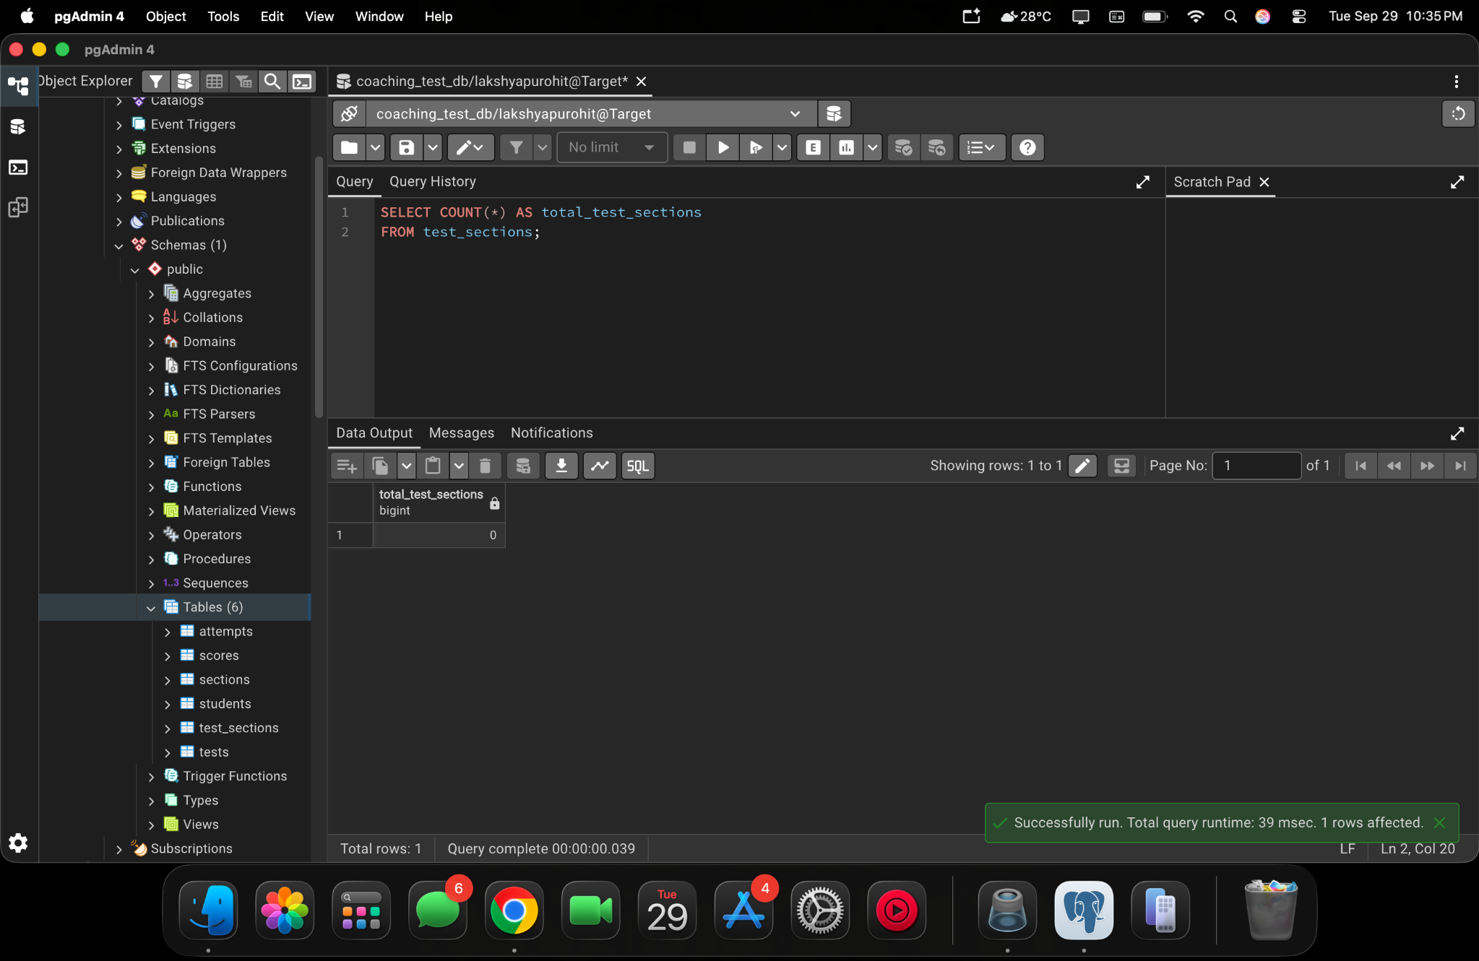
pgAdmin 4 project screenshot — 2026-09-29 at 10.35.28 PM

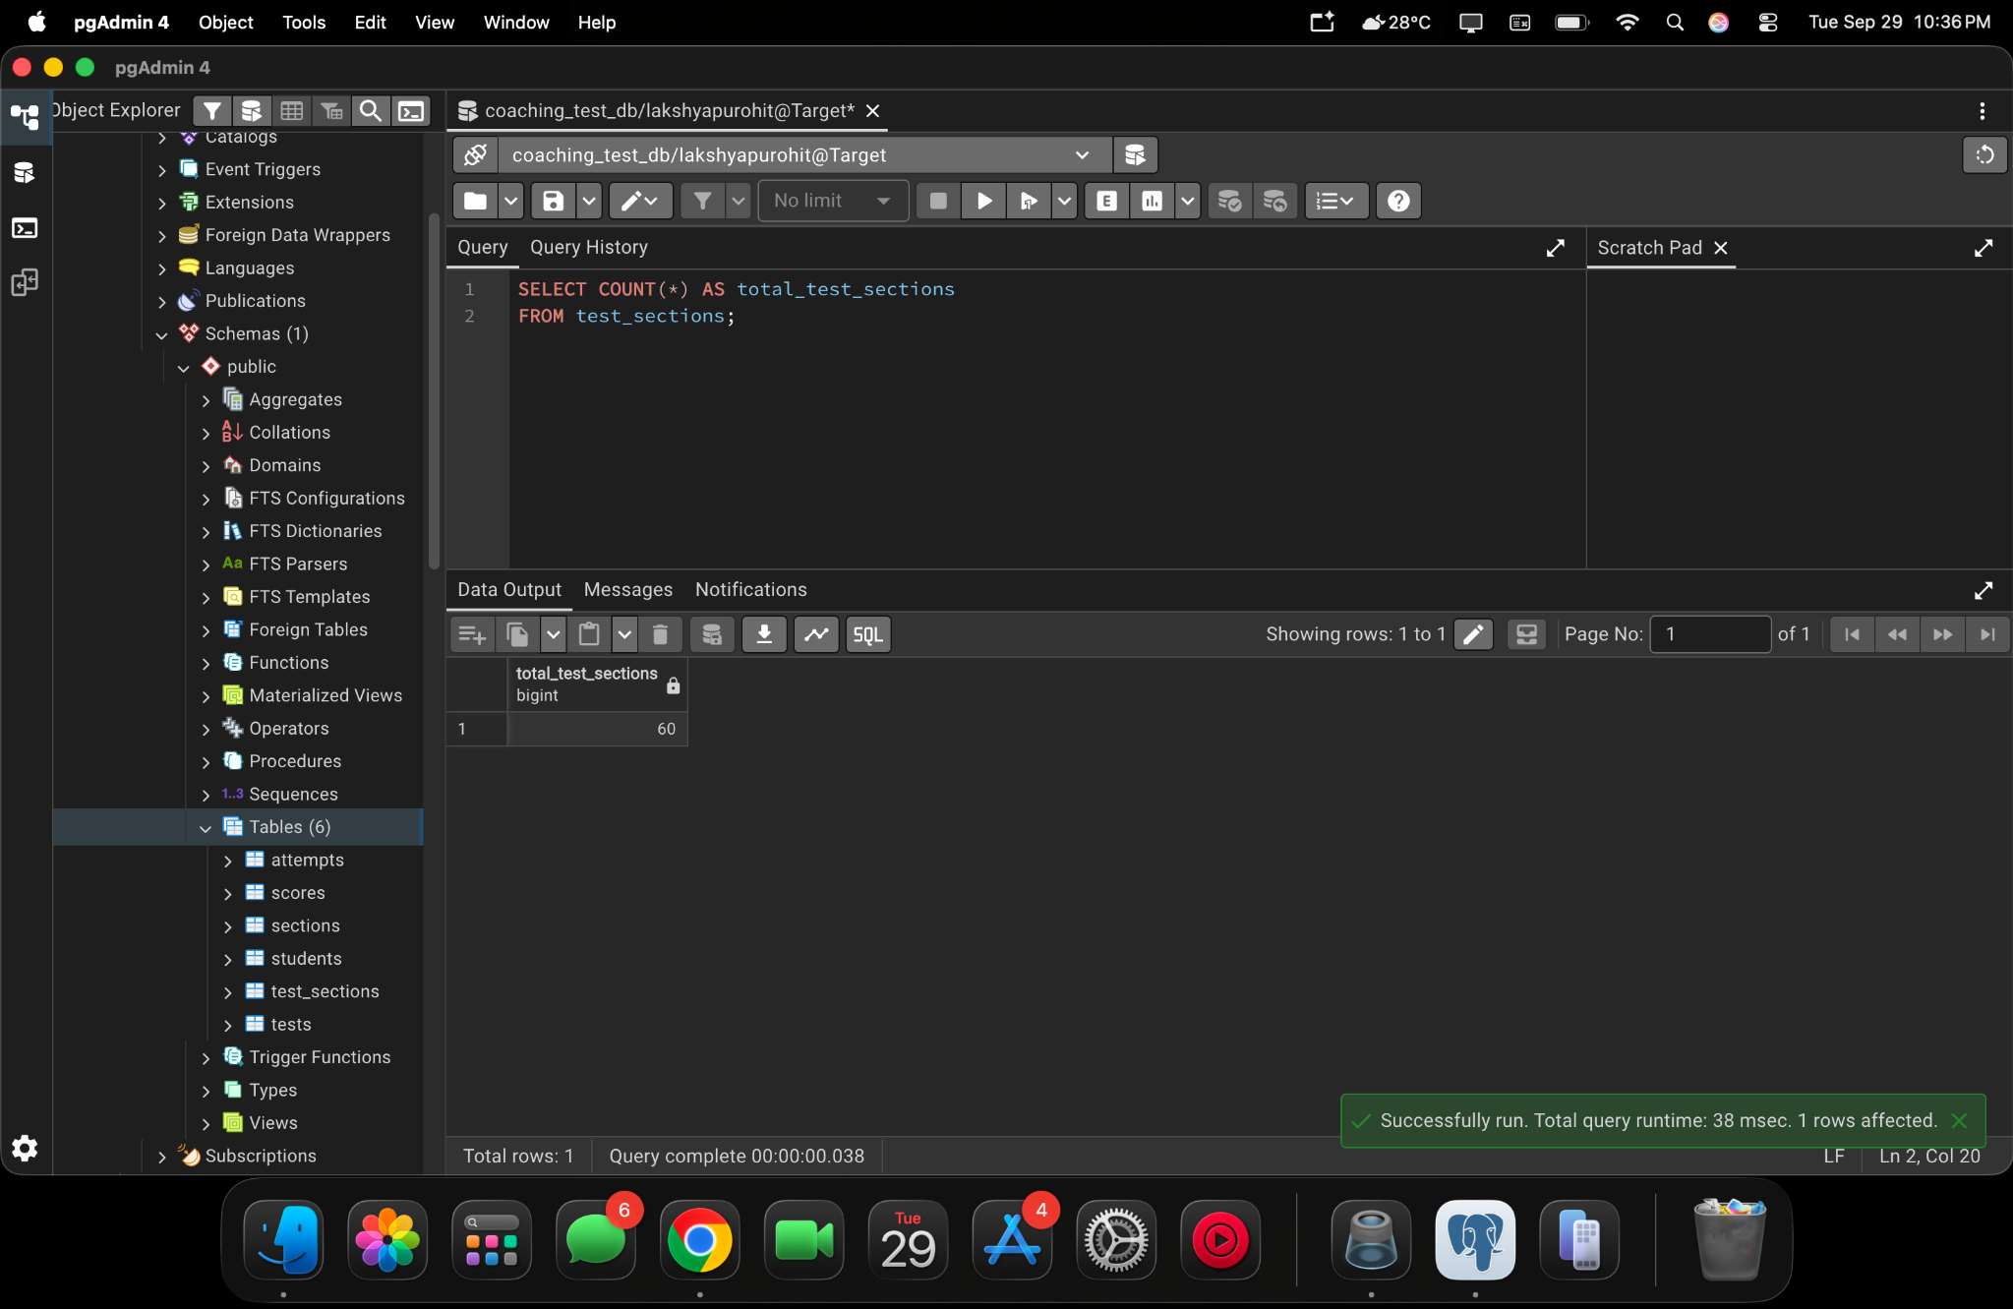
pgAdmin 4 project screenshot — 2026-09-29 at 10.36.03 PM
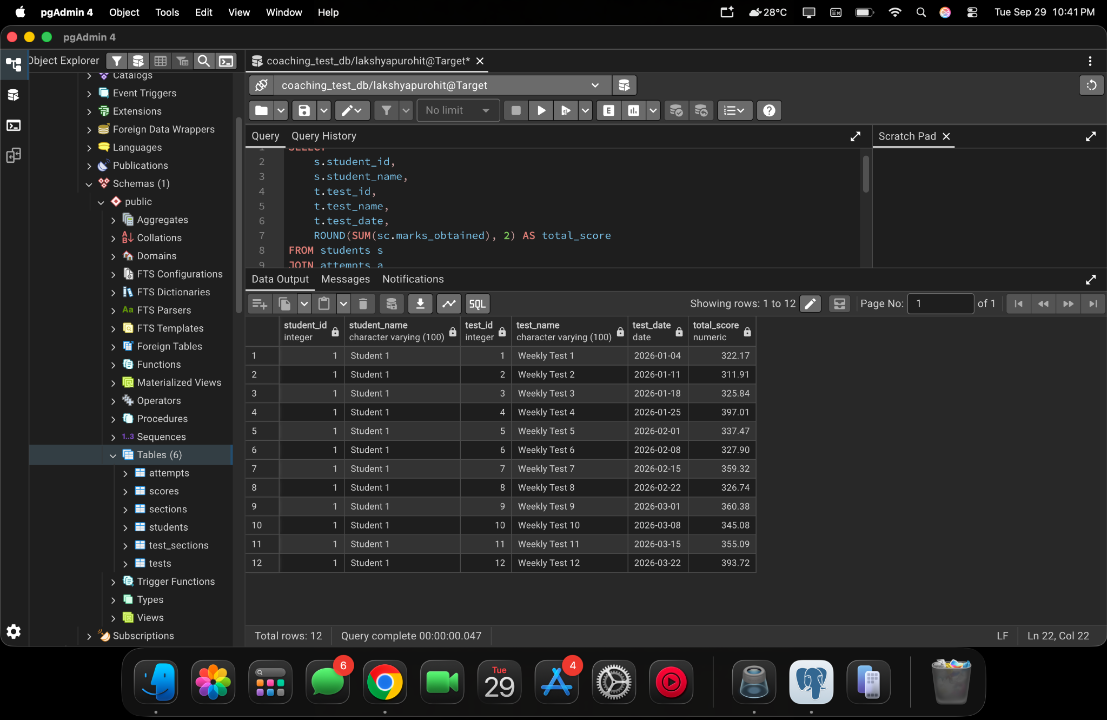
pgAdmin 4 project screenshot — 2026-09-29 at 10.41.18 PM

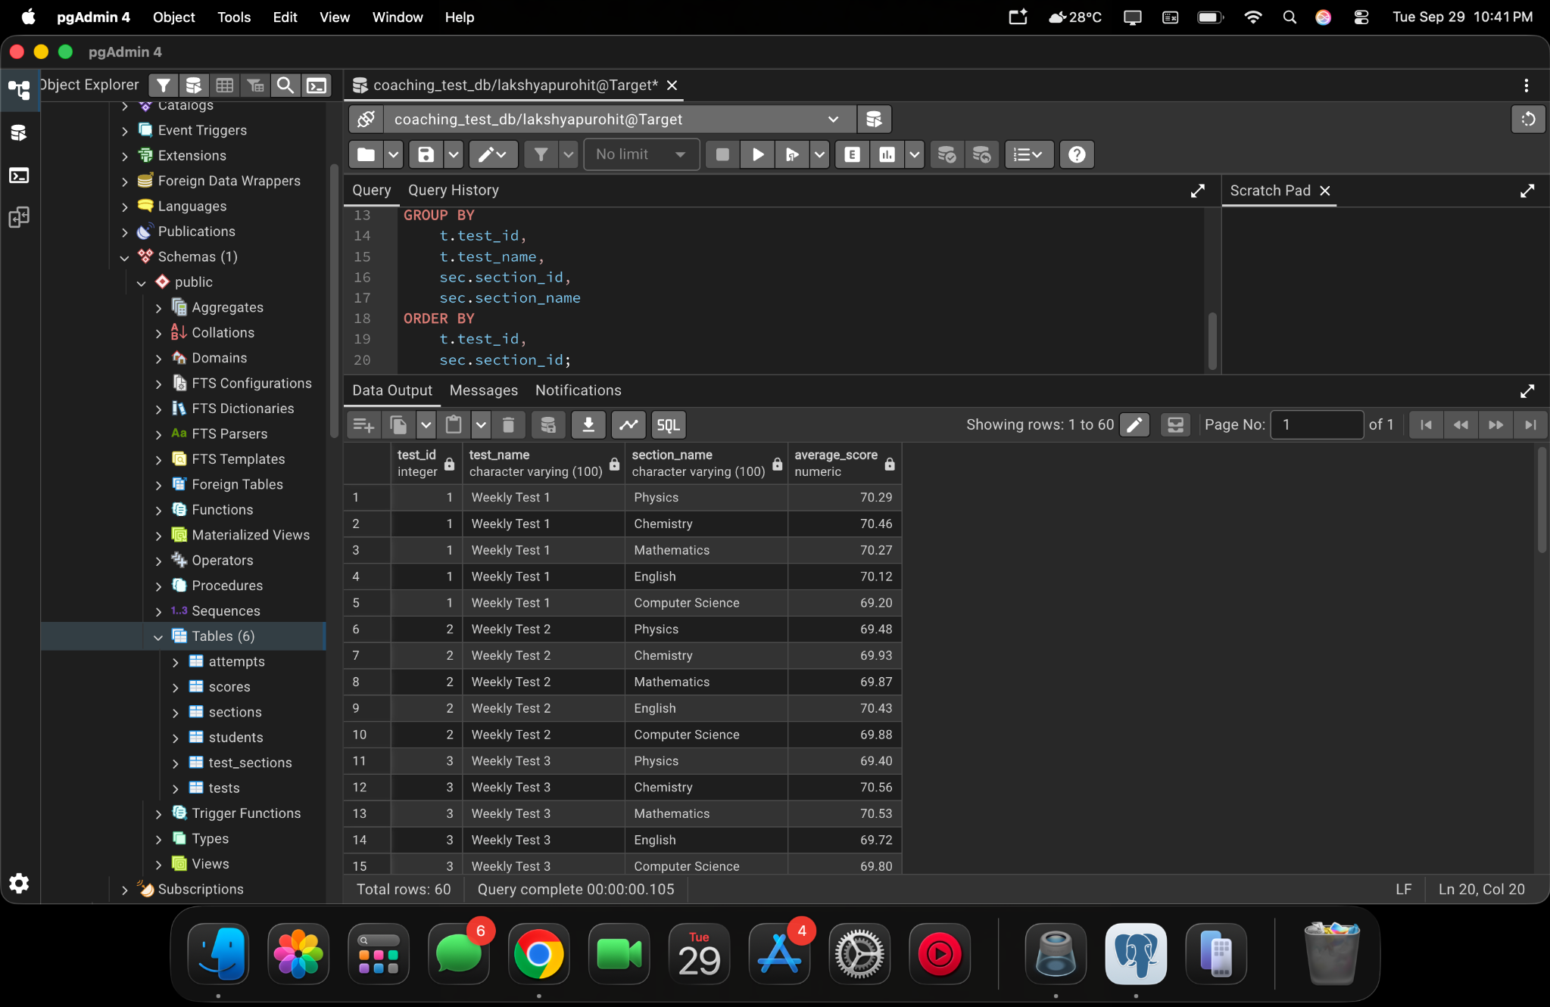
pgAdmin 4 project screenshot — 2026-09-29 at 10.41.45 PM
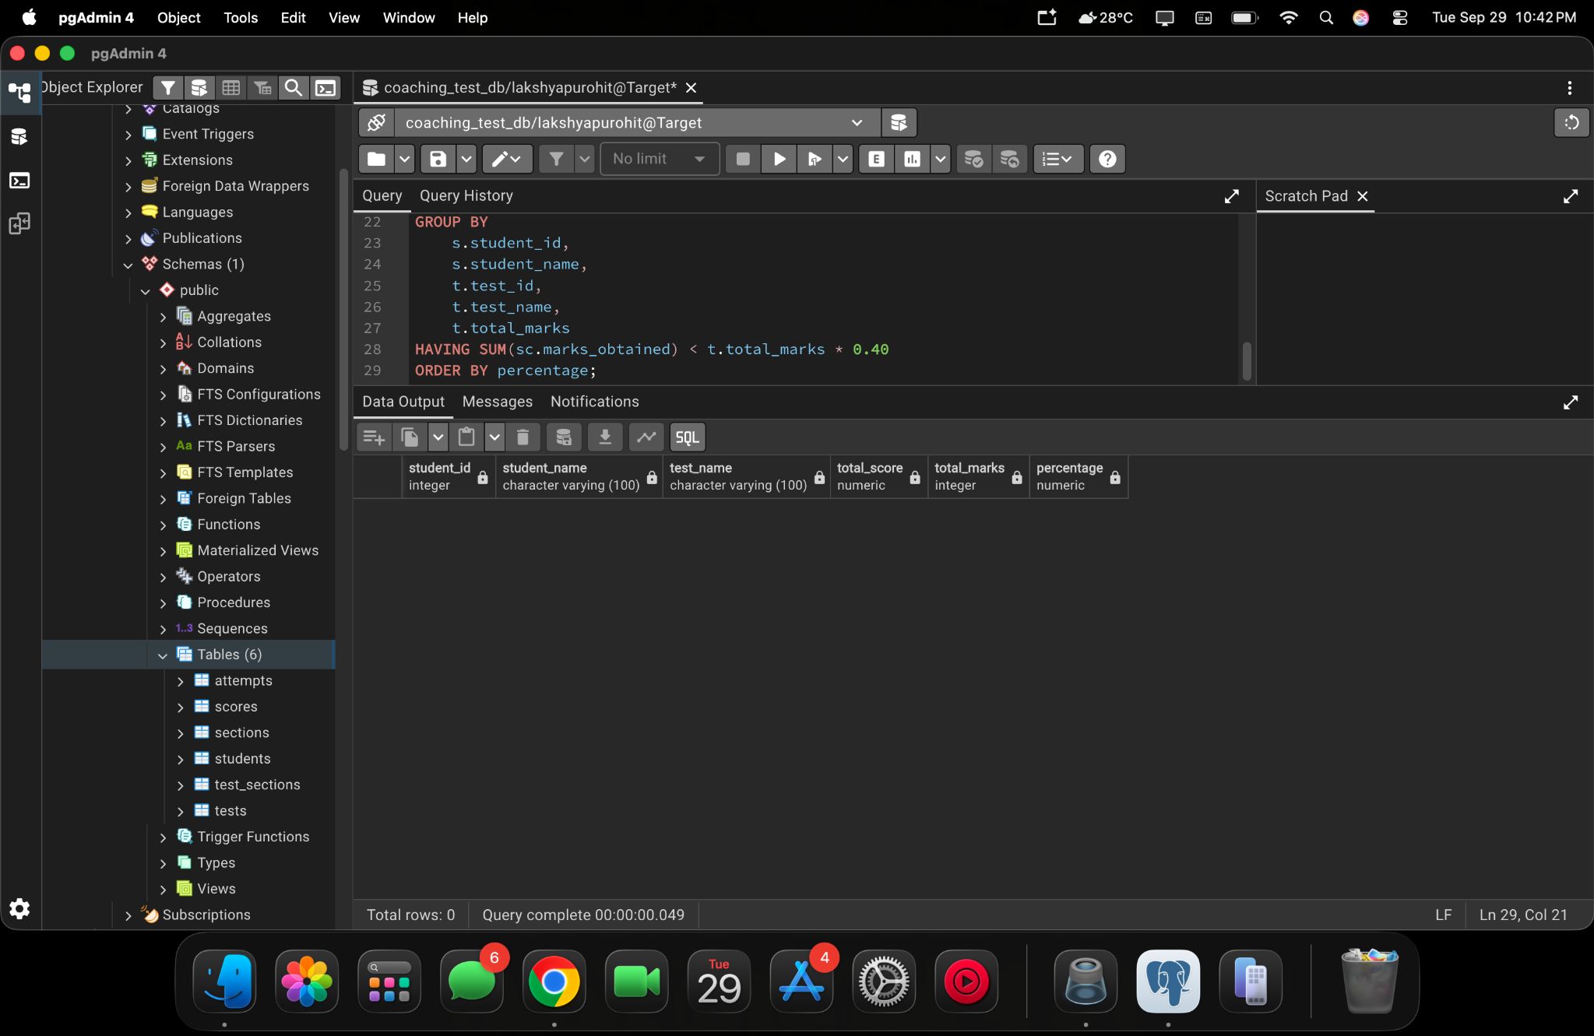
pgAdmin 4 project screenshot — 2026-09-29 at 10.42.26 PM

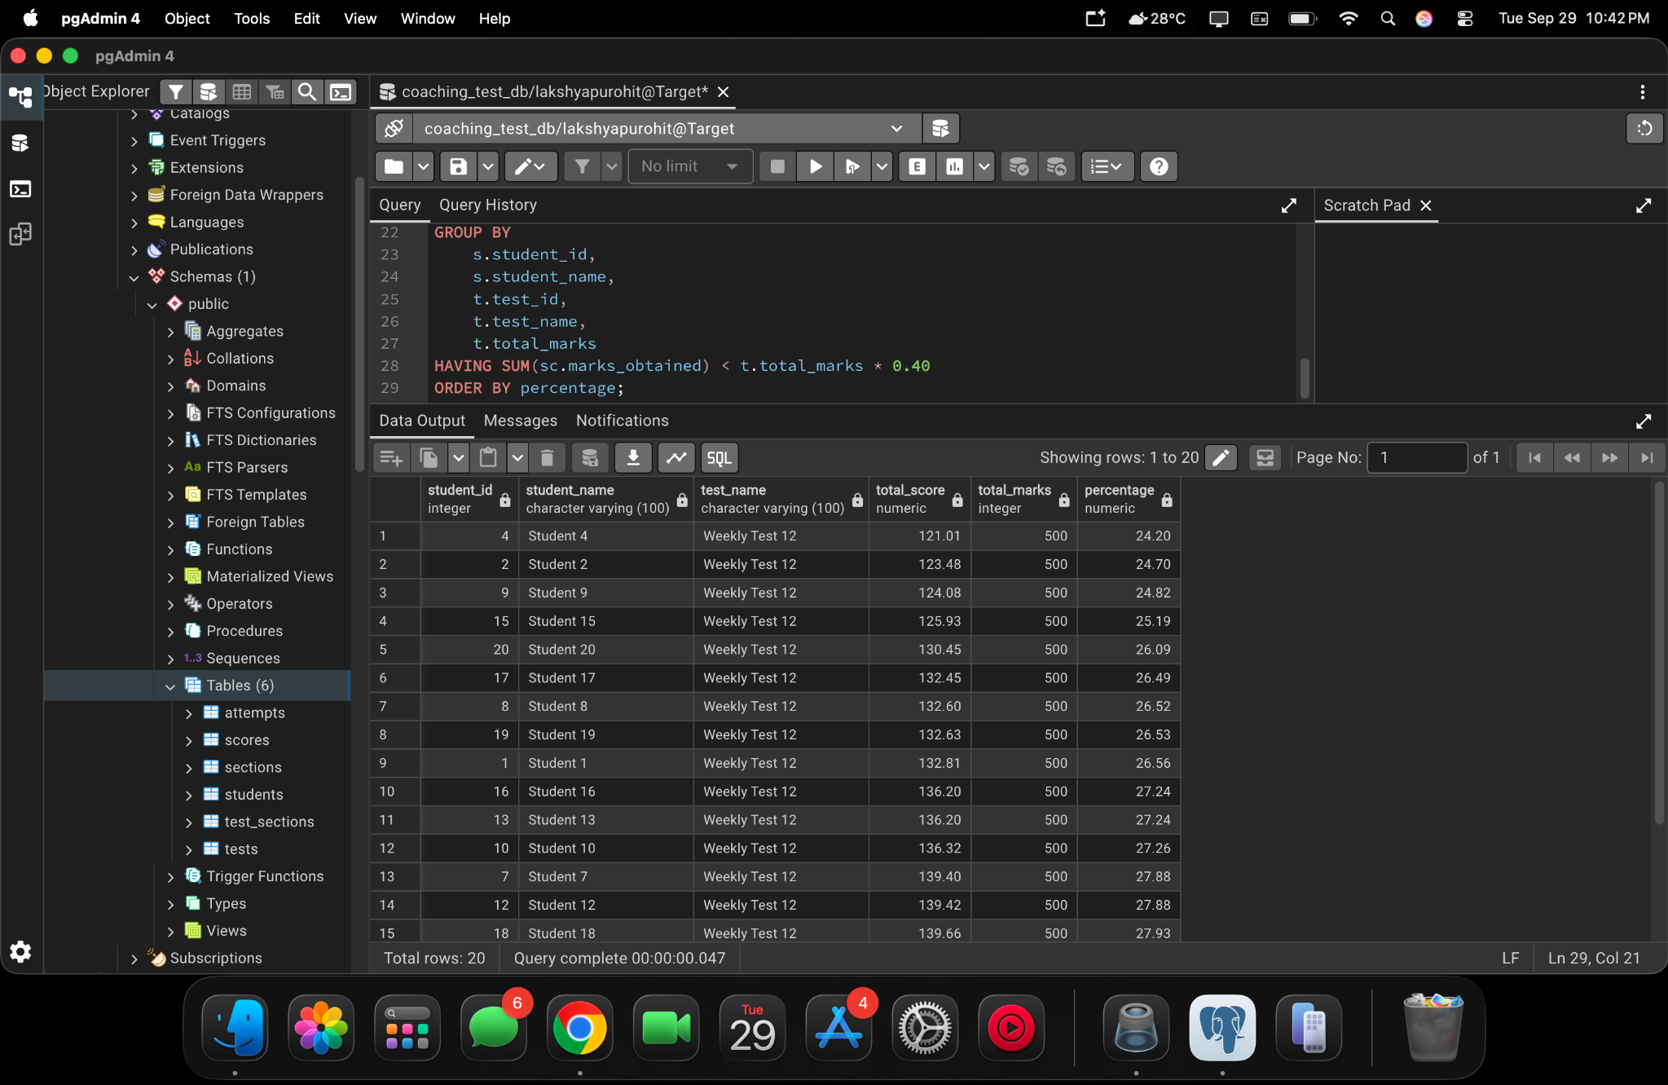
pgAdmin 4 project screenshot — 2026-09-29 at 10.42.55 PM
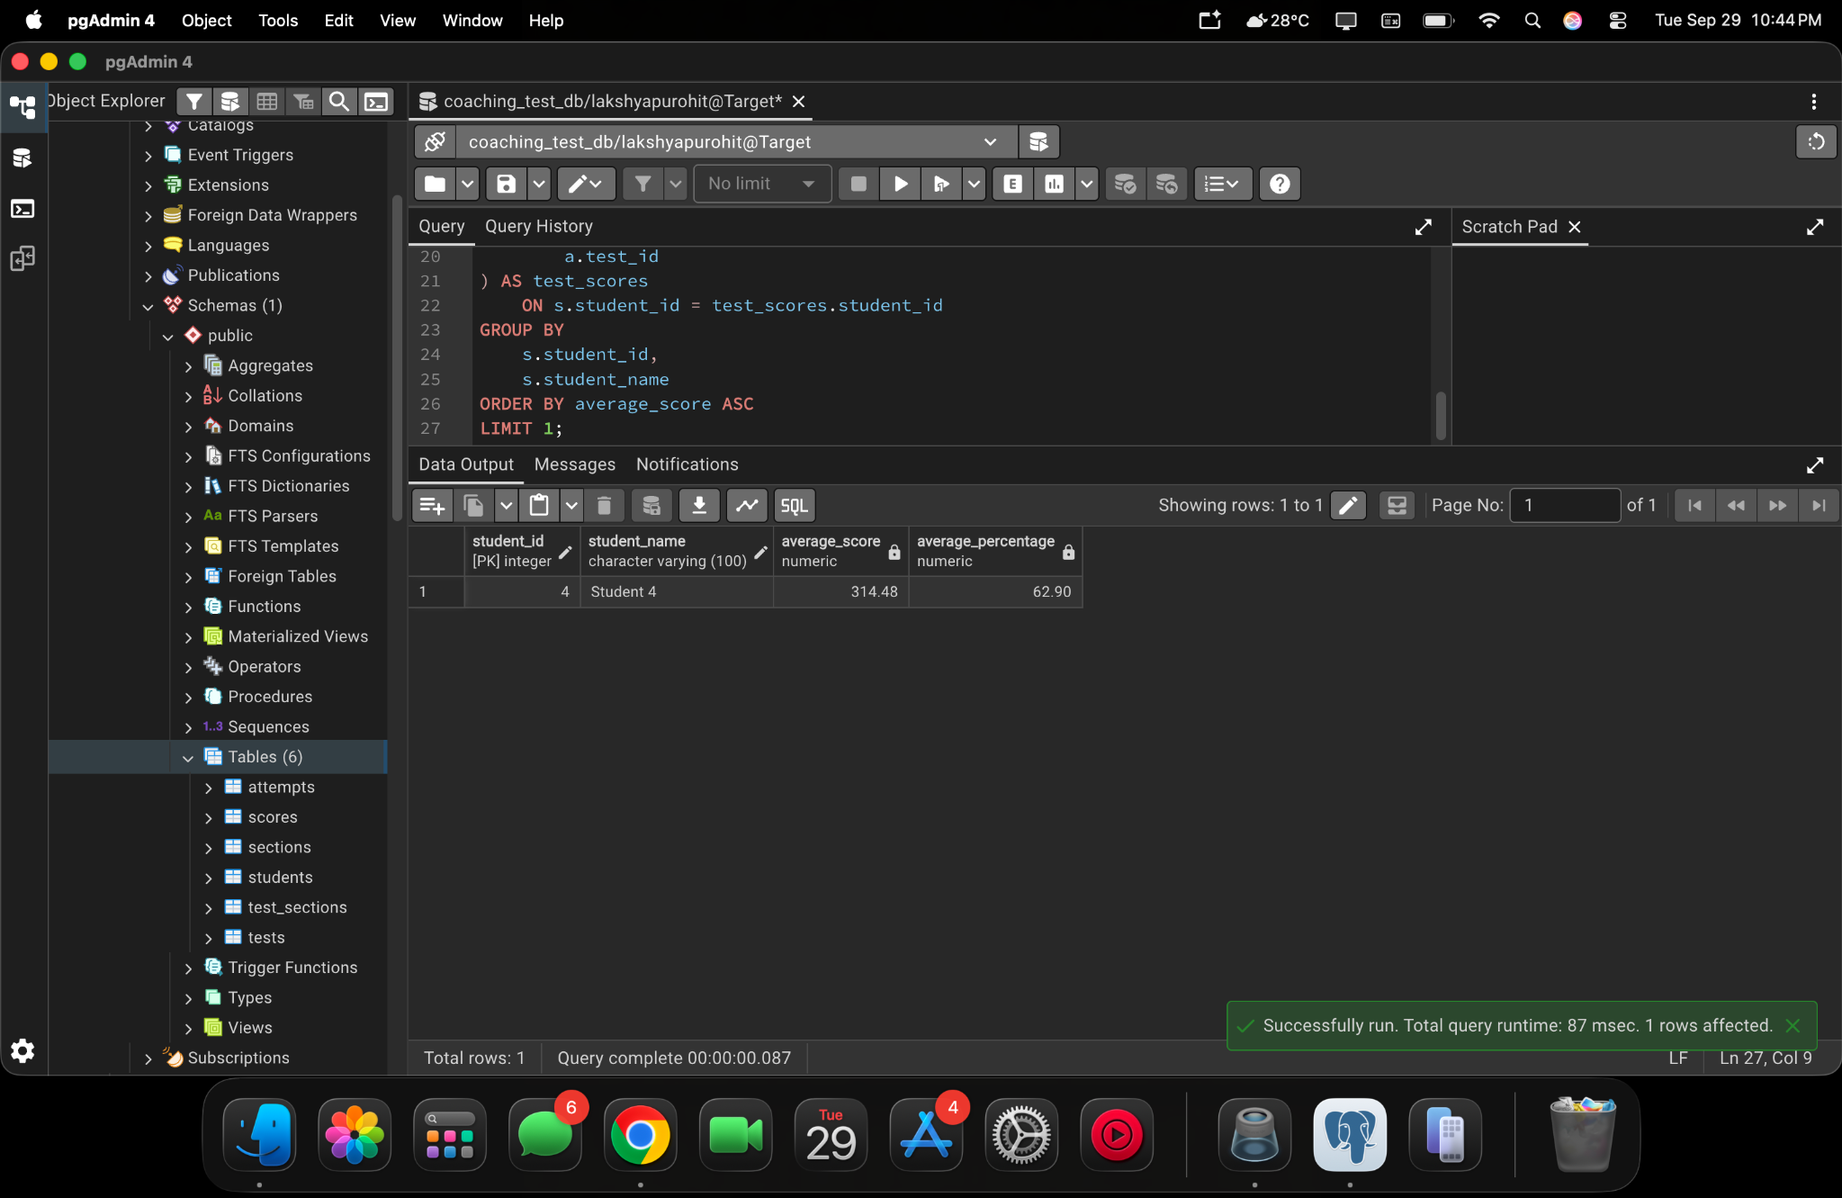
pgAdmin 4 project screenshot — 2026-09-29 at 10.44.17 PM

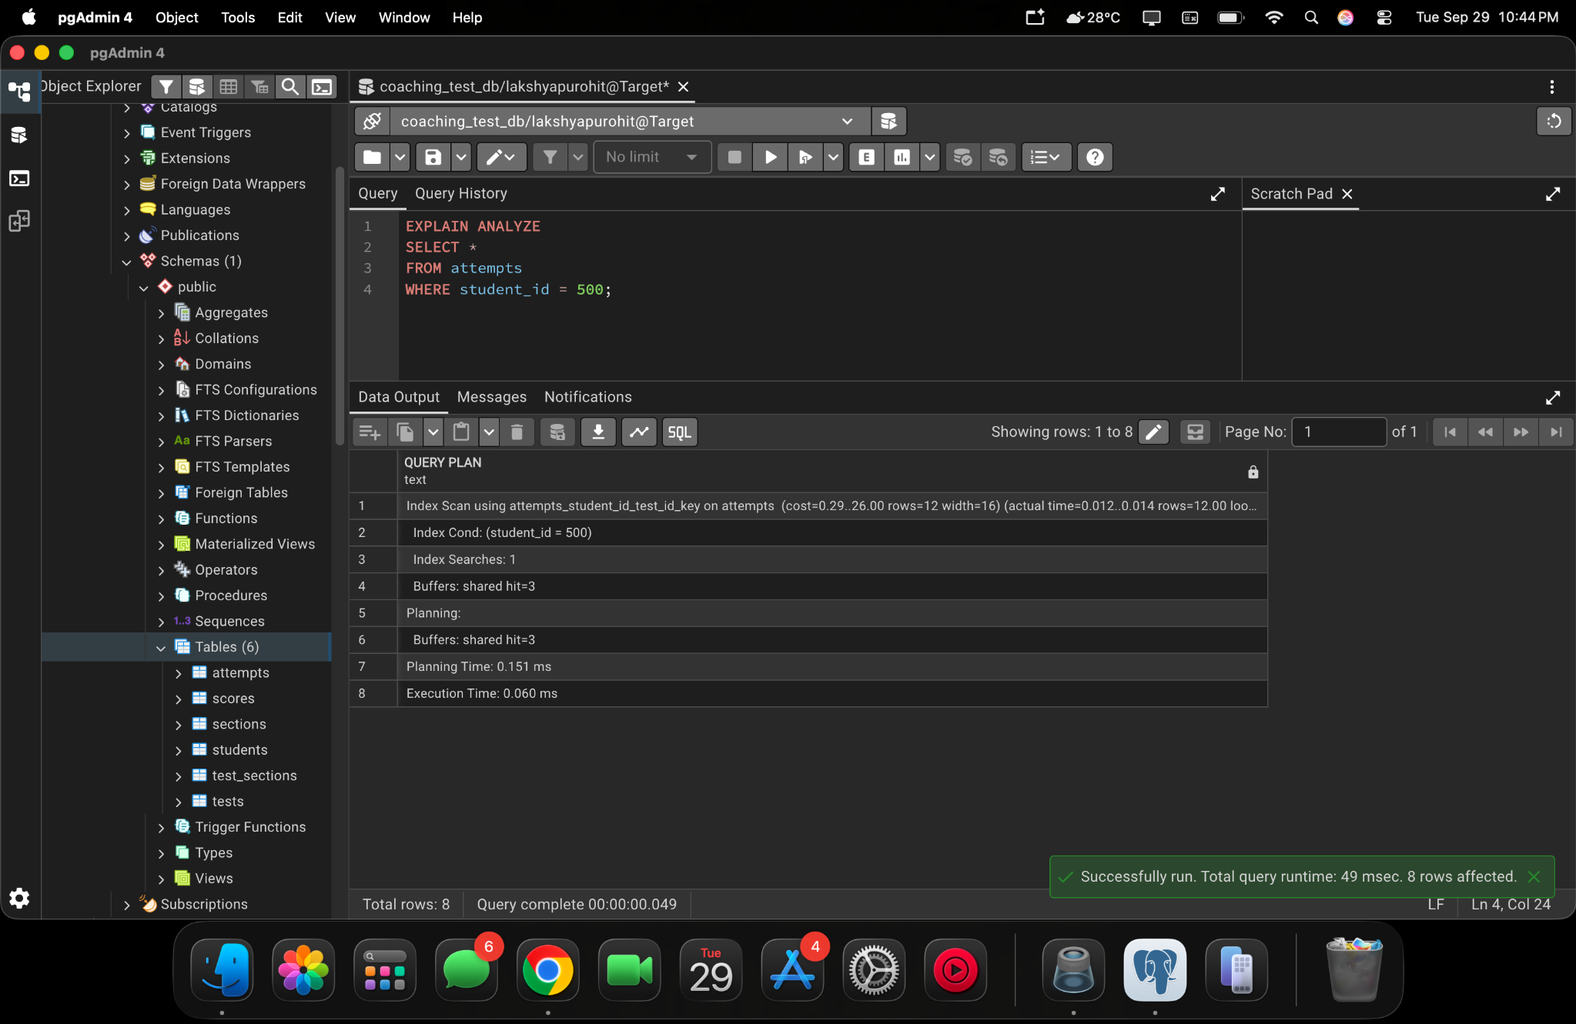
pgAdmin 4 project screenshot — 2026-09-29 at 10.44.49 PM
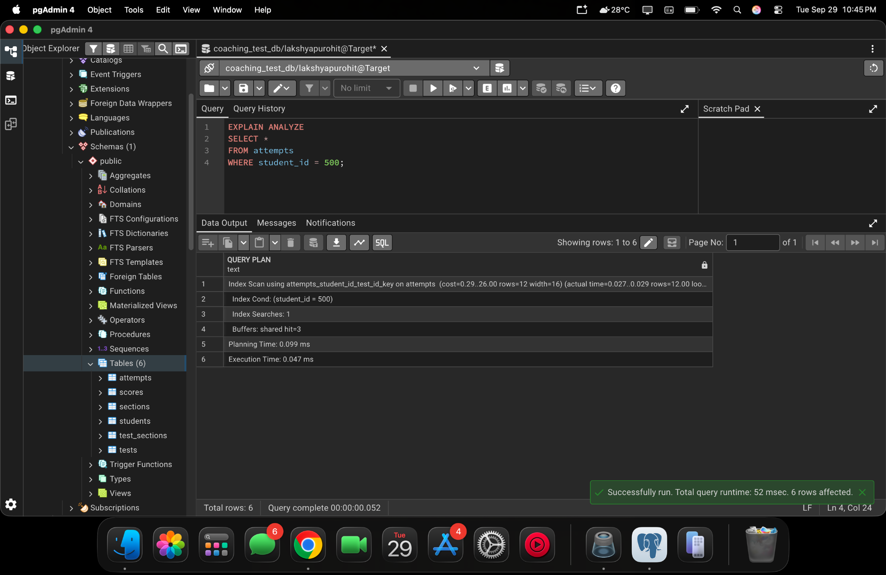
pgAdmin 4 project screenshot — 2026-09-29 at 10.45.14 PM

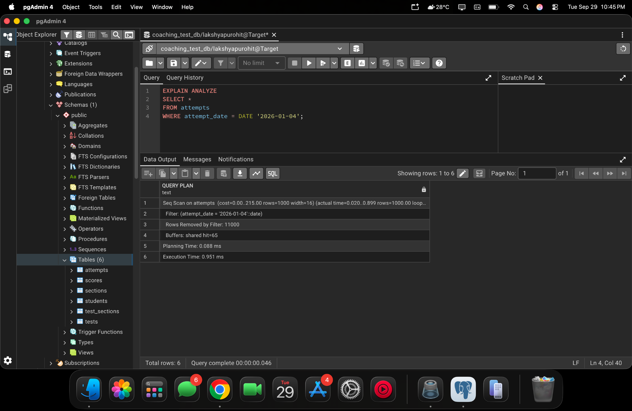
pgAdmin 4 project screenshot — 2026-09-29 at 10.45.41 PM
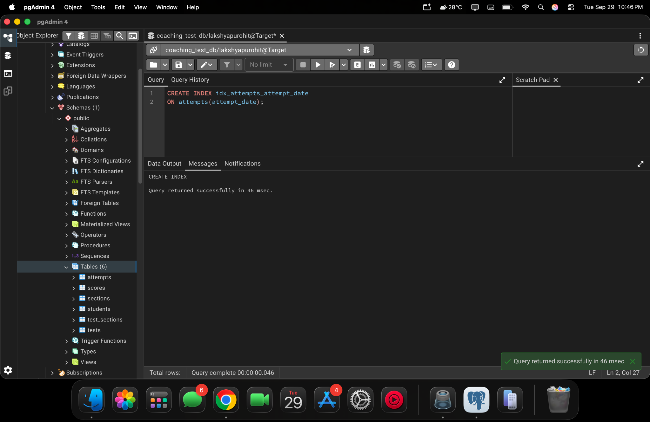
pgAdmin 4 project screenshot — 2026-09-29 at 10.46.07 PM

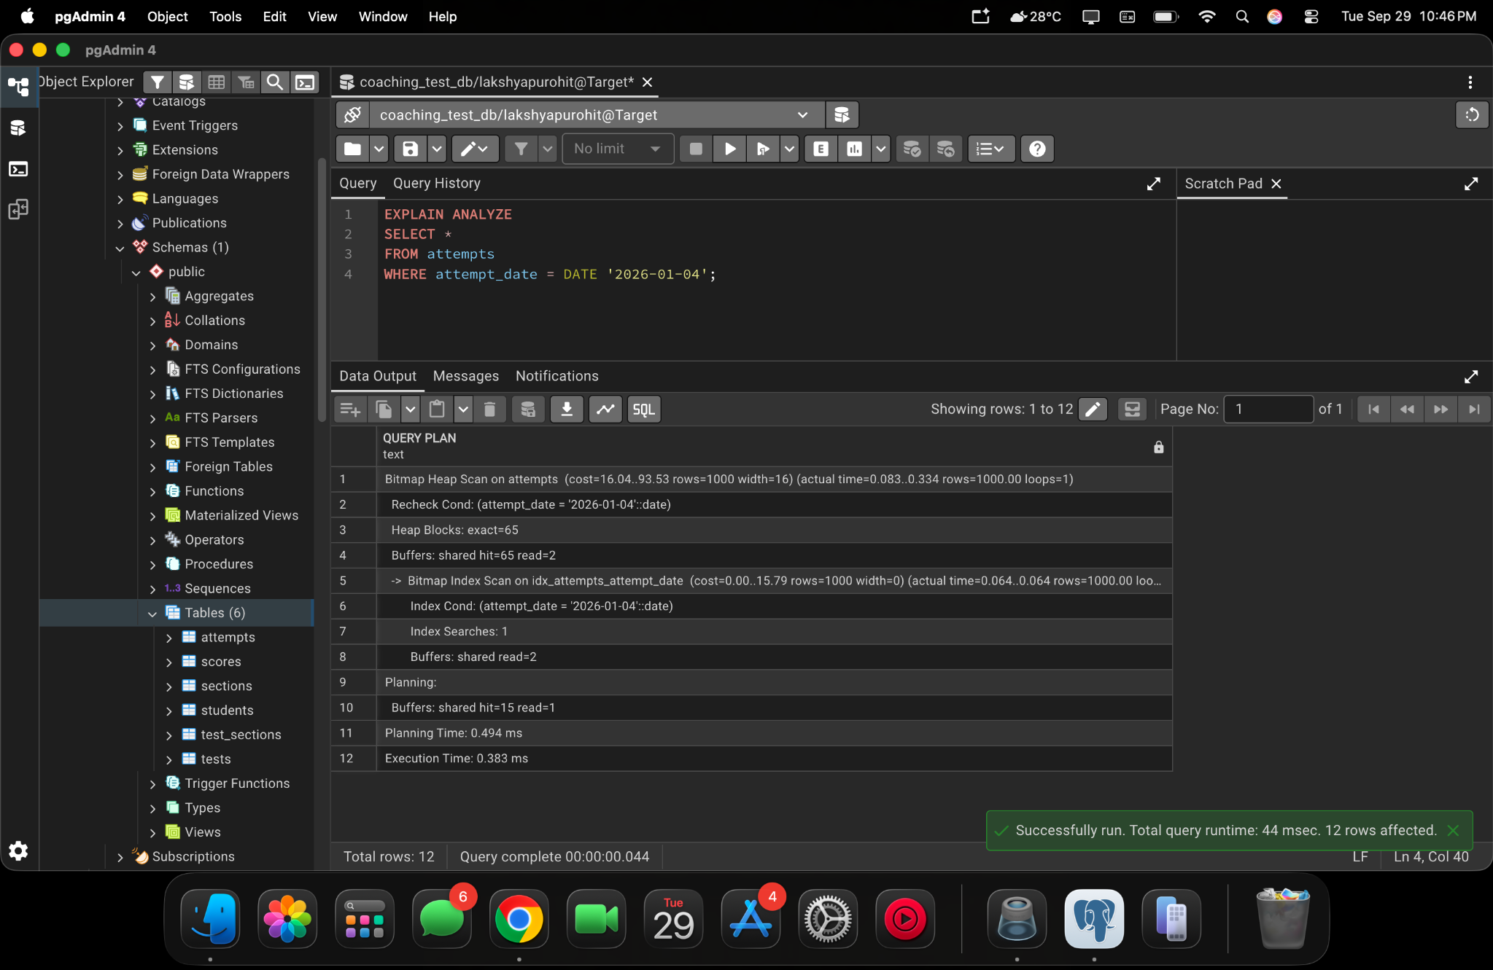
pgAdmin 4 project screenshot — 2026-09-29 at 10.46.41 PM
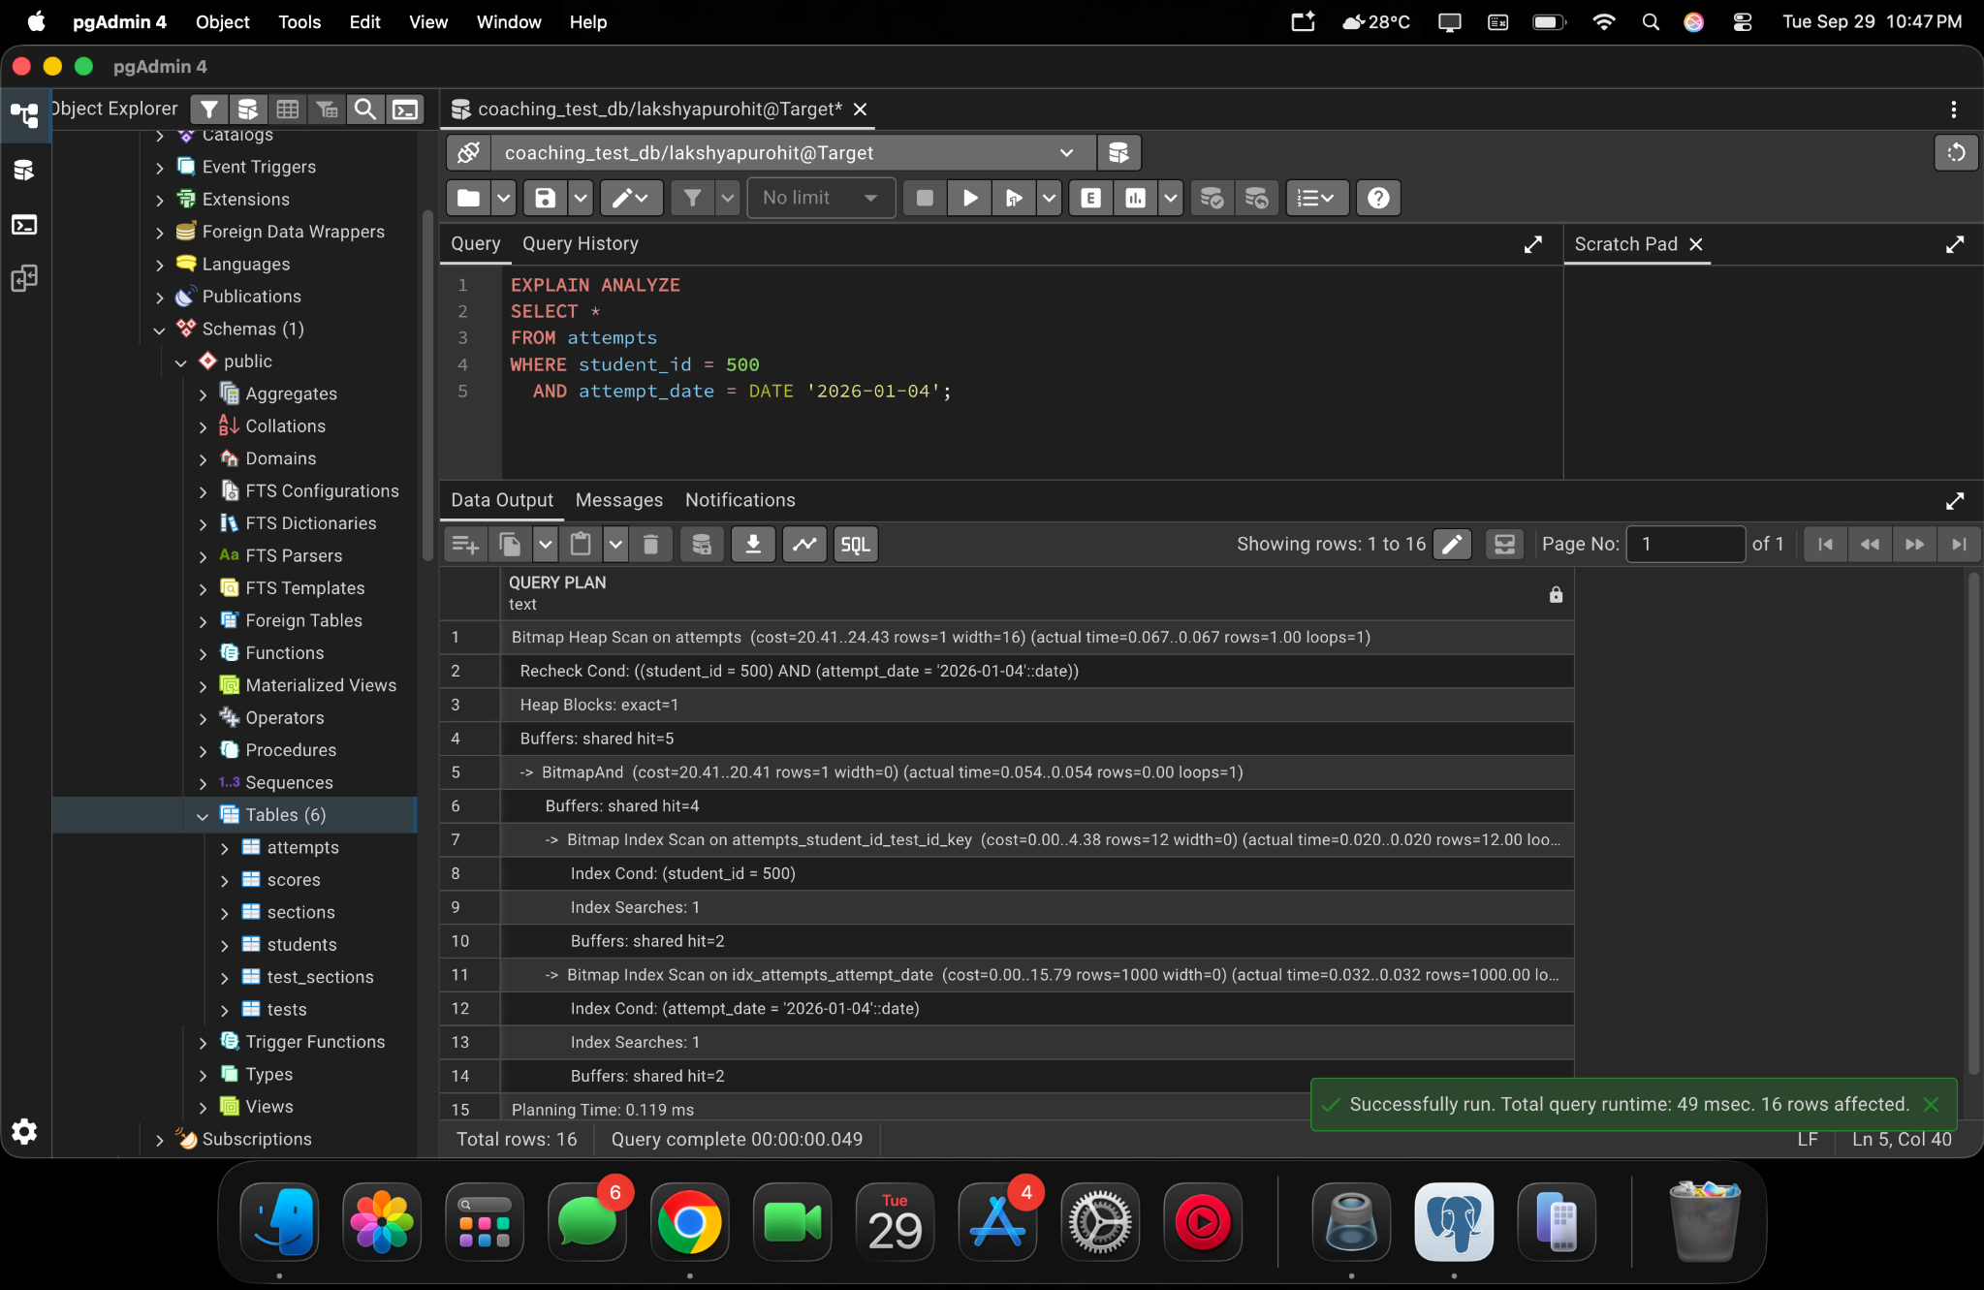
pgAdmin 4 project screenshot — 2026-09-29 at 10.47.17 PM

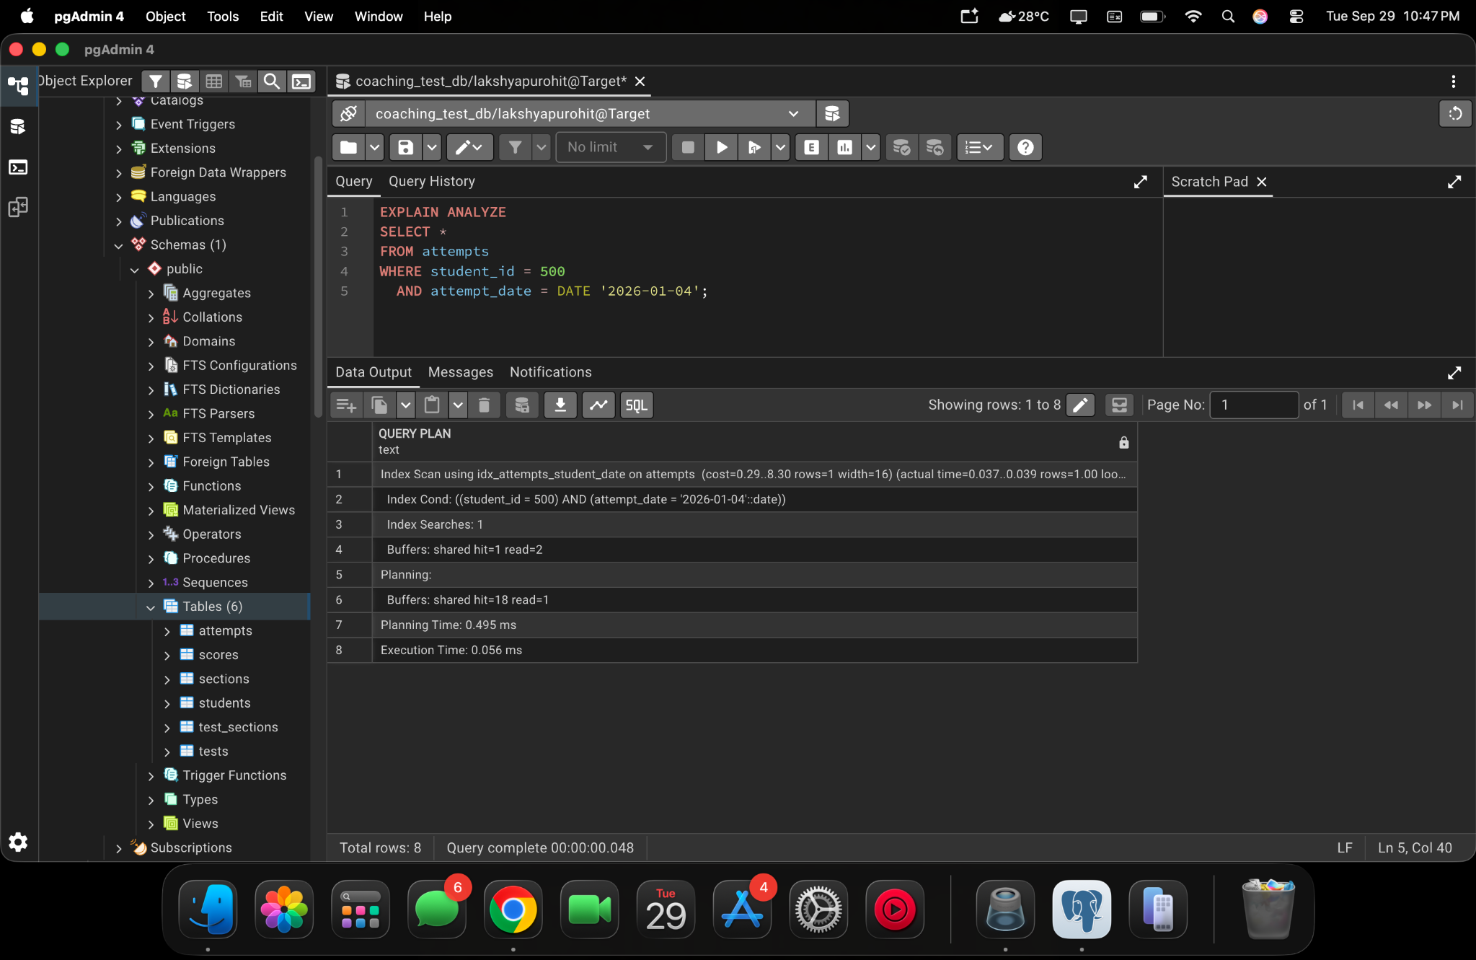
pgAdmin 4 project screenshot — 2026-09-29 at 10.47.57 PM
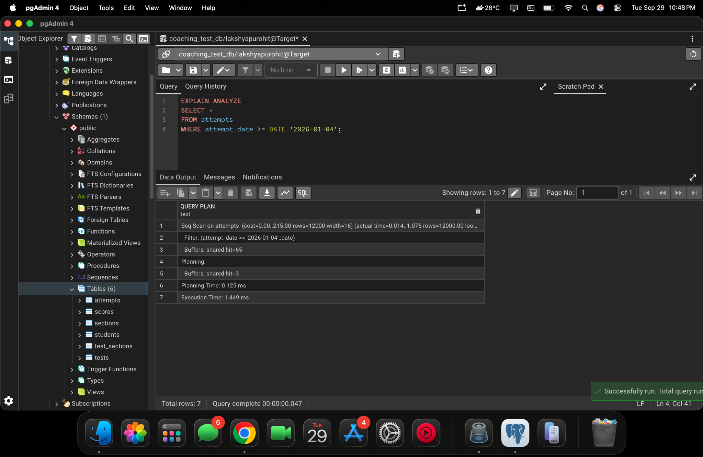
pgAdmin 4 project screenshot — 2026-09-29 at 10.48.38 PM

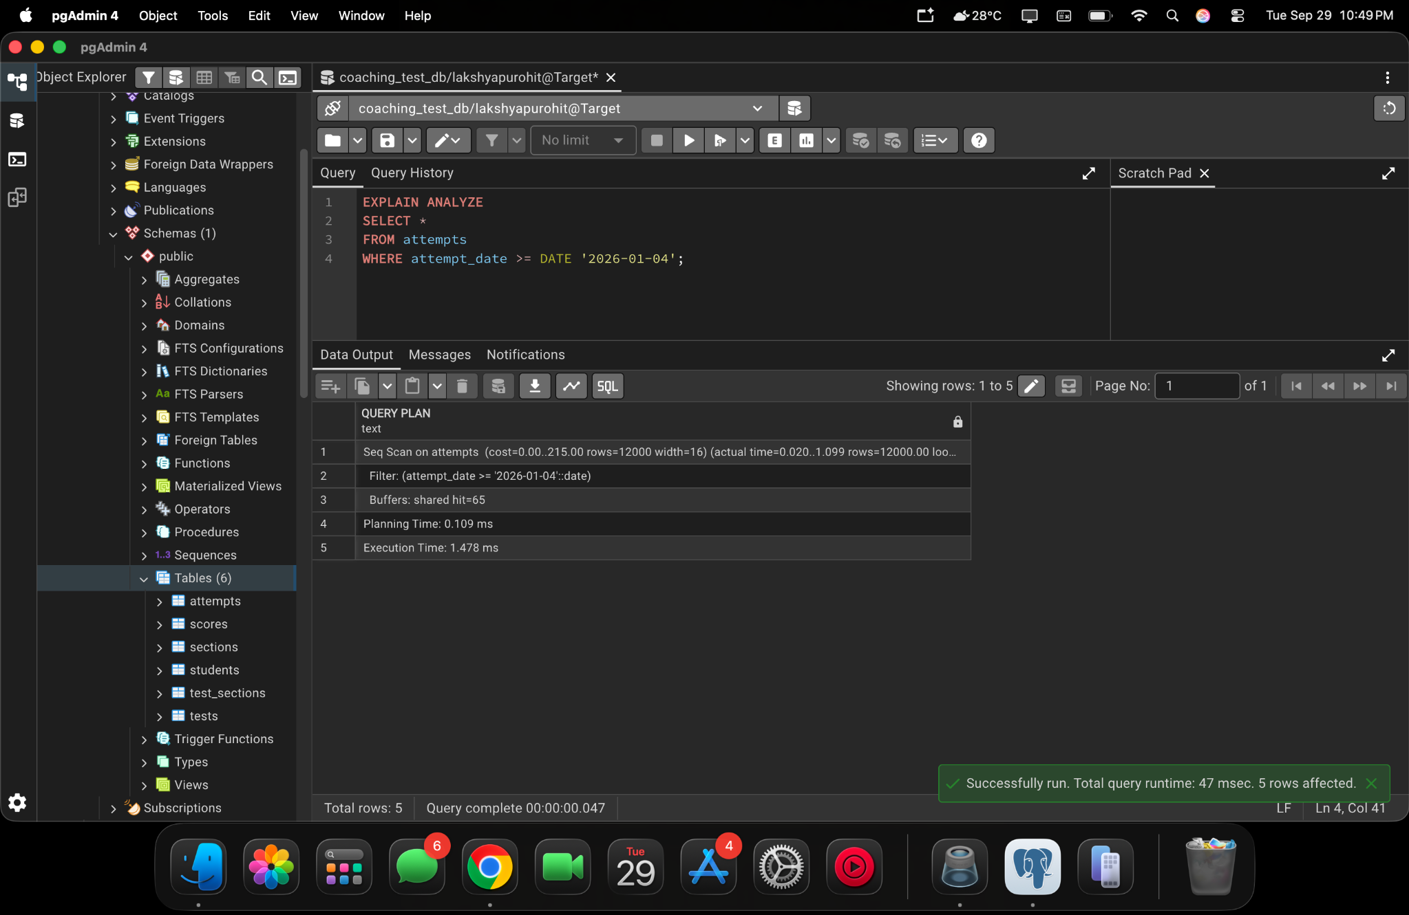
pgAdmin 4 project screenshot — 2026-09-29 at 10.49.01 PM
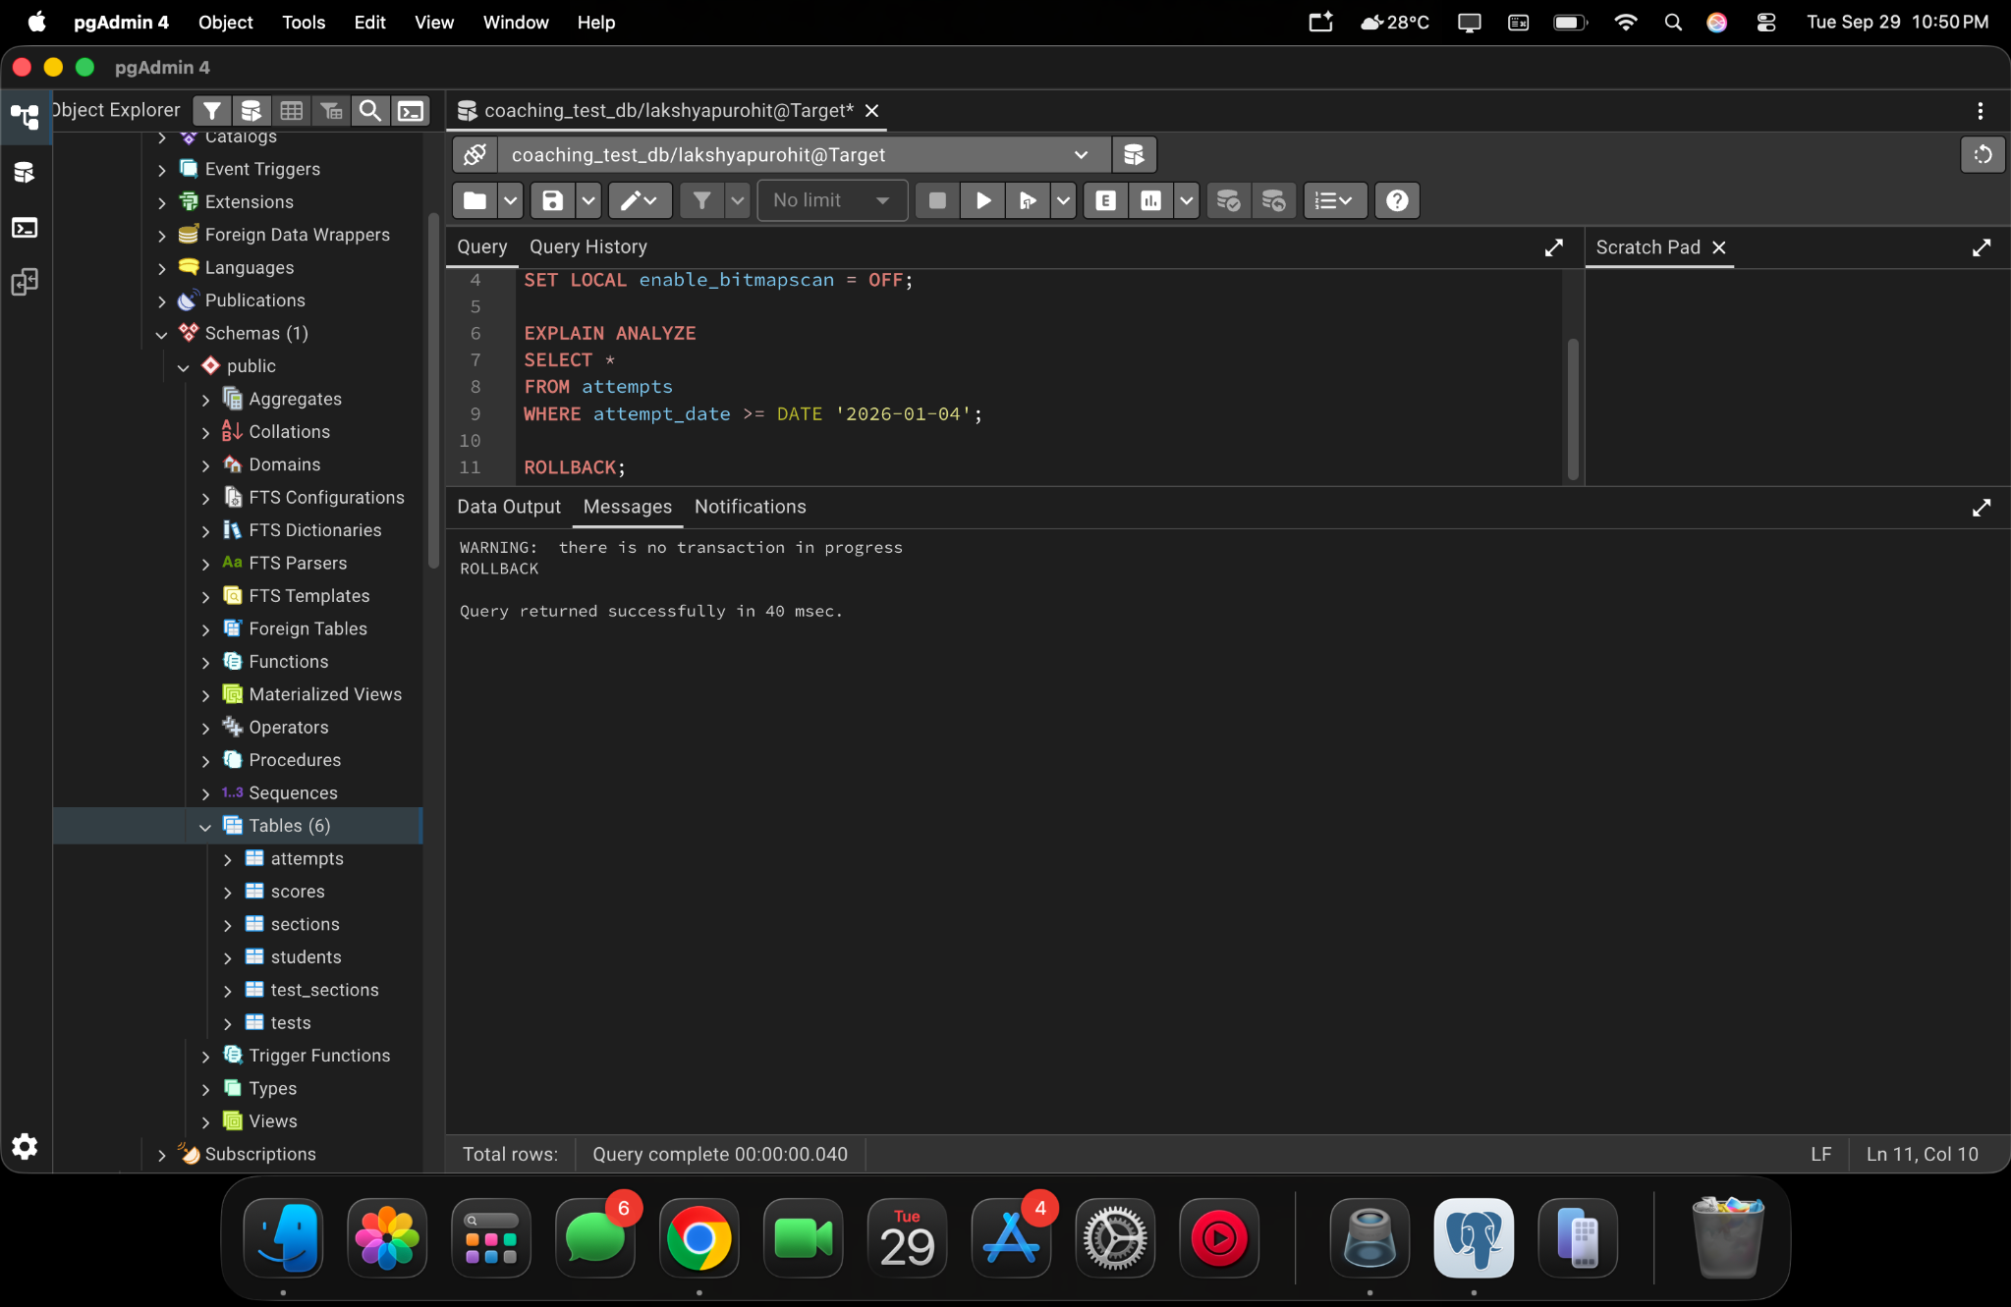
pgAdmin 4 project screenshot — 2026-09-29 at 10.50.11 PM

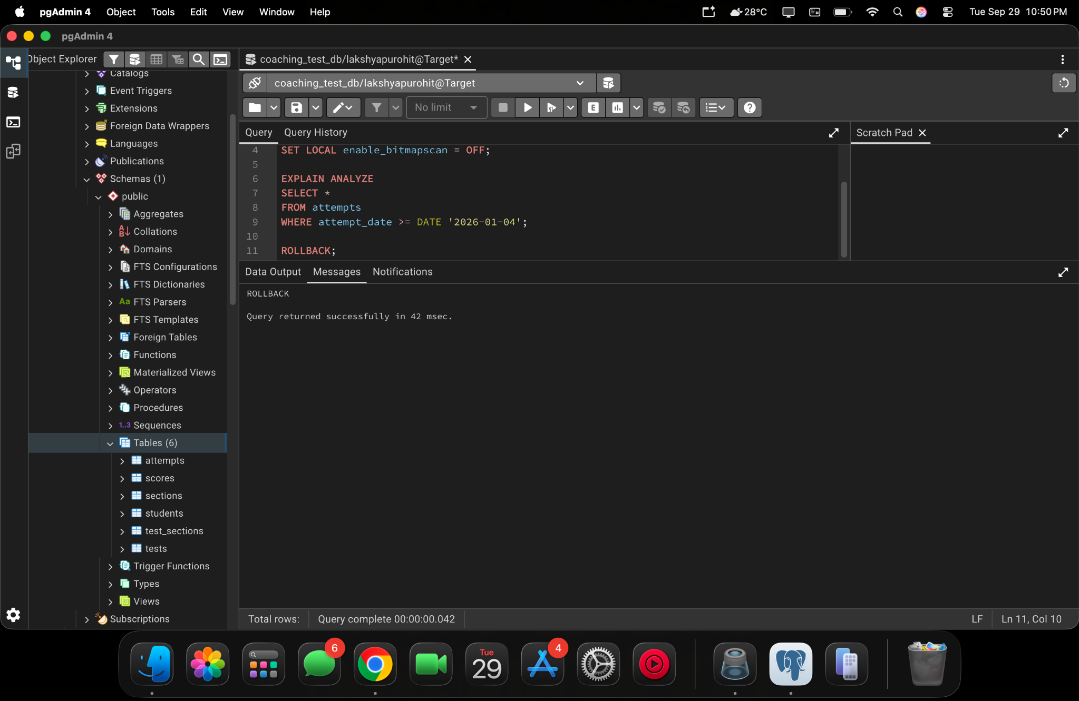
pgAdmin 4 project screenshot — 2026-09-29 at 10.50.33 PM
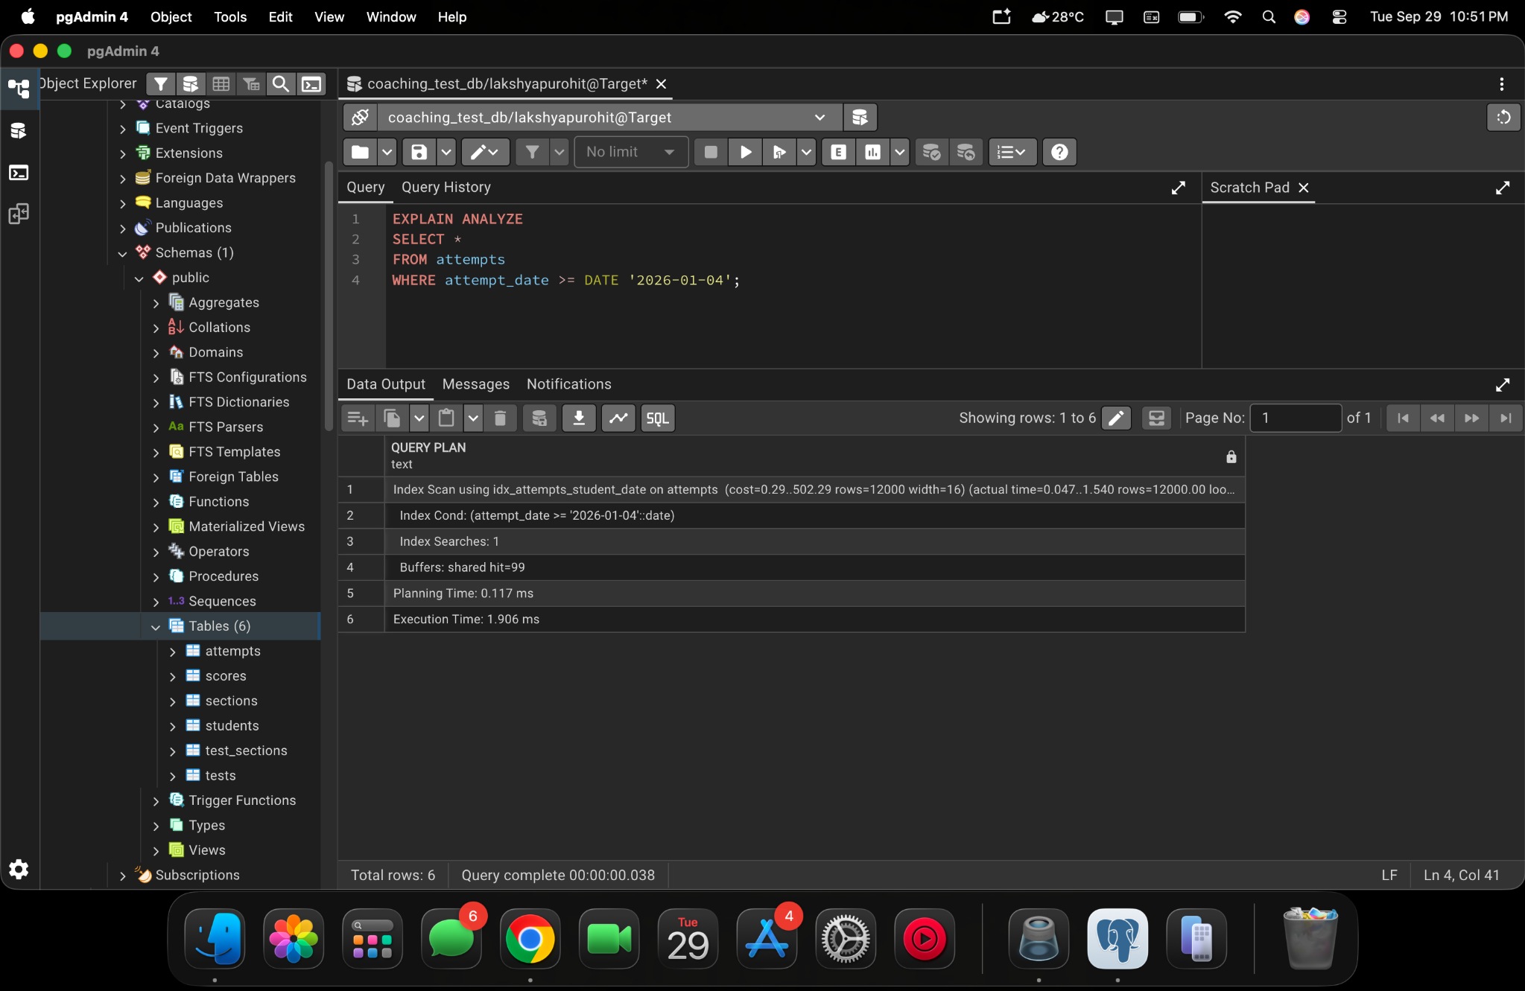
pgAdmin 4 project screenshot — 2026-09-29 at 10.51.05 PM

