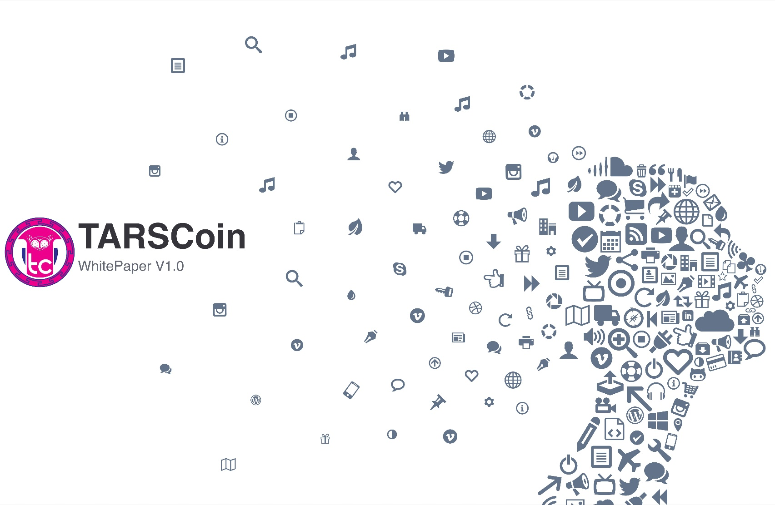

Contents

1.0.0 EXECUTIVE SUMMARY 2

1.1.0 Introduction 2

1.2.0. Paper Structure 6

1.3.0 Abridged Clarification Disclaimer 7

2.0.0 TARS OPERATIONS 7

2.1.0. TARS User Payment Model 8

2.2.0. TARSCoin 9

2.2.1. TARSCoin Security 9

2.3.0 Smart Contracts* 10

2.3.1 Smart Contract Market 10

2.3.2 PSCM 10

2.3.3 TARS Protocol 12

2.3.4 Guarantees and Requirements 18

2.3.5 Verifiability & Validity 18

2.3.6 Repurposed Mining Power 18

2.4.0. TARS Security Considerations 19

3.0.0. MARKETING 20

4.0.0. STAFFING and MANGEMENT 21

4.1.0. Additional Human Resources Concerns 22

4.2.0. International Component 22

5.0.0. OWNERSHIP STRUCTURE 23

6.0.0. UNABRIDGED DISCLAIMER 24

6.1.0. General Information 24

6.2.0. Requsite Awareness 24

6.3.0 Risks 25

6.4.0 Conclusive Information 25

7.0.0. REPRESENTATION AND WARRANTIES 26

8.0.0. GOVERNING LAW AND ARBITRATION 27

# 1.0.0 EXECUTIVE SUMMARY

## 1.1.0 Introduction

Exploring the world of digital cryptographic currency or cryptocurrency requires a moderate amount of programming and computer literacy. Entering this world demands the orchestration of various moving parts all working independently, but in sync with each other. This complex scope of activity, which often entails laborious coordination of webpages and downloads, is precisely the issue the TARS application addresses.

The proprietary mobile application known as TARS sidesteps the industry norm by enabling programmers and nonprogrammers alike to dive into the world of cryptocurrency without having to navigate complex sites or numerous files in a sequential order. More specifically, TARS is an application for your mobile devices that enables cryptocurrency and wallet monitoring as well as smart contract customization and creation in one central location. The ability to tailor and draft smart contracts on one application is exclusive to TARS and requires no programming expertise. (For more information see Smart Contracts Section 2.3.0)

Users of the TARS application don’t have to traverse digital environments to keep track of their cryptocurrencies. One doesn’t have to download multiple intricate programs, draft and program smart contracts, or identify parties who are interested in the contracts to commercially engage vendors, individuals, and business. This can all be done safely and securely via TARS. (For more information on TARS security measures and mechanisms see TARS Security considerations, section 2.4.0).

The safe and intuitive features that are available on the TARS application permit individuals to explore the world of digital money and conduct transactions in cryptocurrency. For users of TARS, this exploration begins by selecting the TARS app and then entering one’s user identification and a password. (**Figure 1**).

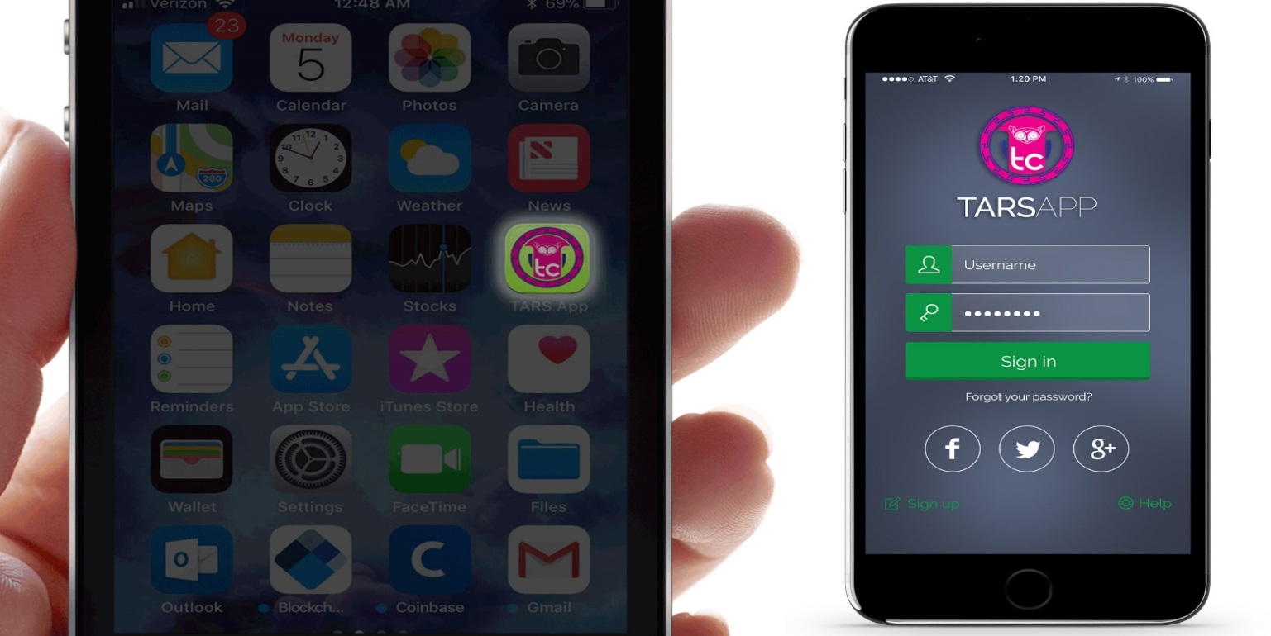

Figure 1

Pressing [ENTER] after performing these simple tasks advances the **USERS** to his/her TARS USER HOME PAGE.

**TARS User HOME PAGE**

On the TARS USER HOME PAGE, a person can view their entire cryptocurrency portfolio – including the number of a particular token they own as well as current total market values. From this HOME PAGE (**Figure 2**) a user can also do the following:

* Access the market by selecting the MARKET tab (see Sections 2.3.1, 2.3.2, and 2.3.3).
* 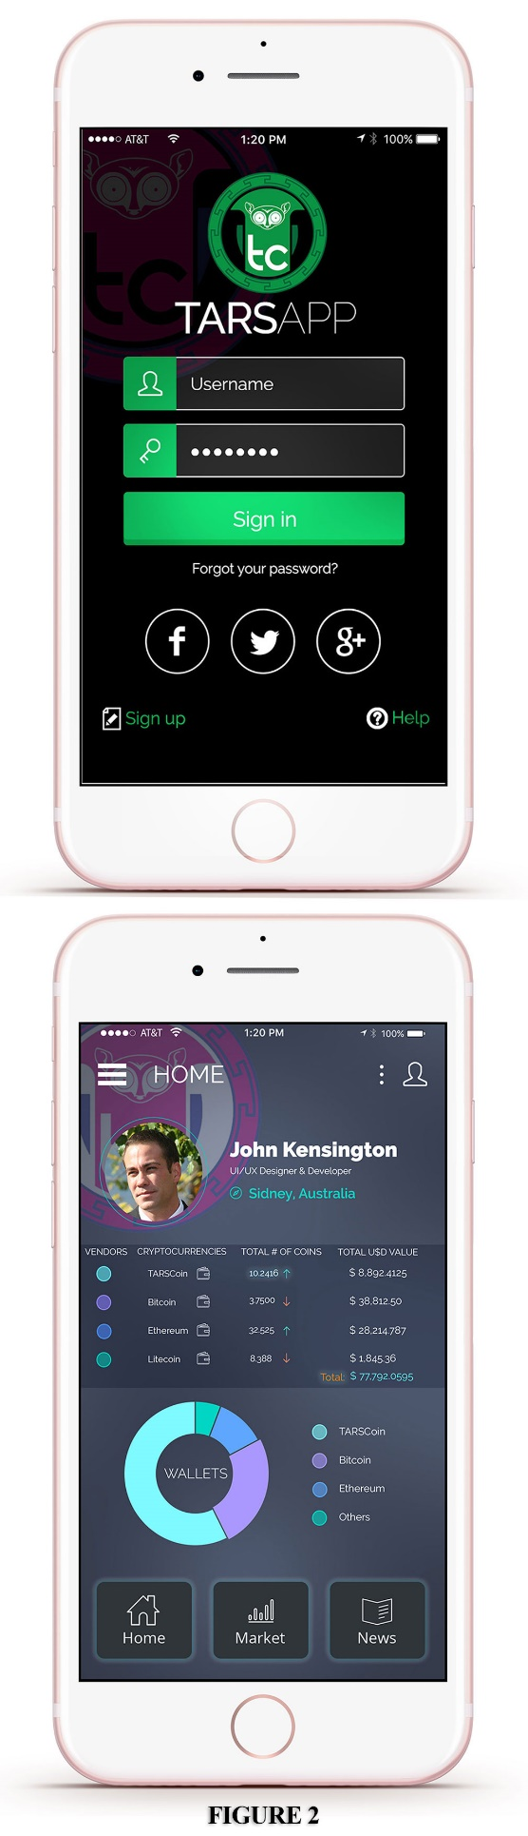See a graphic display of wallets the user owns that contain a particular cryptocurrency by selecting the wallet icon beside the cryptocurrency.
* View links to other vendors who accept a cryptocurrency by selecting the VENDORS icon next to said cryptocurrency.
* Read information regarding past and current events in the cryptocurrency industry by choosing the CRYPTONEWS tab.

**WALLETS**

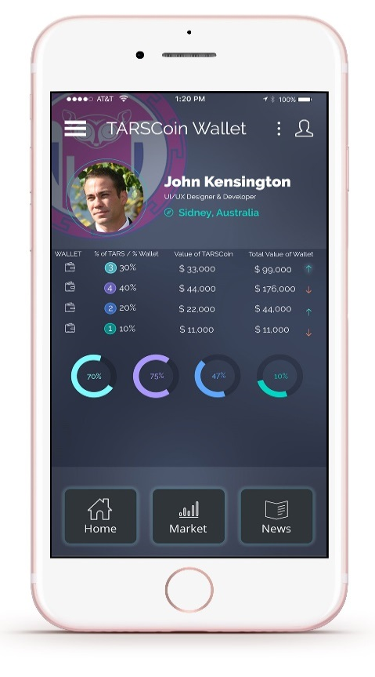Selecting the wallet icon beside any cryptocurrency on the HOMEPAGE will give the user an itemized breakdown of the positions that cryptocurrency holds in various wallets. This breakdown includes the number of tokens of that cryptocurrency in each wallet, the percentage of the wallet this amount constitutes the value of this percentage, and the total current market value of each wallet in its entirety. (Figure 3 shows a graphic representation of a samples user’s TARSCoin breakdown.)

Figure 3

**VENDORS**  
By selecting the VENDORS icon beside a cryptocurrency on the TARS USER HOME PAGE one can access links to vendors who accept that cryptocurrency in exchange for their products/services. Selecting a vendor’s name (see Figure 3) will take the user to that vendor’s website where said user is free to transact with the vendor according to the vendor’s guidelines. (**Figure 4** shows a sample graphics representation of a vendor list for TARSCoin.)

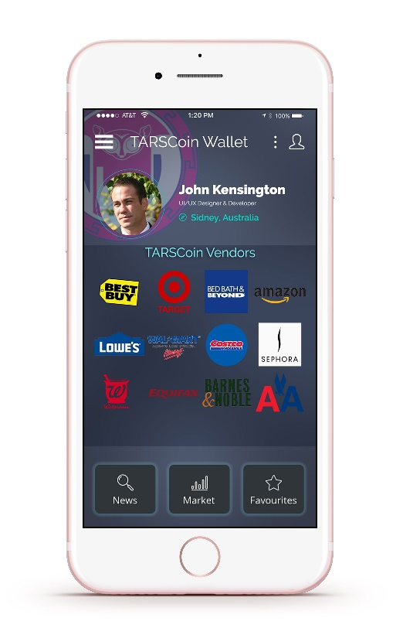**MARKETS**  
Selecting the MARKETS tab on the TARS USER HOME PAGE grants access to either the Smart Contract Market or the Personalized Smart Contract Market (PSCM), as seen in **Figure 5**. The Smart Contract Market allows a user to choose from a list of available smart contracts (see Smart Contracts Market, Section 2.3.1.); and the PSCM enables one to draft fully customized smart contracts from scratch (see Personalized Smart Contract Market, Section 2.3.2).

Figure 4

**TARSCoin**Activities occurring on these markets, as well as access to the TARS Alpha Investor Relations Page, are simplified and actualized via the 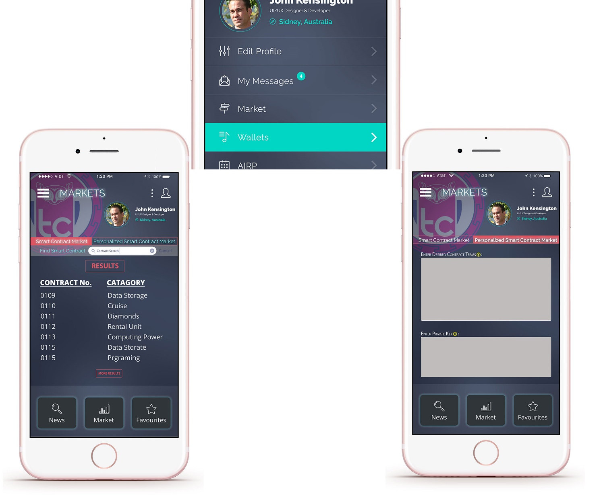

Figure 5

TARS application’s native cryptocurrency: TARSCoin (For more information see TARSCoin, Section 2.2.0.) TARSCoin is a TARS-exclusive utility token that one can exchange for a variety of both novel and utilitarian purposes on the TARS application. It can also be earned by parties who create blocks for the TARS blockchain by contributing to the smart contract creation services offered on the application (see Personalized Smart Contract Market, Section 2.3.2 for details).

1.2.0. Paper Structure  
Following this Executive Summary is TARS Operations Section 2.0.0 which describes the TARS application’s operational mechanisms, including those that are exclusive to the backend of the application. TARS Security Consideration, Section 2.4.0. briefly outlines the extent to which TARS administration have ensured the security of the application. This section is followed by MARKETING, Section 3.0.0 which outlines TARS administrators’ ideas regarding and intentions behind the marketing of the TARS application. Personnel concerns are addressed in the STAFFING AND MANAGEMENT, Section 4.0.0.; OWNERSHIP STRUCTURE, Section 5.0.0. presents the ownership structure of TARS; an unvarnished disclaimer is found in UNABRIDGED DISCLAIMER, Section 6.0.0. and all pertinent legal information/concerns are found in REPRESENTATIONS and WARRANTIES, Section 7.0.0.

1.3.0 Abridged Clarification Disclaimer  
There are risks and uncertainties associated with TARS and/or its distributor and their respective business and operations. (This includes but is not limited to TARSCoin, the TARSCoin initial token sale, and the TARS application, each as referred to in this white paper.) You can find a description of the risk and related to the TARSCoin crowd sale in UNABRIDGED DISCLAIMER, Section 6.0.0., which should be read carefully.

This whitepaper any part thereof, including authorized and unauthorized reproduction must not be taken or transmitted to any country where distribution or dissemination of initial coin offerings like the one described in this whitepaper are prohibited or restricted.

TARSCoin are not intended to constitute securities in any jurisdiction. TARSCoin are utility tokens and cannot have a performance or a particular value outside of the TARS application. This is reiterated throughout this whitepaper by use of the descriptive phrase “TARS – exclusive cryptocurrency” when referring to TARSCoin. Therefore, this whitepaper does not constitute or form any part of an opinion or any advice to sell or any solicitation of any offer by TARS or by TARS’ owner, UK. based C.T.3. (London) LTD. Holdings, to purchase any TARSCoin or give any help in any investment decision.

You are not eligible, and you are not to purchase TARSCoin in the TARSCoin crowd sale if you are a citizen resident (tax or otherwise) or green card holder of the United States of America or a resident of the People’s Republic of China or South Korea.

2.0.0 TARS OPERATIONS  
The TARS application enables users to partake in a plethora of commercial and contractual activities using any applicable cryptocurrency from one convenient location[1]. This app is the gateway to cryptocurrency for the general user. It offers the following (see Figure 6):

* Have a smart contract developed by telling TARS what you want and what you’re willing to pay for it.
* View and choose from a list of potential smart contacts in need of contractual counterparts.
* Delegate oversight of the contact’s execution.
* Have the applicable payment released after the fulfillment of the contract directly into a wallet or an account of your choosing.
* View all cryptocurrencies you own on one page.
* See current market values and breakdown of portfolios by percentage of any cryptocurrency holdings.
* View wallets and related details with the push of a button.
* View and access the website of B2C and B2B businesses that accept payment in any cryptocurrency.
* Mine TARSCoin (the TARS-Exclusive Token) by developing, connecting parties to and orchestrating payment stemming from smart contracts.
* Stay abreast of the latest cryptocurrency and blockchain-related news.
* 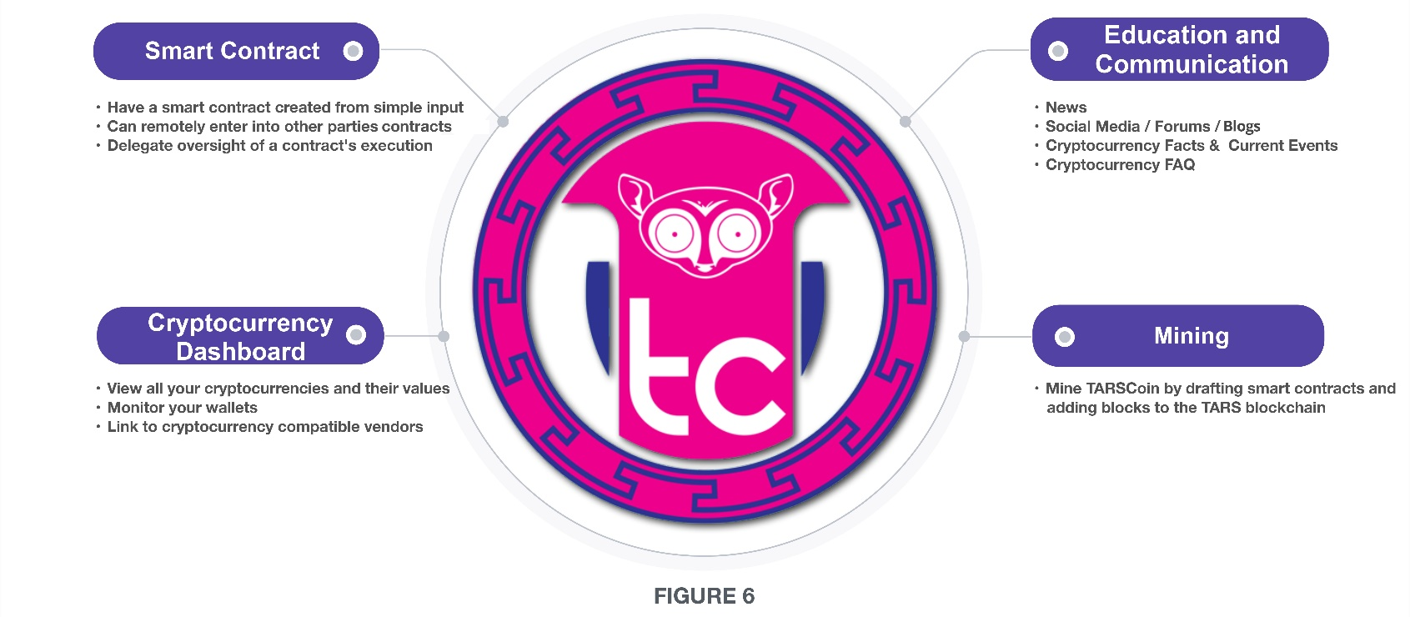Interact with other cryptocurrency owners.

2.1.0. TARS User Payment ModelTARS operates on what’s known as a Freemium Model, granting access to the platform to any non-cryptocurrency owner who agrees to complete a simple questionnaire, and to any cryptocurrency owner who agrees to submit their identifying key information. However, the following activities cost TARSCoin or a fraction thereof (see **Figure 7**):

* Accessing the TARS Alpha Investor Relations Page (AIRP);[2]
* Creating a custom smart contract via the Personal Smart Contract Market;
* Entering into a smart contract that has been listed on the Smart Contract Market;
* 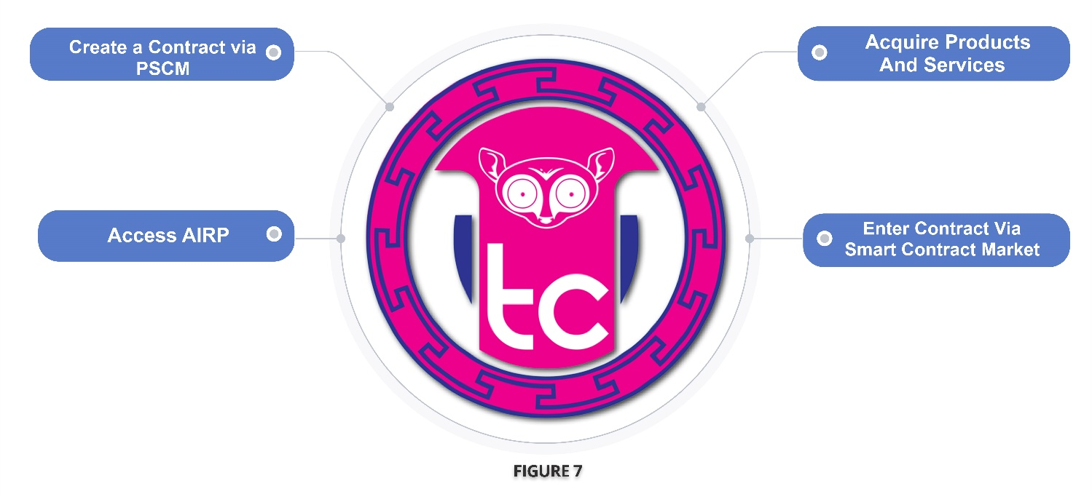Acquiring products/services

After obtaining any of the many cryptocurrencies available, entering their identifying key. Information, and/or completing the TARS questionnaire, a TARS app user will be able to access a user-specific TARS HOME PAGE after logging into TARS. From this HOME PAGE they can monitor their cryptocurrency portfolio in real-time, the value of said holdings, and the specific breakdown of their cryptocurrency assets. By selecting certain options on their HOME PAGE a user can also partake in commercial activity, conduct transactions using their cryptocurrencies and proceed to customize smart contract associated with such activity.

2.2.0. TARSCoin (see **Figure 7**)   
TARSCoin is the TARS blockchain’s native cryptocurrency. Indigenous to TARS, it’s a utility token that grants access to many features unique only to the TARS application. It is created and earned by independent miners loosely affiliated with the Decentralized Miner’s Network ,for detail’s see Decentralized Miner’s Network, Section 2.3.3.9 (a) who create customized smart contract’s for TARS Users. TARSCoin will be available to the public for the first time during an upcoming crowd sale. (for details see TARSCoin Crowd Sale / Allocation Section 2.2.1)

(**Figure 8**) depicts the way in which TARSCoin is intertwined with and ubiquitous throughout the TARS application.

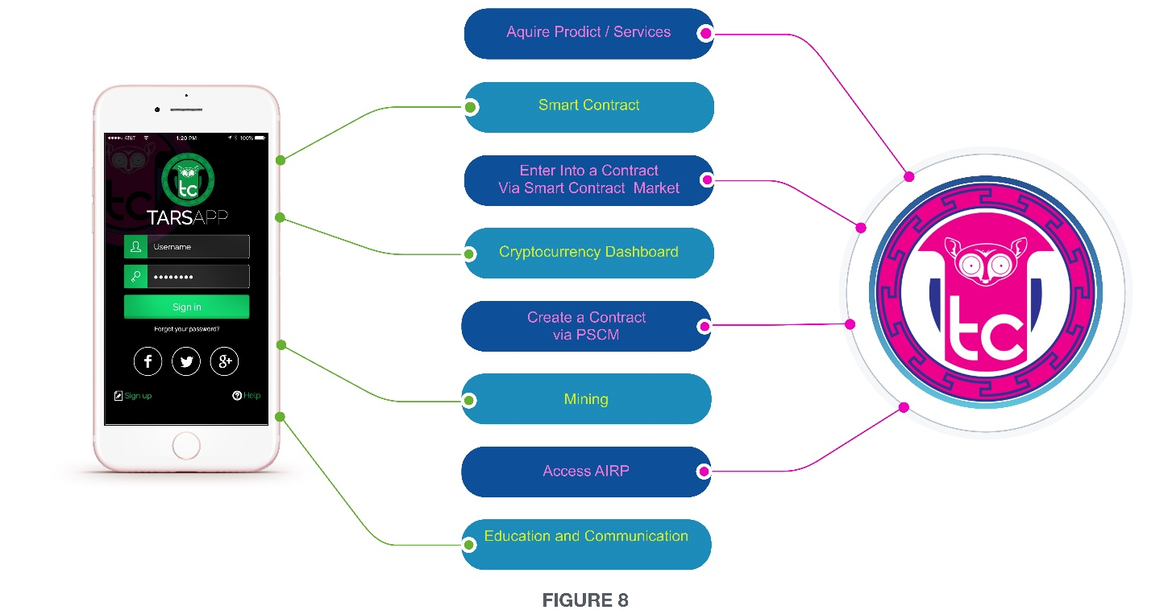

Upon purchasing TARSCoin, the purchaser is given a confidential cryptographic receipt with a 64-digit keycode. This keycode or “private key” functions as the purchaser’s passcode, granting the purchaser access to the wallet that stores their TARSCoin.

### 2.2.1 TarsCoin Security

TarsCoin owners are encouraged to keep their keycode safe, private, and secure to prevent theft and unwanted access to their TARSCoin, TARSCoin owners are also advised to put *do not port* orders on their smartphones; and for verification purposes, said owners are dissuaded from using TXT 2FA and encouraged to instead use authentication apps like Google Authentication. For all password-related needs, individuals are recommended to purchase Qwerty Cards. These cards enable the creation of unique, hard-to-break, yet easy to remember passcodes.

To guard against Trojan horse attacks that Bitcoin and Ether are vulnerable to, TarsCoin owners are implored to keep their private key offline. The suggested medium or a QR code that has been printed on to a piece of paper or a plain text file that stored on a flash drive. For additional protection, owners of TARSCoin are encouraged to encrypt their TARSCoin private key.

Individuals can rest assured that purchasing TarsCoin and partaking in cryptocurrency-related activity on the TARS application will be a safe and secure endeavor. They can feel confident that all activity related to their TARSCoin wallet is as impervious to tampering as feasible.

## 2.3.0 Smart Contracts

The TARS application attracts parties with commercially compatible interest and then coordinates the translation of these parties’ interest into smart contract programing language by miners (which are defined below) before linking the two mechanics of this process.

### 2.3.1 Smart Contract Market

The Smart Contract Market is where TARS users can view all public and available smart contracts listed on the TARS application. A smart contract is considered available if it needs another party before it can be executed.

This market is accessible by selecting the market tab on the TARS USER HOME PAGE; and as indicated in Figure 5, users can search for deals on this market by entering a category of their choice (e.g. real estate, automotive, etc.) in the Smart Contract search bar.

A user can enter into desirable smart contract found on the Smart Contract Market by merely selecting the desired smart contract to express his/her interest

Unless clients design otherwise, custom smart contract drafted via the Personalized Smart Contract Market (PSCM) are considered available and are automatically listed on the Smart Contract Market where they are linked to interested parties and then officially executed.

The Personalized Smart Contract Market (PSCM) is expanded upon in section 2.3.2.

### 2.3.2 PSCM

The PSCM is where TARS users can have smart contracts created and tailored to their desired parameters, all with just a few simple taps.

The following chart (Figure 10) presents the simplicity that the TARS application has introduced to the smart contract industry.

|  |  |
| --- | --- |
| How to Create a Smart Contract | |
| Without (Before) TARS | **With TARS** |
| * Download Solidity (or access Cosmo) and wrote the contact * Download Geth from Ethereum.org to create Ethereum nod. |  |
| * Go back to Solidity, and compile the contract * If using Cosmo, spend Ether and send contract to Ethereum |  |
| * Access your contract via a program called Ethereum web3.js * Test the transaction time of a sample contract | * Login to TARS App |
| * Test your contract’s transaction time; ensure it’s less than 10 seconds * Keep the python library separate | * Select market tab |
| * Start a new client node while using the console window * Start Truffle and type “truffle deploy” to search for errors | * Select PSCM |
| * Type in “*truffle ini*” to create new directory * Find your contract in the directory | * Enter desire contract terms |
| * Go to *config./app.json* and add your contract * Restore your node in separate window and run the command “test pc” | * Enter key |
| * Run root directory * Write a test for the new code | * Press Go |
| * Add all UI to yourtruffle directory * Run Truffle again |  |

Figure 10

As demonstrated by (Figure 10), the TARS application has tremendously simplified the process of developing smart contracts. This application provides the simplicity necessary to make blockchain-based smart contracts attractive to everyday consumers; and it actualizes this simplicity via the proprietary TARS Protocol depicted in (**Figure 11**) and (**Figure 12**).

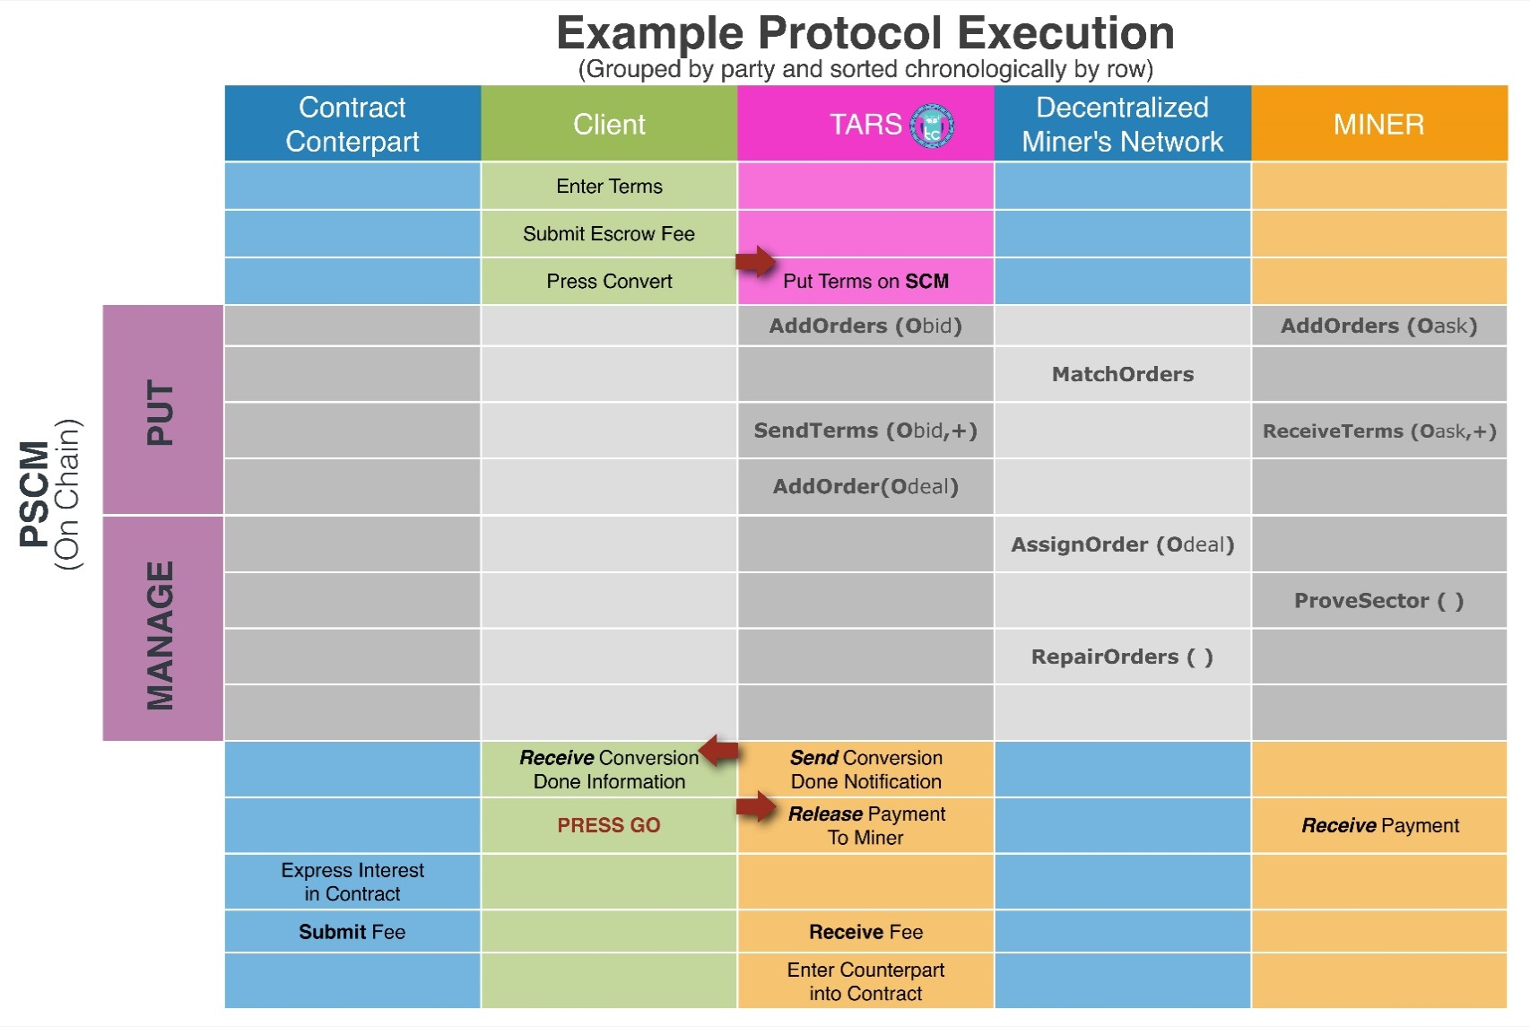

What follows is a technical explanation of this protocol in it’s entirely to better clarify the PSCM.

### 2.3.3 TARS Protocol

The blockchain that undergirds the TARS protocol runs on proof-of-conversion, where blocks are created by independent smart contract creators when prove that they’ve effectively translated clients’ desire contract terms into smart contract compatible programing language i.e. one that is derived from Python or JavaScript. These independent smart contract creators, referred to hereafter as Miners comprise a network that has been termed the Decentralized Miner Network. The arena in which these miners link to those who desire their smart contract creation services is called the Personalized Smart Contract Market (PSCM).

These components can be summarized as follows:

* Decentralized Miner Network (DMN) – The network of independent Miners.
* Proof-of-Conversion – Miners prove that client’s desire contract terms have been effectively converted into a smart contract compatible programming language to mine blocks instead of wasting computing power to solve useless problems to mine blocks.
* PSCM – Whose buy requests and sell requests are submitted to begin the contract creation process (the OSCN is run by DMN)

The TARS protocol is built on a blockchain with a native protocol token call TARSCoin. Miners participate in the creation of the blocks for this underlying blockchain in exchange for TARSCoin (see TARSCoin, Section 2.2.0. for more details).

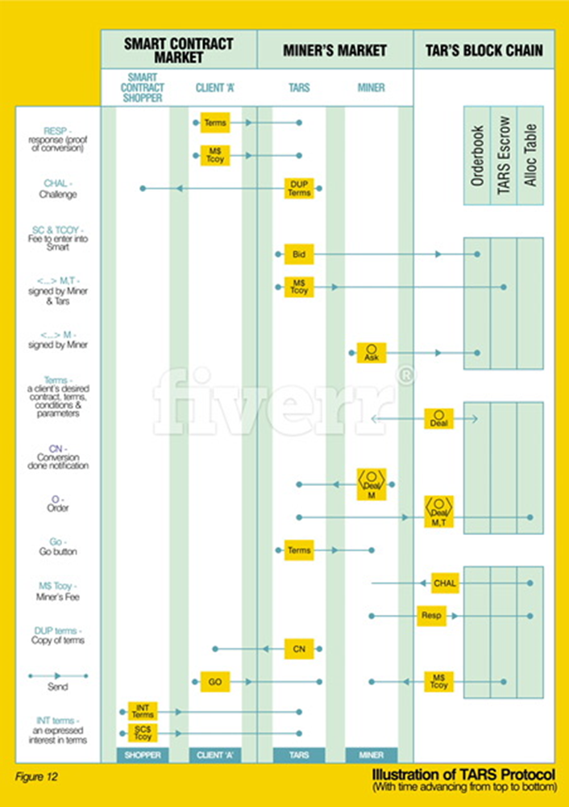

#### 2.3.3. (A) Decentralized Miner Network (DMN)

The DMN aggregates form translation services offered by Miners, self-coordinates to provide these services, and self-verifies the operations carried out by individual parties.

Self-coordination occurs using two command protocols:

* PUT (conversion): Clients execute the Put protocol to have their desired contract terms converted into an appropriate programming language
* MANAGE ( ): the network coordinates to control the available conversion services, audit these services, and repair possible faults.

Management Faults are caused by participants in the MANAGED protocol. The DMN relies on this protocol’s fault tolerance, so violating or exceeding this fault tolerance negatively disrupts the DMN. (The TARS Protocol designers have set the number of faults that can be tolerated.)

##### 2.3.3. (A).1. DMN Properties

The DMN requires that for each successful Put, the network of Miners can generate and verify a proof to prove that the client’s desired contract terms have in fact been translated into a smart contract, and that Miners are rewarded for successfully offering these translation services.

#### 2.3.3. (B) Proof-of-Conversion

Miners are paid to translate client’s desired contract terms into smart contract compatible programming language. They must prove that they’ve done such translation or converting by generating Proof-of-Conversion, which gets verified after the miner submits the proof into the blockchain.

Said clients and any other Miner, TARS user or TARS visitor can verify the integrity of the translation by finding these proofs on the blockchain if they so choose.

To initiate this verification process, the DMN automatically issues what’s known as a challenge to the Miner from the blockchain as soon as the Miner claims to have completed a translation/conversion. The Miner responds to this challenge by transmitting a small constant sample of converted terms that get verified by the DMN via the MANAGE protocol (this transmission is the Proof-of-Conversion).

This represents the mechanics of the Proof-of-Conversion process.

#### 2.3.3. (C) PSCM (continued)

As previously stated, the PSCM is whose TARS users request translation services and whose Miners offer said services in exchange for TARSCoin. On PSCM, TARS submits an order called a bid order to the TARS blockchain on behalf of a TARS user or client who has requested to have their desired contract terns converted into a smart contract.

Simultaneously, Miners who provide such service submit what are called ask orders to the TARS blockchain making it known that they are in fact poised and willing to provide said services and fulfill any applicable bid orders from TARS. The DMN automatically matches these two market participants/orders to kickstart the actual conversion process.

TARS digital escrow algorithms and full nodes on the blockchain make sure Miners are rewarded and (clients are appropriately charged once the conversion request has been successfully fulfilled.

##### 2.3.3. (C). 1 PSCM Elements

The following components comprise the primary elements of the PSCM:

* Terms – the desired parameters within and conditions on which a client wants their smart contract to be based
* Sector – a Miner’s conversion services
* Allocation Table – Keep track of terms and their assigned sectors
* Orderbook – a set of orders
* Escrow – where consideration is held until it gets distributed to the appropriate parties.

#### 2.3.3. (D) Protocol Process Steps

(Figure 13) below depicts a general overview of the TARS Protocol process, with the client’s interface with the protocol outlined in RED.

Following (Figure 13) is a more detailed presentation of the TARS protocol process, step-by-step.

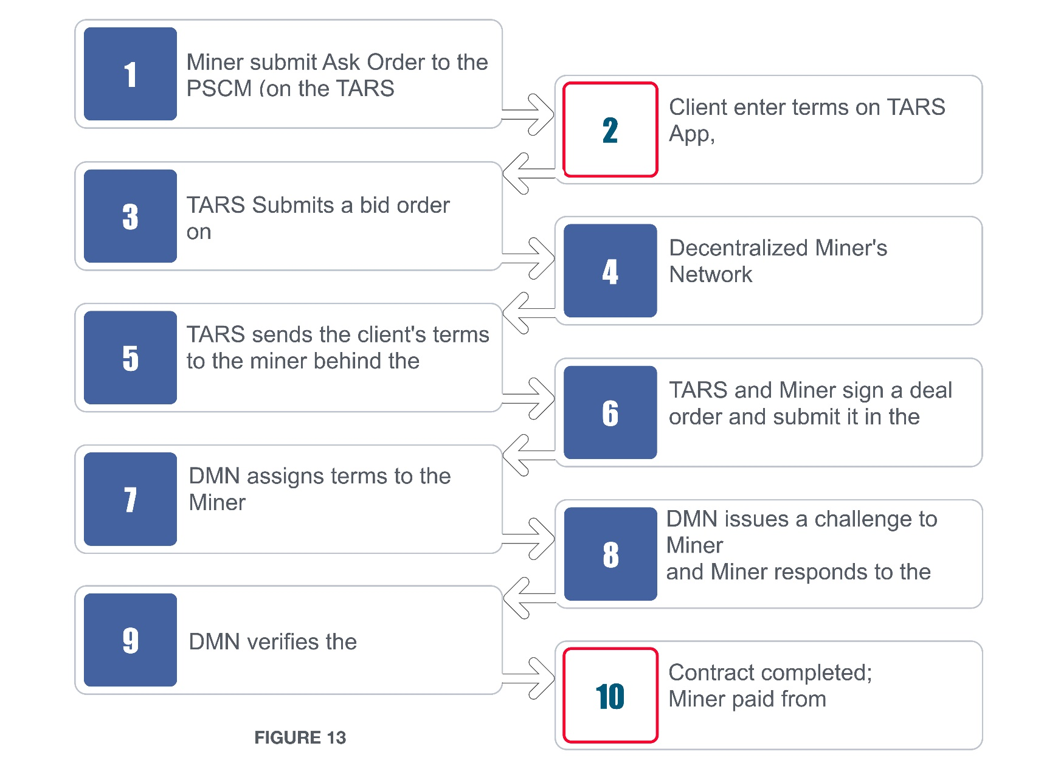

Client interface is marked in Red

1. [Sample User] enters his/her desired contract terms (+) in the TARS app
2. [Sample User] submits fee in TARSCoin, a portion of which is allocated in digital escrow to pay the Miner when the time to do so arrives.
3. [Sample User] press the **CONVERT** button/icon.
4. The Convert button / icon is interpreted by TARS’ algorithm as a command to list the [Sample User]’s terms on the Smart Contract Market and to automatically submit a bid order (Obid) to the PSCM Orderbook which initiates the Put protocol. (The Obid is the [Sample User]’s request for contract creation services expressed) in algorithm terms.)
5. Simultaneously and separately from this activity, independent Miners have been adding Ask orders (Oask) to the PSCM Orderbook, offering their contract creation services in exchange for TARSCoin via Put.AddOrders. After [Sample User] pushes the CONVERT button and after [Sample User]’s Obid is submitted, the DMN matches one Miner’s Oask to the [Sample User]’s Obid by running Put.MatchOrders.
6. When the orders are matched, TARS sends [Sample User]’s terms to the Miner by running Put.SendTerms (Obid, +) and the Miner receives these terms by running Put.ReceiveTerms (Oask, +).
7. When the Miner receives [Sample User]’s terms(+). TARS and the Miner sign a deal order (Odeal) to make the deal official, and then submit (Odeal) to the TARS blockchain to confirm that the exchange of terms(+) has succeeded.
8. [Sample User]’s terms are assigned to the Miner’s sector (the DMN keeps track of each Miner’s sector via the AllocTable). The DMN does this automatically via MANAGE. AssignOrders (Odeal).
9. Once a Miner is assigned terms the Miner translates the terms into smart contract compatible programming language and then generates Proof-of-Conversion to prove that the translation has been done. The proofs are posted on the blockchain for the DMN to verify. This process occurs when the Miner runs MANAGE. ProveSector.
10. The DMN checks to see if the proofs are present and valid. If a proof is missing or invalid, the process fails, and it reverts back to step 5 where a long series of successive Mines fail to submit proofs or continuously submit invalid proofs then [Sample User]’s terms are lost and [Sample User] gets refunded.) This checking process is initiated by running MANAGE.RepairOrder.
11. [Sample User] receives a CONVERSION DONE notification informing the user that the smart contract has been created according to [Sample User]’s desired terms
12. After receiving the CONVERSIONDONE notification, [Sample User] pushes or selects the GO button/icon.
13. TARS interpret the GO button / icon as a command to inform [Sample User] of any other party who has expressed interest in agreeing to [Sample User]’s terms and signing [Sample User]’s smart contract. This other party has most likely expressed such interest by selectin [Sample User]’s terms on the Smart Contract Market. (See step 4 above). The GO button / icon is also TARS’ signal to release payment to the Miner. (See Figure 5 for a graphic representation of the Smart Contract Market Page).
14. To officially agree to, sign, and enter [Sample User]’s smart contract, this other party submits a fee in TARSCoin.

### 2.3.4 Guarantees and Requirements

Through the DMV the TARS Protocol achieves integrity by naming terms after their cryptographic hash it achieves public verifiability by requiring Miners to submit proofs to the blockchain where any Miner is the DMN can verify the validity of the proofs; it achieves auditability by storing the proofs in the blockchain where they serve as a trace of operation that can be audited at any time; it achieves incentive compatibility, by rewarding Miners for effectively and quickly translating client’s terms, requiring Miners to submit proofs, and not rewarding Miners who skip proofs or submit invalid proofs.

### 2.3.5 Verifiability & Validity

**VERIFIABILITY** – The PSM (Where TARS connects clients’ terms to Miners who convert the terms into smart contracts) is verifiable. This means no single entity governs it, transactions are transparent, anyone can participate pseudonymously, Orderbooks are consistent, orders are settled, and services are executed and independently verified.

On this verifiable PSCM all orders must be made public by being submitted to the Orderbook. The Orderbook is open and public, and it’s defined as the set of currently valid and open ask, bid, and deal orders. These orders are only settled if Miners submit proof-of-conversion that are verified by the DMN. Orders are only added to the TARS blockchain if they’re valid.

**VALIDITY** – A bid is only valid if the client has the funds or other object of value in digital escrow and the time isn’t set in the past. An ask is only valid if the Miners can provide the smart contract creation service being requested. A deal is only valid if the applicable ask is in the PSCM Orderbook and no other deal orders mention it and it’s signed by the Miner, and the time isn’t set too for in the future or too far in the past.

### 2.3.6 Repurposed Mining Power

Most permission less blockchains require Miners to expend tremendous resources (i.e. machinery costs and costs associated with energy consumption) to generate useless solutions to complex mathematical problems that have a value beyond securing these particular blockchains. (On these blockchains, solving these problems creates new blocks and releases new tokens which are used to compensate the Miners.)

This is wasteful.

The TARS blockchain repurpose this wasted computing power and reduces costs associated with mining. On the TARS application, the probability that the DMN selects a Miner to create a new block (this is called the Miners voting power) is proportional to the amount of contract creation services the Miner is currently providing relative to the rest of the DMN; where a Miner gets elected to create a new block (and thus release new TARSCoin) has little to do with how much computing power the Miner can muster. This state of affairs compels Miners to streamline and scale their contract creation abilities and capacity, instead of accumulate computing strength. (Under TARS, Miner’s computing power has been repurposed and is now deployed to generate proof that translation is being provided instead of solving math problems.

On the TARS blockchain, a Miner’s power is the sum of his conversion assignments, which are public and are calculated simply by reading the blockchain. Each conversion assignment is proven by a proof-of-conversion that’s also put on the blockchain if it’s valid and verified by the DMN. Thus Miners can’t lie about the number of conversion they’re assigned, can’t deceptively, or erroneously give themselves outsized voting power and undeserved TARSCoin, and they can’t disrupt the properties of the block creation process: namely fairness and public verifiability.

## 2.4.0. TARS Security Considerations

TARS administrators consider security to be the utmost importance. They’re expended tremendous energy ensuring that TARS operate on a secure structure and with the safest possible mechanism in place for service provision. Along with bringing data and network security specialist in-house, TARS administrators have taken various precautions to prevent breaches of all types. The following 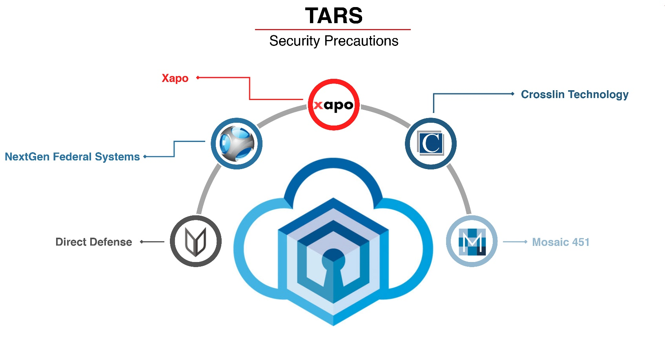additional security-related precaution have been taken in tandem with TARS’ in-house precaution:

* For storage of cryptocurrency accounts, TARS has recommended an alliance with Xapo, a provider of ultra-secure solutions for the storage of cryptocurrency accounts.
* To ensure the security of the TARS information technology network TARS shall utilize the services of Crosslin Technologies, which provides cybersecurity and risk management, litigation support, managed security systems and managed communication services.
* TARS administrators complement the services TARS requires from [Crosslin Technology](http://www.crosslintechnologies.com/) with additional services provided by [NextGen Federal Systems](https://www.nextgenfed.com/), which specializes in software development, information technology system engineering modeling and simulation, data management, and extreme cybersecurity.
* For the additional security that’s needed to protect the information gathered via TAR’s marketing efforts, TARS turns to [Direct Defense](https://www.directdefense.com/) to conduct cybersecurity assessments and to [Mosaic 451](https://www.mosaic451.com/) to erect cybersecurity and digital infrastructure defense mechanisms along with protective barriers for data accumulation.

# 3.0.0. MARKETING

The bulk of the marketing is taking place via elite cryptocurrency groups and social networks geared towards and frequented by qualified purchasers, accredited investors, crypto fund managers, and cryptocurrency zealots.

Proponents of cryptocurrency have launched many online clubs, forums, discussion groups, social media groups for the sake of proliferating on matters pertaining to digital money. These online mechanisms are currently bursting with activity, serving as communicatory hubs where people go to find out “what’s hot” and “what’s not’ in the cryptocurrency world. They are the vehicles cryptocurrency titans and celebrities use to engage with like-minded individuals. These arenas within which new initial coin offering (ICO) are revealed and discussed, within which cryptocurrency values are influenced, and through which cryptocurrency information passes before reaching the masses. These online mechanisms are also the vehicles that are being utilized to introduce TARSCoin to the world.

TARS’ Managing Director, hired by C.T.3. Holdings (London) LTD., oversees the TARSCoin initial coin offering. The Managing Director ensures TARSCoin is heavily promoted on these global cryptocurrency social platforms. Said Director actively introduces TARSCoin to individuals such as Arthur Hayes the Hong Kong based co-founder and chief of the Bitcoin Mercantile Exchange, as well as to other supporters in the potential of digital money.

TARS administrators analyze data pertaining to cryptocurrency users, enhancing the relevance of TARS marketing efforts. (TARS administrators will make arrangements to outsource this analysis to Gimbal, Inc.) Said administrators shall optimize TARS mobile application, TARS administrators have started to make additional arrangements to secure the services of Liftoff Inc. and a team of strategist data scientists, and digital marketing agency such as Mabbly (who provides full-service digital branding).

Social media marketing maybe partially outsourced to Mutesiux and LinkedSelling.

# 4.0.0. STAFFING and MANGEMENT

The specific identities of TARS administrators and of the members of the TARS Advisory Committee shall remain private until such a time that C.T.3. Holdings (London) LTD., (see Ownership Structure Section 5.0.0.) deems the revelation of said identities to be appropriate, needed, and unlikely to result in negative consequences not only for TARS and TARS affiliates but for other unrelated parties whim may or may not be affiliate with an international security provider. Such privacy has been deem warranted due to certain resolved and unresolved clandestine activity of the past and present as well as this Committee’s unconfirmed relationship with an unpredictable influencer.

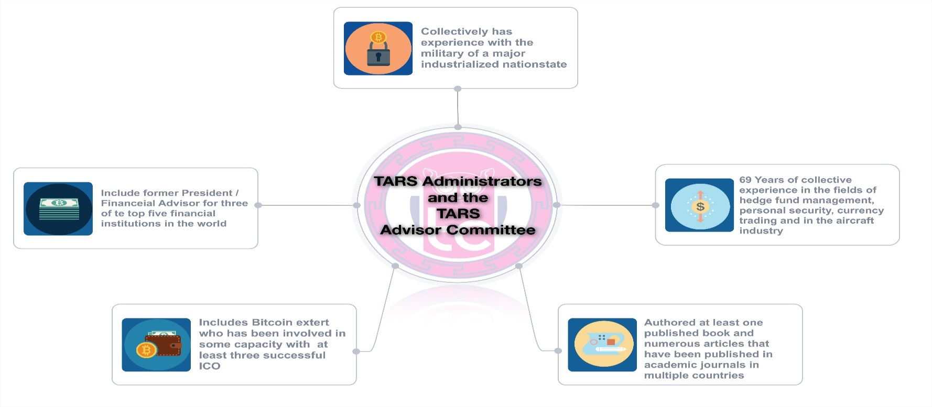Permitted disclosure regarding the TARS Advisory Committee is depicted in the following graphic representation (Figure 15).

Figure 15

## 4.1.0. Additional Human Resources Concerns

General consulting needs as they pertain to applications and information technology, are met by Aspirent Consulting.

Secure supplementary services have been arranged to be acquired from Venezuela-based The Special Us. These supplementary services include webpage design, app development, and information technology network maintenance as well as computer programming.

(The Social Us is a contingency plan in the event that the minimum crowdsale goal is not reached. To minimize cost associated with Venezuela’s rigid foreign exchange controls and the risks associated with the Bolivar compensation-related issues pertaining to The Social Us will be addressed using TARSCoin.)

## 4.2.0. International Component

TARS’ international concerns are addressed in tandem with the following service providers:

* Globalization Partners – This firm offers a suite of services that minimizes the costs and risk of global expansion, easing the hiring of international employees, and managing international payroll (which is mostly TARSCoin based).
* LingPerfect Translations – offers translation services including interpreters technical, medical, and legal document translations, voice-overs (for displays presentations, and tutorials on the TARS application) and localization.

Securing the services of such firms has facilitated TARS’ overseas operation.

# 

# 5.0.0. OWNERSHIP STRUCTURE

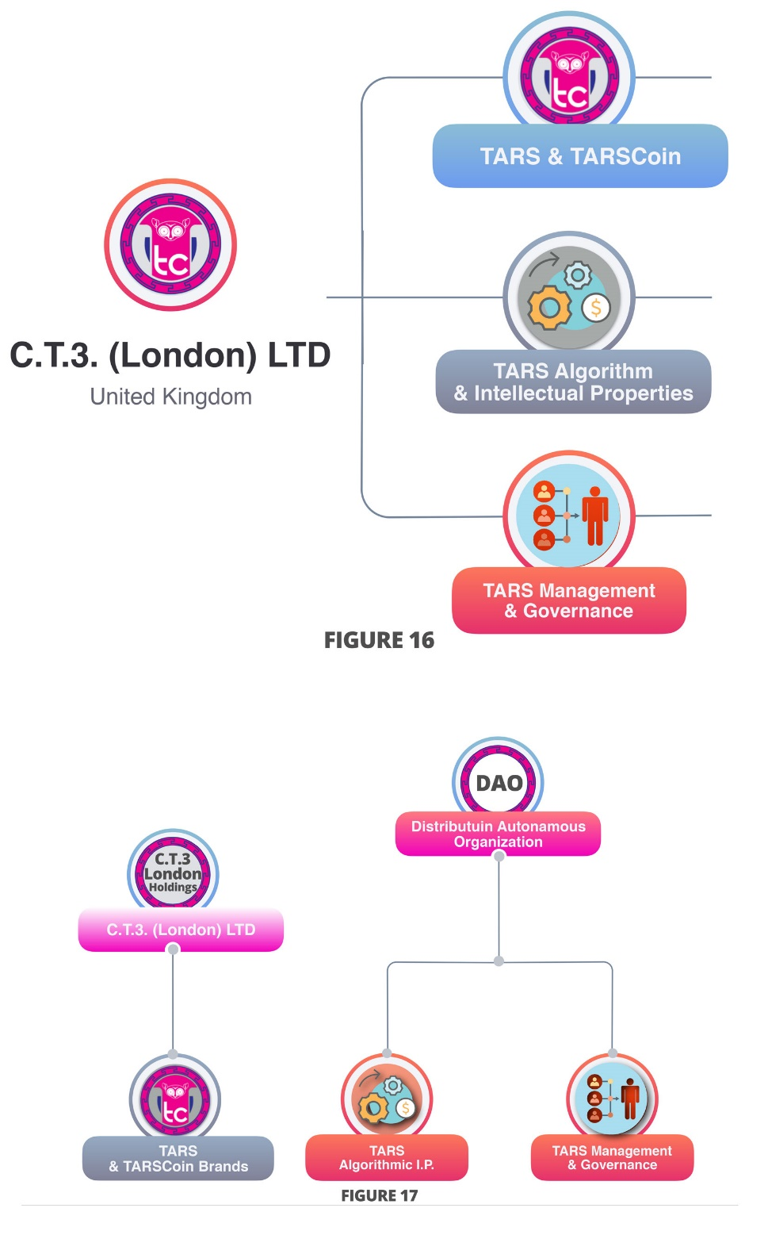All intellectual property, the rights to such property, names, patents, trademarks, logos, brand extensions, assets, copyrights, and any other items, ideas, or entities officially associated with or stemming from TARS or TARSCoin as brand, as cyber abstractions, as programs, or as currency are owned by (T3 Holdings, a United Kingdom based limited liability entity. (This is represented by the organization chart in Figure 16.) C.T.3.Holdings (London) LTD., is manager-managed and it overseas and is responsible for TARS general management and governance as well all other TARS and TARSCoin – related activity.

TARS administrators are also considering the eventual migration of TARS general management and governance as well as pertinent components of TARS intellectual property to a Distribution Autonomous Organization (DAO) such a migration (a visual of the resulting ownership structure is presented in Figure 17) would empower TARS users with direct influence and control over the network and its further development.

In the absence of this migration, TARS social and cryptocurrency application is and will be the exclusive property of C.T.3. Holdings (London) LTD. Access to the TARS application and/or to its inner proprietary mechanism is and will be dictated, granted, and/or restricted as explained in this text or at the sale discretion of, or unless and until otherwise determined by TARS administrators.

# 6.0.0. UNABRIDGED DISCLAIMER

## 6.1.0. General Information

In order to fund the development of the TARS ecosystem, TARSCoin will be sold to the public. TARSCoin is a digital token which will allow the user to access the services provided on the TARS application. Users who intend to purchase TARSCoin are subjected to acceptance of the general terms and condition presented in this text.

TARSCoin does not have legal qualification as a security since it does not give any rights to dividends or interests. TARSCoin are not shares and do not give any right to participate in any general meetings of TARS administrators. TARSCoin shall therefore not be used or purchased for speculative or investment purposes. TarsCoin will not be listed on any regular stock exchange. Neither this whitepaper nor any other material related to the TARSCoin initial coin offering, TARS, or TARS-related activity will be or have been filed with regard to legal standards such as the Federal Act on Stock Exchanges and Security Trading Law, the Financial Market Infrastructure Act, and/or the Collective Investment Schemes Act. Neither of these are applicable to this token sale. Therefore, laws and Acts that ensure investors are sold investments that include all proper disclosure are subject to regulatory scrutiny for the investor’s protection, are not applicable in this case. Every purchaser of TARSCoin should receive proper advice in order to understand whether the purchase of TARSCoin is appropriate for him/her or not.

Anyone purchasing TARSCoin expressly acknowledges and represents that (s) he has carefully reviewed this whitepaper and fully understand the risk, costs, and benefits associated with the purchase of this token.

## 6.2.0. Requisite Awareness

The purchaser of TARSCoin undertakes that (s)he understands and has significant awareness of cryptocurrencies, blockchain systems and services and that (s)he fully understands the risks associated with the crowdsale as well as the mechanisms related to the use of cryptocurrencies on the TARS application.

TARS shall not be responsible for any loss of TARSCoin or for any situations making it impossible to access TARSCoin which may result from any actions or omissions of the user or any person undertaking to acquire TARSCoin as well as from hacker attacks.

## 6.3.0 Risks

Acquiring and storing TARSCoin involves various risks, in particular the risk that TARS may not be able to launch operations develop its blockchain and provide the services promised. Therefore, and prior to acquiring TARSCoin, any user should carefully consider the risks, costs, and benefits of acquiring TARSCoin in the context of the crowdsale and, if necessary, obtain any independent advice in the regard. Any interested person who is not in the position to accept or to understand the risks associated with the activity (include the risks related to the non-development of the TARS application or any other risks associated with the crowdsale) as indicated or implied at any point in this txt should not acquire TARSCoin.

## 6.4.0 Conclusive Information

This whitepaper shall not and cannot be considered as an invitation to enter into an investment. It does not constitute or relate in any way nor should it be considered as an offering of securities in any jurisdiction. This white paper does not include or contain any information or indication that might be considered as a recommendation or that might be used as a basis for any investment decision. TARSCoin are utility token which can be used only in the TARS application and are not intended to be used as an investment.

The offering of TARSCoin on a trading platform is done in order to allow the use of the TARS application and not for speculative purposes. The offering of TARSCoin on a trading platform does not change the legal qualification of the token, which remain a simple means for the user of TARS application and are not a security.

Any information in this whitepaper is provided for general information purposes only and TARS does not provide any warranty as to the accuracy and completeness of this information.

Acquiring TARSCoin shall not grant any right or influence over TARS’ organization and governance to the purchasers.

Regulatory authorities are carefully scrutinizing businesses and operations associated to cryptocurrencies in the world. In that respect, regulatory measures, investigations or actions may impact TARS business and even limit or prevent it from developing its operations in the future. Any person undertaking to acquire TARSCoin should be aware of the TARS business model and should know that this whitepaper may change or need to be modified because of new regulatory and compliance requirements issued by any applicable laws in any applicable jurisdictions. In such a case, purchases and anyone undertaking to acquire TARSCoin acknowledge and understand that neither TARS nor any of its affiliates shall be held liable for any direct or indirect loss or damage caused by such changes.

TARS will do its utmost to launch its operations and develop the TARS application. Anyone undertaking to acquire TARSCoin tokens acknowledges and understands that TARS does not provide any guarantee that it will manage to achieve it. They acknowledge and understand therefore that TARS (include its bodies and employee’s) assumes no liability or responsibility for any loss or damage that would result or relate to the incapacity to use TARSCoin.

# 7.0.0. REPRESENTATION AND WARRANTIES

By participating in crowdsale, the purchaser agrees to the above and in particular, they represent and warrant that they:

* Are authorized and have full power to purchase TARSCoin according to the laws that apply in their jurisdiction of domicile;
* Are not legally restricted from acquiring TARSCoin due to their citizenship according to U.K. laws;
* Live in a jurisdiction which allow TARS to sell TARSCoin through a crowdsale without requiring any local authorization;
* Are familiar with all related regulations in the specific jurisdiction in which they are based and that purchasing cryptographic tokens in that jurisdiction is not prohibited, restricted or subject to additional conditions of any kind;
* Will not use the crowdsale for any illegal activity, including but not limit to money laundering and the financing of terrorism;
* Have sufficient knowledge about the nature of the cryptographic tokens and have significant experience with, and functional understanding of the usage and intricacies of dealing with cryptographic tokens and currencies and blockchain-based systems and services;
* Purchase TARSCoin because they wish to have access to the TARS application;
* Are not purchasing TARSCoin for the purpose of speculative investment or usage.

# 8.0.0. GOVERNING LAW AND ARBITRATION

The client acknowledges and accepts that the TARSCoin initial coin offering operation is taking place within an English legal environment that is still under development. The parties agree to seek an amicable settlement, prior to bringing any legal action. All disputes arising with the whitepaper provided shall be resolved by arbitration, in accordance with the English law in force on the date when the Notice of Arbitration is submitted in accordance with these rules. The arbitration panel shall consist of one arbitrator only. The seat of the arbitration shall be in the United Kingdom. The arbitral proceeding shall be conducted in English.

1. TARS deploy the code of Shapshift.io to facilitate easy oscillation between tokens of cryptocurrencies without hassle and without any lengthy registration. This will remain in effect until TARS can find the development of a streamlined and user-friendly version of the ShapeShift.io application.
2. Accessing the TARS Alpha Investor Relations Page (AIRP) and taking the appropriate action grants TARS users the opportunity to attend the annual TARS meeting. Accessing the TARS AIRP costs 2,000 TARSCoin at the initial coin offering price.