Phase 1: Problem Understanding & Industry Analysis

Consumer Goods Distributor Partner Portal (Salesforce Experience Cloud)

**Executive Summary :**

This document captures the initial understanding and analysis for building a Salesforce Experience Cloud Partner Portal designed for consumer goods distributors. It outlines business requirements, stakeholder roles, key processes, industry context, existing Salesforce solutions, risks, and success criteria that will guide the project’s subsequent phases.

# Requirement Gathering

**Project Objective:** Develop a secure partner portal to enable consumer goods distributors to place and track orders, access real-time inventory and pricing, manage support cases, receive notifications, and have role-based visibility.

Key Features:

* Partner login and secure access
* Real-time inventory and pricing visibility
* Order placement & tracking funtionality
* Support case management System
* Automated Notifications & alerts
* Role-based access controls for different user profiles

# Stakeholder Analysis

|  |  |  |
| --- | --- | --- |
| **Stakeholder** | **Role** | **Responsibilities** |
| Distributor  Partner | Portal User | Place orders, track inventory, raise support  cases |
| Sales Manager | Internal User | Approve/reject orders, monitor sales metrics |
| Support Team | Internal User | Manage and resolve support cases |
| Project Manager | Internal Admin | Validate requirements, oversee delivery |

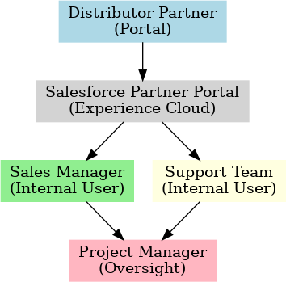

**Business Process Mapping**

Distributor logs into portal → views product catalog and inventory

→ places order → order approval by Sales Manager (optional) → order fulfillment → order status updates sent to distributor → distributor raises support cases as necessary → cases managed by Support Team

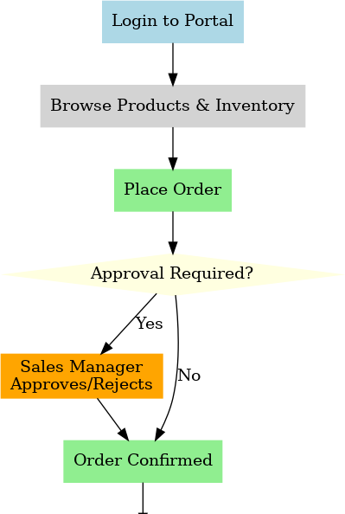

Business Process Flow

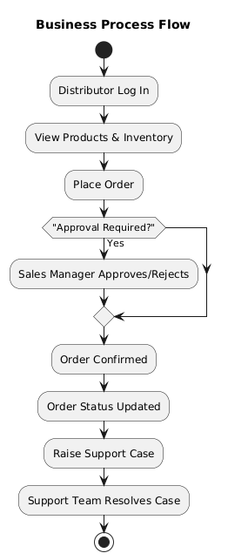

# Industry-Specific Use Case Analysis

Consumer goods portals significantly streamline order accuracy and processing time, improve distributor engagement, and enhance supply chain transparency. Leading brands such as Unilever and P&G leverage Salesforce Experience Cloud solutions for these efficiencies.

# AppExchange Exploration

|  |  |  |
| --- | --- | --- |
| **App Name** | **Description** | **Relevance** |
| Salesforce Partner  Community | Standard partner portal frame-  work | Provides foundational portal features |
| Zimit Partner Man-  agement | Deal registration, lead  distribution | Offers advanced Partner Relationship Management features |
| Impartner PRM | Enterprise-grade partner management | Provides onboarding &  Training Modules |

**Risks and Constraints**

* Ensuring strong security measures (MFA, sharing rules) for external users
* Integration complexity with backend ERP systems for accurate inventory sync
* Partner adoption and training challenges
* Licensing costs and limitations for advanced PRM apps

# Success Criteria

* Distributors place & track orders independently
* SLA: Support cases resolved within 48 hours
* 95% adoption by distributors
* Sales Managers track performance via dashboards