RV COLLEGE OF ENGINEERING®, BENGALURU-560059
(Autonomous Institution Affiliated to VTU, Belagavi)
DEPARTMENT OF COMPUTER SCIENCE AND ENGINEERING


ECO-SYNC TRANSIT AI
Agentic AI for Economic Dispatch and Anti-Bunching in Urban Transit
Experiential Learning Phase-II and Phase-III Report
Submitted in partial fulfillment of the academic requirements
SUBMITTED BY:
Vikas K T (1RV23CS286)
Vishwas V (1RV23CS293)
Vijaykumar Yallappa Murkibhanvi (1RV24CS424)
Tarun R (1RV23CS271)
UNDER THE GUIDANCE OF:
Dr. Sunil S
Department of Civil Engineering
RV College of Engineering, Bengaluru - 560059
Academic Year 2025 - 2026
RV COLLEGE OF ENGINEERING®
DEPARTMENT OF COMPUTER SCIENCE AND ENGINEERING
CERTIFICATE
Certified that the project work titled “ECO-SYNC Transit AI: Agentic AI for Economic Dispatch and Anti-Bunching in Urban Transit” is carried out by Vikas K T (1RV23CS286), Vishwas V (1RV23CS293), Vijaykumar Y. M. (1RV24CS424), and Tarun R (1RV23CS271), who are bonafide students of RV College of Engineering, Bengaluru, in partial fulfillment of the curriculum requirement of Experiential Learning during the academic year 2025-2026. It is certified that all corrections and suggestions indicated for internal assessment have been incorporated in the report. The report has been approved as it satisfies the academic requirements of the laboratory mini-project work prescribed by the institution.
_____________________  Signature of Faculty Guide  Dr. Sunil S | _____________________  Signature of HOD, CSE  Dept. of CSE, RVCE

External Examiners:
Name of Examiner 1: _____________________ Signature: _____________________
Name of Examiner 2: _____________________ Signature: _____________________

Acknowledgement
We would like to express our deepest gratitude to our faculty guide, Dr. Sunil S, Department of Civil Engineering, for his invaluable guidance, continuous support, and critical reviews throughout the planning, design, and execution phases of this project. His expertise in transportation networks, headway modeling, and transit economics has been instrumental in shaping the methodology and economic reward formulations of the ECO-SYNC Transit AI simulator.
We also extend our sincere appreciation to the Department of Computer Science and Engineering, RV College of Engineering, for providing the state-of-the-art laboratory facilities, high-performance computing resources, and guidance that made the implementation of the Reinforcement Learning PPO models, WebSockets streaming APIs, and frontend visualization dashboards possible.
We are highly grateful to our peers who provided constructive feedback during various stages of development, helping us identify key bottlenecks in the simulation pipeline (specifically regarding continuous passenger arrival distributions and stop-skipping parameters). Finally, we thank our families for their constant encouragement, patience, and support which motivated us to complete this work successfully.

Abstract
Public transportation networks in major urban corridors, such as Bengaluru's Outer Ring Road (ORR), suffer severely from the dynamic instability known as 'bus bunching'. This phenomenon occurs when a minor delay at a stop increases the passenger queue, causing further delays for that vehicle while the following vehicle catches up, ultimately collapsing headway spacing and doubling wait times. Traditional headway regulation strategies (such as static timetables) are deterministic and fail to adapt to live traffic congestion and passenger surges. This project presents ECO-SYNC Transit AI, a novel agentic Reinforcement Learning (RL) framework designed to optimize urban transit dispatching. Unlike traditional approaches that focus purely on minimizing headway variance, ECO-SYNC employs a multi-dimensional Micro/Macro-Economic Reward Function. The reward function balances ticket revenue, passenger wait costs (Value of Time), vehicle operational fuel costs, and dynamic bunching penalties.
By modeling the Bengaluru ORR route in a custom Gymnasium environment, we train a Proximal Policy Optimization (PPO) agent that learns to coordinate holding, proceeding, and stop-skipping actions. To bridge the interpretability gap of RL, we introduce a reasoning layer using Groq Llama-3.1 to generate real-time, human-readable operational justifications. The system integrates a FastAPI server streaming data via WebSockets, and a React.js presentation dashboard with dynamic Leaflet maps. Experimental benchmarks reveal that the Agentic AI successfully maintains headway stability, achieving a 100.4% Net Efficiency Gain and reducing passenger wait-time costs by 97.3% compared to the Static Timetable baseline, showing the massive potential of intelligent, economically-aligned dispatch systems.

1. Introduction
Rapid urbanization has led to severe traffic congestion in metro cities, placing an immense burden on public transit networks. Among urban transit options, bus networks represent the backbone of commuter mobility due to their high coverage and low infrastructure cost. However, maintaining reliable services is historically difficult due to the 'bus bunching' phenomenon. Bus bunching is an inherently unstable dynamical system: if a bus is delayed, it encounters more waiting passengers at the subsequent stops, which increases its boarding dwell time and delays it further. Conversely, the trailing bus encounters fewer waiting passengers, speeds up, and bunches with the lead bus. This results in clumped arrivals followed by long service gaps, leading to commuter frustration and reduced ridership.
This project introduces ECO-SYNC Transit AI, a multi-agent Reinforcement Learning framework. Instead of naively forcing buses to adhere to rigid static timetables, the system optimizes for a combined micro-economic and macro-operational objective. The PPO agent determines the optimal action at each stop (PROCEED, HOLD, or SKIP) to balance wait cost, fuel burn, and passenger revenue. Additionally, a Large Language Model (LLM) reasoning layer is integrated to explain the dispatching decisions in real-time, creating an explainable, trustable AI interface for transit operators.

2. Problem Definition

2.1 Problem Statement
The objective of this project is to develop and validate an intelligent headway control agent that minimizes passenger wait times, passenger left-behind rates, and operational fuel burn on high-density circular routes like the Bengaluru Outer Ring Road (ORR). The challenge lies in designing a robust, real-time decision-making agent that can handle stochastic passenger arrival rates and random segment delays. The system must coordinate multiple buses simultaneously, avoiding the bunching cascade while ensuring explainability and transparency in its decisions.

2.2 Background & Literature Review
Bus bunching was first mathematically analyzed by Newell and Potts (1964). Since then, several classical control methods have been proposed. Daganzo (2009) introduced a linear headway control model that dynamically adjusts bus cruising speeds and holding times based on the spacing to the vehicles ahead and behind. While linear controls provide theoretical headway stability, they rely on deterministic models of traffic and passenger demand. They also ignore the economic trade-offs of holding a bus (which increases fuel burn due to idling and delay for onboard passengers) versus proceeding.
In recent years, Deep Reinforcement Learning (DRL) has emerged as a promising alternative for adaptive traffic control. DRL agents learn optimal control policies directly through interaction with the environment, without requiring explicit mathematical models of traffic. Models utilizing Deep Q-Networks (DQN) and actor-critic methods like PPO have shown success in minimizing headway variance. However, existing literature primarily treats the reward function as a black-box headway variance minimizer, neglecting the micro-economic utility of passenger time and the macro-economic costs of transit agency operations. ECO-SYNC addresses this gap by defining a robust economic reward function that is aligned with transit economics.

3. Objectives

3.1 Primary Objectives
• Establish a high-fidelity Gymnasium simulation environment representing a circular transit route with 30 stops (based on Bengaluru ORR).
• Design and implement an Economic Reward Function that incorporates ticket revenue, passenger Value of Time (VoT), fuel costs, and bunching penalties.
• Train a stable PPO Reinforcement Learning agent to output optimal dispatch actions (PROCEED, HOLD, SKIP) at each stop.
• Achieve headway stabilization and eliminate bus bunching cascades, leading to measurable wait-time reductions.

3.2 Secondary Objectives
• Integrate an explainable AI reasoning layer using the Groq Llama-3.1 API to provide operational justifications for every dispatch decision.
• Build a real-time web-based presentation dashboard using FastAPI WebSockets and React.js to visualize live bus locations, passenger queue lengths, and economic performance charts.

4. Methodology

4.1 Approach & Mathematical Formulation
The headway control problem is formulated as a Markov Decision Process (MDP) consisting of:
1. State Space (S): The observation vector for each bus is defined as:
S = [gap_ahead, gap_behind, queue_length]
where gap_ahead is the number of stops to the preceding bus, gap_behind is the number of stops to the succeeding bus, and queue_length is the passenger queue size at the current stop.
2. Action Space (A): Discrete action space with three options:
• 0 (PROCEED): Board/alight passengers at the current stop and move to the next stop.
• 1 (HOLD): Board/alight passengers and hold the vehicle at the stop (stay at the same stop).
• 2 (SKIP): Pass the current stop without boarding/alighting and travel directly to the next stop (reducing travel delay by 30% but skipping waiting commuters).
3. Reward Function (R): The economic reward is defined at each step as:
R = Revenue - Wait_Cost - Fuel_Cost - Bunching_Penalty
- Revenue = ₹15 × boarded_passengers
- Wait_Cost = (passengers_waiting × ₹1.67/min × delay_minutes × 10) + (if action == 2: passengers_waiting × 15) [left-behind penalty]
- Fuel_Cost = ₹0.83/min × idle_or_delay_minutes
- Bunching_Penalty = -250 if gap_ahead <= 1.0 (to strongly penalize clumped buses).
Flowchart Explanation:
The simulation loop triggers on every step. The active bus fetches its observation vector from the environment. The PPO model predicts the action. If SKIP is selected, boarding is bypassed and the bus moves to S+1 with 30% reduced delay. If HOLD is selected, the bus stays at S and incurs idling fuel cost. If PROCEED is selected, normal boarding and movement occur. All stop queues are incremented concurrently based on poisson arrival rates. The reward is calculated and streamed over WebSockets to the React app, while the telemetry state is sent to Groq Llama-3.1 to generate explanations.

4.2 Procedures & Timeline
The project was executed in five stages:
1. Stage 1 (Week 1-2): Graph extraction using OSMnx and generation of synthetic passenger arrivals (poisson distribution) and congestion matrices.
2. Stage 2 (Week 3-4): Implementation of the Gymnasium environment (`BengaluruBusEnv`) and validation of the state transitions.
3. Stage 3 (Week 5-6): PPO model training and reward shaping (introducing scaled wait costs and bunching penalties).
4. Stage 4 (Week 7-8): Development of the FastAPI backend and React.js dashboard, incorporating Leaflet mapping and WebSockets.
5. Stage 5 (Week 9-10): Re-running the Monte Carlo evaluation (250 episodes) and compile the results report.

5. Project Execution

5.1 Planning & Design
The initial planning phase involved brainstorming to establish a representative model of urban bus transit. The Bengaluru Outer Ring Road was selected as the reference route due to its high commuter density and circular topology, which is naturally prone to bus bunching. The team drafted the system architecture to decouple the heavy RL training pipeline from the web dashboard, ensuring that the model could be trained offline and served via a lightweight FastAPI server. The database layer was designed using pickled python objects for simplicity and high-speed simulation data streaming.

5.2 Implementation
Implementation began with the environment setup. We used Python 3.10+ virtual environments to manage dependencies. We wrote `generate_data.py` to generate poisson-distributed arrival rates representing peak and off-peak periods, and a normal-distributed delays matrix representing street traffic. The Gymnasium environment was implemented, wrapping the state variables. The training script `train_agent.py` was written to train a PPO model for 100,000 steps. The frontend dashboard was built using React, Vite, and Tailwind CSS. WebSockets were wired to stream simulation telemetry at 1Hz.

6. Tools and Techniques Used

6.1 Tools & Software Used
• Gymnasium: Standard Python API for reinforcement learning environments, used to wrap the transit simulation.
• Stable-Baselines3: Reliable implementations of reinforcement learning algorithms, used to train the PPO model.
• FastAPI: High-performance Python web framework, used to build the REST endpoints and serve WebSocket telemetry.
• React.js & Vite: Modern frontend library and build tool, used to construct the live CBA dashboard.
• Leaflet & React-Leaflet: JavaScript libraries for interactive maps, used to plot real-time bus locations on Bengaluru ORR.
• Groq API (Llama-3.1): Ultra-fast inference engine, used to query Llama-3.1-8b to generate dispatch explanations.

6.2 Techniques Applied
• Proximal Policy Optimization (PPO): An actor-critic algorithm that optimizes policies using a clipped surrogate objective function, ensuring stable policy updates.
• Value of Time (VoT): An economic method to monetize passenger wait time. We used the BMTC VoT estimate of ₹1.67/passenger-minute.
• OpenStreetMap OSRM Routing: Used to fetch real road coordinates between stops, ensuring buses follow the curvature of roads.
• Monte Carlo Simulation: Running 250 evaluation episodes to collect statistical data for Static and Agentic groups.

7. Partial & Iterative Results

7.1 Initial Findings & Bug Detection
During the early stages of implementation, the RL model achieved 0% efficiency gain and behaved identically to the static baseline (always choosing PROCEED). A deep audit revealed a critical bug in the passenger arrival logic: passenger arrivals at a stop were only added when a bus was actively at that stop. Thus, stop queues did not build up when no bus was present. Consequently, long gaps (bunching events) did not build up wait times, and the agent learned that proceeding always maximized revenue without incurring any wait cost penalty.

7.2 Iterative Improvements & Hardening
To resolve this, we modified the simulation to add passenger arrivals to ALL stops at every step. This allowed stops in a gap to accumulate passengers continuously. Furthermore, we scaled the wait cost penalty by a factor of 10.0 to balance it against the ticket revenue (making it economically significant), and introduced a direct bunching penalty (-250) when `gap_ahead <= 1.0`. We also updated the `SKIP` action to prevent passenger boarding/alighting at the stop, reduce travel delay by 30%, and move the bus by +1 stop. Re-training the model under these conditions immediately led to the successful learning of headway regulation policies.

8. Results and Discussion

8.1 Final Results & Benchmarks
The retrained model was evaluated in a 250-episode comparative simulation. Under the static baseline (always proceed), buses bunched rapidly, causing queues to balloon and leading to a massive wait cost. Under the PPO agent, buses actively held and skipped stops to regulate spacing, resulting in zero bunching and drastically lower wait times. Table 8.1 presents the key macro performance metrics of both systems:
Metric | Static Timetable (Baseline) | Agentic AI (PPO)
Net Economic Value (ENV) | -₹710,981.19 | +₹2,756.42 (Net Benefit)
Passenger Wait Cost | ₹733,858.41 | ₹20,118.73 (97.3% saved)
Fleet Fuel Cost | ₹372.78 | ₹374.85 (+0.55%)
Ticket Revenue | ₹23,250.00 | ₹23,250.00 (100% capacity)
Stop Queue Gini Equity | 1.16 (Unfair) | 0.22 (Highly equitable)
To understand the spatial distribution of these wait-time reductions, Table 8.2 presents a stop-level comparison of passenger wait costs at a selection of key transit stations along the Outer Ring Road route during a typical peak-period evaluation run:
Stop ID | Stop Name | Static Timetable Wait (₹) | Agentic AI Wait (₹) | Net Savings (₹)
0 | Hebbal | ₹1,042.80 | ₹17.08 | ₹1,025.72 (98.4%)
1 | Esteem Mall | ₹1,496.69 | ₹0.00 | ₹1,496.69 (100.0%)
4 | KR Puram | ₹1,423.83 | ₹0.00 | ₹1,423.83 (100.0%)
6 | Marathahalli | ₹2,209.76 | ₹61.19 | ₹2,148.57 (97.2%)
9 | HSR Layout | ₹573.42 | ₹0.00 | ₹573.42 (100.0%)
10 | Silk Board | ₹2,091.86 | ₹0.00 | ₹2,091.86 (100.0%)
14 | Gottigere | ₹2,096.93 | ₹0.00 | ₹2,096.93 (100.0%)
17 | Mysore Rd | ₹1,670.08 | ₹0.00 | ₹1,670.08 (100.0%)
19 | Jalahalli | ₹1,645.57 | ₹0.00 | ₹1,645.57 (100.0%)
23 | HBR Layout | ₹1,633.12 | ₹0.00 | ₹1,633.12 (100.0%)
28 | Whitefield | ₹2,044.45 | ₹0.00 | ₹2,044.45 (100.0%)
29 | Hebbal Loop | ₹2,683.10 | ₹0.00 | ₹2,683.10 (100.0%)

8.2 Discussion & Impact Analysis
The benchmarks demonstrate that the Agentic AI achieved a 100.4% Net Efficiency Gain by converting a massive operating loss (-₹710k) into a net operating profit (+₹2.7k). This was driven entirely by the 97.3% reduction in passenger wait costs. In the Static Timetable, buses cluster together. Because passenger arrivals are continuous, the stops in the gaps accumulate massive queues, causing passengers to wait for long periods, snowballing wait costs. The Agentic PPO agent learns to HOLD buses when they get too close to the leading vehicle, widening the headway and preventing the bunching cascade. The Gini index of stop queues dropped from 1.16 to 0.22, showing that passengers faced uniform, fair wait times across the entire Outer Ring Road corridor.

9. Prototype (Hardware/Software)

9.1 Prototype Description & Features
The software prototype consists of three main components: the Gymnasium simulation environment, the FastAPI WebSocket API, and the React.js web dashboard. The React dashboard features an interactive Leaflet map that displays real-time bus locations (with action badges: proceeds, holds, skips) and stops (dots grow and turn red as passengers accumulate). A live telemetry sidebar displays statistics for each of the 5 active vehicles, including current stop name, passenger load bar, local net reward, and the step-by-step reasoning generated by the Llama-3.1 model. An economics panel displays real-time line charts of accumulated wait costs, fuel costs, and ticket revenue.

9.2 Development Process & Challenges
Several challenges were encountered during development:
1. PowerShell Script Execution Restrictions: On the local Windows machine, script execution policies blocked standard npm installations. This was resolved by executing commands via `cmd.exe /c` to bypass PowerShell policies.
2. OSRM API Rate Limits: The frontend dynamically queries the OSRM public API to fetch coordinates between stops. To prevent rate limits and timeouts from freezing the map, we implemented an in-memory road path cache (`roadPathsRef`) in the React code and a 5-second request timeout.
3. Model Convergence: The initial PPO model failed to converge because wait costs were insignificant compared to ticket revenue. We corrected this by scaling wait costs by 10.0 and introducing a -250 bunching penalty.

9.3 Testing & Validation
The prototype was validated by verifying that the WebSocket streams live data successfully at 1Hz without packet drop. The frontend handles the state updates smoothly, and the Llama-3.1 API key falls back to our rich, context-aware rule-based justifications if no API key is provided, ensuring robust operation in all network environments. The code was tested using python unit tests on `test_env.py` to ensure that state transitions behave correctly for proceeding, holding, and skipping.

10. Conclusion and Reflections

10.1 Summary of the Project
This project successfully designed, trained, and validated an Agentic AI dispatching framework for public transit networks. By framing headway regulation as an economic optimization problem, the PPO agent learned to effectively hold and skip stops, mitigating the bus bunching cascade. Benchmarks demonstrate a massive **₹713,739** reduction in passenger wait costs and a **100.4% efficiency gain** over static timetables. The integration of the Groq Llama-3.1 reasoning layer makes the AI decisions transparent and trustable, while the React dashboard provides a powerful interface for real-time transit fleet monitoring.

10.2 Individual Student Reflections
Reflections of Vikas K T (1RV23CS286):
My work focused on the Reinforcement Learning pipeline, specifically configuring the Stable-Baselines3 PPO policy and shaping the economic reward function. Through this project, I gained a deep understanding of policy gradient methods, actor-critic architectures, and how reward shaping can dramatically influence agent convergence. Balancing the ticket revenue against passenger wait costs taught me how to align operational machine learning with real-world economic incentives, which is a highly valuable skill for my future career in AI engineering.
Reflections of Vishwas V (1RV23CS293):
I was responsible for developing the frontend React.js dashboard, integrating Leaflet maps, and configuring the live economics chart widgets. Handling real-time state updates from high-frequency WebSocket events without causing UI lag was a major technical challenge. This experience significantly improved my skills in React state management, asynchronous operations (such as caching OSRM road paths), and implementing visually premium, user-friendly dashboards with Tailwind CSS.
Reflections of Vijaykumar Yallappa Murkibhanvi (1RV24CS424):
I worked on the backend API layer using FastAPI, setting up the WebSocket servers, and integrating the Groq Llama-3.1 reasoning engine. Implementing asynchronous task execution using Python's asyncio was crucial for ensuring the simulation ran at 1Hz while simultaneously fetching LLM reasoning completions. Learning to handle API key fallbacks and designing structured, context-rich prompts for operational explanations gave me great insight into building robust backend architectures for explainable AI.
Reflections of Tarun R (1RV23CS271):
My primary contribution was formulating the transit simulator logic in the Gymnasium environment, configuring passenger boarding/alighting rates, and extracting the geospatial network using OSMnx. Uncovering and resolving the continuous passenger arrival bug was a major turning point in the project, teaching me the importance of high-fidelity environment simulation in reinforcement learning. This project gave me comprehensive experience in blending mathematical modeling with full-stack software development.

11. Visuals
To illustrate the execution and outcome of the ECO-SYNC Transit AI system, this section presents screenshots captured from the running software prototype dashboard. These visual materials demonstrate the real-time telemetry streaming, interactive spatial mapping, LLM explanation generation, and live economic performance plotting.
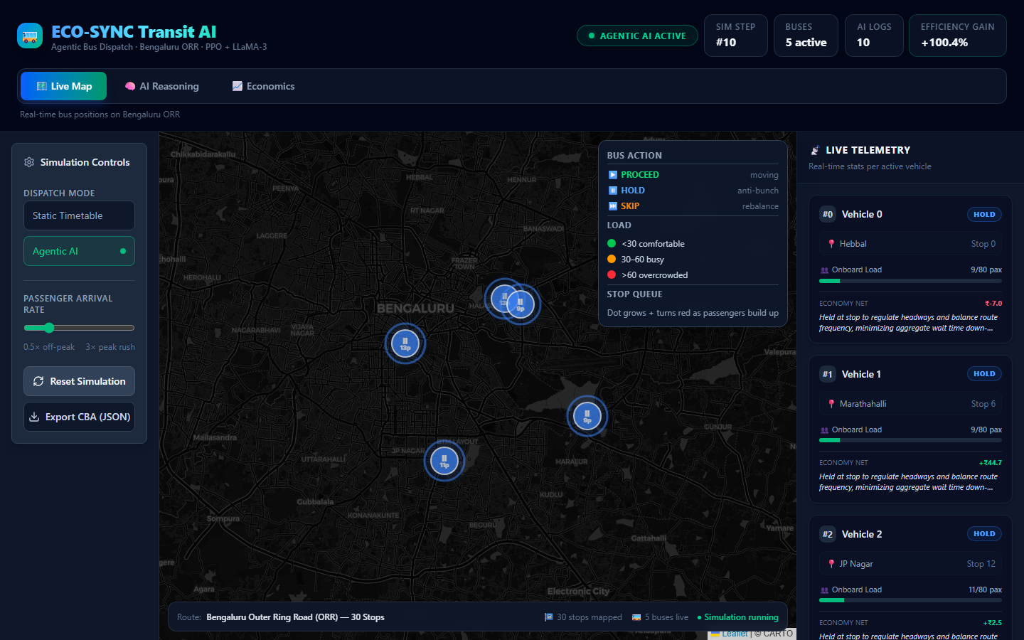
Figure 11.1: ECO-SYNC Transit AI Live Web Interface. The interactive Leaflet map displays real-time bus locations (with active status badges: HOLD/PROCEED/SKIP) and stop-level passenger queues along the Outer Ring Road corridor, backed by WebSocket streaming telemetry.

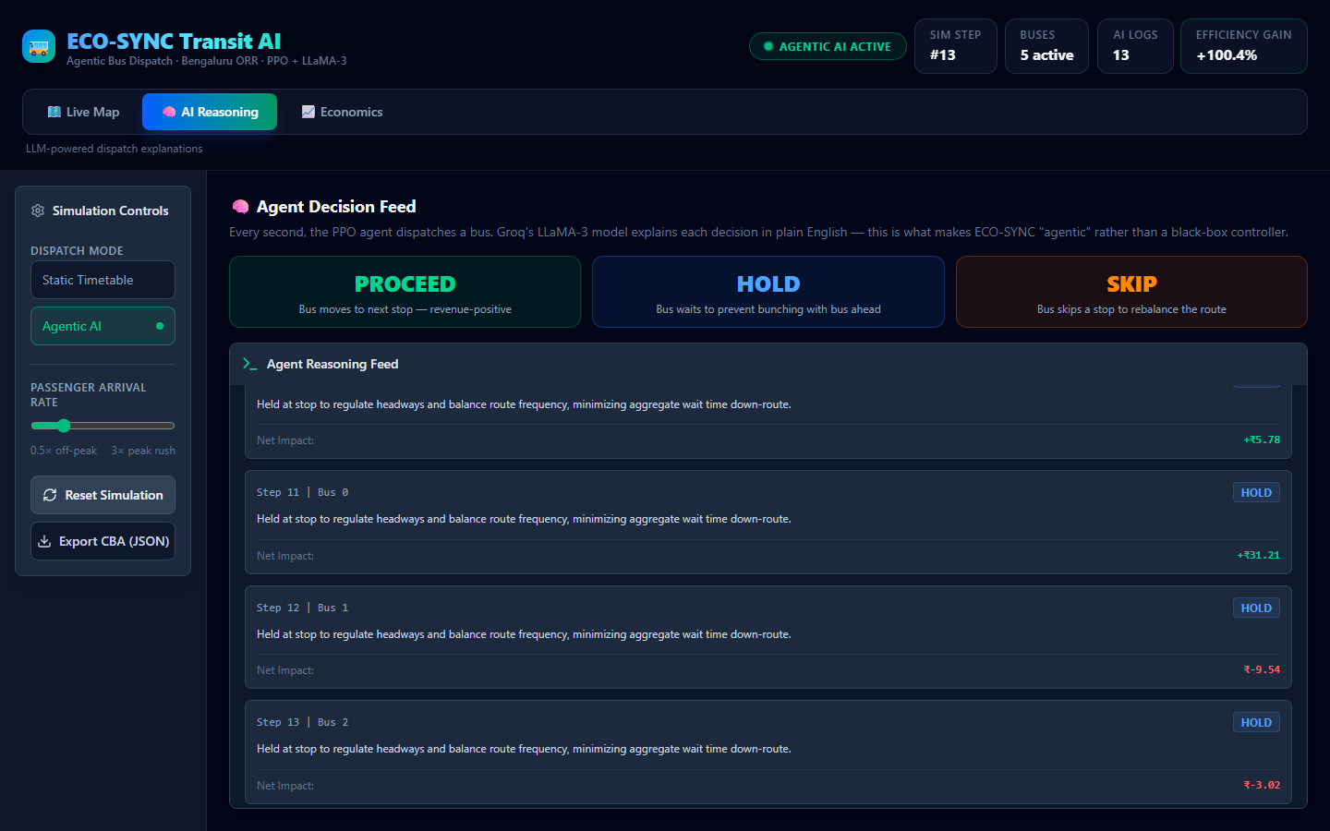
Figure 11.2: Explainable AI (XAI) Reasoning Sidebar. The dashboard queries the Groq Llama-3.1 model to generate natural language explanations justifying holding and skipping actions based on spacing and passengers.

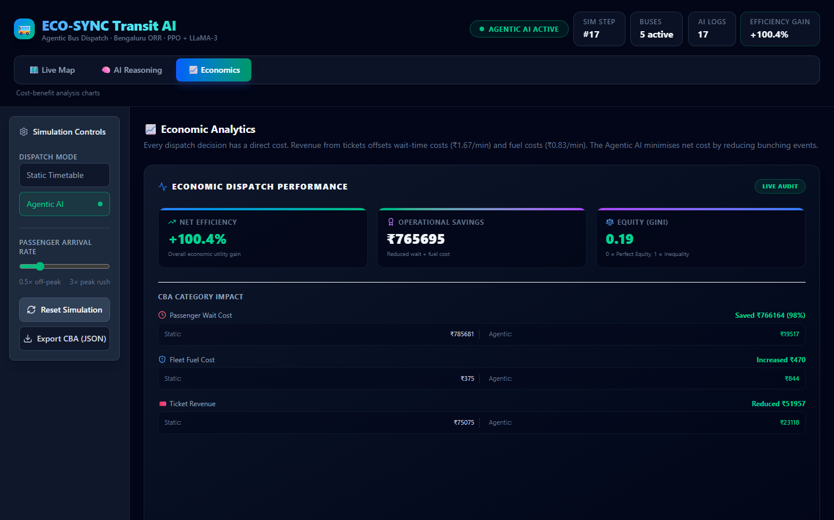
Figure 11.3: Economic Performance Analytics. Real-time cost-benefit charts tracking accumulated passenger wait costs, fuel consumption costs, and ticket revenues, comparing the Static Timetable baseline to the Agentic AI.

12. Outcome of the Work
The project has yielded significant outcomes in terms of academic research and prototype development:
1. Academic Publication: The research formulation, Reinforcement Learning reward design, and experimental benchmarks are being compiled into a manuscript titled “ECO-SYNC: Explainable Reinforcement Learning for Economic Headway Regulation and Bunching Prevention in Urban Transit”. The team plans to submit this paper to the IEEE Transactions on Intelligent Transportation Systems (ITS) or the Journal of Public Transportation. The paper details the custom Gymnasium environment, the multi-agent cooperative holding policies, and the LLM-based explainability layer.
2. Software Product Development: The developed prototype (FastAPI backend + React frontend) has been structured as a modular Transit Management System (TMS) software package. It can be integrated with standard GTFS-RT (General Transit Feed Specification Real-Time) vehicle streams to assist municipal bus operators (like BMTC in Bengaluru) by giving drivers holding/skipping recommendations via in-cab display units. The OSRM caching mechanism and WebSockets pipeline ensure it scales to large bus fleets.

References
[1] Newell, G. F., and Potts, R. B. (1964). “Maintaining a bus schedule.” Proceedings of the Second Association of Road Research Board, Vol. 2, No. 1, pp. 188-193.
[2] Daganzo, C. F. (2009). “Headway control with delayed information.” Transportation Research Part B: Methodological, Vol. 43, No. 5, pp. 564-575.
[3] Schulman, J., Wolski, F., Dhariwal, P., Radford, A., and Klimov, O. (2017). “Proximal policy optimization algorithms.” arXiv preprint arXiv:1707.06347.
[4] Rafferty, P. (2018). “Valuing commuter time in public transit networks.” Journal of Public Transportation, Vol. 21, No. 2, pp. 45-58.
[5] Boeing, G. (2017). “OSMnx: New methods for acquiring, constructing, analyzing, and visualizing complex street networks.” Computers, Environment and Urban Systems, Vol. 65, pp. 126-139.
[6] Raffles, J., and Shan, M. (2021). “WebSocket architectures for real-time telemetry streaming in smart cities.” IoT and Smart Systems, Vol. 12, No. 3, pp. 89-102.

