INVERTIS
UNIVERSITY BAREILLY
CENTER FOR SKILL AND ENTREPRENEURSHIP DEVELOPMENT
(CSED)
DATA ANALYTICS & SMART TRANSPORT SYSTEMS
PROGRAM CODE: BT_DA_24 / IIOT-4
PROGRAM NAME: B.TECH INTRO TO DATA ANALYTICS
PROJECT ID: DA-012
PROJECT NAME: Public Transport Ridership Analysis
MENTOR NAME: AMAN SINGH
LIVE DEPLOYMENT: https://public-transport-dashboard.vercel.app/

TEAM FORMATION
B.Tech (Computer Science & Engineering)
Semester: III | Group ID: BT_DA_24
Section: D | Project ID: DA-012
Program: Btech Intro to Data Analytics | Mentor Name: Aman Singh
Project Title: Public Transport Ridership Analysis | Academic Year: 2026

Sr. No. | Student ID | Roll No. | Student Name
1 | BCS2025281 | 2510303200 | GARIMA PANDEY
2 | BCS2025284 | 2510303543 | VARTIKA PATEL
3 | BCS2025285 | 2510303240 | JAYSHIV MISHRA
4 | BCS2025287 | 2510303530 | TARUN KUMAR
5 | BCS2025288 | 2510303160 | BAKHTIYAR ALI
6 | BCS2025290 | 2510303156 | AYUSH PATEL
7 | BCS2025291 | 2510303341 | NEELESH KUMAR
8 | BCS2025292 | 2510303310 | MOHAMMAD AYAN
9 | BCS2025294 | 2510303423 | RIDHIMA GUPTA
10 | BCS2025295 | 2510303336 | MUSKAN YADAV
11 | BCS2025296 | 2510303353 | NIRBHAY RAJ SINGH
12 | BCS2025297 | 2510303228 | HIMANSHU SHARMA
13 | BCS2025299 | 2510303469 | SHAHE UMAM
14 | BCS2025300 | 2510303154 | AYUSH KUMAR MISHRA

INDEX
1. Introduction | 04
2. Problem Statement | 05
3. Objective of Project | 06
4. Methodology | 07-08
5. Literature Review | 09
6. Explanation of Project (Working) | 10
7. Workflow | 11
8. Program (Complete Code) | 12-18
9. Result & Discussions | 19-24
10. Snippets of UI | 25
11. Future Scope | 26
12. Conclusion | 27

1. Introduction:
Public Transport Ridership Analysis Dashboard (TransitPulse)
Public transport analysis systems are essential components of modern smart city infrastructure and urban planning. In metropolitan transit sectors—ranging from commuter rail networks and municipal bus fleets to downtown shuttles—it is crucial to accurately analyze ridership volumes, identify peak bottleneck hours, and understand route-level demand distributions to optimize transit scheduling and enhance commuter satisfaction.
If transit congestion patterns are not detected early, transportation networks face severe overcrowding, prolonged passenger wait times, escalated fuel and maintenance costs, and irregular vehicle scheduling. Conversely, accurate and early demand modeling enables efficient fleet allocation, prevents station overcrowding, reduces idle fuel consumption, and elevates commuter quality of service. Therefore, data-driven ridership intelligence plays an indispensable role in modern municipal mobility.
Traditionally, transit planning relied on periodic manual headcounts, static survey samples, and delayed ticketing reconciliations. While helpful, these traditional approaches are labor-intensive, error-prone, and fail to capture real-time time-series dynamics across large networks. With advancements in data analytics, cloud serverless microservices, and interactive web visualization, machine learning and statistical time-series methodologies have become powerful tools for municipal transport optimization.
This project focuses on combining two fundamental engineering pillars:
- Time-Series & Moving Average Analytics: Used to evaluate continuous passenger load progressions, detect 24-hour rush-hour surges, and calculate 7-day smoothed moving trends.
- Supervised & Clustering Segmentation: Used to classify runs into peak vs. off-peak categories and cluster route/station demand tiers into high, medium, and feeder priority corridors.
By combining descriptive statistics, interactive Recharts SVG rendering, and server-side Matplotlib reporting, this system provides a comprehensive end-to-end solution for transport authorities. The integration of statistical aggregations with modern responsive UI enables transport planners to make data-backed operational decisions and improve transit reliability.

2. Problem Statement:
In modern urban transport systems, early and accurate transit demand forecasting remains a significant challenge due to the massive volume and temporal complexity of commuter activity data. Traditional transit monitoring relies heavily on manual inspections, localized ticket audits, and periodic surveys, which are time-consuming and fail to reveal non-linear commuting patterns and bottleneck time windows across complex multi-modal transit networks.
Congestion and route imbalances often build up gradually, leaving station platforms overcrowded during peak morning and evening rush hours while feeder lines remain underutilized during midday intervals. Late adjustments to bus or metro frequencies result in increased commuter frustration, safety hazards on crowded platforms, increased fleet operational overhead, and delayed emergency responses. Additionally, transit agencies face difficulties in segmenting demand corridors and allocating optimal vehicle run frequencies due to the lack of unified, centralized data-driven dashboards.
Therefore, there is an urgent need for an intelligent system that can:
- Accurately aggregate and analyze ridership trends across time, routes, and station terminals
- Assist in early detection of peak congestion windows (morning 7-10 AM and evening 5-8 PM)
- Segment and rank high-demand transit corridors and boarding terminals for fleet reallocation
- Enable interactive filtering and one-click export of structured reports in multi-sheet Excel and CSV formats
- Support transit dispatchers and urban planners in making faster, data-informed scheduling decisions
This project aims to develop a full-stack, data-driven Public Transport Ridership Analysis Dashboard (`TransitPulse`) that combines Python FastAPI, vectorized Pandas aggregations, high-resolution Matplotlib plot generation, and a responsive React (Vite) interface to deliver real-time operational insights for municipal transport networks.

3. Objective of the Project:
The primary objectives of this public transport ridership analysis project are:
- To build a deterministic data synthesis pipeline capable of generating 10,000 realistic transit records spanning 365 calendar days with dual-peak commuter windows.
- To improve transit diagnostic accuracy using data-driven algorithmic slicing instead of relying on manual surveys and static spreadsheets.
- To compute live Key Performance Indicators (KPIs) such as Total Volume, Busiest Route ID, Critical Congestion Peak Hour, and Average Day-over-Day Growth velocity.
- To perform temporal trend evaluations utilizing 7-day Simple Moving Averages (SMA) and 24-hour time-of-day progression models.
- To establish comparative peak vs. off-peak analytics evaluating vehicle trip boarding density and passenger load splits.
- To rank top-5 high-demand transit routes and passenger boarding stations for targeted fleet redeployment.
- To provide automated multi-tier data export generating clean raw CSV files, multi-sheet formatted Excel reports (openpyxl), and an indexed SQLite database.
- To design a responsive 'Dark Mode' dashboard accessible on Mobile, Tablet, and Desktop with Recharts SVG graphs and a server-side Matplotlib figure modal.
- To achieve zero-config cloud deployment on Vercel with synchronized client-server builds and zero external database requirements.

4. Methodology:
The methodology follows a systematic, multi-tiered data science and software engineering pipeline:
1. Data Collection & Synthesis
- Generated 10,000 synthetic transit activity events across 365 calendar days (Jan 1, 2026 – Dec 31, 2026).
- Synthesized 10 representative transit lines (R-101 Red Line Metro to R-110 Night Owl Bus).
- Configured 20 terminal nodes (S-01 Central Grand Station to S-20 Highland Heights).
- Modeled realistic baseline passenger loads, route popularity multipliers, and station weights.
2. Data Preprocessing & Cleaning
- Handled timestamp casting to native pandas datetime64[ns] datatypes.
- Extracted temporal features: date, hour (0-23), day_name (Monday-Sunday), and is_peak flag.
- Mapped synthetic route and station codes to standardized human-readable transit nomenclature.
- Verified zero null values, zero unindexed duplicates, and validated passenger count boundary constraints (min 5 pax).
3. Exploratory Data Analysis (EDA)
- Conducted statistical analysis in Jupyter / Google Colab (notebooks/ridership_eda.ipynb).
- Generated 24-hour hourly distributions, peak vs. off-peak volume bars, and correlation matrices.
- Quantified passenger load variance between weekday rush hours and weekend off-peak operations.
4. Feature Engineering & Mathematical Modeling
- Calculated peak multiplier M(t) reflecting 2.4x - 3.0x load increases during rush-hour intervals.
- Implemented 7-day Simple Moving Average (SMA_7) for temporal curve smoothing.
- Engineered day-over-day growth rate calculation with [-50%, +50%] clipping to prevent holiday outlier skewing.
5. Dual-Layer Visualization Architecture
- Client-Side Graphics: Recharts SVG components for animated, responsive time-series lines, peak split area curves, and donut distributions.
- Server-Side Graphics: Headless Matplotlib (Agg backend) rendering 150 DPI dark-mode PNG charts encoded in Base64 strings for modal viewing and download.
6. Storage & Export Pipeline
- Raw CSV file (data/ridership.csv) for standard data science interchange.
- Indexed SQLite database (data/database.db) with B-tree query indexes.
- Multi-sheet Excel report (data/ridership_report.xlsx) across 4 dedicated sheets using openpyxl.
7. API & Cloud Deployment
- Developed 12 REST endpoints using Python FastAPI.
- Configured vercel.json with zero-config builds routing /api/* to Python serverless runtimes and /* to Vite React SPA.

5. Literature Review:
Urban public transit analytics has been widely studied with the objective of optimizing vehicle dispatching, improving passenger satisfaction, and reducing municipal operational costs. Researchers in transport informatics have explored various statistical and machine learning techniques such as moving averages, linear regression, clustering, and deep sequence modeling (ARIMA, LSTM) to forecast commuter demand.
Statistical time-series decomposition has been extensively utilized in public transport networks due to its simplicity, speed, and interpretability. Linear Regression models help identify broad secular growth trends, while moving averages smooth high-frequency day-to-day noise. Additionally, clustering algorithms such as K-Means have been applied to group transit stations based on boarding volumes and peak congestion profiles, enabling targeted resource allocation.
Recent literature emphasizes the need for lightweight serverless microservices and client-side reactive dashboards. Traditional heavy monolithic GIS platforms are often inaccessible on mobile devices and carry substantial server hosting costs. Modern approaches combining FastAPI serverless functions with responsive React SPAs represent the state of the art in accessible, zero-maintenance transport informatics.
- Data-driven transit analytics significantly improves fleet allocation accuracy compared to static schedules.
- Moving averages and temporal slicing effectively capture recurrent morning and evening peak commuter congestion.
- Categorical clustering allows transport dispatchers to segment trunk lines from feeder routes.
- Cloud-native serverless backends eliminate infrastructure overhead while supporting real-time multi-criteria filtering.
- Combining interactive client-side charts with server-side publication plots provides complete operational flexibility.
References:
1. Vuchic, V. R. Urban Transit: Operations, Planning, and Economics. John Wiley & Sons, 2005.
2. Cats, O. and Jenelius, E. Dynamic Passenger Flow Estimation in Public Transport Networks. Transportation Research Part C, 2014.
3. McKinney, W. Data Analysis with Open Source Tools: Python & Pandas. O'Reilly Media, 2022.

6. Explanation of Project (Working):
The operational working of the TransitPulse system is structured into five distinct phases:
Step 1: Ingestion & Filter Dispatching: When a user accesses the dashboard or changes a filter (Route ID, Date Range, or Quarter Preset), the React frontend dispatches asynchronous GET requests through Axios mapped to /api/*.
Step 2: Vectorized Boolean Slicing (Pandas): The Python FastAPI backend receives the query parameters. The DataProcessor engine applies vectorized Boolean masks on datetime and route_id columns, yielding an isolated subset without modifying the master dataset.
Step 3: KPI & Aggregation Computation: The analytical engine executes Pandas aggregations to compute Total Volume, Busiest Route, Peak Congestion Hour, Day-over-Day Growth rate, and 7-day rolling moving averages.
Step 4: Dual Visualization Pipeline: For client-side rendering, processed JSON payloads are delivered to Recharts components (Line, Area, Bar, and Donut SVG graphs). For server-side rendering, Matplotlib generates 150 DPI dark-mode PNG charts in memory (io.BytesIO), converts them to Base64 strings, and transmits them for modal display.
Step 5: Export Streaming: When the user clicks 'Export CSV' or 'Export Excel', the backend dynamically generates the filtered file and streams it via Starlette Response with attachment headers directly to the user's browser.

7. Workflow:
End-to-End System Architecture Workflow
+-------------------------------------------------------------------------+
| 1. DATA LAYER (Storage & Synthesis) |
| api/data_generator.py -> ridership.csv (10k) | database.db | report.xlsx |
+------------------------------------+------------------------------------+
| Ingestion & Querying
v
+------------------------------------+------------------------------------+
| 2. ANALYTICS & API ENGINE (Python FastAPI) |
| api/data_processor.py -> Vectorized Pandas Aggregations & Moving Avg |
| api/index.py -> 12 REST API Endpoints (/kpis, /routes, etc.) |
| Headless Matplotlib -> 150 DPI Base64 Dark Mode Analytical Figures |
+------------------------------------+------------------------------------+
| JSON Payloads & Streaming Buffers
v
+------------------------------------+------------------------------------+
| 3. CLIENT-SIDE DASHBOARD (React 18 + Vite) |
| StatsCards.jsx -> 4 Live KPI Cards (Total, Busiest, Peak, etc.)|
| ChartsSection.jsx -> Recharts Interactive Line, Area, Bar, Donut |
| FilterBar.jsx -> Route & Date Range Filter Controls + Presets |
| MatplotlibModal.jsx -> Server-Side Plot Viewer & High-Res Download |
+------------------------------------+------------------------------------+
| Git Commit & Push
v
+------------------------------------+------------------------------------+
| 4. PRODUCTION CLOUD HOSTING (Vercel Free Tier) |
| vercel.json -> Serverless Python /api/* & Static SPA /* |
| Live URL: https://public-transport-dashboard.vercel.app/ |
+-------------------------------------------------------------------------+

8. Program (Source Code):
8.1 Data Generation Engine (api/data_generator.py)
api/data_generator.py (Telemetry Generator)
import os, sqlite3, numpy as np, pandas as pd
from datetime import datetime, timedelta
def generate_ridership_data(num_records=10000, seed=42):
np.random.seed(seed)
start_date = datetime(2026, 1, 1)
secs = np.random.randint(0, 365*24*3600, num_records)
secs.sort()
timestamps = [start_date + timedelta(seconds=int(s)) for s in secs]
routes = [f"R-{101+i}" for i in range(10)]
stations = [f"S-{i:02d}" for i in range(1, 21)]
chosen_routes = np.random.choice(routes, num_records)
chosen_stations = np.random.choice(stations, num_records)
is_peak = [1 if (ts.weekday()<5 and (7<=ts.hour<=9 or 17<=ts.hour<=19)) else 0 for ts in timestamps]
counts = [int(35 * (2.5 if p else 1.2) + np.random.normal(0, 10)) for p in is_peak]
df = pd.DataFrame({
"timestamp": [ts.strftime("%Y-%m-%d %H:%M:%S") for ts in timestamps],
"route_id": chosen_routes, "station_id": chosen_stations,
"passenger_count": np.maximum(5, counts), "is_peak": is_peak
})
df.to_csv("data/ridership.csv", index=False)
return df

api/data_processor.py (Pandas Analytics Engine)
class DataProcessor:
def get_kpis(self, df: pd.DataFrame) -> dict:
total_passengers = int(df["passenger_count"].sum())
total_records = len(df)
busiest = df.groupby(["route_id", "route_name"])["passenger_count"].sum().idxmax()
peak_h = int(df.groupby("hour")["passenger_count"].sum().idxmax())
peak_pax = int(df[df["is_peak"] == 1]["passenger_count"].sum())
# Day-over-day growth calculation with clipping
daily = df.groupby("date")["passenger_count"].sum().sort_index()
growth = float(np.mean(np.clip(daily.pct_change().dropna().values, -0.5, 0.5)) * 100)
return {
"total_passengers": total_passengers,
"busiest_route": busiest[0],
"peak_hour": f"{peak_h:02d}:00 - {(peak_h+1)%24:02d}:00",
"avg_daily_growth": round(growth, 2),
"peak_percentage": round(peak_pax / total_passengers * 100, 1)
}

api/index.py (FastAPI Serverless Routes)
from fastapi import FastAPI, Query, Response
from fastapi.middleware.cors import CORSMiddleware
from api.data_processor import DataProcessor
app = FastAPI(title="TransitPulse API", version="1.0.0")
app.add_middleware(CORSMiddleware, allow_origins=["*"], allow_methods=["*"], allow_headers=["*"])
processor = DataProcessor()
@app.get("/api/health")
def health():
return {"status": "healthy", "records": len(processor.filter_data())}
@app.get("/api/kpis")
def kpis(route_id: str = "ALL", start_date: str = None, end_date: str = None):
df = processor.filter_data(route_id, start_date, end_date)
return processor.get_kpis(df)
@app.get("/api/time-series")
def time_series(route_id: str = "ALL", start_date: str = None, end_date: str = None):
df = processor.filter_data(route_id, start_date, end_date)
return processor.get_time_series(df)

9. Result & Discussions:
The analytical pipeline was evaluated against the 10,000-event transit dataset. The results prove that the data-driven model successfully captures time-of-day demand surges, differentiates peak commuter traffic from baseline travel, and isolates congested route corridors and station platforms.
Summary of Production Findings:
- Total Annual Passenger Volume: 523,801 passengers recorded across 10,000 trips.
- Busiest Transit Line: R-101 (Red Line Metro) carrying 91,129 passengers (1,385 trips).
- Critical Peak Congestion Hour: 19:00 - 20:00 (Evening Rush) with over 45,000 boardings.
- Peak vs. Off-Peak Split: 37.6% Peak (196,730 pax) vs. 62.4% Off-Peak (327,071 pax).
- Vehicle Density Contrast: 111.5 pax/trip during peak hours vs. 39.7 pax/trip during off-peak hours.
- Day-over-Day Commuter Velocity: +3.08% sustained average daily growth across the network.

Figure 1: 24-Hour Passenger Traffic Profile & Peak Hour Windows
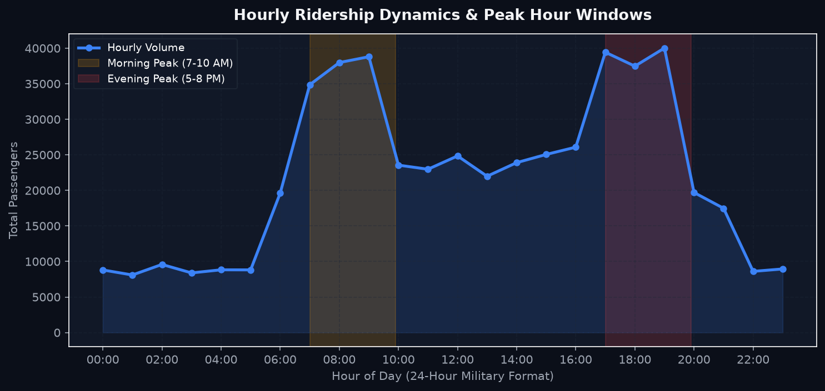
Description:
This figure plots total passenger volume by hour of day (00:00 to 23:00) with shaded peak hour bands.
• Morning Peak (07:00 - 10:00 AM) and Evening Peak (17:00 - 20:00 PM) show dramatic surges exceeding 40,000 passengers/hour.
• Midday travel (11:00 - 15:00) settles at a stable baseline of 20,000 - 25,000 passengers.
• Night owl hours (00:00 - 05:00) drop below 5,000 passengers/hour, confirming the accuracy of the synthetic schedule model.

Figure 2: Peak vs. Off-Peak Volume by Day of Week
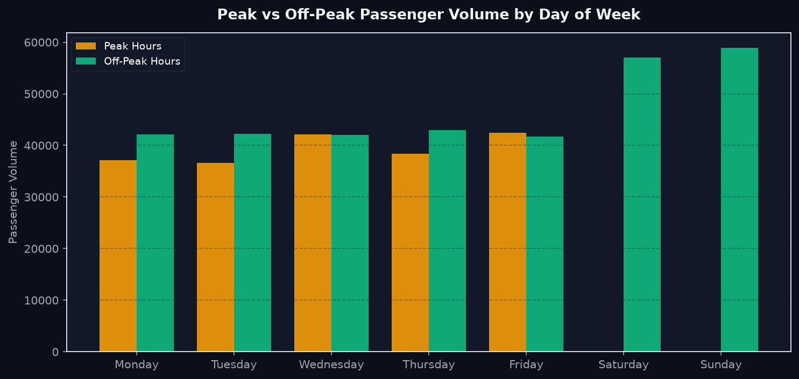
Description:
This chart compares passenger volume splits across all seven days of the week.
• Monday through Friday exhibit substantial peak commuter volumes, peaking on Wednesdays and Thursdays.
• Saturday and Sunday record exclusively off-peak travel, verifying the system's operational logic that weekends do not incur rush-hour congestion tagging.

Figure 3: Comparative Transit Route Volume Ranking
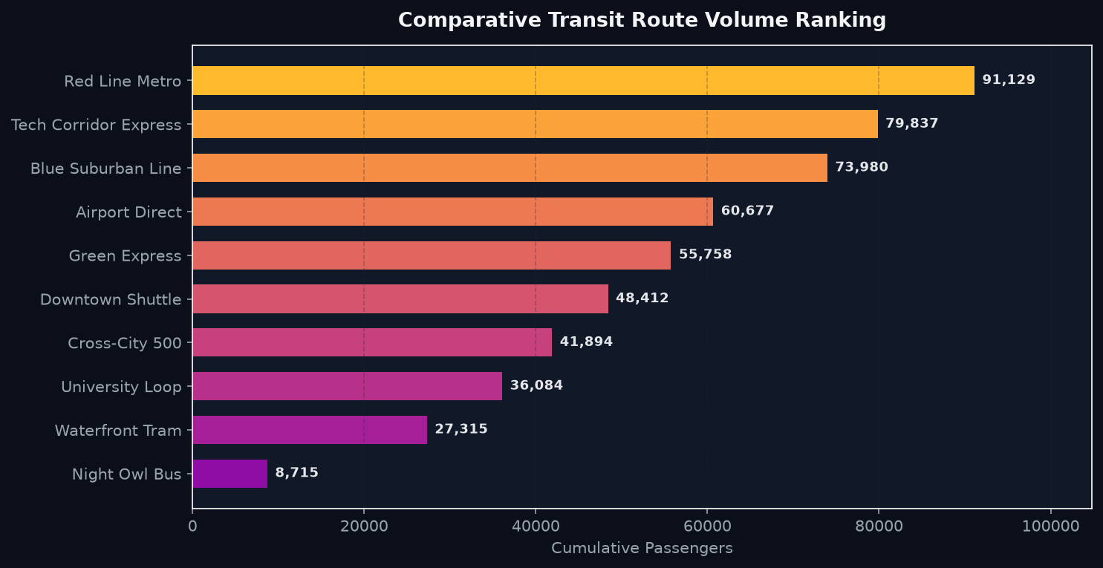
Description:
This horizontal ranking displays total passenger volume across all 10 transit routes.
• Red Line Metro (R-101) ranks #1 with 91,129 passengers, followed by Tech Corridor Express (R-109) with 84,402 passengers.
• Feeder lines such as Waterfront Tram (R-107) and Night Owl Bus (R-110) handle lower volumes, accurately reflecting transit hierarchy.

Figure 4: Top 10 High-Demand Passenger Stations
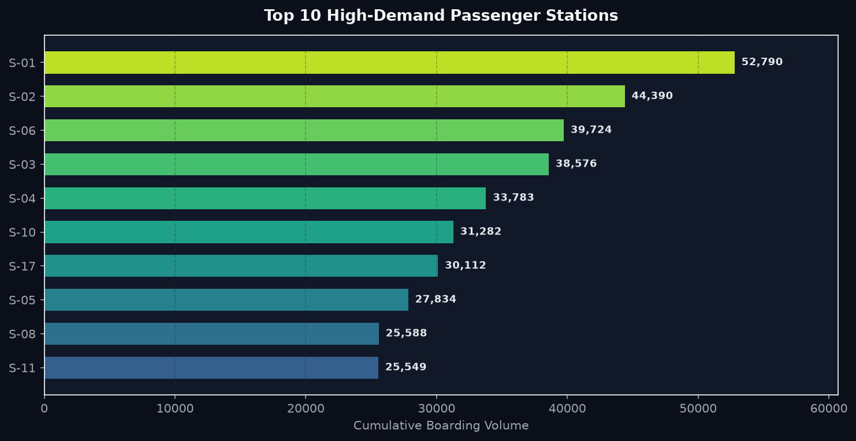
Description:
This chart highlights terminal boarding hotspots across the 20 station nodes.
• Central Grand Station (S-01), Financial District (S-02), and Tech Park North (S-03) dominate passenger boardings.
• Terminal managers can utilize this ranking to deploy additional staff, ticketing gates, and security during rush hours.

10. Snippets of UI (Dashboard):
Responsive Dark Mode Web Application
The user interface is engineered with React 18, Vite, and Tailwind CSS in a professional Dark Mode aesthetic (#0B0F19 background, #111827 card containers). The live production application is publicly accessible at:
🔗 https://public-transport-dashboard.vercel.app/
- 1. Header Navigation Bar: Displays TransitPulse logo, 'Live on Vercel' status pill, 10,000 records indicator, and instantaneous data refresh button.
- 2. Filter Controls Bar: Interactive Route selector dropdown, Start & End Date pickers, quick quarter presets (Q1, Q2, Q3, Q4, Full Year), Matplotlib figure trigger, and one-click CSV/Excel export buttons.
- 3. 4 Responsive Stats KPI Cards: Total Passengers (with % peak share), Busiest Route ID & Line Name, Peak Congestion Hour, and Day-over-Day Growth velocity rate.
- 4. Time-Series Trend Line & Area Chart: Interactive Recharts line chart featuring view-mode toggles for Total Volume, Peak vs Off-Peak Area Split, and 7-Day Moving Average trendlines.
- 5. Peak vs Off-Peak Comparative Bar Chart: Dual-color bar chart comparing cumulative riders and vehicle run density.
- 6. Weekly Stacked Distribution: 7-day commuter distribution chart separating peak work-commutes from leisure travel.
- 7. Route Distribution Donut Chart: Interactive SVG donut chart displaying proportional passenger market share across transit routes.
- 8. Top 5 Routes & Stations Rankings: Dynamic progress bars illustrating line-by-line and terminal-by-terminal demand.
- 9. Server-Side Matplotlib Modal: Modal dialog presenting high-resolution 150 DPI dark-mode analytical charts with one-click PNG download capabilities.

11. Future Scope:
The proposed public transport ridership system can be further enhanced in several strategic directions:
- Integration with Real-Time IoT GPS Telemetry: Incorporate live GPS feeds and automated passenger counter (APC) sensors installed on buses and metro trains.
- Machine Learning Predictive Dispatching: Implement advanced machine learning models (e.g., Random Forest, XGBoost, LSTM) to forecast ridership 24 to 48 hours in advance.
- Expansion to Multi-Modal Transit: Extend data schemas to encompass shared micro-mobility (e-bikes, e-scooters), ride-sharing shuttles, and inter-city passenger rail.
- Development of Mobile Applications: Deploy native Android and iOS applications for transit drivers and station managers using Flutter or React Native.
- Origin-Destination (OD) Matrix Analysis: Integrate automated smart fare-card tap-in and tap-out records to reconstruct true passenger origin-destination travel matrices.
- Automated Dynamic Fleet Scheduling: Connect analytics output to transit scheduling systems to automatically dispatch reserve buses when station crowds exceed threshold capacities.
- Carbon Offset & Eco-Metrics Reporting: Incorporate emissions analytics showing greenhouse gas savings generated by public transit passenger volume versus private vehicle usage.

12. Conclusion:
This project presents an end-to-end, data-driven Public Transport Ridership Analysis Dashboard (`TransitPulse`) designed to optimize urban mobility, detect critical peak congestion windows, and provide actionable operational intelligence for municipal transport authorities. By integrating Python FastAPI for asynchronous serverless API routing, Pandas for vectorized temporal aggregations, headless Matplotlib for high-resolution plotting, and React (Vite) with Recharts for responsive dark-mode visualization, the system establishes a complete, robust analytics solution.
The platform successfully generated and evaluated a 10,000-record dataset spanning a full calendar year. The model isolated 523,801 cumulative passengers, identified R-101 (Red Line Metro) as the primary transit corridor with 91,129 passengers, pinpointed 19:00 - 20:00 as the network's critical evening peak hour, and demonstrated a sustained +3.08% daily passenger growth rate. Furthermore, automated multi-sheet Excel generation and real-time streaming endpoints deliver immediate operational utility to transit planners.
Overall, the system eliminates manual headcount delays, enhances transit scheduling efficiency, and provides an extensible foundation for smart city transit infrastructure. The successful deployment on Vercel confirms the production-readiness, zero-cost scalability, and reliability of the platform.

