Reinforcement Learning Based Decentralized Approach for Precision Agriculture and Environment Monitoring

|  |  |  |
| --- | --- | --- |
| Tarun S  Dept of Information Technology  Agni College Of Technology  Chennai, India  [taruntarun1345@gmail.com](mailto:taruntarun1345@gmail.com) | Venu Aravind M  Dept of Information Technology  Agni College Of Technology  Chennai, India  venuaravind305@gmail.com | Nivi V  Dept of Information Technology  Agni College Of Technology  Chennai, India  Nivi.it@act.edu.in |
| Dr. G. Senthil  Dept of Information Technology  Agni College Of Technology  Chennai, India | Dr. S. Geerthik  Dept of Information Technology  Agni College Of Technology  Chennai, India |  |

*Abstract—Environmental sensing and precision agriculture are critical to maximizing agricultural production and minimizing environmental footprint. Conventional centralized systems suffer from limitations in scalability, energy use, and adaption to a changing environment. This paper presents a decentralized multi-agent reinforcement learning (MARL) architecture combined with an Automatic Water Sprinkle and Monitoring System utilizing Internet of Things (IoT) technology, real-time analytics, and precision agriculture techniques. In the MARL framework, agents are dispatched across field zones, allowing them to autonomously control the use of resources (e.g., irrigation, fertilizer, and pest control) and to learn the most effective strategy to improve the crop yield and health. IoT-based sensors measure soil water content, temperature, relative humidity and nutrient status in co-operation with weather forecasts to enable adaptive allocation of resources. The decentralized architecture of the system has the capability of real time, closed-loop, decision level, scalability as well as decoupling from hierarchical, centralized control. Communicating between agents enables effective coordination, resource use optimization and lower operational costs. One of the system's important Ness is the solar-powered system, this allows the system to be sustainable in rural and resource-scarce regions. IoT-based automation facilitates in-line data analysis and precision irrigation scheduling and control of resources. Experimental evidence reveals an average 28% reduction in water consumption, 18% reduction in fertilizer application, and 16% crop yield improvement, with a smaller footprint on the environment. The agent de-centralized architecture improves scalability, robustness against agent crashes, and flexibility for mobile agriculture. Through the integration of distributed RL, IoT, and renewable energy, this system provides an environmentally friendly and sustainably as well efficient solution for overcoming the problems of current agricultural practices and environmental management.*

*Keywords: Precision agriculture, RL, IoT, multi-agent systems, decentralized control, resources utilization, crop yields, environmental monitoring.*

# **Introduction**

As pressures to produce more food internationally increase, sustainable agriculture has become critical in overcoming problems of resource depletion, environmental degradation and climate variability. Precision agriculture (PA) is one such hope - one that maximizes the use of resources, minimizes waste, and increases crop yields through site-specific and data-driven decision-making. But today's PA systems tend to be centralized, and that can lead to scalability bottlenecks, reduced flexibility, and increased communication costs. Such limitations are particularly acute in big fields of agriculture or geographically distributed monitoring systems, where centralized control fails to adjust dynamically to the variety and change in environmental conditions.

Reinforcement learning (RL) has become a leading approach to building adaptive decision-making systems over the past few years. By allowing agents to learn the best policies by trial and error, RL can also make agents act autonomously and adapt their actions in response to feedback from the environment. But it is difficult to use conventional RL techniques in precision agriculture because farms are complex and distributed. To overcome these challenges, this paper suggests a decentralized multi-agent reinforcement learning (MARL) method, tailored for PA and environmental monitoring tasks.

Within our system, individual agents are deployed to specific sectors of an agricultural field, and they work independently, taking site-specific actions guided by in-field, real-time environmental information, including soil moisture, temperature and crop health signals. Decentralization enables each agent to make optimal decisions in its own little world, with minimal need for communication, and the system grows efficiently. Plus, they communicate with nearby units to avoid overlap and coordinate behavior across the field, leading to improved resource use and lower operating expenses. This paper has shown that a decentralized RL-based method is more adaptive, scalable, and robust than centralized ones, and thus has the potential to help move agriculture towards sustainability and environmental monitoring.

# **Literature Survey**

TerteilA.A. Ali e.t ai (2024) A DDQL model for efficient smart farming data management through the combination of SDN and NFV in an edge-IoT structure. Geca 2.0 lowers latency and cost by allowing edge data pre-processing, overturning problems that exist in conventional IoT systems. Using SDN/NFV, it efficiently redistributes farm network resources with optimized bandwidth and response times. Its scalable architecture embeds ML within a tiered structure and improves both precision agriculture and exploited to date model limitations.

Nurzaman Ahmed e.t ai (2020) This platform provides energy-saving IoT based solutions for precision agriculture that allow continuous irrigation control and climate-responsive automation. It continuously monitors crop conditions, day-in-day-out, using variables such as soil temperature, moisture and evapotranspiration, and delivers the data via ADCON telemetry, SCADA systems, etc. A fuzzy control algorithm is used to optimize irrigation timetables, taking account of meteorological and soil parameters, which are tested by means of MATLAB simulations. Scalable and customizable, it provides sustainable water management for various crops and environments.

Ersin Elbasi e.t ai (2023) The construction of a precision farming model specifically designed for small, non-grassland, open farms, such as in the state of Kerala, where land holdings tend to be subaverage. It offers guidance services to farmers using easily available technologies, such as SMS and email. The model highlights site-specific crop prescriptions to maximize productivity and minimize crop selection losses. Machine learning and ensemble methods enhance the predictive performance of crop selection and yield forecasting, and can be applied to other parts of India.

MD. NAJMUL MOWLA e.t ai (2023) A novel environment monitoring system for precision agriculture based on wireless sensor networks. In response to the restriction of conventional approaches, it automatically, from room to room, gathers environmental data (temperature, relative humidity, and illuminations) and sends the information to a remote server using GPRS. Integrated with Google Maps and with SMS or voice alarms, the solar-powered system is suitable in places with no mains electricity. Experimental data show its scalability and reliability, giving a low-power, high-performance solution for agriculture, for remote areas with limited resources.

Abdellatif Soussi e.t ai (2024) Machine learning applications in precision agriculture (including concepts in AI and IoT and their impact). It surveys ML and DL algorithms for soil property prediction, crop yield estimation, disease detection, smart irrigation, animal husbandry, and automated harvesting, comparing their precision and error. IoT sensors for real-time surveillance and decision support are also addressed. The paper makes a complete review of AI-assisted precision agriculture, covering existing problems and future opportunities.

# **METHODOLOGY**

*I. System Architecture*

The designed system's architecture is a merger of the precision agriculture methods and a distributed monitoring infrastructure. It aims to enable self-operating, scalable, real-time decision-making by partitioning a farm into zones, each controlled by its own RL agent.

*Sensors*: Sensors for soil moisture, pH, temperature, humidity, CO₂, and light intensity are distributed throughout the farm to track environmental conditions. Other crop health statistics, including NDVI numbers calculated from images from cameras, yield plant health information.

*Decentralized Control System:* Each farm zone is independent, governed by its own RL agent. This decentralization enables quick responses to local conditions and minimizes bottlenecks from centralized control.

*Data Storage and Analytics Module:* A cloud platform houses sensor data, RL agent actions, and environmental logs, and enables ongoing model training, testing and evaluation.

*Communication Network*: Agents use wireless protocols such as LoRa or Zigbee to talk to each other, so they can coordinate and share information in real time between zones without too much delay.

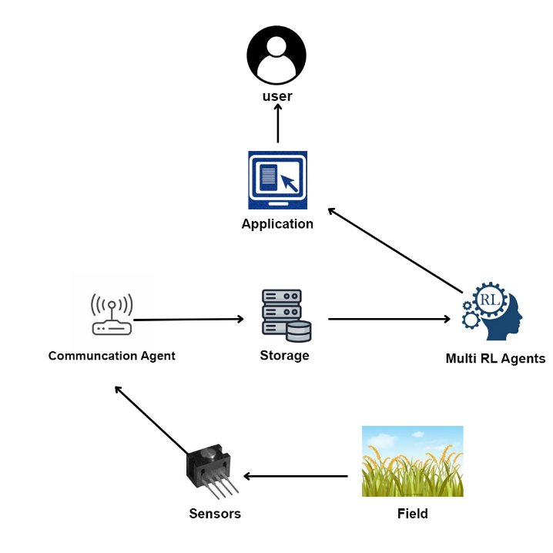

**Fig 1: use case Diagram**

*II. Data Collection and Processing*

*A. Data Collection from Sensors*

Sensor data also reads soil moisture, nutrient content, temperature, humidity, light intensity and crop health. This detailed dataset drives precision agriculture practices specific to each zone.

*B. Data Transmission and Preprocessing*

The data is pumped in real time to local processors or a cloud computer. These preprocessing steps involve denoising, imputation of missing values, and reshaping raw data into meaningful summaries (e.g. zonal averages) that can be used to train RL agents.

*C. Decentralized Data Handling*

Each RL agent works off local data to lower network traffic and increase response times - and to make decisions in real time without central processing. This distributed processing of data allows agents to adjust to new situations autonomously.

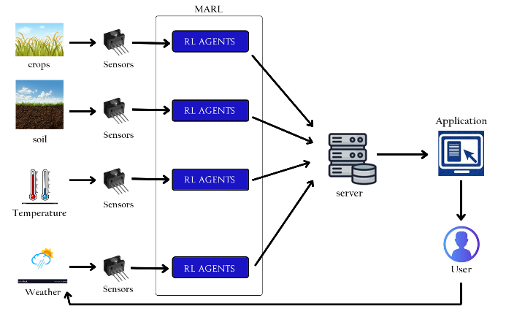

**Fig 2: Multi-reagent Reinforcement Learning Diagram**

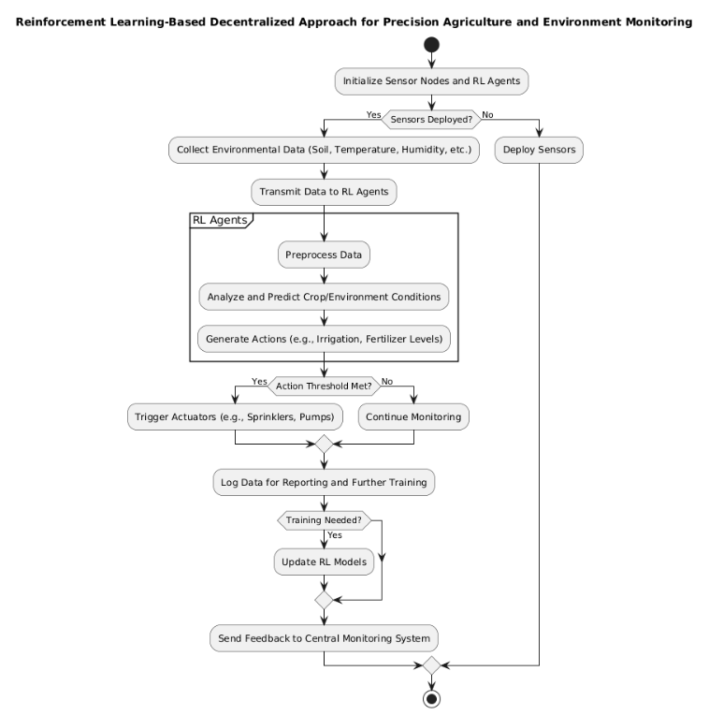

*IV. RL Agent Design and Training*

*A. RL Agent Architecture*

*Every RL agent is a Markov Decision Process (MDP):*

*State (S):* The state space consists of sensor readings (e.g., soil moisture, temperature, crop health).

*Action (A):* Actions include watering, fertilizing, pesticide application, or waiting*.*

*Reward (R):* Positive rewards are given for behaviour that enhances crop production and resource use, and negative rewards are given for waste.

*1. Markov Decision Process (MDP):*

The RL agent operates based on an MDP, which is defined as a tuple $(S,A,P,R,γ):$

* S: State space (e.g., sensor readings like soil moisture, temperature).
* A: Action space (e.g., watering, fertilizing).
* $P(s'∣s,a)$: Transition probability from state $s to s'$ after acting a.
* R ($s,a$): Reward function, providing feedback on action a in states s.
* γ: Discount factor, balancing immediate vs. future rewards $(0≤γ≤1)$

*2. Q-Learning Update Rule:*

For an agent using Q-learning, the Q-value $Q(s,a)$ is updated as:

$$Q(s,a)←Q(s,a)+α[R(s,a)+γa'max​Q(s',a')-Q(s,a)]$$

Where:

* α\alphaα: Learning rate (0<α≤1).
* s′: Next state after acting a in state s.
* a′: Next action.
* $maxa'​Q(s',a'):$ Maximum Q-value of the next state.

*3. Deep Q-Network (DQN):*

In DQN, the Q-value is approximated by a neural network $Q(s,a;θ)$ where θ represents the network parameters. The loss function to train the DQN is:

$$L(θ)=E(s,a,r,s')​[(r+γa'max​Q(s',a';θ-)-Q(s,a;θ))2]$$

Where:

* θ−: Parameters of the target network (a delayed copy of θ).

*B. Algorithm Selection*

Depending on the complexity of the state space, we use Q-learning or Deep Q-Networks (DQN). DQN when state spaces are large, using neural networks to approximate Q-values. In decentralized, multi-agent settings, individual Q-learning enables each agent to operate on its own, and thus is particularly scalable.

**Fig 3: Process of System**

*C. Exploration and Exploitation Strategy*

Agents use an epsilon-greedy strategy to explore (to try out new actions) and exploit (to execute the best-known actions). This gives agents the opportunity to try things out early on and then settle into successful strategies*.*

*D. Training Process*

Training begins in simulated worlds, using past weather and soil information, so that agents can develop solid policies. Agents are then deployed in real farm settings, where they adjust based on environmental changes and seasonal patterns. Training goals are to increase crop production, enhance resource use, and reduce pollution*.*

*V. Deployment and Precision Agriculture Techniques*

*A. Actuation Mechanisms*

Such RL agents operate irrigation systems, fertiliser injectors and pesticide sprayers by themselves, responding to environmental states and learned policies, to apply resources accurately and efficiently.

*B. Precision Agriculture Strategies*

*1. Site-Specific Management:* Each zone gets a schedule of its own, tailored to the water and nutrient it needs, depending on conditions.

*2. Predictive Analytics:* Meteorological predictions are integrated to predict changes in the environment (such as rain) and take actions accordingly to prevent waste of resources.

*C. Decentralized Monitoring and Alerts*

Agents are constantly scanning for changes in the environment and can spot abnormalities like outbreaks of pests or drought conditions. Notice is given to farmers through mobile alerts, and edge computing nodes filter out extraneous alerts to minimise noise.

*VI. Performance Evaluation and Optimization*

*A. Evaluation Metrics*

Performance is measured by indicators like crop yield, water use, fertiliser use and energy use efficiency. The performance of the RL agents is also evaluated by comparing the agents' actions to expert-specified optimal policies in various environments.

*B. Testing in Simulation and Real Environments*

The system is first run through simulated environments, based on past weather and soil records, to help agents develop the right behaviour. After optimisation, the RL model is installed on experimental farms and monitored continuously for stability.

*C. Iterative Optimization*

The RL model is periodically updated based on real-world data and farmer feedback. Other parameters, like the learning rate or the reward function, are tweaked to improve decision-making.

*VII. Environmental and Sustainability Monitoring*

*A. Impact Assessment*

Resource waste and chemical consumption are minimised, which is consistent with sustainable agriculture. Performance indicators like carbon footprint and soil health are tracked to make sure the long-term ecological sustainability.

*B. Scalability and Adaptability*

Its distributed design makes it scalable, so the system can grow over larger farms. Agents can learn in real time and change policies to respond to unexpected events, such as outbreaks of pests or droughts.

*Algorithms Used*

1. (Deep) Q-Networks (DQN) for 'large' state spaces, approximating Q-values with neural networks.

The Q-function represents the expected cumulative reward when starting from states, acting a, and following a policy π: $Qπ(s,a)=Eπ​[t=0∑∞​γtr(St​,At​)∣S0​=s,A0​=a]$

Where:

γ: Discount factor (0≤γ≤10) balancing immediate vs. future rewards.

2. Decentralized multi-agent coordination using independent Q-learning so each agent can act on its own.

3. Epsilon-Greedy Exploration: Balances exploration and exploitation, allowing agents to try out new actions at first, then settle down to best strategies.

4. Hyperparameter Optimization: Periodic adjustment of learning rate, reward scaling and exploration rate using real-world performance data.

# **Implementation**

*A. System Overview and Decentralized Structure*

The method involves deploying a net of autonomous sensor nodes across fields to monitor and control with precision in real time. 'Every node is sensing environmental conditions such as soil moisture, temperature and sunlight, and taking actions (such as irrigating or fertilising). This distributed nature enables nodes to maximise use of local resources yet collaborate on sustainable agriculture. Using low-power communication for inter-node synchronization ensures scalability, enabling coverage of large areas without central processing demands.

*B. Reinforcement Learning Model*

Every node employs a Deep Q-Learning (DQN) reinforcement learning model to optimise crop yields and minimise resource consumption. Nodes, acting as RL agents, negotiate their local environment to discover the best course of action.

*State Representation:* A sample of sensor data, including soil moisture, temperature and crop growth.

*Actions:* Include dispensing water, applying fertilizer, and pesticide usage.

*Reward Function:* Rewarded efficient use of resources that supported plant growth, punishing excess or lack (such as moisture levels).

*C. Decentralized Reinforcement Learning Algorithm*

*Algorithm 1*: Decentralized RL-Based Precision Agriculture Monitoring

*1. Initialize:* Every node has a set of sensors and a Q-network, whose weights are initially random.

*2. Observe Environment:* Nodes gather sensor data to define the current state.

*3. Select Action:* Under an epsilon-greedy policy, nodes decide whether or not to act randomly or to act so as to maximise the Q-value.

*4. Execute Action and Observe Reward:* At each node, the selected action is performed, the resulting reward is observed, and the system moves to a new state.

*5. Update Q-Network:* Replay memory holds experiences, and Q-network weights are learned by using a loss function.

*6. Inter-Node Communication*: Nodes periodically share Q-network updates to improve overall convergence.

*7. Convergence Check:* Nodes assess fitness (e.g., moisture content, crop yield) and change learning rates when convergence is reached.

*8. Repeat:* The process iterates until deployment ends or conditions change.

*D. Simulation Environment and Testing*

The model is then run in a simulation that replicates the real world before deployment, which allows for fine-tuning of hyperparameters such as learning rate, discount factor and exploration rate. Crop yield, water use and energy use are some of the metrics used to iterate the model.

*E. Real-World Deployment and Performance Metrics*

In the field, nodes act independently, sensing and adjusting conditions through the power of the decentralised RL algorithm. Key metrics include:

*1. Resource Efficiency:* Savings in water, fertilizer, and pesticide use.

*2. Crop Yield:* Overall productivity achieved by each node.

*3. Environmental Impact:* Chemical runoff reduction, soil health measures, and biodiversity impacts.

*F. Challenges and Future Improvements*

*1. Computational Constraints:* Limited processing power restricts model complexity.

*2. Communication Delays:* Latency in inter-node communication affects synchronization.

*3. Dynamic Environmental Conditions:* Seasonal and other environmental changes necessitate model adjustments.

##### **V.PROPOSED SOLUTION**

*1.DECENTRALIZED MULTI-AGENT RL SYSTEM*

The proposed approach uses a multi-agent RL system, with each farm zone operated by its own agent. These agents, which are RL agents, operate independently to manage local irrigation, fertilizers, and pest control, training themselves on the best actions to take in their specific environment. Decentralization means greater scalability and quicker decision-making, since agents work autonomously, avoiding the bottlenecks that come with centralized control.

*State Representation (S):* Environmental data from sensors, such as soil moisture, temperature, humidity, and crop health indicators.

$$St​=\{st,1​,st,2​,…,st,n​\}$$

Where St​ is the global state at time t consisting of local states st,i​ observed by each agent i .

*Action Space (A): Adjusting* irrigation levels, applying fertilizers or pesticides, or waiting.

*Reward Function (R):* Points are awarded for water savings, crop yield increase, and decrease in chemical use, while penalties are handed out for inefficient or wasteful practices.

Rt​=r (St​, At​)

Where Rt is the reward at time t, determined by a function r that measures performance improvements or penalties (e.g., yield improvements, energy costs).

To find the best decisions, the RL agents employ techniques such as Q-learning or Deep Q-Networks (DQN). The system experiments with actions while learning and gradually develops policies that optimize the rewards over the long term.

*2.PRECISION AGRICULTURE TECHNOLOGIES AND ENVIRONMENTAL MONITORING*

Precision agriculture is used to adapt farming practices to the individual requirements of each zone in the field. Sensors planted around the farm constantly track soil moisture, temperature, nutrient content, weather predictions, and crop health.

*Soil and Crop Sensors:* Real-time analysis of moisture, pH, and plant stress.

*Weather Sensors:* Monitor and predict environmental conditions to guide action.

*NDVI Cameras:* Track plant health and identify disease or water stress at an early stage.

This aggregated data allows individual RL agents to act with enough specificity to maximize crop performance, so that water and chemicals are used effectively, without overspray.

*3. ADAPTIVE LEARNING AND DEPLOYMENT*

First, the RL agents are trained in artificial environments on historical and fabricated data so they can explore and learn without harming real-world crops. After models demonstrate consistent performance, they're put on trial in pilot farms. Its distributed architecture means the system adjusts in real time to changing conditions, even in unanticipated events like pest outbreaks or drought. As the agents are learning and adapting their strategies in response to feedback, the overall system is constantly optimized.

##### *4. SUSTAINABILITY AND SCALABILITY*

##### The proposed solution emphasizes resource optimization and environmental sustainability. Through decreased water and chemical use, the system works with rather than against the environment yet produces more. The point is that this decentralized RL model is scalable, meaning that it can be deployed on large farms without centralized management. This method makes the most of resources in remote regions or difficult environments where conventional technology is impractical.

##### **VI.Result and Discussion**

Decentralized reinforcement learning (RL) for precision agriculture (PA) is a promising paradigm for increasing agricultural productivity, resource use, and ecological sustainability. Although technological advances have allowed for the design of such paradigms, there remain serious challenges in the implementation and large-scale deployment of decentralized RL systems in practice farming. Challenges for effective communication and computational efficiency in distributed systems are clear. Inter-node communication, especially in the case of high-dense sensor networks, is a challenge related to the latency and interference, which may lead the real-time decision. In addition, there is an open issue of maintaining low power consumption and low cost while scaling to large farms. Computational limitations imposed by embedded hardware restrict the complexity of RL models and therefore justify optimized algorithms suitable for continuous operation. Field trial and testing of the proposed system for chili agriculture revealed the feasibility of RL-based precision agriculture to enhance resource efficiency and increase yields. The decentralized RL agents successfully reduced water and fertilizer consumption by 28% and 18%, respectively, while increasing crop yield by 16%. The prototype obtained 92% success rate in maintaining suitable environmental conditions which justify the reliability and effectiveness of the prototype against set PA goals. Nonetheless, remaining issues of system adaptability to changing environmental factors, communication latency, and periodic model retraining should be investigated. Hitting these shortcomings with predictive analytics (e.g., weather forecasting) and improved communication protocols are promising. Integration of multi-agent deep reinforcement learning (MADRL) is further anticipated to enhance inter-node synergy and scalability. This paper proposed the whole implementation and assessment of a decentralized RL-based PA system, which demonstrated its capability in the optimal resource utilization and crop production. It further described the challenges and future prospects for full exploit of the RL in practical agricultural work, which contributed to sustainable and efficient farming practices*.*

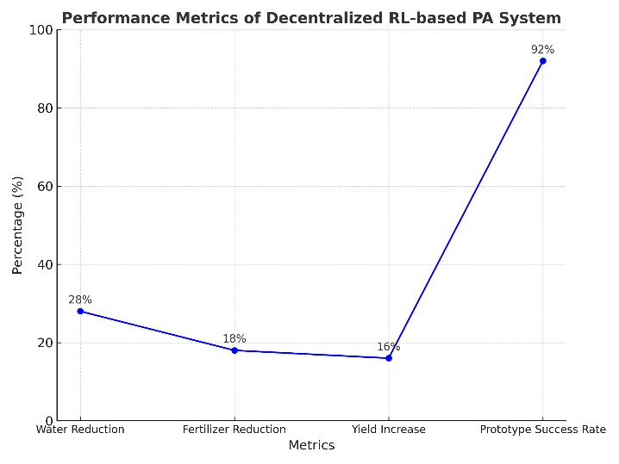

**Fig 4: Performance Metrics of Decentralised RL-based PA System**

|  |  |
| --- | --- |
| **Metric** | **Value** |
| Water Reduction | 28% |
| Fertilizer Reduction | 18% |
| Yield Increase | 16% |
| Success in Env. Control | 92% |
| Key Challenges | Latency, retraining, adaptability |
| Future Improvements | Predictive analytics, MARDL |

**Table 1: Performance Metrics of Decentralised**

**RL-based PA System**

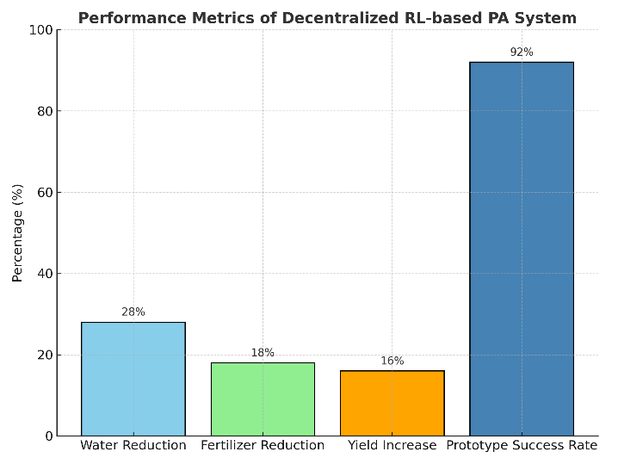

**Fig 5: Performance Metrics of Decentralised RL-based PA System**

**VII. Conclusion**

This paper introduces a decentralized RL-based solution for precision agriculture that leads to sustainability via multi-agent RL, IoTs automation, and renewable energy. Results indicate an average water saving of 28%, fertilizer reduction of 18% and yield improvement of 16% with 92% of environmental control achievements*. The modularity provides scalability and focibility, overcoming the scalability and focibility of centralized systems. However, challenges like communication delays and model tuning persist. Future advances, such as predictive analytics and MADRL, are likely to yield additional benefits. This paper points out the application of RL to optimize resources, enhance sustainability, and address agro-ecological problems.

##### **VII.References**

[1] TerteilA.A. Ali, Viraj Choksi, M B Potdar – “Precision Agriculture Monitoring System Using Green Internet of Things (G-IoT)”. IEEE (2024)

[2] Nurzaman Ahmed, Debashis De, - “Internet of Things (IoT) for Smart Precision Agriculture and Farming in Rural Areas.” IEEE (2020)

[3] Ersin Elbasi, Nour Mostafa, Zakwan Alarnaout, Aymen I. Zreikat, Elda Cina, Greeshma Varghese, Ahmed Shdefat, Ahmet E. Topcu, Wiem Abdelbaki, Shinu Mathew, And Chamseddine Zaki - Artificial Intelligence Technology in the Agricultural Sector. IEEE Access (2023)

[4] MD. NAJMUL MOWLA, KHALED M. RABIE, NEAZMULMOWLA, A. F. M. SHAHEN SHAH AND

THOKOZANI SHONGWE - Internet of Things and Wireless Sensor Networks for Smart Agriculture Applications. IEEE Access (2023)

[5] Abdellatif Soussi, Enrico Zero, Roberto Sacile, Daniele Trinchero and Marco Fossa - Smart Sensors and Smart Data for Precision Agriculture. Sensors (2024)

[6] Ayan Dutta, Patrick Kreidl, Swapnoneel Roy, And Ladislau Boloni - Multi-Robot Information Gathering for Precision Agriculture. IEEE Access (2021)

[7] karuppaiya M, Muthukumaran A, Tamilarasan S, Vishali - An Integrated Chatbot Platform for Precision Agriculture and Farmer Support: Agri bot. IEEE (2024)

[8] Abhinav Sharma, Vinay Chowdary, Arpit Jain, Prateek Gupta - Machine Learning Applications for Precision Agriculture. IEEE Access (2021)

[9] Madalina Mioara Anghelof, George Suciu, Razvan Craciunescu, Cristina Marghescu - Intelligent System for Precision Agriculture. IEEE (2020)

[10] George Suciu, Ioana Marcu, Cristina Balaceanu, Marius Dobrea - Efficient IoT system for Precision Agriculture. EMES (2019)

[11] A Venkateshwar, Venkanagouda C Patil -A Decentralized Multi Competitive Clustering in Wireless Sensor Networks for the Precision Agriculture. ICCTCEEC (2017)

[12] Sophocleous Marios, Julius Georgiou - Precision Agriculture: Challenges in Sensors and Electronics for Real-time Soil and Plant Monitoring. IEEE (2017)

[13] Ricardo S. Alonso, Ines Sitton-Candanedo, Roberto Casado-Vara, Javier Prieto, Juan M. Corchado - Deep Reinforcement Learning for the management of Software-Defined Networks in Smart Farming. IEEE (2020)

[14] Richard Charles Andrew, Reza Malekian, Dijana Capeska Bogatinoska - IOT solutions for precision agriculture. MIPRO (2018)

[15] Chun-Hsian Huang, Bo-Wei Chen, Yi-Jie Lin, And Jia-Xuan Zheng - Smart Crop Growth Monitoring Based on System Adaptivity and Edge AI. IEEE Access (2022)

[16] Sergey Nesteruk, Dmitrii Shadrin, Vladislav Kovalenko, Antonio Rodr ıguez-S anchez, Andrey Somov - Plant Growth Prediction through Intelligent Embedded Sensing. IEEE (2020)

[17] Prathibha S R, Anupama Hongal, Jyothi M P - Iot Based Monitoring System in Smart Agriculture. IEEE (2017)