*Dear Editor,*

*We thank the Referee for reviewing our paper and furnishing this report.*

*We have considered all comments, and we have applied changes to the original version of the paper to address the issues raised. We have also made a few additional modifications.*

*First, we updated the mass range that was never explored by haloscope experiments before and cited the latest papers from ADMX and CAPP. We also updated Figure 11 and added the results from CAST, UF, RBF, and the 2022 CAPP paper. Second, the limits on the axion-two-photon couplings are updated due to an improved calculation of the cavity form factor in the Ansys HFSS microwave simulation. Third, we add one more citation to a theory paper. More details of these additional changes are presented at the end of this letter.*

*We are at your disposal for any further clarifications.*

*Sincerely,*

*TASEH Collaboration*

===============================================================

Color code:

Black: the original text of the referee comments

Blue: our response

Green: quoted original text

**Bold green: changes to the paper**

Red: explanation regarding the additional changes

===============================================================Referee Comments for the paper “Taiwan Axion Search Experiment with Haloscope: CD102 Analysis Details”

**Summary:**

This paper describes the analysis details of the Taiwan Axion Search Experiment with Haloscope (TASEH) science run which searched for axion generated microwave signals between 4.70750 – 4.79815 GHz from Oct 13 - Nov 14, 2021.

**General Comments:**

1. The authors did a very nice job of laying out the details of their analysis methods and this paper is an excellent companion to the PRL that they wrote outlining the scientific results. I appreciated the attention to detail, and I only had some minor comments and questions (see below). The only minor general criticism I had was that the analysis seemed to follow the generally accepted methods that had been outlined in other experiments and did not appear to add anything significantly novel to the process of searching for axions and setting appropriate limits with a null result. That said it does provide all the important details needed to assess the scientific results which are the more important. I’d recommend publication once the minor comments and questions below are addressed.

**Specific Comments, Questions & Suggested Fixes:**

1. Page 2: Equation 3: You are missing the dielectric constant in the form-factor equation #3.

Thanks for pointing this out to us. We have added the vacuum permittivity in Heaviside-Lorentz units in Eq. 3 and also cited the axion review paper by P. Sikivie. Now the text is as follows:

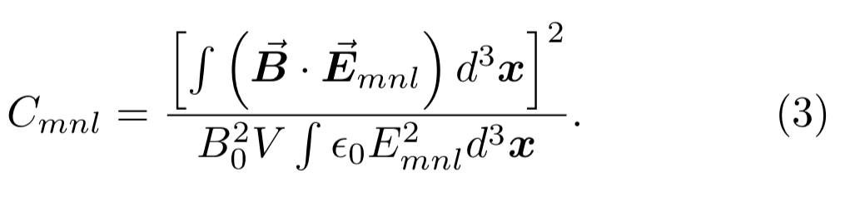

**Here, the vacuum permittivity in Heaviside-Lorentz units ε0 = 1 is used [48].**

**[48] P. Sikivie, Rev. Mod. Phys. 93, 015004 (2021).**

1. Page 3: When you list the T_sys of 2.0-2.3 K it would be useful to make clear at this point in the  paper that the noise is dominated by the first stage HFET amplifier. Perhaps add “... T_sys for  TASEH is about 2.0-2.3 K, **dominated by the first stage amplifier**, which gives a...”

Thanks for your suggestion. The original text

the baseline value of Tsys for TASEH is about 2.0–2.3 K, which gives a noise power of approximately (1.4 − 1.6) × 10−19 W within the 5-kHz axion signal line- width, five orders of magnitude larger than the signal.

is now modified to:

**the baseline value of Tsys for TASEH is about 2.0– 2.3 K, dominated by the first stage amplifier. Therefore, the noise power is approximately (1.4 − 1.6) × 10−19 W within the 5-kHz axion signal line-width, five orders of magnitude larger than the signal.**

1. Page 4: Can you updated Reference 52 in the bibliography with were you are submitting that  paper? Is it also going to PRD or another journal?

This paper was submitted to and accepted by Review of Scientific Instruments. It is not yet published. Therefore, we added a note in Reference 56 (Reference 52 in the first manuscript):

**[56] H. Chang, J.-Y. Chang, Y.-C. Chang, Y.-H. Chang, Y.-**

**H. Chang, C.-H. Chen, C.-F. Chen, K.-Y. Chen, Y.- F. Chen, W.-Y. Chiang, W.-C. Chien, H. T. Doan, W.-C. Hung, W. Kuo, S.-B. Lai, H.-W. Liu, M.-W. OuYang, P.-I. Wu, and S.-S. Yu (TASEH Collabora- tion), (2022), accepted by Review of Scientific Instru- ments, arXiv:2205.01477 [physics.ins-det].**

1. Page 4: I was a bit surprised by the relatively large variation (1.9 to 2.2 K) over the relatively  small frequency band of 4.72-4.8 GHz. Does this frequency dependent variation match the HFET datasheet or is there something else going on (reflections in the line for example from impedance mismatches)? Not a criticism but I am curious.

Presumably the frequency-dependent variation of the system noise in Figure 1 could be coming from the frequency response of the HEMT noise, or from the frequency-dependent attenuation between the noise source and the HEMT amplifier due to impedance mismatches. We check the HEMT added noise as a function of frequency in the datasheet provided by the HEMT manufacture. However, both the frequency resolution and the noise magnitude resolution of the HEMT added noise in the datasheet are too coarse to see this level of variation. Therefore, at this point we are not sure about the major cause of this variation.

1. Page 4: You mention data before and after an earthquake. Can you specify the data and magnitude of the earthquake that caused the issue? Does this correspond to a frequency range where data was taken before and after the earthquake?

We have modified our text to clarify what happened. The original text

The biggest difference is 0.076 K in the frequency range during which the data were recorded after an earthquake. The source of the difference is not understood, therefore, the difference is quoted as a systematic uncertainty together with the RMS of the noise.

Is now modified to:

**The biggest difference is ≈ 0.076 K in the resonant frequency range of 4.779- 4.788 GHz, during which the CD102 data were recorded after a magnet quench at 09:20 on October 16 due to a failure of cooling water and before the first rescan (see Sec. IV E for the definition of rescan). In this period, an earthquake of the intensity scale 4 struck the lab at 13:11 on October 24. Both the magnet quench and the earthquake may have impacts on the readout during the data taking [56]. However, the exact source of the readout change is not understood. Therefore, the difference is quoted as a systematic uncertainty together with the RMS of the noise.**

1. Page 5: Figure 1. Are the 19 measurements for each frequency taken close in time or are they spread out during the run?

The data of the 19 calibration measurements presented in Figure 1 were taken close in time (from 9:04pm on November 18 to 6:43am on November 20) after the data taking. The original text

The average of the added noise Ta over 19 measurements has the lowest value of 1.9 K at the frequency of 4.8 GHz and the highest value of 2.2 K at 4.72 GHz, as presented in Fig. 1.

is now modified to:

**The average of the added noise Ta over 19 measurements, performed after the data taking, has the lowest value of 1.9 K at the frequency of 4.8 GHz and the highest value of 2.2 K at 4.72 GHz, as presented in Fig. 1.**

1. Page 5: You mention that this paper considers uncertainties to be uncorrelated between frequency bins but that Ref [45] does not. Can you explain why you chose that assumption or why the assumption from ref 45 doesn’t apply?

We have plotted the δ/σ (or the so-called normalized power excess in Fig. 4 of the HAYSTAC paper), after performing each stage of the analysis and fitted the distributions to a Gaussian function. The means are all consistent with zero after combining and merging. The widths are consistent with unity after combining but slightly smaller than unity (0.987±0.002) after merging, see the figure below. This width after merging is also confirmed by 10000 toy simulations (width=0.9832±0.0002). Compared with the width seen by HAYSTAC (0.93), we conclude that the correlation is smaller in our case. From the papers of ADMX, CAPP, and HAYSTAC, we understand that taking into account correlation improves the limits. However, given that this is our first analysis, we have decided to take a more conservative but simpler approach and assume the uncertainties are uncorrelated across different frequency bins.

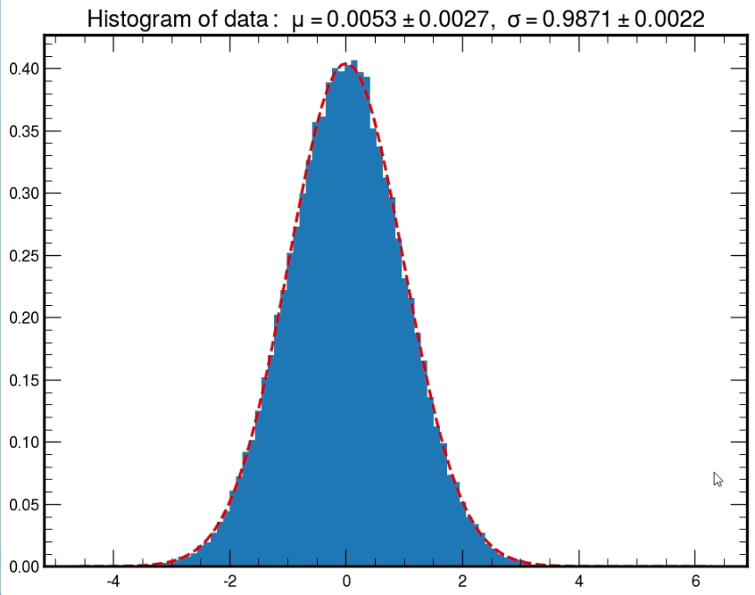

Figure 1: The histogram of the ratio δ/σ obtained from data after merging.

We also did a quick estimate of the correction of the σ in each frequency bin in the final spectrum, based on Equation 27 of Ref [49] (Ref[45] in the first manuscript). The correction is about 0.3% to 2.7% (0.3% for most frequency bins), which results in ~0.1% change in the limits.

The original text

In this paper, the uncertainties are considered to be uncorrelated between different frequency bins while Ref. [45] takes into account the correlation.

is now modified to:

**While Ref. [49] takes into account the correlation of the uncertainties between different frequency bins, this paper adopts a simple and conservative approach and considers the uncertainties are uncorrelated.**

1. Page 5: You mention two independent groups doing the analysis. This is an excellent idea. Can you provide a note on any differences that were discovered between the analysis and how they may have gotten resolved? Are these groups at different institutions?

The two groups are from different institutions. The initial disagreement came from different understandings of the analysis procedure developed by HAYSTAC. For example, one group considered frequency misalignment in the Maximum Likelihood weights for merging and the other did not. Others are more technical issues, such as using different programs to fit the added noise from calibration or quality factors/resonant frequency, etc. However, we consider these details are not of interest to the readers and prefer to keep the text as it is. Thanks for your understanding.

1. Page 6: Just to make it explicit can you add to the sentence “...the difference between the frequency f_ij in bin j and the **cavity** resonant frequency f_ci.”

Done.

1. Page 8: Please adjust the following sentence: “... if there were any potential signal with **~~an~~ a** SNR larger than 3.355, a rescan would be **~~proceeded~~ performed** to check if it **~~were~~ was** a real signal or a statistical fluctuation.”

Done.

1. Page 8: Please adjust the following sentence: “... adjusting the tuning rod of the cavity **~~so~~** to match the resonant frequency **~~to the frequency~~** of the candidate.”

Done.

1. Page 8: You mentioned that you had a signal that was persistent after the magnetic field was shut off but that you could not identify with any external signals. Do you look at it on any other modes? Is there any way to rule it out as a potential dark photon?

Due to the limited amount of DR time available to TASEH, we did not look at it on any other modes. Therefore, we cannot rule this signal out as a potential dark photon. Thanks for pointing this out to us. We will keep this in mind in our next run of data taking.

1. Page 8: At the beginning of Section V: “Analysis of the Synthetic Axion Data” I got a bit confused as to which were the hardware injected synthetic axions and which were the simulated injected axions put into the analysis chain via software. Can you be a bit more specific on how many “hardware injected synthetic axions” and “software injected synthetic axions” were used and when? Is there a reason you did not perform the hardware injections before or during the run and only after it or did I misunderstand the timing?

Indeed, we performed the hardware synthetic axion injection   
experiments only after the data taking to verify analysis procedures.

Before the data taking, we performed the scattering parameter   
measurements, S11, S22, S12, and S21, of the two-port cavity to   
verify the availability of the microwave system. (The probe 1 has weak   
coupling for injecting the synthetic signals and the probe 2 has   
adequate coupling for data taking.). We also carried out the noise   
calibration. The microwave system functioned properly and stably and the   
noise performance was decent. We then went into the data taking   
straightly.

After analyzing the data from the hardware synthetic axion signals, we also applied the same analysis procedure using simulated axion signals to validate the SNR results. We have modified the original text

After TASEH finished collecting the CD102 data on November 15, 2021, the synthetic axion signals were injected into the cavity and read out via the same trans- mission line and amplification chain.

In order to validate the results of the SNRs, the analysis procedure is also applied to the simulated spectra that include both noise and a signal with the same power and the same line shape as those of the injected synthetic axions.

to the following text to make it more clear:

**After TASEH finished collecting the CD102 data on November 15, 2021, the synthetic axion signals produced by a vector signal generator (VSG) were injected into the cavity and read out via the same transmission line and amplification chain.**

**In order to validate the results of the SNRs, the analysis procedure is also applied to the simulated spectra that include both noise and a signal with the same power and the same line shape as those of the injected synthetic axions from the VSG.**

1. Page 8: Why was the hardware injected axion signal wider at 8 kHz than the expected axion signal?

We used a vector signal generator to synthesize microwave signals via IQ modulation for the synthetic axion experiment. We miscalculated the effect of a parameter in the IQ sequences on the line shape of the synthetic axion signals, and accidentally generated 8-kHz wide synthetic axion signals for the experiment. The details of the hardware setup are described in the instrumentation paper Ref [56].

1. Page 9: Please adjust the following sentence: “Uncertainty due to the **frequency** misalignment...”

Done.

1. Page 10: Perhaps I missed it but did the systematic uncertainties of 4.6% apply uniformly or was there any offset bias?

Among all the sources of systematic uncertainties, only the 1.8% uncertainty on the limits due to the SG parameters is applied to all frequency bins uniformly. All the other uncertainties are studied by varying the source ±1σ according to the uncertainty on the source and the resulting effects on the limits are quoted. The 4.6% is an average relative uncertainty of all frequency bins, ranging from 4.4% to 4.8%. The original text

Overall the total relative systematic uncertainty is ≈ 4.6%.

is now modified to:

**The average of the total relative systematic uncertainty from all frequency bins is ≈ 4.6%.**

To make it less confusing, the following lines in the systematic uncertainty section on pages 9 and 10 are modified to:

**A 3.6% variation of this product results in a 1.9% uncertainty on the |gaγγ| limits on average.**

**These two uncertainties on Ta result in a 2.8% uncertainty on the |gaγγ| limits on average.**

**The comparison shows that δfm = 0 gives the largest difference on the limit, which is used as the systematic uncertainty from the misalignment. The average of the uncertainties from all frequency bins is 2.8%.**

**the maximum deviation of 1.8% on the |gaγγ| limit is used, uniformly for all frequency bins, as a conservative estimate of the systematic uncertainty from the SG filter.**

1. Page 11: Is figure 9 referenced anywhere in the text? I didn’t see that it was.
   1. It was referenced on page 10 in the following text
      1. –  Compare the mean μnoise and the width σnoise of the measured power after applying the SG filter, assuming that no signal is present in the data. See Fig. 9 for an example distribution of the measured power from the averaged spectrum of a single scan;
2. Page 11: Please make clear at the end of section VII that reference [54] is for 90% confidence  limits and not the 95% that is used in this paper.
   1. Due to additional references, now the ADMX paper is Ref[58]. We added the following text at the end of Section VII:

**Note in Ref. [58], the limits were derived at 90% C.L., rather than at 95% C.L. as presented in this paper.**

Additional changes

1. We have added citations to the searches performed by ADMX and CAPP that have a small overlap with our mass window. Instead of quoting the full mass window 19.4687 < ma < 19.8436 μeV, now we emphasize that the range 19.4687 < ma < 19.7639 μeV has never been explored by haloscope experiments before. The changes have been applied to the main text.

On page 1, we added the following text:

**Using a “sidecar” cavity and a Josephson Traveling Wave Parametric Amplifier, ADMX G2 had recently searched for axions at around 19.84μeV [37].**

On page 2, the text is modified to:

**The Center for Axion and Precision Physics Research (CAPP) constructed and ran simultaneously several experiments targeting at different frequencies [41–44]; they have pushed the limits towards the KSVZ value within the mass regions of 10.7126– 10.7186 μeV [43] and 19.764–19.890 μeV [44], respectively**.

On page 11 in the section of Conclusion, the text is modified to:

**It is also the first time that a haloscope-type experiment places constraints in the mass region of 19.4687 < ma < 19.7639μeV.**

1. We have updated the limits and the corresponding text due to an improved calculation of form factors. We noticed recently that in the Ansys HFSS microwave simulation software using the curvilinear mesh option for a model with rounded surfaces gives more accurate results. We redo the simulation for the cavity using the curvilinear mesh. The difference of form factor between the simulated results with the original mesh and with the curvilinear mesh is 3%, which results in a 1.3-1.4% change in the limits. Note the changes do not alter the understanding of the cavity. The limits reported in the text and Figs 3, 4, 10 and 11 have been modified. Note the ADMX-style limit increases rather than decreases because an inconsistent form factor was used in the previous calculations. The new calculations now use the same form factors as those for the central values.

The abstract is modified to:

**The analysis of the TASEH CD102 data excludes models with the axion-two-photon coupling |gaγγ | ≳ 8.1 × 10−14 GeV−1.**

On page 4 in Table I, the number is changed to:

**C010 0.614-0.630**

In Section VII Results on page 11, the text is modified to:

**The limits on |gaγγ | range from 5.2×10−14 GeV−1 to 8.7×10−14 GeV−1, with an average value of 8.1×10−14 GeV−1;**

**The results of TASEH exclude the models with the axion-two-photon coupling |gaγγ | ≳ 8.1×10−14 GeV−1**

**If the |gaγγ| limits are derived from the observed SNR as described in the ADMX paper [58], rather than using the 5σ target SNR, the average limit on |gaγγ| will be ≈ 5.1 × 10−14 GeV−1.**

In the conclusion on page 11:

**The experiment excludes models with the axion-two-photon coupling |gaγγ | ≳8.1×10−14 GeV−1 at 95% C.L.,**

1. We have added one more citation [23] to a theory paper by M. Gorghetto, E. Hardy, and G. Villadoro. It is added near the end of the first paragraph on page 1.

**In the post-inflationary PQ symmetry breaking scenario, where the PQ symmetry is broken after inflation, cur- rent calculations suggest a mass range of O(1–100)μeV for axions so that the cosmic axion density does not exceed the observed cold DM density [10–23].**

**[23] M. Gorghetto, E. Hardy, and G. Villadoro, J. High Energ. Phys. 07 (2018), 151.**