Software Architecture and Design Specification
Project: Task Manager Application
Version: 1.0
Authors: Team 4 (Aniyath Amrita Pradeep, Shaikh Abdullah Mahdi, Shrungashree K R, Shivanand M)
Date: 04-10-2026
Status: Draft

Revision History
Version | Date | Author | Change Summary
1.0 | 04-10-2026 | Team 4 | First draft of the architecture and design, based on SRS v1.0 and STP v1.0.

Approvals
Role | Name | Signature/Date
QA Lead | Aniyath Amrita Pradeep
Test Engineer | Shaikh Abdullah Mahdi
Developer | Shrungashree K R
Product Owner | Shivanand M

1. Introduction

1.1 Purpose
This document describes how the Task Manager Application will be built. It takes the requirements from the SRS and decides which components exist, how they talk to each other, where the data lives and how the main flows run. The goal is that every team member codes against the same picture, and that the testers can connect the cases in the STP to actual parts of the system.

1.2 Scope
The design covers everything in SRS v1.0. That means registration, login and logout, profile and password management, creating and editing tasks, categories, filtering and sorting, reminders sent 24 hours before a due date, the dashboard charts, persistent storage, per-user access control, the 30 minute session timeout, manual backup and restore, and timestamps on key task actions. The product is an Android app with a server behind it. Ideas that are not in the SRS, such as shared lists or recurring tasks, are left out.

1.3 Audience
The developers on the team, the QA group that wrote the STP, the Product Owner, and the instructors reviewing the submission. Anyone who picks up the project later can also use it as a map of the code.

1.4 Definitions
API is the set of HTTP endpoints the app uses to talk to the server. REST is the style of API used here, with JSON bodies. ADR stands for Architecture Decision Record, a short note on a design choice and the reason for it. FCM is Firebase Cloud Messaging, the service that delivers push notifications to Android. SMTP is the protocol used to send email. bcrypt is a salted one-way password hashing function. STRIDE is a checklist of six threat types used in Section 3.9. RTM is the Requirements Traceability Matrix from the STP.

2. Document Overview

2.1 How to use this document
Section 3 covers the structure of the system and the reasons behind it. Section 4 covers the detailed design, which includes the sequence diagrams, the API, error handling and the screens. Developers will spend most of their time in 3.4 and 4.3. Testers can use 3.8 to see which component a requirement ends up in.

2.2 Related Documents
The Project Proposal, the Software Requirements Specification (SRS) v1.0 and the Software Test Plan (STP) v1.0, all written by Team 4. The RTM named in the STP will be filled in during testing.

3. Architecture

3.1 Goals and Constraints
The system has to stay small enough for four students to finish in a semester while still hitting the measurable targets in the SRS. The dashboard must load in under 3 seconds, and that includes an account holding 1,000 tasks. A task operation that was accepted must not be lost or quietly altered. One user must never be able to read another user's data.
The constraints come straight from the SRS. It has to be an Android application. Passwords are stored with one-way hashing. Every task feature needs a logged in user, and a session ends after 30 minutes with no activity. Reminders go out as push notifications 24 hours before the due date. The database has to support a manual backup and a restore that works. Password reset email and push delivery come from outside services we do not control, so the design treats both as things that can fail.

3.2 Stakeholders and Concerns
- End users, mostly students and working people, want to add a task quickly, trust the reminders, and know that nobody else can read their list.
- The Product Owner wants each SRS requirement to be visible and demonstrable.
- Developers want clear module boundaries so four people are not editing the same files.
- The QA team needs parts that can be tested alone, mock email and push services, and a repeatable 1,000 task data set.
- Evaluators want to follow a requirement into the design and then into a test.

3.3 Component (UML) Diagram
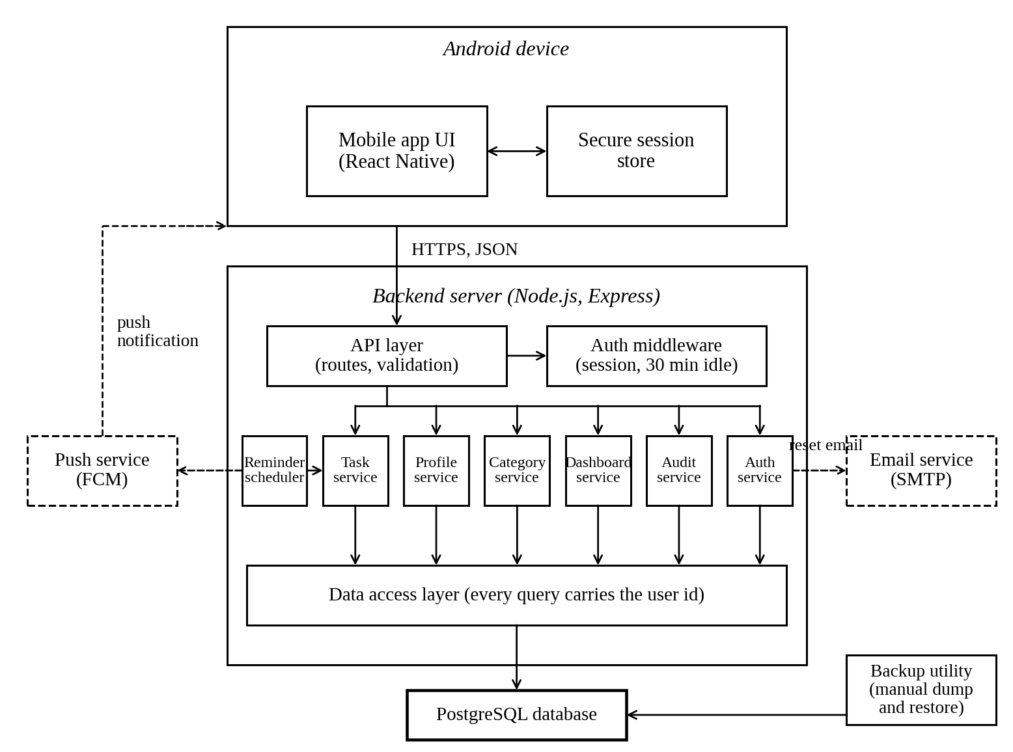
Figure 1. Component diagram
The phone talks to one backend over HTTPS. Inside the backend every request goes through the API layer and the auth middleware before it reaches a service. Services never touch the database directly, they go through the data access layer. The scheduler and the backup utility run separately from user requests. The two dashed boxes are external services.

3.4 Component Descriptions
Component | Responsibility
Mobile app UI | Android screens for registration, login, profile, password change and reset, task list and form, categories, filters and sorting, and the dashboard charts. It also sends the device token used for push.
Secure session store | Keeps the session token in Android secure storage. No task data is kept here permanently.
API layer | Defines the REST endpoints and validates input before anything else runs, for example email format, password strength, a non-empty title and an allowed priority value.
Auth middleware | Runs before every protected route. It looks up the session, checks that it was active in the last 30 minutes, refreshes the activity time, and otherwise answers 401.
Auth service | Registration, login, logout, password change and password reset. It hashes passwords with bcrypt, creates and deletes sessions, and asks the email service to send reset links.
Profile service | Lets a user view and edit their own profile.
Task service | Creating, viewing, editing, completing and deleting tasks, plus due date, priority, description and category. Every query is limited to the logged in user.
Category service | Create, rename and delete categories. Deleting one leaves its tasks in place with no category, as FR-20 says.
Dashboard service | Computes task counts by status and by priority with database aggregate queries, and returns the numbers the pie and bar charts need.
Audit service | Writes a timestamped event whenever a task is created, edited, completed or deleted. The events stay after the task row is gone.
Reminder scheduler | A job that runs every minute, finds unfinished tasks due within 24 hours that have not been reminded yet, and sends the owner a push notification.
Data access layer | The only code that talks to the database. It uses parameterized queries and passes the user id into every one.
PostgreSQL database | Stores users, sessions, reset tokens, categories, tasks and task events.
Backup utility | Scripts for a manual dump and restore of the database.
Email service | External SMTP provider, used only for password reset messages.
Push service | Firebase Cloud Messaging, used only to deliver reminders.

3.5 Chosen Architecture Pattern and Rationale
We chose a client-server layered architecture. The Android app is the presentation layer. The backend is one Node.js application split into an API layer, a service layer for the business rules, and a data access layer. A layer only calls the one below it.
The reasons are practical. The feature list is small and fixed, so one backend is enough. Each developer can own a service without agreeing on network contracts with the others. Security rules such as authentication, user scoping and hashing sit in a few known places, which makes the access control tests in the STP easy to aim. And one relational database with proper indexes handles 1,000 tasks per user without effort.
Microservices were rejected because separate deployments, networking and debugging add cost and give nothing back at this size. Keeping all data on the phone was rejected as well, since the SRS needs email reset, push reminders, backup and data that survives a reinstall, and all of those need a server.
ADR-1. Layered monolith instead of microservices. Small scope and small team, simpler to build and test.
ADR-2. PostgreSQL as the database. Transactions support NFR-05 and NFR-06, standard tools handle backup for NFR-07, and aggregate queries keep the dashboard fast.
ADR-3. Server-side sessions with a last activity time. This makes the 30 minute timeout (FR-28) and immediate logout (FR-03) simple, because deleting the session row cuts off access at once.
ADR-4. bcrypt for passwords, since it is salted, one-way and widely supported (NFR-02).
ADR-5. A scheduler inside the backend plus FCM for reminders. It meets FR-23 without adding another service to run.
ADR-6. Dashboard numbers come from SQL aggregates and not from loading every task into the app, so NFR-01 and NFR-08 hold at 1,000 tasks.
ADR-7. A separate task_events table for timestamps, so the record of a deletion survives after the task itself is removed (NFR-09).

3.6 Technology Stack and Data Stores
The mobile client is built with React Native for Android. The backend uses Node.js with Express, and node-cron runs the reminder job. Data is kept in PostgreSQL. Passwords are hashed with bcrypt, and traffic between the app and the server uses HTTPS. Reminders go through Firebase Cloud Messaging and password reset mail goes through an SMTP provider, with mock versions of both in the test environment as planned in the STP. Jest is used for unit tests, Postman for API tests, and the Android Studio emulator for running the app. The proposal listed React with Node or Django as options, and the SRS requires an Android app, so the React Native and Node combination was the one that fit both.
The database has six tables.
users holds id, email (unique), password_hash, name, device_token and created_at.
sessions holds id, user_id, created_at and last_activity_at.
password_resets holds id, user_id, a hash of the reset token, expires_at and a used flag.
categories holds id, user_id and name.
tasks holds id, user_id, title (required), description, due_at, priority (Low, Medium or High), status (Pending or Completed), category_id (may be empty), reminder_sent, created_at, updated_at and completed_at.
task_events holds id, user_id, task_id, action (CREATED, EDITED, COMPLETED or DELETED) and occurred_at.
Indexes on tasks for (user_id, status), (user_id, due_at) and (user_id, priority) support the filters, the sorting and the dashboard counts.

3.7 Risks and Mitigations
Risk | Mitigation
Dashboard goes past 3 seconds as tasks pile up | Aggregate queries with indexes and no per-task loops. Checked with the 1,000 task data set from the STP.
A reminder is missed or sent twice | The scheduler sets reminder_sent after a successful send and clears it if the due date changes. It runs every minute, so a short outage only delays a reminder.
Email or push provider is down | Failures are logged and retried. The rest of the app keeps working. Test builds use mocks.
One user sees another user's data | The user id comes from the session and never from the request body, and the STP has cross-user test cases.
Data lost or changed without the user doing anything | Every write is a database transaction, nothing in the background edits task data apart from the reminder flag, and backups are scripted.
A lost or left-open phone exposes a session | 30 minute idle timeout, and logout deletes the session row.
Four developers build mismatched interfaces | The API tables in Section 4.3 are the shared contract.
Network failure at the user's end | The app shows a clear error and lets the user retry. It does not claim a save succeeded until the server confirms.

3.8 Traceability to Requirements
Requirement | Where it is handled
FR-01, FR-04, FR-07 | API layer validation, Auth service
FR-02, FR-03 | Auth service, Auth middleware, sessions table
FR-05, FR-06 | Profile service
FR-08, FR-09 | Auth service, email service, password_resets table
FR-10 to FR-18 | Task service, data access layer
FR-19, FR-20 | Category service, Task service
FR-21, FR-22 | Task service (query parameters), indexes on tasks
FR-23 | Reminder scheduler, push service
FR-24, FR-25 | Dashboard service, charts in the mobile app UI
FR-26 | PostgreSQL database
FR-27 | Data access layer, user_id on every record
FR-28 | Auth middleware, sessions table
NFR-01, NFR-08 | Dashboard service, database indexes
NFR-02 | Auth service (bcrypt)
NFR-03 | Auth middleware
NFR-04 | Data access layer and every service that reads or writes user data
NFR-05, NFR-06 | Database transactions, data access layer
NFR-07 | Backup utility
NFR-09 | Audit service, task_events table

3.9 Security Architecture
The threat model uses STRIDE. Each threat is listed with how it could show up in this app and what stops it.
Spoofing. Someone logs in as another user or reuses a stolen token. Credentials are checked against bcrypt hashes, session tokens are random, sessions expire after 30 minutes idle, and logout deletes the session.
Tampering. A user edits another user's task by changing an id in a request. The user id is taken from the session and is part of every query. Input is validated and all SQL is parameterized.
Repudiation. A user says they never deleted a task. task_events keeps a timestamped record of every create, edit, completion and delete.
Information disclosure. Reading someone else's tasks, a leaked password table, or data read in transit. Queries are scoped per user, passwords are hashed, traffic uses HTTPS, error messages are generic, and logs never hold sensitive data. A task that belongs to someone else gets the same 404 as one that does not exist.
Denial of service. Hammering the login or reset endpoints. Those endpoints are rate limited and request sizes are capped.
Elevation of privilege. A normal user reaching things they should not. The app has a single role, and every access check happens on the server against the session owner, never in the app.
Password reset tokens are single use, expire quickly and are stored only as a hash. The reset request gives the same reply whether or not the email is registered.

4. Design

4.1 Design Overview
The backend follows one path for every request: route, validate, authorize, service, data access. The auth middleware attaches the user id from the session, and services never accept a user id from the client. Writes that change task data run inside a database transaction, and where the SRS asks for a timestamp the task_events row is written in that same transaction, so the change and its record either both happen or neither does. The server database is the single source of truth. The app only displays what the server sends.

4.2 UML Sequence Diagrams
Three flows are shown. Login covers FR-02 and the session handling behind FR-28. Create task covers FR-10, NFR-03 and NFR-09. The reminder flow covers FR-23.
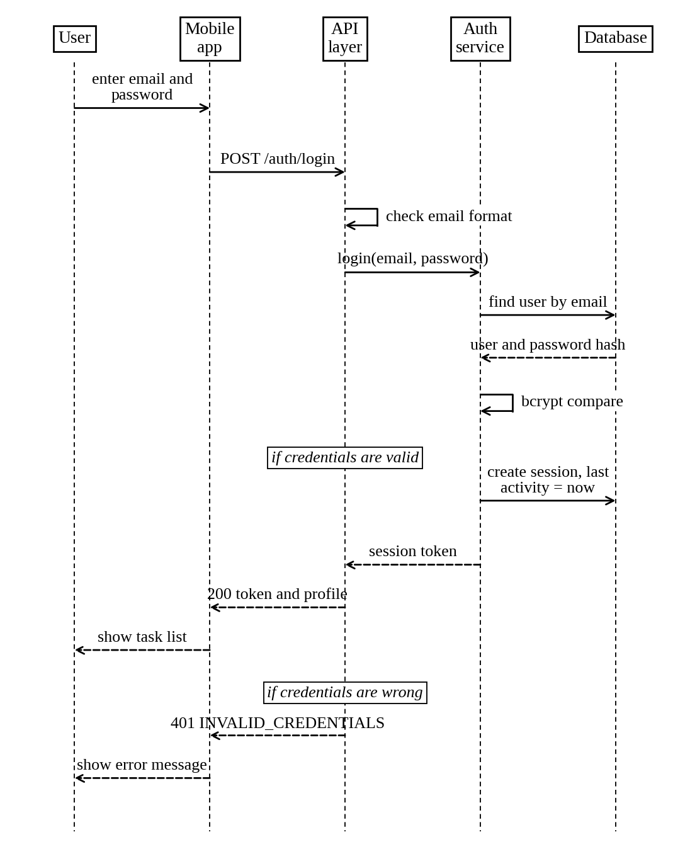
Figure 2. Sequence diagram for user login
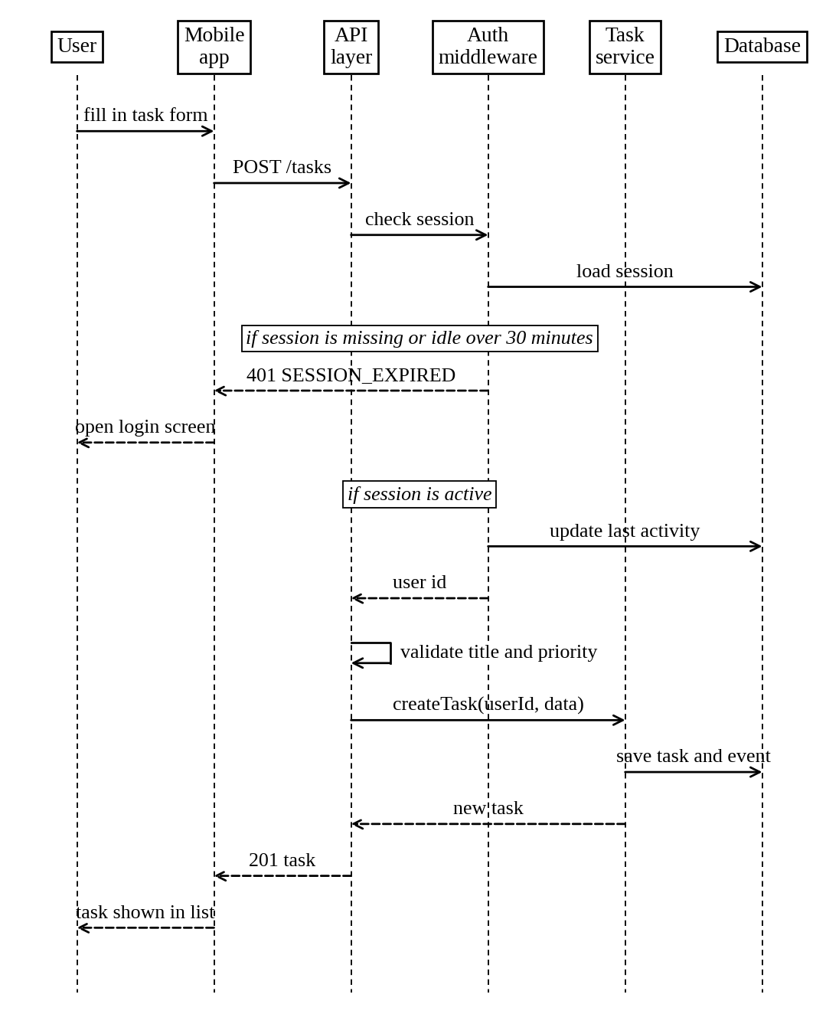
Figure 3. Sequence diagram for creating a task
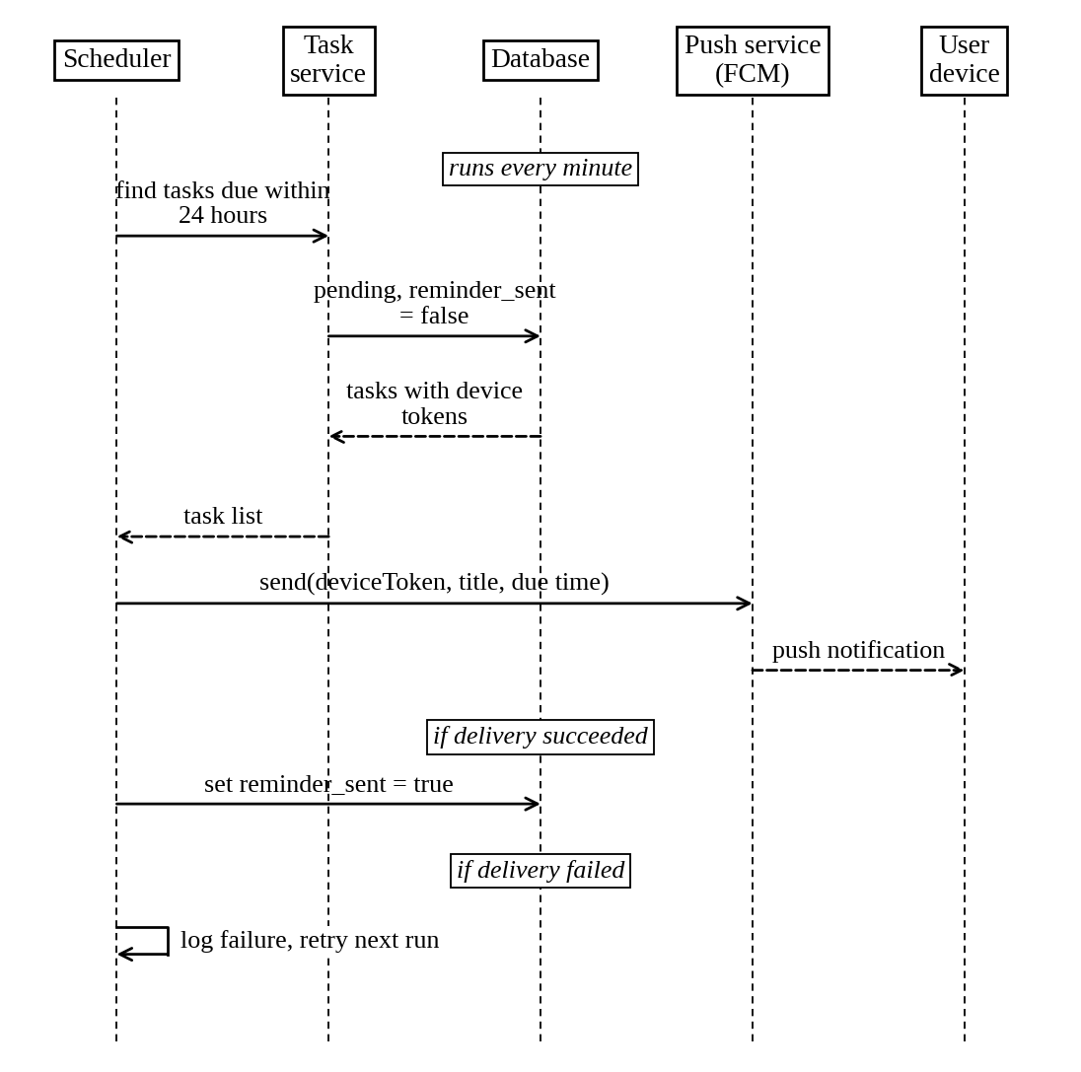
Figure 4. Sequence diagram for the due date reminder

4.3 API Design
All endpoints use HTTPS and JSON. Every endpoint except register, login and the two password reset calls needs the session token in the Authorization header. A missing, wrong or idle-expired session returns 401 SESSION_EXPIRED.
Accounts and profile
Endpoint | Request body | Success and errors
POST /auth/register | email, password | 201 with userId. 400 INVALID_EMAIL, 400 WEAK_PASSWORD, 409 EMAIL_EXISTS.
POST /auth/login | email, password | 200 with token and user. 401 INVALID_CREDENTIALS.
POST /auth/logout | none | 204.
POST /auth/change-password | currentPassword, newPassword | 204. 400 WEAK_PASSWORD, 401 INVALID_CREDENTIALS.
POST /auth/forgot-password | email | 202, same reply whether or not the email exists. 400 INVALID_EMAIL.
POST /auth/reset-password | resetToken, newPassword | 204. 400 WEAK_PASSWORD, 400 INVALID_OR_EXPIRED_TOKEN.
GET /profile | none | 200 with profile.
PUT /profile | fields to change | 200 with profile. 400 VALIDATION_ERROR.
PUT /profile/device-token | deviceToken | 204.

Tasks and categories
Endpoint | Request body or query | Success and errors
POST /tasks | title, description, dueAt, priority, categoryId (only title is required) | 201 with task. 400 TITLE_REQUIRED, 400 INVALID_PRIORITY, 404 CATEGORY_NOT_FOUND.
GET /tasks | query: status, priority, categoryId, dueBefore, dueAfter, sortBy, order | 200 with task list. 400 INVALID_QUERY.
GET /tasks/{id} | none | 200 with task. 404 TASK_NOT_FOUND.
PUT /tasks/{id} | any of title, description, dueAt, priority, categoryId | 200 with task. 400 VALIDATION_ERROR, 404 TASK_NOT_FOUND.
PATCH /tasks/{id}/complete | none | 200 with task. 404 TASK_NOT_FOUND.
DELETE /tasks/{id} | none | 204. 404 TASK_NOT_FOUND.
GET /categories | none | 200 with categories.
POST /categories | name | 201 with category. 400 NAME_REQUIRED, 409 CATEGORY_EXISTS.
PUT /categories/{id} | name | 200 with category. 404 CATEGORY_NOT_FOUND, 409 CATEGORY_EXISTS.
DELETE /categories/{id} | none | 204, its tasks become uncategorized. 404 CATEGORY_NOT_FOUND.

Dashboard
Endpoint | Request body | Success and errors
GET /dashboard | none | 200 with total, completed, pending, and counts by priority (low, medium, high).

A task id that belongs to someone else gets the same 404 TASK_NOT_FOUND as an id that does not exist, so the response says nothing about other accounts. This is how NFR-04 is met at the API.
Example request for creating a task:
POST /tasks {"title": "Submit SASD", "description": "Deliverable 3", "dueAt": "2026-10-10T17:00:00+05:30", "priority": "High", "categoryId": 4}
Response, status 201:
{"id": 812, "title": "Submit SASD", "status": "Pending", "priority": "High", "dueAt": "2026-10-10T17:00:00+05:30", "categoryId": 4, "createdAt": "2026-10-04T10:30:00+05:30"}

4.4 Error Handling, Logging and Monitoring
Every failure uses the same response shape, an error object with a code and a short message, for example TASK_NOT_FOUND with the message "Task not found.", along with the matching HTTP status. Messages are written for the user. They never include stack traces, SQL or anything about other users. Validation errors name the field that failed. When a session has gone idle for too long the server returns 401 SESSION_EXPIRED, and the app clears its stored token and opens the login screen.
Logs record the request id, user id, endpoint, status code, response time and error code. They never record passwords, session tokens, reset tokens, or the titles and descriptions of tasks. Failures from the email and push services are logged with a user or task id only.
Monitoring watches dashboard response time against the 3 second limit, the API error rate, failed logins, the share of reminders that were delivered, the time the scheduler last ran, and the date and result of the latest backup. Backups are triggered by hand, as the SRS says, and a restore is rehearsed during the recovery test (TC-REC-01 in the STP).

4.5 UX Design
The app is meant to be used with one hand on a phone. A bottom bar switches between Tasks, Dashboard, Categories and Profile. The task list shows the title, due date, a priority marker and a completion checkbox, with filter and sort controls along the top. Overdue and high priority tasks are marked with a label as well as styling, so the meaning does not depend on colour. The task form asks for the title first and puts the optional fields underneath, and the keyboard changes to suit each field. The dashboard opens with the summary counts, then the status pie chart and the priority bar chart, and shows a loading indicator while the numbers arrive.
Deleting a task or a category asks for confirmation. Form errors appear next to the field in plain words, such as "Password needs at least 8 characters with an uppercase letter, a lowercase letter, a number and a special character." Touch targets are at least 48 dp and text follows the system font size.

4.6 Open Issues and Next Steps
A few decisions are still open. We have to settle how the 30 minute timeout counts while the app sits in the background (the current plan is to count from the last API call), where the backend will be hosted, and what a reminder should do if the user changes time zone.
Next, the team will finalize the schema and write migration scripts, build the authentication and task modules first as the proposal planned, write the script that generates the 1,000 task account for NFR-08, document the API in Swagger, and complete the RTM so each component links to its test cases. Biometric login, recurring tasks and shared lists could come later, but they are outside the SRS.

5. Appendices

5.1 Glossary
Task, category, priority, dashboard and session are used as defined in the SRS. API, REST, FCM, SMTP, bcrypt, STRIDE, ADR and RTM are explained in Section 1.4. RBAC means role-based access control, TLS is the encryption used by HTTPS, and UML is the notation used for the diagrams.

5.2 References
Task Manager Application Project Proposal, SRS v1.0 and STP v1.0. IEEE 42010 for architecture descriptions. OWASP guidance on mobile and API security. NIST SP 800-63B for password and session handling. Firebase Cloud Messaging and PostgreSQL documentation.

5.3 Tools
Python with matplotlib was used to draw the diagrams in this document. PlantUML or draw.io can be used to edit them later. Swagger for the API definition, Postman for API testing, Android Studio and its emulator, and GitHub for source control.

