| How to control a robot? |
| --- |

Preparation:

One laptop computer with MindStorms Lego Robot Inventor installed, and a crane robot. Download the file from this folder [7th December Activity 1 draft plan and files - Google Drive](https://drive.google.com/drive/u/1/folders/1XnFZcZ534s7JHnxX0yqZm2ljNd4M0lXX). Please download Activity2forTASSpike.lms for the TAS Spike hub, or Activity2NewHub.lms for the new Lego hub. Please take the 12 arrow print outs to the activity.

The aim of this activity is to engage children on how to control a robot. There is no need to show this sheet to the children. This activity expects the participating children to do it in a group together.

1. Firstly, show the children how this robot works with two colours: red and black. A red colour block will be put into the red tray (featured by a red colour plug), and a black colour block will be put into the black tray (featured by a black colour plug).
2. Secondly, explain to the children that we are going to use machine learning techniques to control this robot now. We have two choices, images, and voices.
3. (~15 min) Let’s experiment with images first. Click the drop-down menu of a machine learning event “When prediction is”, choose to “create new model”, choose Images, provide minimum 8 samples to each class, including a background class, click done. Train the model. Choose to Activate when being prompted.
4. You can also choose to use the existing trained models by clicking the drop downs > Go to model library > Image Model 1 > Activate. If they don’t work, you can retrain them by editing the model.
5. Click the drop downs to assign the appropriate predictions to the machine learning events, for example, prediction Red to direction red, prediction Black to direction black, and prediction Background to the machine learning event that has no action.
6. Before downloading the code to the robot, adjust the angles of reset, goToRed, and goToBlack to the correct angles in the code. Because when repeatedly working with machine learning models, whenever a wrong prediction is made or different predictions interfere with each other, the motor angles might change significantly.
7. Download the code to the robot, click the start button to run it, let the children issue commands to the robot by holding the arrows to the camera. Make sure not hold the arrow image to the computer camera after the prediction has been made to avoid both predictions being interfered with each other. At the end, or if the predictions interfere with each other, show the yellow colour to the colour sensor, which will stop the prediction.
8. (~15 min) Then experiment with voices. Click the drop-down menu of a machine learning event “When prediction is”, choose to “create new model”, choose voice, record 20 seconds of background, and provide minimum 8 samples to each class, click done. Train the model. Choose to Activate when being prompted.
9. Repeat step (4) 5-7 as appropriate adaptations to the voice model.
10. (~15 min) Discuss with the children about their preferences of using voices or images when thinking about the previous experiences. Moreover, invite the children’s opinions and imaginations just for start/stop commands while the robot automatically executes the task with colour sensors. In the experiments of both models, a yellow colour will trigger the task of stopping the predictions. This experiment simulates full autonomy with emergency commands. We can reflect on how much the users trust the robot and if they feel safe having emergency commands.

Finally, ask, encourage, and discuss with the children about the Points to be taken:

Robots can be controlled by normal methods, and machine learning methods. An important concern is that the imprecision will lead to safety risks. However, this does not mean that machine learning is less secure than the traditional methods. In a well thought out and carefully prepared machine learning project, it could mean more security than a traditionally built project. Are you motivated to involve in such a trustworthy AI project in the future?

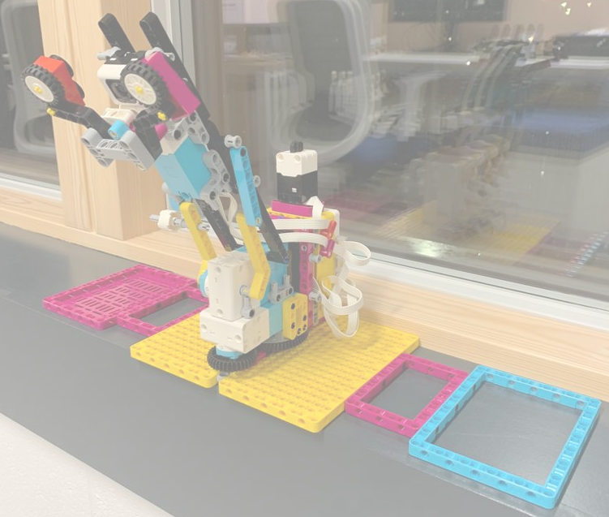

**How to control this robot and safely?**

Aim: understanding how to control a robot in a machine learning way