| Does the computer understand your pictures? |
| --- |

Preparation:

One iPad and one laptop computer. (Each for one child to draw, and then swap after 6 pictures). Both devices should turn on the sounds.

On both devices, open [Quick, Draw! (quickdraw.withgoogle.com)](https://quickdraw.withgoogle.com/), explain that the algorithm behind is a neural network.

There is no need to show this sheet to the children. This activity expects the children doing it individually, and you can swap to another child after 6 pictures.

1. Explain points 1-3 to the children. It is normal if the neural network can not recognize their drawings. It does not necessarily mean that their drawings are bad. They just need to draw an easy picture for the neural network to recognize each time. You can pause a few seconds and think about how to draw the picture before clicking the button.
2. Up to two children to draw each time. Allow 2.5 or 3 minutes to each child and let other children in the group to wait and observe. They are welcome to give advice on how to draw, as long as the child who is drawing is ok with it. Make them be aware that it is a game, not a test.
3. When the children don’t know the word to be drawn, tell them or allow them to google. Discussions are also allowed and encouraged.
4. There will be two rounds for each child, and each round has six pictures to draw, with 20 seconds each. Let the children click the “Let’s Draw” button. Swap the devices after the first 6 pictures.
5. At the end of the group, tell the children that it is normal if the neural network does not know what they draw because it relies on data. Show the data that the 50 million people around the world drew. There are multiple ways to show. You can click the “data” link on the final page, or go to the [home page](https://quickdraw.withgoogle.com/) and click the link of [world’s largest doodling data](https://quickdraw.withgoogle.com/data) set to show a lot of small pictures on the page, then click any of the small pictures, to show a whole screen of the same type of pictures. (Clicking “Play the Game” at the top right corner of the screen will take you back to the game.)

Finally, ask, encourage, and discuss with the children about the Points to be taken:

Neural network might not know what you are drawing. It relies on data.

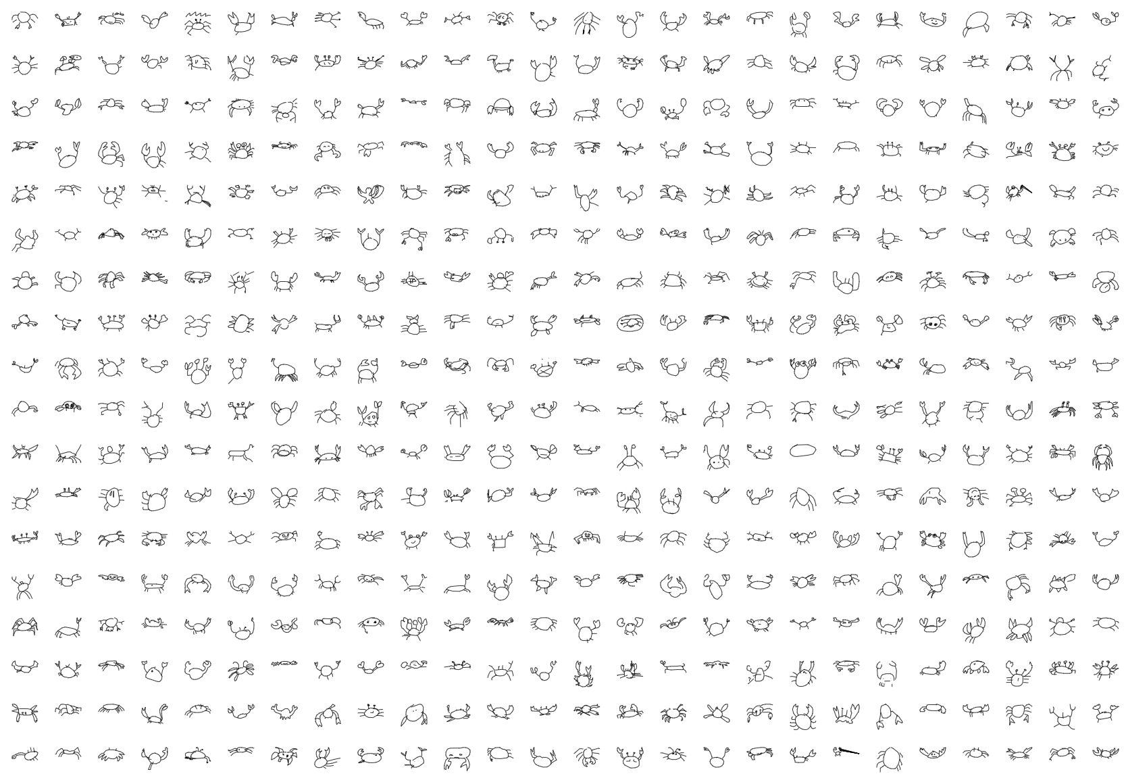

**Does the computer understand your pictures?**

Aim: understanding how computers recognize images