| |  |  | |  | | --- | --- | --- | --- | |  | |  | |   Zombie Escape! |
| --- | --- | --- | --- | --- | --- | --- | --- | --- |

Preparation:

Download zombie-escape (updated).sb3 in this folder [7th December Activity 1 draft plan and files - Google Drive](https://drive.google.com/drive/u/1/folders/1XnFZcZ534s7JHnxX0yqZm2ljNd4M0lXX). Open <https://scratch.machinelearningforkids.co.uk/> -> File -> Load from your computer, select the downloaded file. In the upper right screen, click the full screen control button .

Print out page 2-4 in use to explain the features to the children.

This activity is for the children to do in a group.

Show the feature table page to the children. Then explain to the children:

You are trapped in a huge hotel that has been overrun by zombies! You need to train your robot to learn the way the zombies behave, and what sort of places the zombies seem to like. To save your time, it is trained already, you can use the predictions it makes to guide you to safety. There are 12 features for each room. We will tell you the meaning and the importance of each parameter. Can you take the advice and work out which room does not have Zombies each time? Your mission is to escape the zombies. Good luck! 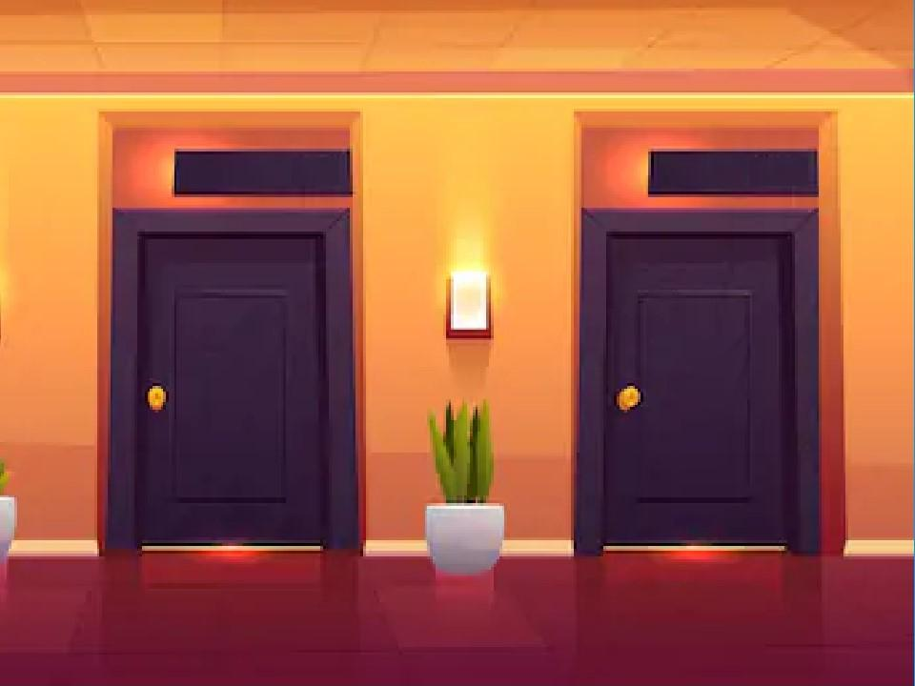

Children: Click “Escape” to run. Let them try with no information for a few rooms. Then discuss what zombies like, what will affect them. Show them page 2 (or 2-4) and explain. Then let them try again.

 This http://creativecommons.org/licenses/byproject worksheet is licensed under a Creative Commons Attribution Non-nc-sa/4.0/-Commercial Share-Alike License

| **Ask them: What information do you think will be the most useful to your robot to predict whether there is a zombie lurking behind each door?**  Then explain the Help table (advice and the bar chart) information to them. Give the children half or one minute to think and discuss. Leave the mouse to them. |
| --- |

| **Lighting type**    This sensor will tell you the type of lighting in the room – e.g. fluorescent tube, or halogen bulb. | **Humidity**    This sensor will tell you how damp the room is, by measuring the humidity percentage in the room. |
| --- | --- |
| **Temperature**    This sensor will tell you the temperature in the room in °Celsius. | **Wall colour**    This sensor will tell you what colour the walls in the room are. |
| **Floor type**    This sensor will tell you what the floor is covered with – e.g. carpet. | **Number of chairs**    This sensor will tell you how many chairs are in the room. |
| **Room size**    This sensor will tell you how big the room is, by measuring the floor space in square metres. | **Number of windows**    This sensor will tell you the number of windows in the room. |
| **Brightness**    This sensor will tell you how bright the room is in lux. | **Noise level**    This sensor will tell you how noisy the room is in decibels. |
| **Number of mirrors**    This sensor will tell you the number of mirrors in the room. | **Room number**    This sensor can read the room number from the room door. |

| **Help** | |
| --- | --- |
| **Advice** | * Choosing more than five sensors will work (and can result in a more accurate model) however it makes the Scratch script more complicated to make. * Choosing fewer sensors (e.g. 3) will make the Scratch script much simpler, however it may result in ML models performing less well. * I wouldn’t recommend sharing the following information with students until the end of the lesson, but if it’s helpful for you to answer their questions about what they’re seeing in their projects, the zombie behaviour is as follows:   **Lighting** – Zombies don’t like harsh lighting. They prefer no lighting at all, and like halide lighting least of all. In order (from least likely to have zombies to most): strongest, strong, medium, weak, none.  **Humidity** – Zombies like it damp. The more humid, the more likely to find a zombie.  **Temperature** – Zombies prefer room temperature – very cold or very hot temperatures make zombies less likely. The colder/hotter, the less likely they are. This has a big difference on whether you’ll find zombies.  **Wall colour** – Zombies very slightly prefer dark colours like black or brown, but this only makes a very small difference to which rooms they’re in.  **Floor type** – Zombies don’t care about floor type. This makes no difference.  **Number of chairs** – Zombies don’t use chairs. This makes no difference.  **Room size** – Zombies prefer bigger rooms, but this makes only a small difference.  **Number of windows** – Zombies can get in through the windows, so more windows do make zombies a bit more likely.  **Brightness** – Zombies prefer the dark. Darkness makes them much much more likely. This makes a bigger difference than anything else.  **Noise levels –** Zombiesdon’t care about noise. This makes no difference.  **Number of mirrors** – Mirrors help make you jump when you see a zombie, so a mirror in the room will make a zombie a little more likely, but the number of them doesn’t matter.  **Room number** – Zombies don’t read, so the hotel room number makes no difference.    There is some correlation between the values – e.g. strongest lighting and number of windows can make a higher brightness more likely, whereas no lighting and no windows makes a lower brightness more likely. |

|  | The relative impact of the different sensor values can be seen below:  Chart, bar chart  Description automatically generated  This means a student who picks: “room number”, “noise”, “flooring”, “chairs”, “wall colour” as their five sensors will have a machine learning model that performs very poorly and will probably make mostly inaccurate predictions.    It also means a student who picks: “brightness”, “temperature”, “humidity”, “lighting”, “windows” as their five sensors will have a very accurate machine learning model that allows for a perfect escape. |
| --- | --- |

Finally, ask, encourage, and discuss with the children about the Points to be taken:

Machine learning has many features and some of them are more important than others. However, because machines learn by themselves, sometimes they make mistakes that humans could not understand.

Experience to escape successfully:

Lighting, Brightness, Humidity, and temperature are important.

There is also some correlation between the– e.g. strongest lighting and number of windows can make a higher brightness more likely, whereas no lighting and no windows makes a lower brightness more likely.

When they contradict, the number of features can offset each other. When the numbers of features equal, the extent of their influence matters. Alternatively, if precisely speaking, what really matters should be the sum of the products of features by their weights. This game gives people a direct feeling of how the machine learning formula works.

Above five features can make successful escapes over 90% of the time.

**Can you escape the zombies?**

Aim: understanding features that lead to safety