Documentation

EDUPMSv-0.91 (Alpha)

(CSE Department)

East Delta University, CTG

TOC:

* Intro
* Back-story
* Intended users
* Features
* How-tos
* Limitations
* Future feature-plan
* Conclusion
* Special thanks

1Intro_

PMS stands for Patient Management system. EDUPMS is a patient management system which is based on AdminLTE. The main purpose of this Application is removing barriers for doctors, patients. Also making appointment and prescription management process trouble-free, reliable and convenient.

2 Back-story _

We strongly believe that, those who are in acute need of basic and vital needs deserve services to fulfill their needs first, before any other services or goods that are optional or not as vital as basic needs.

Receiving treatment service is one of those basic needs that everyone deserves, which is crucial for the existence of humankind. The healthcare sector is providing different services to the masses, and it has its specific needs and limitations. They are doing a tremendous job for the society, which is vital, we respect it.

We realized that If we could build a solution that will serve those needs and remove limitations, that will bring a lot of value to those lives, save time, and improve human lives in general, here on earth. And we loved it.So we asked ourselves a question.

What is that one fear ... which we can remove from it, build a service around it, and then improve it?

We found that there are many, but we needed at least one that we can start work with. We thought the fear of losing prescriptions is a fear that causes a lot of sufferings to the both groups (doctors and patients) when it is manually managed, and is more acute in patients. So we decided to work on it first (of course with other benefits as well). We wanted to make the solution around software application this time, preferably a web application.

Looked like it is possible. And with the power of software application, we can achieve a lot. Then we counted two more additional questions,

. Can we make the whole process easier and smoother?

. Can we automate the workflow?

When it comes to software engineering, we knew that these were possible. We agreed and decided to move forward. As a result, a new name was born, which became the name of our project –

[ EDUPMS ]

3Intended users_

The application is aimed for doctors and their patients. Additionally, clinic admins can also use the application to manage their administrative works (Including assistant management).

4Features_

Added features:

1. Registration of patients up to 100,000

2. Separate dashboard for both doctor and patient

3. Visiting doctor profile and getting an appointment (for patients)

4. Visiting patients profile, viewing their prescription history, and prescribing to patients (for doctor)

5. Viewing daily patients list and their status (for doctor)

6. Viewing prescription history (for patient)

5How-tos_

5.1. Logging in, logging out and registering a new membership:

5.2. Adding appointment (from a patient account):

5.3. Writing prescription (from doctor account):

5.4. Viewing daily patients list(from doctor account):

5.5. Viewing prescription history(from a patient account):

5.6. Changing password and personal info:

5.1. Logging in, logging out and registering a new membership:

To login to EDUPMS enter your email and password, which you used to create a patient account (if you are trying to login as a patient) or enter email and password for the doctor account and then click on “**log in**”.

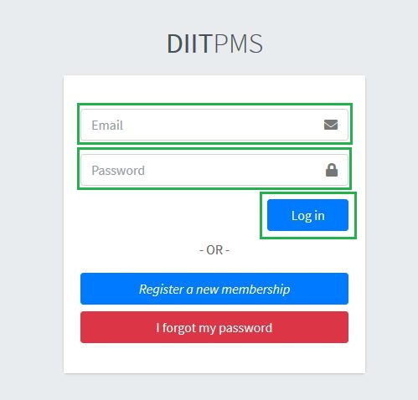

To log out, click on the down arrow button located on the top right corner of the page, and then click on “**Log out**”.

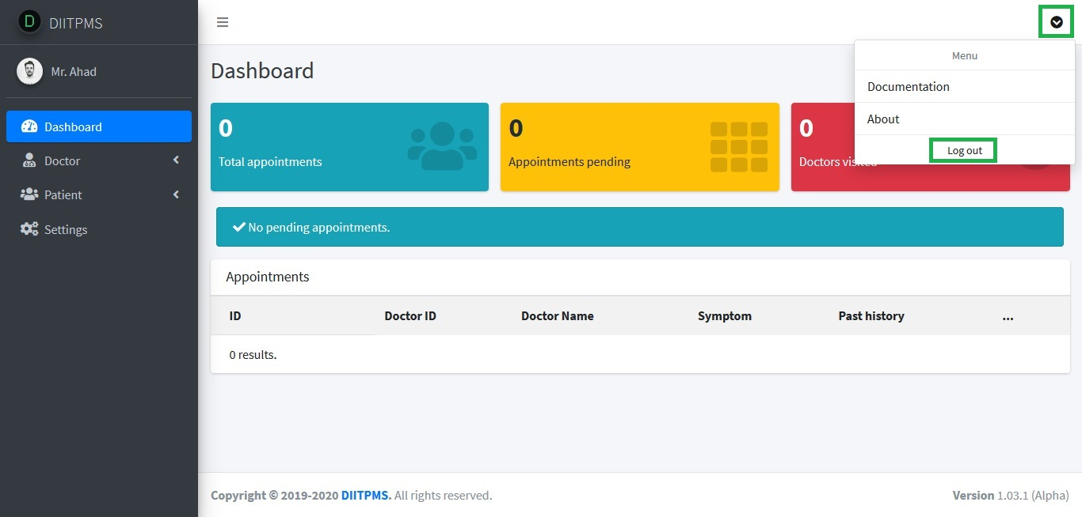

Additionally, you can register for a patient account by clicking on the “**Register a new membership**” button from the login page.

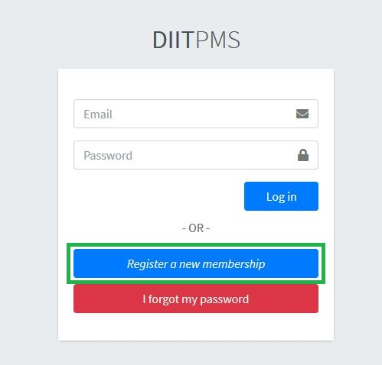

5.2. Adding appointment (from a patient account):

To add an appointment login as a patient. Then from the left panel menu, click on “**Doctor**” and then from submenu click on “**Add appointment**”.

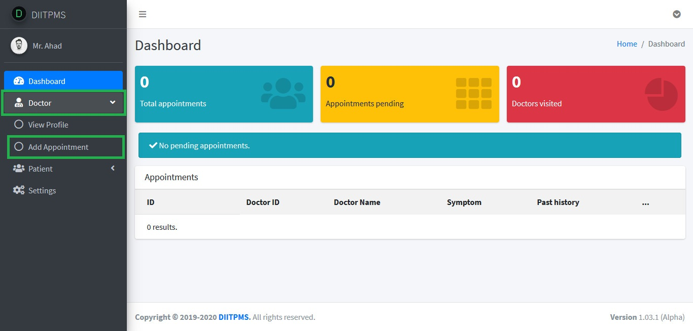

Appointment page will appear, give details about symptoms, past history, blood pressure and test result, and then click on “**Submit**”.

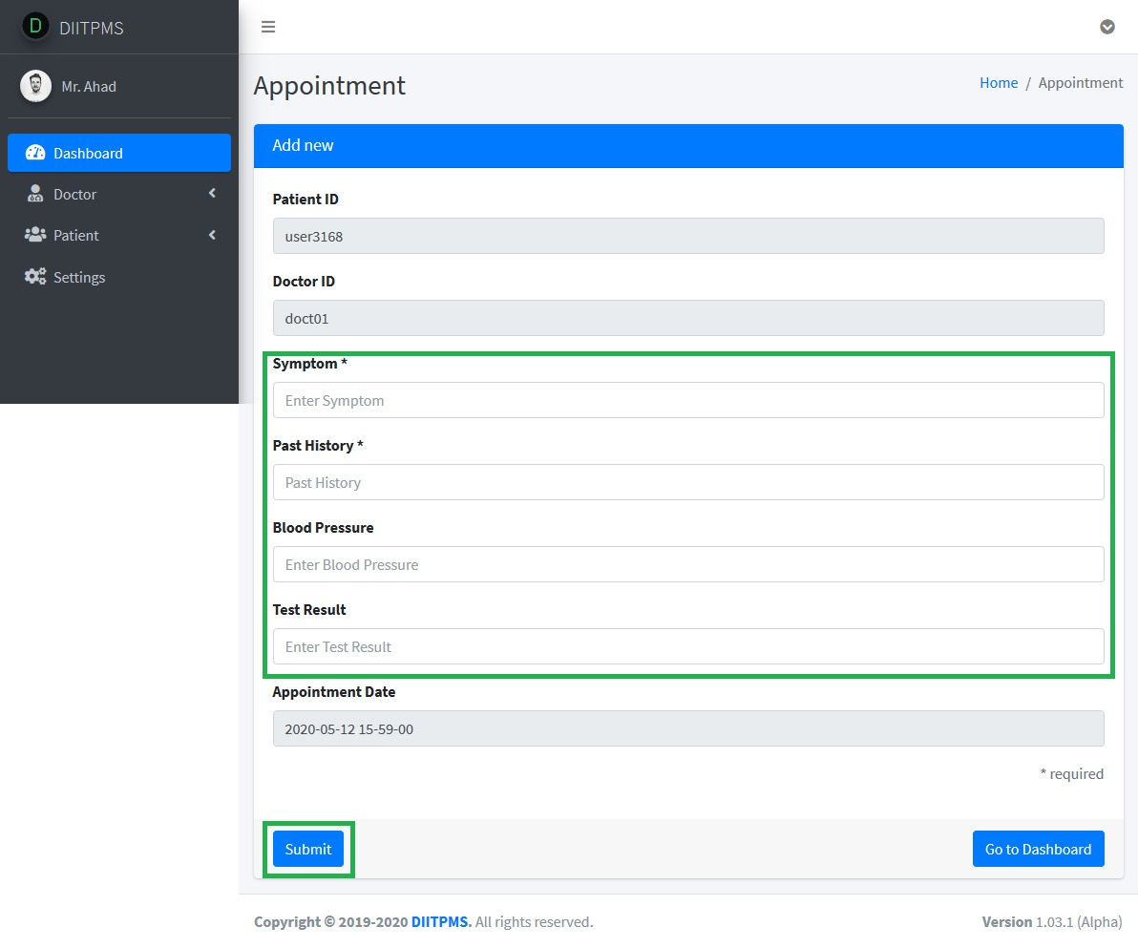

A confirmation message will appear on top of the page.

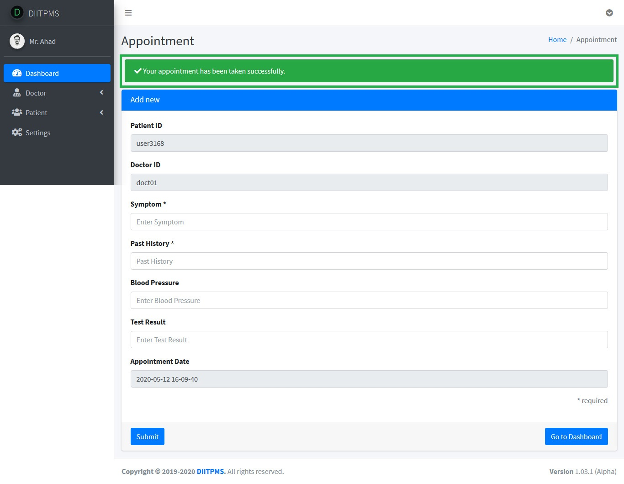

5.3. Writing prescription (from doctor account):

As a doctor you can write prescription for your patients. To do this, log in as doctor. The dashboard will appear, from appointment list click on “**View Patient**” button. It will take you to patient status page.

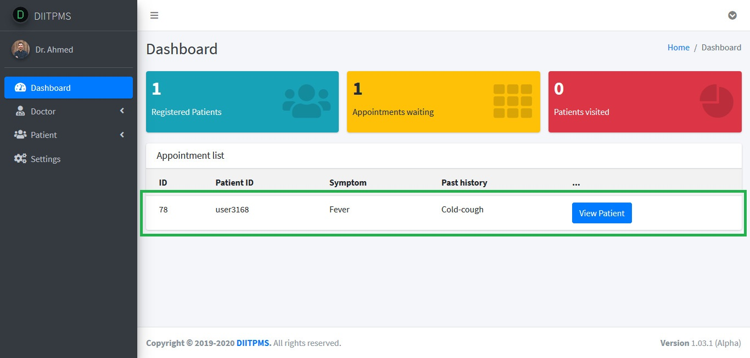

From that page you can either click on “**View History**”or “**Prescribe**” button. Click on “**View History**” button to view patient’s history.

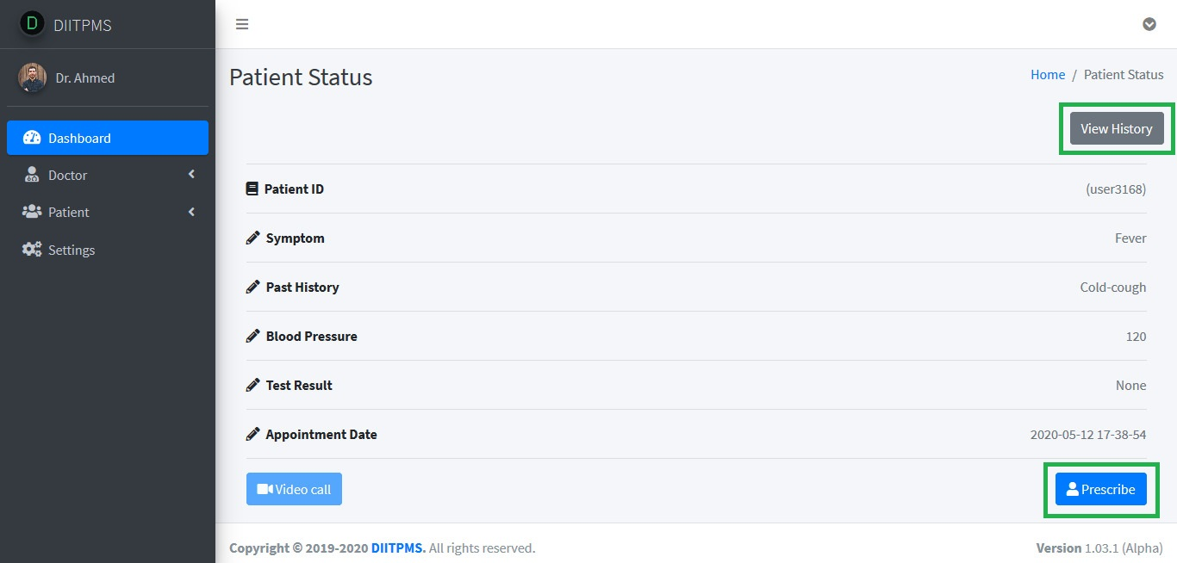

History page will appear. To go back, click on the “**back**” button of your browser to go to patient status page again. Then click on “**Prescribe**” button to prescribe.

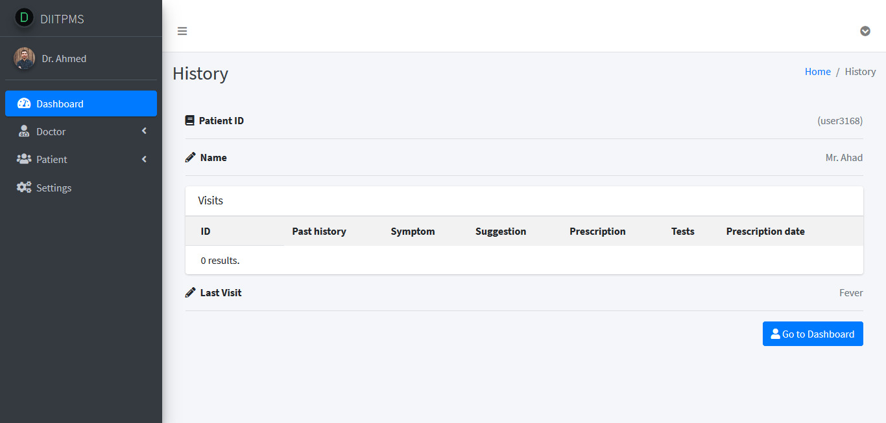

Fill in the fields including prescription and then click on “**Submit**” button, to submit your prescription.

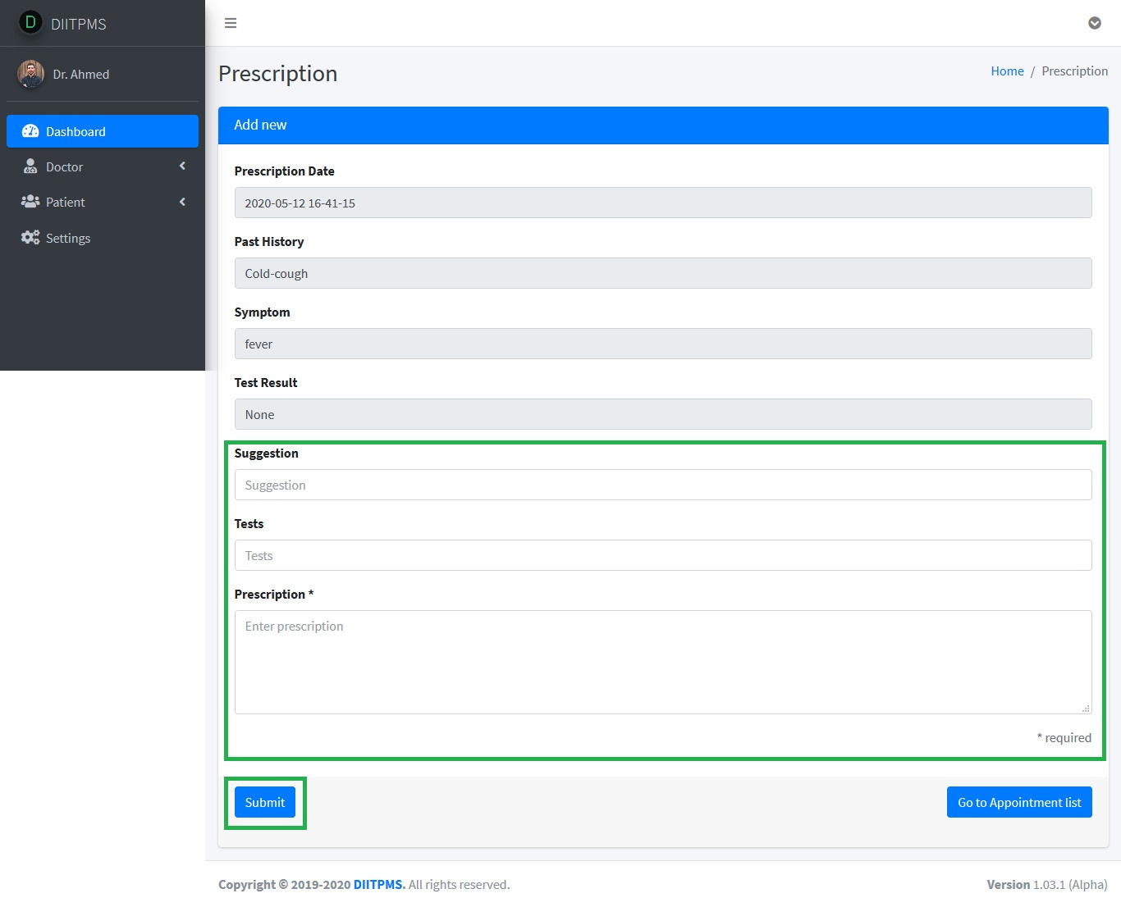

A confirmation message will appear on top of the page.

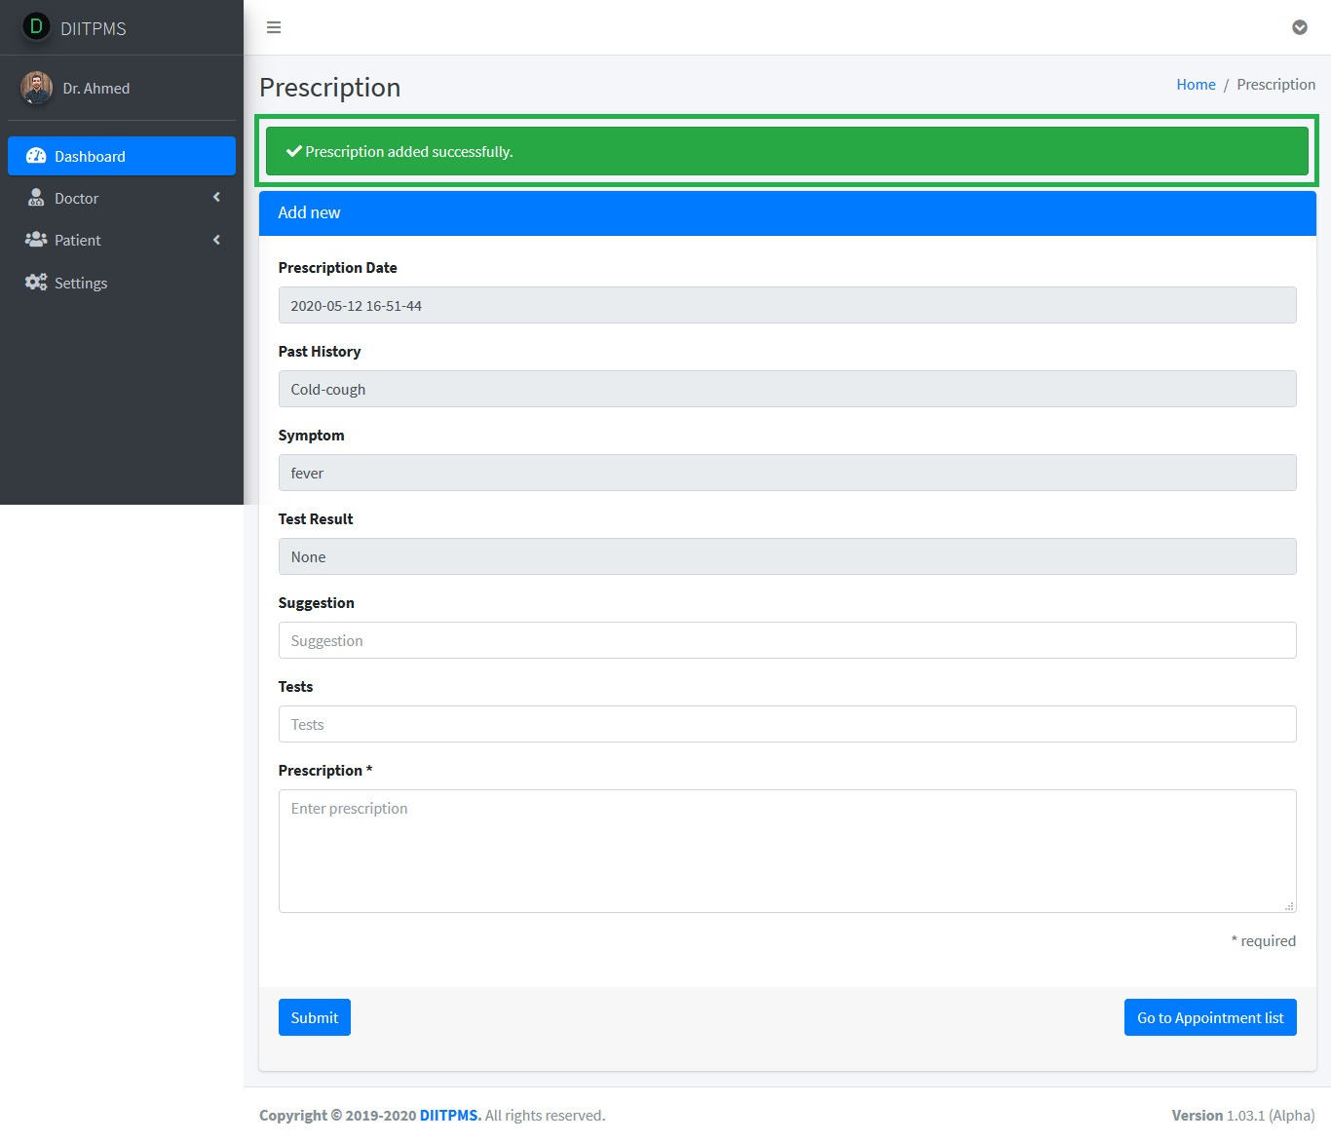

5.4. Viewing daily patients list (from doctor account):

A doctor has the option to view daily patients. To do so, log in as a doctor, from the left panel menu click on “**Patients**” and from the submenu click on “**View patients today**”.

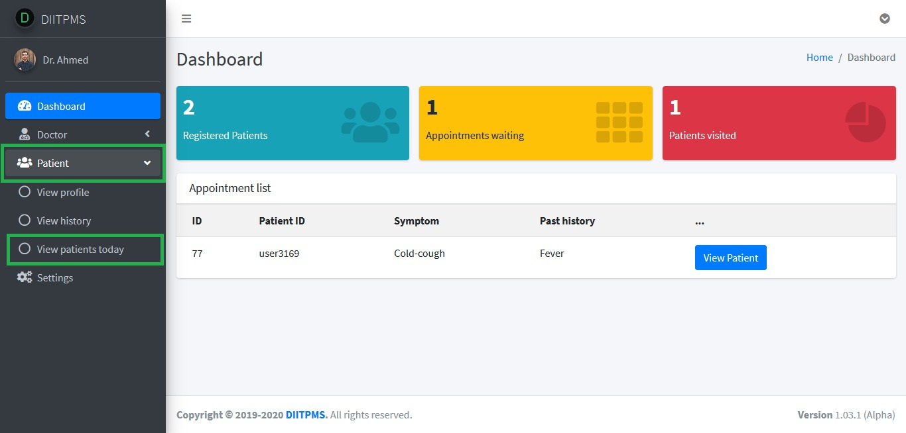

You can verify patient status as well. Here’s how it looks like -

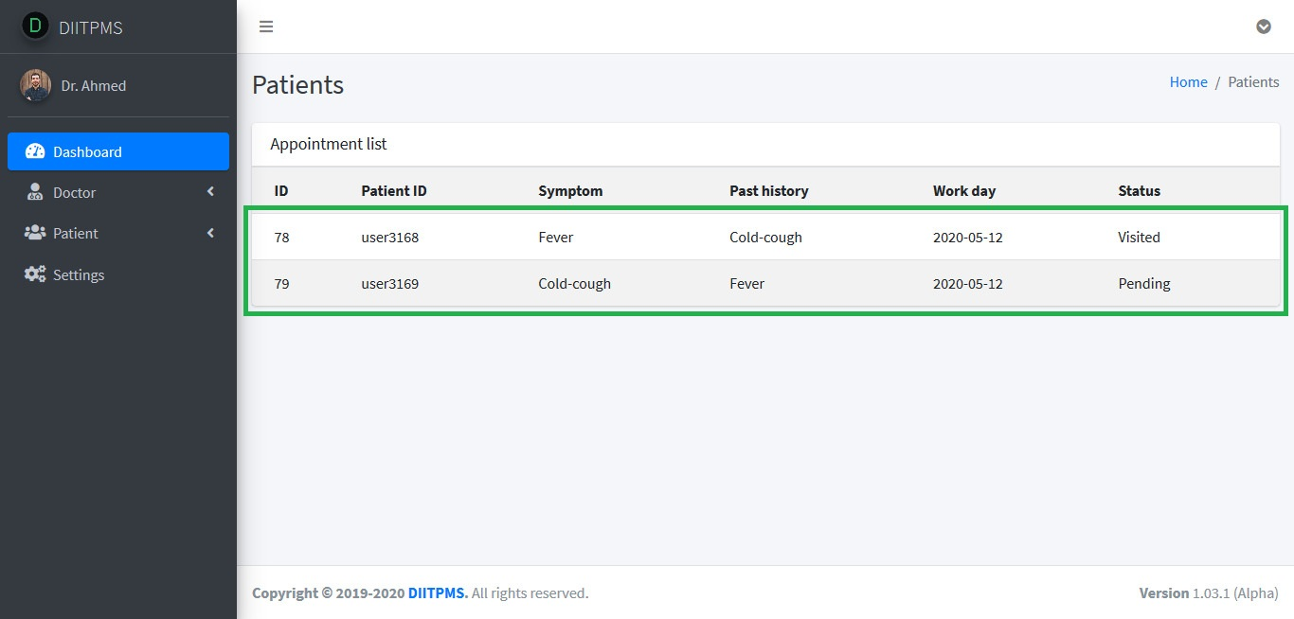

5.5. Viewing prescription history (from a patient account):

A patient has the benefit to view their past prescriptions as prescription history. To do this, log in as a patient, from the left panel menu click on “**Patients**” and from the sub-menu click on “**Prescription history**”.

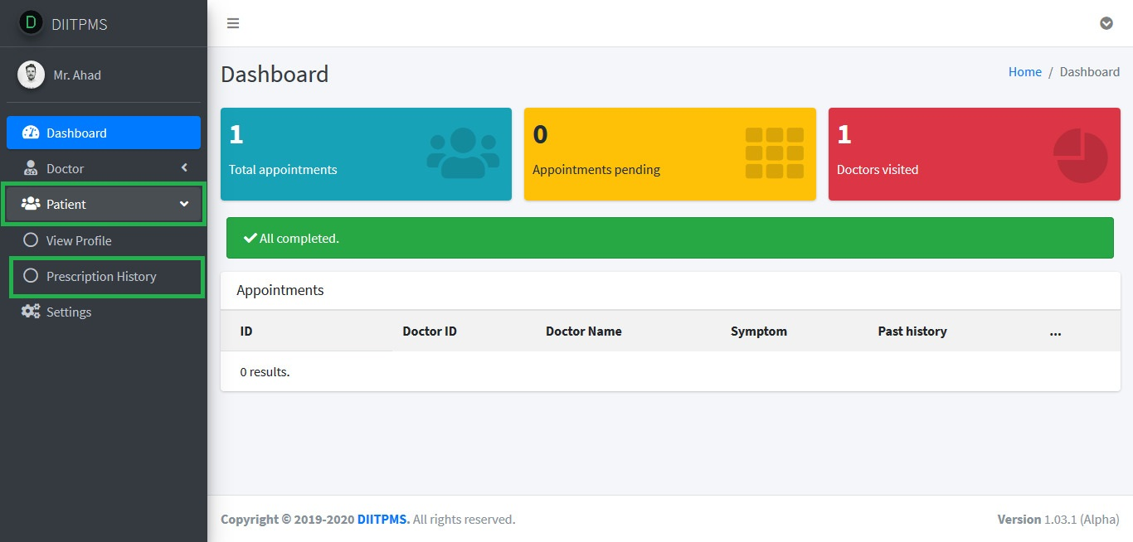

Here’s how it looks like -

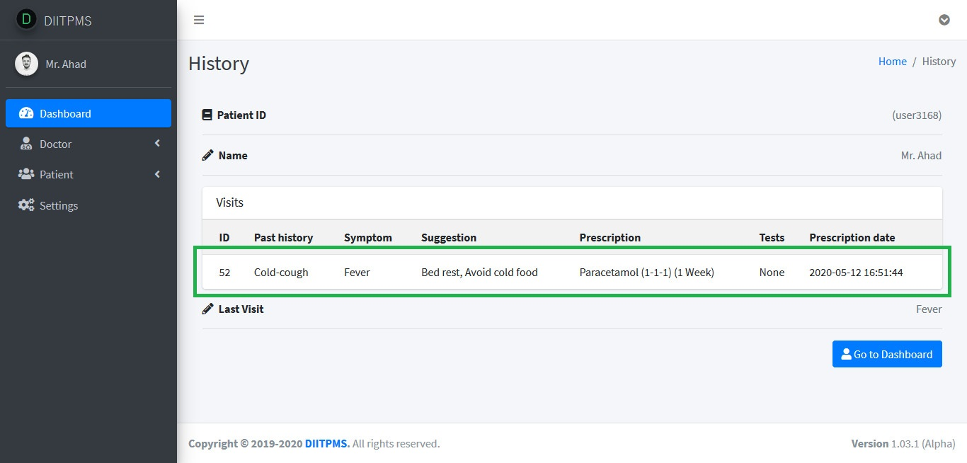

5.6. Changing password and personal info:

This feature is currently available on patient profiles only.

To change your password or personal info, log in from a patient account. From the left panel menu click on “**Settings**”.

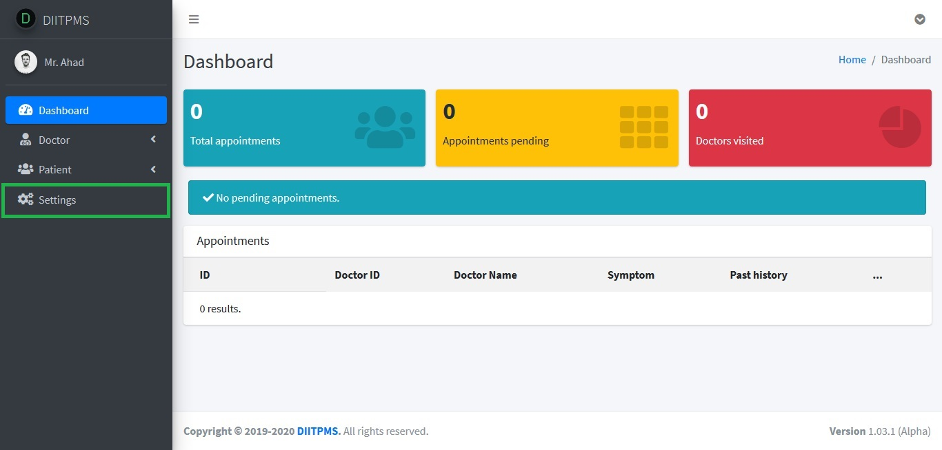

Now from right side of the page you can change your password and change your personal info.

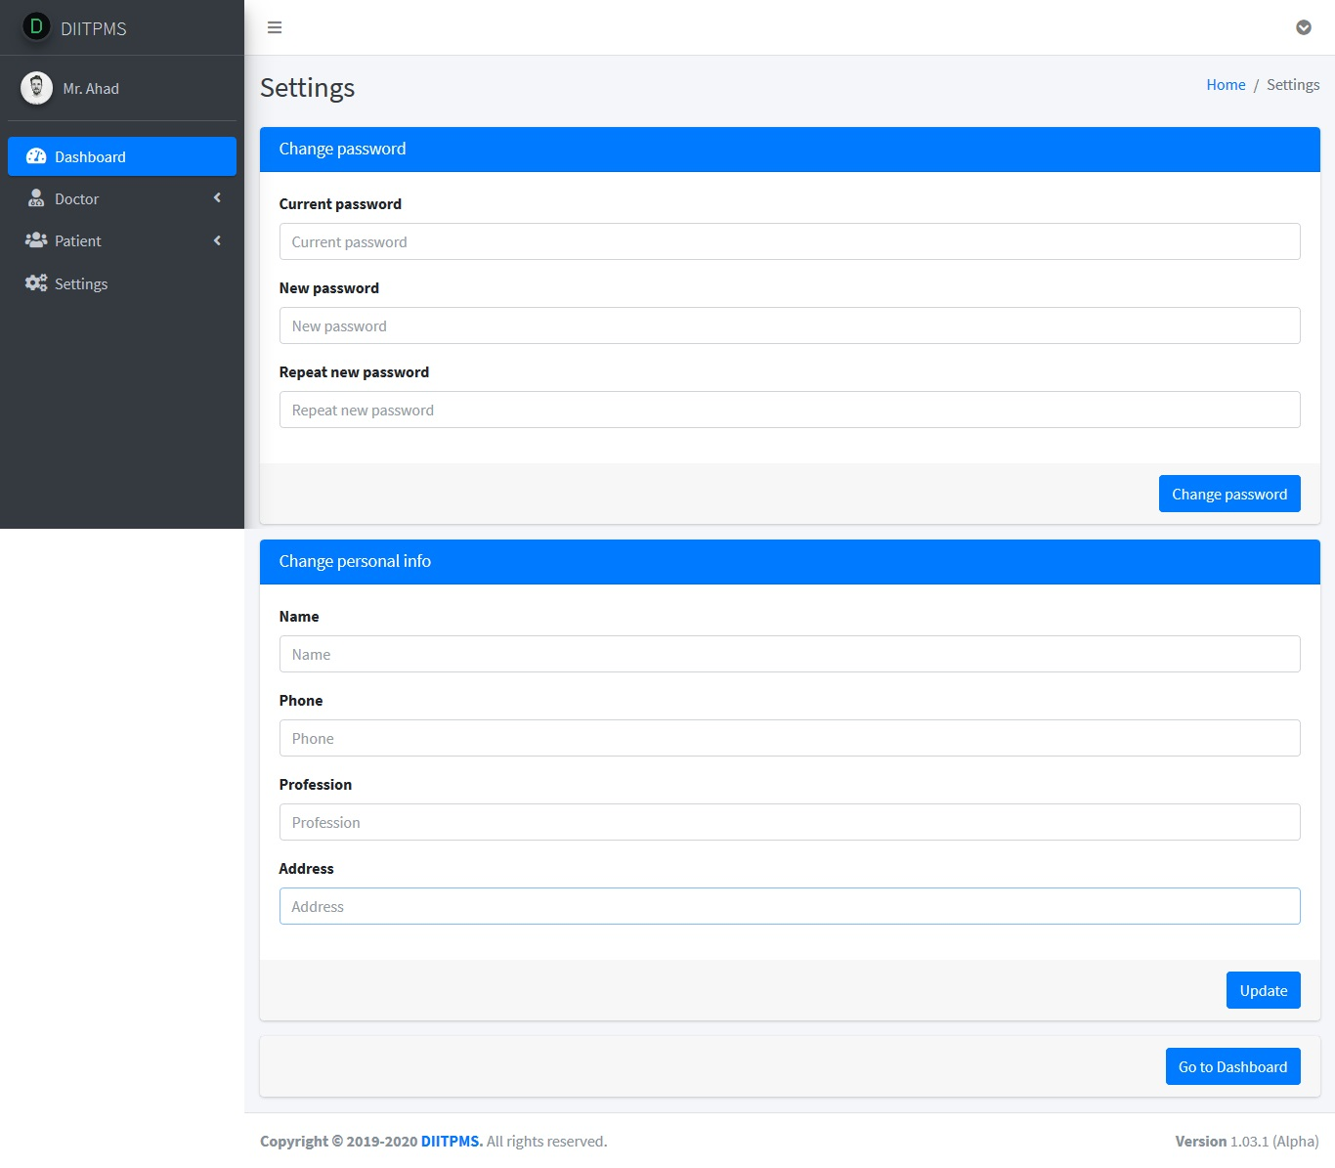

To change your password, provide current password, new password and repeat new password, and then click on “**Change password**”. You will get a confirmation on top of the screen.

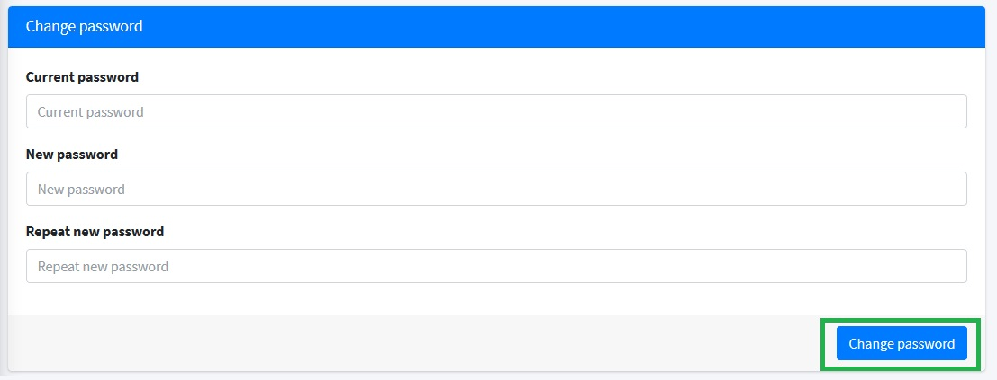

To change personal info, from the Change personal info section, add your new details and then click on “**Update**”. You will get a confirmation on top of the screen.

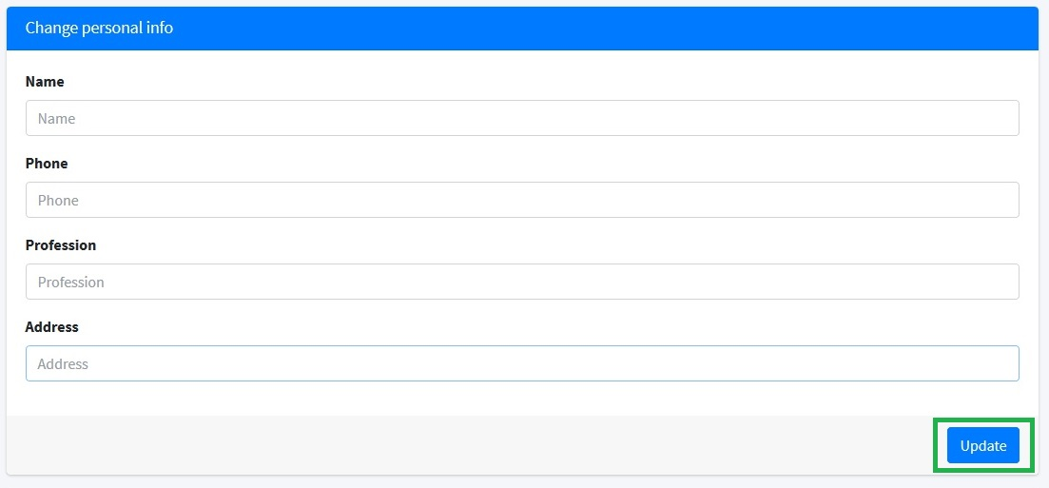

6Limitations_

Currently the application is capable of handling patients up to 100,000.Saving appointments and prescriptions to the database is fully functional. Patient’s registration module of the site is not fully complete yet, and there are scopes where we can improve it further, to make it fully stable and smoothly operational. Another known limitation is that the beta version supports only Single Doctor Login system.

Please note that the application is in its beta version, which means it is still under development. Beta versions are mostly functional, but those are not out of exceptions.

7Future feature-plan_

We’ve tried our best to make the application as simple as possible, and make it user-friendly to facilitate better user experience. But we think and believe that a lot more can be achieved and more useful features can be added (like video calling feature) to make the experience even better.

In the future, if we can release a final full version of it, it will be nice to work with some new features like –

. Messaging feature

. Generating monthly revenue

. Sending reports to doctor (from assistant account)

8Conclusion_

Thanks for your interest in EDUPMS. We look forward to hearing from you about it and any feedback to improve it is highly appreciated.

Send it here, if you have any- acacdmml@gmail.com

Thanks for reading.

9Special Thanks_

Special thanks to –“Supervisor”. For assistance, suggestions and support.