**CSCI 544 HW6**

**Qifan Wang**

**9369314001**

1.2.

this part is copied from 1.1 report, just to show the improvement I have got.

POS tag identify

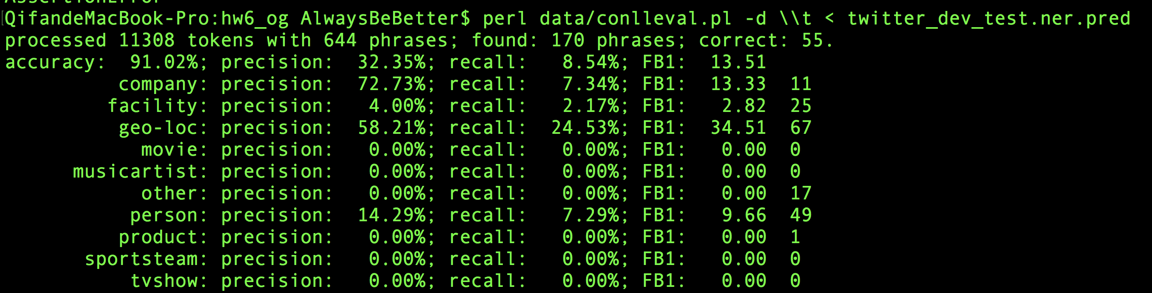

The original logistic regression on the test file gives about 13.51 score.

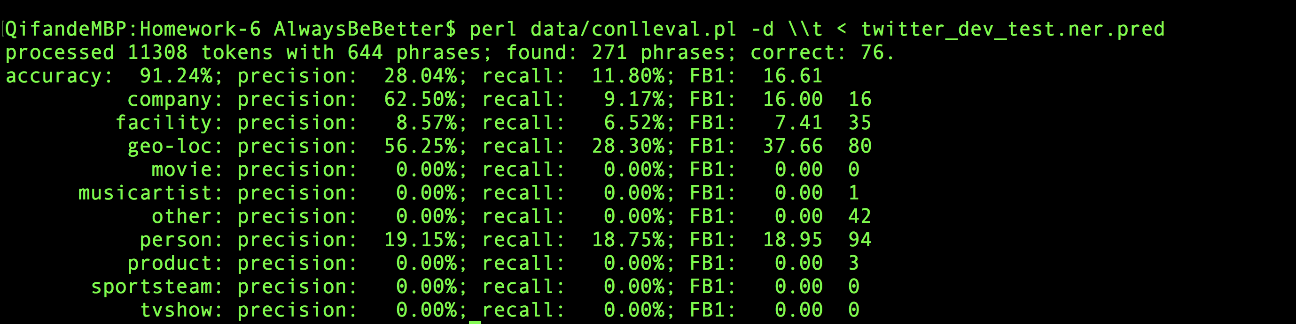

And after I add these feature, it improve up to 16.61, especially when I added word[:3] and word[-3:], it goes up quite a bit.

Also, the a very important part lexicons joined after I implement these basic feature improvement.

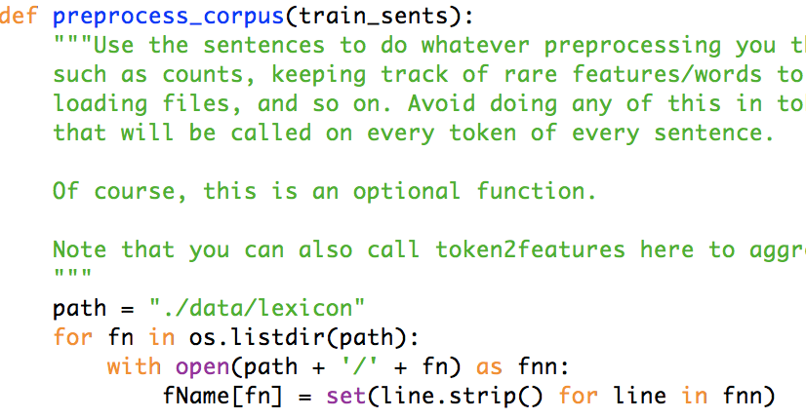

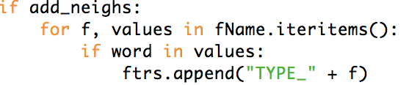

first of all, I just achieve some very simple goals, which are searching words inside the lexicons dictionary, if it exist, then tag added.

And here is what the result improvement looks like.

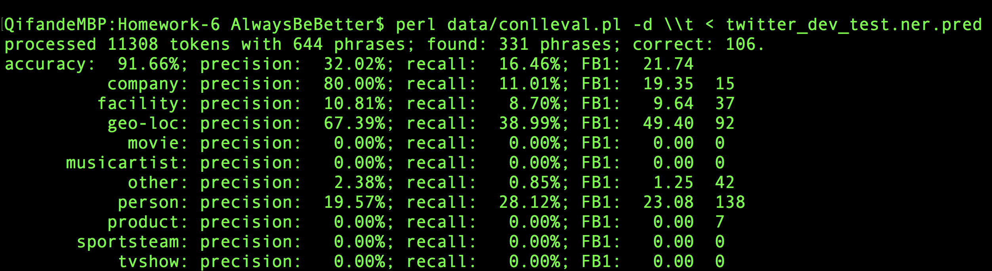

from 16 up to 21 almost 22.