**CSCI 544 HW6**

**Qifan Wang**

**9369314001**

2.1.

The pseudo code is pretty straight forward,

Assume it is an N x L matrix.

for each state i from 1 to L:

back_pointer[0,i] = -1

viterbi[0,i] = start_scores[i] + emission_scores[0,i]

for each state i from 1 to N:

for each state j from 1 to L:

for each state k from 1 to L:

current_score = viterbi[i-1,k] + trans_scores[k,j] + emission_scores[i,j]

if current_score > viterbi[i,j]:

viterbi[i,j] = current_score

back_pointer [i,j] = k

**Description**:

The above pseudo is a modified version specifically for this assignment, and it is pretty straight forward. For the first for loop, it just initialize the very start of this data matrix (which need start scores).

For the second for loop, it just implement the equation

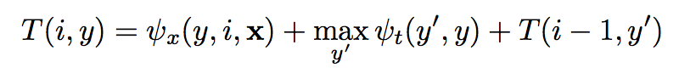

into code, basically it means that current score is the score of previous data matrix value (where it comes from), plus the transition score from previous cell to current cell, and plus the current cell value, and it matches the equation goals. Then if the current score is bigger than current cell value, it update, and the back pointer will record the position of where it comes from.