**CSCI 544 HW6**

**Qifan Wang**

**9369314001**

3.1.

I believe CRF is the better solution to solve sequence tagging problem. By using feature engineering, tasks will create a lot difference in CRF model, which will result a bigger improvement in the final score. However for the logistic regression, I think the parameter is relatively similar, which will cause a resistance for changing and give similar result. Since this question is pretty similar, I will do more explanations in 3.2.

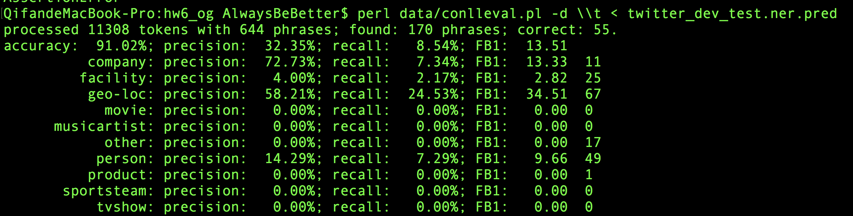

Original Logistic Regression

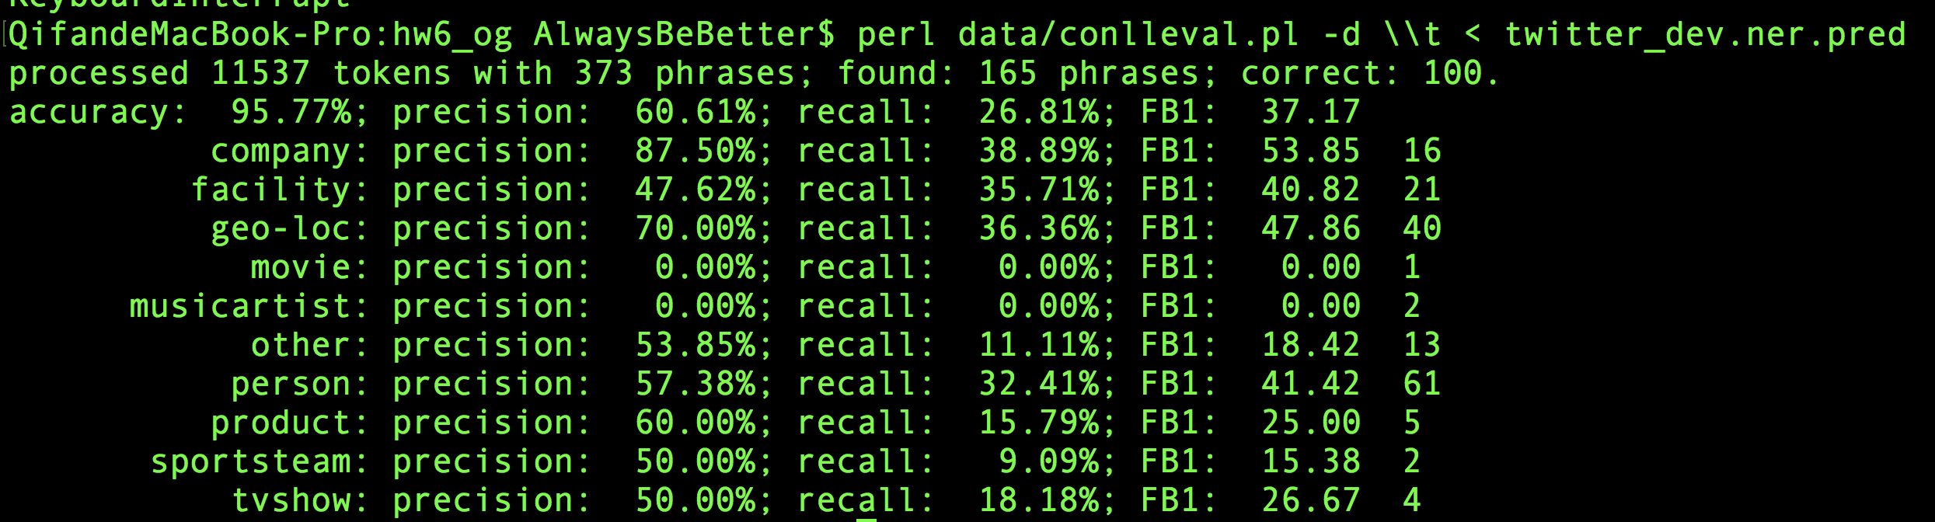

Original CRF

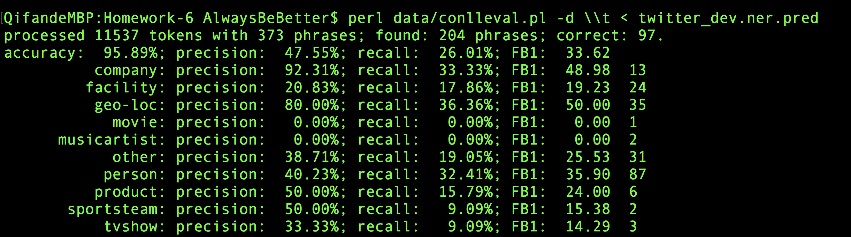

Featured Logistic Regression

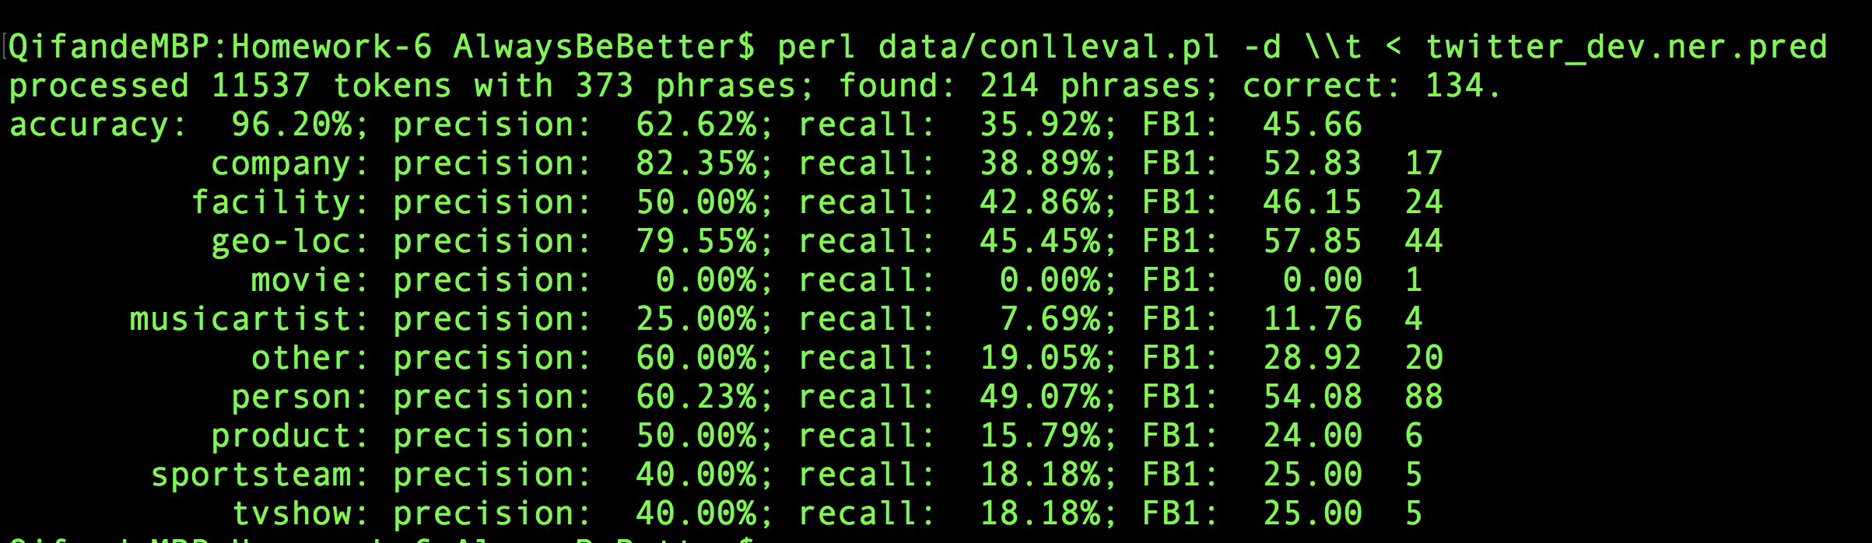

Featured CRF