**CSCI 544 HW6**

**Qifan Wang**

**9369314001**

3.2.

As I explained in 3.1 with the picture, CRF is obviously the better solution to solve sequence tagging problem, and the result matched my result. The reason I give is the same as 3.1, by using feature engineering, tasks will create a lot difference in CRF model, which will result a bigger improvement in the final score. However for the logistic regression, I think the parameter is relatively similar, which will cause a resistance for changing and give similar result. But interestingly, for some reason, while I tuning the parameter for some non-lexicons features, the logistic show the result is different, but the conlleval shows non-difference. So combined with all result, it seems like all crf results are higher then logistic regression by 10 of the score.

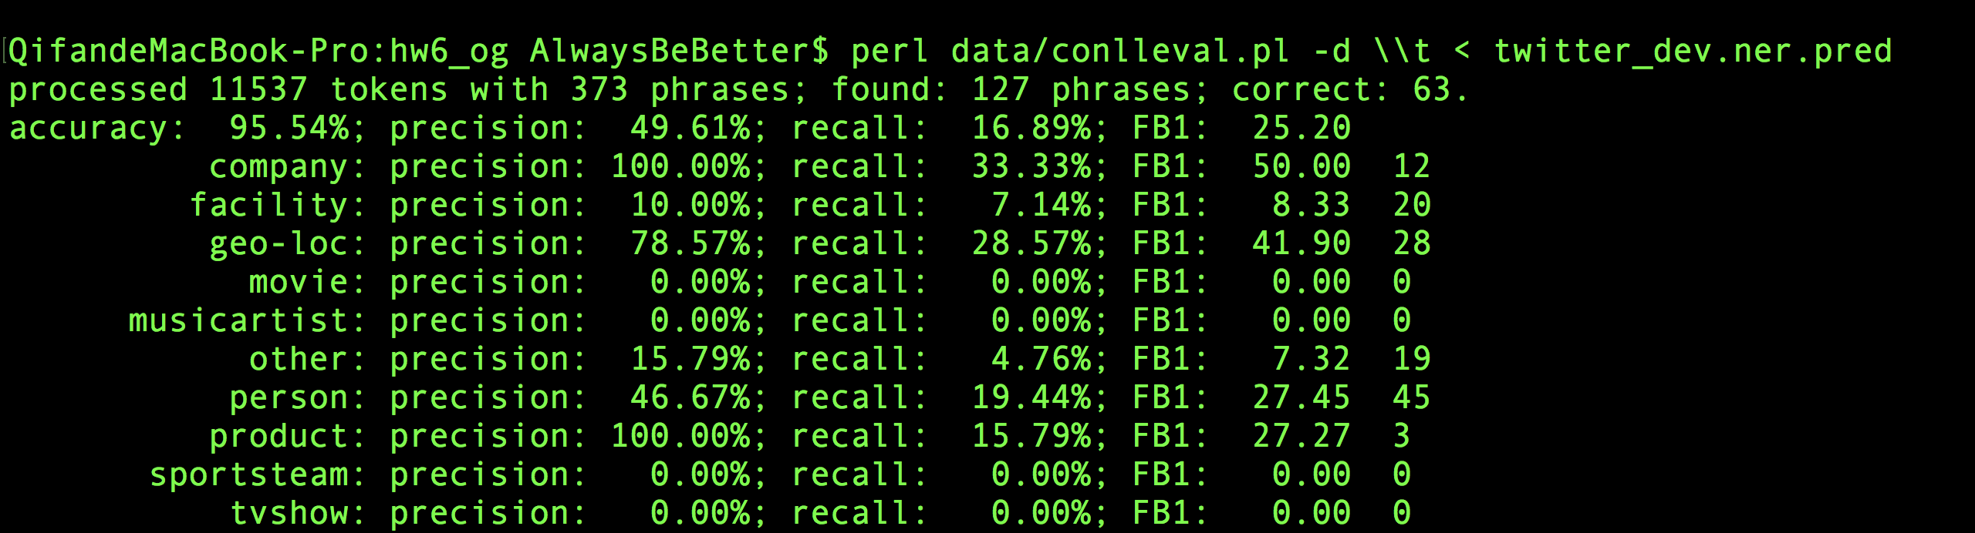

Original Logistic Regression on dev

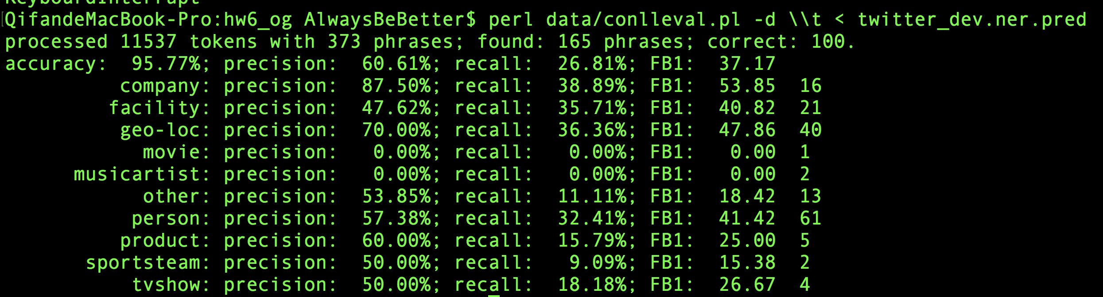

Original CRF on dev

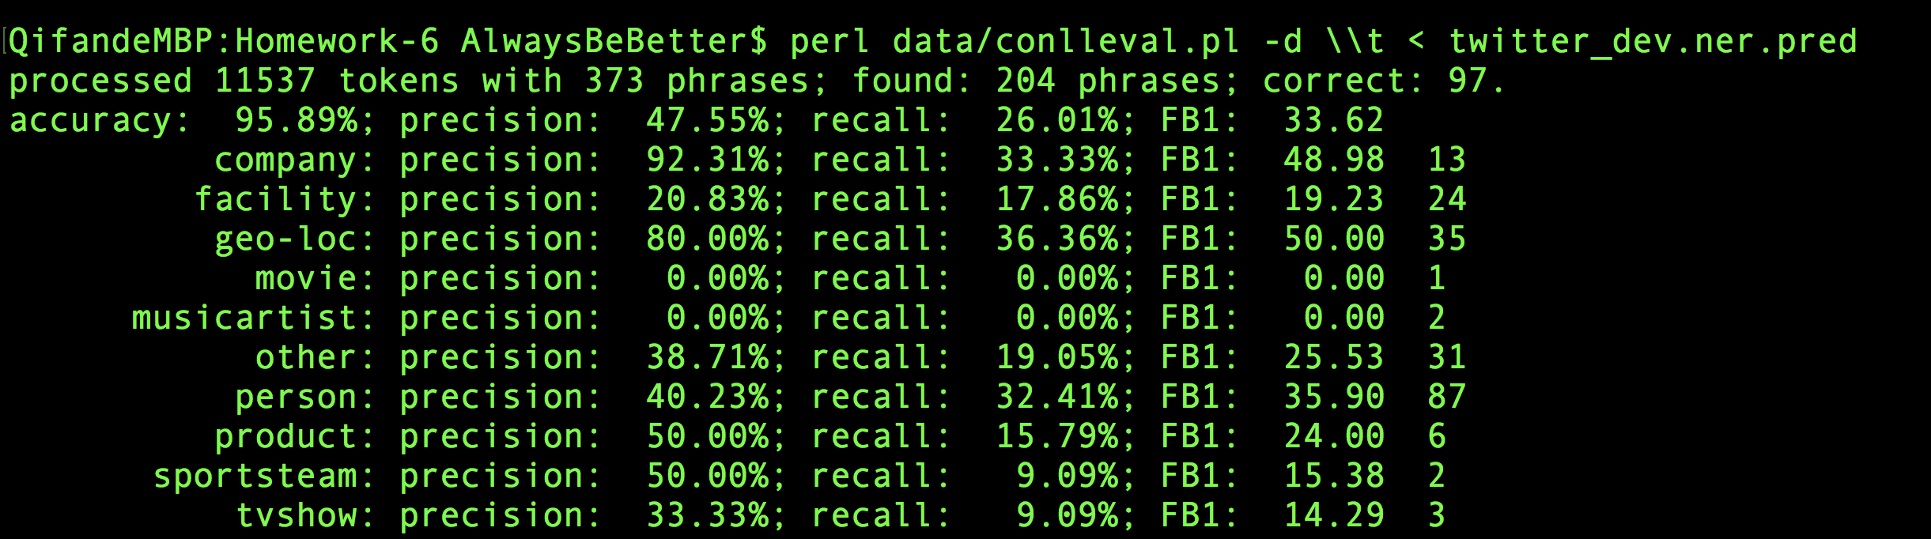

Featured Logistic Regression on dev

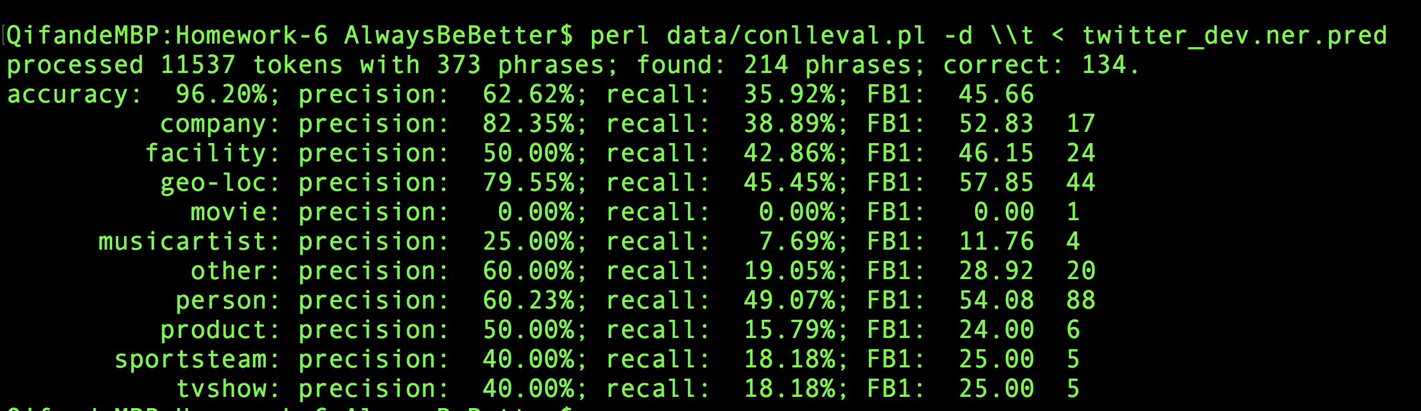

Featured CRF on dev

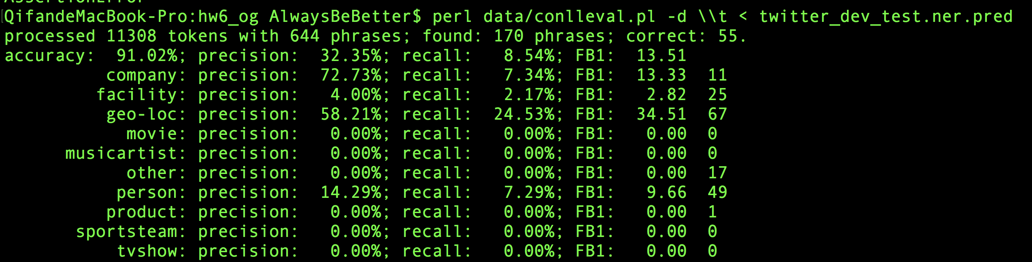

Original Logistic Regression on dev test

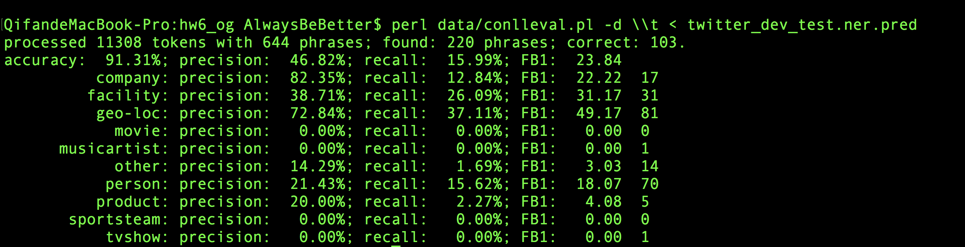

Original CRF on dev test

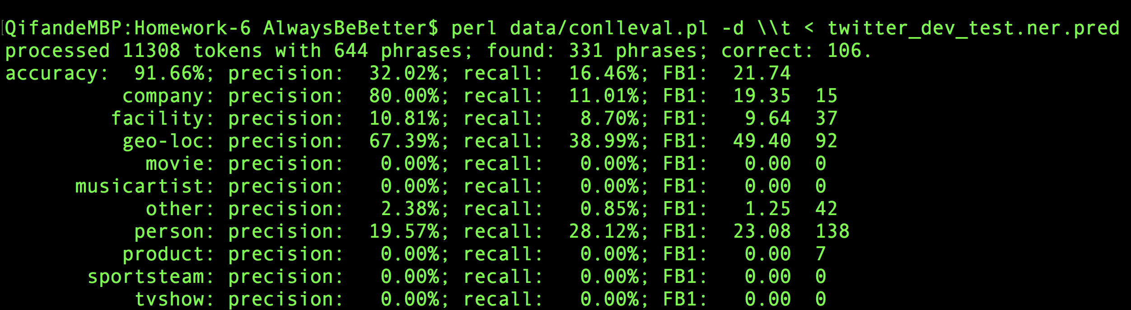

Featured Logistic Regression on dev test

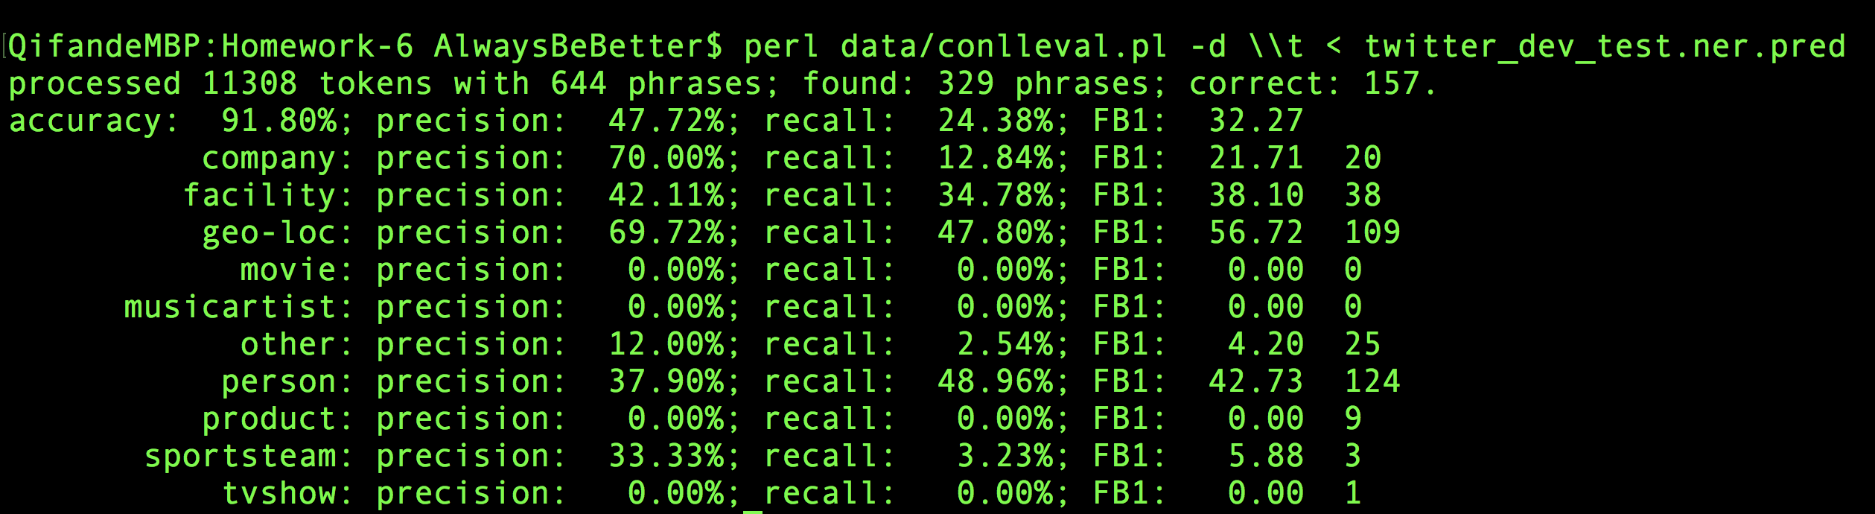

Featured CRF on dev test