**a)**

**[b,a]=butter(2,0.1)**

**b =**

**0.0201 0.0402 0.0201**

**a =**

**1.0000 -1.5610 0.6414**

**b)**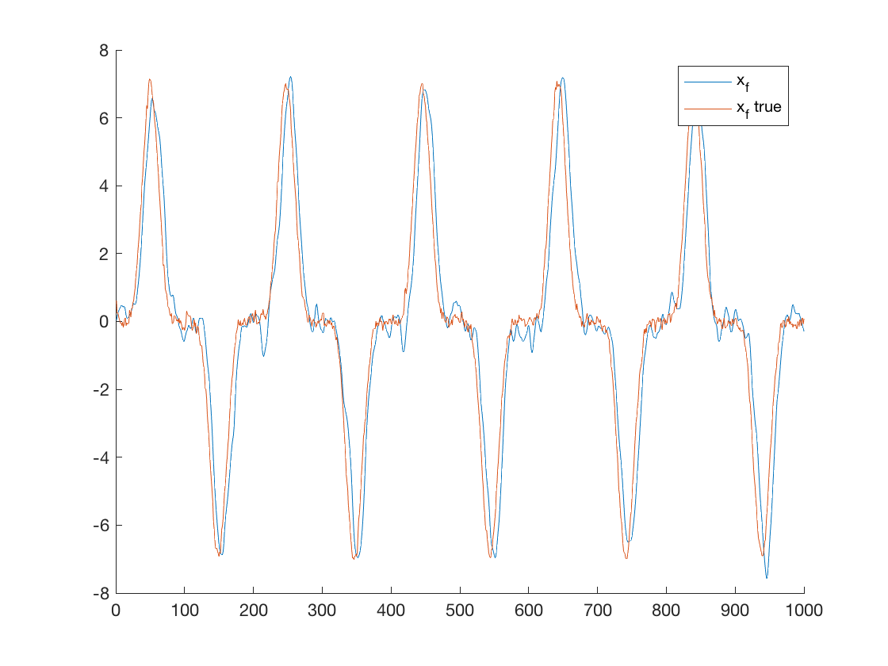

The delay of the filter is about 10 milliseconds

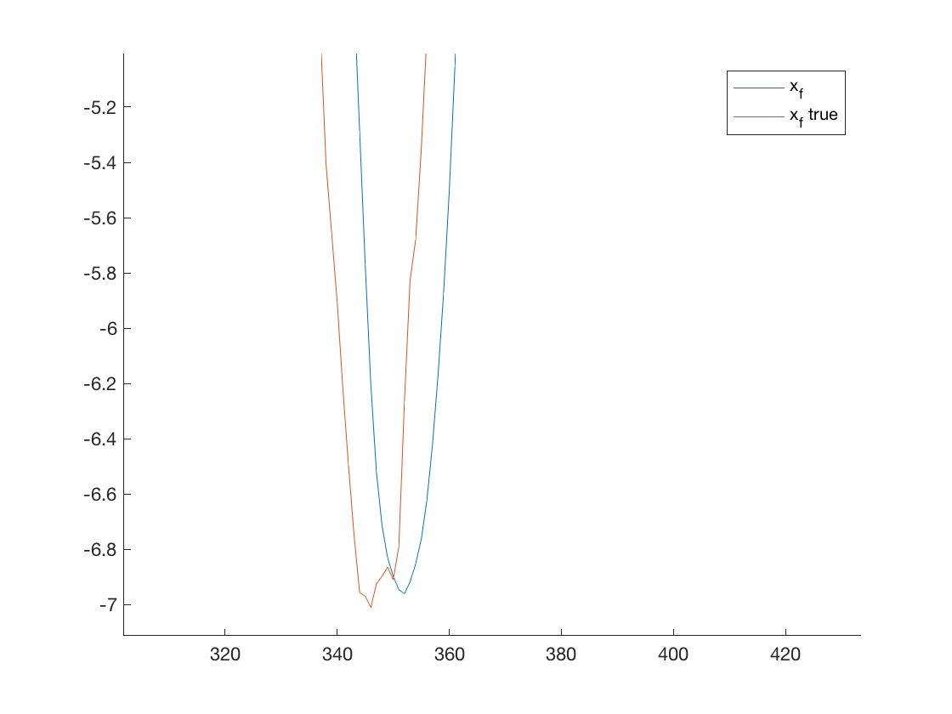

So after the filter, delay is small but still can be seen, signal becomes a little more smooth especially during the section which has a small slope, however the change is not significant.

C)

Print-out of program:

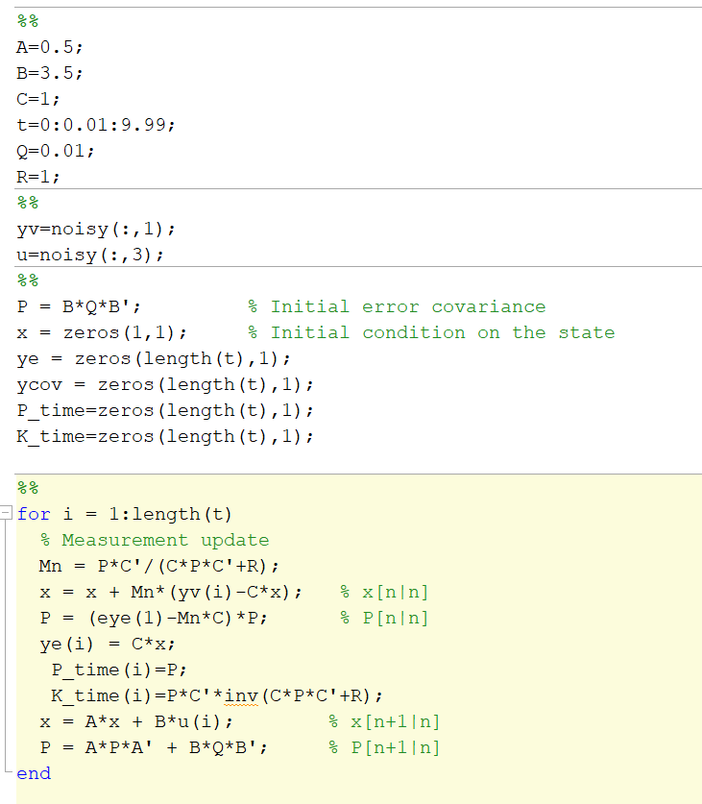

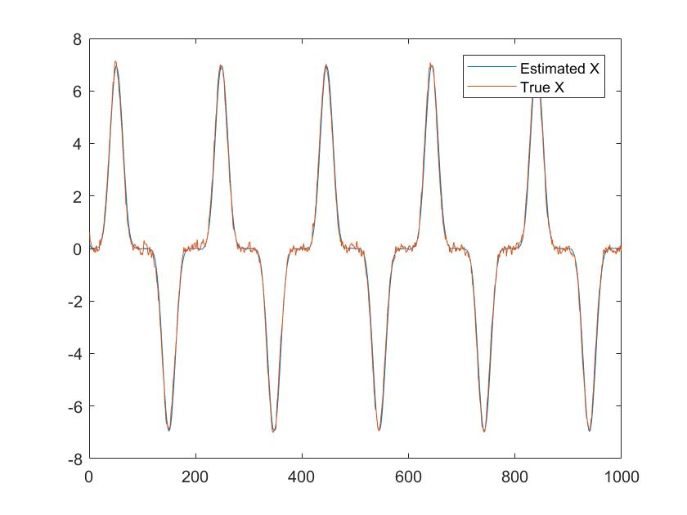

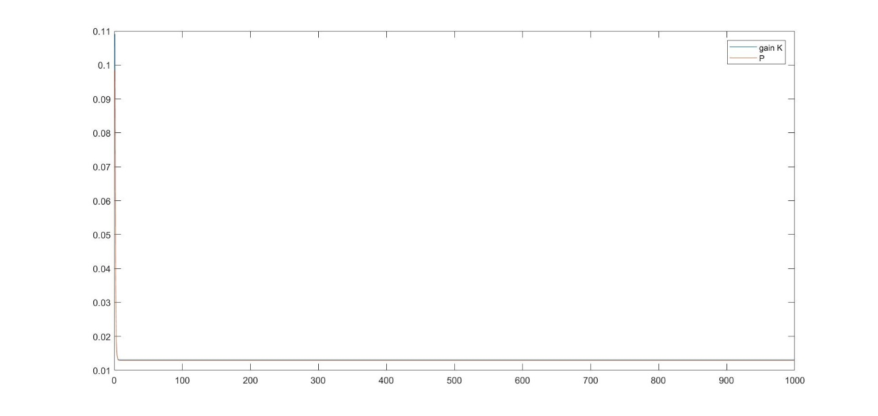

Initialization:

P = Q;

Estimate the delay < 1 millisecond

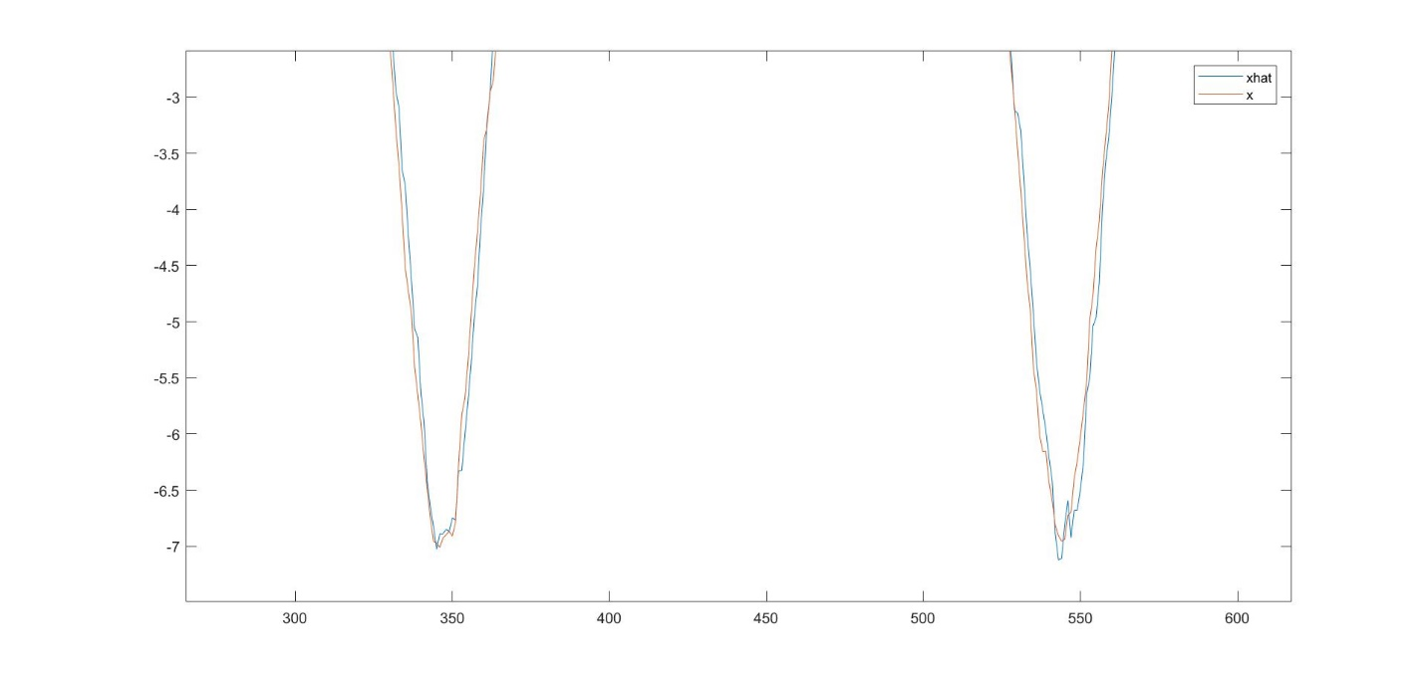

The quality is way better than the Butterworth filter, the signal becomes almost perfectly smooth, and the delay is less than 1 ms which is very good.