

THE ENIGMA PROJECT

“The Bletchley Code Breakers” Project



December 2, 2020

Technical knockout v2.0

Burgas, Bulgaria

Contents

1. About 2

1.1. Team distribution: 2

2. Introduction 3

I. Game Overview 4

1. General concept 5

2. Game Elements 6

3. Game Factions 7

3.1. The Germans 7

3.2. The United Kingdom 8

4. Win/Lose Scenarios 9

II. Technical Overview 10

1. Functions overview 11

2. Quality Assurance and Testing 12

3. Blockschemes 13

3.1. Singleplayer 13

3.2. Multiplayer 13

## About

### Team distribution:

1. Tsvetan Tinev – tatinev18@codingburgas.bg

– Manager

1. Ivan Dimov – iidimov18@codingburgas.bg

– Backend Developer

1. Martin Atanasov – mvatanasov18@codingburgas.bg

– Frontend Developer

1. Kristian Milanov – kamilanov18@codingburgas.bg

– Code Checker

1. Dimitar Kalchev – dmkalchev18@codingburgas.bg

– Quality Assurance

1. Aleksandar Hristov – aihristov18@codingburgas.bg

– Documentary

## Introduction

This document is split into two main chapters – Game Overview and Technical Overview. Both chapters contain various sub-chapters which go into detail about different aspects of the project. The first chapter, Game Overview, covers a variety of aspects about the purpose of the game and its’ elements. The Technical Overview goes into detail about how the game functions and what methods were used to create it.

# Game Overview

## General concept

The game is available to be played in 2 modes – Singleplayer and Multiplayer. In Singleplayer, the player takes control of the United Kingdom and is supposed to guess a secret code created by the computer-controlled Germans. If the player manages to guess the code, they will repel the German invasion and win the game. However, if they don’t find out what the code is by the 13th turn, the Germans will win.

In the Multiplayer mode, the player competes against a different player. This time the player is given a choice between the United Kingdom and German factions. The point of the game is similar to the Singleplayer mode, as the Germans create a four-digit number at the beginning of the game and the British are supposed to guess it. However, this concept is expanded on immensely including different game elements like giving the Germans the ability to purchase and deploy three different naval units alongside with the possibilty to use currency to make farms which produce more currency per turn. The Multiplayer mode also allows for both players to talk to each other during the game using the in-built text chat.

## Game Elements

* The pace of the game is turn-based with 13 turns available for each game.
* Players can choose between two factions: The United Kingdom (Defense) and the Germans (Attack)
* The Germans create a code at the start of each game which the United Kingdom is supposed to crack by the 13th turn.
* There is a currency system available to the German faction (Gold) and a points system for the United Kingdom.
* Both players have access to 5 provinces which differ based on the faction.
* If the United Kingdom has not guessed the code by the 13th turn, the Germans will attempt an invasion on a chosen province. The success of this invasion is determined by a damage potential system based on their naval units.

## Game Factions

### The Germans

At the start of each game, the player must think of a four-digit number that will act as a secret code for the rest of the game. In order to combat boredom while waiting for the other player to guess the number, we’ve introduced a number of features to keep the player engaged. First, we’ve added a currency system (Gold) which the player can use to purchase both combat and production units. They receive 250G at the beginning of the game. The combat units consist of the following:

* Ships – Steel behemoths created to wreck havoc upon the ocean waves using their superior firepower. The ship is an expensive unit which costs 250G to make and deals 9 points of damage.
* Planes – The plane is a vehicle designed to control the skies and provide support to units on the battlefield. The plane unit is fairly balanced with a cost of 150G and the ability to deal 7 points of damage.
* Landing Craft – A small transport boat used to convey a landing force from the sea to the shore during an amphibious assault. The landing craft is the weakest unit in the game and also the cheapest. It costs 125G to make and deals only 3 points of damage.

Along with the Germans being able to make combat units, they are also capable of creating farms which will boost their income per turn. The farm unit can be placed inside one of the five provinces for the cost of 200G. A singular farm will produce 100G per turn, this income can be increased if more farms are built on the remaning provinces.

In order for the Germans to win the game, they must accumulate at least 100 points of damage by the 13th turn in order to launch an invasion on the other player. These 100 points of damage can be collected by creating a large fleet of combat units using the provided statistics above.

### The United Kingdom

As the United Kingdom, the player’s goal is to find out the secret code the Germans have made by guessing it. In order to give the player more time to guess the code, a special tool has has been added to the United Kingdom’s arsenal – the Scanner. The Scanner is an ability which allows the United Kingdom to destroy one of the farms placed by the Germans. It costs 10 points to use. A different amount of points can be earned depending on the amount of numbers and positions guessed. If the player guesses a number but not its position, they will gain half a point. If the player guesses both the number and its position, they will gain a full point. However, the player cannot repeatedly enter the same number in order to gain more points due to a system which prevents them from doing so.

In order for the United Kingdom to achieve a victory scenario, they must crack the code by the 13th turn or survive the German invasion in the case they do not deal enough points of damage.

## Win/Lose Scenarios

* Scenario “United Kingdom Victory” – The United Kingdom manages to crack the Germans’ secret code and successfully repel their invasion.
* Scenario “United Kingdom Victory №2” – The United Kingdom fails to crack the Germans’ secret code however they successfully repel their invading forces due to their lack of firepower.
* Scenario “German Victory” – The United Kingdom fails to crack the Germans’ secret code and succumb to the power of their fleet.

# Technical Overview

## Functions overview

This part of the documentation has been made using JSdoc in order to create a good visual representation of the project’s functions and the purpose they serve.

These JSdocs are split into two files which contain information about the Singleplayer and Multiplayer functions. In order to access these files, follow the paths listed down below:

For Singleplayer:

..\public\js\out\index.html

For Multiplayer:

..\private\js\out\index.html

Or click on the following hyperlinks:

* [Singleplayer](../public/js/out/index.html)
* [Multiplayer](../private/js/out/index.html)

## Quality Assurance and Testing

Unit Testing – We implemented unit testing in our project, by using the javascript test framework, called “Mocha”. It helped us, because we can test some of our functions automatically.

Example of unit testing:

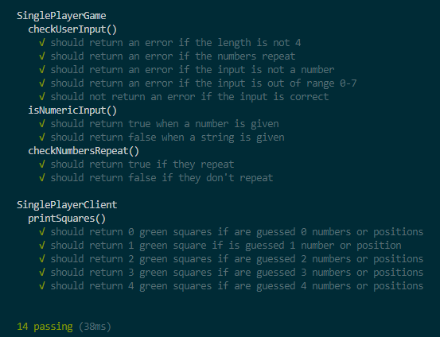

Manual Testing – We created an excel workbook, where we described the tests for each of our files. There we tested the code functionallity, alogithm, front end and etc.

The manual testing excel workbook can be found at this hyperlink:

* [Manual testing workbook](manual_tests.xlsx)

## Blockschemes

### [Singleplayer](Blockschemes/Singleplayer_Diagram.png)

### [Multiplayer](Blockschemes/Multiplayer_Diagram.png)