

Practices for Secure Software Report

Table of Contents
Document Revision History 3
Client 3
Instructions 3
Developer 4
1. Algorithm Cipher 4
2. Certificate Generation 4
3. Deploy Cipher 4
4. Secure Communications 4
5. Secondary Testing 4
6. Functional Testing 4
7. Summary 4
8. Industry Standard Best Practices 4

Document Revision History

Version | Date | Author | Comments
1.0 | 2/27/2026 | Travis Williamson

Client



Instructions

Submit this completed practices for secure software report. Replace the bracketed text with the relevant information. You must document your process for writing secure communications and refactoring code that complies with software security testing protocols.

- Respond to the steps outlined below and include your findings.
- Respond using your own words. You may also choose to include images or supporting materials. If you include them, make certain to insert them in all the relevant locations in the document.
- Refer to the Project Two Guidelines and Rubric for more detailed instructions about each section of the template.

Developer
Travis Williamson

Algorithm Cipher

For robust data security, it is recommended to implement the RSA algorithm for encryption in combination with the SHA256 hash function. RSA is a widely adopted public-key (asymmetric) cryptographic algorithm that enables secure data transmission by leveraging a pair of mathematically linked keys, one public and one private. In this scheme, sensitive information is encrypted with the recipient’s public key and can only be decrypted by their corresponding private key, ensuring confidentiality and integrity in communications.
The SHA256 hash function generates a fixed-length, 256-bit hash value from any input data, providing a high degree of resistance to collision and preimage attacks. This bit strength makes SHA256 a reliable tool for verifying data integrity and supporting digital signatures within the RSA framework. By integrating SHA256 with RSA, organizations can ensure that transmitted messages are both encrypted and verifiable, greatly reducing the risk of tampering or unauthorized access.
Random number generation plays a critical role in both RSA and SHA256 implementations. Secure random values are required for key generation and cryptographic operations, contributing to the overall unpredictability and security of the encryption process. In contrast to symmetric-key algorithms, which use the same secret key for both encryption and decryption, non-symmetric (asymmetric) algorithms like RSA utilize two distinct keys, enhancing security for public communications and key distribution.
Historically, encryption began with simple ciphers, such as the Caesar cipher, and advanced to complex symmetric algorithms like DES and AES. The advent of asymmetric encryption, exemplified by RSA in the late 1970s, marked a significant breakthrough by enabling secure key exchange over untrusted networks. Today, RSA and SHA256 represent the industry standard for secure communications, offering proven reliability and compatibility with current software security protocols.

Certificate Generation
Insert a screenshot below of the CER file.
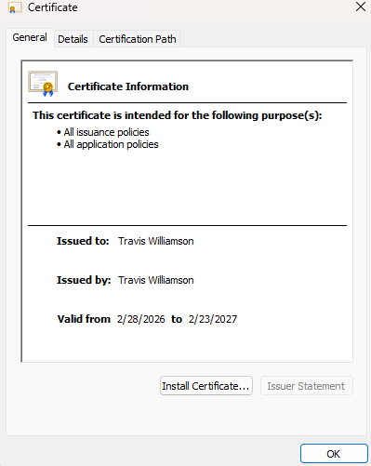
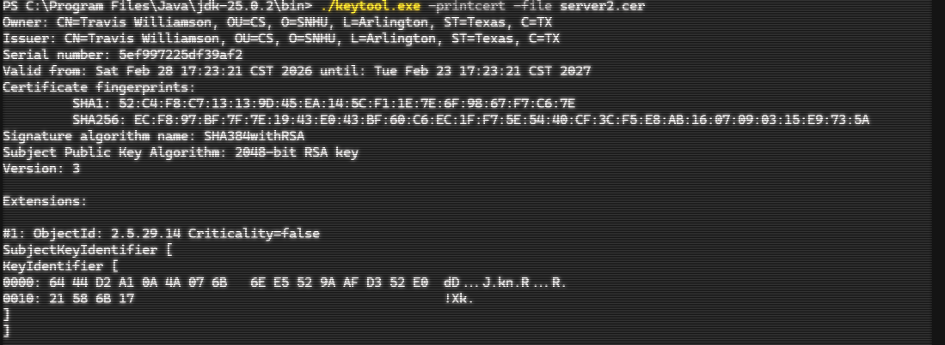

Deploy Cipher
Insert a screenshot below of the checksum verification.



Secure Communications
Insert a screenshot below of the web browser that shows a secure webpage.



Secondary Testing
Insert screenshots below of the refactored code executed without errors and the dependency-check report.
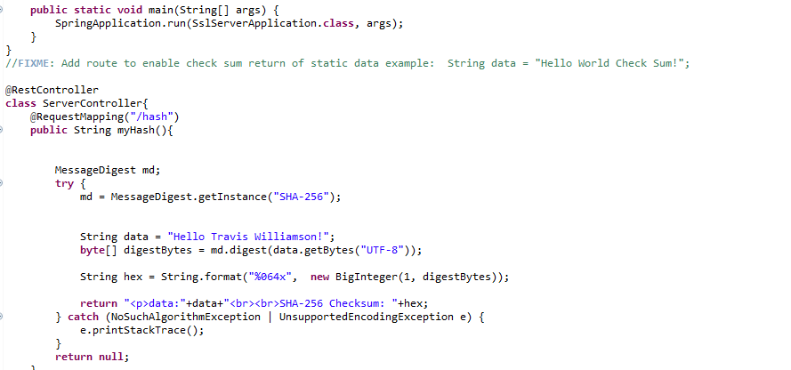

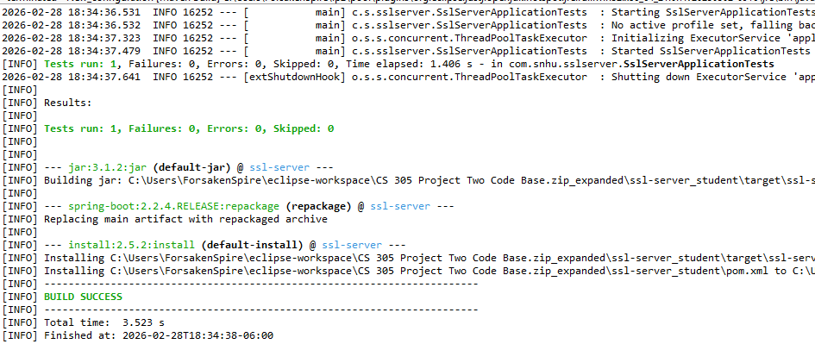
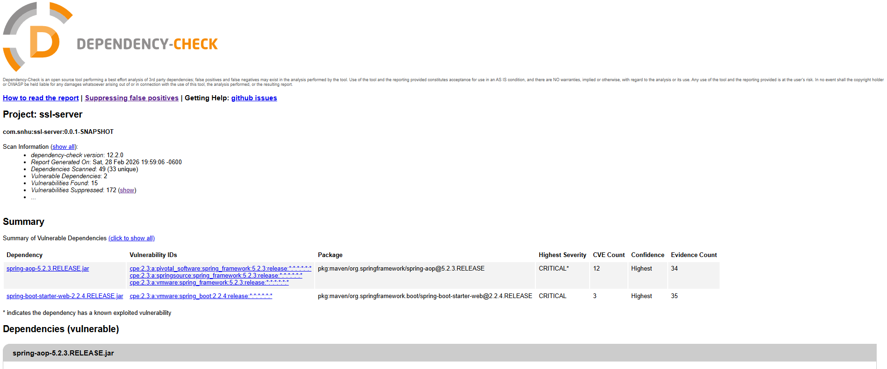

Functional Testing
Insert a screenshot below of the refactored code executed without errors.
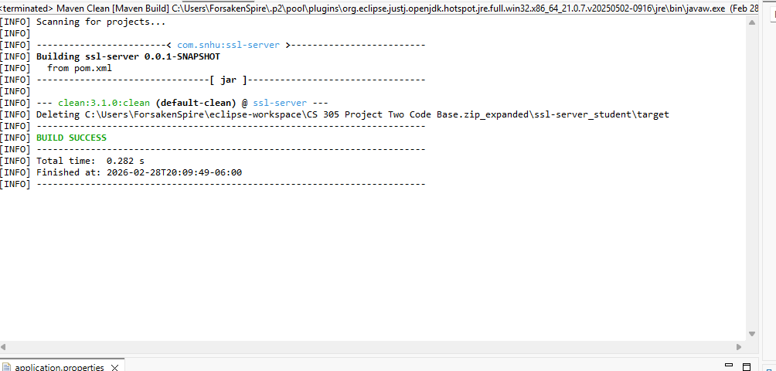

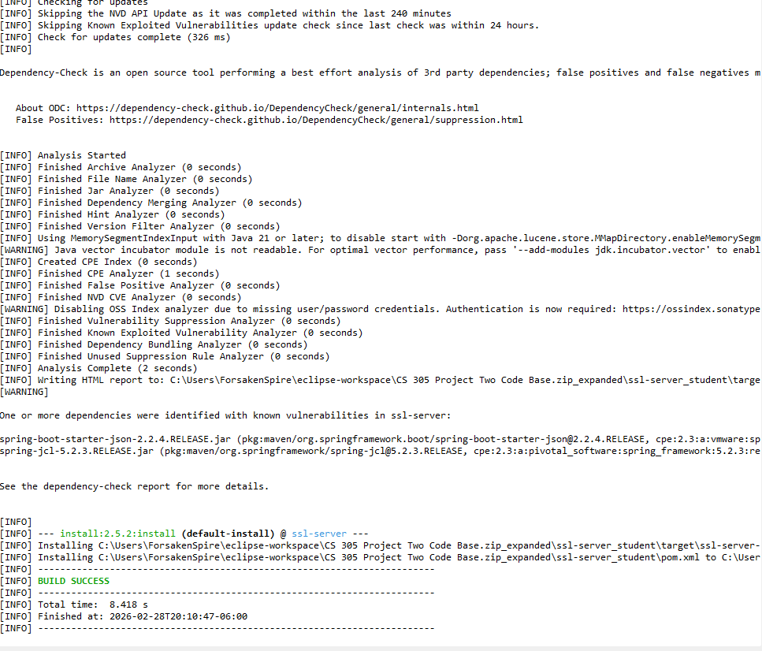
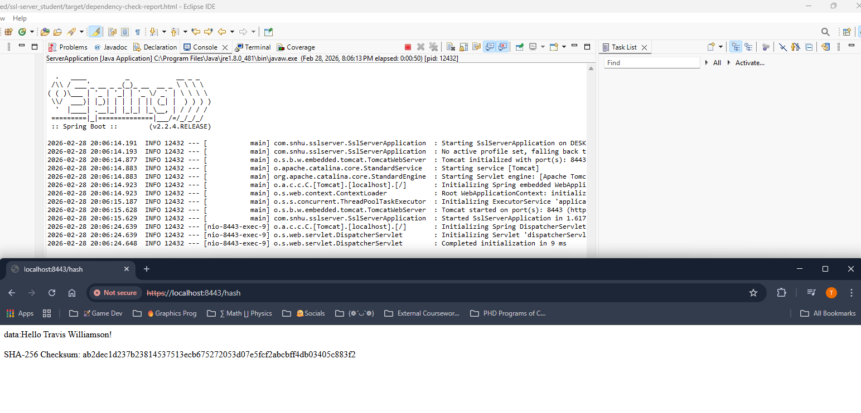

Summary

In refactoring the code, several critical areas of security were addressed to enhance the overall protection of the application. First, SHA256 was implemented as the hashing algorithm within authentication and data integrity functions. By using SHA256, sensitive information such as passwords and tokens are securely hashed, making it computationally infeasible for attackers to reverse-engineer the original data from the hash and ensuring that stored credentials are protected even if the database is compromised.
Additionally, the process included generating and validating digital certificates to establish proper authorization. Certificate generation involved creating a Certificate Signing Request (CSR), obtaining a certificate from a trusted Certificate Authority (CA), and installing the certificate on the server. Validation steps were implemented in the code to verify the authenticity and integrity of certificates during secure communications, preventing unauthorized access and man-in-the-middle attacks.
Finally, to ensure secure data transmission, the application was configured to enforce the usage of the HTTPS protocol. By requiring HTTPS, all communication between the client and server is encrypted using TLS, which safeguards sensitive information such as login credentials and personal data from interception or tampering during transit. These layered enhancements collectively strengthen the application's security posture, ensuring that data remains confidential, authorized, and integral throughout its lifecycle.

Industry Standard Best Practices

Throughout the development process, industry standard best practices were consistently applied to maintain the software application's existing security. This included following secure coding guidelines such as input validation, proper error handling, and regularly updating dependencies to address known vulnerabilities. Additionally, techniques like code reviews, static code analysis, and the principle of least privilege were used to ensure that the application remained robust against potential threats.
Applying these best practices not only strengthens the application's security posture but also benefits the company as a whole. It reduces the risk of security breaches, protects sensitive data, and helps maintain customer trust. By proactively addressing security concerns, the company minimizes potential financial losses and reputational damage, ensuring long-term stability and compliance with industry regulations.

