# Software Projects Milestone 2

# Initial User Requirements & Market Survey

## Group Number: 20

## Concept Name: Garden Assistant App

## Initial User Requirements

I interviewed two stakeholders. The first stakeholder is aged between 65-85. He is retired and part of a community who enjoys gardening. He describes himself as a forgetful person and the idea of an app that would remind him of his gardening tasks would be of great help to him. He also likes the fact that this app could raise awareness on conservation and help the environment by growing your own produce.

The second stakeholder is aged between 30-40. She works full-time and although she has a small garden, she does not have a lot of time to maintain it as much as she would like to. She describes herself as an artistic person who takes pictures of colourful flowers for inspiration. She is definitely interested in growing her own garden and would find an app extremely useful to help manage her tasks and to clearly visualise what her new and improved garden could look like.

Neither of the stakeholders have found or heard of a garden assistant app.

From the interviews carried out it is apparent that an app to assist gardeners would be extremely useful. However, it is important to design the app with the elderly in mind to ensure it is user-friendly and easy to access. The three features (reminders/notifications to update the user, drawing out their garden and viewing their personalised calendar) were received positively by the participants.

In regards to research to bolster the viability of our application, with stakeholders aside, identifying and comparing competition then generating a persuasive study reflecting the feasibility/necessity of our application was the primary goal this week. Given this, we did some research and came to the conclusion that there was prior competition on our intended platforms for the application (iOS/Android), despite the bulk of replies from the currently collected results on our surveys being that a majority had never encountered a garden maintenance application.

From the information gathered through Arianna’s interview with stakeholders, Taylor’s online market survey, Habib’s survey to the left of the page, and Khari’s research discussed further down, we concluded that not many people are aware of the currently existing gardening apps. With this in mind, we proceeded with collecting survey data with the intention of generating the quantitative backing for our application in the final project submission.

Taylor created an online survey to get an idea of how people wold respond to the app, as well as the features that we wanted to implement. We also asked for any other features they wold find useful. After circulating the survey, we discovered a very strong approval for the features that we had planned as well as some useful insight into functionality people wold like to see within the features that we proposed.

Link to online market research: <https://www.surveymonkey.com/stories/SM-QM3X5FD7/>

Through Huan’s market We found other posible features to be included and some posible problems.

1. that the app may be counter productive for people with smaller-sized or indoor gardens because with very few plants the app may be unesasary.
2. That by alowing users to upload plants to the database we run the risk of incorect or disingenuos informatio.

Khari did research on other existing examples of apps similar in concept to ours. In particular, three different applications stuck out as they were quite similar to functionality to our proposed concept, although there were nuances. For example:

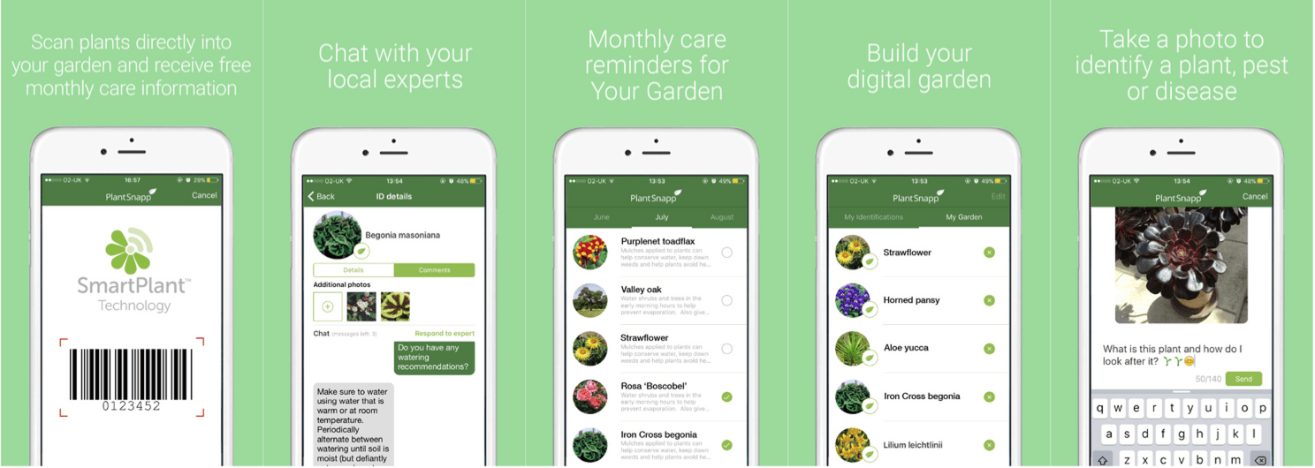One example was: ‘**SmartPlant’**. Similar to our app, SmartPlant has a large library of information on a large variety of different plants/vegetables. As well as this, it also gives users the ability to add plants from their own garden in integration with the calendar function to create a personalised calendar which regularly sends notifications to remind you of what you should do to maintain your garden efficiently.

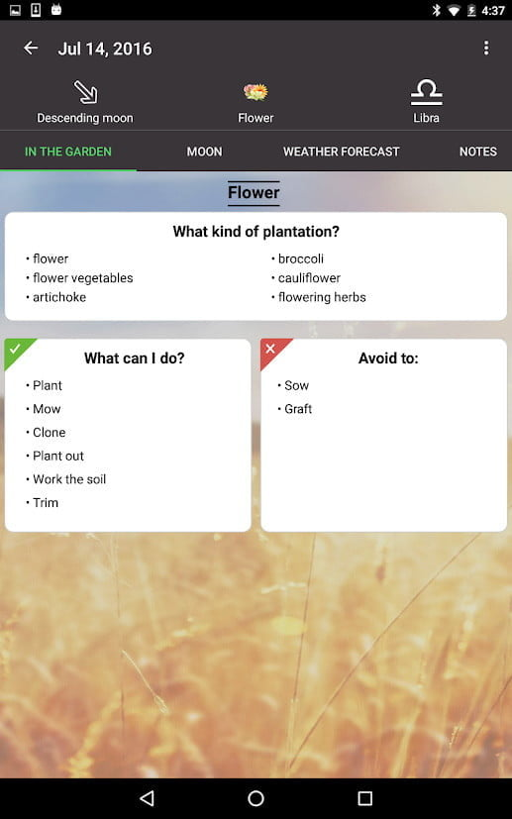However, a difference between this app and ours is that ours allows its users to not only access a database of plants/vegetables along with detailed summaries for each, but also add their own plants to the database for them and other users. Furthermore, we intend to distinguish our app from ‘SmartPlant’ through a drawing app assisting the user with generating a layout of what they would like their garden to look, while maintaining healthy vegetation through the alert system, positioning for optimal sunlight, and cross culture avoidance.

The second example was: ‘**Moon and Garden**’. This application once again provides similar features to our proposed concept in that it advises users on actions, they can take in order to take care of their garden in the most efficient way possible.

However, unlike our app which takes note of your location and local weather (via Google Maps and weather apps) to create an accurate calendar for reminders, ‘Moon and Garden’ instead gets its information from the phases of the moon to advise you on what actions to take the very next day (rather than for a month).

The third example was: ‘**Gardenate**’. Likewise, to ours and other garden apps, ‘Gardenate’ creates calendars designed to keep its users on track, as well as, provide useful tips and specific information for a variety of vegetables for caring for your garden. It also boasts a ‘Planting Now’ section where it tells users what plants are currently “in season” and what are best to plant each month.

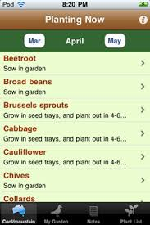A difference between our concepts, ­however, is that our app is planned to have the functionality to give users the ability to draw their own garden so that they can plan what it should look like (in both design and actual content of vegetation) before they create it.

## Open Questions about this concept

From the information we have received we will need to think about how:

we will design our application to be accessible and appealing to people with little to no experience with technology?

if we open our database to user input then how we will verify the information?

We will include some of the new features that have been suggested?