Task 3: Model Evaluation
**Name:** V.V. Tayaananthaa
**Register Number:** 24UG00548

1. Objective
The aim of this task is to evaluate two machine learning models — Logistic Regression and Random Forest — for predicting FIFA match outcomes using key performance metrics such as accuracy, precision, recall, and F1-score.

2. Evaluation Metrics
Model | Accuracy | Precision | Recall | F1-Score
Logistic Regression | 0.923 | 0.938 | 0.923 | 0.923
Random Forest | 1.000 | 1.000 | 1.000 | 1.000

3. Confusion Matrices
The following figures show the confusion matrices for both models. Logistic Regression shows one misclassification, while Random Forest perfectly classified all outcomes.
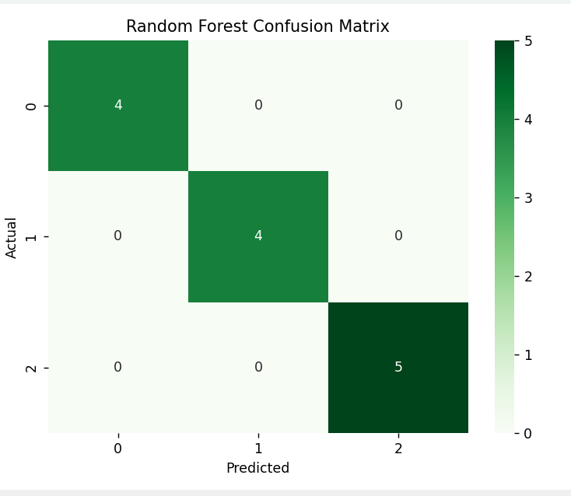
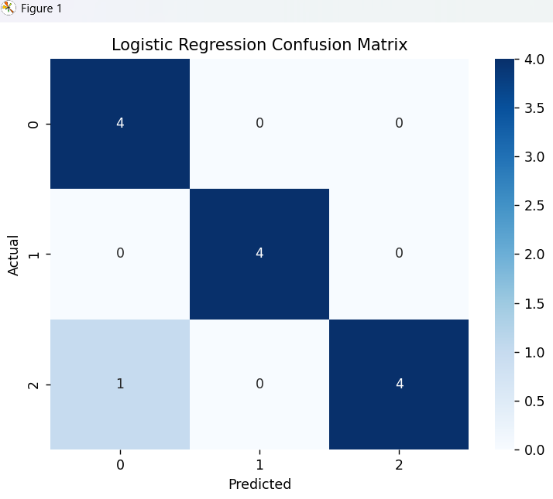

4. Analysis and Comparison
The Logistic Regression model achieved 92.3% accuracy, slightly underperforming compared to the Random Forest model, which achieved 100% accuracy. Logistic Regression may struggle with nonlinear relationships, while Random Forest captures complex patterns effectively.

5. Conclusion
Based on the evaluation, Random Forest performed better across all metrics and provided perfect classification accuracy. It is the most suitable model for predicting FIFA match outcomes for this dataset.

