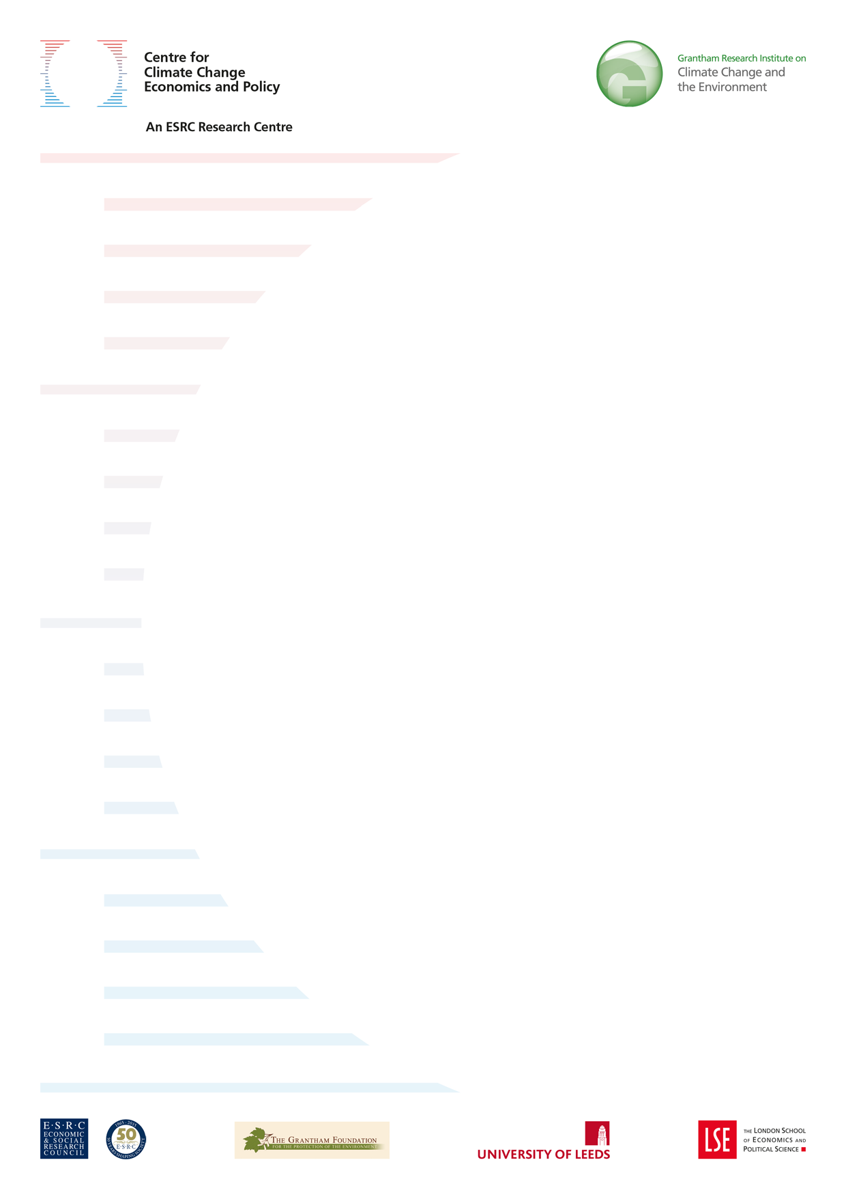

**Critical minerals today and in 2030: an analysis of OECD countries**

**Renaud Coulomb, Simon Dietz, Maria Godunova and Thomas Bligaard Nielsen**

**Policy paper**

**November 2015**

**ESRC Centre for Climate Change Economics and**  **Policy**

**Grantham Research Institute on Climate Change and the Environment**

**The Centre for Climate Change Economics and Policy (CCCEP)** was established in 2008 to advance public and private action on climate change through rigorous, innovative research. The Centre is hosted jointly by the University of Leeds and the London School of Economics and Political Science. It is funded by the UK Economic and Social Research Council. More information about the ESRC Centre for Climate Change Economics and Policy can be found at: http://www.cccep.ac.uk

**The Grantham Research Institute on Climate Change and the**   
**Environment** was established in 2008 at the London School of Economics and Political Science. The Institute brings together international expertise on economics, as well as finance, geography, the environment, international development and political economy to establish a world-leading centre for policy-relevant research, teaching and training in climate change and the environment. It is funded by the Grantham Foundation for the Protection of the Environment, which also funds the Grantham Institute for Climate Change at Imperial College London. More information about the Grantham Research Institute can be found at: http://www.lse.ac.uk/grantham/

This policy paper is intended to inform decision-makers in the public, private and third sectors. It has been reviewed by at least two internal referees before publication. The views expressed in this paper represent those of the   
author(s) and do not necessarily represent those of the host institutions or funders.



**Unclassified**  **ENV/WKP(2015)12**

Organisation de Coopération et de Développement Économiques

Organisation for Economic Co-operation and Development **08-Sep-2015** ___________________________________________________________________________________________ **English - Or. English ENVIRONMENT DIRECTORATE**

**CRITICAL MINERALS TODAY AND IN 2030: AN ANALYSIS FOR OECD COUNTRIES - ENVIRONMENT WORKING PAPER No. 91**

**by Renaud Coulomb, Simon Dietz, Maria Godunova and Thomas Bligaard Nielsen (Grantham Research Institute on Climate Change and the Environment at the London School of Economics and Political Science (LSE), London, U.K.)**

*OECD Working Papers should not be reported as representing the official views of the OECD or of its member countries. The opinions expressed and arguments employed are those of the author(s).*

*Authorised for publication by Simon Upton, Director, Environment Directorate.*

*Keywords: Critical minerals, critical materials, resource scarcity, recycling, material recovery, material security, circular economy*

*JEL classification: Q320, Q370, O130, F690*

OECD Environment working papers are available at www.oecd.org/environment/workingpapers.htm

**JT03381385**

**Complete document available on OLIS in its original format**   
***This document and any map included herein are without prejudice to the status of or sovereignty over any territory, to the delimitation of international frontiers and boundaries and to the name of any territory, city or area.***

ENV/WKP(2015)12

**OECD ENVIRONMENT WORKING PAPERS**

OECD Working Papers should not be reported as representing the official views of the OECD or of its member countries. The opinions expressed and arguments employed are those of the author(s).

OECD Working Papers describe preliminary results or research in progress by the author(s) and are published to stimulate discussion on a broad range of issues on which the OECD works.

This series is designed to make available to a wider readership selected studies on environmental issues prepared for use within the OECD. Authorship is usually collective, but principal author(s) are named. The papers are generally available only in their original language -English or French- with a summary in the other language.

Comments on OECD Working Papers are welcomed, and may be sent to:

OECD Environment Directorate   
2 rue André Pascal, 7577[5 PARIS CEDEX 16,](mailto:env.contact@oecd.org) France   
 or by e-mail: [env.contact@oecd.org](mailto:env.contact@oecd.org)

--------------------------------------------------------------------------- OE[CD Environment Working Papers are published](http://www.oecd.org/environment/workingpapers.htm) on   
*[www.oecd.org/environment/workingpapers.htm](http://www.oecd.org/environment/workingpapers.htm)*   
--------[-----------------------------------------------------------](http://www.oecd.org/environment/workingpapers.htm)--------

This document and any map included herein are without prejudice to the status of or sovereignty over any territory, to the delimitation of international frontiers and boundaries and to the name of any territory, city or area.

The statistical data for Israel are supplied by and under the responsibility of the relevant Israeli authorities. The use of such data by the OECD is without prejudice to the status of the Golan Heights, East Jerusalem and Israeli settlements in the West Bank under the terms of international law.

**© OECD (2015)**

You can copy, download or print OECD content for your own use, and you can include excerpts from OECD publications, databases and multimedia products in your own documents, presentations, blogs, websites and teaching materials, provided that suitable acknowledgment of OECD as source and copyright owner is given. All requests for commercial use and translation rights should be submitted to **rights@oecd.org.**

2

ENV/WKP(2015)12

**ABSTRACT**

Raw materials are essential for the global economy and future development depends on their continued supply. Like fossil fuels, minerals are non-renewable. In general, their deposits in the Earth’s crust are also geographically clustered, making security of supply a potential risk. In many cases, the exhaustion of economically competitive minerals deposits in industrialized countries has made supplies increasingly dependent on the political stability of mineral-rich emerging economies. At the same time, increasing demand from these emerging markets, new technologies that require large amounts of rare minerals , low substitutability in applications and low rates of recycling have made economies more vulnerable to potential supply disruptions. Consequently policy-makers in several OECD countries and regions have developed reports that assess the vulnerability of their respective economies to disruptions in the supply of minerals. A common aim of many of these studies is the identification of a list of so-called ‘critical minerals’, defined as minerals for which the risk of disruptions in supply is relatively high and for which supply disruptions will be associated with large economic impacts.

The purpose of this report is to perform for the first time an analysis of critical minerals for the OECD countries as a whole. In addition, this is done not only today, as previous reports have done, but also in 2030, in order to form an initial picture of how possible trends in economic development will affect which minerals are critical in the long-run future. 51 different minerals are included in our analysis. Three measures of mineral supply risk are used: substitutability, recycling rates and the concentration of production in countries that are judged by international datasets to be relatively politically unstable. Physical scarcity is not considered to be a source of supply risk, certainly in the short term. While the non-renewable nature of minerals is an eventual constraint on what can be extracted, reserves are generally large and market mechanisms work to alleviate the problem. Potential disruptions are instead perceived to come from the nexus of production concentration and geopolitical risks. It is also rather unlikely that physical scarcity will affect supply risk in the period up to 2030, but the report does allow for such a scenario by introducing to the index of supply risk a measure of the number of years to forecast depletion of reserves. Vulnerability to supply risk – i.e. the ‘economic importance’ of a mineral – is more challenging to estimate and there is no consensus among existing studies. This report looks at how each mineral is used in different sectors, as well as how economically important these sectors are for the economy.

The analysis identifies around 12 to 20 minerals or minerals groups, which are critical in the OECD today. Minerals like the rare earth elements (heavy and light), germanium and natural graphite have a particularly high supply risk, while minerals such as barytes, tungsten and vanadium are particularly economically important. Looking out to 2030, a stronger role is assumed for the physical availability of reserves in determining where production takes place, which results in increased supply risk for barytes, borate, phosphate rock and molybdenum. Also, the economic development along a baseline scenario that assumes continued reliance on fossil fuels for energy does not change significantly the pattern of economic importance of the various minerals concerned. Future work should evaluate whether this also holds true for a pathway towards green, low-carbon growth. Lastly the report shows what improvements in the substitutability of minerals and in their recycling rates would be sufficient today and more importantly by 2030 to mitigate supply risks and vulnerability to them. This could be a focus for public support for R&D in the OECD. The results are highly mineral-specific, with some minerals requiring huge increases in substitutability and/or recycling from a low base, while others require only small improvements.

**Keywords:** Critical minerals, critical materials, resource scarcity, recycling, material recovery, material security, circular economy

**JEL classification:** Q320, Q370, O130, F690

3

ENV/WKP(2015)12

**RÉSUMÉ**

Les matières premières sont essentielles pour l'économie mondiale et le développement futur dépend de leur approvisionnement continu. Comme les combustibles fossiles, les minerais ne sont pas renouvelables. Par ailleurs, leurs dépôts dans la croûte terrestre sont, en général, regroupés géographiquement, faisant ainsi de la sécurité de l'approvisionnement un risque potentiel. Dans de nombreux cas en effet, pour ce qui est des pays industrialisés, l'épuisement des réserves en minerais économiquement compétitifs a rendu l'approvisionnement en matières premières une activité de plus en plus dépendante de la stabilité politique des pays émergents riches en minerais. Dans le même temps, la demande croissante de ces marchés émergents, mais aussi les nouvelles technologies qui nécessitent de grandes quantités de minerais rares, ainsi qu’une faible substituabilité dans leurs applications concrètes et des taux de recyclage faibles, ont rendu les économies plus vulnérables aux éventuelles ruptures d'approvisionnement. Par conséquent les décideurs dans plusieurs pays et régions de l'OCDE ont commandé des rapports qui évaluent la vulnérabilité de leurs économies respectives face à des perturbations dans l'approvisionnement en minerais. L’objectif commun d'un grand nombre de ces études est l'identification d'une liste de soi-disant «minerais critiques», définis comme les minerais pour lesquels le risque de perturbations de l'approvisionnement est relativement élevé et pour lesquels les ruptures en approvisionnement seront associées à de grands impacts économiques.

Le but de ce rapport est de réaliser pour la première fois une analyse des minerais essentiels pour les pays de l'OCDE dans son ensemble. Cette analyse est un état des lieux à la date d’aujourd’hui, comme les rapports précédents l’ont fait. En outre, l’étude propose aussi une projection à l’an 2030 afin d’analyser quelle incidence peuvent avoir les tendances dans le développement économique sur tel ou tel minerai à long terme. 51 minerais différents sont inclus dans notre analyse. Trois mesures d’analyse du risque d'approvisionnement en minerais sont utilisées: la substituabilité, les taux de recyclage et la concentration de la production dans les pays qui sont jugés par les ensembles de données internationales pour être relativement instables politiquement. La rareté physique d’un minerai ne doit pas être considérée comme une source de risque pour l’approvisionnement, au moins à court terme. Bien que la nature non renouvelable d’un minerai soit une contrainte éventuelle sur les quantités qui peuvent être extraites, les réserves sont généralement de grande taille et les mécanismes du marché fonctionnent pour atténuer le problème. Les perturbations potentielles sont plutôt à anticiper du côté du lien qui existe entre la concentration de la production et les risques géopolitiques. Il est également peu probable que la rareté physique d’un minerai ait une incidence sur le risque d’approvisionnement, au moins pour ce qui est de la période allant jusqu'à 2030, mais le rapport prévoit toutefois un tel scénario en introduisant à l'indice de risque d'approvisionnement une mesure du nombre d'années pour prévoir l'épuisement des réserves. La vulnérabilité en matière de risque d’approvisionnement - à savoir « l'importance économique» d'un minerai - est plus difficile à estimer et il n'y a pas de consensus entre les études existantes. Ce rapport examine comment chaque minerai est utilisé dans différents secteurs et il montre ainsi l'importance économique de ces secteurs sur l'économie dans son ensemble.

L'analyse identifie autour de 12 à 20 minerais ou groupes de minerais qui sont essentiels aux pays de l'OCDE aujourd'hui. Des minerais comme les terres rares (aussi bien lourds que légères), le germanium et le graphite naturel présentent un risque particulièrement élevé en approvisionnement, tandis que les minerais tels que la barytine, le tungstène et le vanadium sont particulièrement importants sur le plan économique. A l’horizon 2030, on peut supposer qu’un rôle plus important sera accordé à la disponibilité physique des réserves pour déterminer les lieux de production, ce qui entraînera un risque accru en approvisionnement pour la baryte, le borate, le phosphate et le molybdène. En outre, le développement économique basé sur un scénario de référence qui suppose une dépendance continue aux combustibles fossiles pour l'approvisionnement en énergie ne change pas de manière significative le modèle de développement économique des différents minerais concernés. Les travaux futurs devraient évaluer si cela

4

ENV/WKP(2015)12

est également vrai si l’on s’engage vers une croissance verte à faible émission en carbone. Enfin, le rapport montre quel amélioration de la substituabilité des minerais et de leur taux de recyclage seraient nécessaire aujourd'hui et plus important encore en 2030 pour atténuer les risques d'approvisionnement et de la vulnérabilité face à cela. Cela pourrait être une priorité pour l’investissement public en R & D au sein des pays de l'OCDE. Les résultats restent toutefois très spécifiques pour chaque minerai car certains minerais ayant de très faibles sources d’approvisionnement nécessitent d'énormes augmentations de substituabilité et / ou de recyclage tandis que d'autres ne nécessitent que de petites améliorations dans leur exploitation.

**Mots clés :**Matériaux critiques, minéraux critiques, rareté des ressources, recyclage, récupération des matériaux, sécurité matérielle, économie circulaire

**Classification JEL:** Q320, Q370, O130, F690

5

ENV/WKP(2015)12

**TABLE OF CONTENTS**

ABSTRACT .................................................................................................................................................... 3 RÉSUMÉ ......................................................................................................................................................... 4 1. INTRODUCTION ....................................................................................................................................... 8 2. IDENTIFYING CRITICAL MINERALS ................................................................................................. 11 2.1 An emerging framework for identifying critical minerals: supply risk versus economic importance . 11 2.2 This study ............................................................................................................................................. 13 2.2.1 Supply risk ..................................................................................................................................... 13 2.2.2 Economic importance .................................................................................................................... 18 2.2.3 Long-list of minerals, and data sources ......................................................................................... 19 3. RESULTS .................................................................................................................................................. 20 3.1 Critical minerals in OECD countries today ......................................................................................... 20 3.1.1 Supply risk today ........................................................................................................................... 20 3.1.2 Economic importance and overall criticality today ....................................................................... 21 3.1.3 An alternative measure of supply risk today ................................................................................. 26 3.2 Critical minerals in OECD countries in 2030 ...................................................................................... 28 3.2.1 Future supply risks ........................................................................................................................ 28 3.2.2 Future economic importance ......................................................................................................... 31 3.3 Recycling and substitutability needs .................................................................................................... 32 4. ROBUSTNESS CHECKS ......................................................................................................................... 37 4.1 Weighting factors ................................................................................................................................. 37 4.2 Alternative risk measures ..................................................................................................................... 38 4.3 An alternative approach to economic importance ................................................................................ 41 5. LIMITATIONS ......................................................................................................................................... 43 6. CONCLUSION ......................................................................................................................................... 45 REFERENCES .............................................................................................................................................. 46 Reports and papers ..................................................................................................................................... 46 Websites ..................................................................................................................................................... 47 APPENDIX ................................................................................................................................................... 48

**Tables**

|  |  |
| --- | --- |
| Table 1. Table 2. Table 3. Table 4. Table 5. Table 6. | Minerals included in our analysis ............................................................................................ 9 Minerals with a high concentration of production ................................................................. 15 Summary of sources .............................................................................................................. 19 The top ten minerals in terms of supply risk ......................................................................... 20 Correlations between the elements of the supply risk index ................................................. 38 Supply risk values for all minerals. ....................................................................................... 48 |

6

ENV/WKP(2015)12

**Figures**

Figure 1. Criticality matrix ................................................................................................................... 12

Figure 2. Identifying critical minerals in the OECD ............................................................................. 13

Figure 3. Relationship between reserves and resources ........................................................................ 16

Figure 4. Mine production and static lifetimes predictions for (a) copper and (b) nickel..................... 17

Figure 5. Minerals as a function of production concentration and substitutability ............................... 21

Figure 6. Critical minerals in OECD countries today ........................................................................... 23

Figure 7. Economic importance for the USA vs. the OECD as a whole, today .................................... 24

Figure 8. Economic importance for Japan vs. the OECD as a whole, today ........................................ 25

Figure 9. Economic importance for the EU vs. the OECD as a whole, today ...................................... 26

Figure 10. Production-to-reserves ratio .............................................................................................. 27

Figure 11. Comparing modified supply risk with the original formula .............................................. 28

Figure 12. Supply risk predictions for 2030 using the production-to-reserves ratio method .............. 29

Figure 13. Supply risk predictions for 2030 using reserve distribution instead of production ........... 31

Figure 14. Economic Importance in 2030 ........................................................................................... 32

Figure 15. Changes in substitutability needed to mitigate criticality today ........................................ 33

Figure 16. Changes in substitutability needed to mitigate criticality in 2030 ..................................... 34

Figure 17. Changes in recycling needed to mitigate criticality today ................................................. 35

Figure 18. Changes in recycling needed to mitigate criticality in 2030 .............................................. 36

Figure 19. Supply risk based on PRS vs. Supply risk based on WGI ................................................. 39

Figure 20. Supply risk based on OMI vs. Supply risk based on WGI ................................................ 40

Figure 21. Economic importance for the USA of 9 minerals according to different methods ........... 42

**Boxes**

|  |  |
| --- | --- |
| Box1.  Box 2. | What is the relevance of material criticality to the CIRCLE project ........................................... 8 Production and reserves of phosphate rock ............................................................................... 30 |

7

ENV/WKP(2015)12

**1. INTRODUCTION1**

Raw materials are essential for the global economy and future development depends on their continued supply. Covering a large variety of resources from metals to fossil fuels, raw materials enter the economic system through a similarly large variety of applications. Coal, oil and natural gas continue to dominate the global economy’s primary energy mix. Tin is used in steel containers and electrical circuits, nickel for plating and copper for electrical applications, phosphorus and potassium are used as soil fertilizers, rare earth elements (REEs) are central in information and communications technologies and green technologies, and germanium, gallium and antimony are used in semi-conductors.

While much attention has been paid to whether the supply of fossil fuels can (and should) meet energy demand now and in the future, global consumption of non-energy minerals increased markedly in the second half of the 20th century and particularly during the last two to three decades, where it outstripped growth in fossil energy carriers (Krausmann et al., 2009). This trend is likely to accelerate with demands for a green-growth transition, as many environmental technologies depend crucially on rare minerals.

Like fossil fuels, minerals are non-renewable. In general, their deposits in the Earth’s crust are also geographically clustered, making security of supply a potential risk. In many cases, the exhaustion of economically competitive minerals deposits in industrialised countries has made supplies increasingly dependent on the political stability of mineral-rich emerging economies. At the same time, increasing demand from these emerging markets, new technologies that require large amounts of rare minerals (DERA, 2012), low substitutability in applications and low rates of recycling have made economies more vulnerable to potential supply disruptions.

|  |
| --- |
| **Box1.**  **What is the relevance of material criticality to the CIRCLE project**  Further degradation of the environment and natural capital compromises prospects for future economic growth and human well-being. Without more ambitious policies, the costs and consequences of inaction on important environmental challenges such as climate change, biodiversity loss, water scarcity and health impacts of pollution will be significant.  The OECD’s “**C**ost of **I**naction and **R**esource Scarcity; **C**onsequences for **L**ong-term **E**conomic Growth” (CIRCLE) project aims at identifying how feedbacks from poor environmental quality, climatic change and natural resource scarcity are likely to affect economic growth in the coming decades.  This report contributes to the resource scarcity track of the CIRCLE project. Considerations of material criticality are relevant to this work, as supply shocks resulting from disruptions of trade, or sudden surges in demand for certain minerals resulting from technological innovation can be expected to impact economic outcomes. This report provides insights into the materials and sectors that may potentially be affected by such shocks, as well as the policies that may be helpful in mitigating their effects. |

Consequently policy-makers in several countries and regions – for example, France, Germany, the EU, UK and US – have commissioned reports to assess the vulnerability of their respective economies to disruptions in the supply of minerals. A common aim of many of these studies is the identification of a list of so-called ‘critical minerals’, defined as minerals for which the risk of disruptions in supply is relatively high and for which supply disruptions will be associated with large economic impacts, i.e. high vulnerability. The purpose of this report is to perform for the first time an analysis of critical minerals for

|  |  |
| --- | --- |
| 1 | The authors acknowledge helpful comments on earlier drafts from Peter Börkey, Alex Bowen, Ayman Elshkaki, Sam Fankhauser,Thomas Graedel, and Adrian Chapman and for the provision of key data from Jean Chateau and other colleagues from OECD. The views expressed in this paper are those of the authors. |

8

ENV/WKP(2015)12

the OECD countries as a whole. In addition, this is done not only today, as previous reports have done, but also in 2030, in order to form an initial picture of how possible trends in economic development will affect which minerals are critical in the long-run future. 51 different minerals are included in our analysis, listed in Table 1.

**Table 1. Minerals included in our analysis**

|  |  |  |
| --- | --- | --- |
| Aluminium | Gypsum | REE (Light) |
| Antimony | Hafnium | Rhenium |
| Barytes | Indium | Scandium |
| Bauxite | Iron ore | Selenium |
| Bentonite | Limestone | Silica sand |
| Beryllium | Lithium | Silicon metal |
| Borate | Magnesite | Silver |
| Chromium | Magnesium | Talc |
| Clays | Manganese | Tantalum |
| Cobalt | Molybdenum | Tellurium |
| Coking coal | Natural Graphite | Tin |
| Copper | Nickel | Titanium |
| Diatomite | Niobium | Tungsten |
| Feldspar | Perlite | Vanadium |
| Fluorspar | Platinum Group Metals (PGMs) | Zinc |
| Gallium | Phosphate Rock |  |
| Germanium | Potash |  |
| Gold | REE (Heavy) |  |

Three measures of mineral supply risk are used: substitutability, recycling rates and the concentration of production in countries that are judged by international datasets to be relatively politically unstable. Physical scarcity is not considered to be a source of supply risk, certainly in the short term. While the non-renewable nature of minerals is an eventual constraint on what can be extracted, reserves are generally large and market mechanisms work to alleviate the problem. Increased scarcity stimulates price adjustments, which trigger technological development, new exploration, higher recycling efforts and the search for substitutes. Potential disruptions are instead perceived to come from the nexus of production concentration and geopolitical risks. It is also rather unlikely that physical scarcity will affect supply risk in the period up to 2030, but the report does allow for such a scenario by introducing to the index of supply risk a measure of the number of years to forecast depletion of reserves.

Vulnerability to supply risk – i.e. the ‘economic importance’ of a mineral – is more challenging to estimate and there is no consensus among existing studies. One key study quantified economic importance

9

ENV/WKP(2015)12

as the substitutability of minerals, assuming that a mineral is more critical if few substitutes exist (National Resource Council of the National Academies, 2008). Another major study embarked on a more elaborate assessment and identified how each mineral is used in different sectors, as well as how economically important these sectors are for the economy (European Commission, 2010, 2014). This latter approach is the one this report takes.

A weakness of existing studies is their static nature. Minerals criticality is a dynamic concept, as market fundamentals change over time. Structural change, shifting political risks, new technologies, changes in recycling behavior, the discovery of new substitutes, demand growth, environmental policies besides other factors, all affect criticality. Taking the full gamut of these dynamic factors into account is impracticable, yet understanding the scope of potential changes in the set of critical minerals over the next decade and a half may be as important for policy actions that could be taken in the near future as assessing current levels of criticality. By incorporating projections of the future sectoral composition of the OECD economies based on OECD macro-economic modeling, as well as various scenarios for how the global distribution of minerals production evolves, the report explores how dynamics affect minerals criticality from today until 2030. Moreover we place special focus on the question of what recycling rates and substitution levels will be needed to mitigate threats, since current policies on innovation in the minerals sector could exert an effect on this timescale.

In sum this report serves several aims:

•It offers a coherent and transparent framework to study critical minerals across the OECD;

•It introduces a dynamic perspective up to 2030, considering several scenarios;

•It provides policy recommendations on recycling efforts and the development of substitutes.

What demarcates critical minerals in a framework like this is ultimately and unavoidably arbitrary, but the analysis identifies around 12 to 20 minerals or minerals groups, which are critical in the OECD today. Minerals like the rare earth elements (heavy and light), germanium and natural graphite have a particularly high supply risk, while minerals such as barytes, tungsten and vanadium are particularly economically important.

While it is beyond the scope of this report to assess which minerals are critical for OECD countries individually, the analysis is broken down for the EU, Japan and the United States and finds at most small differences between these countries/regions individually and the OECD on aggregate. The one exception is barytes, the economic importance of which is due to its use in the oil and gas industry in the United States.

Using an alternative measure of the concentration of production that accounts for physical constraints to minerals extraction (i.e. the production-to-reserves ratio), shows that antimony has a much higher supply risk in the OECD today, while the group of heavy rare earth elements has a much lower supply risk.

Looking out to 2030, a stronger role is assumed for the physical availability of reserves in determining where production takes place, which results in increased supply risk for barytes, borate, phosphate rock and molybdenum. Also, the economic development along a baseline scenario that assumes continued reliance on fossil fuels for energy does not change significantly the pattern of economic importance of the various minerals concerned. Future work should evaluate whether this also holds true for a pathway towards green, low-carbon growth.

Lastly the report shows what improvements in the substitutability of minerals and in their recycling rates would be sufficient today and more importantly by 2030 to mitigate supply risks and vulnerability to them. This could be a focus for public support for R&D in the OECD. The results are highly mineral-

10

ENV/WKP(2015)12

specific, with some minerals requiring huge increases in substitutability and/or recycling from a low base, while others require only small improvements.

There are numerous limitations to this analysis and it should consequently be seen as exploratory. Measuring economic importance convincingly on the one hand and systematically for large numbers of minerals across many countries on the other hand, appears vital. An important message to emerge from an evaluation of the limitations of the report is that most of them stem from a severe shortage of data on minerals supply and use, which makes a systematic comparison of criticality across a wide range of minerals very difficult to achieve. Economic importance is the leading example of this.

Therefore a key conclusion of the report is that there is an urgent need to improve the availability to researchers and public policy-makers of data on the main components of minerals supply risk and use, globally.

**2. IDENTIFYING CRITICAL MINERALS**

**2.1 An emerging framework for identifying critical minerals: supply risk versus economic importance**

In recent years, the rapid increase in minerals use has motivated significant interest in systematically analysing their scarcity. As a consequence, several studies have been published, which attempt to do so across a wide range of minerals and for a particular economy in focus.

These studies by and large share a common framework that defines a mineral as critical, *relative* to other minerals, if it is characterised by both high supply risks and high vulnerability to a restriction on supply (Figure 1). Some studies add a third dimension that accounts for the environmental implications of mineral extraction and use (see Graedel et al., 2012).

The philosophy behind this approach seeks to strike a balance between using ‘hard’ data and rigorous theory on the one hand and exercising judgement on the other hand, because at the heart of the analyst’s problem in identifying critical minerals is the disconnect between the scope of what policy-makers would like to know and the severe shortage of comparable data on minerals. In the words of one of the chief developers of the framework, “a balance has been sought between analytical rigor and data availability to evaluate the criticality of as many metals as possible and to draw attention to cases for which data are simply not adequate” (Graedel et al., 2012, p1064).

*Minerals, Critical Minerals, and the US Economy* was a report by the specially established ‘Committee on Critical Mineral Impacts on the U.S. Economy’ of the National Research Council of the National Academies (2008). The motivation behind the study is typical of this emerging literature, namely the concern “that the impacts of potential restrictions on the supply of nonfuel minerals to different sectors of the US economy were not adequately articulated in the national discussion on natural resource use” (p2). To analyse minerals criticality, the Committee proposed a ‘Criticality Matrix’ much like Figure 1, placing a measure of supply risk on one axis and a measure of the impact of a supply fluctuation (i.e. whether the mineral is essential in use) on the other axis. Having analysed a set of 11 minerals within this framework, the study found that for the US economy at the time, indium, manganese, niobium, platinum group metals (PGMs), and the rare earth elements were critical.

11

ENV/WKP(2015)12

**Figure 1. Criticality matrix**

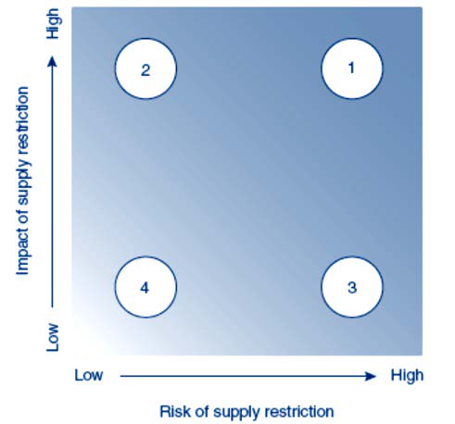

**Interpretation of the zones:**   
1. High risk and high impact of supply restrictions   
2. Low risk but high impact of supply restrictions   
3. High risk but low impact of supply restrictions   
4. Low risk and low impact of supply restrictions   
Minerals falling in area 1 are thus defined as being more critical than those in 2, 3 or 4.

*Source: Graedel and Allenby (2010)*

The European Commission published its own analysis of minerals criticality in 2010 – *Critical Raw Materials for the EU* (European Commission, 2010) *–* and updated it in 2014 (European Commission, 2014)*.* The 2010 report proposed a framework for identifying critical minerals that comprised three dimensions. Like the US study it analysed supply risk on the one hand and a measure of the ‘economic importance’ – to use the EU terminology – of a mineral on the other hand, but in addition it included a third measure, environmental risk. To be precise, this was an indicator of “the risks that measures might be taken by countries with the intention of protecting the environment and by doing so endangering the supply of raw materials to the European Union” (European Commission, 2010, p29).2 A critical mineral was then a mineral that scored highly on the measure of economic importance, as well as on the measure of supply risk *and/or* environmental risk. However, since environmental risk was not found in practice to significantly determine minerals criticality, it was dropped in the 2014 update. Out of 54 materials studied in 2014, 20 were identified as critical for the EU: antimony, beryllium, borates, chromium, cobalt, coking coal, fluorspar, gallium, germanium, indium, magnesite, magnesium, natural graphite, niobium, PGMs, phosphate rock, heavy and light rare earth elements, silicon metal, and tungsten.

Another study in this tradition was carried out for the UK economy by Oakdene Hollins (2008); *Material Security: Ensuring Resource Availability for the UK Economy*. This report relied on a two-dimensional analysis of supply risk against ‘material risk’, where material risk can be given various interpretations or indicators, including those in line with measuring economic vulnerability to fluctuations in supply, i.e. global consumption levels and availability of substitutes, and those more similar to environmental risk, i.e. contribution to global warming (in terms of Global Warming Potential). Out of

2 Note that this is a different conception of the environmental implications of mineral use than that put forward in Graedel et al. (2012) and mentioned above, which explicitly considers environmental impacts of minerals *beyond* the possible contribution of environmental regulations to supply-security threats.

12

ENV/WKP(2015)12

69 materials analysed, seven were identified as being most critical or ‘insecure’ in the language of the report. These were gold, rhodium, platinum, strontium, silver, antimony and tin.

The sets of minerals identified as being critical differ across these studies depending not only on the economy in focus (e.g. UK versus US), but also on the specific research design, i.e. how the general framework introduced at the start of this section is put into operation. A key difference between the studies is the number of dimensions (two or three) and in what each dimension is taken to mean. In addition, another important source of difference is in how the performance of a mineral on each dimension is quantified. Erdmann and Graedel (2011) provide a review.

**2.2 This study**

This study of critical minerals for the OECD countries builds upon the framework discussed above. A mineral is defined as critical if it is of high economic importance and its supply is associated with significant risk. The reportparticularly draws on the latest report for the EU (European Commission, 2014), because it is relatively well rooted in ‘objective’, quantitative data, and because the approach is practicable for large numbers of minerals and many countries, given the current availability of data. However, because the scope of the analysis extends beyond the present day to 2030, the report builds on the framework by incorporating dynamic considerations, i.e. changes over time in the supply risk attending to and economic importance of minerals.

Several robustness checks are also carried-out, analysing how different measures of supply risk relate to each other, how the analysis changes if alternative measures of political stability are used, and how it might change if an alternative measure of economic importance would be used for all minerals (we can only make this particular comparison for a limited number of minerals and only for the US). The general methodology is represented in Figure 2.

**Figure 2. Identifying critical minerals in the OECD**

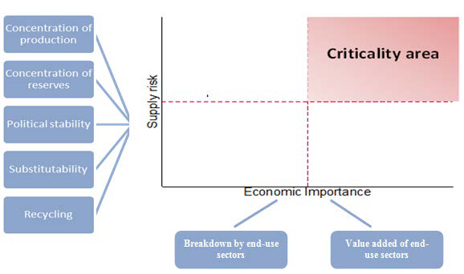

***2.2.1 Supply risk***

Following the European Commission (2014) study, supply risk is quantified on the basis of the following formula:

13

ENV/WKP(2015)12

(1)𝑆𝑆𝑆𝑆𝑆𝑆𝑆𝑆𝑆𝑆𝑆𝑆 𝑅𝑅𝑅𝑅𝑅𝑅𝑅𝑅𝑖𝑖= 𝜎𝜎𝑖𝑖(1 −𝜌𝜌𝑖𝑖) ∑(𝑆𝑆𝑖𝑖𝑖𝑖)2𝑃𝑃𝑃𝑃𝑃𝑃𝑃𝑃𝑃𝑃𝑃𝑃𝑃𝑃𝑐𝑐

*where:*   
*i – mineral*   
*s – sector*   
*c – country*   
𝜎𝜎𝑖𝑖 *– Substitutability =* ∑𝐴𝐴𝑖𝑖𝑖𝑖𝜎𝜎𝑖𝑖𝑖𝑖*, where* 𝐴𝐴𝑖𝑖𝑖𝑖 *is the share of consumption of mineral I in end-use sector s*   
𝜌𝜌𝑖𝑖 *– Recycling rate*   
𝑆𝑆𝑖𝑖𝑖𝑖 *– Production shares by country*   
𝑃𝑃𝑃𝑃𝑃𝑃𝑃𝑃𝑃𝑃𝑃𝑃𝑃𝑃𝑐𝑐 *– Economic and political stability by country*

The supply risk index is high if a mineral has few substitutes (a high 𝜎𝜎𝑖𝑖 means that few substitutes exist), if its rate of recycling is low, and if its production is concentrated in politically unstable countries.

**Substitutability and recycling:** two major factors that can mitigate supply risk in the framework introduced above are substitutability and recycling. The existence of substitutes reduces suppliers’ market power, while high recycling rates create an alternative source of supply.3 Both substitutability and recycling depend heavily on R&D, which can be strongly influenced by policy-makers.

Recycling rates are defined as the ‘End-of-life Recycling Input Rate’. This is a measure of “the proportion of metal and metal products that are produced from End-of-Life scrap and other metal-bearing low grade residues worldwide” (European Commission, 2014).4 The substitutability index is based on expert judgment, with values taken from European Commission (2014). In that study, substitutes are not explicitly identified for each material.

In attempting to project the set of critical minerals in 2030, the substitutability and recycling rates for all minerals are held constant at current levels. This assumption is very unlikely to hold as a description of the economic baseline, but it allows for an important policy question to be explored: by separating out the impact of baseline changes in exogenous production and political-risk factors, which might be seen to be reasonably outside the control of OECD resources policies, “necessary” rates of substitutability and recycling can be identified in order to make critical minerals less critical. These “necessary” rates are thus not predicted values; instead they serve as targets for policies aiming at mitigating criticality (coming from high supply risk).

**Production shares by country:** the supply-risk index of this report accounts for the concentration of production/reserves by incorporating a modified Herfindahl-Hirschman index for each mineral. The Herfindahl-Hirschman index is traditionally used as a measure of the size of firms with respect to the industry they belong to. Here we consider countries rather than firms.

The global distribution of economically exploitable mineral deposits (reserves) is highly asymmetric due to the lack of homogeneity of geological structures in the Earth’s crust. These natural differences mean that production is often concentrated, which in turn can lead to strategic limitations to trade, creating large economic uncertainties. China, for instance, accounts for 91% of REE production, 84% of tungsten production and South Africa represents 73% of platinum production (USGS, 2014). Table 2 presents an extended list of minerals, where production is highly concentrated.

|  |  |
| --- | --- |
| 3  4 | It should be noted, however, that attention must be given to the criticality of substitutes.  As Graedel et al. (2011) discuss, the calculation of EOL-RIRs is difficult at the country level due to the lack of information about the recycled content of imported produced metals. This measure is also known as “Recycled Content”. |

14

ENV/WKP(2015)12

**Table 2. Minerals with a high concentration of production**

|  |
| --- |
| **Mineral**  **Country** |
| ***More than 90% of production is concentrated in one country*** |
| Rare Earth Elements China |
| ***80%-90% is concentrated in one country*** |
| Antimony China |
| Beryllium USA |
| Germanium China |
| Magnesium China |
| Natural graphite China |
| ***70%-80% is concentrated in one country*** |
| Lithium Australia |
| PGM South Africa |
| Tantalum Canada |

Source: USGS, 2014

A particular challenge is to project the global distribution of production of minerals in 2030. The size of reserves is a candidate for quantifying the longer-run availability of a mineral, especially when compared to the level of current production/consumption. In particular, one possibility is a static lifetime measure, which identifies how many years of reserves are left given current rates of production/consumption.

Most minerals are abundant on the planet, but technology only allows extraction from the Earth’s crust. This substantially reduces the total recoverable resources. *Resources* represent the entire physical quantity of a mineral. They thus include already discovered, estimated stocks, as well as undiscovered resources. *Reserves* are generally understood as the proven quantity of a resource that is recoverable at today’s prices with today’s technology and which is legally mineable. The relationship between undiscovered resources, identified resources, and reserves is illustrated in Figure 3.

15

ENV/WKP(2015)12

**Figure 3. Relationship between reserves and resources**

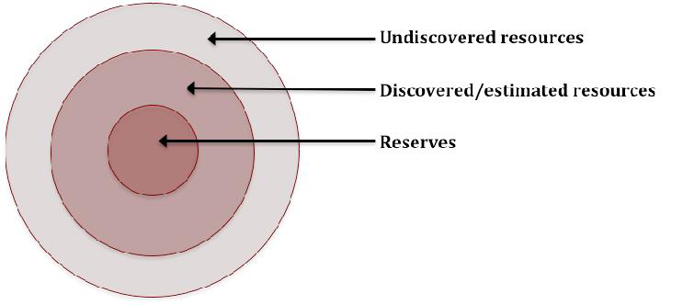

A widely recognised problem with using reserves and static lifetime measures is, however, that they can motivate misleading conclusions. Reserves are by definition endogenously determined and therefore they are not fixed. They can thus grow over time, for example tungsten reserves grew by a factor of one and a half, and REEs by 27%, between 2000 and 2013 (USGS, 2014). Forecasts based on such measures are as a consequence highly unreliable, as Figure 4 illustrates for copper and nickel.

In fact, both reserves and resource estimates are subject to upward revision due to exploration and discoveries. Exploration depends on the expected benefits of discoveries that vary with future minerals prices, on the probability of finding new deposits (which is negatively correlated with past exploration), and on exploration costs. High minerals prices thus stimulate both exploration and extraction. Discoveries and technical progress in extractive technologies explain why the reserves estimates of most minerals increased over the course of the last century, despite massive extraction.

16

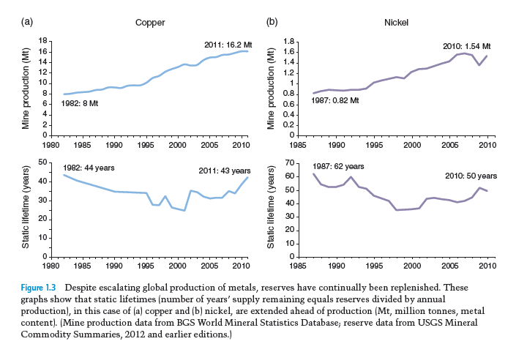

ENV/WKP(2015)12

**Figure 4. Mine production and static lifetimes predictions for (a) copper and (b) nickel**

Source: Critical Metals Handbook (2014) “Metal Resources, Use and Criticality

Complete depletion is currently irrelevant for most minerals (see e.g. Cathles, 2010). As a consequence, existing studies do not put much emphasis on physical availability *per se*. The EU and UK studies do not include the measure in their estimates, while the US study concludes that physical availability is only meaningful in combination with other parameters.

Given all of this, the report takes two different approaches to projecting production shares by country in 2030. First, it uses the distribution of reserves instead of the distribution of production, on the grounds that, in the longer run, production-related supply risks can be predicted by the current distribution of reserves. However, since using reserve measures in isolation can be a misleading indicator of resource scarcity as just discussed, the report augments formula (1) with the current production/reserves ratio:

|  |  |  |
| --- | --- | --- |
| (2)𝑆𝑆𝑆𝑆𝑆𝑆𝑆𝑆𝑆𝑆𝑆𝑆 𝑅𝑅𝑅𝑅𝑅𝑅𝑅𝑅𝑖𝑖= 𝜎𝜎𝑖𝑖(1 −𝜌𝜌𝑖𝑖) ∑(𝑆𝑆𝑖𝑖𝑖𝑖)2𝑃𝑃𝑃𝑃𝑃𝑃𝑃𝑃𝑃𝑃𝑃𝑃𝑃𝑃𝑐𝑐 | (50 ∗ | 𝑃𝑃𝑃𝑃𝑃𝑃𝑃𝑃𝑃𝑃𝑃𝑃𝑃𝑃𝑃𝑃𝑃𝑃𝑃𝑃𝑖𝑖 𝑅𝑅𝑅𝑅𝑅𝑅𝑅𝑅𝑅𝑅𝑅𝑅𝑅𝑅𝑅𝑅𝑖𝑖)1/2 |

This approach assumes that countries continue to produce the same share of their reserves, meaning that the distribution of production gradually converges towards the distribution of reserves as resources are depleted. This specific functional form was chosen in order to keep results comparable to the original index values. The added multiplying factor thus ensures that the index remains unchanged if the production-to-reserves ratio equals 1/50, implying that existing reserves are enough to satisfy the current rate of production rate for exactly 50 more years. Minerals with less than 50 years of reserves will, in other words, be given a relatively higher supply risk value and vice versa.

**Economic and political stability:** in recent years, production of minerals and the concentration of remaining reserves have shifted from Europe and the United States to emerging and developing economies. This trend can be explained by the increasing minerals requirements of emerging economies, as well as the depletion of competitive resource deposits in countries that industrialised first. But some developing economies are less politically stable than their industrialised counterparts. This shift in production has

17

ENV/WKP(2015)12

therefore meant that the political stability of producer countries has become an important parameter when quantifying the supply security of minerals.

Three different indices are being used to measure political stability and limits to minerals trade:

1. *World Government Indicators* (WGI, 2014): this source, which is used for the main results in Section 3, includes indicators on: voice and accountability; political stability; government effectiveness; regulatory quality; rule of law, and; control of corruption. Data are from the World Bank.

2. *Political Risk Services* (PRS, 2014) from the International Country Risk Guide (ICRG): the ICRG offers an index on government stability. This index, which is introduced when carrying out robustness checks in Section 4, is based on expert assessments of both the government’s ability to carry out its declared program, and its ability to stay in office.

3. *The Open Market Index* (OMI, 2014): this measures openness to trade and consists of the following subcomponents: trade openness; trade policy; Foreign Direct Investment (FDI) openness, and; trade enabling infrastructure. The International Chamber of Commerce (ICC) provides the data. Again, this measure isused in performing robustness checks in Section 4.

***2.2.2 Economic importance***

Again taking the European Commission (2014) study as the starting point, the economic importance of minerals is defined as follows:

|  |
| --- |
| 1  (3)𝐸𝐸𝐸𝐸𝐸𝐸𝐸𝐸𝐸𝐸𝐸𝐸𝐸𝐸𝐸𝐸 𝐼𝐼𝐼𝐼𝐼𝐼𝐼𝐼𝐼𝐼𝐼𝐼𝐼𝐼𝐼𝐼𝐼𝐼𝐼𝐼𝑖𝑖=∑𝑄𝑄𝑠𝑠∑𝐴𝐴𝑖𝑖𝑖𝑖𝑄𝑄𝑠𝑠  *where:*  *i – mineral*  *s – sector*  𝑄𝑄𝑠𝑠 *- Gross value added (GVA) of sector s*  𝐴𝐴𝑖𝑖𝑖𝑖 *- The share of consumption of mineral i in end–use sector s* |

A mineral that is used heavily in a sector that constitutes a large part of the economy will thus have a relatively high economic importance index value.

It is important to note that this methodology does not directly capture the value added by specific minerals and the economic importance index should therefore be interpreted with caution. A mineral can thus in practice be very important for a sector’s output, despite the sector only accounting for a relatively small share of the total quantity consumed.

To make the economic importance measure dynamic, the report uses OECD modelling of baseline economic growth to 2030, performed with the ENV-LINKAGES computable general equilibrium model, to project structural change and the future sectoral composition of the OECD economies. The relative importance of sectors thus changes and this alters the economic importance of minerals. The end-use breakdown of minerals by sector is assumed fixed at current levels.

18

ENV/WKP(2015)12

***2.2.3 Long-list of minerals, and data sources***

The report assesses which of 51 minerals are critical for the OECD countries. The long-list of minerals includes: aluminium, antimony, barytes, bauxite, bentonite, beryllium, borate, chromium, clays, cobalt, coking coal, copper, diatomite, feldspar, fluorspar, gallium, germanium, gold, gypsum, hafnium, indium, iron ore, limestone, lithium, magnesite, magnesium, manganese, molybdenum, natural graphite, nickel, niobium, perlite, PGMs, phosphate rock, potash, REE (heavy), REE (light), rhenium, scandium, selenium, silica sand, silicon metal, silver, talc, tantalum, tellurium, tin, titanium, tungsten, vanadium, and zinc.

Following the US study (National Research Council of the National Academies, 2008) and the EU studies (European Commission, 2010; 2014), some elements are grouped together into the Platinum Group Metals (PGMs), and some into the Rare Earth Elements (REE). PGMs include iridium, osmium, palladium, platinum, rhodium and ruthenium. The REE group is divided into three groups: heavy rare earth elements, light rare earth elements and scandium, following again the EU reports. The heavy rare earth elements are europium, gadolinium, terbium, dysprosium, erbium, yttrium, holmium, thulium, ytterbium, and lutetium. The light rare Earth elements are lanthanum, cerium, praseodymium, neodymium and samarium. While similar properties and/or market characteristics may justify this grouping in part, a more careful analysis would require analysing each element separately, to take account of the different levels of criticality within these groups. Disaggregating the PGM and REE groups would require specific data for each element that is not currently available.

Data for the analysis are taken from a range of different sources. Table 3 provides an overview.

**Table 3. Summary of sources**

|  |  |
| --- | --- |
| ***Variable*** | **Main source(s)** |
| *Production shares* | USGS (2014), WMD (2014), European Commission (2014) |
| *Reserves* | USGS (2014), BGS (2014) |
| *End-use sector\** | European Commission (2010, 2014) |
| *Gross value added\*\** | OECD |
| *Substitutability and recycling rates* | European Commission (2010, 2014) |
| *Political stability* | WGI (by WB, 2014), PRS (2014), OMI (by ICC, 2014) |

* To identify the end-use sectors of minerals, the authors relied on data compiled for the European Commission (2014) report. This dataset is originally based on data from the USGS.

** Information on the gross value added of sectors, current and predicted, is based on data provided by the OECD. This dataset is on country level and is GTAP-coded.-

19

ENV/WKP(2015)12

**3. RESULTS**

This section presents the results of the analysis. First, estimates of the set of critical minerals today are introduced, using the most up-to-date data (for 2012). These are built-up from estimates of supply risk, which are then united with estimates of economic importance to obtain an overall mapping of criticality. This serves as a benchmark for presenting changes in the set of critical minerals that are projected to occur between now and 2030. The section concludes with a series of policy thought-experiments concerning what recycling and substitutability changes would be needed to make critical minerals non-critical, today and in the future.

**3.1 Critical minerals in OECD countries today**

***3.1.1 Supply risk today***

The analysis begins with the index of supply risk, described above in Equation (1). Table 4 identifies the ten minerals in the set of 51 with the highest value on the supply-risk index, and compares these with some characteristics of the whole set of minerals. Supply risk data for each of the 51 minerals are listed in Appendix 1.

**Table 4. The top ten minerals in terms of supply risk**

|  |  |  |  |  |
| --- | --- | --- | --- | --- |
| **Mineral** | **Supply risk** | **Recycling rate** | **Substitutability** | **Political risk (HHI)** |
| **1) REE (Heavy)** | 4.6 | 0 | 0.77 | 5.99 |
| **2) Germanium** | 3.6 | 0 | 0.86 | 4.20 |
| **3) Natural Graphite** | 3.2 | 0 | 0.72 | 4.50 |
| **4) REE (Light)** | 3.1 | 0 | 0.67 | 4.64 |
| **5) Niobium** | 2.6 | 0.11 | 0.69 | 4.26 |
| **6) Magnesium** | 2.4 | 0.14 | 0.64 | 4.42 |
| **7) Antimony** | 2.3 | 0.11 | 0.62 | 4.24 |
| **8) Cobalt** | 2.2 | 0.16 | 0.71 | 3.76 |
| **9) Fluorspar** | 2.1 | 0 | 0.80 | 2.59 |
| **10) Magnesite** | 1.9 | 0 | 0.72 | 2.71 |
| **Sample characteristics (all 51 minerals)** | | | | |
| ***Mean*** | *1.1* | *0.08* | *0.69* | *1.77* |
| ***25th percentile*** | *0.3* | *0* | *0.59* | *0.71* |
| ***Median*** | *0.9* | *0* | *0.70* | *1.27* |
| ***75th percentile*** | *1.6* | *0.15* | *0.83* | *2.17* |

A high substitutability value means that few substitutes exist.

The minerals group with, by some margin, the highest supply risk for OECD countries today is the heavy rare earth elements. Its value on the index is over five times that of the median (iron ore and tin

20

ENV/WKP(2015)12

share the median value). The heavy rare earth elements are followed by germanium, natural graphite and the light rare earth elements.

Figure 5 plots the 51 minerals on two dimensions: substitutability on the one hand and political risk on the other hand. Those minerals classified in the top ten for supply risk as per Table 4 are highlighted.

The minerals with the highest supply risk correspond closely with a group characterised by high political risk, at the same time as low substitutability (i.e. a high substitutability index value).5 This indicates that the main drivers of supply risk are indeed these two elements of the index, rather than recycling rates.

**Figure 5. Minerals as a function of production concentration and substitutability**

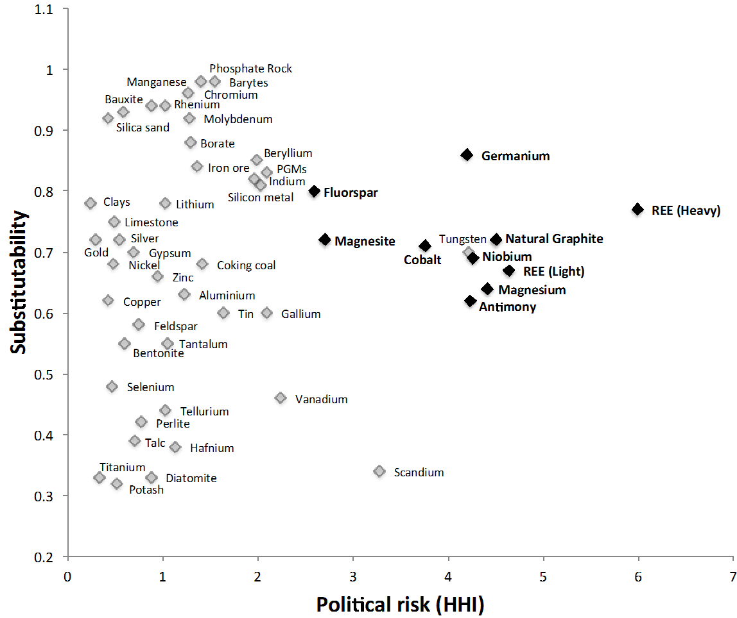

***3.1.2 Economic importance and overall criticality today***

Figure 6 combines estimates of supply risk with estimates of economic importance, to achieve an overall mapping of minerals criticality in OECD countries today. Recall that the measure of economic importance seeks to identify minerals used heavily in sectors comprising a large share of aggregate OECD

|  |  |
| --- | --- |
| 5 | Within the cluster of minerals highlighted as belonging to the top ten in terms of supply risk is tungsten, which in fact lies just outside the top ten, i.e. twelfth. |

21

ENV/WKP(2015)12

output. Minerals located towards the top right of Figure 6 are relatively critical according to the framework.

While the heavy rare earth elements stand out in terms of supply risk, they lie only around the middle of the distribution on the economic importance dimension. It is a similar story for germanium and the light rare earth elements. Natural graphite is relatively more economically important, but still does not stand out in this regard.

By contrast, the most economically important minerals in OECD countries today (i.e. the top ten) are, in descending order: barytes; tungsten; vanadium; coking coal; chromium; zinc; bauxite; nickel; potash, and; magnesite. But of these, only magnesite lies within the top ten on supply risk.

Some examples of where these economically important minerals are used include barytes of which over three quarters are used in drilling fluids in oil and gas exploration; tungsten is a metal with a wide range of uses, the largest of which is as tungsten carbide in cemented carbides, which are wear-resistant materials used by the metalworking, mining and construction industries; vanadium is used in automobiles and machinery as an alloy. It is also used together with aluminium in jet engines and high-speed airframes.

In a framework such as this, the boundary between what is critical and what is non-critical is arbitrary. From visual inspection of the figure, there is an axis of minerals starting with the outliers on supply risk (most notably the heavy rare earth elements), which swings to the southeast to take in those with high, but not extremely high, supply risk, but that have extremely high economic importance, such as barytes and tungsten.

Another approach to demarcating the set of critical minerals is to make a comparison with previous work that has set thresholds as such, in particular the previous EU studies that identified as critical those minerals with an economic importance index value above 0.05 and a supply risk index value above 1 (European Commission, 2010; 2014). Doing so identifies 21 minerals as critical for the OECD on aggregate today: antimony; barytes; beryllium; borate; chromium; cobalt; fluorspar; gallium; germanium; indium; magnesite; magnesium; natural graphite; niobium; PGMs; phosphate rock; REE (heavy); REE (light); silicon metal; tungsten, and; vanadium.

22

ENV/WKP(2015)12

**Figure 6. Critical minerals in OECD countries today**

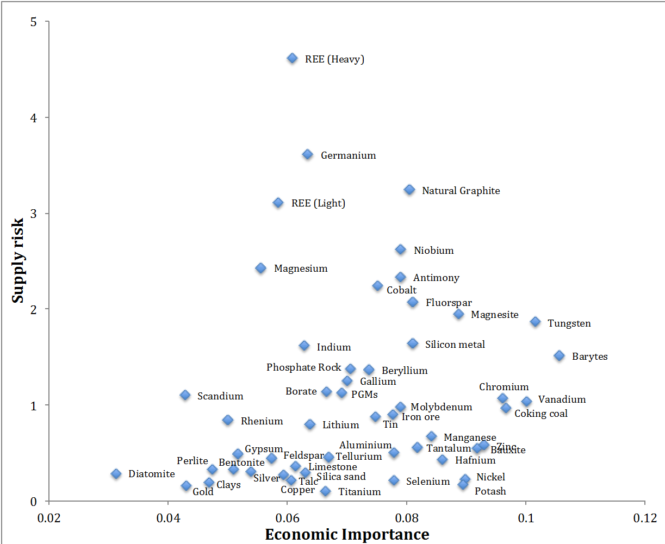

Most of the analysis is carried out for the OECD economy on aggregate, yet it is clearly important for each OECD country to understand which minerals are critical for it alone. Our measure of supply risk is the same for each and all OECD countries (more on this below), but economic importance may differ across countries and regions depending on the sectoral composition of their economies. While a country-by-country analysis is beyond the scope of this report, criticality can be compared for three major OECD countries/regions, namely the US, Japan and the EU. The results of this analysis are presented in Figures 7 to 9.

On the horizontal axis these figures show economic importance calculated for the entire OECD, while on the vertical axis they show economic importance for the US, Japan and EU respectively. Minerals above (below) the 45-degree line are more (less) economically important for a given country/region than for the OECD as a whole.

23

ENV/WKP(2015)12

**Figure 7. Economic importance for the USA vs. the OECD as a whole, today**

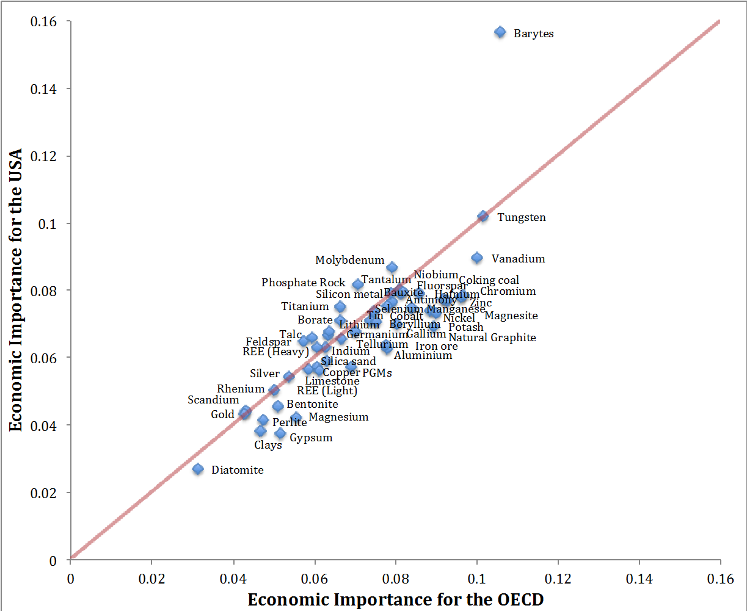

As Figure 7 shows, there is a close relationship between which minerals are economically important for the OECD as a whole and which are economically important for the US alone. This is explained by the large aggregate size of the US economy relative to the rest of the OECD. The clear exception to this is barytes, which is much more economically important for the US than it is for the aggregate OECD economy, being heavily used in the US’s large, economically important oil-extraction industry. Indeed, from a US perspective barytes is by a long way the most economically important of the 51 minerals analysed, according to the method we use.

24

ENV/WKP(2015)12

**Figure 8. Economic importance for Japan vs. the OECD as a whole, today**

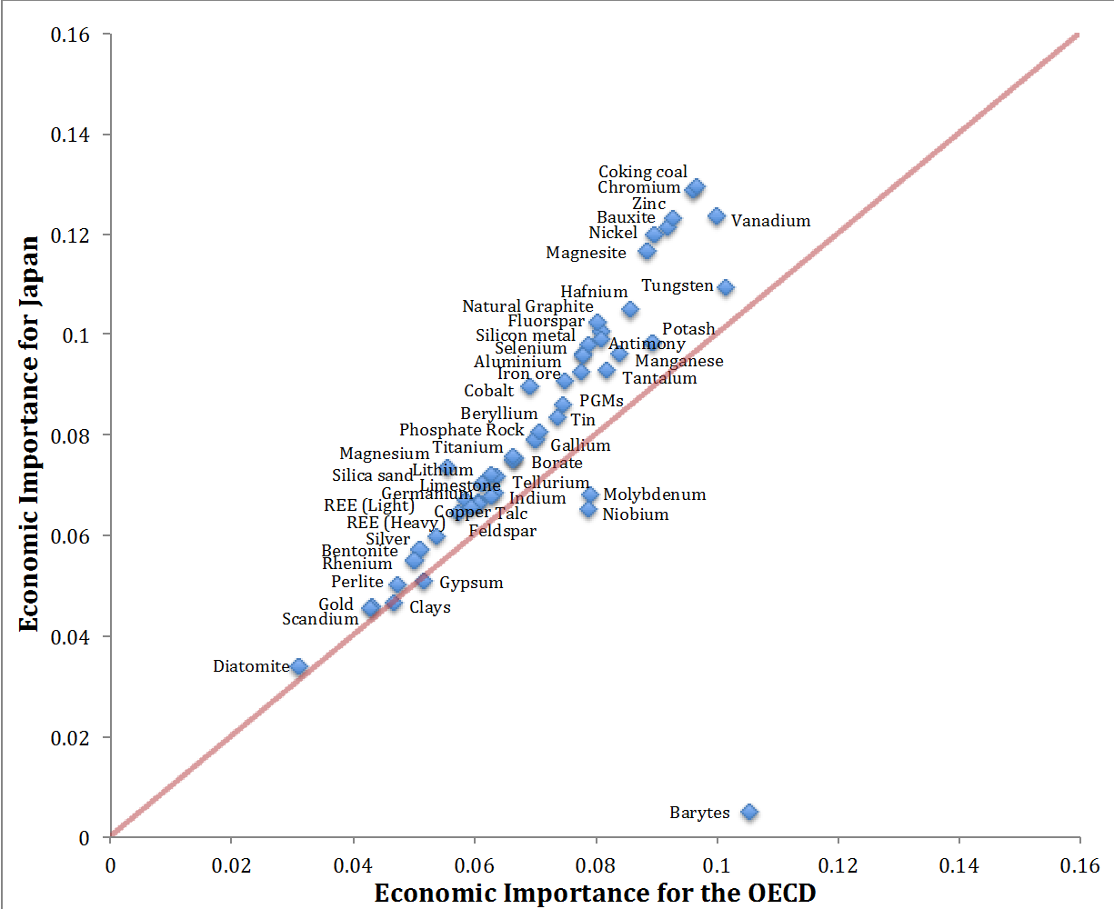

Figure 8 shows the difference between economic importance for Japan and for the OECD as a whole. Barytes is again an outlier, for the same reason; the economic importance of this mineral to the US dominates the OECD aggregate. Otherwise the remaining 50 minerals are much closer to the 45-degree line that marks out a perfect correspondence between economic importance in Japan and in the aggregate OECD, except that a trend emerges, whereby most minerals – all, in fact, except molybdenum and niobium – are more economically important for Japan than they are for the aggregate OECD. Indeed the difference grows, the more economically important the mineral is. That is to say, apart from barytes the largest disparities are for minerals like coking coal and chromium, which are also among the most economically important minerals to either the OECD or Japan.

To complete this set of regional comparisons, Figure 9 plots economic importance today for the EU versus the OECD. With the by-now familiar exception of barytes, it is clear that there is a particularly close correspondence between which minerals are economically important in the EU and which are economically important for the aggregate OECD, with most data points close to the 45-degree line. Like for Japan, the majority of minerals are marginally more economically important for the EU than they are for the aggregate OECD. This is the converse of what we observe for the US, showing how some of the large OECD economies offset each other in the aggregate data.

25

ENV/WKP(2015)12

**Figure 9. Economic importance for the EU vs. the OECD as a whole, today**

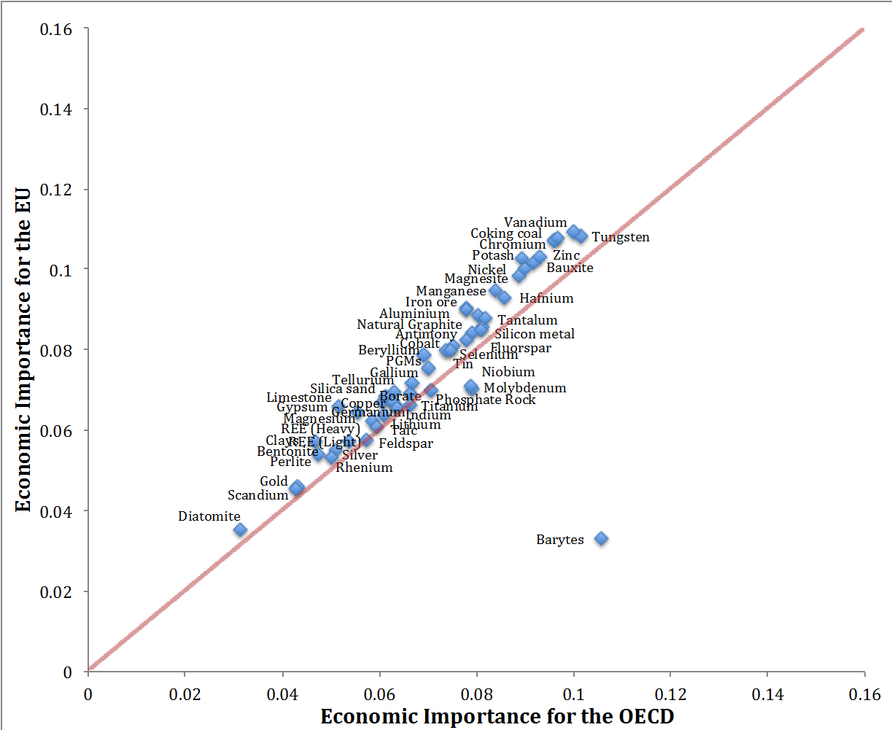

Figures 7 to 9 suggest that estimates of which minerals are economically important do vary across OECD countries according to the structure of their economies and these country/region differences should be understood by policy-makers and accounted for when evaluating the consequences of supply disruptions. Nonetheless only a relatively few major disparities are apparent, most notably barytes.

It is important to note, however, that one of the limitations associated with the measure of economic importance is the country-invariant breakdown of minerals by end-use sectors, which may differ across countries in reality. For example, barytes is extensively used as a weighting agent in oil- and gas-well drilling fluids and thus is especially important for the mining sector in economies rich in oil. But its share in this sector may be lower in other economies. Following this logic, barytes may be even less economically important in the EU and Japan than Figures 8 and 9 suggest.

***3.1.3 An alternative measure of supply risk today***

The introduction of a static lifetime measure (production-to-reserves ratio) to the supply risk formula allows to account for physical constraints to extraction. The ratio of production to reserves varies across minerals, as Figure 10 shows. Minerals with high values on this ratio will have higher supply risk according to formula (2). In particular, minerals with a production-to-reserves ratio to the right of the red

26

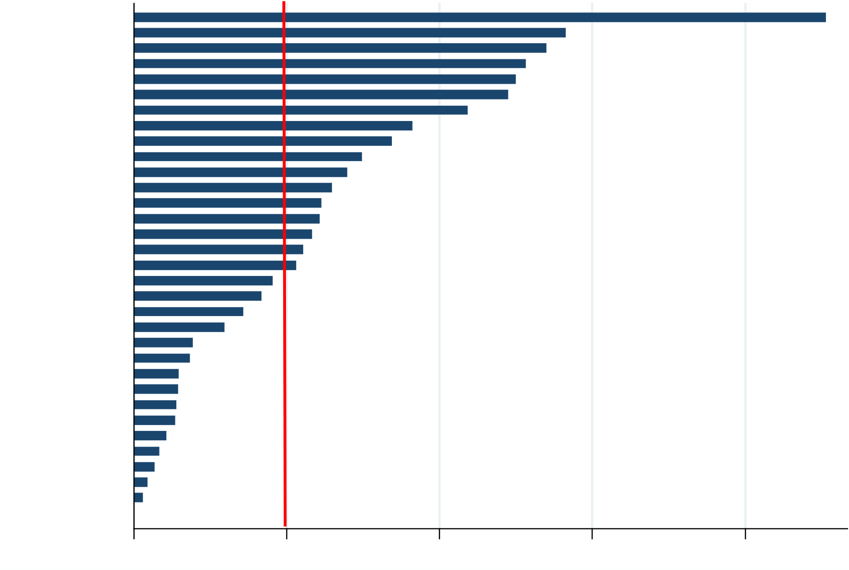

ENV/WKP(2015)12

line can be treated as relatively scarce, as they have less than 50 years of reserves at current levels of production.

**Figure 10. Production-to-reserves ratio**

Antimony   
 Chromium   
 Zinc   
 Gold   
 Silver   
 Tin   
 Titanium   
 Iron ore   
 Nickel   
 Manganese   
 Fluorspar   
 Copper   
Molybdenum   
 Barytes   
 Borate   
 Tungsten   
 Rhenium   
 Selenium   
 Cobalt   
Natural Graphite   
 Niobium   
 Bauxite   
 PGMs   
 Tantalum   
 Potash   
 Tellurium   
 Vanadium   
 Perlite   
Phosphate Rock   
 Lithium   
 Aluminium   
 REE (Heavy)

|  |  |  |  |  |
| --- | --- | --- | --- | --- |
| 0 | .02 | .04 | .06 | .08 |

Where reserves data were available, supply risk was estimated based on equation (2) and the results are presented in Figure 11. From this figure it can be seen that antimony becomes much more critical and heavy rare earth elements become much less critical from a supply risk perspective, reflecting very different production-to-reserves ratios. However, otherwise there is not a major difference between supply risk as estimated by the two approaches.

27

ENV/WKP(2015)12

**Figure 11.**  **Comparing modified supply risk with the original formula**

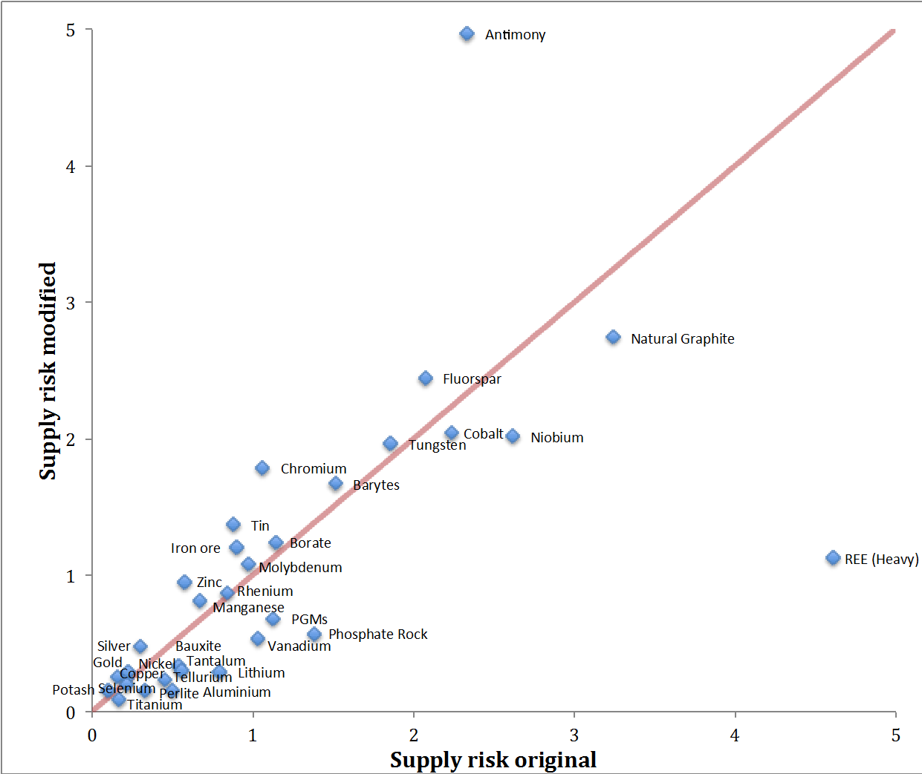

**3.2 Critical minerals in OECD countries in 2030**

Future criticality of minerals depends on a range of unknowns. Some of these are very difficult to forecast, especially future technologies. This affects both supply risk, through discoveries and expansion of reserves, substitutability and recycling opportunities, and economic importance, through applications of minerals in different sectors, and the weight of different sectors in the whole economy. It is impossible to predict with a high degree of confidence which minerals will be critical in the future. Incorporating credible dynamics into the criticality assessment can, however, give an indication of possible directions of change based on current information.

***3.2.1 Future supply risks***

Political risk and the distribution of minerals production are important factors determining supply risk and consequently the set of critical minerals. Future changes in political risk are difficult to predict, so for the purposes of this report current risk estimates are assumed to apply up until 2030. Thus it is assumed that currently relatively unstable countries will remain so.

28

ENV/WKP(2015)12

Attention therefore turns to predicting the future distribution of production. To capture the range of potential outcomes, three scenarios are proposed. First, as a baseline scenario production shares are assumed to remain constant, in which case supply risk estimates will not change. Second, as discussed in Section 2, the distribution of production is assumed to converge gradually towards the distribution of reserves as they are depleted. In practice it is assumed that countries continue to produce the same share of their reserves every year up to 2030. This naturally motivates a gradual shift of production towards reserve-rich countries as deposits are reduced.

Conducting this exercise for the minerals with available and reliable reserves data yields the results presented in Figure 12 Supply risk in 2030 using the current distribution of production is on the horizontal axis – i.e. current supply risk – while supply risk in 2030 using the production-to-reserves ratio method is on the vertical axis.

Barytes, borate and molybdenum see the greatest increase in supply risk. For both borate and molybdenum, production is predicted to move to China, which is associated with a relatively higher political risk according to the baseline measure from the World Governance Index of the World Bank. Phosphate rock also sees a significant increase in supply risk, as reserves are extremely concentrated (see Box 2). At the same time, some relatively critical minerals are predicted to become less so by 2030, notably cobalt, fluorspar and tungsten.

**Figure 12.**  **Supply risk predictions for 2030 using the production-to-reserves ratio method**

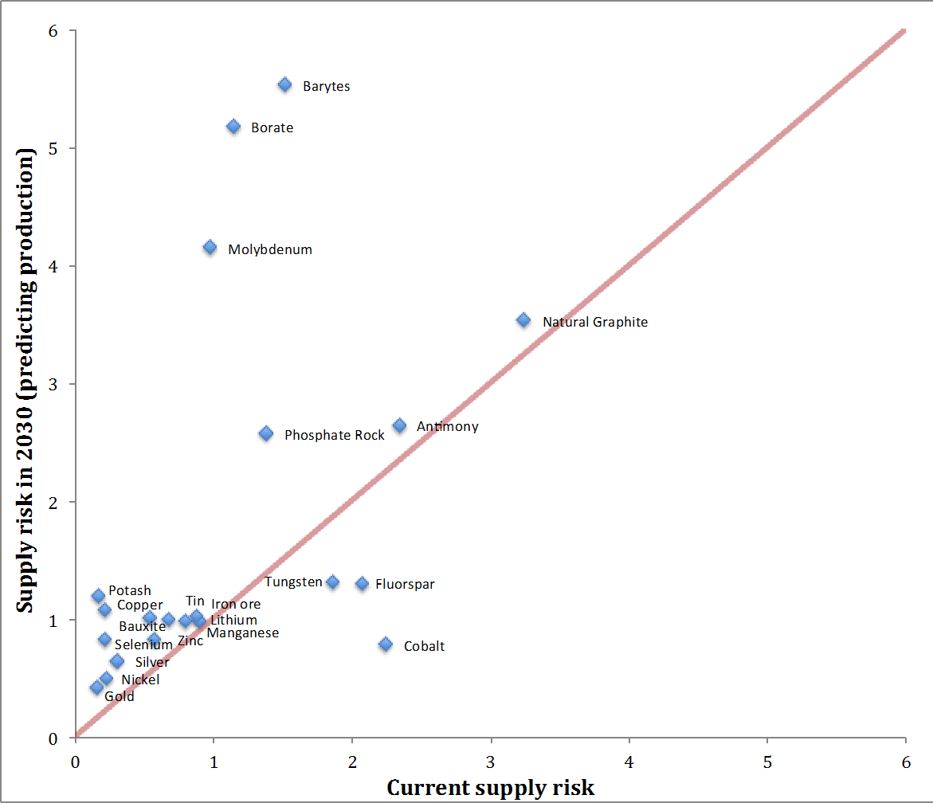

29

ENV/WKP(2015)12

|  |
| --- |
| **Box 2.**  **Production and reserves of phosphate rock**  *Phosphate rock is a sedimentary rock containing large amounts of phosphate-bearing minerals. It is currently the only economically viable source of phosphorus for nitrogen-phosphorus-potassium fertilizers, which are used widely on food crops. Phosphate rock is also used in animal feed supplements, food preservatives, anti-corrosion agents, cosmetics, fungicides, ceramics, water treatment and metallurgy. Phosphate rock is fairly common and found worldwide, but reserves are concentrated in Morocco and Western Sahara (75% of all reserves), while production is concentrated in China (45%).*  *An extremely high concentration of reserves in a rather unstable region explains why supply risk increases significantly in the period up to 2030 (Figure 11).* |

The third scenario assumes that future production occurs where reserves are currently present, meaning that the production distribution in 2030 will equal the current distribution of reserves. This is considered to be the extreme scenario of future supply risk. Figure 13 compares supply risk according to this measure with supply risk according to today’s distribution of production, in a manner analogous to the previous figure.

As can be seen, the supply risk attending to phosphate rock is particularly large according to the reserves-based measure, due to its concentration in Morocco and Western Sahara (Box 2). By contrast, the supply risk index value is markedly lower than today for natural graphite, although this mineral remains among the most risky from a supply perspective, fluorspar, antimony, cobalt, tungsten and, interestingly, barytes.

30

ENV/WKP(2015)12

**Figure 13. Supply risk predictions for 2030 using reserve distribution instead of production**

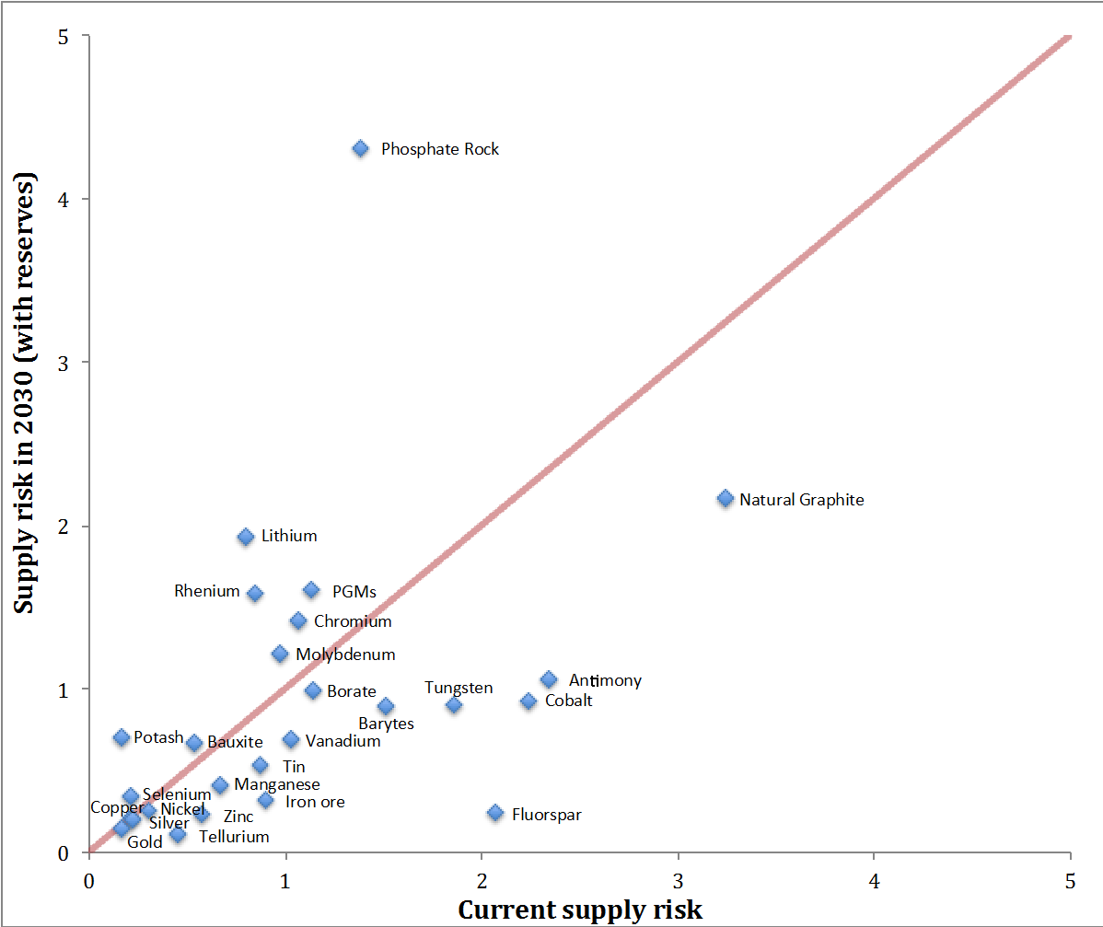

***3.2.2 Future economic importance***

Economic Importance in 2030 depends on how the consumption of minerals in the future will be shared between different end-use sectors, as well as the relative economic importance of these sectors. The mineral consumption of a specific end-use sector depends heavily on technology. It is therefore difficult to predict which sectors will use which minerals in 2030. In the context of this report, consumption shares are therefore assumed constant. As an example, this means that since 26% of aluminium is currently going to the Construction Materials sector, it will remain so in 2030.

The second component determining economic importance is the relative value added by sector. As discussed in Section 2, we use the results of macroeconomic modelling with OECD’s ENV-LINKAGES model to project the sectoral composition of OECD economies in 2030.

Conducting the criticality analysis with the model-based forecast of sectoral composition in 2030 yields the results presented in Figure 14 below.

31

ENV/WKP(2015)12

|  |  |
| --- | --- |
| **Figure 14.** | **Economic Importance in 2030** |

|  |
| --- |
|  |

In comparison with the changes observed when making supply risk dynamic, the estimates of economic importance in 2030 are relatively similar to those today.

**3.3 Recycling and substitutability needs**

Substitutability and recycling rates were kept constant in the analysis presented above. This was done for two reasons. First, it is difficult to predict how they will develop over time, as they depend on technological innovation, relative prices and future policy initiatives, among other things. Second, keeping them constant in the baseline, in order to then evaluate what changes to substitutability and recycling rates are needed to mitigate criticality, serves as an interesting exercise in policy analysis. OECD policy-makers have to take many market conditions – such as the location of production of minerals – as given, but they can influence domestic and international R&D towards the development of substitutes, as well as national recycling policies.

This section first calculates the increase in the level of substitutability that is necessary to make critical minerals non-critical according to the application of the thresholds from the EU studies (European Commission, 2010; 2014), while holding constant recycling rates, as well, of course, as political stability and the concentration of production. This exercise is conducted both for critical minerals today, and for

32

ENV/WKP(2015)12

minerals that are critical according to the 2030-scenario in which production converges gradually towards the distribution of reserves as they are depleted.

Figure 15 presents the results for today and Figure 16 those for 2030. Note that not all minerals are present in the estimates for 2030, as reserves data are only available for a subset. Recall that a high value on the substitutability measure indicates that a mineral is relatively difficult to substitute.

Focusing on 2030, a timescale in which R&D policies could be reasonably expected to deliver results, Figure 15 shows that the improvements required to mineral substitutability vary widely. For minerals such as borate, barytes, phosphate rock and molybdenum, very large increases in substitutability will be required from a very low starting point, suggesting that significant investments in R&D would be necessary for these minerals. By contrast, only small improvements would be required for manganese, bauxite, copper and potash, although again in the cases of manganese and bauxite substitutability is currently very low, so gains may not be won easily.

**Figure 15.**  **Changes in substitutability needed to mitigate criticality today**

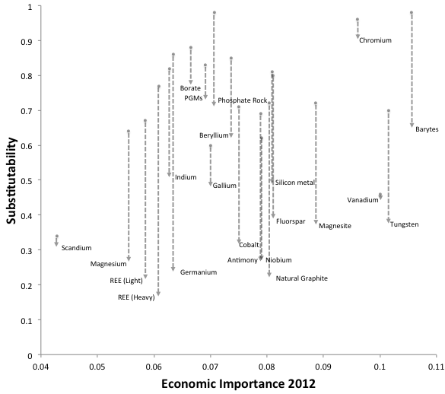

Notes:

A higher value on the substitutability axis implies that the mineral is less substitutable and thus associated with high supply risk.

At the substitutability levels indicated by the end-point of the arrows, currently critical minerals would be non-critical.

33

ENV/WKP(2015)12

**Figure 16. Changes in substitutability needed to mitigate criticality in 2030**

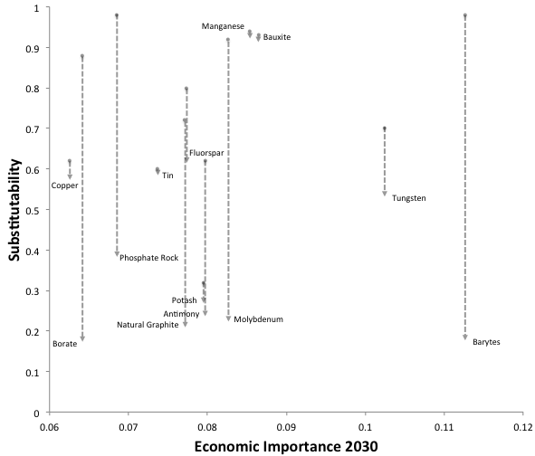

Notes:

A higher value on the substitutability axis implies that the mineral is less substitutable and thus associated with high supply risk.

At the substitutability levels indicated by the end-point of the arrows, currently critical minerals would be non-critical.

The same procedure is also applied to the case of recycling rates. Necessary recycling rates to mitigate criticality today and in 2030 are presented in Figures 17 and 18. Most of the minerals analysed in this report currently have recycling rates at zero, in particular: barytes; borate; fluorspar; gallium; germanium; indium; magnesite; phosphate rock; heavy rare earth elements; light rare earth elements; silicon metal, and; vanadium. Achieving lower supply risk for these minerals via recycling could thus require inventing new technologies. However, this is not the case for a range of minerals where recycling is currently taking place, in particular: antimony; beryllium; chromium; cobalt; iron ore; magnesium; molybdenum; niobium; PGMs; scandium, and; tungsten. For these minerals, higher recycling rates require either using existing technologies more efficiently or developing new ones.

34

ENV/WKP(2015)12

**Figure 17.**  **Changes in recycling needed to mitigate criticality today**

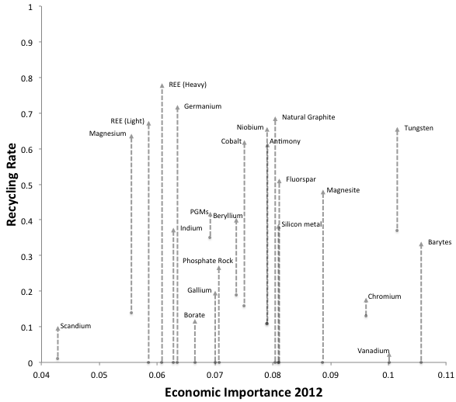

Notes:   
Higher recycling rates are associated with lower supply risk.

At the recycling rates indicated by the end-point of the arrows, currently critical minerals would be non-critical.

35

ENV/WKP(2015)12

**Figure 18.**  **Changes in recycling needed to mitigate criticality in 2030**

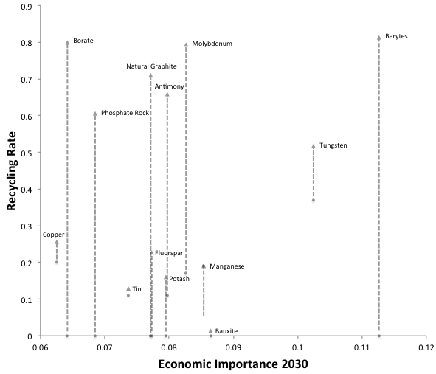

Notes:

Higher recycling rates are associated with lower supply risk.

At the recycling rates indicated by the end-point of the arrows, currently critical minerals would be non-critical.

From both Figures 17 and 18, it is important to notice that for some minerals recycling requirements are especially high (assuming no improvements in substitutability). To mitigate criticality today, it would be necessary to have recycling rates of over 60% for magnesium, REEs (heavy and light), germanium, natural graphite, niobium, cobalt, antimony and tungsten. On the other hand, scandium, borate, chromium, gallium and especially vanadium require relatively low recycling rates today in order to change status and become non-critical (less than 20%).

In 2030, it is copper, fluorspar, manganese, potash, tin and bauxite that require relatively low rates of recycling in order to change status from critical to non-critical according to the thresholds from the EU studies, whereas for barytes, borate, molybdenum, natural graphite, antimony and phosphate rock huge improvements would still be required. Tungsten would also need to be recycled to a high degree in 2030 (over 50%), but the recycling rate for this mineral is already at about 40%.

Section 2 explained that, in this study, recycling rates are defined as the End-of-life Recycling Input Rate (EOL-RIR). Increases in EOL-RIRs to mitigate criticality might be infeasible in practice. For a given

36

ENV/WKP(2015)12

utilisation of metals, increasing the recycling rate would require either increasing the collection rate of old scrap, and/or increasing the recycling efficiency of old scrap (the percentage of metals or materials in end-of-life products that is recycled). However, ultimately EOL-RIR values depend on the current demand for metals compared to past metal production. Even with perfect recycling of metals embodied in old products, an EOL-RIR value for a metal can still be low, if the demand for this metal is increasing through time.

It is difficult to forecast improvements in recycling, and to define recycling rates that could be considered feasible in the future. Looking at past achievements may give a hint of the potential for improvement, but unfortunately historical data on recycling rates are available only for a very few major metals. It is unlikely that trends observed for major metals such as iron and copper apply to other metals, because each metal has specific properties that make its recycling more or less complex. Graedel et al. (2011) stress that recycling efficiency largely depends on “the form in which a metal is used (pure, alloyed, etc.), the quantity of a metal in a specific product, [and] the design of a product (easy or hard to disassemble)”. In the short term, recycling is constrained by the availability of recycling installations, and recycling efforts and installations are impacted by the market value of metals. In addition, as mentioned earlier, EOL-RIR measures also rely on current demand for metals. If current demand is large compared to past production, recycled metal cannot match current needs.

Therefore it is important to conclude this section by reminding that the analysis has merely mapped out the extremes of what might be required from recycling and improvements in substitutability.

**4. ROBUSTNESS CHECKS**

This section tests the robustness of the results obtained to various key methodological choices. Section 4.1 discusses how criticality depends on the weighting of the different components of the supply risk index. Section 4.2 evaluates alternative measures of political risk. Section 4.3 compares the results of the estimation of economic importance with the results of two studies that use an alternative method.

**4.1 Weighting factors**

In this report, supply risk is a compound index aggregating three dimensions multiplicatively: substitutability, recycling rates and the concentration of production in politically unstable countries (formulae (1) and (2)). Alternative weightings of these dimensions would lead to different values of the aggregate index.

Table 5 presents correlation coefficients between the different components of the supply risk index, as well as with overall supply risk, for our sample of minerals. A very tight positive correlation between political risk and the overall index of supply risk can be observed, as well as a negative correlation between substitutability and overall supply risk (more substitutable means lower supply risk). Putting more weight on political risk and/or substitutability would hence not change the relative ranking of materials according to supply risk by very much. This echoes what was shown in Figure 5, namely that political risk and substitutability are the main drivers of supply risk. However, the correlation between recycling rates and the overall index of supply risk is low. Putting more weight on recycling rates could change significantly the relative ranking of materials according to supply risk.

37

ENV/WKP(2015)12

**Table 5. Correlations between the elements of the supply risk index**

|  |  |  |  |  |
| --- | --- | --- | --- | --- |
|  | ***Overall supply risk*** | ***Substitutability*** | ***Recycling*** | ***Political risk*** |
| ***Overall supply risk*** | 1 |  |  |  |
| ***Substitutability*** | 0.27 | 1 |  |  |
| ***Recycling*** | -0.19 | 0.14 | 1 |  |
| ***Political risk*** | 0.95 | 0.11 | -0.05 | 1 |

**4.2 Alternative risk measures**

Geographical concentration of production is weighted by an index measuring political stability to produce the overall estimate of political risk attending to each mineral in the sample used in this report. The analysis relies primarily on the World Governance Index (WGI) of political stability provided by the World Bank. The index is constructed based on expert assessments, but is not necessarily a correct representation of the risks facing minerals production and export. The index describes the political situation based on three different sub-indices, including Government Effectiveness and the Rule of Law. It is therefore useful to determine how sensitive our findings are to using this particular measure of political risk.

Two alternative measures of risk are applied and compared the resulting estimates of supply risk with our main findings computed using the WGI. The first alternative candidate is the Political Risk Services Group’s (PRS) index of government stability. This index is an expert assessment of both the government’s capability to carry out its declared program, and its ability to stay in office. The rationale behind using this is that government stability is the foundation for providing minerals to the world market. The second alternative candidate for quantifying risks facing minerals production and export is the Open Markets Index (OMI) provided by the International Chamber of Commerce. This index captures the extent to which countries are genuinely open economies. It consists of three sub-indices describing trade openness, trade policy and trade-enabling infrastructure. The principle behind using this index is that the openness of economies is an important factor that mitigates supply risk. Figures 19 and 20 present the results of this robustness check.

38

ENV/WKP(2015)12

**Figure 19.**  **Supply risk based on PRS vs. Supply risk based on WGI (Supply risk predictions for 2030)**

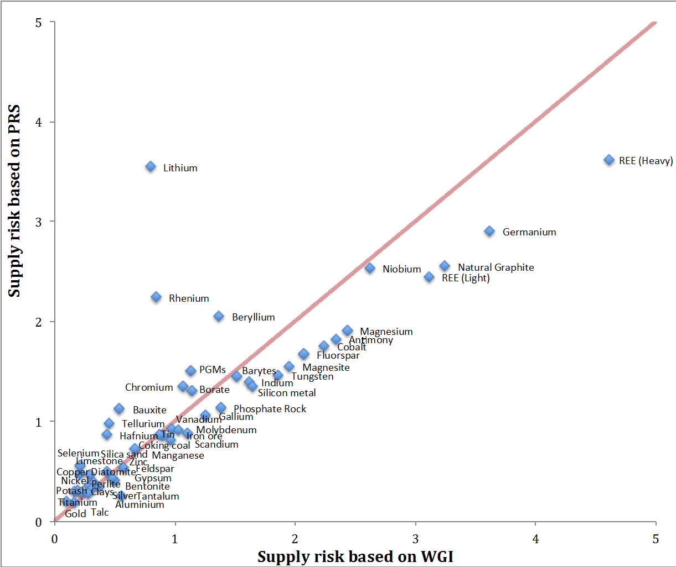

In general, minerals have lower supply risk according to the PRS index than according to the WGI (with the exception of a handful of minerals, most notably lithium, rhenium and beryllium). The important factor here is that China is considered more stable according to the PRS index than according to the WGI index. This is quantitatively important for the most risky minerals from a supply perspective, notably heavy rare earth elements, germanium, natural graphite and light rare earth elements, but, despite shifting downwards on the supply risk index, these minerals remain the most risky. That is to say, our results are qualitatively robust to substituting the PRS index for the WGI index.

Reviewing the OMI findings (Figure 20) shows that supply risk is generally higher when using openness to trade rather than when using the WGI index of political stability. The exception to this trend is cobalt, for which supply risk is significantly lower. Generally, however, there are only minor differences, and findings are thus also robust to using the OMI index rather than the WGI index.

39

ENV/WKP(2015)12

**Figure 20. Supply risk based on OMI vs. Supply risk based on WGI (Supply risk predictions for 2030)**

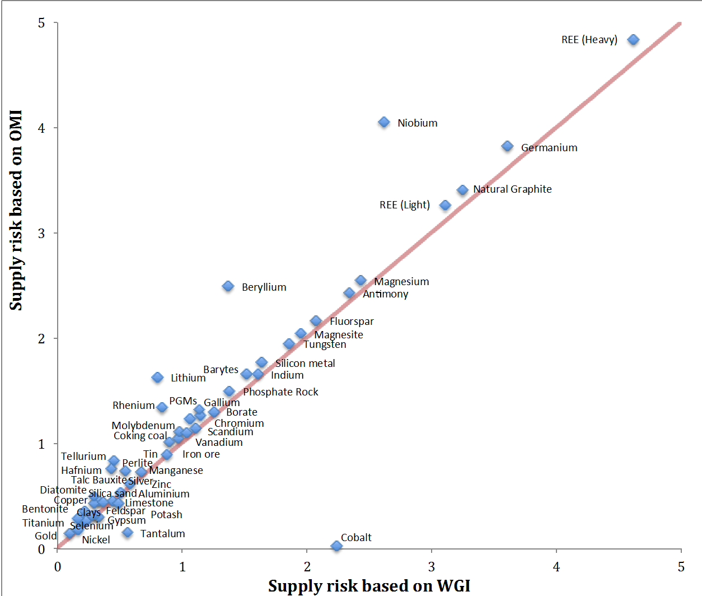

40

ENV/WKP(2015)12

**4.3 An alternative approach to economic importance**

The report’s estimates of economic importance are based on how heavily a particular mineral is used in each of a set of economic sectors, and what is the share of these sectors in the Gross Value Added of the economy. The analysis comprises 17 sectors, sometimes called ‘megasectors’ (originally by the European Commission, 2010), because they are constructed in such a way as to approximate value chains for minerals use. With only 17 sectors, this is a fairly coarse aggregation of different economic activities.

The megasectors approach is a practicable way to obtain consistent estimates of economic importance for a large set of minerals and a large group of countries such as the OECD, but it comes with problems. Principally, while a megasector might be economically important, a mineral might only be used in some sub-sectors of this megasector, so that greater disaggregation, were it possible, would reveal a different picture. In particular, the economic importance of minerals with highly specialised uses may be exaggerated.6

Here we compare our estimates with those obtained by Harper et al. (forthcoming) and Nuss et al. (2014), both of which use an alternative approach. According to this alternative approach, economic importance (at the national level) is the sum of the value of a mineral on a measure of national economic importance and of its value on a measure of so-called ‘material assets’. National economic importance is measured as the value of the mineral used as a share of national GDP, converted to a 1-100 scale. The material assets measure is obtained from a transformation of the ratio of the national per-capita in-use stock of a mineral to the sum of the national in-use stock and national reserves.

The estimates from Harper et al. (forthcoming) and Nuss et al. (2014) are only available for a total of nine of the minerals we analyse, and only for the US. Figure 21 presents this limited comparison. The two approaches lead to estimates on two different scales, therefore the estimates are not easy to compare, but what we would hope to see is that the ordering of minerals is the same, whichever approach is taken. However, what the figure shows is that in fact the two different approaches give a quite different ordering. For instance, while according to the megasectors method vanadium is the most economically important mineral for the US, according to the alternative method it is only 7/9. Conversely iron ore is the most economically important mineral according to the alternative method, but according to the megasectors method it is the joint least important.

Therefore it cannot be concluded that the analysis of economic importance is robust to the use of alternative approaches, but at the same time an enormous data-gathering effort would be required to roll out alternative approaches to a large set of minerals and to the whole OECD.

|  |  |
| --- | --- |
| 6 | This problem is acknowledged in European Commission (2010, p59): “As a particular raw material is not used by all subsectors within a given mega-sector, there is a risk that a raw material's importance to a mega-sector will be exaggerated.” |

41

ENV/WKP(2015)12

|  |  |
| --- | --- |
| **Figure 21.** | **Economic importance for the USA of 9 minerals according to different methods** |

|  |  |  |  |  |  |  |  |  |  |  |  |  |  |  |  |  |  |  |  |  |  |  |  |  |  |  |  |  |
| --- | --- | --- | --- | --- | --- | --- | --- | --- | --- | --- | --- | --- | --- | --- | --- | --- | --- | --- | --- | --- | --- | --- | --- | --- | --- | --- | --- | --- |
| |  |  |  |  |  |  |  |  |  |  |  |  |  | | --- | --- | --- | --- | --- | --- | --- | --- | --- | --- | --- | --- | --- | | **EI (Harper et al; Nuss et al.)** | 80 | |  |  |  |  |  | | --- | --- | --- | --- | --- | |  |  |  |  |  | | | | | | | |  | |  | |  | |  | |  | |  | |  | |  | |  |  |  |  |  |  |  | |

ENV/WKP(2015)12

**5. LIMITATIONS**

This section focuses on further limitations to the methodology and discusses potential improvements.

**Production and transport costs:** understanding the dynamics of production and transport costs is important, in order to have an insight into future price increases of key minerals. To determine long-term minerals prices, two opposing effects play a major role. On the one hand, because of extensive past extraction, new production is usually from deeper layers of the Earth’s crust. This tends to increase extraction costs. In addition, because of extensive past production, new production is located in areas remote from the places of consumption, and competition between different land-uses also pushes mines away from production centers, increasing transportation costs. On the other hand, technical progress tends to decrease investments costs (all else equal), making more deposits profitable. In the short-term, extraction costs are increasing with the extraction flow, reflecting short-term capital constraints and the fact that less-productive capacities have to be used to meet demand. Data concerning these costs are difficult to obtain, and forecasts are particularly complicated. The US study (Natural Resource Council of the National Academies, 2008) accounts for cost parameters in technological availability criteria, while other studies do not take these considerations into account, as is the case of this report.

**By-products:** many minerals are produced as by-products of the production of other major minerals (e.g. iron, copper and tin) and their market characteristics are therefore unconventional. The elasticity of supply of by-products is difficult to assess. Their supply depends on the production of major minerals, the concentration of by-products in deposits, economic incentives, and capacities to separate these by-products from main minerals. Demand for a by-product and its associated major mineral can evolve in different ways, putting at risk the supply of by-products. As a result, these by-products can exhibit strong price volatility, jeopardising supply security in the short run.

Previous studies (Nassar et al., 2012; Nuss et al., 2014) have pointed out that there is no clear distinction between host metals, only produced for themselves, and companion metals, entirely produced as by-products. Both of these studies apply the methodology developed in Graedel et al. (2012) and use “the companion metal fraction” for each metal they analyse. This measure represents “the fraction of an element obtained as a by-product with another metal” (Nuss et al., 2014). Nassar et al. (2012) assess the criticality of copper and its companion metals: arsenic, gold, selenium, silver, and tellurium. Whereas copper and gold are mostly produced as main metals, the other elements (arsenic, selenium, silver, and tellurium) are mostly produced as by-products. Following a similar approach, Nuss et al. (2014) study the criticality of iron and its principal alloying elements: vanadium, chromium, manganese and niobium. The companion metal fraction differs substantially between these different elements. About 82% of vanadium, but only 13% of niobium and 4% of manganese, was produced as a companion metal in 2008. The production of chromium and iron from chromium-rich and iron-rich ores respectively accounted for all of their production in 2008.

The US study (National Resource Council of the National Academies, 2008) also considered by-products. It focused on 11 minerals or mineral groups: copper; PGMs; REEs; niobium; gallium; indium; lithium; manganese; tantalum; titanium, and; vanadium. It found that by-product production, so to speak, of gallium, indium and vanadium represented “most” or all of their total world primary production, while PGMs and REEs are primarily co-products.

It is commonly acknowledged that data concerning companion metals are difficult to obtain. In the US study, fractions of by-product production come from “judgment based on published descriptions of production.” Nassar et al. (2012) and Nuss et al. (2014) have focused on a relatively small number of

43

ENV/WKP(2015)12

elements (six and five respectively) for their more data-driven approach. The present study considers a larger number of minerals and mineral groups. Obtaining companion metal fractions for each metal would require extensive data collection. Therefore This report does not introduce a measure of the companion metal fraction in the analysis. This extension is left for future investigation.

**Externalities:** accounting for externalities associated with the extraction of minerals and/or the use of these resources can be important for correctly identifying criticality. These externalities can be local, regional or global and are not necessarily internalised by regulators. An example of a local externality is the radioactive by-products of REE processing. In these cases, accounting for environmental costs might be necessary. Taking account of these externalities can threaten supply and increase minerals production costs, and consequently influence the location of their production. Variations across countries in standards of environmental protection could thus explain why some countries specialise themselves in highly polluting minerals extraction. Most studies recognise the importance of externalities. The European Commission (2010) study considered environmental risk as a separate dimension of criticality, though it was dropped in the 2014 study as it did not change results. The US study (National Resource Council of the National Academies, 2008) considered an environmental availability parameter as one criterion of availability and the UK study (Oakdene Hollins, 2008) accounted for both Global Warming Potential in mineral risk and vulnerability to the effects of climate change in key supplying regions as a part of supply risk.

44

ENV/WKP(2015)12

**6. CONCLUSION**

The purpose of this report has been to analyse critical minerals for the OECD countries as a whole, today and in 2030. The analysis identified around 12 to 20 minerals or mineral groups, which are critical in the OECD today. Minerals like the rare earth elements (heavy and light), germanium and natural graphite have a particularly high supply risk, while minerals such as barytes, tungsten and vanadium are particularly economically important.

While it is beyond the scope of this report to assess which minerals are critical for OECD countries individually, the analysis was broken down for the EU, Japan and the United States and found at most small differences between these countries/regions individually and the OECD on aggregate. The one exception was barytes, the significant economic importance of which is due to its use in the oil and gas industry in the United States.

Using an alternative measure of the concentration of production that accounts for physical constraints to minerals extraction (i.e. the production-to-reserves ratio), the report found that antimony has a much higher supply risk in the OECD today, while the group of heavy rare earth elements has a much lower supply risk.

Looking out to 2030, a stronger role for the physical availability of reserves was assumed in determining where production takes place and the analysis found that the supply risk attending to barytes, borate, phosphate rock and molybdenum consequently increases. It was found that economic development along a baseline scenario that assumes continued reliance on fossil fuels for energy does not change significantly the pattern of economic importance of the various minerals concerned. Future work should evaluate whether this also holds true for a pathway towards green, low-carbon growth.

Lastly the report showed what improvements in the substitutability of minerals and in their recycling rates would be sufficient today and more importantly by 2030 to mitigate supply risks and vulnerability to them. This could be a focus for public support for R&D in the OECD. The results were highly mineral-specific, with some minerals requiring huge increases in substitutability and/or recycling from a low base, while others require only small improvements.

There are numerous limitations to this analysis and it should consequently be seen as exploratory. Measuring economic importance convincingly on the one hand and systematically for large numbers of minerals across many countries on the other hand, appears vital. This and other limitations essentially stem from a severe shortage of data on minerals supply and use, which makes a systematic comparison of criticality across a wide range of minerals very difficult to achieve. Therefore a key conclusion of the report is that there is an urgent need to improve the availability to researchers and public policy-makers of data on the main components of minerals supply risk and use, globally.

45

ENV/WKP(2015)12

**REFERENCES**

**Reports and papers**   
Behrend, S., M. Scharp and L. Erdmann, 2007, Rare Metals: Measures and concepts for the solution of the problem of conflict-aggravating raw material extraction – the example of Coltan. Institute for Future Studies and Technology Assessment, Dessau.

Cathles, L. M., 2010, ‘A path forward’, SEG Newsletter **83**   
DERA, 2012, Energy Study 2012: Reserves, Resources and Availability of Energy Resources. German Mineral Resources Agency (DERA), Hannover   
Erdmann, L. and T. E. Graedel, 2011, ‘Criticality of non-fuel minerals: a review of major approaches and analyzes’, Environmental Science and Technology **45**, 7620-7630   
European Commission, 2010, Critical Raw Materials for the EU: Report of the Ad-hoc Working Group on defining critical raw materials. DG Enterprise and Industry. Brussels   
European Commission, 2014, Report on Critical Raw Materials for the EU: Report of the Ad hoc Working Group on defining critical raw materials. DG Enterprise and Industry, Brussels   
Graedel, T. E. and B. R. Allenby, 2010, Industrial Ecology and Sustainable Engineering, Prentice Hall, Michigan   
Graedel, T. E., J. Allwood et al., 2011, ‘What do we know about metal recycling rates?’, Journal of Industrial Ecology **15(3)**, 355-366   
Graedel, T. E., R. Barr et al., 2012, ‘Methodology of metal criticality determination’, Environmental Science and Technology **46(2)**: 1063-1070   
Harper, E. M., G. Kavlak et al., forthcoming, ‘Criticality of the geological zinc, tin, and lead family’, Journal of Industrial Ecology, DOI: 10.1111/jiec.12213   
Krausmann, F., S. Gingrich et al., 2009, ‘Growth in global materials use, GDP and population during the 20th century’, Ecological Economics **68(10)**, 2696-2705   
National Resource Council of the National Academies, 2008, Minerals, Critical Minerals, and the US Economy, Washington, DC, National Academies Press   
Nassar, N. T., R. Barr et al., 2012, ‘Criticality of the geological copper family’, Environmental Science and Technology **46**, 1071-1076   
Nuss, P., E. M. Harper et al., 2014, ‘Criticality of iron and its principal alloying elements’, Environmental Science and Technology **48**, 4171-4177   
Oakdene Hollins, 2008, Material Security: Ensuring Resource Availability for the UK Economy   
U.S. Geological Survey, 2012, Minerals Yearbook 2010

46

ENV/WKP(2015)12

Waeger, P., D. J. Lang et al., 2012, ‘Towards a more sustainable use of scarce metals: a review of intervention options along the metals life cycle’, Gaia **21(4)**: 300-309

**Websites**

The O[pen Market Index (OMI, 2014) from the International Chamber of Commerce](http://www.iccwbo.org/global-influence/g20/reports-and-products/open-markets-index/) *[www.iccwbo.org/global-influence/g20/reports-and-products/open-markets-index/](http://www.iccwbo.org/global-influence/g20/reports-and-products/open-markets-index/)*

Politi[cal Risk Services (PRS, 2012) from the International Country Risk](https://www.prsgroup.com/about-us/our-two-methodologies/icrg) [Guide (ICRG)](http://www.iccwbo.org/global-influence/g20/reports-and-products/open-markets-index/) *<https://www.prsgroup.com/about-us/our-two-methodologies/icrg>*

Miner[al profiles from the U.S. Geological Survey](https://www.prsgroup.com/about-us/our-two-methodologies/icrg)   
*<http://minerals.usgs.gov/minerals/pubs/commodity/mcp.html>*

World [Government Indicators (WGI, 2014) from the World Bank](http://info.worldbank.org/governance/wgi/index.aspx%23home) *[http://info.worldbank.org/governance/wgi/index.aspx#home](http://info.worldbank.org/governance/wgi/index.aspx%23home)*

47

ENV/WKP(2015)12

**APPENDIX**

**Table 6. Supply risk values for all minerals.**

|  |  |  |  |  |
| --- | --- | --- | --- | --- |
|  | | | | |
|  | | | | |
| **Mineral** | **Supply risk** | **Recycling rate** | **Substitutability** | **Political risk (HHI)** |
| **Aluminium** | 0.5 | 0.35 | 0.63 | 1.23 |
| **Antimony** | 2.3 | 0.11 | 0.62 | 4.24 |
| **Barytes** | 1.5 | 0 | 0.98 | 1.55 |
| **Bauxite** | 0.5 | 0 | 0.93 | 0.58 |
| **Bentonite** | 0.3 | 0 | 0.55 | 0.60 |
| **Beryllium** | 1.4 | 0.19 | 0.85 | 1.99 |
| **Borate** | 1.1 | 0 | 0.88 | 1.30 |
| **Chromium** | 1.1 | 0.13 | 0.96 | 1.27 |
| **Clays** | 0.2 | 0 | 0.78 | 0.24 |
| **Cobalt** | 2.2 | 0.16 | 0.71 | 3.76 |
| **Coking coal** | 1.0 | 0 | 0.68 | 1.42 |
| **Copper** | 0.2 | 0.2 | 0.62 | 0.43 |
| **Diatomite** | 0.3 | 0 | 0.33 | 0.88 |
| **Feldspar** | 0.4 | 0 | 0.58 | 0.75 |
| **Fluorspar** | 2.1 | 0 | 0.8 | 2.59 |
| **Gallium** | 1.3 | 0 | 0.6 | 2.09 |
| **Germanium** | 3.6 | 0 | 0.86 | 4.20 |
| **Gold** | 0.2 | 0.25 | 0.72 | 0.30 |
| **Gypsum** | 0.5 | 0.01 | 0.7 | 0.70 |
| **Hafnium** | 0.4 | 0 | 0.38 | 1.14 |
| **Indium** | 1.6 | 0 | 0.82 | 1.97 |
| **Iron ore** | 0.9 | 0.22 | 0.84 | 1.37 |
| **Limestone** | 0.4 | 0 | 0.75 | 0.49 |
| **Lithium** | 0.8 | 0 | 0.78 | 1.02 |
| **Magnesite** | 1.9 | 0 | 0.72 | 2.71 |
| **Magnesium** | 2.4 | 0.14 | 0.64 | 4.42 |
| **Manganese** | 0.7 | 0.19 | 0.94 | 0.88 |
| **Molybdenum** | 1.0 | 0.17 | 0.92 | 1.28 |
| **Natural Graphite** | 3.2 | 0 | 0.72 | 4.50 |
| **Nickel** | 0.2 | 0.32 | 0.68 | 0.49 |
| **Niobium** | 2.6 | 0.11 | 0.69 | 4.26 |
| **Perlite** | 0.3 | 0 | 0.42 | 0.78 |
| **PGMs** | 1.1 | 0.35 | 0.83 | 2.10 |
| **Phosphate Rock** | 1.4 | 0 | 0.98 | 1.41 |
| **Potash** | 0.2 | 0 | 0.32 | 0.52 |

48

ENV/WKP(2015)12

|  |  |  |  |  |
| --- | --- | --- | --- | --- |
| **REE (Heavy)** | 4.6 | 0 | 0.77 | 5.99 |
| **REE (Light)** | 3.1 | 0 | 0.67 | 4.64 |
| **Rhenium** | 0.8 | 0.13 | 0.94 | 1.03 |
| **Scandium** | 1.1 | 0.01 | 0.34 | 3.28 |
| **Selenium** | 0.2 | 0.05 | 0.48 | 0.47 |
| **Silica sand** | 0.3 | 0.24 | 0.92 | 0.42 |
| **Silicon metal** | 1.6 | 0 | 0.81 | 2.02 |
| **Silver** | 0.3 | 0.24 | 0.72 | 0.55 |
| **Talc** | 0.3 | 0 | 0.39 | 0.71 |
| **Tantalum** | 0.6 | 0.04 | 0.55 | 1.06 |
| **Tellurium** | 0.5 | 0 | 0.44 | 1.02 |
| **Tin** | 0.9 | 0.11 | 0.6 | 1.64 |
| **Titanium** | 0.1 | 0.06 | 0.33 | 0.33 |
| **Tungsten** | 1.9 | 0.37 | 0.7 | 4.22 |
| **Vanadium** | 1.0 | 0 | 0.46 | 2.24 |
| **Zinc** | 0.6 | 0.08 | 0.66 | 0.95 |

49