

SERVICES DOMESTIC REGULATION IN THE WTO: CUTTING RED TAPE, SLASHING TRADE COSTS, AND FACILITATING SERVICES TRADE

NOVEMBER 2021

 

Services domestic regulation in the WTO:   
**Cutting red tape, slashing trade costs, and facilitating services trade**

19 November 2021

**Key messages**

|  |  |
| --- | --- |
| •  •  •  • | **Improving business climate:** At the 12th WTO Ministerial Conference, the Joint Initiative on Services Domestic Regulation will conclude negotiations on a set of good regulatory practices with a focus on procedural aspects of licensing and authorization procedures for services suppliers. By enhancing the transparency, efficiency, and predictability of regulatory systems, the disciplines on services domestic regulation that the Joint Initiative has negotiated will address the practical challenges that affect the ability of businesses and suppliers to operate.  **Facilitating services trade:** Building on efforts to identify and disseminate good regulatory practice, an increasing number of "new generation" trade agreements have moved beyond the removal of quantitative restrictions and discriminatory measures to include a comprehensive set of disciplines largely equivalent to those developed by the Joint Initiative. At the same time, economies at all levels of income have also implemented reforms with a view to making their regulatory environment more trade facilitative for services businesses.  **Lowering trade costs and generating broader trade benefits:** Through the full implementation of the disciplines on services domestic regulation, economies can lower trade costs and reap substantial trade benefits: annual trade cost savings could be in the range of USD 150 billion, with important gains in financial services, business services, communications and transport services. Moreover, a positive correlation between the implementation of services domestic regulation measures and services trade by all four modes of supply, as well as a more active engagement of economies in global value chains, hints to even broader economic benefits.  **Widespread gains beyond participants:** Exporters from all WTO members will benefit from the improved regulatory conditions when they trade with participants of the Joint Initiative. However, significantly larger benefits will accrue to WTO members that are implementing the disciplines themselves in their internal regulatory frameworks. |

Services are the most dynamic and fastest growing sector of today's global economy. They represent over 60% of world GDP in value-added terms and more than 50% of employment worldwide. Services also provide critical inputs to other sectors. For instance, transport, logistics, communications or financial services facilitate the functioning of global value chains while research, development or engineering services foster productivity and innovation in all economies. Thereby, services constitute a critical component of a sound, sustainable, and inclusive economic recovery from the COVID-19 pandemic.

However, the ability of service suppliers to engage in trade and the potential of the services sector overall remains constrained by a variety of trade barriers: the cost of trading services is twice as high as that of goods, and regulation-related factors account for more than 40% of these costs (WTO World Trade Report, 2019). OECD estimates suggest that the barriers recorded in the OECD Services Trade Restrictiveness Index (STRI) involve average trade costs between 50% and 250% of export values (Benz & Jaax, 2020). Among the obstacles, the lack of transparency of laws and regulations, and pervasive procedural inefficiencies figure prominently.

In the services field, many activities require licenses or authorisations to operate. International discussions on services domestic regul[ation aim to facilitate trade in services by eliminati](https://www.wto.org/english/tratop_e/serv_e/xserv_e/jsdomreg_e.htm)ng the unintended trade-restrictive effects of such measures. The [Joint Initiative on Services Domestic Regulation](https://www.wto.org/english/tratop_e/serv_e/xserv_e/jsdomreg_e.htm) will conclude at the 12th WTO Ministerial Conference negotiatio[ns on a set of good regulatory practices to](https://www.wto.org/english/tratop_e/serv_e/xserv_e/jsdomreg_e.htm) enhance [transparency, efficiency, and predictability of regula](https://docs.wto.org/dol2festaff/Pages/SS/directdoc.aspx?filename=q:/INF/SDR/1.pdf&Open=True)tory systems to obtain authorization to supply services - the ["Reference Paper on Services](https://docs.wto.org/dol2festaff/Pages/SS/directdoc.aspx?filename=q:/INF/SDR/1.pdf&Open=True) [Domestic Regulation"](https://docs.wto.org/dol2festaff/Pages/SS/directdoc.aspx?filename=q:/INF/SDR/1.pdf&Open=True). Sixty-six WTO members are currently participating in this p[lurilateral negotiating process,](https://docs.wto.org/dol2festaff/Pages/SS/directdoc.aspx?filename=q:/INF/SDR/1.pdf&Open=True) [covering more than 9](https://docs.wto.org/dol2festaff/Pages/SS/directdoc.aspx?filename=q:/INF/SDR/1.pdf&Open=True)0% of world services trade.

The disciplines on services domestic regulation (SDR disciplines) that the Joint Initiative has agreed build upon three core principles: (i) **transparency**, namely measures aimed at promoting prompt publication and availability of information relevant to service suppliers and their engagement in regulatory decision-making processes; (ii) **legal certainty and predictability**, namely measures aimed at ensuring regulatory and procedural guarantees to be followed by competent authorities when dealing with applications for authorization to supply services; (iii) **regulatory quality and facilitation**, namely measures aimed at disseminating good regulatory practices to facilitate services suppliers' ability to trade.

OECD-WTO Trade Policy Brief | **1**

|  |  |
| --- | --- |
|  |  |

|  |  |  |  |  |  |  |
| --- | --- | --- | --- | --- | --- | --- |
| **The disciplines on services domestic regulation – in brief**  **Transparency**   |  |  | | --- | --- | | • • • | Publish and make available information required to comply with requirements and procedures for authorization, including through electronic means;  Establish appropriate mechanisms for responding to enquiries from service suppliers;  Engage stakeholders by publishing proposed laws and regulations, providing opportunity for comments from interested persons, and considering comments received. |   **Legal certainty and predictability**   |  |  | | --- | --- | | • • • •  • • •  • | Establish indicative timeframes for processing applications;  Process applications in a timely manner;  Provide information on the status of applications;  Allow applicants to correct minor deficiencies in incomplete applications and identify additional information required;  Inform applicants of reasons for rejection of applications and allow resubmission;  Allow authorization once granted to enter into effect without undue delay;  Allow reasonable time between publication of laws and regulations and date of required compliance by service suppliers;  Hold examinations at reasonably frequent intervals. |   **Regulatory quality and facilitation**   |  |  | | --- | --- | | • •  • •  •  •  • • • •  • | Require applicants to approach only one competent authority to obtain authorization;  Permit submission of applications at any time throughout the year, or at least, allow reasonable periods of time for submission;  Accept electronic applications and authenticated copies of documents;  Ensure that authorization fees are reasonable, transparent, and do not in themselves restrict the supply of service;  Support professional bodies wishing to establish dialogues on issues relating to recognition of professional qualifications;  Ensure that competent authorities reach their decisions in a manner independent from services suppliers;  Consolidate relevant information on a single online dedicated portal;  Develop technical standards through open and transparent processes;  Base measures relating to authorization on objective and transparent criteria;  Ensure that procedures are impartial, adequate and do not unjustifiably prevent fulfilment of authorization requirements;  Ensure that authorization measures do not discriminate between men and women. | |

The SDR disciplines closely resonate with work that several international economic fora, such as the OECD, the World Bank, and APEC, have undertaken on good regulatory practices. While such initiatives generally look beyond the services trade field, they share a common goal – to address the practical challenges that affect the ability of businesses to operate and make regulatory environments more conducive to trade.

Over the past years, many economies have introduced broad internal regulatory reforms to streamline their regulations in services sectors and signal their commitment to good regulatory practices to any interested – foreign or domestic – suppliers. The OECD STRI database records 56 of such liberalising policy changes related to the SDR disciplines between 2014 and 2020 (Figure 1). Most of these policy reforms are of horizontal nature, affecting a large number of sectors. Financial services stand out with the greatest sector-specific efforts towards more efficient services regulation.

**2** | OECD-WTO Trade Policy Brief

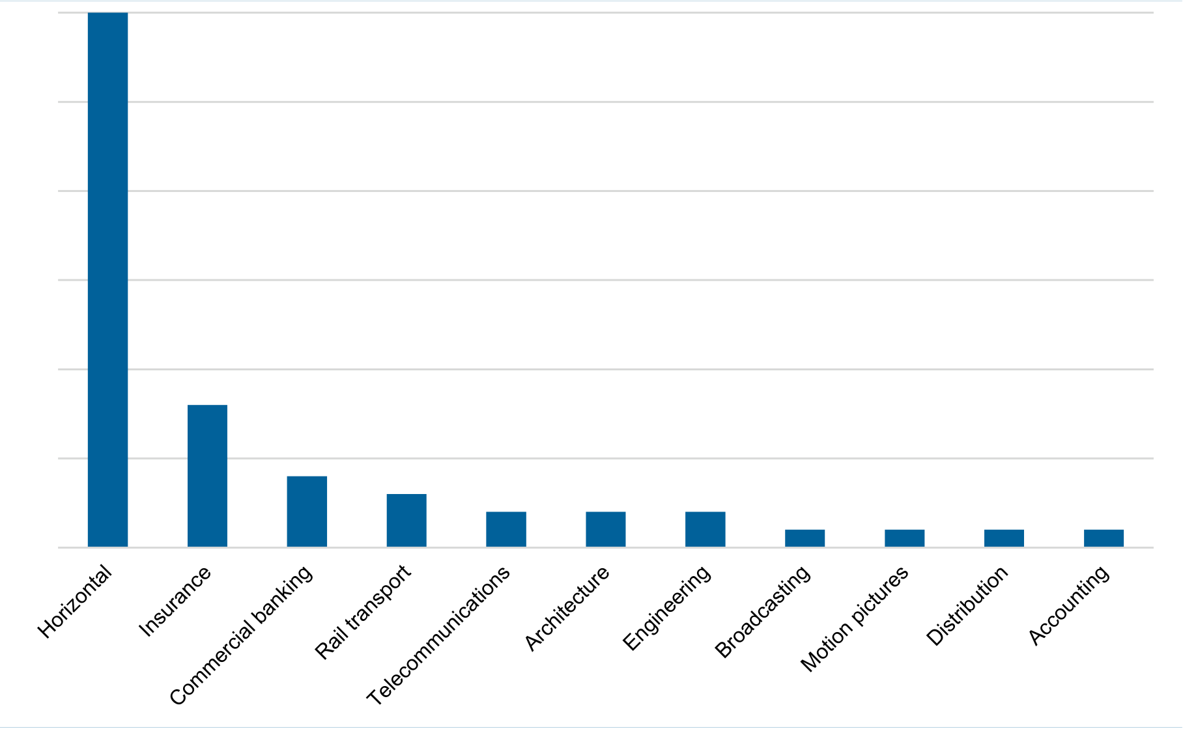

 

**Figure 1: Number of liberalising policy reforms related to SDR disciplines between 2014-2020**

30

25

20

15

10

5

0

*Note*: Sum over 52 SDR JI participants for which OECD STRI data are available. The OECD STRI database records applied regulations across 56 economies and 22 sectors, covering several disciplines included in the Reference Paper on Services Domestic Regulation. Inter alia, these include transparency in the rule-making process, administrative and procedural hurdles related to registering companies, as well as licensing and authorization requirements across different sectors, including some prof[essional service](http://oe.cd/stri)s such as legal, accounting, architecture and engineering service (for further details on the STRI measures, see [http://oe.cd/stri)](http://oe.cd/stri).

*Sou[rce](http://oe.cd/stri)*[: OECD STR](http://oe.cd/stri)I database.

At the same time, good regulatory practices have also progressively found their way into bilateral and regional "new generation" trade agreements, with a view to ensuring the effectiveness of liberalization commitments in services markets. An increasing number of WTO members – 82 WTO members by 2010, 98 WTO members by 2015, and 112 WTO members by 2020 – have concluded at least one trade agreement with GATS-plus regulatory obligations. Among them, some 40 WTO members have concluded by now at least one agreement that reflects almost entirely the full set of SDR disciplines of the Reference Paper agreed upon by the Joint Initiative.

**Lowering trade costs through services domestic regulation implementation**

Despite the increasing awareness of good regulatory practices for the smooth function of services markets, there remains scope for further progress on streamlining domestic regulation of services sectors. This assessment is based on a benchmarking of the various disciplines of the Joint Initiative against the database of the OECD Services Trade Restrictiveness Index (STRI). Full implementation of the SDR disciplines would make an important contribution to facilitate cross-border services trade. Benchmarking of SDR disciplines against the STRI database shows that impediments to services trade could be lowered by 11% in the average across all economies participating in the Joint Initiative for which data is available (Figure 2). Most barriers could be eliminated in sectors such as computer services, commercial banking, and telecommunications services (all -16%), which are key intermediate services contributing to all economic activities. Moreover, as most of these sectors are important pillars of the digital economy, streamlining domestic regulations would also benefit digital trade.

OECD-WTO Trade Policy Brief | **3**

 

**Figure 2: Streamlining SDR reduces barriers to services trade**   
Average percentage of decrease in STRI values resulting from removal of existing impediments

|  |  |
| --- | --- |
| **STRI reduction in %** | **Average** |

0%

-5%

-10%

|  |  |  |
| --- | --- | --- |
|  |  |  |

-15%

-20%



*Note*: Simple average of 52 SDR JI participants for which OECD STRI data are available. Values of some sectors are based on a smaller number of countries. Trade-weighted average of intra-EEA restrictiveness and MFN restrictiveness for EU members. Trade data from the OECD-WTO Balanced Trade in Services dataset (BaTIS).

*Source*: OECD calculations.

These reductions of services trade barriers highlight some of the challenges faced by services companies when providing services to foreign jurisdictions. Streamlined regulations in services sectors could reduce the time and cost required for dealing with administrative barriers and regulatory red tape. These cost savings can incentivise new trade and new investment. They can also be passed on through lower prices to users of these services, including consumers and businesses. While the exact distribution of cost savings is difficult to assess, it is possible to quantify the magnitude of potential savings based on the current volume of services trade.

Annual services imports of all economies participating in the Joint Initiative are in the range of USD 3 trillion. More than USD 2.6 trillion of these are between participating countries, while less than USD 400 billion correspond to services imports from WTO members that are currently not participating in the negotiations. Based on the reduction of services trade cost in individual sectors outlined above, annual trade cost savings on services trade between the Joint Initiative's participants could be around USD 135 billion (calculations based on estimated ad valorem equivalents of services trade barriers from Benz & Jaax, 2020). Substantial benefits accrue in a number of sectors, including financial services sector with USD 47 billion, business services with USD 36 billion, as well as communications and transport services, with both around USD 20 billion (Figure 3).

**4** | OECD-WTO Trade Policy Brief

 

**Figure 3: Annual trade cost savings in five broad services sectors, billion USD**

|  |  |
| --- | --- |
| **Between SDR JI participants** | **With non-participants** |

60

50

|  |  |
| --- | --- |
| D billion | 40 |
| savings in US | 30 |
| Trade cost | 20 |

10

|  |  |  |  |  |  |
| --- | --- | --- | --- | --- | --- |
| 0 | Transport | Insurance and pension | Finance | Communications | Business services |

Note: Simple average of 52 SDR JI participants for which OECD STRI data are available. Values of some sectors are based on a smaller number of countries. Trade-weighted average of intra-EEA restrictiveness and MFN restrictiveness for EU members. Trade data from the OECD-WTO Balanced Trade in Services dataset (BaTIS).

Source: OECD calculations.

Additional trade cost savings may result from services exports of non-participants to participating economies. Due to the MFN nature of the SDR disciplines, exporters from all WTO members will benefit from higher transparency and predictability of authorisation and licensing processes, including exporters from economies not participating in the Joint Initiative. Total trade cost savings from these trade flows are around USD 17 billion, which are divided relatively equally across the five sectors.

**Broader trade benefits of implementing services domestic regulation**

Besides significant trade costs savings, the implementation of SDR disciplines can bring broader economic benefits, including an increase in services trade and enhanced participation in global value chains (GVCs).

The implementation of SDR disciplines tends to correspond to more services trade by all four modes of supply (Figure 4). Trade in services is critical to economic growth and development. For developing economies, services trade offers opportunities to build know-how and technological capacity and achieve competitiveness at the global level. Moreover, there is evidence that services exporters pay higher wages than non-exporting firms.

Cutting red tape in regulatory frameworks can help create new services trade opportunities for suppliers of all sizes and women entrepreneurs. It can benefit particularly micro, small and medium-sized enterprises (MSMEs), which typically face limited resources to navigate complex and costly requirements and procedures.

OECD-WTO Trade Policy Brief | **5**

 

**Figure 4: Correlation between implementation of SDR disciplines and volume of services trade**

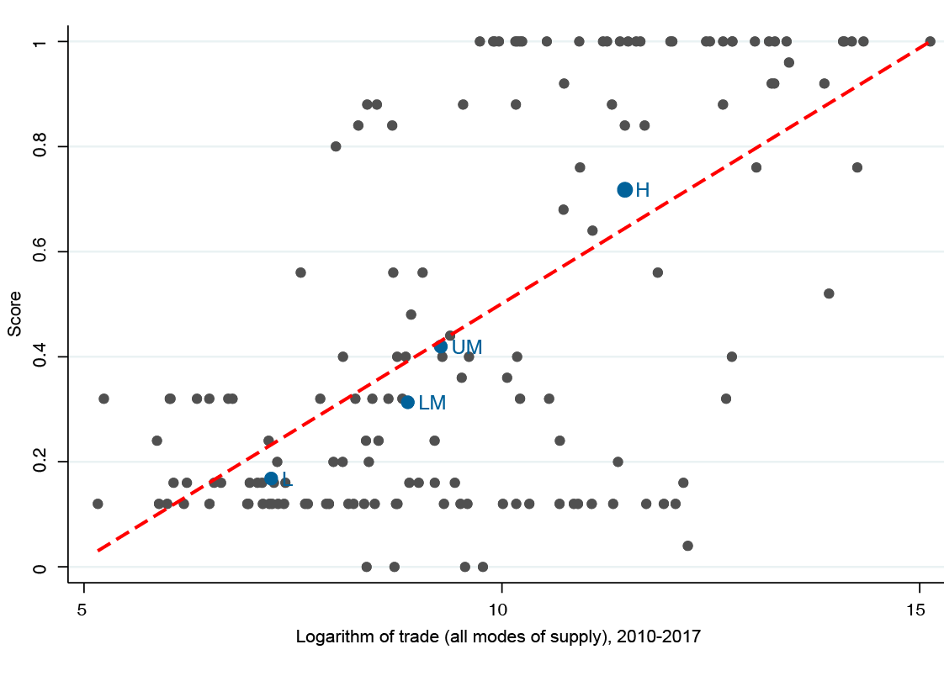

*Note*: (1) H, UM, LM and L denote the average for high, upper−middle, lower−middle and low-income economies. Number of economies = 150. (2) Scores measure the level of inclusion of disciplines in RTAs. They are defined as simple averages across all SDR disciplines, ranging from 0 (discipline absent) to 1 (discipline adopted). Implementation is assumed when a WTO member has included the discipline at least once in its RTAs. The logarithm of services trade by all four modes of supply, measured as the sum of exports and imports, is derived from a new experimental dataset on Trade in Services by mode of supply (TISMOS) from the WTO.

*Source*: Baiker, Bertola & Jelitto (2021).

Furthermore, the implementation of SDR disciplines is associated with more active engagement in GVCs (Figure 5). By fostering the efficiency and competitiveness of domestic services sectors, participation in GVCs can assist the development efforts of lower-income economies. GVCs offer opportunities to integrate into the global economy, especially for MSMEs. They promote employment, and generate positive spill over effects, including knowledge and technological progress.

As GVCs rely intensively on services, measures on authorization requirements and procedures that regulate the supply of services play a particularly prominent role. Hence, removing red tape and delays, as well as bridging regulatory divergence is key to the effective and efficient operation of GVCs.

**6** | OECD-WTO Trade Policy Brief

 

**Figure 5: Correlation between implementation of SDR disciplines and participation in global value chains**

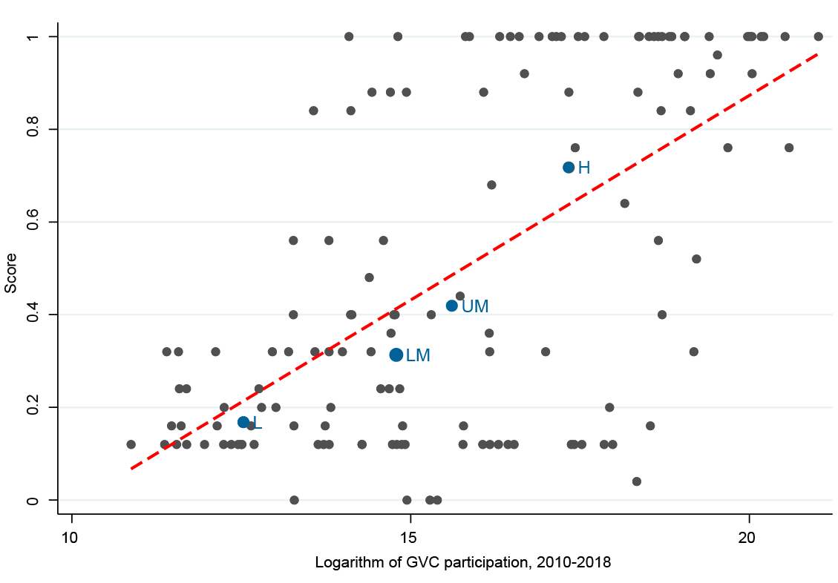

*Note*: (1) H, UM, LM and L denote the average for high, upper−middle, lower−middle and low income economies. Number of economies: 136 (2) Scores measure the level of inclusion of disciplines in RTAs. They are defined as simple averages across all SDR disciplines, ranging from 0 (discipline absent) to 1 (discipline adopted). Implementation is assumed when a WTO member has included the discipline at least once in its RTAs. GVC participation, calculated as the sum of foreign value-added in a country's own exports (backward participation) and domestic value-added in other countries' exports (forward participation), is derived from the UNCTAD-Eora Global Value Chain Database.

*Source*: Baiker, Bertola & Jelitto (2021).

**Concluding remarks**

At a time when businesses advocate for more transparency and predictability of regulatory frameworks, and even more so against the backdrop of the current COVID-19 pandemic, the SDR disciplines will consolidate a set of internationally recognized good regulatory practices within the WTO legal framework. Through the implementation of these disciplines, economies can significantly lower trade costs, with an estimated reduction of around USD 150 billion annually, and reap related trade benefits, including enhancing volumes of services trade and fostering participation in global value chains.

**Further Reading**

Baiker, L., Bertola, E., & Jelitto, M. (2021). "Services Domestic Regulation – Locking in Good Regulatory Practices. Analyzing the Prevalence of Services Domestic Regulation Disciplines and their Potential Linkages [with Economic Performance."](https://www.wto.org/english/res_e/reser_e/ersd202114_e.htm) *[WTO Staff Working Paper ERS](https://www.wto.org/english/res_e/reser_e/ersd202114_e.htm)D-2021-14.*

<https://www.wto.org/english/res_e/reser_e/ersd202114_e.htm>

[Benz, S. and A. Jaax (2020), "The costs of regulatory barriers](https://www.wto.org/english/res_e/reser_e/ersd202114_e.htm) to trade in services: New estimates of ad valorem [tariff equivalents", OECD Trade Poli](https://doi.org/10.1787/bae97f98-en)cy Papers, No. 238, OECD Publishing, Paris,   
[https://doi.org/10.1787/bae97f98-en.](https://doi.org/10.1787/bae97f98-en)

[World](https://doi.org/10.1787/bae97f98-en) [Trade Organization (WTO) (2019), “World Trade Report 2019:](https://www.wto.org/english/res_e/publications_e/wtr19_e.htm) The future of services trade”, Geneva: WTO. <https://www.wto.org/english/res_e/publications_e/wtr19_e.htm>

OECD-WTO Trade Policy Brief | **7**