A PROJECT REPORT

On

INVENTORY MANAGEMENT SYSTEM

Submitted in partial fulfillment of the requirements for the award of the degree of

MASTER OF COMPUTER APPLICATION

Undertaken at

NATIONAL INFORMATICS CENTRE (NIC)

DEPARTMENT OF INFORMATION TECHNOLOGY, GOVT. OF INDIA
CGO COMPLEX, LODHI ROAD, NEW DELHI



tecnia institute of advanceD studies



SUBMITTED BY:
DHRUVIKA PATEL
M. C. A .
ENROLLMENT NO.-0371704404
NIC ID-9238

ACKNOWLEDGEMENT

It is a great sense of satisfaction and a matter of privilege to me to work at National Informatics Centre, New Delhi. I wish to express my heartiest thanks to Border Road Organisation Division for providing me the opportunity to under go training in the esteemed organization. Under such a nice environment, systematic work approach and target oriented task management of this division provided me with the much-desired training experience needed for future software professional.

It is my pleasure to thank Shri. K.C. Dwivedi, Senior Technical Director and Head of Shipping , Road Transport and Highways Informatics Division, NIC, to whom I owe a lot for giving me an opportunity to do my training in this organization; I also owe a special thanks to Dr. J.K. Ghosh ,Technical Director, and Mr. Pravin Srivastava,System Analyst, Shipping , Road Transport and Highways Informatics Division, NIC for allowing me to do project under their guidance.

My heartfelt thanks to Major Ravi Bist,Dy Dir/E4 Inv,Dir Gen Border Roads, who accepted me as a project trainee in his group and helping in the projects with words of encouragement and has shown full confidence in my abilities.

The project would not be a success without the constant and valuable guidance of Ms. Surbhi Kohli, my internal guide for the project, who is rendering all sorts of help as and when required.

(Dhruvika Patel)

INVENTORY MANAGEMENT SYSTEM

Submitted in partial fulfillment of the requirements
for the award of the degree of MCA

Guides Submitted by:

Internal: Ms.Surbhi Kohli Ms.Dhruvika Patel
External:Shri. K.C.Dwivedi Enrollment No.: 0371704404
Dr. J.K Ghosh NIC ID: 9238
Mr. Pravin Srivastava

Tecnia Institute of Advanced Studies
Guru Gobind Singh Indraprastha University
Delhi



GOVERNMENT OF INDIA
MINISTRY OF COMMUNICATIONS & INFORMATION TECHNOLOGY

DEPARTMENT OF INFORMATION TECHNOLOGY

National Informatics Centre

This is to certify that Miss Dhruvika Patel ID.N0-9238 a student of MCA from Tecnia Institute of Advanced Studies (Institute/University) has done his/her full-semester project training at Training Division, NIC, New Delhi, from Jan to May.The project work entitled “Inventory Management” embodies the original work done by Miss Dhruvika Patel during his/her above full semester project training period.

Project Guide/HOD Head, Training Division


Tecnia Institute of Advanced Studies
Guru Gobind Singh Indraprastha University
Delhi

CERTIFICATE

This is to certify that the project entitled “Inventory Management System” submitted in partial fulfillment of the degree of MASTER OF COMPUTER APPLICATIONS (MCA), done by Ms.Dhruvika Patel, Roll No. 0371704404 is an authentic work carried out by her at National Informatics Centre under my guidance. The matter embodied in this project work has not been submitted earlier for award of any degree or diploma to the best of my knowledge and belief.

Signature of the student Signature of the Internal Guide

(Ms. DHRUVIKA PATEL) (Ms. SURBHI KOHLI)

DECLARATION

I do, hereby, declare that the dissertation entitled “INVENTORY MANAGEMENT SYSTEM” is an authentic work developed by me at Border Road Organisation (NIC Division), National Informatics Centre, New Delhi , under the guidance of Dr J.K Ghosh (Technical Director) and Mr. Pravin Srivastava submitted in partial fulfillment of the requirements for the award of the degree of Master Of Computer Application (MCA) of Guru Gobind Singh Indraprastha University.

I also declare that, any or all contents incorporated in this dissertation have not been submitted in any form for the award of any degree or diploma of any other institution or university.

DHRUVIKA PATEL
M.C.A.(VIth sem)
Tecnia Institute Of Advanced Studies
Rohini,Delhi

Project Title : Inventory Management System

Abstract : The project has been developed to keep track of detail regarding the equipments. The current product is a window-based. To provide the basic services related to the Supply of the equipments to maintain their PRE-SO (Supply Order) and POST-SO details. The product will take care of all the supply orders. Pre-So is maintained from the starting of the financial year. It is concern to keep the records of each Supply Order, which is received, from firm, supplying equipments. These equipments are then assigned a unique ISG Number given by BRO, further they are supplied to different project departments of BRO.

After the completion of PRE-SO, BRO maintains the POST-SO worksheet. The supply and liability to the current year is being prepared in this worksheet. First the details of the supply order for the current year is prepared at the end of the current year followed by the liability worksheet that is being carry forward.

At last Guide Sheet is formed that include budget allotted, liabilities of last three year cleared in current year, liabilities to be carry forward to next year.

Tools & Technologies used :

- Microsoft-SQL Server 2000
- Microsoft Windows 2000
- Visual Studio .Net 2003

Keywords : ISG,RSG,SO Num, Part Num, Rate or LPP, V/E/P Type, ESC, Tender Price, Price List, ESD, WSD,LPP Reference.

Module / Name of Student Trainee(s) / Trainee Id : (July Semester, 2007)
- PRE-SO / DHRUVIKA PATEL / 9238
- POST-SO / DEEPIKA SAXENA / 9373

Table of Content

- Introduction
  - NIC
  - Organisation
  - Introduction To Inventory Management
    - Project Description

  - Component Assigned
    - Goal Of The Proposed System
    - Limitation of the Existing System
- System Analysis
  - Requirement Analysis/ SRS of the Component
    - Problem Definition
    - Performance Requirements
    - System Requirements
    - Acceptance Criteria
  - Feasibility Study
    - Economic Feasibility
    - Technical Feasibility
    - Behavioral Feasibility
  - Proposed System Functionality

System Design

Design Goals
Functional Flow/Flow Chart
ER Diagram
Data Flow Diagram
Database Design
Data Dictionary

- Technologies Used

- Testing and Debugging

5.1 Goals and Objectives
5.2 Statement of scope
5.3 Test Case
5.4 Testing Process
5.5 Debugging

6 . Implementation
6.1 Conversion
6.2 Direct Implementation
6.3 Module Diagram

7. Scope and Limitation

8. Conclusion

9 User Manual And Screen Shots
9.1 User Manual
9.2 Input/Output Interfaces(Screen Shots)
10 . Annexure

1.Introduction

1.1- NIC

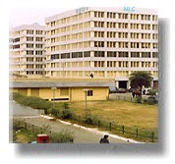
National Informatics Centre (NIC) of the Department of Information Technology is providing network backbone and e-Governance support to Central Government, State Governments, UT Administrations, Districts and other Government bodies. It offers a wide range of ICT services including Nationwide Communication Network for decentralised planning, improvement in Government services and wider transparency of national and local Governments. NIC assists in implementing Information Technology Projects, in close collaboration with Central and State Governments, in the areas of (a) Centrally sponsored schemes and Central sector schemes, (b) State sector and State sponsored projects, and (c) District Administration sponsored projects. NIC endeavours to ensure that the latest technology in all areas of IT is available to its users.

NIC Headquarters is based in New Delhi. At NIC Headquarters, a large number of Application Divisions exist which provide total Informatics Support to the Ministries and Departments of the Central Government. NIC computer cells are located in almost all the Ministry Bhawans of the Central Government and Apex Offices including the Prime Minister’s Office, the Rashtrapati Bhawan and the Parliament House. Apart from this, NIC has various Resource Divisions at the Headquarters which specialize into different areas of IT and facilitate the Application Divisions as well as other NIC Centres in providing state-of-the-art services to the Govt.

At the State level, NICs State/UTs Units provide informatics support to their respective State Government and at the District level lie the NIC District Infomatics Offices.

NIC has conceptualised, developed and implemented a very large number of projects for various Central and State Government Ministries, Departments and Organisations. Many of these projects are continuing projects being carried out by various divisions of NIC at New Delhi Headquarters and State/District centres throughout the country. Some of the most important note worthy projects, which offer a glimpse of the multifaceted, diverse activities of NIC, touching upon all spheres of e-governance and thereby influencing the lives of millions of citizens of India are given below :

- Agrictural Marketing Information Network (AGMARKNET).
- Central Passport System.
- Community Information Centres (CICs).
- Computerised Rural Information Systems Project (CRISP).
- Court Information System (COURTIS).
- Department of Agriculture Network (DACNET).
- Examination Results Portal.
- India Image.
- Land Records Information System (LRIS).
- National Hazardous Waste Information System (NHWIS).
- Public Grievance Redress and Monitoring System (PGRAMS).
- Spatial Data Infrastructure (SDI).
- Video Conferencing.

Web Site of NIC http://indiaimage.nic.in/

1.2-Organisation

 Border Road Organisation (BRO)

The early years post Independence saw India with a 15000 kilometers long border to be secured and a vast, remote and economically backward North and North Eastern Region, with an inadequate road communication network, to support its future development.

The 1950’s was one of consolidation and learning, politically and militarily. With the advent of the Five Year Plans from 1951, the Central and State Government stepped in. With the Constitution having declared road development as a State subject , the responsibility of road development continued in the North and North Eastern States to be entrusted to the PWD, even where defence strategy was involved.

However, what become apparently clear was that, the roads for the Border States were forbidding challenges, needing dedicated commitment, time and money, to open up the hinterland to the out side.

Vision

Nation’s most reputed, multifaceted, transnational, modern construction Organisation committed to meeting the strategic needs of the armed forces with enlightened leadership, a strong, skilled and committed work force, a well ingrained value system and a strong environment conscience. Playing a national role in socio economic development through its large-scale contribution to infrastructure development.

Mission

- To support the armed forces meet their strategic needs by committed, dedicated and cost effective development and sustenance of the infrastructure.

- To achieve international levels of quality excellence and time consciousness in a diversified sphere of construction activity in a cost effective manner.

- Optimise potential and expertise through increased involvement in agency, transnational and national development projects.

- To attain leadership in development, adoption, assimilation and use of state of the art technology.

- To create the environment for accurate, real time and effective decision making through optimising use of information technology.

- Through a focus on core competencies; ensure highest level of skill and proficiency in construction activity.

- To sustain a sense of values in the Organisation that will ensure a high level of self esteem in each individual and immeasurable synergy in the Organisation.

- To help enrich the quality of life of the community and ensure all rough growth.

Role of the BRO

In Peace

(a)Develop & Maintain The Operational Road Infrastructure Of General Staff In The Border Areas.

(b) Contribute To The Socio-Economic Development Of The Border States.

In War

(a) To Develop & Maintain Roads To Keep L Of C Through In Original Sectors And Re-Deployed Sectors .

(b) To Execute Addl Tasks As Laid Down By The Govt Contributing To The War Effort.

Web Site of BRO http://bro.gov.in/

1.3 Introduction To Inventory Management

Inventory Management System deals with the maintainance of equipments. BRO works for many projects on building roads and bridges for which they have to purchase equipments.

1.3.1 Project Description

The primary role of Border Road Organisaton is to undertake road development departmently in remote border areas of the Northern & North Eastern reagons of the country.the role envisages implementation of time bound works plan base on Defence priorities and regional development.this aim is achieved by co-ordinating the activities of a dedicated General Reserve Engineers Force comprising of both the GREF and service personnel.the road construction activites are backed by a mechanized fleet of about 130 different type of vehicles,equipments and plants.
BRO procure the equipments.The purchase decision of equipments from different firms on the basis of the Tender Price coated bt resp firms.Then these equipments are used in different projects of BRO.
For the maintainance of these equipment’s spare parts Inventory Management System is developed.
Basic Operation performed:
- PRE-SO (Supply Order)
- POST-SO details.

Pre-So is maintained from the starting of the financial year. It is concern to keep the records of each Supply Order that is received from firm, supplying equipments. These equipments are then assigned a unique ISG Number given by BRO, further they are supplied to different project departments of BRO.

After the completion of PRE SO BRO maintains the POST SO worksheet. The supply and liability to the current year is being prepared in this worksheet. First the details of the supply order for the current year is prepared at the end of the current year followed by the liability worksheet that is being carry forward.

At last Guide Sheet is formed that include budget allotted, liabilities of last three year cleared in current year, liabilities to be carry forward to next year.

1.4 Component Assigned

1.4.1 Goal Of The Proposed System
The goal of the proposed system is to prepare PRE-SO on the basis of order made.
This module contain two stages:
- SO Sheet
- Pre_SO Worksheet
The preliminary stage of this project is to create the SO (Supply Order) sheet for each equipment order.In this sheet each equipment spare part is assign a unique identifier i.e ISG Num.
SO sheet contains the Rate of each spare part.When the worksheet is being prepare then this rate acts as the LPP.The reference of Last Purchase Price (LPP) of the equipments corresponding to the ISG (Initial Stocking Guide) is maintain to form the transaction sheet of the particular financial year. Each firm specifies their Tender Price (TP) respective to the spare parts. Each equipment can have multiple spare parts, uniquely identified by their Part No.

Pre-SO worksheet is being prepared approx at the end of each financial year on the basis of SO transaction sheet and Tender Price coated.In this worksheet basic operation is to get the last purchase price, and its reference.

    - Limitation of the Existing System

- Existing system was manual.
- Time consuming as data entry which include calculations took lot of time.
- Searching was very complex as there could be 100’s of entry every year.
- The proposed system is expected to be faster than the existing system.

2. System Analysis

System Analysis refers into the process of examining a situation with the intent of improving it through better procedures and methods. System Analysis is the process of planning a new System to either replace or complement an existing system. But before any planning is done the old system must be thoroughly understood and the requirements determined. System Analysis, is therefore, the process of gathering and interpreting facts, diagnosing problems and using the information to re-comment improvements in the System. Or in other words, System Analysis means a detailed explanation or description. Before computerized a system under consideration, it has to be analyzed. We need to study how it functions currently, what are the problems, and what are the requirements that the proposed system should meet.

System Analysis is conducted with the following objectives in mind:

- Identify the customer’s need.

- Evaluate the system concept for feasibility.

- Perform economic and technical analysis.

- Allocate functions to hardware, software people, database and other system elements.

- Establish cost and schedule constraints.

- Create a system definition that forms the foundation for all the subsequent engineering work.

  - Requirement Analysis/ SRS of the Component

    - Problem Definition

To provide the basic services related to the Supply of the equipments spare part, to maintain their PRE-SO (Supply Order) and POST-SO details. The product will take care of all the supply orders. Pre-So is maintained from the starting of the financial year. It is concern to keep the records of each Supply Order, which is received, from firm, supplying equipments. These equipments are then assigned a unique ISG Number given by BRO, further they are supplied to different project departments of BRO. The reference of Last Purchase Price (LPP) of the equipments corresponding to the ISG (Initial Stocking Guide) is maintain to form the transaction sheet of the particular financial year.

2.1.2 Performance Requirements

The following performance characteristics should be taken care of while developing the system:
User friendliness: The system should be easy to learn and understand so that new user can also use the system effectively, without any difficulty.
User satisfaction: The system should meet user expectations.
Response time: The response time of all the operations should be low. This can be made possible by careful programming.
Error handling: Response to user errors and the undesired situations should be taken care of to ensure that the system operates without halting.
Safety: The system should be able to avoid or tackle catastrophic behavior.
Robustness: The system should recover from undesired events without human intervention.

2.1.3 System Requirements

SOFTWARE REQUIREMENT

- Visual Studio .Net 2003
- SQL Server 2000
- Windows 2000 Server edition

HARDWARE REQUIREMENT

- Pentium III processor
- 256 MB RAM
- 20GB HARD DISK

Acceptance Criteria:-

The following acceptance criteria were established for the evaluation of the new system:

User friendliness:- The system should meet user needs and should be easy to learn and use.
Modularity:- The system should have relatively independent and single function parts .
Maintainability:- The system should be such that future maintenance and enhancements times and efforts are reduced.
Timeliness:- The system should operate well under normal, peak and recovery conditions.
The system developed should be accurate and hence reliable i.e. The error rate should be minimized and the outputs should be consistent and correct.
Both the execution time and response time should be negligibly low.
The system should be efficient i.e. the resources utilization should be optimal.
The system should have scope to forsee modifications and enhancements i.e. it should be able to cope with the changes in future technology.

2.2 FEASIBILITY STUDY :

All projects are feasible given unlimited resources and infinite time. Unfortunately the development of computer-based system in many cases is more likely to be plagued by scarcity of resources and delivery date. Hence, we have made use the concept of reusability that is what Object Oriented Programming (OOPS) is all about.
The feasibility report of the ptoject holds the advantages and flexibility of the project. This is divided into three sections:
- Economical Feasibility
- Technical Feasibility
- Behavioral Feasibility

2.2.1 Economic Feasibility:

Economic analysis is the most frequently used method for evaluating the effectiveness of the candidate system. More commonly known as cost/benefit analysis, the procedure is to be determining the benefits and savings that are expected from a candidate and compare them with costs. If benefits outweigh costs, then the decision is made to design and implement the system.

A systems financial benefit must exceed the cost of developing that system. i.e. a new system being developed should be a good investment for the organization. Economic feasibility considers the following
i. The cost to conduct a full system investigation.
ii. The cost of hardware and software for the class of application.
iii. The benefits in the form of reduced cost or fewer costly errors.
iv. The cost if nothing changes (i.e. The proposed system is not developed).

The proposed “INVENTORY MANAGMENT” is economically feasible because
i. The system requires very less time factors.
ii. The system will provide fast and efficient automated environment instead
of slow and error prone manual system, thus reducing both time and man
power spent in running the system.
iii. The system will have GUI interface and very less user-training is required
to learn it.
iv. The system will provide service to view various information for proper
managerial decision making.

Technical Feasibility:

Technical feasibility centers around the existing computer system (Hardware and Software etc) and to what extend it support the proposed addition. For example, if the current computer is operating at 80 percent capacity - an arbitrary ceiling - then running another application could overload the system or require additional Hardware. This involves financial considerations to accommodate technical enhancements. If the budgets is a serious constraint ,then the project is judged not feasible. In this project, all the necessary cautions have been taken care to make it technically feasible. Using a key the display of text/object is very fast. Also, the tools, operating system and programming language used in this localization process is compatible with the existing one.

Behavioral Feasibility:

People are inherently resistant to change, and computers have been known to facilitate change. An estimate should be made of how strong a reaction the user staff is likely to have toward the development of a computerized system. Therefore it is understandable that the introduction of a candidate system requires special efforts to educate and train the staff.The software that is being developed is user friendly and easy to learn.In this way, the developed software is truly efficient and can work on any circumstances ,tradition ,locales.
Behavioral study strives on ensuring that the equilibrium of the organization and status quo in the organization are nor disturbed and changes are readily accepted by the users.

2.3 Proposed System Functionality

The proposed system will be designed to support the following features:-

- The proposed system has a user friendly Interface for porting of data to server.

- The proposed system provides the facility to pull the data from the server of the specified Supply order number and get the respective report.

- The proposed system provides the no replication of data.

- User can get the desired output according to their queries .This is an added advantage.

3.System Design

Designing is the most important phase of software development. It requires a careful planning and thinking on the part of the system designer. Designing software means to plan how the various parts of the software are going to achieve the desired goal. It should be done with utmost care because if the phase contains any error then that will effect the performance of the system, as a result it may take more processing time, more response time, extra coding workload etc.

Software design sits at the technical kernel of the software engineering process and is applied regardless of the software process model that is used. After the software requirements have been analyzed and specified, software design is the first of the three technical activities Designing, Coding and Testing that are required to build and verify the software. Each activity transforms information in such a manner that ultimately results in validated computer software.

3.1 DESIGN GOALS

The following goals were kept in mind while designing the system:

Make system user-friendly. This was necessary so that system could be used efficiently and system could act as catalyst in achieving objectives.

Make system compatible i.e. It should fit in the total integrated system. Future maintenance and enhancement must be less.

Make the system compatible so that it could integrate other modules of system into itself.

Make the system reliable, understandable and cost-effective.

3.2 FUNCTIONAL FLOW OF THE SYSTEM

Prepare SO Sheet

Start
To prepare Work Sheet
Search ISG from SO sheet

ISG
Exists?
Y=Current Year

New Entery ?

YES

NO
YES

IN Y?
Prepare
Work Sheet
NO
YES
Y=Y-1

Stop

3.3- ENTITY RELATIONSHIP DIAGRAM

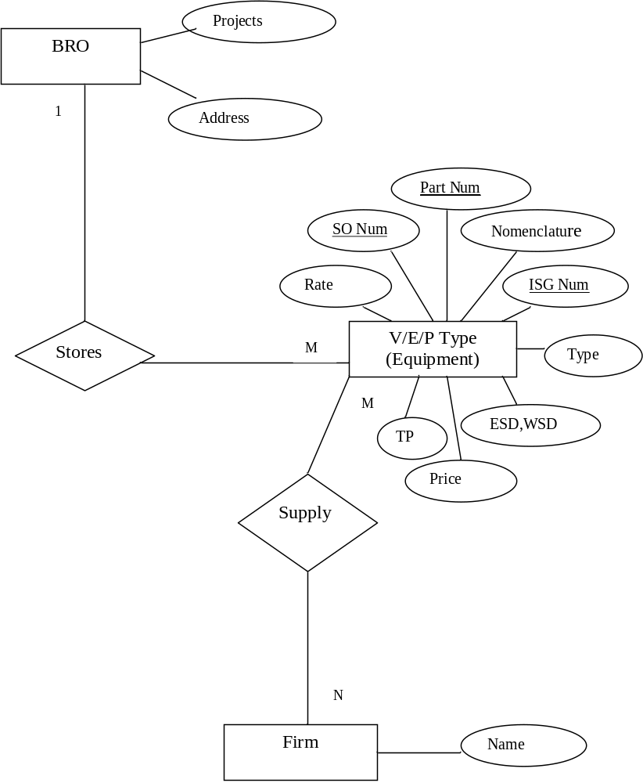

3.4-DATA FLOW DIAGRAM

The Data Flow Diagram shows the flow of data or information. It can be partitioned into single processes or functions. Data Flow Diagrams can be grouped together or decomposed into multiple processes.

The DFD is an excellent communication tool for analysts to model processes and functional requirements. Used effectively, it is a useful and easy to understand modeling tool. It has broad application and usability across most software development projects. It is easily integrated with data modeling, workflow modeling tools, and textual specs. Together with these, it provides analysts and developers with solid models and specs. Alone, however, it has limited usability. It is simple and easy to understand by users and can be easily extended and refined with further specification into a physical version for the design and development teams.
The different versions are Context Diagrams (Level 0), Partitioned Diagrams (single process only -- one level), functionally decomposed, and leveled sets of Data Flow Diagrams.
Data Store
A repository of information. In the physical model, this represents a file, table, etc. In the logical model, a data store is an object or entity.
Data Flows
DFDs show the flow of data from external entities into the system, showed how the data moved from one process to another, as well as its logical storage. There are only four symbols:
- Squares representing external entities, which are sources or destinations of data.
- Rounded rectangles representing processes, which take data as input, do something to it, and output it.
- Arrows representing the data flows, which can either, be electronic data or physical items.
- Open-ended rectangles representing data stores

There are several common modeling rules for creating DFDs:
- All processes must have at least one data flow in and one data flow out.
- All processes should modify the incoming data, producing new forms of outgoing data.
- Each data store must be involved with at least one data flow.
- Each external entity must be involved with at least one data flow.
- A data flow must be attached to at least one process.

BRO INVENTORY MANAGEMENT (PRE-SO)
SO Num
Nomenclature
Part Num
ISG Num
V/E/P Type
Firm Name
Rate
Tender Price(TP)
Price List
ESD,WSD Qty
Amt on TP
Amt on LPP
Num of Months
ESC
(Annual, Overall)
Date
LPP Ref

CONTEXT- FREE DIAGRAM ( 0-Level DFD)

Data Flow Diagram
Supply Order

2
SO Sheet

ISG
SO Num
V/E/P Type
Firm Name
Part Num
Nomenclature
ESD, WSD
Date
Rate

1
LOGIN
UserID
Administrator
Password

User Account

Price List
Tender Price (TP)

3
Work-Sheet
ESC
Num of Months
Amount on TP
Amount on LPP
LPP Ref

RSG WORK-SHEET

3.5-TABLE DESIGN

- SO_RECORD

This table contains the information about the various details and rate for each supply order of the each equipments ad their spare parts.

FIELD NAME | FIELD TYPE | SIZE | REMARKS
SO Num | numeric | 9 | NOT NULL
Date | datetime | 8 | NOT NULL
ISG Num | nvarchar | 50 | NOT NULL
Part Num | varchar | 50 | NOT NULL
Alternate Part Num1 | varchar | 50
Alternate Part Num2 | varchar | 50
Offered Part Num | varchar | 50 | NOT NULL
Nomenclature | varchar | 50 | NOT NULL
Nomenclature1 | varchar | 50
Nomenclature2 | varchar | 50
A/U | varchar | 50 | NOT NULL
ESD qty | numeric | 9 | NOT NULL
WSD qty | numeric | 9 | NOT NULL
Total qty | numeric | 9 | NOT NULL
Rate | float | 8 | NOT NULL
Amount | float | 8 | NOT NULL
V/E/P Type | varchar | 50 | NOT NULL
Firm Name | varchar | 50 | NOT NULL

- Worksheet

This table contains the information about the various supply order made in the current year including their LPP reference, Tender Price, Price List of respective equipments.

FIELD NAME | FIELD TYPE | SIZE | REMARKS
Date | datetime | 8 | NOT NULL
RSG Num | nvarchar | 50 | NOT NULL
Part Num | varchar | 50 | NOT NULL
Alternate Part Num1 | varchar | 50
Alternate Part Num2 | varchar | 50
Offered Part Num | varchar | 50 | NOT NULL
Nomenclature | varchar | 50 | NOT NULL
Nomenclature1 | varchar | 50
Nomenclature2 | varchar | 50
A/U | varchar | 50 | NOT NULL
ESD | numeric | 9 | NOT NULL
WSD | numeric | 9 | NOT NULL
Total | numeric | 9 | NOT NULL
Tender Price | float | 8 | NOT NULL
LPP | nvarchar | 50 | NOT NULL
Amount on TP | float | 8 | NOT NULL
Amount on LPP | nvarchar | 50 | NOT NULL
LPP Ref_SO Num | numeric | 9
LPP Ref_SO Date | datetime | 8
Num of Months | numeric | 9 | NOT NULL
Overall ESC | nvarchar | 50 | NOT NULL
Annual ESC | nvarchar | 50 | NOT NULL
Price List | nvarchar | 50 | NOT NULL
Remarks | varchar | 50
V/E/P Type | varchar | 50 | NOT NULL

3.6 Data Dictionary

Data Dictionary is a simply repositories to store information about all data items. A data dictionary contains a list of all files in the database, the number of records in each file, and the names and types of each field. Most database management systems keep the data dictionary hidden from users to prevent them from accidentally destroying its contents.

User: Administrator
Rite Of Security : Administrator
Data Bases: bro
Tables:
- inv
- rsg
- login
Files:
- front.aspx: Front page of the project
- log.aspx : Loging page
- main.aspx : Menu based form to enter into the different operations.
- Inv.aspx : To insert,update and delete the entries into the SO Sheet.
- Rsg.aspx : To insert,update and delete the entries into the Work-Sheet.
- Invspe.aspx : To query for the SO Num to get its report.
- Rsgspe.aspx : To query for the specific V/E/P Type to get its report.
Data Items:

SO Num
Date
ISG Num
Part Num
Alternate Part Num1
Alternate Part Num2
Offered Part Num
Nomenclature
Nomenclature1
Nomenclature2
A/U
ESD qty
WSD qty
Total qty
Rate
Amount
V/E/P Type
Firm Name
Tender Price
LPP
Amount on TP
Amount on LPP
LPP Ref_SO Num
LPP Ref_SO Date
Num of Months
Overall ESC
Annual ESC
Price List

4.Technologies Used

4.1 Hardware

Processor : Pentium III Processor
RAM : 256 MB
Hard Disk : 20 GB

4.2 Software
- Visual Studio .Net 2003
- Microsoft SQL Server 2000

A Microsoft SQL Server 2000

Features of SQL Server 2000
- Internet Integration.
The SQL Server 2000 database engine includes integrated XML support. It also has the scalability, availability, and security features required to operate as the data storage component of the largest Web sites. The SQL Server 2000 programming model is integrated with the Windows DNA architecture for developing Web applications, and SQL Server 2000 supports features such as English Query and the Microsoft Search Service to incorporate user-friendly queries and powerful search capabilities in Web applications.
- Scalability and Availability.
The same database engine can be used across platforms ranging from laptop computers running Microsoft Windows® 98 through large, multiprocessor servers running Microsoft Windows 2000 Data Center Edition. SQL Server 2000 Enterprise Edition supports features such as federated servers, indexed views, and large memory support that allow it to scale to the performance levels required by the largest Web sites.

- Enterprise-Level Database Features.
The SQL Server 2000 relational database engine supports the features required to support demanding data processing environments. The database engine protects data integrity while minimizing the overhead of managing thousands of users concurrently modifying the database. SQL Server 2000 distributed queries allow you to reference data from multiple sources as if it were a part of a SQL Server 2000 database, while at the same time, the distributed transaction support protects the integrity of any updates of the distributed data. Replication allows you to also maintain multiple copies of data, while ensuring that the separate copies remain synchronized. You can replicate a set of data to multiple, mobile, disconnected users, have them work autonomously, and then merge their modifications back to the publisher.
- Ease of installation, deployment, and use.
SQL Server 2000 includes a set of administrative and development tools that improve upon the process of installing, deploying, managing, and using SQL Server across several sites. SQL Server 2000 also supports a standards-based programming model integrated with the Windows DNA, making the use of SQL Server databases and data warehouses a seamless part of building powerful and scalable systems. These features allow you to rapidly deliver SQL Server applications that customers can implement with a minimum of installation and administrative overhead.
- Data warehousing.
SQL Server 2000 includes tools for extracting and analyzing summary data for online analytical processing. SQL Server also includes tools for visually designing databases and analyzing data using English-based questions.

SQL Server Enterprise Manager

Microsoft Management Console (MMC) is a tool that presents a common interface for managing different server applications in a Microsoft Windows network. Server applications provide a component called an MMC snap-in that presents MMC users with a user interface for managing the server application. SQL Server Enterprise Manager is the Microsoft SQL Server™ MMC snap-in.
SQL Server Enterprise Manager is the primary administrative tool for SQL Server and provides an MMC-compliant user interface that allows users to:
- Define groups of SQL Server instances.
- Register individual servers in a group.
- Configure all SQL Server options for each registered server.
- Create and administer all SQL Server databases, objects, logins, users, and permissions in each registered server.
- Define and execute all SQL Server administrative tasks on each registered server.
- Design and test SQL statements, batches, and scripts interactively by invoking SQL Query Analyzer.
- Invoke the various wizards defined for SQL Server.

Overview of the SQL Server Tools

Microsoft SQL Server 2000 includes many graphical and command prompt utilities that allow users, programmers, and administrators to:
- Administer and configure SQL Server.
- Determine the catalog information in a copy of SQL Server.
- Design and test queries for retrieving data.
- Copy, import, export, and transform data.
- Provide diagnostic information.
- Start and stop SQL Server.
In addition to these utilities, SQL Server contains several wizards to walk administrators and programmers through the steps needed to perform more complex administrative tasks.
b.Vb.Net
Introduction on .NET Framework
.NET is the framework for which we develop applications. It sits in between our application programs and operating system. Applications developed for .NET run inside .NET and are controlled by .NET. It supports both Windows and web applications.
.NET provides an object oriented environment. It ensures safe execution of the code by performing required runtime validations. For example, it is never possible to access an element of an array outside the boundary. Similarly, it is not possible to a program to write into another programs area, etc. The runtime validations performed by .NET makes the entire environment robust.
Components of .NET
.NET framework has two main components. They are:
- Common Language Runtime
- .NET class library
Common Language Runtime
The Common Language Runtime (CLR) is the environment where all programs in .NET are run. It provides various services, like memory management and thread management. Programs that run in the CLR need not manage memory, as it is completely taken care of by the CLR. For example, when a program needs a block of memory, CLR provides the block and releases the block when program is done with the block.
All programs targeted to .NET are converted to MSIL (Microsoft Intermediate Language). MSIL is the output of language compilers in .NET . MSIL is then converted to native code by JIT (Just-in Time Compiler) of the CLR and then native code is run by CLR.
As every program is ultimately converted to MSIL in .NET, the choice of language is pure personal. A program written in VB.NET and a program written in C# are both converted to MSIL. Then MSIL is converted to native code and run. So, whether you write program in C# or VB.NET at the end it is MSIL all that you get.
MSIL in .NET is same as Bytecode in concept. CLR is same as JVM (Java virtual machine that .

.NET Class Library
.NET comes with thousands of classes to perform all important and not-so-important operations. Its library is completely object oriented, providing around 5000 classes to perform just about everything.
Visual Basic .NET (VB.NET) is an object-oriented computer language that can be viewed as an evolution of Microsoft's Visual Basic (VB) implemented on the Microsoft .NET framework. The great majority of VB.NET developers use Visual Studio .NET as their integrated development environment (IDE).
Visual Basic .NET provides the easiest, most productive language and tool for rapidly building Windows and Web applications. Visual Basic .NET comes with enhanced visual designers, increased application performance, and a powerful integrated development environment (IDE). It also supports creation of applications for wireless, Internet-enabled hand-held devices. The following are the features of Visual Basic .NET with .NET Framework 1.0 and Visual Basic .NET 2003 with .NET Framework 1.1.
Some Features of Vb.net:
Powerful Windows-based Applications
Visual Basic .NET comes with features such as a powerful new forms designer, an in-place menu editor, and automatic control anchoring and docking. Visual Basic .NET delivers new productivity features for building more robust applications easily and quickly. With an improved integrated development environment (IDE) and a significantly reduced startup time, Visual Basic .NET offers fast, automatic formatting of code as you type, improved IntelliSense, an enhanced object browser and XML designer, and much more.
Building Web-based Applications
With Visual Basic .NET we can create Web applications using the shared Web Forms Designer and the familiar "drag and drop" feature. You can double-click and write code to respond to events. Visual Basic .NET 2003 comes with an enhanced HTML Editor for working with complex Web pages. We can also use IntelliSense technology and tag completion, or choose the WYSIWYG editor for visual authoring of interactive Web applications.

Simplified Deployment
With Visual Basic .NET we can build applications more rapidly and deploy and maintain them with efficiency.
Powerful, Flexible, Simplified Data Access
You can tackle any data access scenario easily with ADO.NET and ADO data access. The flexibility of ADO.NET enables data binding to any database, as well as classes, collections, and arrays, and provides true XML representation of data. Seamless access to ADO enables simple data access for connected data binding scenarios. Using ADO.NET, Visual Basic .NET can gain high-speed access to MS SQL Server, Oracle, DB2, Microsoft Access, and more.
Improved Coding
You can code faster and more effectively. A multitude of enhancements to the code editor, including enhanced IntelliSense, smart listing of code for greater readability and a background compiler for real-time notification of syntax errors transforms into a rapid application development (RAD) coding machine.
Direct Access to the Platform
Visual Basic developers can have full access to the capabilities available in .NET Framework 1.1. Developers can easily program system services including the event log, performance counters and file system. The new Windows Service project template enables to build real Microsoft Windows NT Services. Programming against Windows Services and creating new Windows Services is not available in Visual Basic .NET Standard, it requires Visual Studio 2003 Professional, or higher.
Full Object-Oriented Constructs
You can create reusable, enterprise-class code using full object-oriented constructs. Language features include full implementation inheritance, encapsulation, and polymorphism. Structured exception handling provides a global error handler and eliminates spaghetti code.

5.Testing and Debugging

Software testing is a critical element of the ultimate review of specification design and coding. Testing of software leads to the uncovering of errors in the software functional and performance requirements are met .Testing also provides a good indication of software reliability and software quality as a whole. The result of different phases of testing are evaluated and then compared with the expected results. If the errors are uncovered they are debugged and corrected. A strategy approach to software testing has the generic characteristics:
- Testing begins at the module level and works “outwards” towards the integration of the entire computer based system.
- Different testing techniques are appropriate at different points of time.
- Testing and debugging are different activities, but debugging must be accommodated in the testing strategy

5.1 Goals and Objectives

“Testing is a process of executing a program with the intent of finding an error”. A good test case is one that has a probability of finding an as yet undiscovered error. A successful test is one that uncovers an as yet undiscovered error. Our Objective is to design test processes that systematically uncover different classes of errors and do so with minimum amount of time and effort.

5.2 Statement of scope

A description of the scope of the software testing is developed. All the features to be tested are noted as follows. The basic principles that guides software testing are,

- All test cases should be traceable top customer requirements. The most severe defects from the customer’s point of view are those that cause the program to fail to meet its requirements.

- Test case should be planned long before testing begins. Testing plan can begin as soon as the requirement model is complete. Detailed definition of the test cases can begin as soon as the design is solidified. Therefore, the entire test can be planned before any code has been generated.

- Testing should begin “in the small” and progress towards “in the large”. The first test planned and executed generally focus on the individual modules. As testing progresses testing shifts focus in an attempt to find errors in integrating clusters of modules and ultimately in the entire system

5.3.Test Case

Before the project is released, it has to has pass through a test cases suit, so that the required functionality is met and previous functionality of the system is also not broken to do this, there is an existing test cases which checks for the previous functionality. New test cases are prepared and added to this existing test suit to check for the added functionality.
Test case describes an input description and compare the observed output with expected output to know the outcome of the test case. If it is different, then, there is a failure and it must be identified.

Test Cases for different field used.

V/E/P Type: should be a character value till length 50

Test Cases | INPUT  (a) | Expected Output
1 | 123 | Invalid Input
2 | cumins | Valid Company Name
3 | Asdfghjklqwertyuiop zxcvbnmasdfghjpoiuyttqwert hello | Invalid Input(out of range)
4 | -12 | Invalid input

Firm Name: should be a character value till length 50

Test Cases | INPUT  (a) | Expected Output
1 | 123 | Invalid Input
2 | Cumins ltd | Valid Company Name
3 | Asdfghjklqwertyuiop zxcvbnmasdfghjpoiuyttqwert hello | Invalid Input(out of range)
4 | -12 | Invalid input

SO Num: should be a numeric value till length 9

Test Cases | INPUT  (a) | Expected Output
1 | 123 | Valid Number
2 | cumins | InValid Input
3 | -12 | Invalid input
4 | 1234567892 | Invalid Input(out of range)
5 | 112.3 | Invaild Input

Part Num: should be a alphanumeric value till length 50

Test Cases | INPUT  (a) | Expected Output
1 | 123 | valid Input
2 | C12345 | Valid Num
3 | -12 | Invalid input
4 | Asdfghjklqwertyuiop123 zxcvbnmasdfghjpoiuyttqwert hello | Invalid Input(out of range)

ISG Num: should be a float value till length 9

Test Cases | INPUT  (a) | Expected Output
1 | 123 | valid Input
2 | cumins | Invalid Input
3 | 1123.43 | Valid Num
4 | -12 | Invalid input
5 | 1234567891.6 | Invalid Input(out of range)

Nomenclature: should be a alphanumeric value till length 50

Test Cases | INPUT  (a) | Expected Output
1 | 123 | valid Input
2 | C12345 | Valid Num
3 | Asdfghjklqwertyuiop123 zxcvbnmasdfghjpoiuyttqwert hello | Invalid Input(out of range)
4 | -12 | Invalid input

ESD: should be a numeric value till length 9

Test Cases | INPUT  (a) | Expected Output
1 | 123 | Valid Number
2 | cumins | InValid Input
3 | 1234567892 | Invalid Input(out of range)
4 | -12 | Invalid input
5 | 112.3 | Invaild Input

WSD: should be a numeric value till length 9

Test Cases | INPUT  (a) | Expected Output
1 | 123 | Valid Number
2 | cumins | InValid Input
3 | 1234567892 | Invalid Input(out of range)
4 | -12 | Invalid input
5 | 112.3 | Invaild Input

Rate: should be a float value till length 9

Test Cases | INPUT  (a) | Expected Output
1 | 123 | valid Input
2 | cumins | Invalid Input
3 | 1123.43 | Valid Num
4 | 1234567891.6 | Invalid Input(out of range)
5 | -12 | Invalid input

Amount: should be a float value till length 9

Test Cases | INPUT  (a) | Expected Output
1 | 123 | valid Input
2 | cumins | Invalid Input
3 | 1123.43 | Valid Num
4 | 1234567891.6 | Invalid Input(out of range)
5 | -12 | Invalid input

Tender Price: should be a float value till length 9

Test Cases | INPUT  (a) | Expected Output
1 | 123 | valid Input
2 | cumins | Invalid Input
3 | 1123.43 | Valid Num
4 | 1234567891.6 | Invalid Input(out of range)
5 | -12 | Invalid input

ESC(overall/annual): should be a float value till length 9

Test Cases | INPUT  (a) | Expected Output
1 | 123 | valid Input
2 | cumins | Invalid Input
3 | 1123.43 | Valid Num
4 | 1234567891.6 | Invalid Input(out of range)
5 | -12 | valid input
6 | -12.87 | valid input

Price List: should be a float value till length 9

Test Cases | INPUT  (a) | Expected Output
1 | 123 | valid Input
2 | cumins | Invalid Input
3 | 1123.43 | Valid Num
4 | 1234567891.6 | Invalid Input(out of range)
5 | -12 | Invalid input

A pictorial representation of this can be shown as follows.

Result Of Testing

Comparator
Existing Test Case
New Test Case

Software
Under Testing
Output

5.4Testing Process
The testing process can be shown as:

Levels of testing
Test Plan
Test Procedures

Test Case Specification

Test Case Execution
Yes

Is Error Uncovered?
Test Case Analysis

No

Test Report

Following types of testing are done on the System.

a) Unit Testing

The module interface is tested to ensure that information properly flows into and out of the program unit under test. The unit testing is normally considered as an adjunct step to coding step. Because modules are not a standalone program, drivers and/or stubs software must be developed for each unit. A driver is nothing more than a “main program” that accepts test cases data and passes it to the module. A stub serves to replace the modules that are subordinate to the modules to be tested. A stub may do minimal data manipulation, prints verification of entry and returns.
Approaches used for Unit Testing were:

Functional Test: Each part of the code was tested individually and the panels were tested individually on all platforms to see if they are working properly.
Performance Test: These determined the amount of execution time spent on various parts of units and the resulting throughput, response time given by the module.

Stress Test: A lot of test files were made to work at the same time in order to check how much workloads can the unit bear.

Structure Test: These tests were made to check the internal logic of the program and traversing particular execution paths.

b) Integration Testing
“If they all work individually, they should work when we put them together.” The problem of course is “putting them together “. This can be done in two ways:
Top down integration: Modules are integrated by moving downwards through the control hierarchy, beginning with main control module are incorporated into the structure in either a depth first or breadth first manner.

Bottom up integration: It begins with construction and testing with atomic modules i.e. modules at the lowest level of the program structure. Because modules are integrated from the bottom up, processing required for the modules subordinate to a given level is always available and the need of stubs is eliminated.

- Testing includes

- Verification and Validation
- Verification:-is a process of confirming that software meets its specification.
- Validation:- is the process of confirming that software meets the customer’s requirements.

c) Validation Testing

Validation succeeds when software functions in a manner that can be reasonably expected by the customer. It covers the following :-

Validation test criteria: Performance, functional characteristics and uncovered deviation from specification

Configuration review: Ensures that all the elements of software configuration have been properly developed cataloged and have support for the maintenance phase of software life cycle

Alpha Beta testing: Alpha test is conducted by developer’s site by customer. Beta test is conducted at one or more customer site by software end user

Modular integration testing:
Modular integration testing is done to ensure that the module is working independently. The inputs as required by the module are given as required and the output is tested as per the specifications

5.5 Debugging
Debugging occurs as a consequence of successful testing i.e. when a test case uncovers an error, debugging is the process that results in identifying the location of error ad the removal of error. The poorly understood mental process that connects a symptom to cause is debugging. This process will always have one of the two outcomes:
- The cause will be found, corrected and then removed or
- The cause will not be found. In the latter case the person performing debugging may suspect a cause, design a test case to help validate his suspicion, and then work towards the correction of errors in the interactive fashion.
Following three approaches of debugging were used:
- Debugging by Induction
- Debugging by Deduction
- Backtracking
- In this project we mainly used PRINT STATEMENTS debugging technique.

- Implementation

Once the system was tested, the implementation phase started. A crucial phase in the system development life cycle is successful implementation of new system design. Implementations simply mean converting new system design into operation. This is the moment of truth the first question that strikes in every one’s mind that whether the system will be able to give all the desires results as expected from system. The implementation phase is concerned with user training and file conversion.

The term implementation has different meanings, ranging from the conversion of a basic application to a complete replacement of computer system Implementation is used here to mean the process of converting a new or revised system design into an operational one. Conversion is one aspect of implementation. The other aspects are the post implementation review and software maintainence. There are three types of implementation:
- Implementation of a computer system to replace a manual system
- Implementation of a new computer system to replace an existing one.
- Implementation of a modified application to replace an existing one.

6.1 Conversion

Conversion means changing from one system to another. The objective is to put the tested system into operation while holding costs, risks and personnel irritation to a minimum. It involves creating computer compatible files; training the operational staff; installing terminals and hardware. A critical aspect of conversion is not disrupting the functioning of organization.

6.2 Direct Implementation

In direct implementation; the previous system is stopped and new system is started up coincidentally. Here there is a direct change over from manual system to computer-based system. In direct change over implementation; employess can face the problems. Suppose our software is not working much efficiently as manual one then we can’t find the defects in our software. It will not be beneficial in finding errors.

- The proposed system “Inventory Management” is fully implemented using Direct Implementation.

Module Diagram

Inventory Mangment System
Enter
Deliver Repots
Pre-SO
Supply Order Sheet
Rate List
Send ISG Num
LPP Reference
Work Sheet
BRO Database
Genrate Report
Administrator

- Scope and Limitation

Scope of the proposed System:

The proposed system provides the automated generation of LPP reference that includes the LPP Rate and the reference date. LPP is used at the time of Worksheet preparation along with the tender price, which helps to obtain the overall and annual escalation. Escalation is related to the number of months, calculated by the LPP reference date and the worksheet preparation date of the particular financial year.

The “Inventory Management System” software is being developed as an accurate and efficient system for the user . In this system the record of the each request details are preserved along with their transaction related to them. The system is also made secured as all the updation and transaction can be done by the authorized person .

Limitation of the Proposed System:

- Databased used is SQL Server and every database have a stack limit.
- Manual Errors at the time of entering the data can’t be check,only the validation required w.r.t proposed system is checked.

8.Conclusion

The objective of this project was to build a program for maintaining the details of all Supply Order .The system developed is able to meet all the basic requirements. It will provide the facility to the user so that they can keep tracks of all the equipments being supplied. The management of the Inventory will be also benefited by the proposed system, as it will automate the whole supply procedure, which will reduce the workload. The security of the system is also one of the prime concerns.

There is always a room for improvement in any software, however efficient the system may be. The important thing is that the system should be flexible enough for future modifications. The system has been factored into different modules to make system adapt to the further changes. Every effort has been made to cover all user requirements and make it user friendly.

- Goal achieved: The System is able provide the interface to the user so that he can replicate his desired data. .

- User friendliness: Though the most part of the system is supposed to act in the background, efforts have been made to make the foreground interaction with user as smooth as possible. Also the integration of the system with Inventory Management project has been kept in mind throughout the development phase.

9. User Manual & Screen Shots

9.1.User Manual

In the system there are mainly one user interface using which a user is able to
- Store
- Update/Delete
- Search
- View

System contains various forms for different Interfaces :

LOGIN:

This allows the user to enter into the system. User has to enter User ID and Password. If invalid then User ID or Password is entered the an alert message of invalid data is flashed.

MENU INTERFACE:

If User ID and Password both are correct then user enters into Menu Interface.
This Interface contains Menus for various operations to be performed on Basic Processes of Pre-SO.
These processes are :
- Supply Order:- for preparing SO-Sheet.
- RSG :- For preparing Worksheet.
- Report:- To view the Output.
These menus have submenus to perform operations like: Insert, Update, Delete.

SubMenu of Supply Order:

Insert

- Insert Interface : Enter Data to prepare SO-Sheet.
Steps:
- Enter V/E/P Type (vehicle/equipment/part type)
- Enter firm Name from where V/E/P Type is procured.
- Enter SO-Num i.e. The Supply Order Number of V/E/P type of the current Financial Year.
- Select Date of the Supply Order of the current Financial Year.
- Enter ISG Num i.e. a unique identification number of spare parts given by BRO.
- Enter Part Numbers of the equipments assigned by firm.
- Enter Nomenclature i.e. name of the equipments.
- Enter the quantity for ESD and WSD.
- Enter the Rate of the parts.
- Click on Submit to save these data or Reset to clear entries.

Update:

This has some Submenus that are:
Update Data – To alter the data entered in the Specified SO-Num and ISG Num.
Data Interface: To alter records
Steps:
Select SO-Num.
Select required ISG Num.
Alter the entries.
Click Update Button to reflect these changes.

Date- To change the Supply Order Date.
Date Interface:
Steps:
- Enter the SO Number whose Date is to be change.
- Select the new Date.
- Click on Ok button to reflect these changes.

SO-Num - To change the Supply Order number.
SO Interface:
Steps:
- Enter the SO Number to be change.
- Enter the new SO Num.
- Click on Ok button to reflect these changes.

Delete
To delete the Specific record .
Steps:
Select SO-Num.
Select required ISG Num.
Click Delete Button to delete the record.

SubMenu of RSG:

Insert

- Insert Interface : Enter Data to prepare Work-Sheet.
Steps:
- Select V/E/P Type (vehicle/equipment/part type).
- Enter RSG-Num/Part Num to retrieve the respective LPP Reference.
- Select Date of the Work-Sheet of the current Financial Year.
- Enter the quantity for ESD and WSD.
- Enter the Tender Price of the parts.
- Enter the Price List.
- Click on Submit to save these data or Reset to clear entries.

Update:

Update Data – To alter the data entered in the Specified RSG-Num.
Update Interface: To alter records
Steps:
Select V/E/P Type.
Select required RSG Num.
Alter the entries.
Click Update Button to reflect these changes.

Delete
To delete the Specific record.
Steps:
Select V/E/P Type.
Select required RSG Num.
Click Delete Button to delete the record.

SubMenu of Report:

- Supply Order:

Steps:
  - Select SO-Num.
  - Click OK Button to view the Supply Order Report.
  - To print this report click on the printer button on bar of the report.

- RSG:

Steps:
  - Select V/E/P Type.
  - Select Date.
  - Click OK Button to view Report.
  - To print this report click on the printer button on bar of the report.

Terminology Used:

This section enlists the terminology and conventions adopted throughout the document.

ESD | East Stock Division.
ISG | Initial Stock Guide.
LPP | Last Purchase Price.
Nomenclature | Name/Description of the V/E/P Type.
RSG | Revised Stock Guide.
SO-Num | Supply Order Number.
TP | Tender Price.
V/E/P Type | Vehicle/Equipment/Plant Type.
WSD | West Stock Division.

9.2 Screen Shots

A.Main User Interface of Inventory Management System

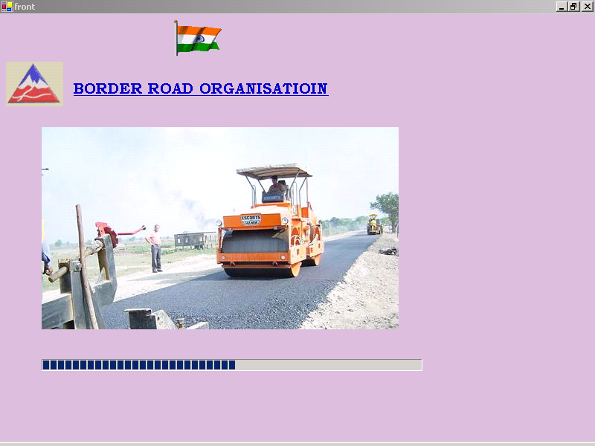

LOGIN Interface to enter the system..

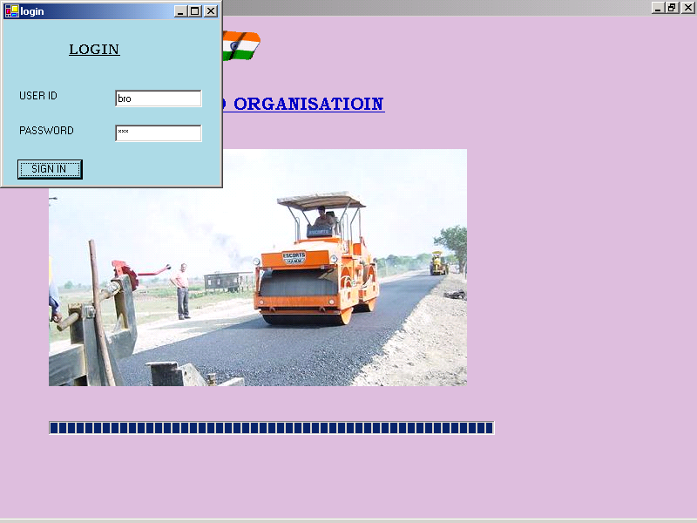

Menu Interface of Inventory Management System
- Supply Order-To prepare/manage SO Sheet
- RSG- To prepare/manage Work Sheet
- Report

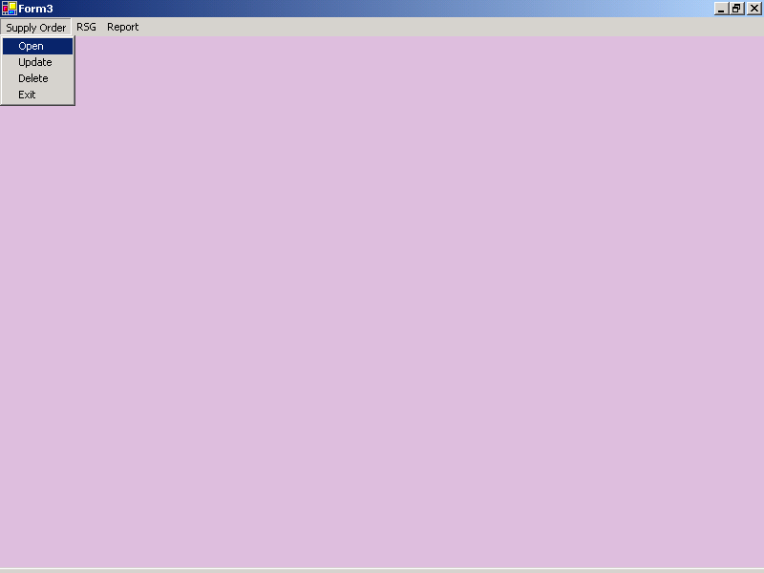

To insert the records in SO Sheet

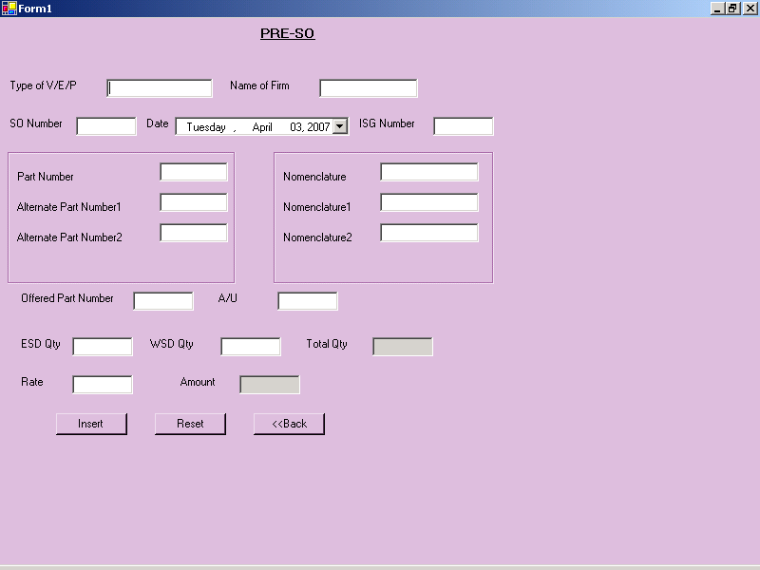

To update the records from SO Sheet

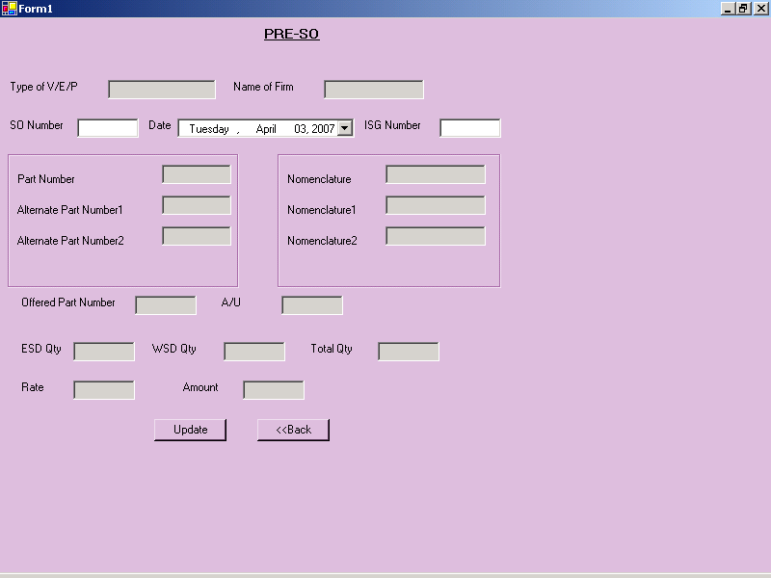

To delete the records from SO Sheet

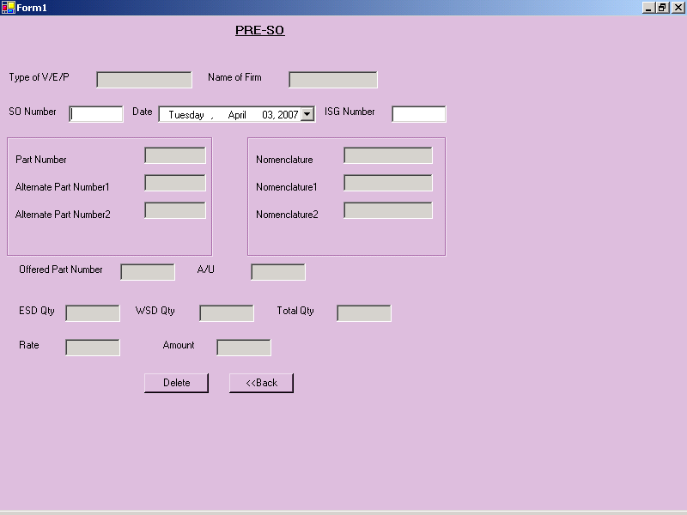

RSG- To prepare/manage Work Sheet

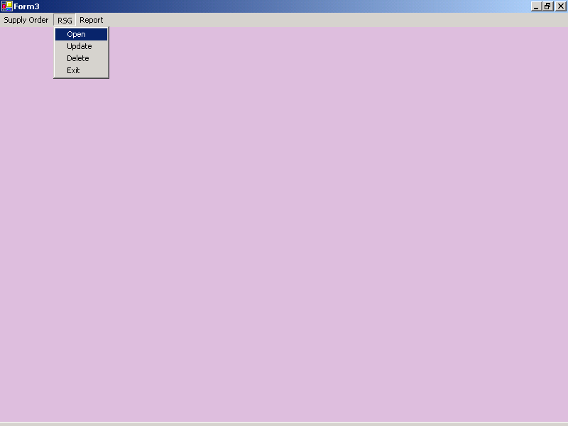

To insert the records in WORK Sheet

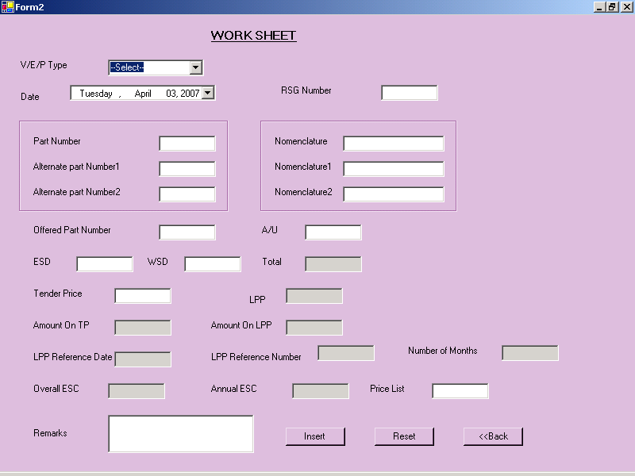

To update the records from WORK Sheet

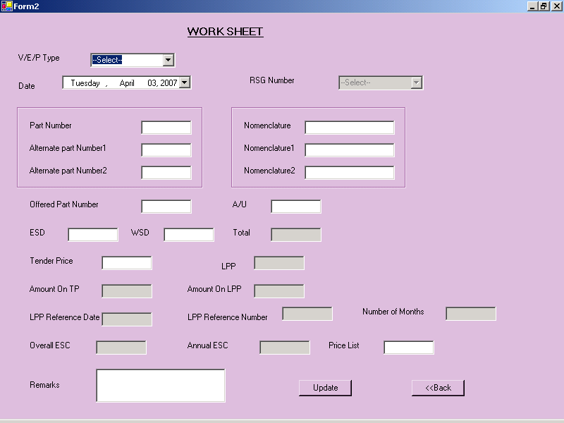

To delete the records from WORK Sheet

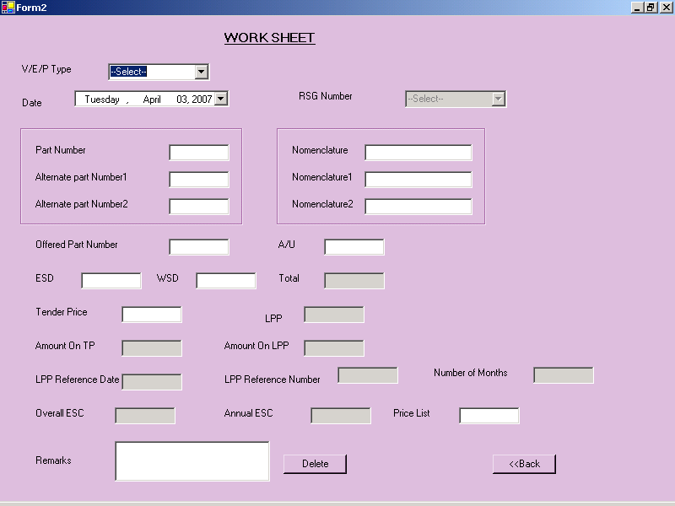

REPORT

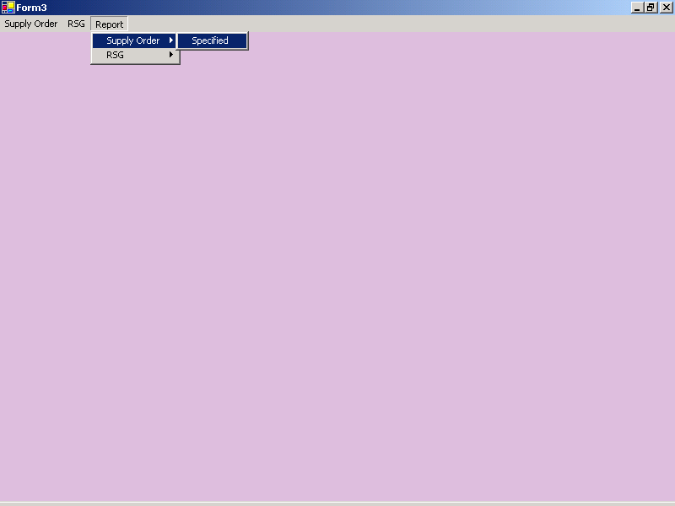

- Supply Order:-of specified SO Num

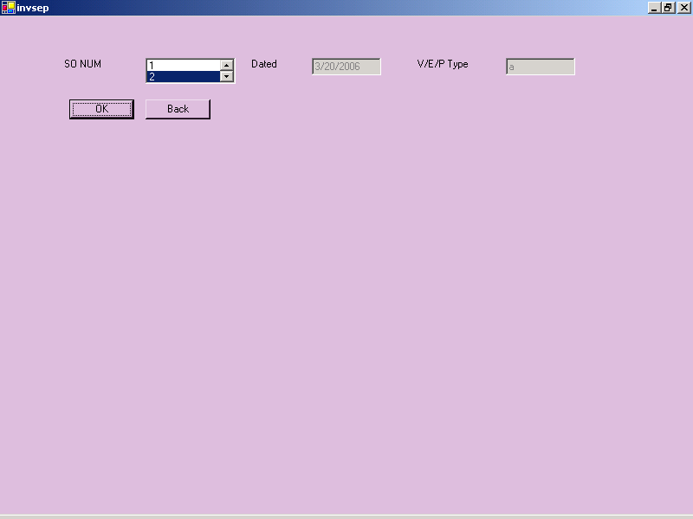

Report

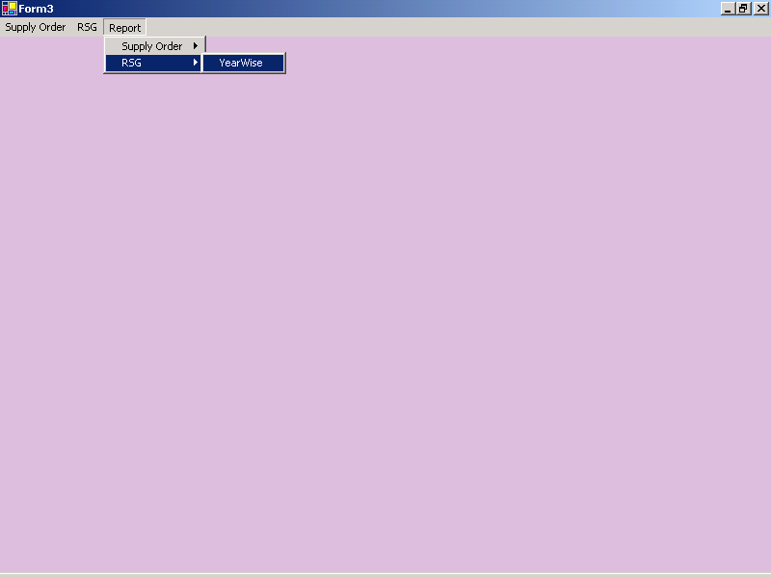

- Report of Work Sheet resp to equipment type

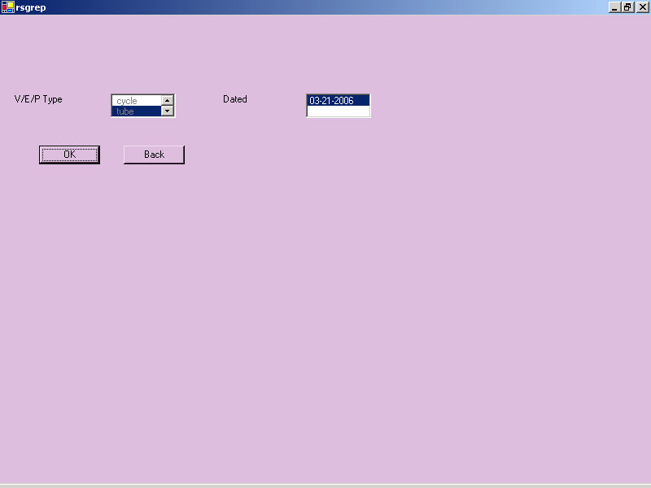

10 . Annexure

10.2 Bibliography

Books Referred

- “Microsoft Learning Vb.Net ”
- “Teach Yourself VB.NET in 21 Days”- Sams Pearson Education [Lowell Mauer]
- “Professional ASP.NET 2.0” –Wrox [Evajen,Hanselma,Muhammad,Sivakumar,Rader]
- “ASP.NET 2.0 Uleashed”-Sams Pearson Education [Stephen Walther]
- “Software Engineering” [Pankaj Jalote]
- “Software Engineering” [K.K. Aggarwal & Yogesh Sighn]

Sites Referred

- www.w3schools.com
- http://bro.gov.in
- www.aspalliace.com
- www.vbforums.com/showthread.php?p=2686697
- www.final-yearprojects.co.cc

