Tyler Anderson

EECS 476

**Open Loop Control**

The first time I ran my code the robot got stuck on a wall, about one meter off course. After I changed the numbers to correct it getting stuck on the wall, it was clear watching the mobot move that it was not following my intended path very accurately and it ended about three meters away from my desired goal location.

**Linear Control**

During this section, I mention oscillations frequently. This is to explain the effect shown on the graph when the velocity that is published overshoots the desired speed and then over-corrects, and then over-corrects, and etc. until it reaches the desired speed. Smaller oscillations means the trajectory is being followed more closely. Larger oscillations means the trajectory is being deviated from more.

The mobot reached the desired location with very small (<0.03m) difference. This is the plot for default magic numbers.

Whole trip:

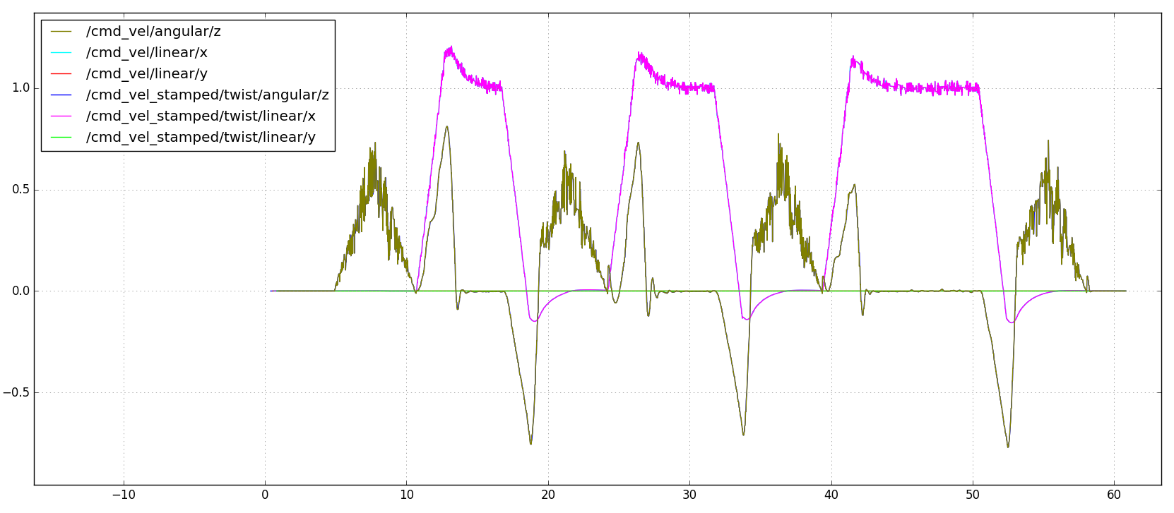

When I changed the max speed and max omega to 2.0 each, the mobot made it to the desired goal location with no noticable change in time and with a little increased error, which is seen in the oscillations on the graph.

Whole trip:

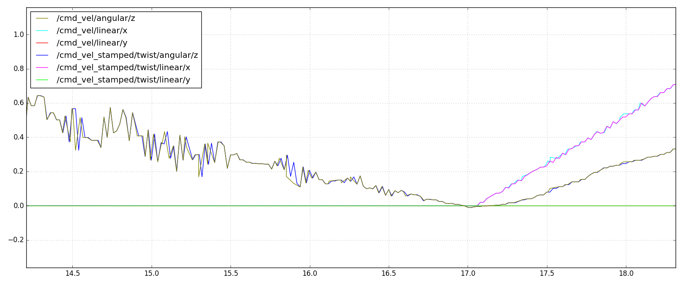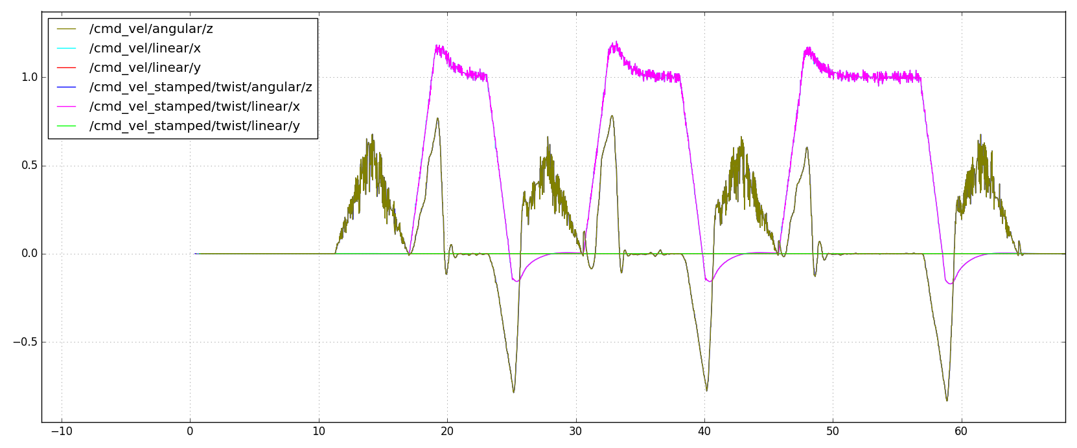

Then, I tested 0.5 each. The graph looks a little different with some plateaus, but still more oscillations that the default.

Whole trip:

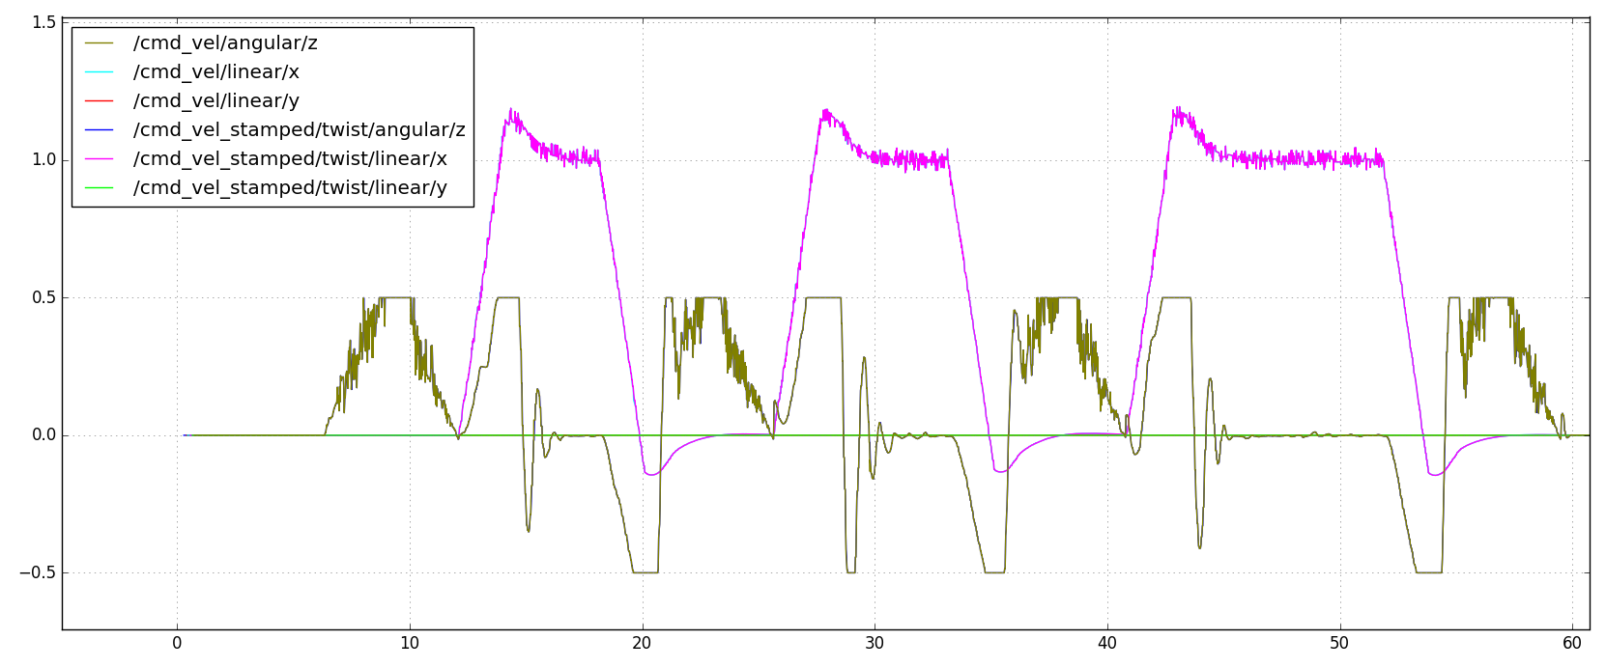

Staying at 0.5 each for max speed/omega

Changing KTRIPDIST to 2.0:

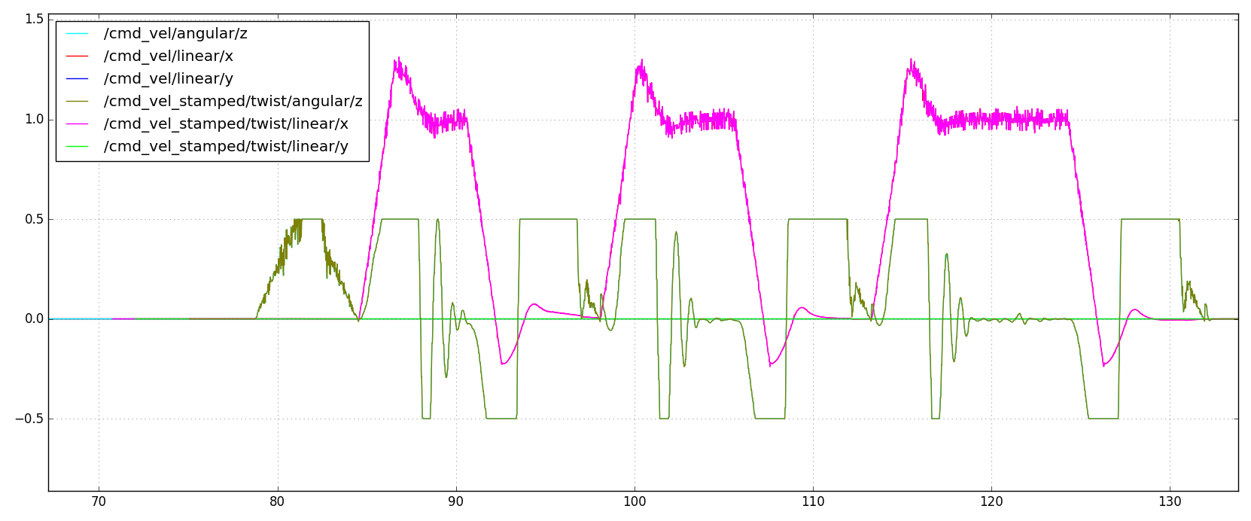This graph shows how increasing the trip distance makes the signal oscillate because it overshoots the velocities multiple times and over-corrects when it overshoots so does not follow the trajectory as well. It also doesn’t noticeably affect the time.

Changing KTRIPDIST to 0.5:

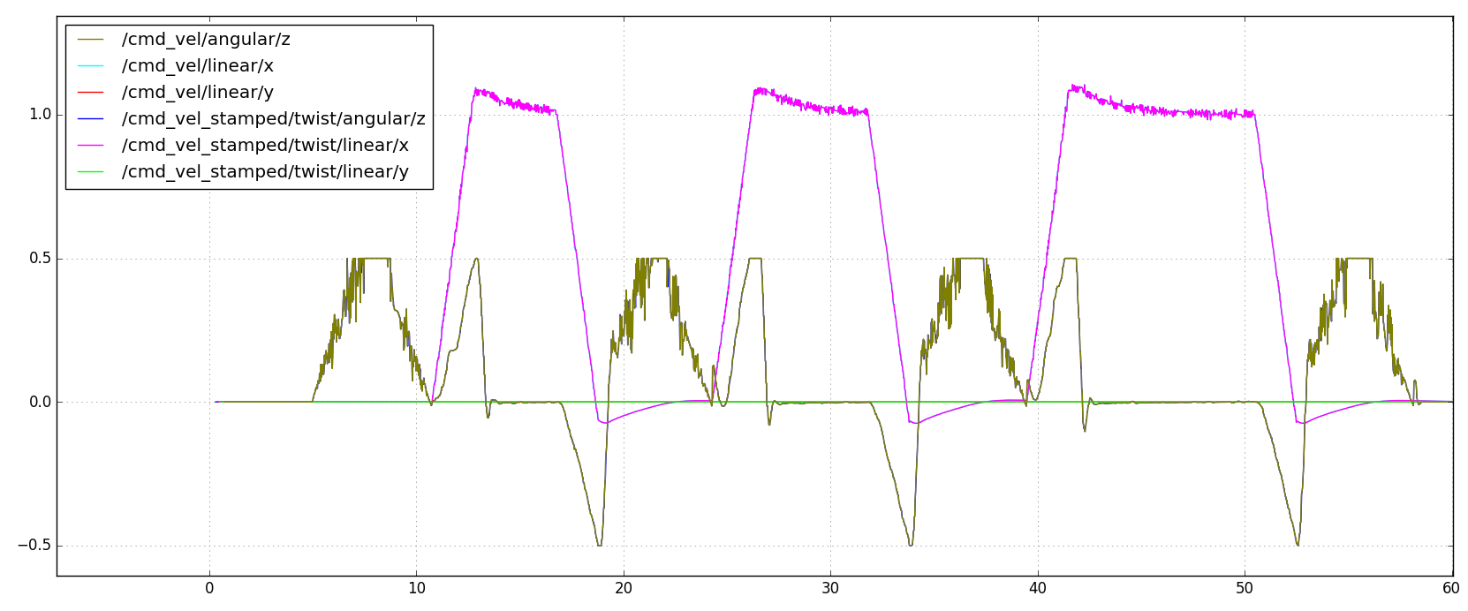

Decreasing the trip distance smoothed out the oscillations, but shortened the plateaus.

Then I changed back to the default magic numbers but changed DISP to 1.5.

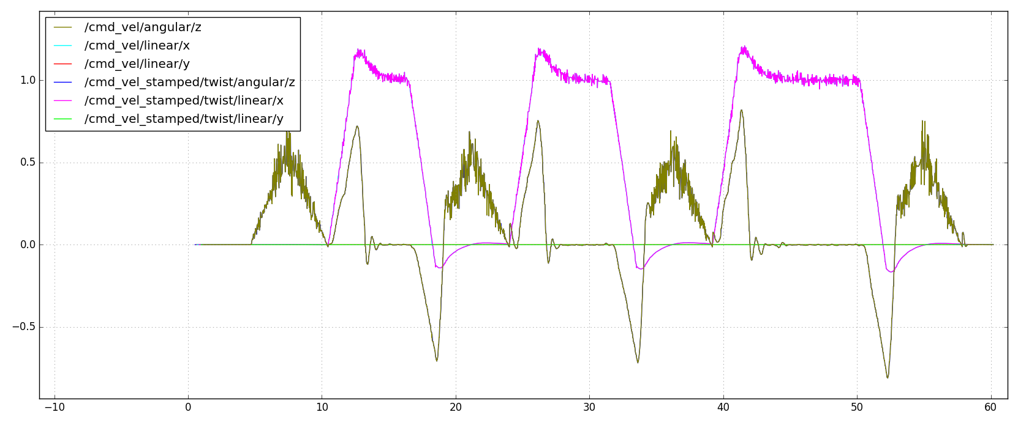The graph shows an increase in oscillations from shortening the DISP.

Then I changed DISP to 4.5

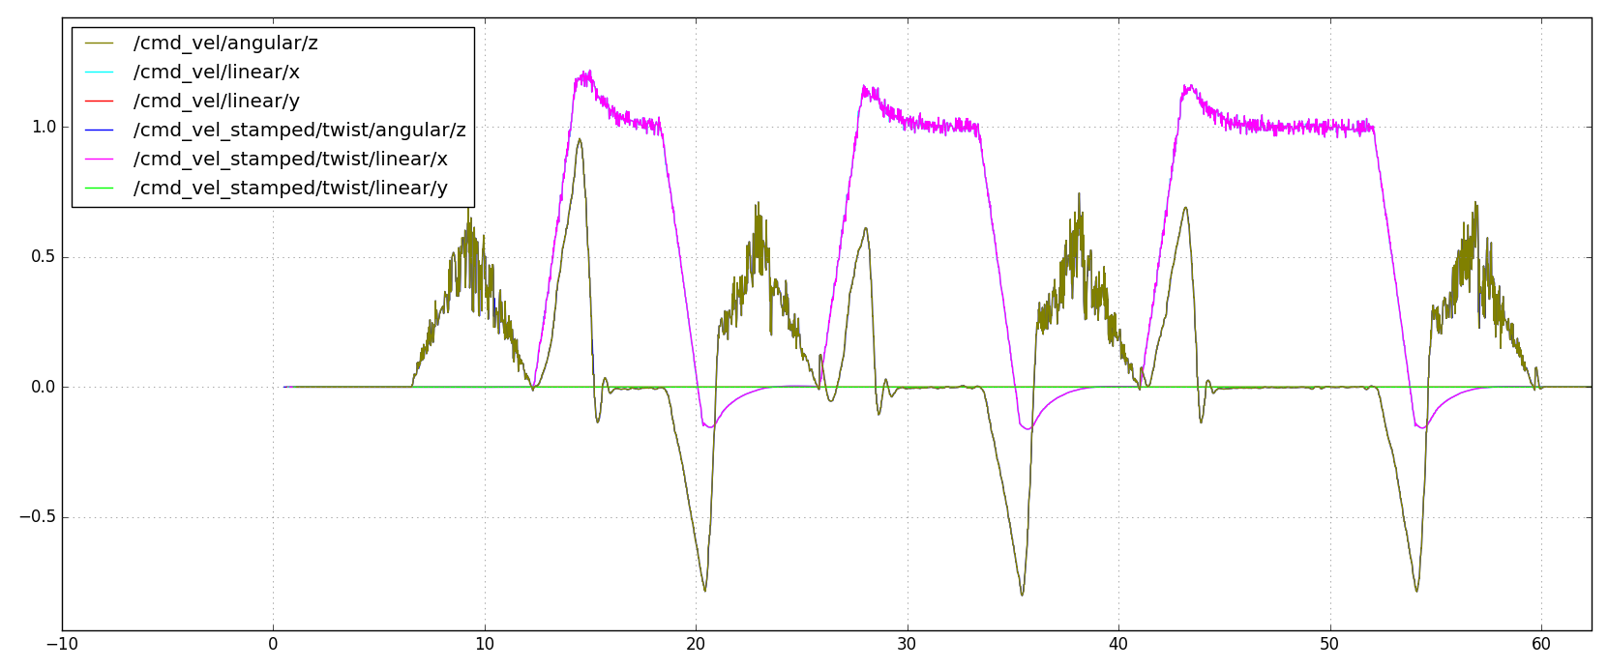

The graph shows an increase in oscillations from lengthening the DISP. The DISP of 3.0 is good as is.

Then I changed DISP back to 3 and PHI to 7.0

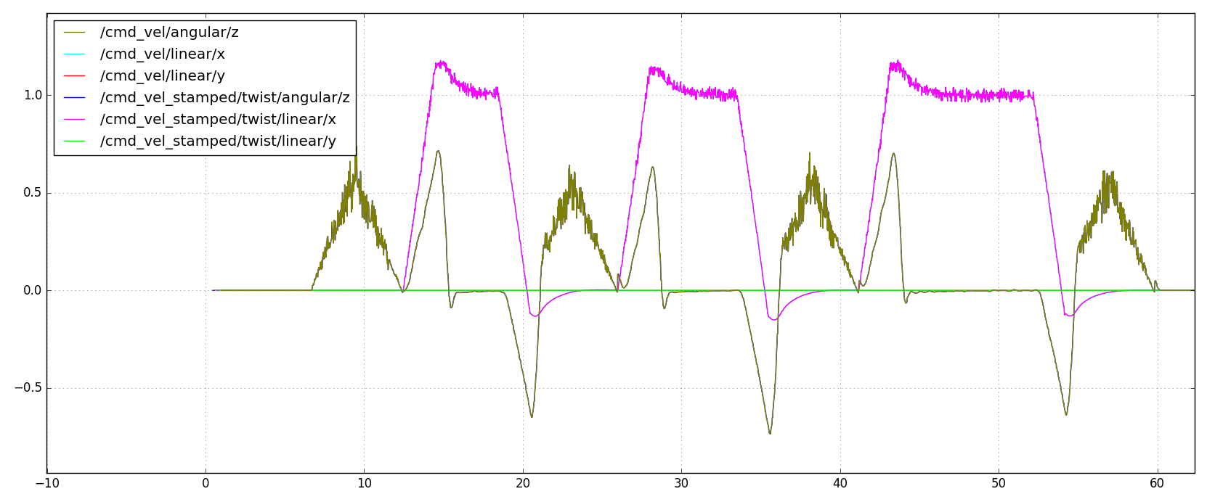The graph shows that a smaller PHI smooths out the oscillations. More work could be done to find the best magic number for PHI.

Then I changed PHI to 13.0

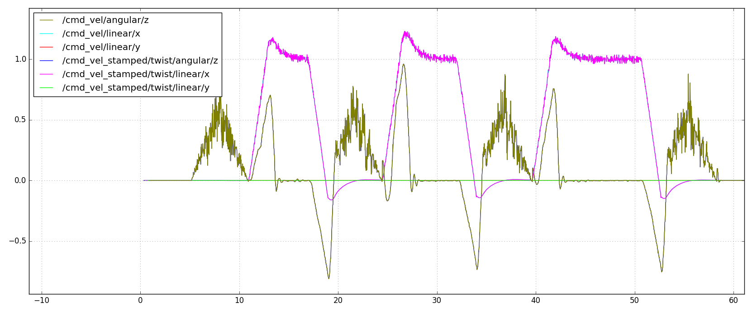The graph shows an increase in oscillations, which is expected since a smaller PHI decreased the oscillations.

**Conclusion:**

All of the magic numbers should stay the same except for PHI, which should be smaller.