INTERMEDIATE ALGEBRA
Chapter 1
Solving Equations & Factoring
Lecture notes — based on Professor Leonard · Parts 1–7
This guide collects the core methods for solving equations and for factoring polynomials: clearing parentheses and fractions, isolating the variable, and the full factoring decision path (GCF → counting terms → special forms, the diamond method, and grouping). Each method is shown with a worked example and a diagram.

Contents
1. Solving Simple Linear Equations 3
2. Equations Containing Fractions 3
3. Equations Containing Powers — Factoring 5
3.1 Step 1 — Factor out the GCF 5
3.2 Step 2 — Count the terms 5
Quick Reference 9

1. Solving Simple Linear Equations
To solve an equation such as 4(x − 2) = 6x − 10, work through three steps in order.

The three steps
- Simplify both sides. Distribute any factor across parentheses, then combine like terms on each side.
- Eliminate the smaller variable term. Move the variable term with the smaller coefficient to the other side (by adding or subtracting) so the remaining variable stays positive.
- Solve what is left. Add or subtract constants, then divide by the coefficient to isolate the variable.

Worked example
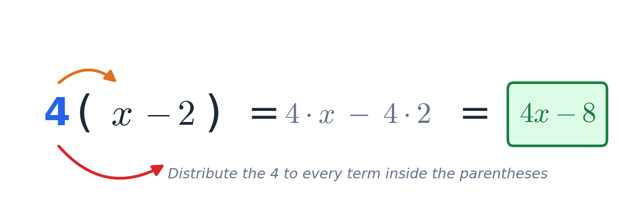
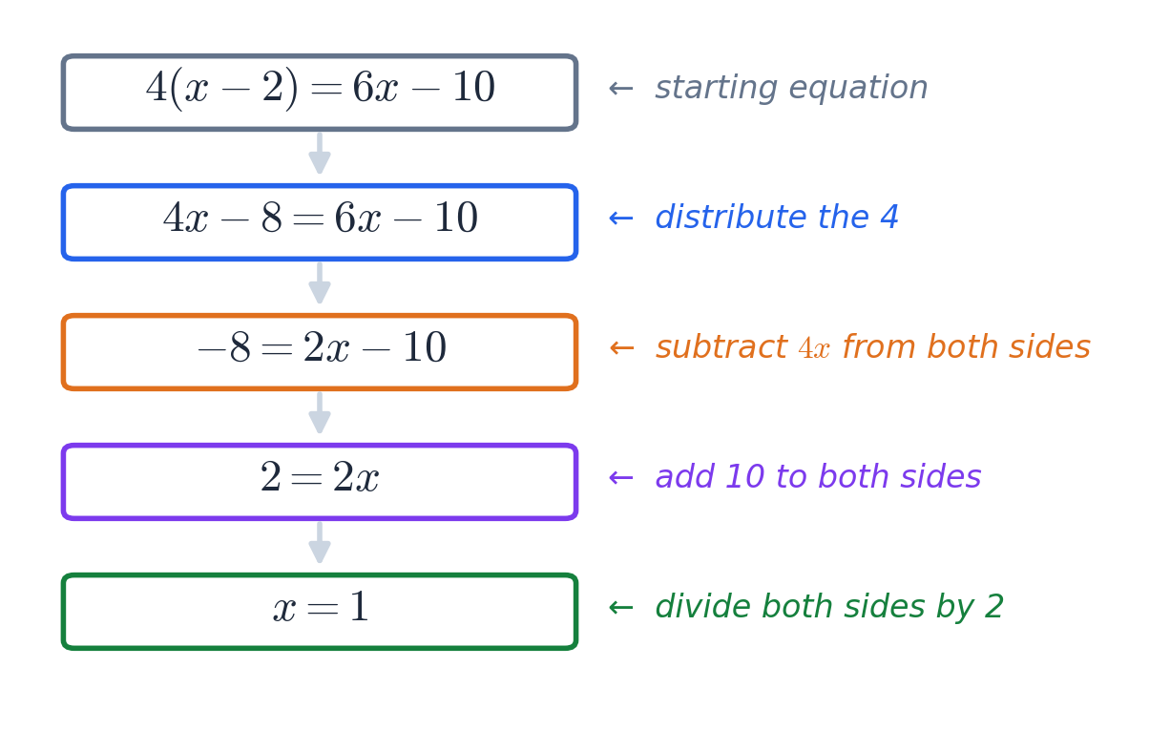
Result: after distributing, moving the smaller term 4x, and isolating, we get x = 1.

2. Equations Containing Fractions
When an equation contains fractions, clear them first: multiply every term on both sides by the LCD (Least Common Denominator). After multiplying, the fractions cancel and an ordinary linear equation remains.
Key idea
Multiply each term — on both sides — by the LCD. Forgetting a single term is the most common mistake.

Worked example
Solve the equation below.
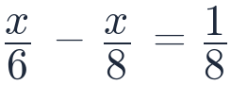
The denominators are 6 and 8, so the LCD = 24. Multiply every term by 24:
Step by step
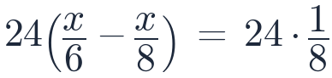
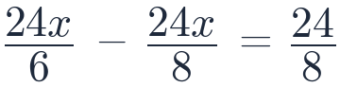
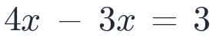
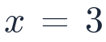
Each fraction reduces cleanly because 24 is a multiple of every denominator.

3. Equations Containing Powers — Factoring
When an equation contains a power, for example x² + 5x + 6 = 0, keep all the variable terms on the same side and then factor. Factoring follows one consistent decision path.
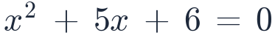

The factoring decision path
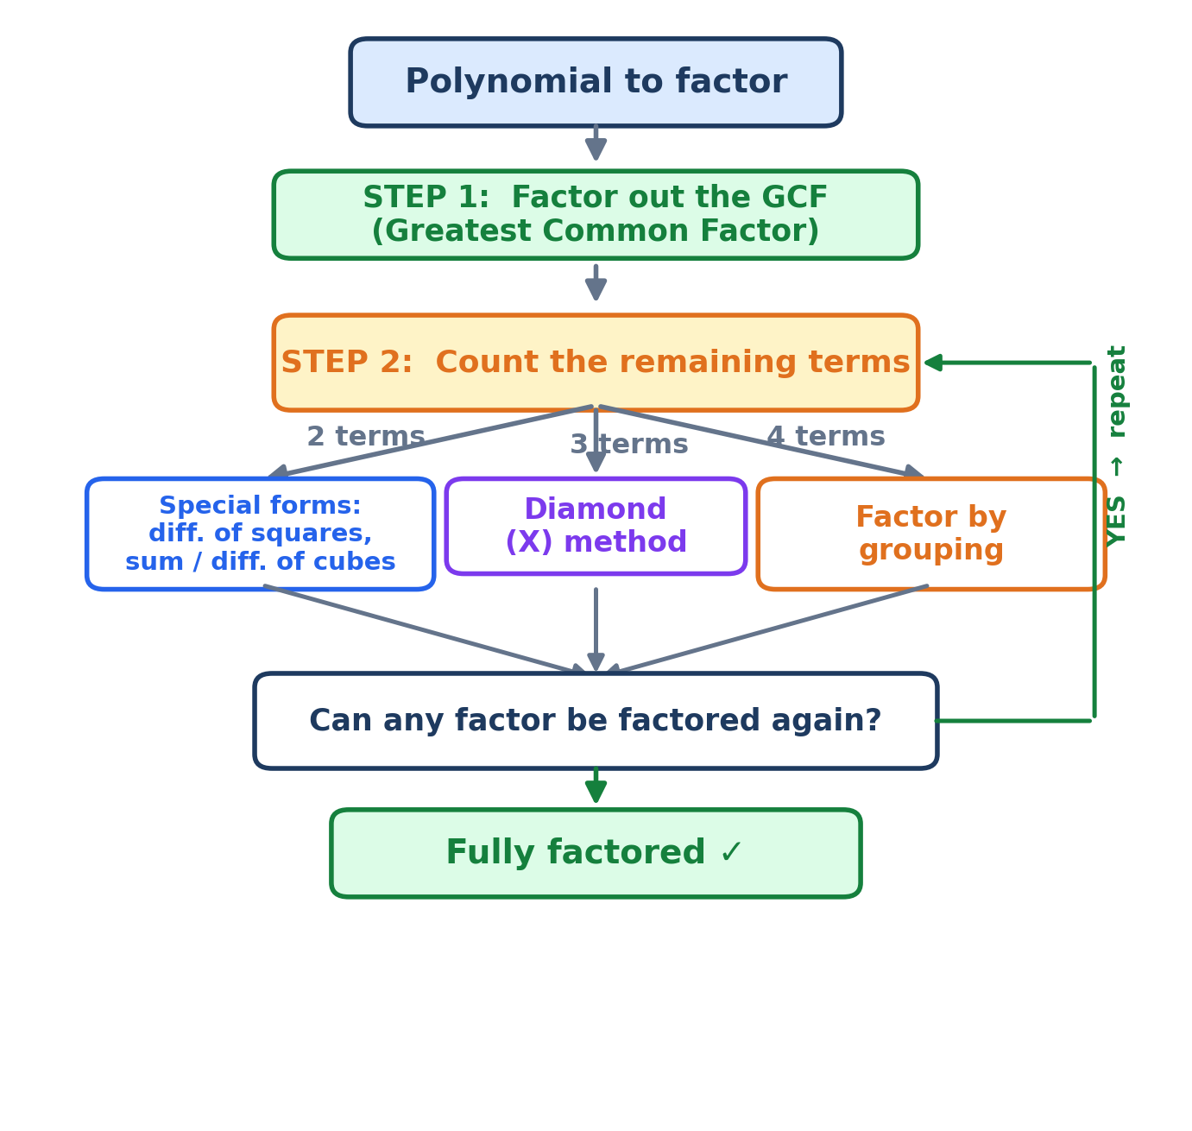

3.1 Step 1 — Factor out the GCF
Always begin by factoring out the Greatest Common Factor (GCF): the largest factor shared by every term. This simplifies whatever remains.

3.2 Step 2 — Count the terms
Once the GCF is removed, count how many terms remain. The number of terms decides which method to use.

Two terms — special forms
With two terms, check whether the expression matches one of the special product forms:
Form (two terms) | Factored result
Difference of squares  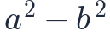 | 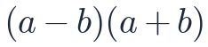
Difference of cubes  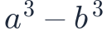 | 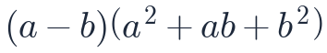
Sum of cubes  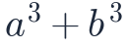 | 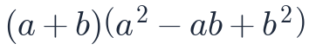
Sum of squares  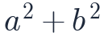 | Generally not factorable (over the real numbers)
Tip: after applying a form, always check whether the new factors can be factored again.
The difference-of-squares pattern can be seen geometrically: a square of side a with a smaller b × b square removed has the same area as a rectangle with sides (a + b) and (a − b).
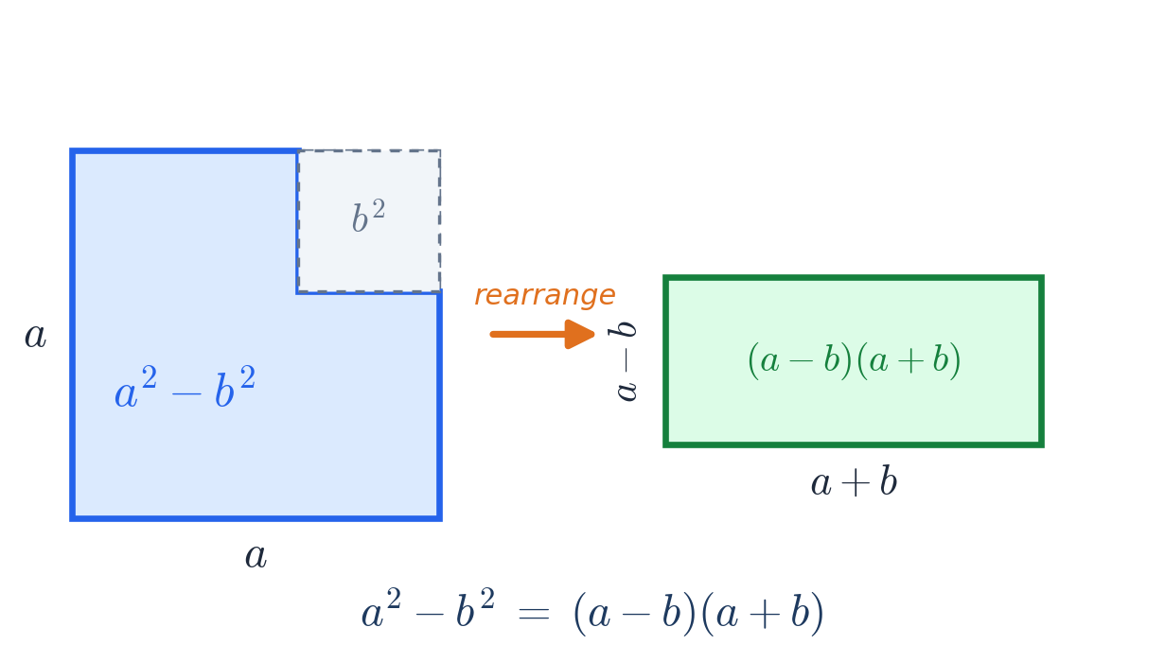
Examples
Example — GCF only
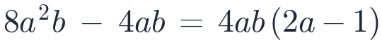
Note: your notes wrote 8a² − 4ab; for the common factor 4ab to be correct the first term must contain a b, i.e. 8a²b. The GCF is 4ab.
Example — difference of squares
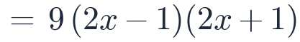
Example — difference of squares

Three terms — the Diamond (X) method
For a trinomial ax² + bx + c, use the diamond. Find two numbers n and m whose product is a·c and whose sum is b.
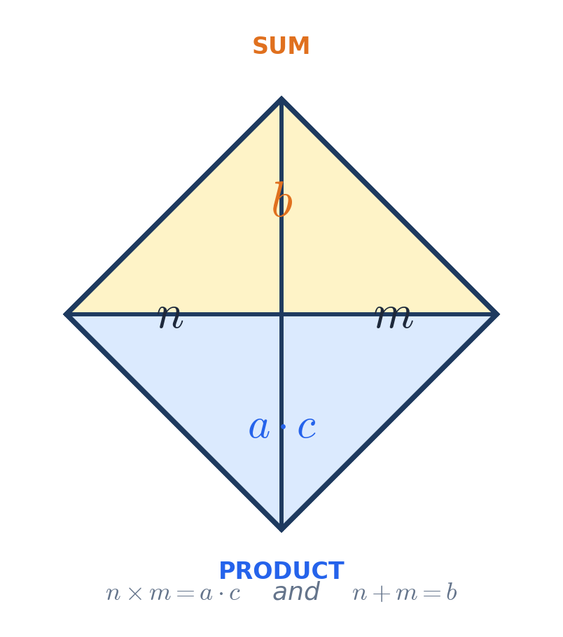
Example of the numbers
If b = −5 and a·c = −24, then n = −8 and m = 3 (since −8 × 3 = −24 and −8 + 3 = −5).
Examples
Example — diamond method
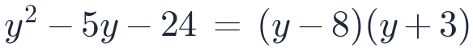
Example — diamond method
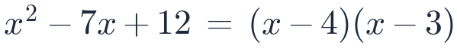

Four terms — factor by grouping
With four terms, group them into pairs, factor each pair, and then factor out the common binomial.
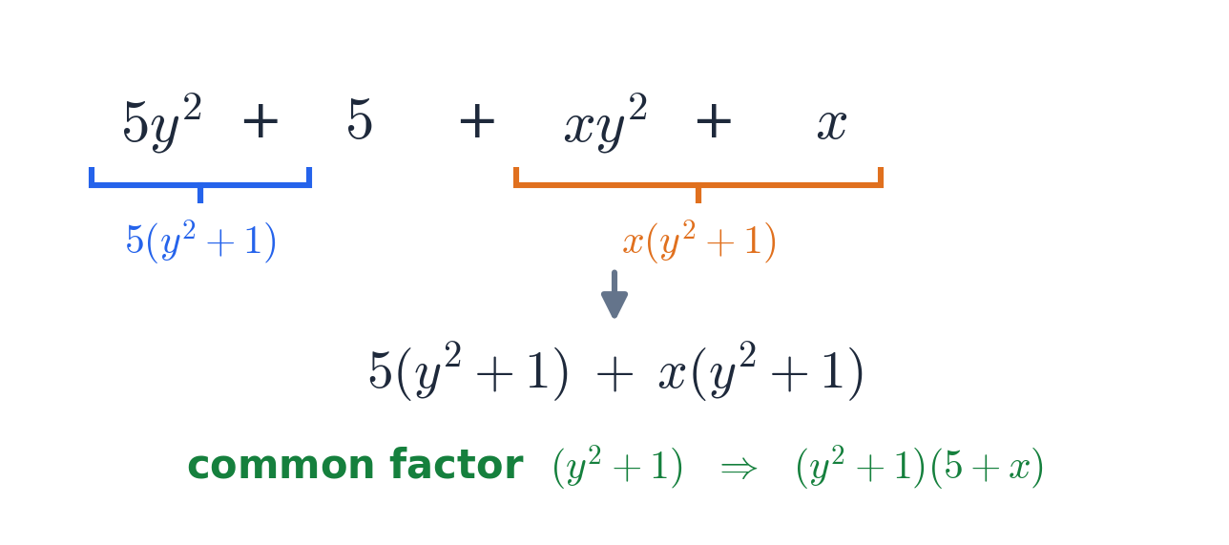
Example — grouping
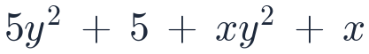
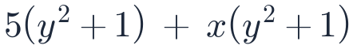
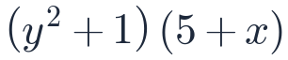
Take each pair separately, then keep factoring while you can.

Splitting the middle term (when a ≠ 1)
Sometimes a three-term trinomial is turned into four terms first: split the middle term using the two diamond numbers, then factor by grouping. This is the go-to approach when the leading coefficient a is not 1.
Example — split then group
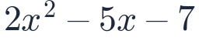
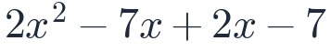
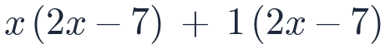
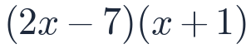
a·c = 2·(−7) = −14; the numbers −7 and +2 multiply to −14 and add to −5.
Example — perfect-square result


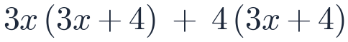
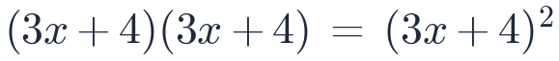
a·c = 9·16 = 144; the numbers 12 and 12 multiply to 144 and add to 24.

Quick Reference

Solving equations
- Linear: simplify (distribute + combine) → move the smaller variable term → isolate the variable.
- Fractions: multiply every term on both sides by the LCD to clear them, then solve.
- Powers: collect terms on one side, then factor.

Factoring checklist
- Factor out the GCF.
- Count the terms: 2 → special forms · 3 → diamond method · 4 → grouping.
- Trinomial with a ≠ 1: split the middle term, then group.
- Check every factor — can it be factored again?

Special-product formulas
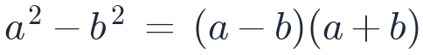
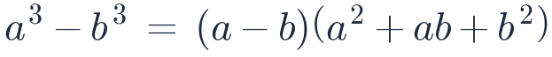
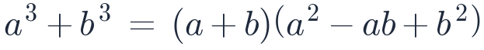
( a² + b² is generally not factorable over the reals )

