Power BI Version Control Process

Executive Summary:
Earlier, Power BI had limited support for structured version management due to the binary nature of .pbix files. The introduction of .pbip (Power BI Project) changed report storage into structured and readable files, enabling integration with Git-based platforms and modern development practices.
The Limitations of Traditional Power BI Versioning:
- Binary File Format: The standard .pbix file stores report components in a binary format, preventing developers from viewing detailed changes in measures, visuals, and metadata.
- Limited Change Visibility: Individual changes could not be tracked at a component level.
- Collaboration Challenges: Multiple developers faced difficulties while working on the same project simultaneously.
- Dependency on Manual Methods: Teams often relied on file copies and SharePoint version history to manage report versions.
Version control is possible with both PBIX and PBIP, but there is a major difference in how effectively it works.
Feature | PBIX | PBIP
Can store in GitHub | Yes | Yes
Track individual changes | No | Yes
View DAX changes | No | Yes
Compare file differences | Difficult | Easy
Merge change from multiple developers | Very difficult | Supported
Team collaboration | Limited | Better
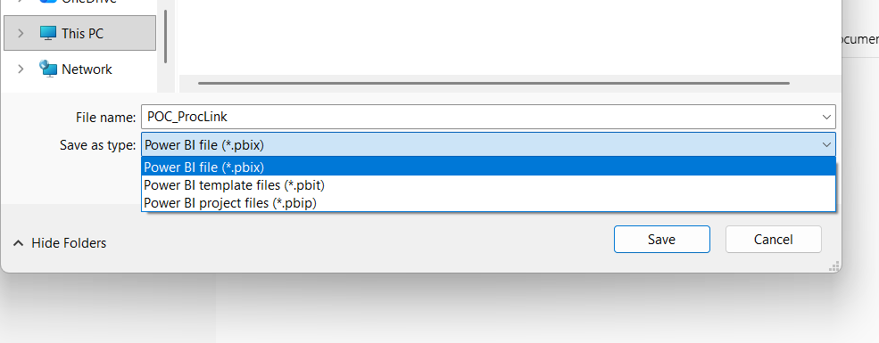
Git vs GitHub: What Is Actually Required?
A common point of confusion is whether we need Git, GitHub, or both. They are two different things, and understanding the difference matters when setting up the team:
• Git (required). Git is the version control software itself. It runs locally on each developer's machine and is the engine that actually tracks changes, records commits, creates branches, and merges work together. Without Git there is no version control – it is always required.
• GitHub (required for teamwork). GitHub is a cloud service that hosts a shared copy of the Git repository (the “remote” or “origin”). It is what allows multiple team members to push, pull, and review each other's work, and it acts as the central backup. Git alone is enough for a single developer working locally, but for a team a shared remote such as GitHub is essential. (Azure DevOps, GitLab, or Bitbucket can play the same role.)
• GitHub Desktop (optional, recommended). GitHub Desktop is only a user-friendly interface on top of Git. Importantly, installing GitHub Desktop installs Git automatically, so no separate Git installation is needed when using it. Developers who prefer Visual Studio, VS Code, or the command line must install Git separately from git-scm.com.
Component | What It Is | Where It Runs | Required?
Git | The version control engine – tracks changes, commits, branches, merges. | Locally, on each developer's machine | Yes – always
GitHub | Cloud hosting of the shared repository; enables collaboration, pull requests, backup. | Cloud (github.com) | Yes, for team collaboration
GitHub Desktop | Graphical interface for Git; bundles Git inside its installer. | Locally | Optional – easiest option
Git Bash / command line | Terminal interface to Git for advanced users. | Locally | Optional
VS Code / Visual Studio | Editors with built-in Git support (Git must be installed). | Locally | Optional
In short: Git does the version control; GitHub makes team collaboration possible. In practice we need both – GitHub Desktop conveniently provides them together.
Prerequisites – What Each Team Member Needs
• Power BI Desktop (latest version) with the Power BI Project (.pbip) save option enabled.
• GitHub Desktop (includes Git), or Git installed separately if using VS Code / command line.
• A GitHub account, added as a collaborator to the team repository (or team organisation).
• Access permissions agreed: who can merge to the main branch, who reviews changes.

Transitioning to Power BI Project (.pbip)
The primary enabler of modern version control is the .pbip file format. This format separates the report's metadata from the data itself, saving definitions in a text-formatted JSON structure.
Enabling the Feature
To utilize this format, users must enable it within Power BI Desktop:
- Navigate to File > Options and settings > Options.
- Select Preview features.
- Check the box for Power BI Project (.pbip) save option.
- Restart Power BI Desktop.

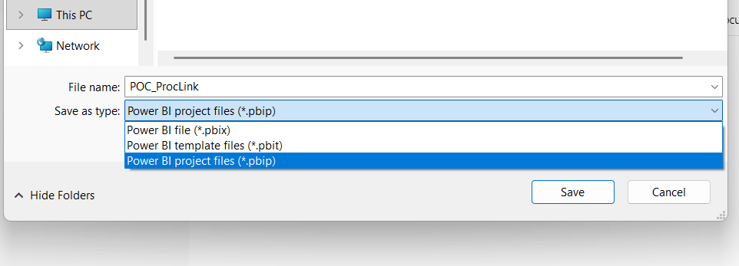Project File Structure
When a report is saved as a .pbip file, Power BI creates a folder containing several distinct components rather than a single file:
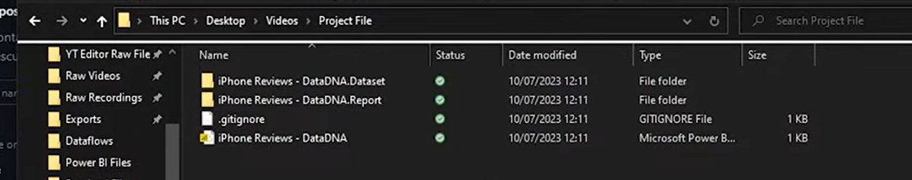
Inside of dataset folder:
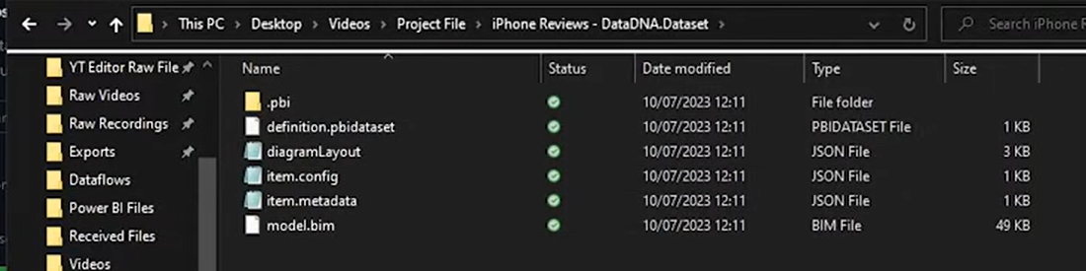

Component | Description
. pbip File | The core project file used to open the report in Power BI Desktop.
Dataset Folder | Contains the data model definitions.
. bim File | Located in the Dataset folder; stores all measures and calculations in a readable JSON format.
Report Folder | Stores the visual and layout definitions of the report.

Implementing Git-Based Version Control
With the report definitions now in text format, developers can use GitHub to track every modification. The following workflow outlines the standard practice for managing these files.
1. Tool Selection
While several tools exist for version control, the following are common options:
- GitHub Desktop: Recommended for its user-friendly interface and ease of tracking local directory changes.
- Visual Studio: Offers native Git integration.
- Git Bash: A terminal-based tool for users who prefer command-line interfaces.
2. Creating a Repository
To begin, the developer must initialize a Git repository within the project folder. This process links the local file directory to GitHub, allowing the software to monitor changes. An "initial commit" is typically performed to capture the baseline state of all files in the project.

We want to able to commit and publish all of the changes into our repository and give us the ability to revert any of the changes that we made to previous versions so these three would be key things that will benefits us when we are developing Bi reports.

Link: - GitHub
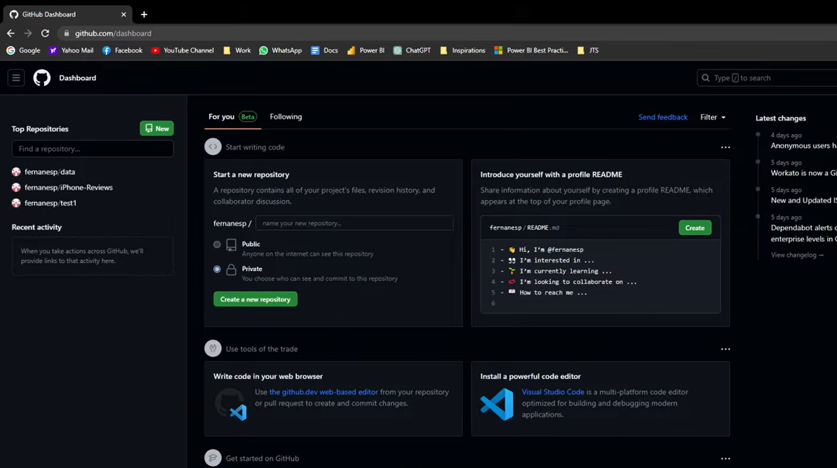
Create New Repository:
GitHub Desktop.
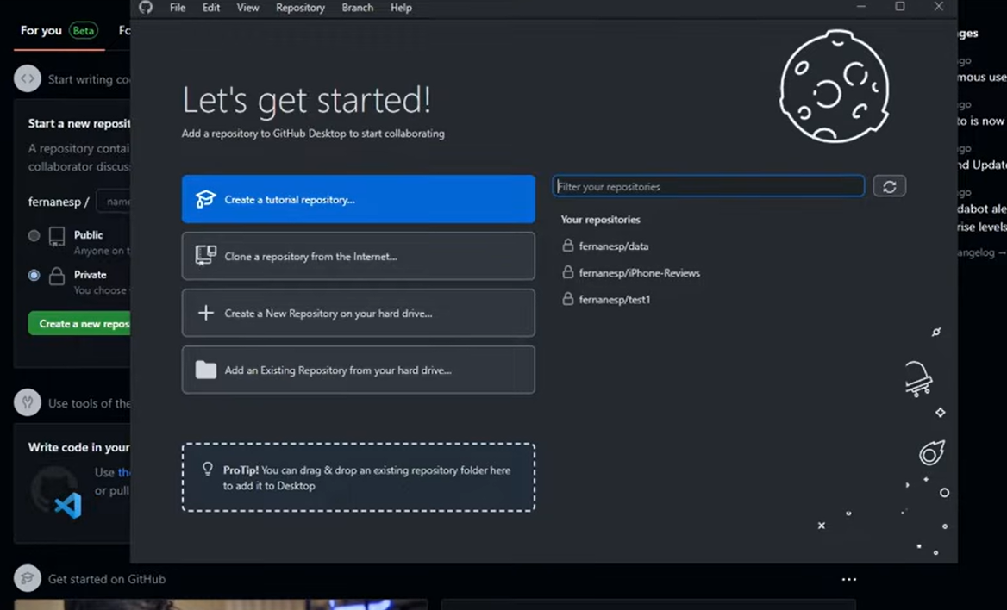
If we have an Existing Repository, click the “Add an Existing Repository” File.
And it open up “add local repository” for local path.
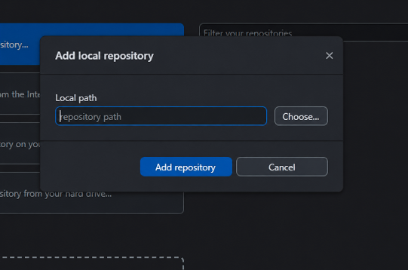
And choose the local path, in existing project file and click open.
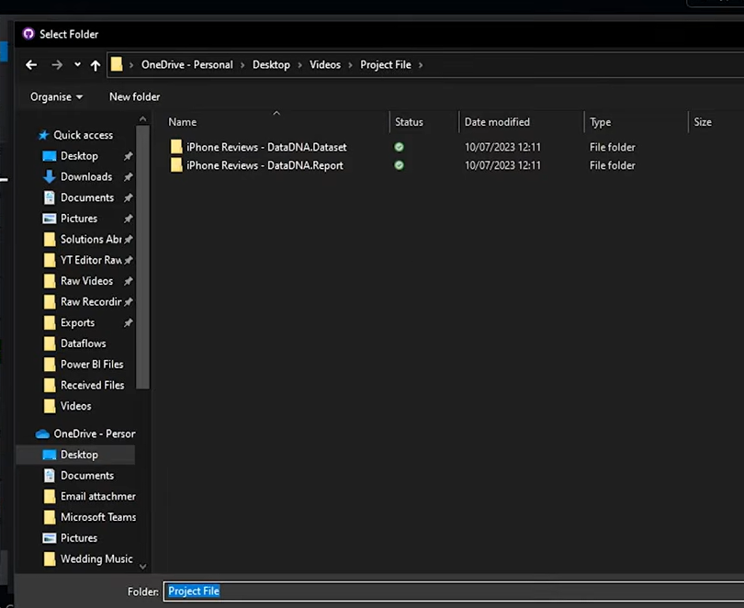
Here after give a name of new repository, check the local path and click the “Create repository”
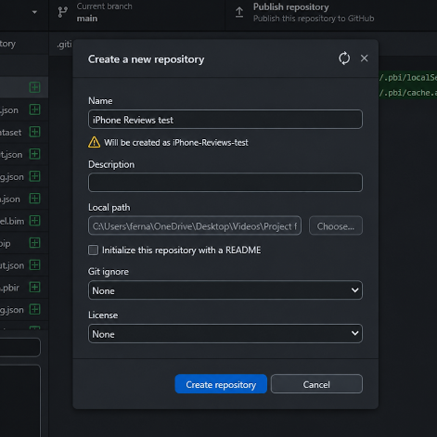
Here after, comes to desktop and click the “Publish Repository”
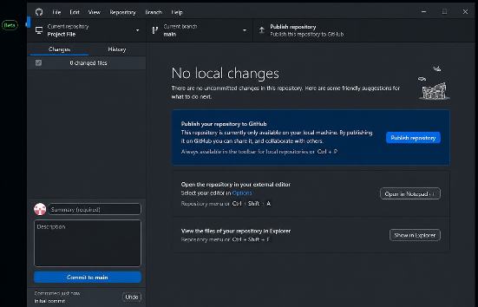
And write the name of repository. And publish again.
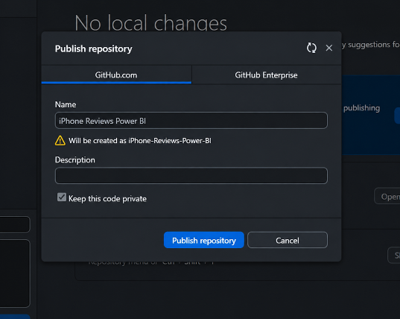
Now going to click “View on GitHub” in desktop
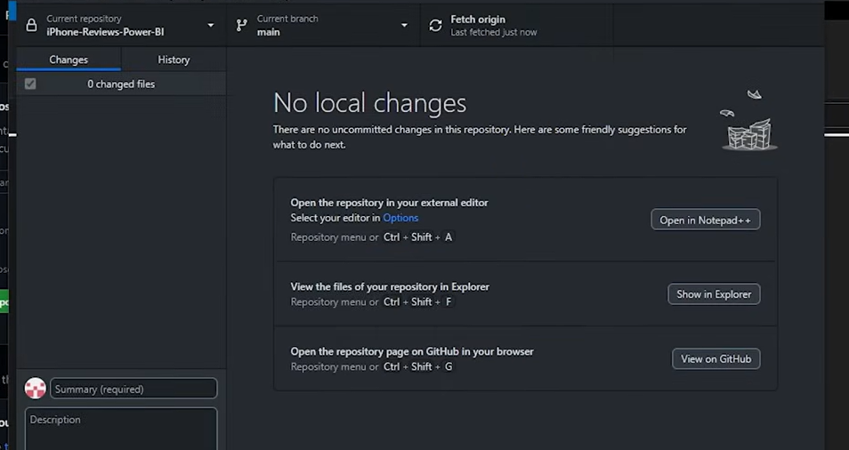
And which will open that repository that will be created. Now that have the version control setup have done the first commits
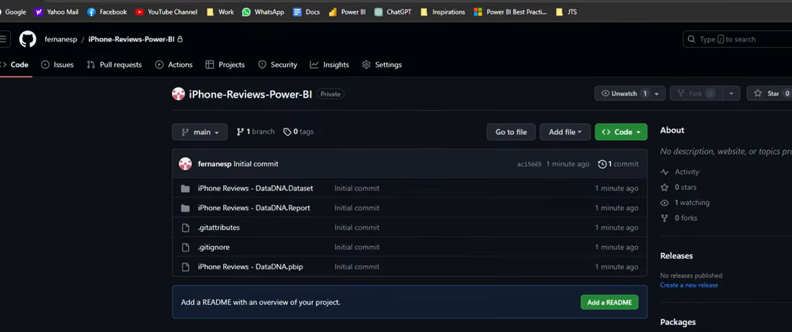
Tracking Changes and Committing
When changes are made (e.g., adding a new DAX measure), Power BI Update the corresponding JSON files (such as the .bim file).
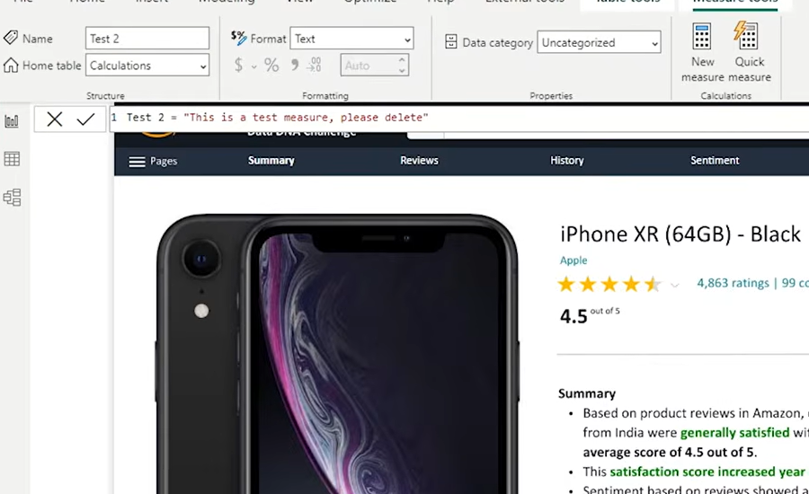
Visual Tracking: GitHub Desktop highlights changes, showing the "before" and "after" states of the code. New additions are typically highlighted in green.
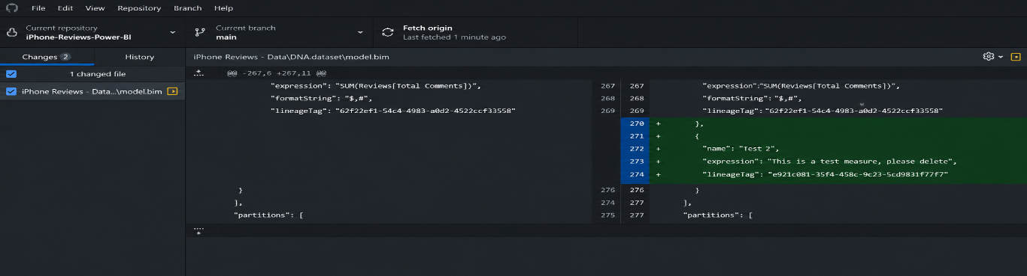
That is sort of version control is allow us do to it lets us track those individual changes within our either model or within our report

Committing: A "commit" is a snapshot of the code at a specific point in time. Developers should provide a concise title and a verbose description of the changes to assist other collaborators in understanding the project's evolution.
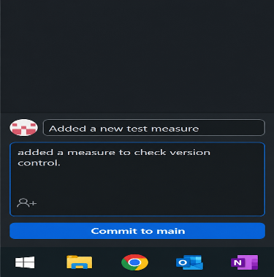
After hit the Commit to main_
Pushing to Origin: After committing locally, the developer "pushes" the changes to the remote repository (GitHub.com) to update the central version of the project.
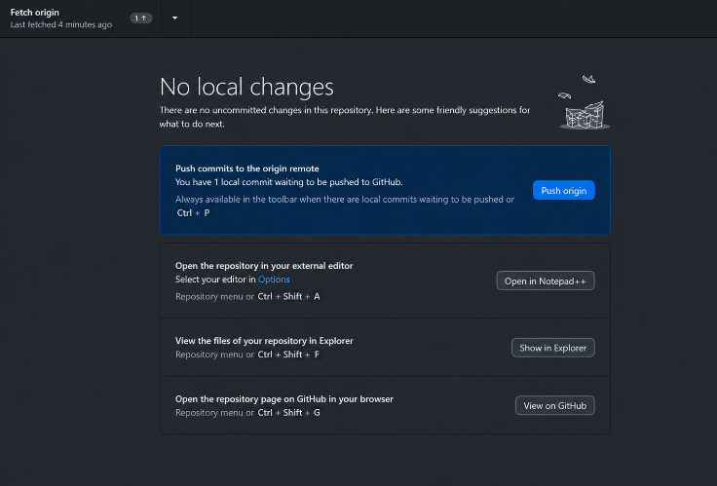
And hit the Push origin, after go to View on GitHub, see that change that we have made is showing up now here in this folder and this is where we have updated so this is the title of the change the we have created and these are from the initial command so these haven’t changed since we did first initial commit
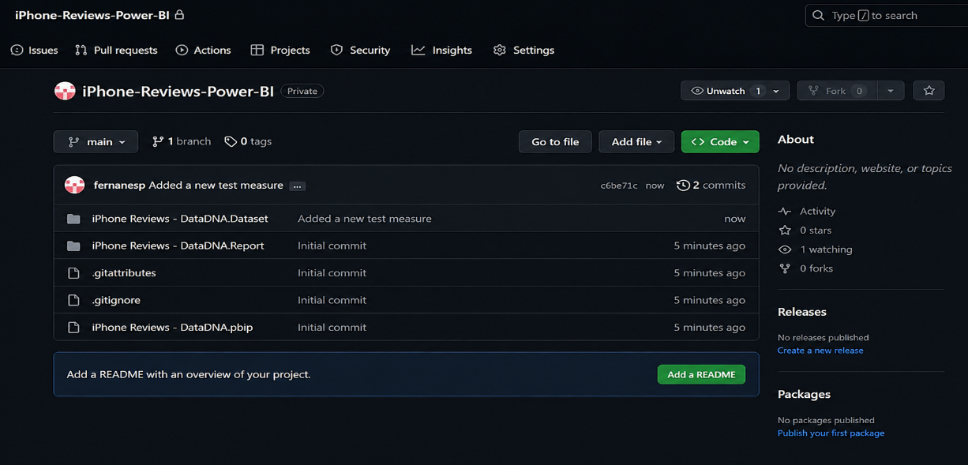
Reverting Changes
One of the most critical benefits of this system is the ability to undo errors or accidental deletions.
- Example: If the main .pbip file is accidentally deleted in local file, the developer can navigate to the History tab in GitHub Desktop.
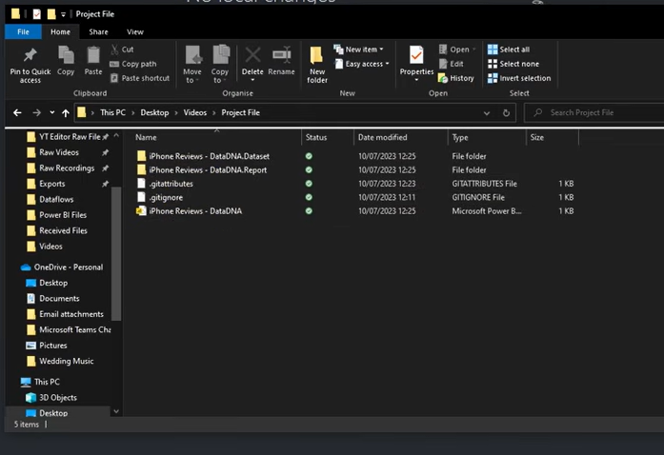
In our GitHub Desktop it shows red which means that file has been deleted.
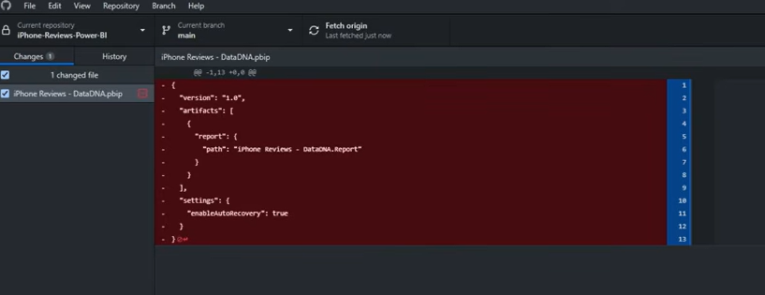
And check the GitHub repository also deleted this .pbip file, before we follow the commit to main and write description and push the origin for deleting .pbip file.
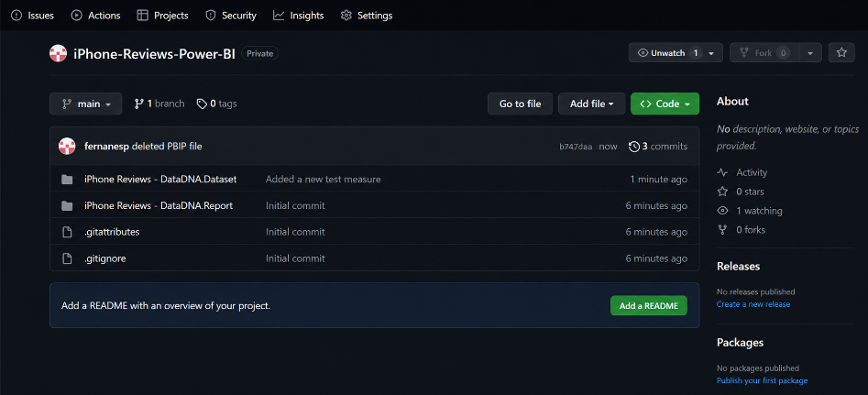

- Reversion: By right clicking a previous commit and selecting "Revert changes in commit," the software automatically restores the missing files to the local directory.
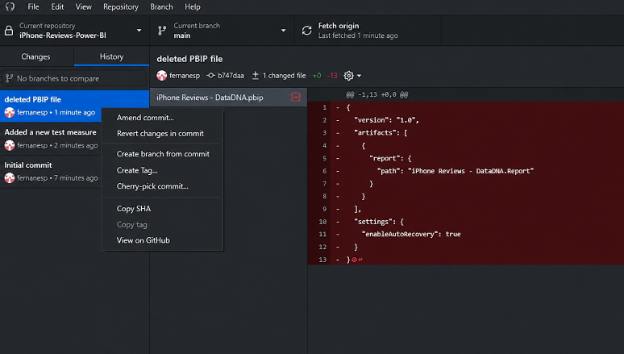
After it will create a new version where it restored that file that you have deleted into your local folder.
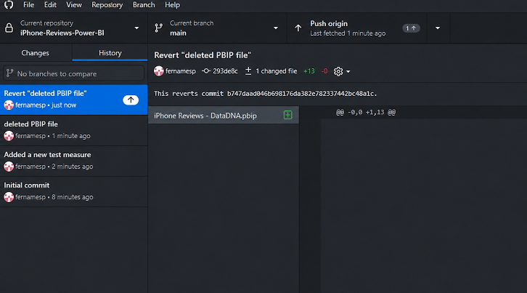
In Local file also revert the .pbip file.
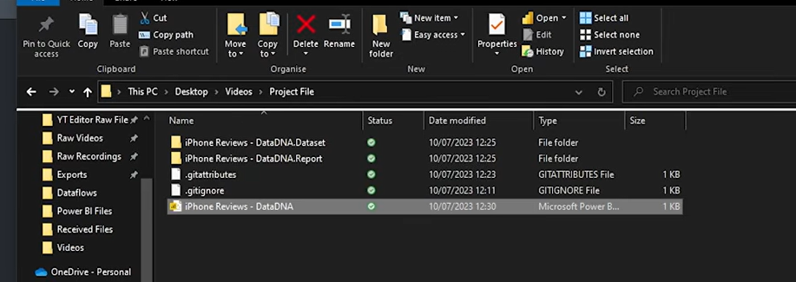
- Synchronization: Pushing the revert commit to GitHub ensures the remote repository is also restored.
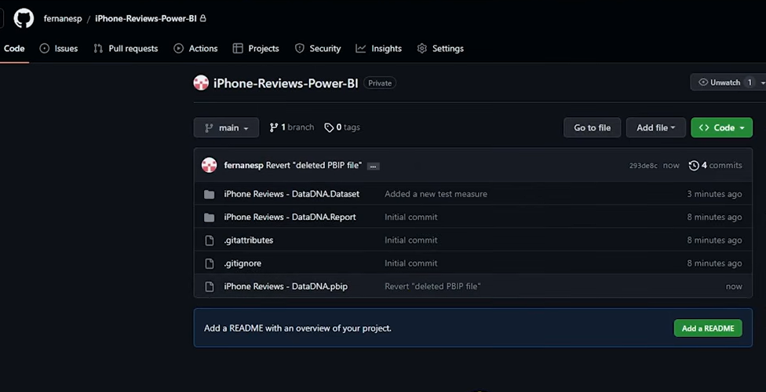
Working in a Team: Version Control with Multiple Developers
The workflow described so far covers a single developer committing directly to the main branch. With multiple team members this is not safe: two people pushing to the same branch will run into each other's changes, and the last push can overwrite completed work. Team-based version control relies on three mechanisms: branches, pull requests, and merge conflict resolution.
1. The Golden Rule: Nobody Works Directly on Main
The main branch should always contain the latest working, production-ready version of the report. Each developer does their work on a separate branch (an isolated copy of the project), and changes only reach main through a reviewed pull request. This is the standard practice in software teams and works identically for Power BI projects.
2. Step-by-Step Team Workflow (GitHub Desktop)
Step | Action | How (GitHub Desktop) | Purpose
1. Update | Pull the latest main branch before starting any work. | Fetch origin → Pull origin | Start from the newest version; avoids conflicts later.
2. Branch | Create a personal branch for the task. | Branch menu → New Branch (e.g. feature/sales-kpi, fix/date-filter) | Isolates your work from everyone else's.
3. Develop | Open the .pbip in Power BI Desktop, make changes, save. | Power BI Desktop updates the project's text files. | Normal report development.
4. Commit | Commit changes with a clear title and description. | Summary + Description → Commit to <branch> | Records a snapshot of your work.
5. Push | Publish the branch to GitHub. | Publish branch / Push origin | Makes your branch visible to the team (and backs it up).
6. Pull Request | Open a pull request from your branch into main. | Branch menu → Create Pull Request (opens github.com) | Requests that your changes be merged.
7. Review | A teammate reviews the changes – DAX and layout changes are visible line by line. | Files changed tab on github.com; comment / approve | Quality control; catches mistakes before production.
8. Merge | After approval, merge the pull request and delete the branch. | Merge pull request button on github.com | Your work becomes part of main.
9. Sync | Everyone pulls the updated main before their next task. | Switch to main → Pull origin | Keeps the whole team on the same version.

3. Handling Merge Conflicts
A merge conflict happens when two developers change the same lines of the same file – for example, both edit the same DAX measure or the same visual. Git cannot decide which change is correct, so it asks a human to choose.
• How it appears: when merging or pulling, GitHub Desktop flags the conflicted files and offers to open them in an editor. Inside the file, both versions are shown between conflict markers (<<<<<<< / ======= / >>>>>>>).
• How to resolve: open the file, keep the correct version (or combine both), remove the conflict markers, save, and commit the merge. For model files, tools such as VS Code or ALM Toolkit make the comparison easier. After resolving, open the report in Power BI Desktop to confirm it still loads correctly before pushing.
• How to prevent most conflicts: partition the work – avoid two people editing the same report page or the same table/measure group at the same time; agree ownership in stand-ups; keep branches short-lived and merge small changes frequently instead of letting branches drift for weeks; keep the shared dataset (semantic model) and thin reports in separate projects so model work and report work do not collide.
4. Protecting the Main Branch (Governance)
GitHub can enforce the team workflow so it does not depend on discipline alone. In the repository: Settings → Branches → Add branch protection rule for main:
• Require a pull request before merging – blocks direct pushes to main.
• Require at least one approval – every change is reviewed by a second person.
• Add team members as collaborators with appropriate roles (Write for developers, Maintain/Admin for leads).
5. Team Conventions and Repository Hygiene
• Always pull before you start working – never build on an outdated copy.
• Commit small and often, with meaningful messages (“Add YoY Sales measure”, not “updates”).
• One report/project per folder; keep the repository structure flat and predictable.
• Add a .gitignore so local cache files and any data files are never committed (e.g. *.pbix backups, .pbi/localSettings.json, cache.abf, unsaved data folders). Never commit credentials or business data.
• Tag releases (e.g. v1.4.0) so the team knows exactly which commit is in production.
6. Beyond GitHub Desktop: Workspace-Level Integration (Optional Next Step)
For larger teams, Microsoft Fabric offers Git integration at the workspace level: a Power BI workspace is connected directly to a branch in GitHub or Azure DevOps, so whatever is deployed in the workspace always corresponds to a known commit. Combined with deployment pipelines (Dev → Test → Prod), this gives a fully governed release process. Note that this requires Fabric capacity or Premium Per User licensing, whereas everything described above works with free tooling.

Current Limitations
While Power BI Projects significantly improve development workflows, there are currently known limitations:
- Sensitivity Labels: These are not supported within the .pbip file format at this time.
- Feature Maturity: As a preview feature, the project format is subject to ongoing updates and potential changes in functionality.

• Merge conflicts still require humans: the text format makes merging possible, not automatic – when two people change the same measure or visual, someone must resolve it manually.
• Data is not versioned: version control tracks definitions (model, queries, layout), not the data itself. Reverting restores logic, not last month's numbers.
• Noisy report diffs: without the enhanced report format (PBIR), the report layout is stored as one large report.json file, which makes changes hard to review. Enabling the PBIR preview feature stores each page and visual as its own small file.
• Not everything is covered: classic dashboards, gateway bindings, subscriptions, and app configurations are not part of the project files and must be managed separately.
Summary
Git provides the version control engine and GitHub provides the shared, central repository – together with the .pbip format they give Power BI development the same safety net as professional software development: full history, visible diffs of DAX and visuals, safe parallel work on branches, peer-reviewed pull requests, and one-click recovery of any previous version. The single most important team rule is that nobody commits directly to main: every change travels through a branch and a reviewed pull request.

