CLIENT PRESENTATION

Power BI Q&A
Natural-Language Analytics for Business Users
Ask questions in plain English · Get instant visuals · No coding
Prepared for: [Client Name]
Prepared by: Analytics Advisory Team
Date: July 2026

Contents

1. What is Power BI Q&A?
Power BI Q&A is a built-in feature that lets users ask questions about their data in plain, everyday language — such as “what are total sales by region” — and instantly get the answer as a chart or table. It behaves like a chatbot search box sitting directly inside the report: the user types a question, and Power BI interprets it, chooses the right visual, and displays the result in real time.
It requires no DAX, no data-modelling knowledge, and no report-building skills from the person asking. Q&A is available on Power BI Pro at no additional cost, which makes it the fastest way to give business users a self-service, conversational way to explore their data.
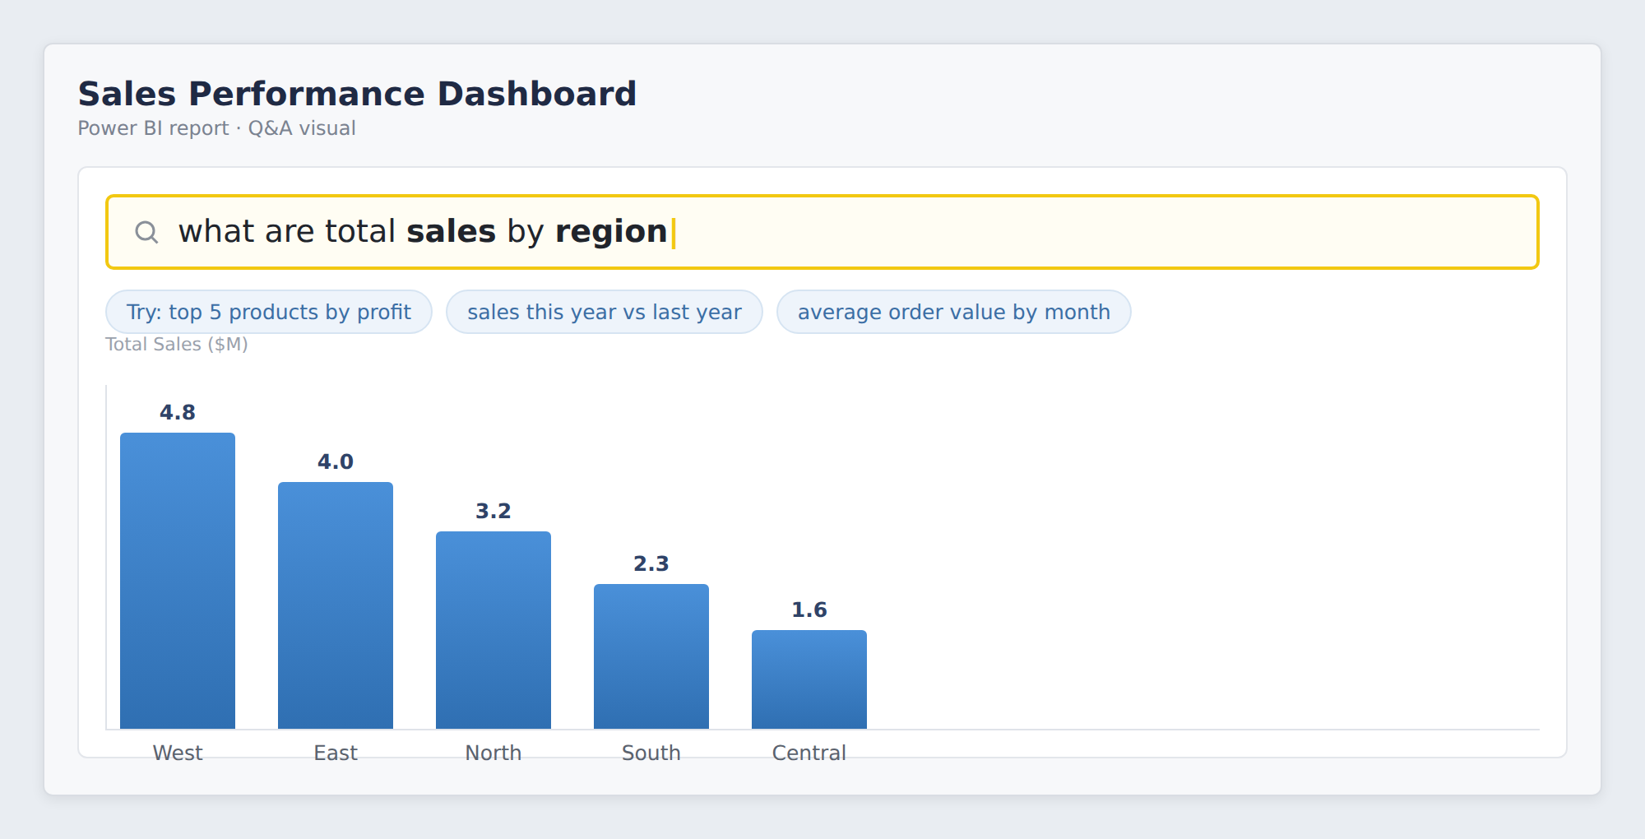
Figure 1. The Q&A visual inside a report — a user types a plain-language question and gets an instant chart (illustrative).

2. How Q&A is Useful to Business Users
- Plain-language self-service: users ask questions the way they speak — no technical training needed.
- Instant answers: results appear immediately, with no waiting in a report-request queue.
- Guided by suggestions: as users type, Q&A auto-completes and suggests valid questions, so they always get a usable answer.
- Right visual, automatically: Q&A picks the most suitable chart (bar, line, map, card) for the question asked.
- Trusted, governed data: answers come from the same certified dataset everyone else uses — one version of the truth.
- Available on Pro: no premium capacity required — it is included in the standard Power BI Pro licence.
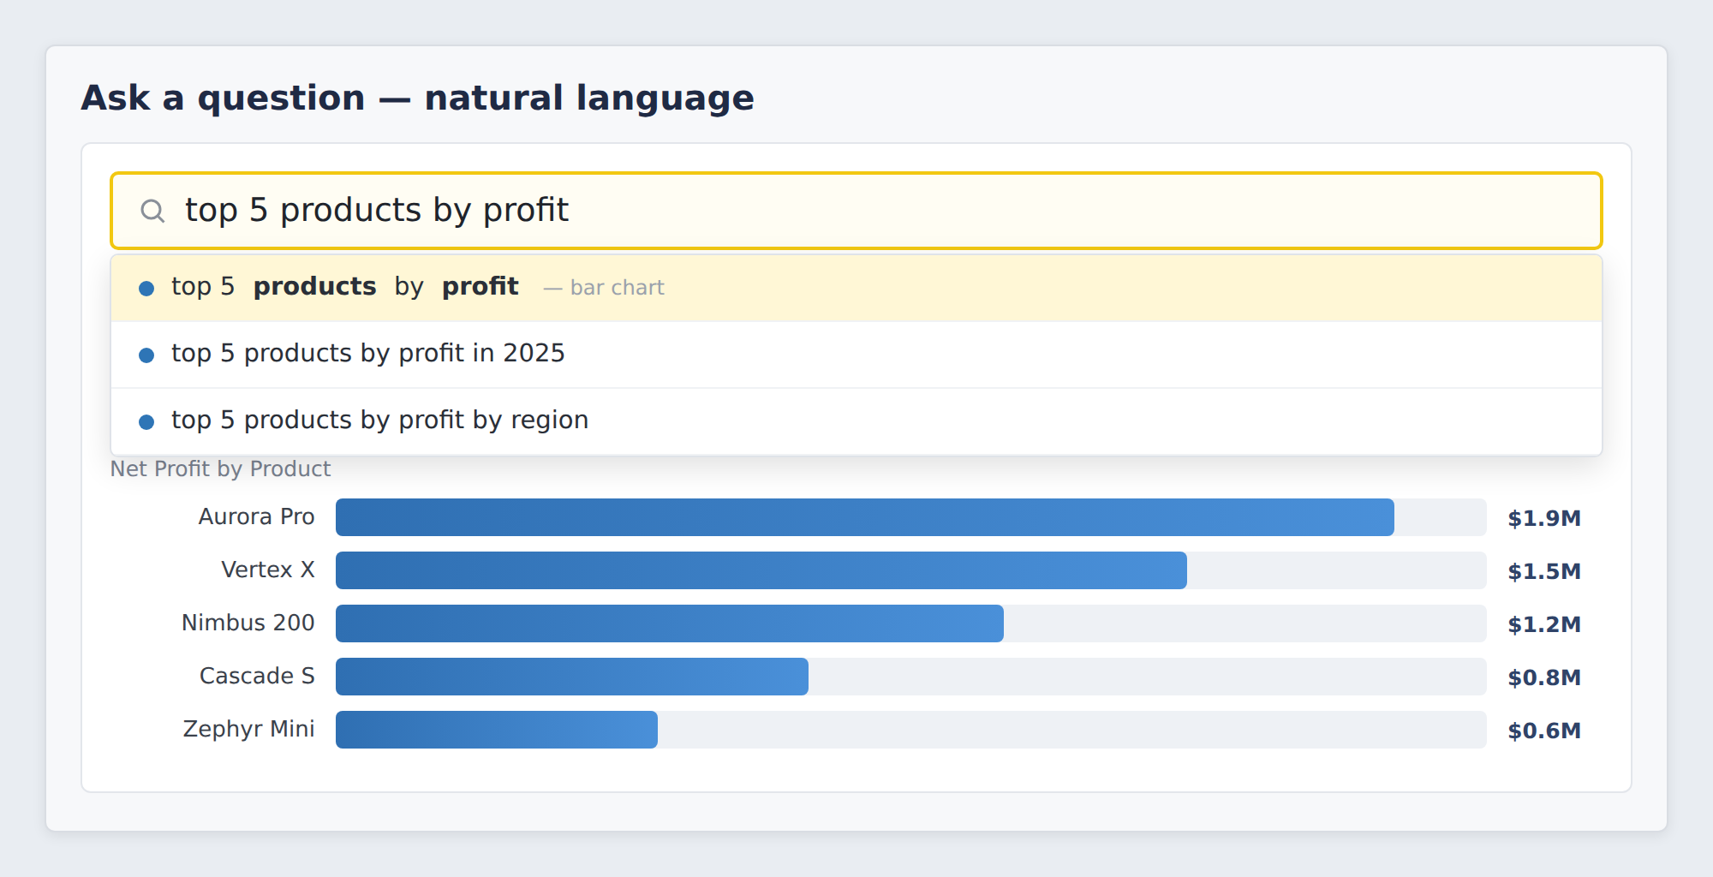
Figure 2. Q&A suggests and auto-completes questions as the user types, then renders the matching visual (illustrative).

3. How to Enable Q&A
Enabling Q&A takes only a few minutes in Power BI Desktop. The steps below add the Q&A visual to a report and tune it so answers match the language your business users actually use.

3.1 Add the Q&A visual
- — Open your report in Power BI Desktop and select the page where you want the Q&A box.
- — On the ribbon, go to the Insert tab and click Q&A (in the AI visuals group).
- — A question box is placed on the canvas. Resize and position it like any other visual.
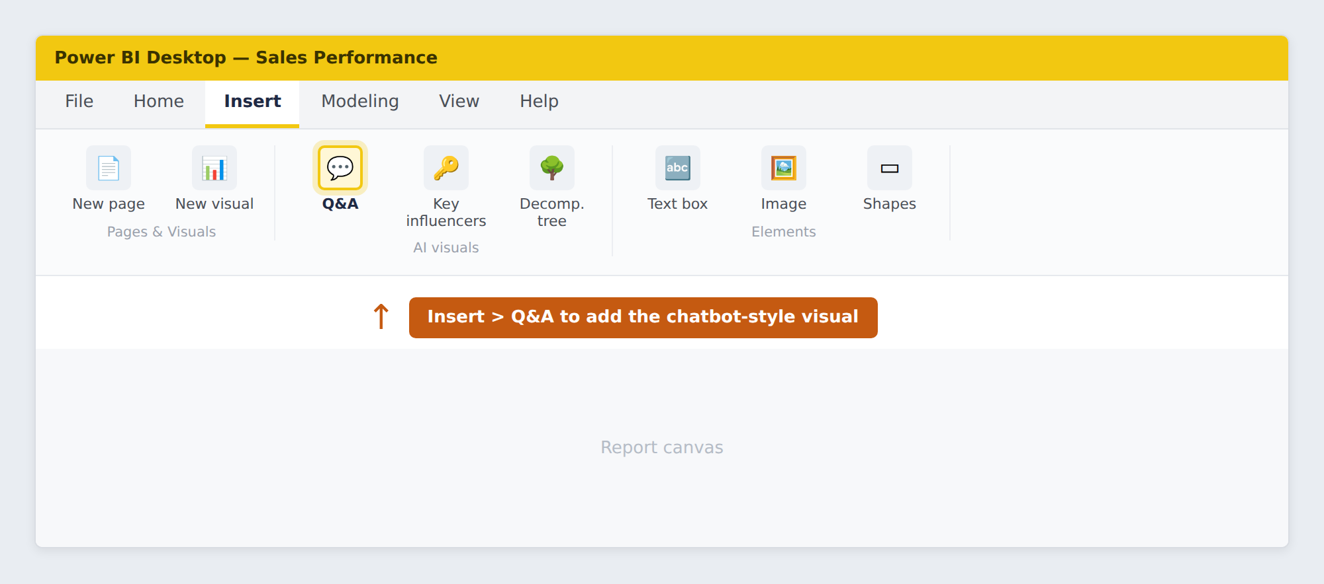
Figure 3. Insert ▸ Q&A adds the natural-language visual to the report canvas (illustrative).

3.2 Tune Q&A so answers are accurate
To make sure Q&A understands business terms, the report author uses Q&A setup (Modeling ▸ Q&A setup):
- Synonyms: map business words to fields — e.g. “revenue”, “turnover” and “sales” all mean Sales Amount.
- Teach Q&A: resolve any phrase Q&A did not understand, so it learns your terminology.
- Review questions: see what users are asking and improve coverage over time.
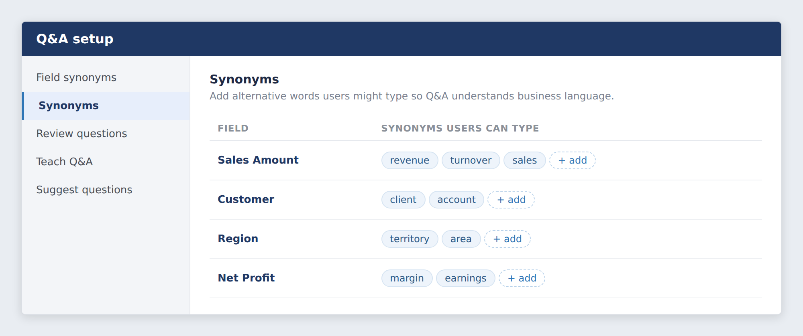
Figure 4. Q&A setup — adding synonyms so Q&A understands the terms your users type (illustrative).

3.3 Publish and share
- Publish: publish the report to the Power BI Service.
- Share: anyone with a Pro licence and access to the report can use Q&A immediately — no extra setup on their side.
Licensing note
The Q&A visual works on Power BI Pro at no extra cost. It is different from Copilot (generative AI), which requires a paid Fabric or Premium capacity. For most Pro customers, Q&A delivers conversational, natural-language analytics without any upgrade.

4. How Q&A Reduces Manual Effort
Q&A removes a large share of the routine, repetitive work that surrounds day-to-day reporting — for both the business users and the analytics team.

Manual effort today | With Q&A | Result
Raising a ticket and waiting for a new report | User just types the question and gets the answer | No wait, no ticket
Analysts building one-off reports on request | Users self-serve common questions | Analyst time freed
Hunting through dashboards for a number | Ask directly and get the exact figure | Seconds, not minutes
Exporting to Excel to slice differently | Re-ask the question a new way | No manual re-work
Training users on how to build visuals | Users type in plain English | Little/no training

The net effect: business users become self-sufficient for everyday questions, and skilled analysts stop spending their time on low-value, repetitive report requests — redirecting it to deeper analysis.
Typical outcome
Teams that roll out Q&A commonly cut a large portion of ad-hoc report requests to the BI team, because users answer routine questions themselves — often reducing report-request volume by 30–50%.

5. Summary & Recommendation
- Useful: gives every business user a plain-language, chatbot-style way to explore trusted data.
- Easy to enable: added from the Insert tab in minutes and tuned with synonyms; works on Power BI Pro.
- Reduces manual effort: users self-serve, ad-hoc report requests fall, and analysts focus on higher-value work.
- No extra cost: included in the Pro licence — no Premium or Fabric capacity required to start.

Recommendation
Enable the Q&A visual on your most-used reports now as a fast, zero-cost win. Invest a short session in configuring synonyms and Teach Q&A so answers match your business language — this is what makes adoption stick.

Ask a question. Get an answer. No waiting, no coding.

Note: The figures in this document are illustrative representations of the Power BI Q&A experience created for this presentation; the live interface may vary by version.

