## Save

### SoftPLC

*Server.go* : on écrit la variable **savedJson**

Remarque : on ne peut que save une configuration qui est effacé si on ferme le programme

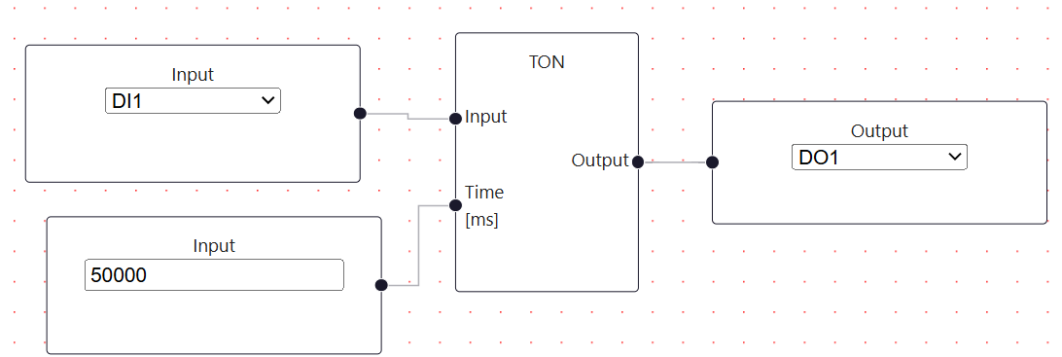

**CMD :**

*OutputNodes:*

*&{8 digitalOutput [{ DO1 {0xc00032a090 Input bool}}]}*

*LogicalNode:*

*&{4 OrNode [{0xc00014e138 Input0 bool} {0xc00014e180 Input1 bool}] [{0 Output bool}]}*

*&{6 TONNode [{0xc00032a0f0 Input bool} {0xc00031cfd8 Time [ms] value}] [{0 Output bool}] {<nil> false} false 0 false}*

*InputNodes:*

*&{0 digitalInput [{ DI1 {0xc00014e138 Output bool}}]}*

*&{5 digitalInput [{ DI2 {0xc00014e180 Output bool}}]}*

*&{7 constantInput [{ {0xc00031cfd8 Output value}}]}*

*Const:*

*{7 5000}*

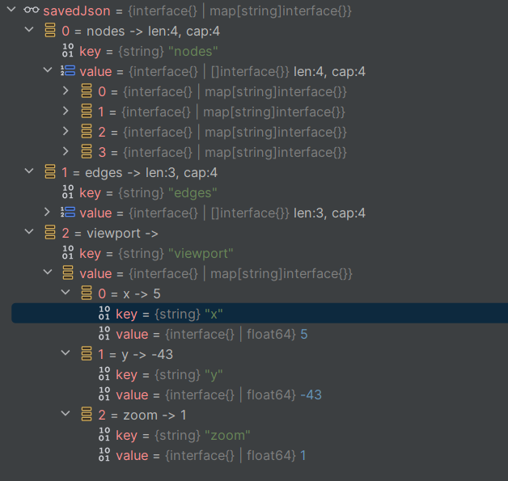

## Ajout de fonction TOF

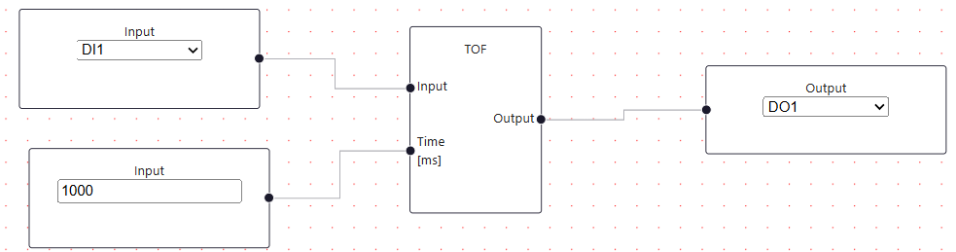

{  
 "edges": [  
 {  
 "id": "reactflow__edge-2Output-0Input",  
 "source": "2",  
 "sourceHandle": "Output",  
 "target": "0",  
 "targetHandle": "Input",  
 "type": "step"  
 },  
 {  
 "id": "reactflow__edge-0Output-3Input",  
 "source": "0",  
 "sourceHandle": "Output",  
 "target": "3",  
 "targetHandle": "Input",  
 "type": "step"  
 },  
 {  
 "id": "reactflow__edge-4Output-0Time [ms]",  
 "source": "4",  
 "sourceHandle": "Output",  
 "target": "0",  
 "targetHandle": "Time [ms]",  
 "type": "step"  
 }  
 ],  
 "nodes": [  
 {  
 "data": {  
 "accordion": "Timer",  
 "display": "Tof Node",  
 "id": "0",  
 "inputHandle": [  
 {  
 "dataType": "bool",  
 "name": "Input"  
 },  
 {  
 "dataType": "value",  
 "name": "Time [ms]"  
 }  
 ],  
 "label": "TOF",  
 "outputHandle": [  
 {  
 "dataType": "bool",  
 "name": "Output"  
 }  
 ],  
 "primaryType": "LogicalNode",  
 "selectedFriendlyNameData": "",  
 "selectedServiceData": "",  
 "selectedSubServiceData": "",  
 "services": [],  
 "stretchable": false,  
 "subServices": [],  
 "type": "TOFNode",  
 "valueData": ""  
 },  
 "dragging": false,  
 "height": 172,  
 "id": "0",  
 "position": {  
 "x": 791,  
 "y": 275  
 },  
 "positionAbsolute": {  
 "x": 791,  
 "y": 275  
 },  
 "selected": false,  
 "type": "LogicalNode",  
 "width": 122  
 },  
 {  
 "data": {  
 "accordion": "Input",  
 "dataType": "",  
 "display": "Digital Input",  
 "id": "2",  
 "inputHandle": [],  
 "label": "Input",  
 "outputHandle": [  
 {  
 "dataType": "bool",  
 "name": "Output"  
 }  
 ],  
 "primaryType": "inputNode",  
 "selectedFriendlyNameData": "",  
 "selectedServiceData": "DI1",  
 "selectedSubServiceData": "",  
 "services": [  
 {  
 "friendlyName": "",  
 "nameServices": [  
 "DI1",  
 "DI2",  
 "DI3",  
 "DI4",  
 "DI5",  
 "DI6",  
 "DI7",  
 "DI8"  
 ]  
 }  
 ],  
 "stretchable": false,  
 "subServices": [],  
 "type": "digitalInput",  
 "valueData": ""  
 },  
 "dragging": false,  
 "height": 92,  
 "id": "2",  
 "position": {  
 "x": 432,  
 "y": 259  
 },  
 "positionAbsolute": {  
 "x": 432,  
 "y": 259  
 },  
 "selected": false,  
 "type": "inputNode",  
 "width": 222  
 },  
 {  
 "data": {  
 "accordion": "Output",  
 "dataType": "",  
 "display": "Digital output",  
 "id": "3",  
 "inputHandle": [  
 {  
 "dataType": "bool",  
 "name": "Input"  
 }  
 ],  
 "label": "Output",  
 "outputHandle": [],  
 "primaryType": "outputNode",  
 "selectedFriendlyNameData": "",  
 "selectedServiceData": "DO1",  
 "selectedSubServiceData": "",  
 "services": [  
 {  
 "friendlyName": "",  
 "nameServices": [  
 "DO1",  
 "DO2",  
 "DO3",  
 "DO4"  
 ]  
 }  
 ],  
 "stretchable": false,  
 "subServices": [],  
 "type": "digitalOutput",  
 "valueData": ""  
 },  
 "dragging": false,  
 "height": 82,  
 "id": "3",  
 "position": {  
 "x": 1063,  
 "y": 311  
 },  
 "positionAbsolute": {  
 "x": 1063,  
 "y": 311  
 },  
 "selected": false,  
 "type": "outputNode",  
 "width": 222  
 },  
 {  
 "data": {  
 "accordion": "Constant",  
 "dataType": "",  
 "display": "Constant value",  
 "id": "4",  
 "inputHandle": [],  
 "label": "Input",  
 "outputHandle": [  
 {  
 "dataType": "value",  
 "name": "Output"  
 }  
 ],  
 "primaryType": "inputNode",  
 "selectedFriendlyNameData": "",  
 "selectedServiceData": "",  
 "selectedSubServiceData": "",  
 "services": [],  
 "stretchable": false,  
 "subServices": [],  
 "type": "constantInput",  
 "valueData": "1000"  
 },  
 "dragging": false,  
 "height": 92,  
 "id": "4",  
 "position": {  
 "x": 441,  
 "y": 387  
 },  
 "positionAbsolute": {  
 "x": 441,  
 "y": 387  
 },  
 "selected": false,  
 "type": "inputNode",  
 "width": 222  
 }  
 ],  
 "viewport": {  
 "x": 0,  
 "y": 0,  
 "zoom": 1  
 }  
}

},  
 {  
 "dataType": "value",  
 "name": "Time [ms]"  
 }  
 ],  
 "label": "TOF",  
 "outputHandle": [  
 {  
 "dataType": "bool",  
 "name": "Output"  
 }  
 ],  
 "primaryType": "LogicalNode",  
 "selectedFriendlyNameData": "",  
 "selectedServiceData": "",  
 "selectedSubServiceData": "",  
 "services": [],  
 "stretchable": false,  
 "subServices": [],  
 "type": "TOFNode",  
 "valueData": ""  
 },  
 "dragging": false,  
 "height": 172,  
 "id": "0",  
 "position": {  
 "x": 791,  
 "y": 275  
 },  
 "positionAbsolute": {  
 "x": 791,  
 "y": 275  
 },  
 "selected": false,  
 "type": "LogicalNode",  
 "width": 122  
 },  
 {  
 "data": {  
 "accordion": "Input",  
 "dataType": "",  
 "display": "Digital Input",  
 "id": "2",  
 "inputHandle": [],  
 "label": "Input",  
 "outputHandle": [  
 {  
 "dataType": "bool",  
 "name": "Output"  
 }  
 ],  
 "primaryType": "inputNode",  
 "selectedFriendlyNameData": "",  
 "selectedServiceData": "DI1",  
 "selectedSubServiceData": "",  
 "services": [  
 {  
 "friendlyName": "",  
 "nameServices": [  
 "DI1",  
 "DI2",  
 "DI3",  
 "DI4",  
 "DI5",  
 "DI6",  
 "DI7",  
 "DI8"  
 ]  
 }  
 ],  
 "stretchable": false,  
 "subServices": [],  
 "type": "digitalInput",  
 "valueData": ""  
 },  
 "dragging": false,  
 "height": 92,  
 "id": "2",  
 "position": {  
 "x": 432,  
 "y": 259  
 },  
 "positionAbsolute": {  
 "x": 432,  
 "y": 259  
 },  
 "selected": false,  
 "type": "inputNode",  
 "width": 222  
 },  
 {  
 "data": {  
 "accordion": "Output",  
 "dataType": "",  
 "display": "Digital output",  
 "id": "3",  
 "inputHandle": [  
 {  
 "dataType": "bool",  
 "name": "Input"  
 }  
 ],  
 "label": "Output",  
 "outputHandle": [],  
 "primaryType": "outputNode",  
 "selectedFriendlyNameData": "",  
 "selectedServiceData": "DO1",  
 "selectedSubServiceData": "",  
 "services": [  
 {  
 "friendlyName": "",  
 "nameServices": [  
 "DO1",  
 "DO2",  
 "DO3",  
 "DO4"  
 ]  
 }  
 ],  
 "stretchable": false,  
 "subServices": [],  
 "type": "digitalOutput",  
 "valueData": ""  
 },  
 "dragging": false,  
 "height": 82,  
 "id": "3",  
 "position": {  
 "x": 1063,  
 "y": 311  
 },  
 "positionAbsolute": {  
 "x": 1063,  
 "y": 311  
 },  
 "selected": false,  
 "type": "outputNode",  
 "width": 222  
 },  
 {  
 "data": {  
 "accordion": "Constant",  
 "dataType": "",  
 "display": "Constant value",  
 "id": "4",  
 "inputHandle": [],  
 "label": "Input",  
 "outputHandle": [  
 {  
 "dataType": "value",  
 "name": "Output"  
 }  
 ],  
 "primaryType": "inputNode",  
 "selectedFriendlyNameData": "",  
 "selectedServiceData": "",  
 "selectedSubServiceData": "",  
 "services": [],  
 "stretchable": false,  
 "subServices": [],  
 "type": "constantInput",  
 "valueData": "1000"  
 },  
 "dragging": false,  
 "height": 92,  
 "id": "4",  
 "position": {  
 "x": 441,  
 "y": 387  
 },  
 "positionAbsolute": {  
 "x": 441,  
 "y": 387  
 },  
 "selected": false,  
 "type": "inputNode",  
 "width": 222  
 }  
 ],  
 "viewport": {  
 "x": 0,  
 "y": 0,  
 "zoom": 1  
 }  
}

## ProcessGraph

