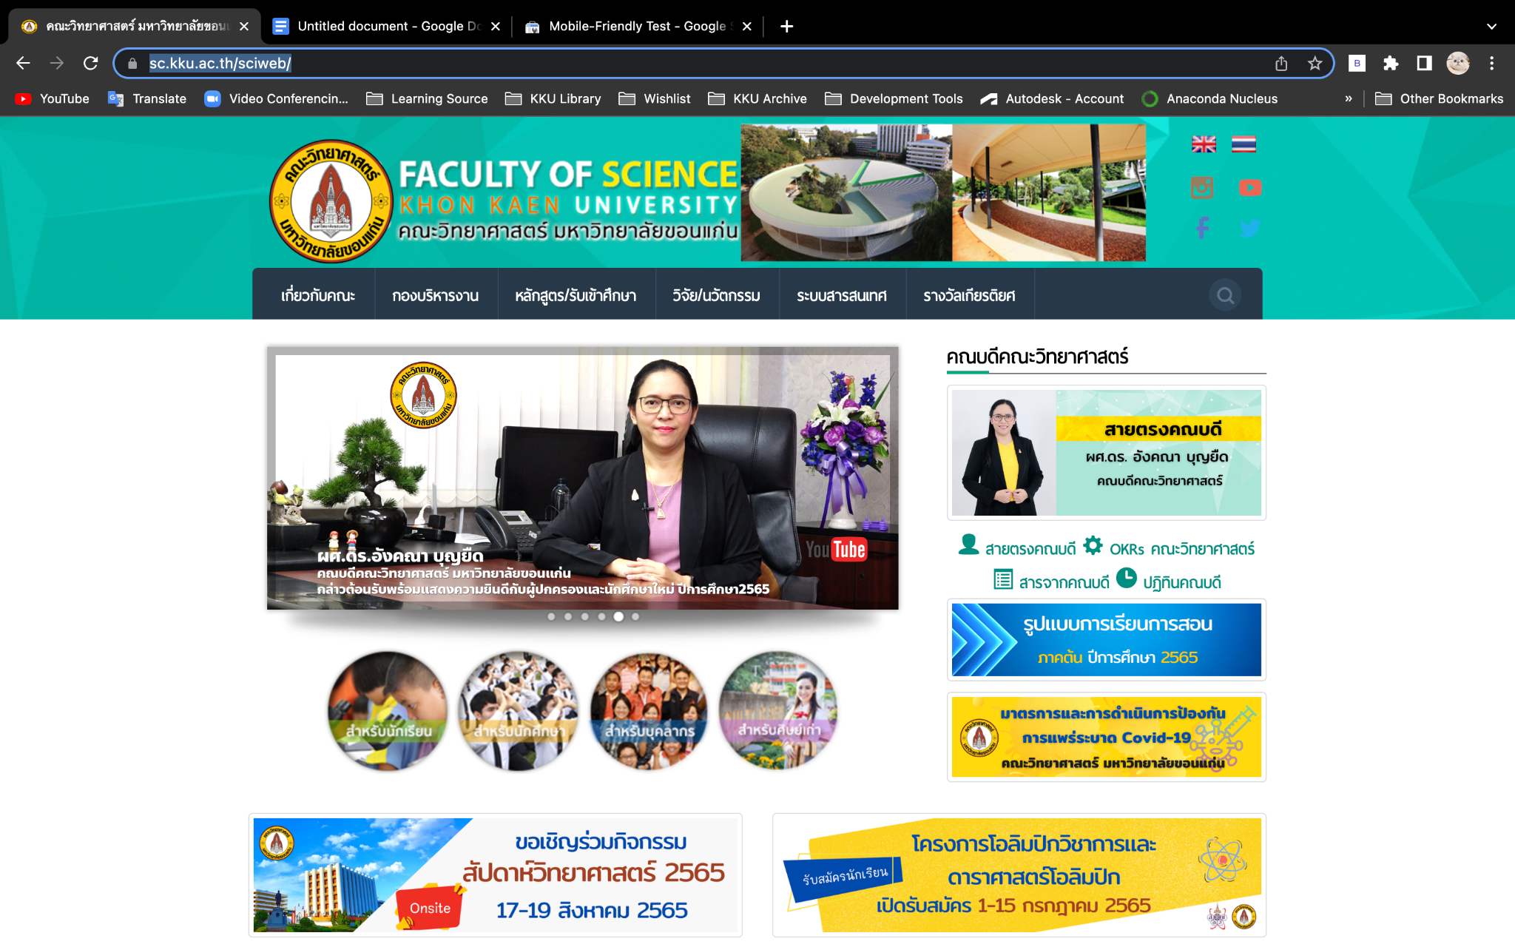

My UX/UI opinion on the faculty of Science KKU.

Things I like

1. Easy to navigate through other pages.
2. I like the color schemes of the web.

Things web should improve

1. Too many text and links -> Should emphasize important images or links and group them for navigation

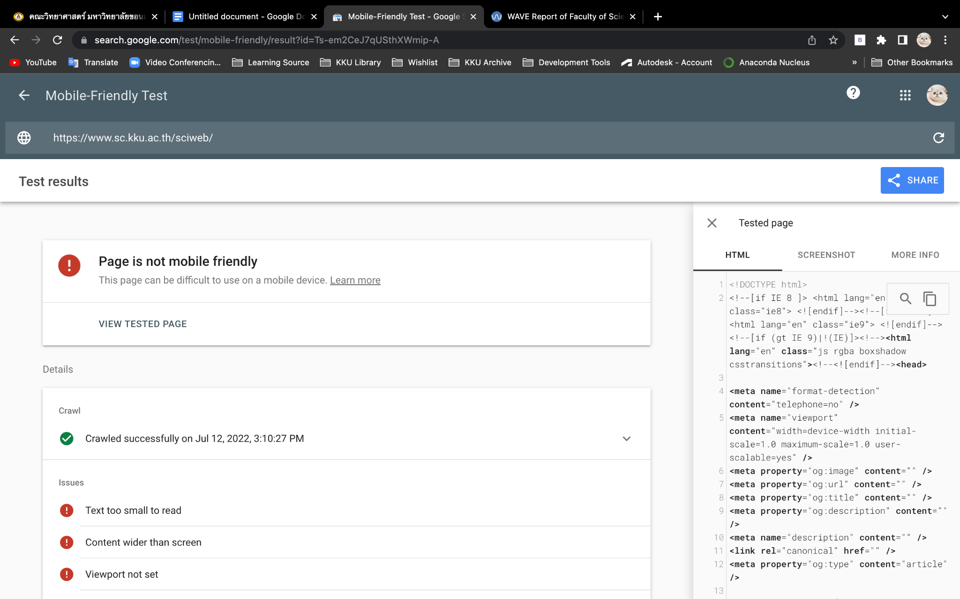

1. The web is not mobile-friendly so the developer should implement responsive design to the web.

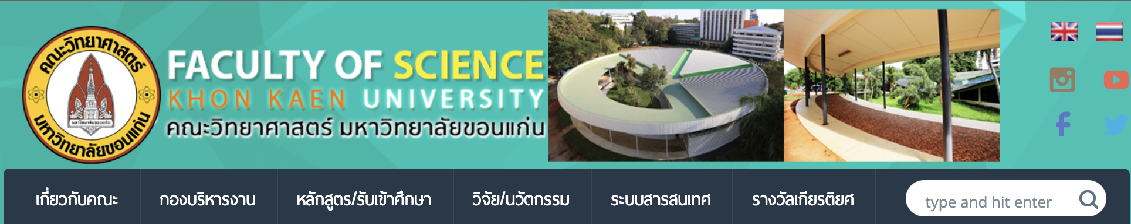

1. The image in the header seems odd to me the header should emphasize more faculty or the vision of faculty. If developers want to add an image to the header they should use it as background and carefully consider color contrast and accessibility.