Data Cleaning and Transformation Trade Study
ML Classifier Project @ The Boring Club at UW
Date: 10/29/2025 - 11/06/2025
Summary:
We have chosen to use OpenCV and VidGear. OpenCV is the industry standard when it comes to open source real time video processing tools, and VidGear is an open source tool that combines OpenCV, FFmpeg and many other tools into one compact framework. Next, we will be testing these software out.

Outline
Video on image processing with Python:
https://www.youtube.com/watch?v=kSqxn6zGE0c

Datasets (Labelled Images)
https://www.kaggle.com/datasets/atulanandjha/lfwpeople
-umass
https://www.kaggle.com/datasets/hereisburak/pins-face-recognition
-from pinterest
https://www.kaggle.com/datasets/vasukipatel/face-recognition-dataset
-celebrities
https://www.kaggle.com/datasets/kasikrit/att-database-of-faces
-credit at&t
https://www.kaggle.com/datasets/dataturks/face-detection-in-images
-Already marked with bounding boxes
https://research.google/resources/datasets/
-on github (?)
- Have to fill out a google form and request access
https://www.kaggle.com/datasets/olgabelitskaya/yale-face-database
- Multiple subjects, emotional expressions for each

Understanding Data Needs
- What types of data does the ML model require? (e.g., image formats, resolution, labels, metadata)
  - https://www.cloudfactory.com/training-data-guide
  - Labeled data is easier to process, especially for images.
    - Labelled data = data manually tagged for the model to learn from
    - Each label needs weight/scoring applied to it
- What are the key features that must be extracted from raw images to train the model effectively?
  - Patterns, textures, colors, shapes, edges, etc.
  - https://www.cloudfactory.com/training-data-guide
- How much data is required to achieve meaningful model performance?
  - https://postindustria.com/how-much-data-is-required-for-machine-learning/
  - Also depends on range of error, features that need to be accounted for
    - “10 times rule,” The amount of input data should be at least 10 times more than the number of degrees of freedom of a model (parameters) (mostly useful for a rough estimate)
  - Range from couple hundred to tens of thousands, depends on how complicated the model is.

Data Acquisition & Sourcing
- How can we automate the collection of raw data from sensors, devices, or other sources?

Data Cleaning & Transformation
- How can raw images be preprocessed into formats suitable for ML models? (resizing, normalization, augmentation)
  - https://keylabs.ai/blog/best-practices-for-image-preprocessing-in-image-classification/
    - Resized into a standard aspect ratio
    - Linear normalization usually involves subtracting a certain value and then multiplying by a factor
- What transformations are needed to handle inconsistencies or noise in the raw data?
  - Adjusting brightness and contrast
- Are there existing tools or libraries to streamline preprocessing? (OpenCV, PIL, TensorFlow, PyTorch)
  - https://milvus.io/ai-quick-reference/what-is-the-difference-between-opencv-and-tensorflow
  - OpenCV: Simple to use, comprehensive
  - Pillow: Supports various formats, straightforward capabilities. Useful for converting images to various different color formats.
  - TensorFlow: End-to-end open source tools
  - Scikit-image: Various image processing algorithms built on NumPy and SciPy

Data Pipeline Design
- How can we design a pipeline to ingest, process, and store data efficiently?
- What architecture will allow for scalability and easy collaboration with other subteams?
- Which frameworks or tools are best suited for real-time or batch data pipelines? (Airflow, Prefect, Kafka, Spark, pandas)
- Kafka/Spark for real-time, and Airflow/Prefect/pandas for batch processing.

Data Validation & Quality Assurance
- How can we measure the quality of our training data? (label accuracy, class balance, completeness)
- What techniques can detect and mitigate bias or class imbalance?
- How do we validate that processed data improves model performance?
- What metrics should we track to ensure ongoing data quality? (accuracy, loss, F1 score, confusion matrices)

Testing & Iteration
- How can we test pipelines with sample datasets before full-scale deployment?
- Just run the model with testing datasets that are separated from the training dataset
- What experiments can we run to validate that our preprocessing improves ML performance?

Data Acquisition
Some questions that we should be asking ourselves when we choose what kind of tools we are using for live image processing includes:
- What types of image or video inputs are supported (e.g., camera feeds, image sequences, video files, streaming protocols)?
- What formats can the tool generate or export (e.g., processed video, annotated frames, data overlays, feature maps)?
- Specifications and capabilities?
- What processing capabilities does the tool offer?
- Are there limitations on resolution, frame rate, or color depth?
- Are there APIs or SDKs available for customization and integration?

OpenCV
What:
- Windows bitmaps: .bmp, .dib (always supported)
- JPEG files: .jpeg, .jpg, .jpe
- JPEG 2000 files: .jp2
- Portable Network Graphics: .png
- WebP: .webp
- Portable image format: .pbm, .pgm, .ppm, .pxm, .pnm (always supported)
- Sun rasters: .sr, .ras (always supported)
- TIFF files: .tiff, .tif
- OpenEXR Image files: .exr
- Radiance HDR: .hdr, .pic (always supported)

Pillow
Can’t take in video formats like MP4, AVI, or MOV directly, for actual video processing, other libraries recommended, so probably can’t use it by itself.
- Can work it in with OpenCV, imageio, or MoviePy to extract individual frames while Pillow image objects.
- Overall thing seems to be that it should be complemented with libraries like OpenCV or scikit-image
- But it seems to be good for manipulating, image enhancement, filtering, color space conversion, and pixel-level operations.
- Specs: Cross-platform (windows, linux, macOS), designed fo fast access to pixel data.
Types of data it can accept:
Fully Supported (Read/Write): JPEG, PNG, BMP, GIF, TIFF, WebP, AVIF, ICNS, ICO, PCX, PPM, SGI, TGA, XBM.
Read- Only: Photoshop files, FITS, FLI/FLC, MPO, PCD, WMF
Write-only: PDF, Palm

Output to Other Data Types: NumPy Arrays, Byte Buffers/Strings

Output File Formats: JPEG, PNG, TIFF, GIF, BMP, PDF, WebP, AVIF, DDS, SGI, TGA

Format Size Limits
- ICO: MAx size is 256 * 256
- WebP: 16383 * 16383
https://pillow.readthedocs.io/en/stable/index.html

TensorFlow Image:
Input: I guess as long as it can be transformed into a pil image it’s good.
Output: same as above.
- Good for more complex recognition models
- Recommended to work with OpenCV or other tools
- Built for higher performance
- Highly scalable across different project sizes
- Might be more complex to work with compared to other tools
- Significant amount of available tools to work with
- Limitations will depend on available hardware and the videos being worked with

FFmpeg (and its libraries)
FFmpeg isn’t specifically a “vision” library but a media toolkit: decode/encode many formats, handle streaming, containers, protocols. Useful for ingesting live camera streams, converting formats, streaming out processed frames.
- Local files: .mp4, .avi, .mkv, .mov, .flv, .mxf, etc.
- Raw image sequences: .jpg, .png, .bmp, .tiff, etc.
- Streaming inputs: RTSP, RTMP, HLS, MPEG-TS, SRT, WebRTC (via integrations)
- Live camera feeds: USB webcams, IP cameras, capture cards, system devices (/dev/video* on Linux, dshow on Windows)
FFmpeg is effectively “format-agnostic”—if a format exists, FFmpeg can likely read it.
It’s also capable of handling multi-stream and multi-source input for advanced workflows.
While FFmpeg is not a full computer vision framework like OpenCV, it provides a rich set of built-in filters and transformations that can be applied to live or recorded video streams. Examples:
- Image and video transformations: crop, resize, rotate, flip, scale
- Color space conversion: RGB ↔ YUV, grayscale, thresholding
- Filtering: blurring, sharpening, denoising
- Compositing: overlaying text, logos, or watermarks
- Frame rate adjustments: upsampling/downsampling frames
- Edge detection and motion estimation (basic)
- Split/Merge streams: e.g., process multiple camera feeds simultaneously
- Frame-by-frame output for external ML inference
Downside: The API has a learning curve; debugging can be complex compared to higher-level frameworks.

VidGear
VidGear is a Python video-processing framework built on top of FFmpeg, OpenCV, etc. It supports real-time processing, frame-by-frame access, streaming, network transfers. GitHub+1
- Best if you are working in Python and want a higher-level API for grabbing frames, streaming, chunking, etc.
- Consider: for very high performance or very high resolution you may need to drop down a level or use GPU acceleration.
Summary: VidGear is a High-Performance Video Processing Python Library that provides a Multi-Threaded + Asyncio API Framework on top of specialized libraries like OpenCV, FFmpeg, ZeroMQ, picamera2, starlette, yt_dlp, pyscreenshot, dxcam, aiortc and python-mss serving at its backend, and enable us to use their internal parameters and methods, while error-handling and real-time performance. VidGear primarily focuses on simplicity, and thereby lets programmers and software developers to easily integrate and perform Complex Video Processing Tasks, in just a few lines of code.
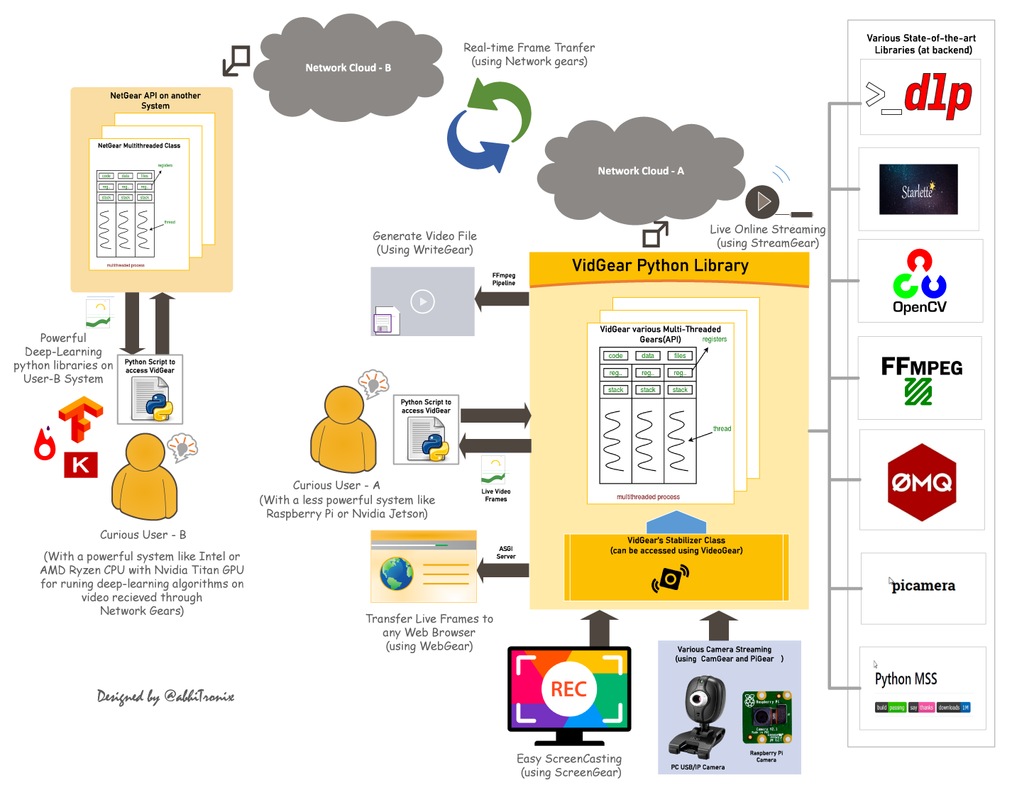

Py-Torch
Used in research and industry for image classification, object detection, and feature extraction
Let's you:
- Design and train convolutional neural networks (CNNs)
- Import pre-trained models (like ResNet, VGG, MobileNet)
- Fine-tune models on your own dataset of images or videos
Some limitations are
- Can be slow or inefficient without a GPU
- Memory usage can be high, challenging to achieve real-time performance without converting or optimizing the model for the target hardware
- Installation and setup can also be complex, especially when configuring dependencies on embedded systems

TorchVision:
(Toolkit that works like a supportive companion library to PyTorch)
Input/output: same as TensorFlow
Benefits:
- Has access to Pre-trained Models for transfer learning
Limitations:
- Input/Output are primarily optimized for offline data loading
  - Not designed for direct, real-time, low-latency streaming protocols or camera interaction

Scikit-Image

