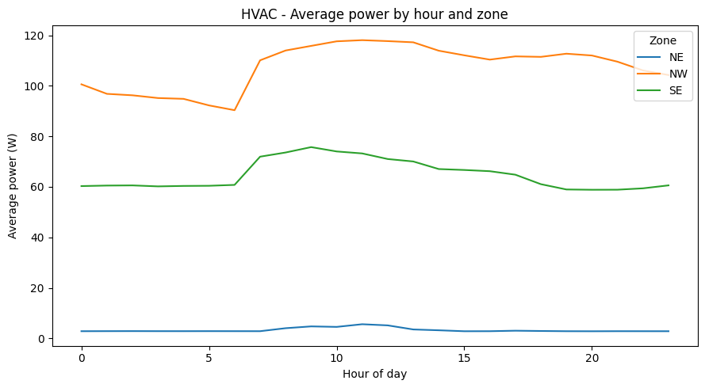
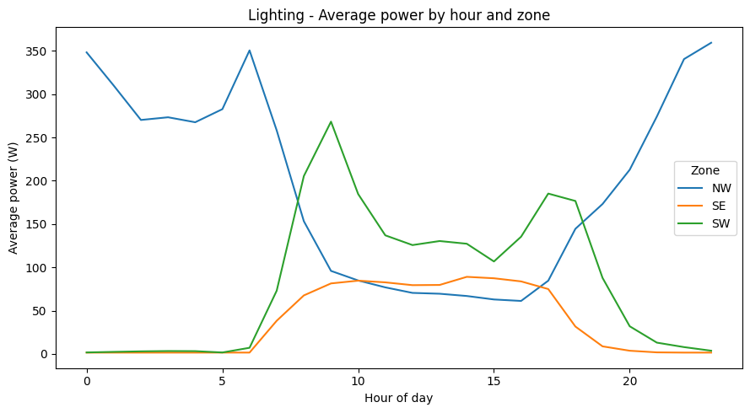
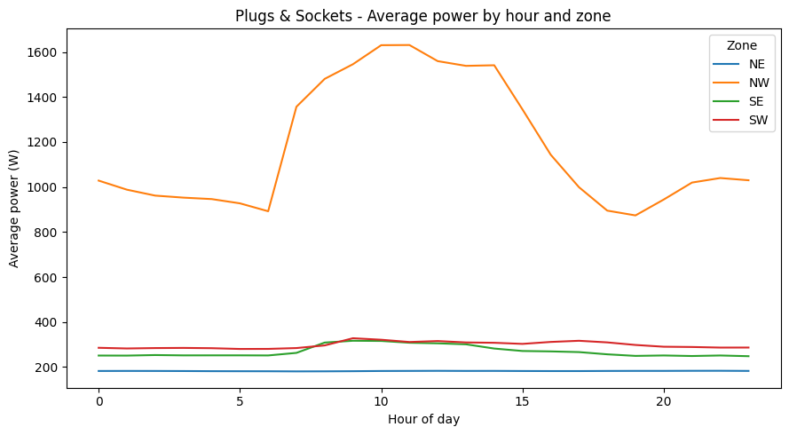
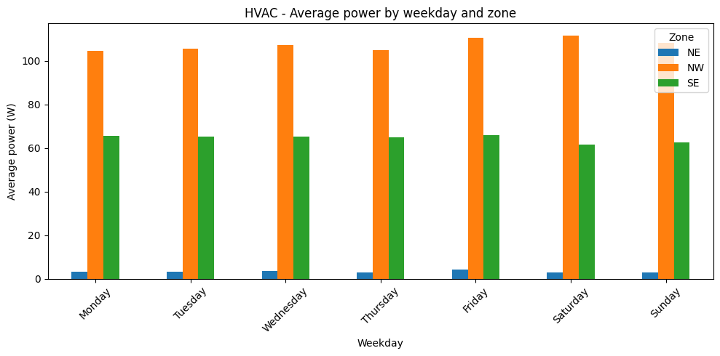
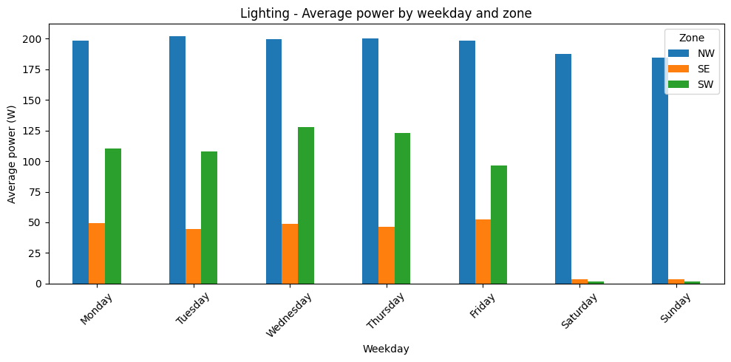
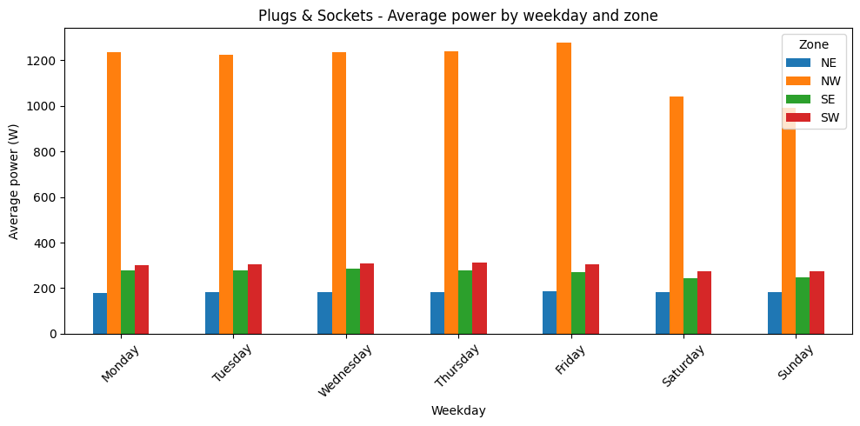
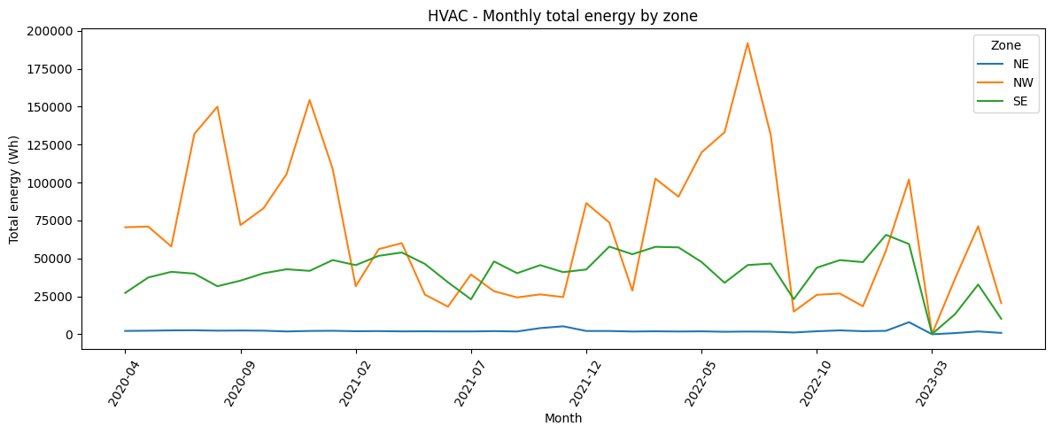
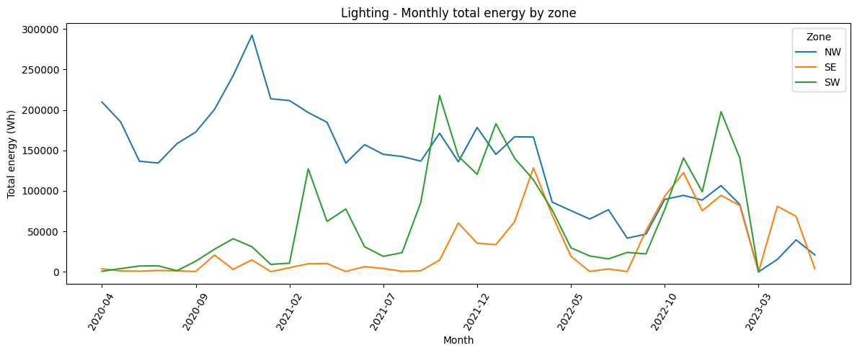
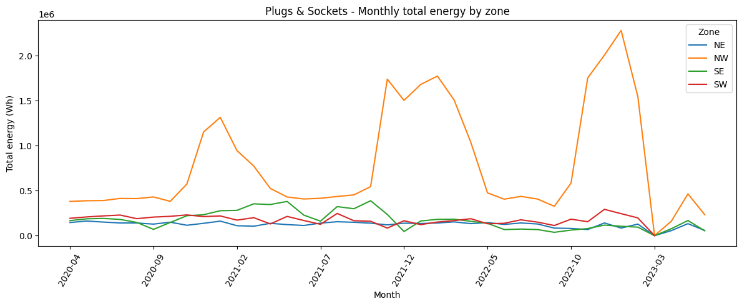
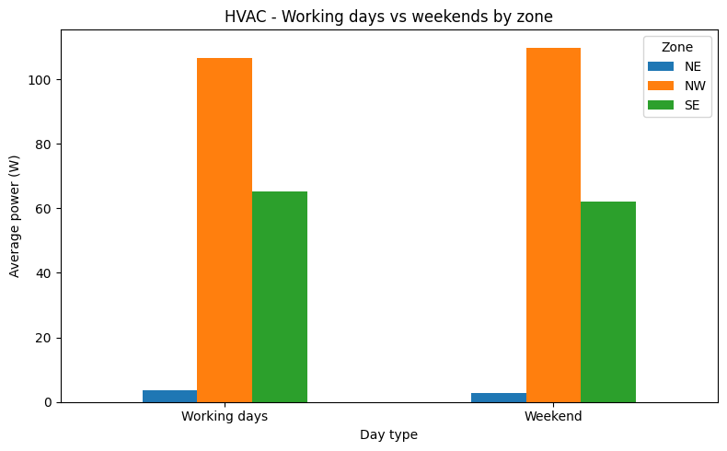
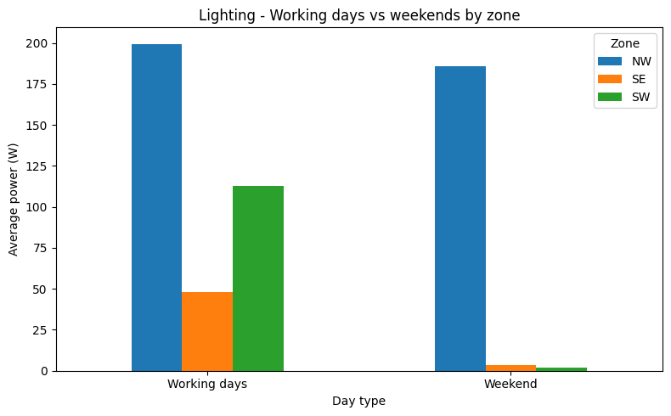
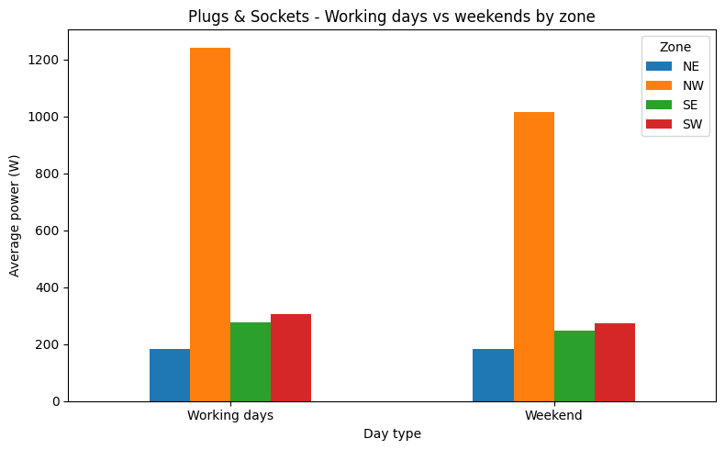
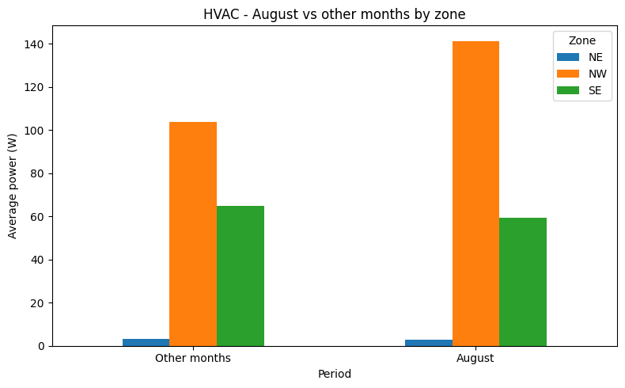
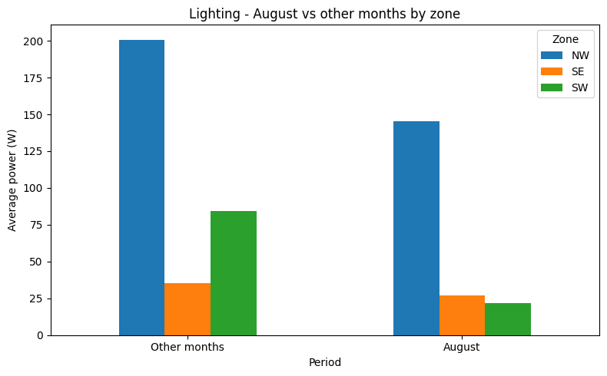
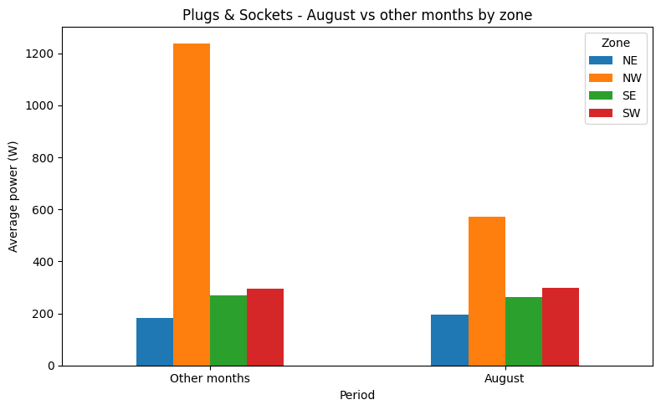
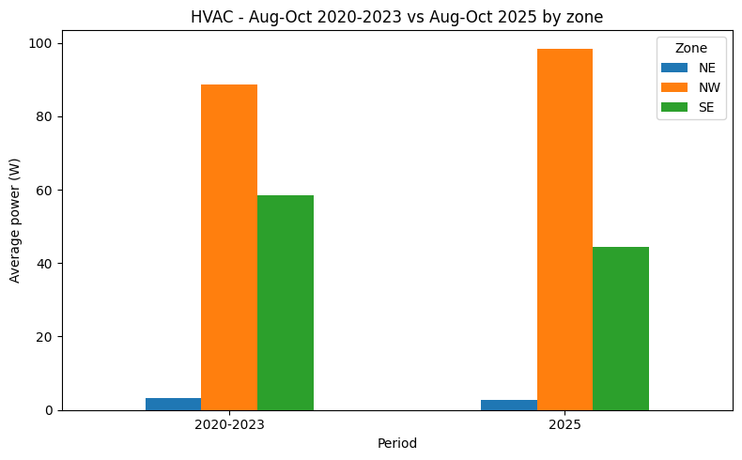
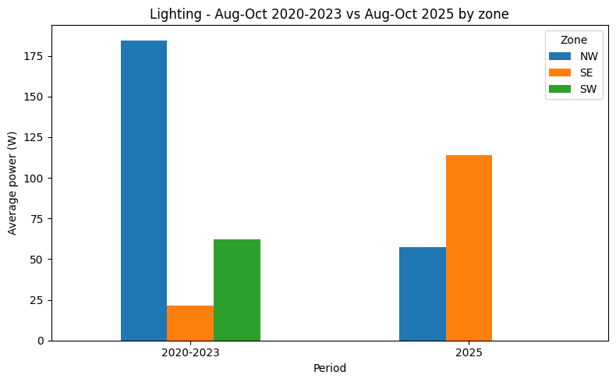
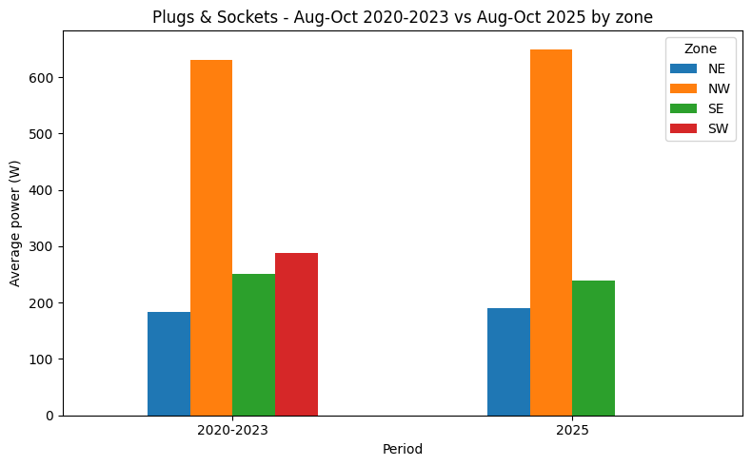
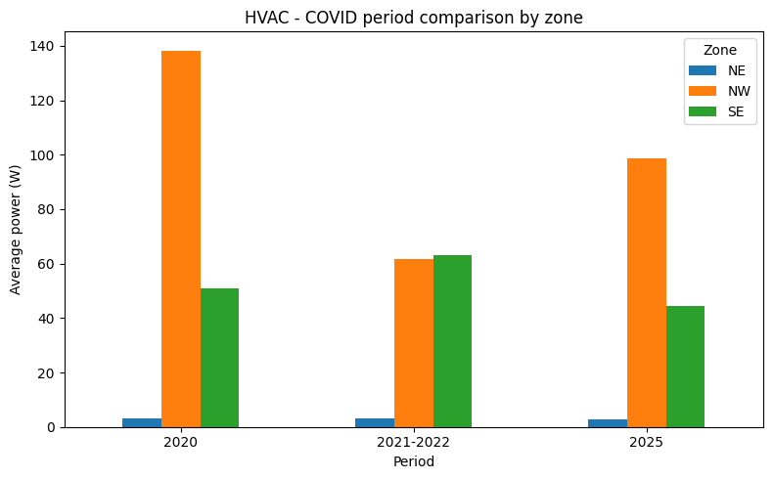
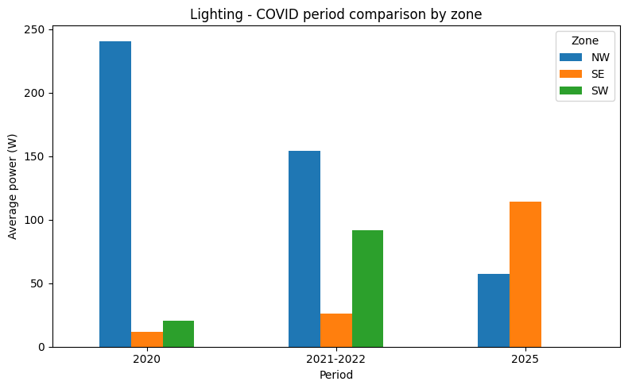
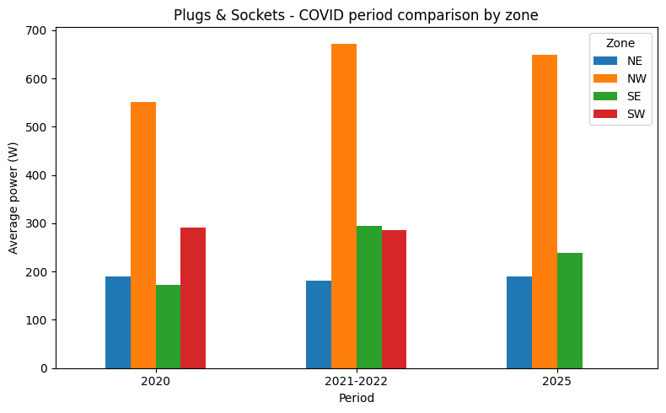
Before extending the analysis to all zones and load types, I first used NW HVAC as a pilot case. The objective was to verify the cleaned dataset, check the behaviour of the main variables, and define a consistent analysis workflow for hourly profiles, weekday patterns, monthly behaviour, weekends, August, and historical-period comparisons. After validating the approach on NW HVAC, the same methodology was extended systematically to the main load types and zones
AVERAGE POWER BY HOUR OF DAY HVAC HVAC consumption differs markedly across zones. NW has the highest average power throughout the day, SE shows an intermediate profile, while NE remains much lower. Despite these different levels, all zones show a daily pattern, suggesting that both zone and hour of day are relevant forecasting features.
Lighting Lighting profiles differ strongly across zones and hours of the day. NW maintains relatively high consumption, particularly during night and evening hours, while SE and SW show more pronounced daytime patterns. This indicates that both zone and hour of day are important predictors of lighting demand.
Plugs & Sockets Plugs & Sockets consumption differs strongly across zones. NW shows much higher average power and a clear daytime peak, while NE, SE and SW remain considerably lower and more stable. This suggests that both zone and hour of day are important features for this load type.
AVERAGE POWER BY WEEKDAY HVAC HVAC consumption differs much more across zones than across weekdays. NW consistently shows the highest average power, SE an intermediate level and NE the lowest. Weekday effects appear relatively limited compared with the strong zone effect.
Lighting Lighting consumption shows a strong weekday effect, especially in SE and SW, where weekend consumption drops close to zero. NW remains much higher throughout the week, although it also decreases during the weekend. This indicates that both zone and day of the week are relevant predictors of lighting consumption.
Plugs & Sockets Plugs & Sockets consumption is relatively stable across weekdays in most zones, although NW remains substantially higher than the others and shows some reduction during the weekend. This suggests that zone is the dominant factor, while weekday effects are more relevant for some specific areas.
MONTHLY ENERGY TOTALS HVAC Monthly HVAC energy consumption is strongly zone-dependent. NW shows the highest totals, with a clear summer peak in July and August. SE is more moderate and relatively stable, while NE remains much lower. This confirms the importance of both zone and seasonality for HVAC demand.
Lighting Lighting monthly totals vary strongly across both zones and months. NW consistently shows the highest consumption, while SW presents a pronounced seasonal pattern with much lower totals in late spring and summer. SE remains comparatively low throughout the year. This suggests that both zone and seasonality are important for lighting demand.
Plugs & Sockets Monthly Plugs & Sockets consumption is highly zone-dependent. NW shows much higher totals than the other zones, with particularly high consumption in some winter months. NE, SE and SW remain considerably lower and more stable. This suggests that both zone and seasonality affect plug-load consumption.
WORKING DAYS VS WEEKENDS HVAC HVAC consumption does not show a clear reduction during weekends. NW presents slightly higher average power during weekends, while SE changes only moderately and NE remains low. This suggests that the working-day/weekend distinction alone does not fully explain HVAC behaviour and should be interpreted together with season and year.
Lighting Lighting consumption shows a clear difference between working days and weekends, but the effect varies strongly across zones. In SE and SW, average power drops sharply during weekends, suggesting that lighting use is closely linked to building occupancy and working activity. NW remains relatively high even during weekends, indicating a different operating pattern that should be investigated further.
Plugs & Sockets Plugs & Sockets consumption is strongly zone-dependent. NW shows the highest values and a clear reduction during weekends, while NE, SE and SW remain much more stable. This suggests that day type is especially relevant for NW plug-load consumption.
AUGUST VS OTHER MONTHS HVAC HVAC consumption in NW is clearly higher in August than during the other months. SE shows a slight decrease in August, while NE remains very low and almost unchanged. This suggests that the August effect is strongly zone-dependent and particularly relevant for HVAC in NW.
Lighting Lighting consumption is lower in August across all zones, with the strongest reduction in SW. This suggests that August has a clear effect on lighting demand and should be considered as a relevant calendar feature.
Plugs & Sockets August has a strong effect on Plugs & Sockets consumption in NW, where average power falls substantially. The other zones show much smaller changes. This indicates that the August effect is strongly zone-dependent.
AUG–OCT HISTORICAL PERIOD VS 2025 HVAC Comparing the August–October window, HVAC consumption changes differently across zones. NW is slightly higher in 2025, SE is lower, and NE remains low in both periods. This suggests that the shift between the historical period and 2025 is zone-dependent rather than uniform.
Lighting Lighting consumption changes noticeably between the historical period and 2025. In NW, average consumption is lower in 2025, while in SE it is higher. SW also shows a substantial change. Overall, the differences between the historical period and 2025 are not uniform across zones.
Plugs & Sockets Plugs & Sockets consumption is broadly similar between the historical period and 2025 in most zones, with a slight increase in NW and NE. SW shows a much larger change, so its 2025 results should be interpreted cautiously.
AUG–OCT HISTORICAL PERIOD VS 2025 HVAC Comparing the August–October window, HVAC consumption changes differently across zones. NW is slightly higher in 2025, SE is lower, and NE remains low in both periods. This suggests that the shift between the historical period and 2025 is zone-dependent rather than uniform.
Lighting Lighting consumption changes noticeably between the historical period and 2025. In NW, average consumption is lower in 2025, while in SE it is higher. SW also shows a substantial change. Overall, the differences between the historical period and 2025 are not uniform across zones.
Plugs & Sockets Plugs & Sockets consumption is broadly similar between the historical period and 2025 in most zones, with a slight increase in NW and NE. SW shows a much larger change, so its 2025 results should be interpreted cautiously.

