T31 (F3.3) – Day-ahead forecast of zone 1NE without environmental sensors
DataPack Energy Forecaster – CeDInt floor 1 (TBDA) · Sprint 3 · Author: Riccardo Tardanico
Code: T31_ne_forecast.py · Results: T31_NE_results.xlsx · Predictions: T31_NE_predictions.csv · Figures: F_T31_1 … F_T31_6

1. Summary
- Problem. Zone NE has no indoor sensors: temperature, humidity, light and presence are missing in 100 % of its hours, so the drivers used for the other zones cannot be measured there.
- What was done. Both NE loads (HVAC and Plugs & Sockets) were forecast 24 h ahead with a gradient-boosting model, once without environmental data and once with each of three proxies: zone NW, the two adjacent zones (NW + SE) and the whole floor (NW + SE + SW). The proxy idea was then checked on zones that do have sensors (leave-one-zone-out test).
- NE Plugs & Sockets is forecastable: the best models reach CV(RMSE) 25–27 % on validation and test 2023 and 8–9 % on test 2025 (ASHRAE 14 hourly limit 30 %), with NMBE within ±10 %.
- NE HVAC is a stand-by load (about 3 Wh per hour, 2 devices) with rare spikes up to 700 Wh. On test 2025 all models pass ASHRAE 14 (CV(RMSE) 19–20 %, better than the naive baselines at 23–25 %). In test 2023, 11 spike hours carry 57 % of the energy, and no method can forecast them (CV(RMSE) above 900 %).
- The proxies change accuracy by at most about 3 percentage points, in either direction. The leave-one-zone-out test shows the same thing for SE and NW: even a zone's own sensors do not improve a day-ahead forecast. The lack of sensors in NE therefore costs almost no accuracy. What matters is the load's own history (lag 24 h) and the calendar.
- Recommendation. Forecast NE with the persistence-anchored model and the NW proxy (M1) or with no proxy (M0). Report NE HVAC spikes as candidate anomalies (T35), not as forecast failures.

2. Data
Source: cedint_f1_hourly_clean.csv. NE is the only zone whose environmental columns are completely empty:
Zone | temp_c valid % | hum_pct valid % | lum_lux valid % | occupancy valid %
NE | 0.0 | 0.0 | 0.0 | 0.0
NW | 53.9 | 53.9 | 53.9 | 53.9
SE | 52.3 | 52.3 | 52.3 | 52.3
SW | 52.6 | 52.9 | 52.9 | 52.9
Table 1 – Share of all hours from April 2020 to October 2025 with valid indoor environmental readings (sheet Env_availability). The 902-day gap is included, so the zones with sensors cannot reach 100 %.
The indoor climate of the zones with sensors is similar: temperature correlates at r = 0.78 (NW–SE, NW–SW) and r = 0.94 (SE–SW), with a mean absolute difference of 1.5–3.1 °C. Humidity, light and presence are much more local (r between −0.08 and 0.57). A neighbour's temperature is therefore a credible proxy for NE, while its presence is not. Sheet Proxy_similarity has all pairs.
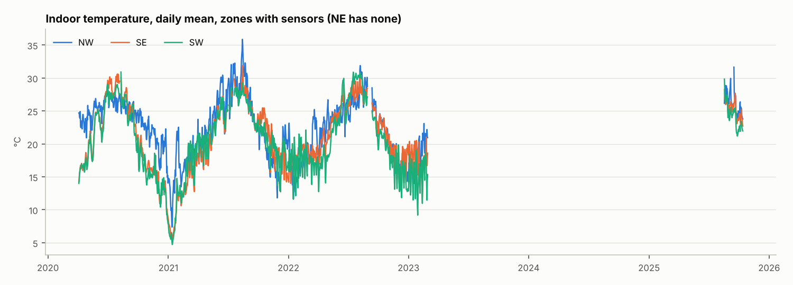
Figure F_T31_1 – Daily mean indoor temperature of the three zones with sensors. The zones move together, which justifies using them as a proxy for NE.
The two NE series behave very differently from the office-type loads of the other zones (Figure F_T31_2). Plugs & Sockets is an almost constant base load of about 190 Wh per hour, day and night, that switches to a low-power state of about 24 Wh for days or weeks (e.g. October–November 2022 and January 2023, confirmed by both the power and the counter readings). HVAC stays at about 3 Wh per hour, with a few isolated spikes. Neither has a clear working-hours pattern (the daily range is only about 4 Wh for plugs and 0.1 Wh for HVAC), so occupancy-type drivers have little to explain.
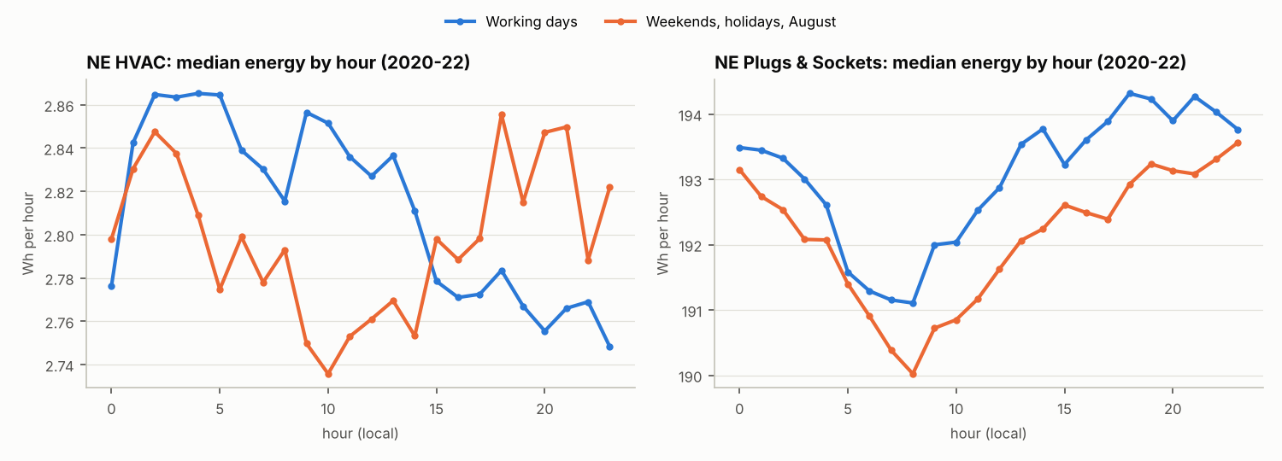
Figure F_T31_2 – NE median energy by hour of the day, working days vs weekends, holidays and August (2020–2022).
Load | Split | Valid hours | Mean Wh | Median Wh | Max Wh
HVAC | train | 18194 | 3.14 | 2.82 | 698.3
HVAC | val | 4072 | 2.75 | 2.59 | 387.6
HVAC | test_2023 | 1392 | 7.34 | 3.27 | 708.3
HVAC | test_2025 | 1322 | 2.67 | 2.69 | 4.2
Plugs & Sockets | train | 18194 | 186.40 | 192.55 | 425.7
Plugs & Sockets | val | 4072 | 158.40 | 190.89 | 481.3
Plugs & Sockets | test_2023 | 1392 | 153.25 | 191.10 | 269.7
Plugs & Sockets | test_2025 | 1316 | 188.00 | 190.39 | 268.6
Table 2 – NE target series per split (sheet NE_series). The 2023 test covers January–February 2023; the 2025 test covers August–October 2025.

3. Method

3.1 Proxy scenarios
- M0 – no environmental data: calendar features (hour, weekday, month, weekend, Madrid holiday, August, COVID-2020) plus lags of the series itself (24, 48, 72, 168 and 336 h, previous-day mean and maximum, previous-week mean).
- M1 – M0 plus the NW environment (NW is the north neighbour of NE).
- M2 – M0 plus the mean of NW and SE, the two zones that touch NE on the floor plan.
- M3 – M0 plus the mean of NW, SE and SW (whole floor).
- M4 – like M2, but with same-hour proxy values, as if the drivers were known in advance. This is an upper bound and cannot be used in operation.
- M0d – reference: the same features as M0, but the model predicts the level directly with squared-error loss (the usual set-up).
- Baselines (as in T21) – naive day (same hour yesterday) and seasonal naive (same hour last week).
- M5/M6 – outdoor weather from Open-Meteo, alone and together with the adjacent proxy. The script supports these (--weather or --download-weather), but they were not run here because no internet access was available. They should be run with the T26 weather file.

3.2 Day-ahead rule, split and model
The forecast for every hour of day D is issued at 00:00 of day D, so only information that is at least 24 h old is used: target lags of 24 h or more, rolling windows shifted by 24 h, and the proxy values of the previous day. Calendar features are known in advance. The split is the one of T32: train 2020-06-01 to 2022-06-30, validation 2022-H2 (choice of hyper-parameters from a grid of 8), and test on 2023 and 2025. For the test, the selected model is refitted on train + validation.
The model is HistGradientBoostingRegressor (scikit-learn), a histogram gradient-boosting model from the same family as LightGBM that handles missing values natively. Two choices were made after the first runs (section 4.1):
- Persistence-anchored target. The model learns the change with respect to the same hour of the previous day (y − lag24), and the forecast is lag24 + predicted change.
- Absolute-error loss. The model predicts the median change, which makes it robust to spikes and to regime switches.
Metrics are the same as in T19/T38: MAE, RMSE, CV(RMSE) = RMSE / mean(y), and NMBE = Σ(y − ŷ) / ((n − 1) · mean(y)), where a positive NMBE means under-forecasting. ASHRAE Guideline 14 hourly criteria: CV(RMSE) ≤ 30 % and |NMBE| ≤ 10 %. All methods are evaluated on the same hours, namely those where the target and both baselines exist. Daily-total metrics are also in the workbook.

3.3 Leave-one-zone-out check
The value of the NE proxy cannot be measured in NE itself, because the true NE environment is unknown. The same pipeline was therefore run for SE and NW, which do have sensors, in three variants: no environment, the zone's own sensors, and a proxy from the other zones. If the proxy is about as good as the zone's own sensors, it is a fair substitute in NE.

4. Results

4.1 Model set-up
With the usual set-up (M0d: level model, squared error) the model loses to the naive-day baseline on NE Plugs & Sockets: CV(RMSE) on validation is 31.5 % against 26.5 %. The tree model averages the base-load level and the low-power regime, and is pulled by a few extreme hours. Anchoring the model on lag24 and using absolute-error loss removes this problem (25.7 % for M0). For HVAC, the same choice cuts the 2025 test error from 56.6 % to 19.9 %. All scenarios M0–M4 use this set-up.

4.2 NE Plugs & Sockets
Method | Val 2022-H2 | Test 2023 | Test 2025 | ASHRAE 14 (val / 2023 / 2025)
B_naive_day | 26.5 / 0.1 | 26.2 / -0.2 | 10.3 / 0.4 | PASS / PASS / PASS
B_seasonal_naive_week | 44.8 / 0.3 | 54.5 / 0.4 | 11.4 / 0.7 | FAIL / FAIL / PASS
M0d_no_env_direct | 31.5 / -5.2 | 32.0 / -2.3 | 8.2 / 0.3 | FAIL / FAIL / PASS
M0_no_env | 25.7 / -4.7 | 27.2 / -3.9 | 8.8 / -0.4 | PASS / PASS / PASS
M1_proxy_NW | 25.2 / -3.3 | 27.1 / -3.5 | 8.9 / -0.5 | PASS / PASS / PASS
M2_proxy_adjacent | 26.7 / -6.0 | 29.6 / -7.0 | 8.5 / -0.7 | PASS / PASS / PASS
M3_proxy_floor | 28.5 / -7.7 | 27.2 / -6.0 | 8.3 / -0.9 | PASS / PASS / PASS
M4_proxy_adjacent_ideal | 26.1 / -4.8 | 28.5 / -8.0 | 8.7 / -0.7 | PASS / PASS / PASS
Table 3 – NE Plugs & Sockets, hourly CV(RMSE) % / NMBE % (sheet NE_results).
All models except the weekly naive and M0d pass ASHRAE 14 in every period. M1 (NW proxy) is the best model on validation (25.2 %) and is tied with M0 and M3 on test 2023 (27.1–27.2 %). On test 2025 all models (8.3–8.9 %) beat both baselines (10.3–11.4 %). The proxies change CV(RMSE) by at most about 3 points in either direction, and the ideal proxy (M4) is not better than the operational ones. Test 2023 is hard for every method because it contains two switches between the 24 Wh and the 190 Wh regimes, which no driver anticipates (Figure F_T31_4). Persistence is wrong for one day after each switch. The models are anchored to persistence, so they are also wrong for that day, and they need one or two more days to settle on the new level.

4.3 NE HVAC
Method | Val 2022-H2 | Test 2023 | Test 2025 | ASHRAE 14 (val / 2023 / 2025)
B_naive_day | 343.5 / -0.0 | 973.5 / 0.2 | 23.1 / 0.9 | FAIL / FAIL / PASS
B_seasonal_naive_week | 343.8 / 0.5 | 973.2 / 0.9 | 25.0 / 3.8 | FAIL / FAIL / PASS
M0d_no_env_direct | 280.0 / -10.4 | 689.0 / 35.0 | 56.6 / 7.0 | FAIL / FAIL / FAIL
M0_no_env | 333.5 / -0.5 | 948.3 / 7.4 | 19.9 / 3.5 | FAIL / FAIL / PASS
M1_proxy_NW | 338.8 / 0.4 | 970.2 / 2.5 | 19.4 / 0.1 | FAIL / FAIL / PASS
M2_proxy_adjacent | 337.4 / 0.5 | 962.1 / 8.6 | 19.2 / 0.5 | FAIL / FAIL / PASS
M3_proxy_floor | 333.6 / 0.1 | 970.4 / 4.0 | 20.1 / 2.7 | FAIL / FAIL / PASS
M4_proxy_adjacent_ideal | 332.2 / 0.5 | 967.3 / 5.0 | 19.1 / 2.0 | FAIL / FAIL / PASS
Table 4 – NE HVAC, hourly CV(RMSE) % / NMBE % (sheet NE_results).
On test 2025 every anchored model passes ASHRAE 14 (19.1–20.1 %) and beats the naive baselines (23.1 % and 25.0 %). The proxies help very slightly: M2 reaches 19.2 % against 19.9 % without environment. In validation and test 2023 all methods fail by a wide margin. The reason is visible in sheet NE_HVAC_spikes: the 11 hours above 28 Wh (10 × the training median) are 57.5 % of the energy in test 2023, they occur without warning, and they account for about half of the squared error of every method. When a spike occurs, persistence and the models also predict a spike for the same hour on the following day. For a 2-device stand-by load, these spikes are better treated as candidate anomalies (T35) than as something to forecast.
Period | Method | Spike hours | % of energy | % of squared error
val | B_naive_day | 2 | 5.2 | 49.8
val | M2_proxy_adjacent | 2 | 5.2 | 51.6
test_2023 | B_naive_day | 11 | 57.5 | 50.0
test_2023 | M2_proxy_adjacent | 11 | 57.5 | 51.2
test_2025 | B_naive_day | 0 | 0.0 | 0.0
test_2025 | M2_proxy_adjacent | 0 | 0.0 | 0.0
Table 5 – Weight of the NE HVAC spike hours (sheet NE_HVAC_spikes).
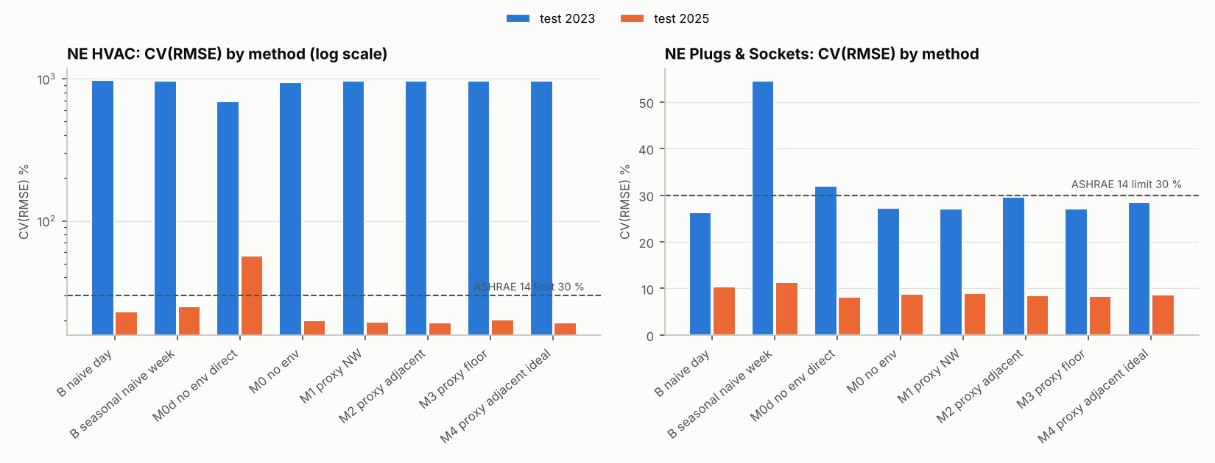
Figure F_T31_3 – CV(RMSE) by method on the two test periods. The HVAC panel uses a log scale; the dashed line is the ASHRAE 14 limit.
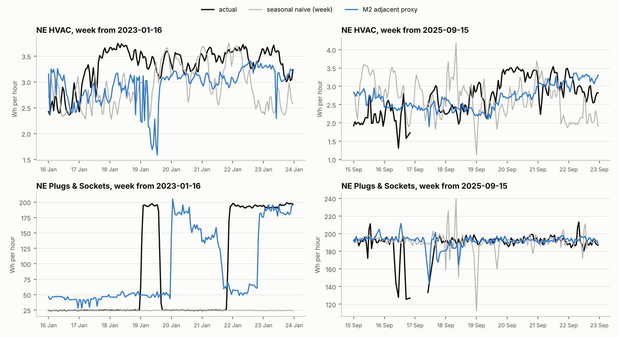
Figure F_T31_4 – Forecast vs actual for one test week in 2023 and one in 2025. Black: actual; grey: seasonal naive; blue: M2 (adjacent proxy).

4.4 Does the proxy work? Leave-one-zone-out
Series | Variant | Val | Test 2023 | Test 2025
SE HVAC | B_seasonal_naive_week | 64.9 | 63.7 | 46.9
SE HVAC | no_env | 53.6 | 48.3 | 40.0
SE HVAC | own_sensors | 53.2 | 48.6 | 41.2
SE HVAC | proxy_NW+SW | 53.4 | 48.3 | 43.5
SE Plugs & Sockets | B_seasonal_naive_week | 159.8 | 168.9 | 48.7
SE Plugs & Sockets | no_env | 122.4 | 138.4 | 38.3
SE Plugs & Sockets | own_sensors | 125.4 | 137.6 | 39.2
SE Plugs & Sockets | proxy_NW+SW | 122.9 | 139.8 | 40.2
NW HVAC | B_seasonal_naive_week | 105.3 | 103.9 | 135.5
NW HVAC | no_env | 70.4 | 45.5 | 104.6
NW HVAC | own_sensors | 71.5 | 47.4 | 98.3
NW HVAC | proxy_SE+SW | 69.0 | 46.8 | 104.7
NW Plugs & Sockets | B_seasonal_naive_week | 73.9 | 63.3 | 54.8
NW Plugs & Sockets | no_env | 55.0 | 52.1 | 40.4
NW Plugs & Sockets | own_sensors | 55.1 | 53.1 | 41.7
NW Plugs & Sockets | proxy_SE+SW | 56.5 | 51.6 | 39.5
Table 6 – CV(RMSE) % for SE and NW with own sensors, a proxy, or no environment (sheet LOZO_validation).
In all four series, the variants with own sensors, with a proxy and without environment are within about 3 points of each other, and the differences change sign from one period to another. The one exception is NW HVAC on test 2025, where the zone's own sensors are about 6 points better (98 % against 105 %), but all variants are far above the 30 % limit there. For example, SE HVAC on test 2023 gives 48.6 % with own sensors, 48.3 % with the proxy and 48.3 % with no environment. So for a 24-hour-ahead forecast, yesterday's indoor environment adds little beyond the load's own history and the calendar, even when it is measured in the zone itself. The proxy is as good as the real sensors, and NE loses nothing measurable by not having them.
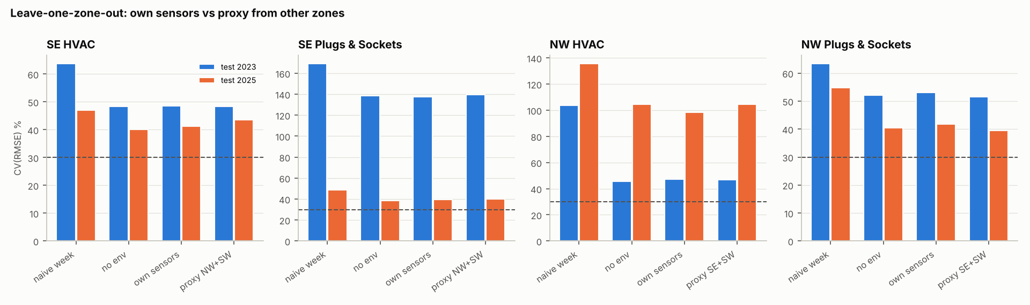
Figure F_T31_5 – Leave-one-zone-out: own sensors vs proxy vs no environment.

4.5 Which features matter
Permutation importance on the validation set (M2, Figure F_T31_6) is led by lag24 for both loads. For Plugs & Sockets, the previous-day mean proxy temperature comes second. This variable most likely captures the season, and the building's state that goes with it, rather than a physical driver of NE plug load: removing all proxies (M0) costs less than 1 point on the test sets. The SHAP analysis of T33 can confirm this.
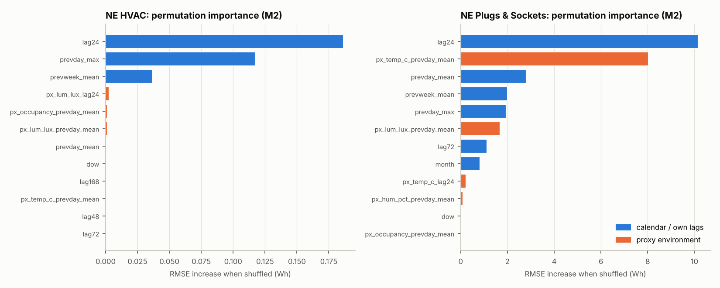
Figure F_T31_6 – Permutation importance (increase of RMSE when a feature is shuffled). Blue: calendar and own lags; orange: proxy environment.

5. Limitations
- No ground truth for the NE environment. The value of the proxy is measured indirectly, on SE and NW. NE could have its own micro-climate (e.g. the east façade in the morning), which the proxy cannot capture.
- The proxy is a mean of other zones. Presence and light are local and hardly correlated between zones (r ≤ 0.17 for presence), so they are poor proxies for NE. Only temperature carries over.
- Short and seasonal test periods. Test 2023 covers January–February only (1,344 hours); test 2025 covers August–October only (about 1,100 hours). Summer cooling in 2023 and winter in 2025 are not tested.
- Unforecastable events. The Plugs & Sockets regime switches (190 ↔ 24 Wh) and the HVAC spikes cannot be predicted from any available driver. The day after a switch is always wrong.
- Outdoor weather was not tested here. M5/M6 need the Open-Meteo file of T26 (or internet access). Because the NE loads are flat and weather-insensitive, a large gain is not expected.
- Holiday list. The dataset used (v0.3) has no is_holiday column, so a built-in Madrid holiday list is used. With dataset v0.4 the script uses the T24 flags automatically.
- Model family. Only gradient boosting and the baselines were run. SARIMAX or LightGBM from T29 could be compared on the same split (T39).

6. Conclusions and next steps
- NE can be forecast day-ahead without its own sensors. Plugs & Sockets passes ASHRAE 14 in every period; HVAC passes on 2025 and fails on 2023 only because of isolated spikes.
- Proposed model for NE in the final comparison (T39): the persistence-anchored HistGradientBoosting with the NW proxy (M1). It is the best on validation and needs only one neighbour zone.
- Hand-over: send the NE HVAC spike hours and the Plugs & Sockets low-power periods to T35 (anomalies); send T31_NE_predictions.csv to T34, T38 and T40; send the persistence-anchoring finding to subteam D (T29/T32), because it may also help the other base-load series.
- To do when the T26 weather file is available: run python T31_ne_forecast.py --weather <file> and add the M5/M6 rows.

Appendix A – Experiment-log rows (T20 format)
Columns abridged; the full rows (with author, model, train period and notes) are in sheet Experiment_log_rows and can be pasted into experiment_log.xlsx.
ID | Series | Features | Test | MAE | RMSE | CV(RMSE) | NMBE
T31-01 | 1NE HVAC | B_naive_day | 2023 | 8.91 | 73.063 | 973.51 | 0.24
T31-02 | 1NE HVAC | B_seasonal_naive_week | 2023 | 8.992 | 73.038 | 973.17 | 0.91
T31-03 | 1NE HVAC | M0d_no_env_direct | 2023 | 7.238 | 51.714 | 689.05 | 34.98
T31-04 | 1NE HVAC | M0_no_env | 2023 | 8.844 | 71.172 | 948.3 | 7.38
T31-05 | 1NE HVAC | M1_proxy_NW | 2023 | 8.902 | 72.816 | 970.21 | 2.45
T31-06 | 1NE HVAC | M2_proxy_adjacent | 2023 | 9.126 | 72.21 | 962.14 | 8.56
T31-07 | 1NE HVAC | M3_proxy_floor | 2023 | 8.988 | 72.827 | 970.36 | 4.03
T31-08 | 1NE HVAC | M4_proxy_adjacent_ideal | 2023 | 9.019 | 72.6 | 967.33 | 4.99
T31-09 | 1NE HVAC | B_naive_day | 2025 | 0.496 | 0.623 | 23.06 | 0.9
T31-10 | 1NE HVAC | B_seasonal_naive_week | 2025 | 0.543 | 0.675 | 24.99 | 3.76
T31-11 | 1NE HVAC | M0d_no_env_direct | 2025 | 0.922 | 1.529 | 56.55 | 7.03
T31-12 | 1NE HVAC | M0_no_env | 2025 | 0.44 | 0.538 | 19.91 | 3.48
T31-13 | 1NE HVAC | M1_proxy_NW | 2025 | 0.414 | 0.523 | 19.35 | 0.11
T31-14 | 1NE HVAC | M2_proxy_adjacent | 2025 | 0.417 | 0.52 | 19.24 | 0.54
T31-15 | 1NE HVAC | M3_proxy_floor | 2025 | 0.428 | 0.544 | 20.13 | 2.69
T31-16 | 1NE HVAC | M4_proxy_adjacent_ideal | 2025 | 0.419 | 0.517 | 19.12 | 2.04
T31-17 | 1NE Plugs & Sockets | B_naive_day | 2023 | 11.957 | 40.6 | 26.25 | -0.18
T31-18 | 1NE Plugs & Sockets | B_seasonal_naive_week | 2023 | 43.23 | 84.291 | 54.49 | 0.42
T31-19 | 1NE Plugs & Sockets | M0d_no_env_direct | 2023 | 28.695 | 49.449 | 31.97 | -2.31
T31-20 | 1NE Plugs & Sockets | M0_no_env | 2023 | 17.092 | 42.062 | 27.19 | -3.95
T31-21 | 1NE Plugs & Sockets | M1_proxy_NW | 2023 | 16.191 | 41.912 | 27.1 | -3.5
T31-22 | 1NE Plugs & Sockets | M2_proxy_adjacent | 2023 | 20.956 | 45.729 | 29.56 | -7.05
T31-23 | 1NE Plugs & Sockets | M3_proxy_floor | 2023 | 18.247 | 42.022 | 27.17 | -5.99
T31-24 | 1NE Plugs & Sockets | M4_proxy_adjacent_ideal | 2023 | 19.765 | 44.119 | 28.52 | -8.01
T31-25 | 1NE Plugs & Sockets | B_naive_day | 2025 | 7.386 | 19.483 | 10.33 | 0.39
T31-26 | 1NE Plugs & Sockets | B_seasonal_naive_week | 2025 | 9.09 | 21.509 | 11.4 | 0.65
T31-27 | 1NE Plugs & Sockets | M0d_no_env_direct | 2025 | 7.007 | 15.545 | 8.24 | 0.25
T31-28 | 1NE Plugs & Sockets | M0_no_env | 2025 | 6.304 | 16.616 | 8.81 | -0.43
T31-29 | 1NE Plugs & Sockets | M1_proxy_NW | 2025 | 6.399 | 16.822 | 8.92 | -0.55
T31-30 | 1NE Plugs & Sockets | M2_proxy_adjacent | 2025 | 6.063 | 15.968 | 8.47 | -0.73
T31-31 | 1NE Plugs & Sockets | M3_proxy_floor | 2025 | 5.945 | 15.665 | 8.31 | -0.89
T31-32 | 1NE Plugs & Sockets | M4_proxy_adjacent_ideal | 2025 | 6.429 | 16.392 | 8.69 | -0.67

Appendix B – How to reproduce
pip install pandas numpy scikit-learn matplotlib openpyxl
python T31_ne_forecast.py --data cedint_f1_hourly_clean.csv

