Tanush Bikram Shah

M00948151

Block 3 Project Report

Game Creation

# Introduction

In the realm of game design, simplicity meets complexity as designers aim to create captivating experiences. Each game has different components that come together as a whole, captivating players through realistic gameplay, intricate gameboards, dynamic scoreboards, and immersive multiplayer modes. In this project, our objective is to delve into the intricate interplay between these components, exploring how they synergize to elevate the overall gaming experience.

In the current design for the game, I have tried to prioritize simplicity and intuitiveness and balancing it with little complexity in order to provide a captivating experience. As such I have created the game with three frames. As the players start with the game, they are greeted with a frame containing a title and play and exit buttons. This allows players with clear navigation options, allowing them to quickly get into the game without much difficulty, setting the stage for a seamless transition into the gaming experience.

The second frame introduces the players to the heart of the game. This frame contains three inner components: a dynamic text message, 2 static text messages and a game board. The dynamic text message is the most visually striking, the static being the second most. This allows the players to constantly be updated on whose turn it is and the rules and method to play the game as it will be in sight at all times.

The third frame allows the user to see the result and exit the game. It is kept in a simplistic way that allows the user to see the result and quickly exit the game.

# Frame 1: Title Frame

As mentioned in the introduction, we used a simple design in order to make a title screen in the game. The only components it contains is a title, and two buttons in a vertical panel.

The minimalistic design of the title ensures that players can focus solely on initiating the gameplay or exiting the application. In just one glance, they can identify the core functionalities, thus being beneficial for new players. Besides the player load, it also lessens the load on the program, allowing for a fast and seamless program.

Overall, the choice to employ a simple design for the title screen shows the commitment for user-oriented design. By prioritizing clarity, ease of use, and accessibility, I ensured that players could engage with our game effortlessly, from the moment they launch the application to the instant they decide to exit.

# Frame 2: Game Frame

Frame 2 is the main game frame where everything is done. This frame has 3 components: a dynamic message, 2 static messages and the game board.

## Dynamic Message

The dynamic message allows the players to know whose turn it is. It changes after every turn after determining whether a valid button is pressed.

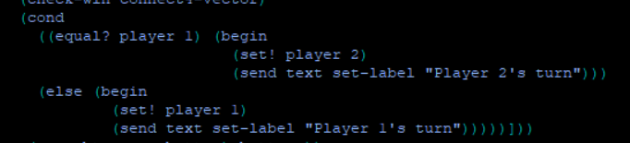

## Static message

The static message allows the player to know the method to play the game and the objective of the game.

## Game Board

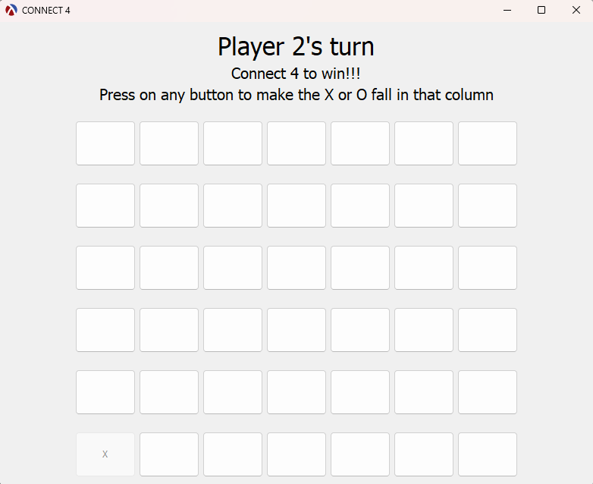The game board consists of buttons placed in a 6×7 grid formation. If any button is pressed, it de-activates the lowest available button in the column of the pressed button and replaces the label of the de-activated button with the respective player’s symbol.

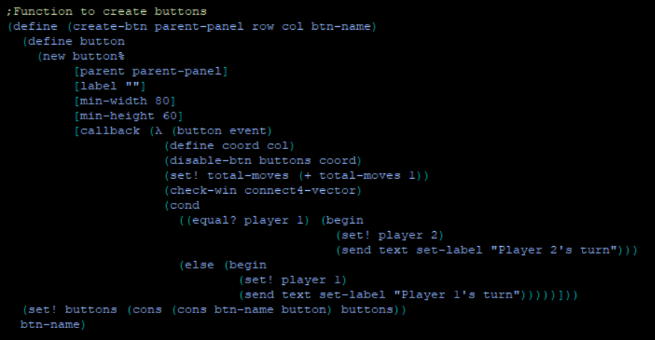This discourages users from pressing the bottom button and shows the intention that the bottom button is already filled. This is done using the button’s callback function. The callback function sends the column number to a button called ‘disable-btn’.

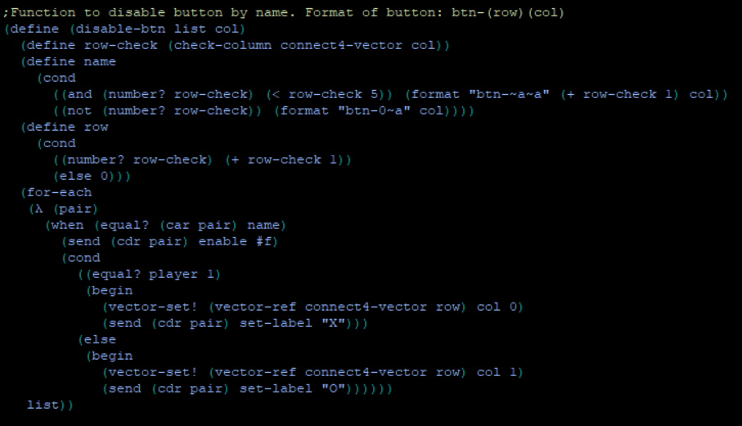The ‘disable-btn’ function checks till where the specified column is filled. Then it calls the board’s vector grid to set the value of the last unfilled vector as the player number. Lastly, the ‘disable-btn’ vector goes through a list of vector button pairs in order to find the vector filled in and disables the respective button.

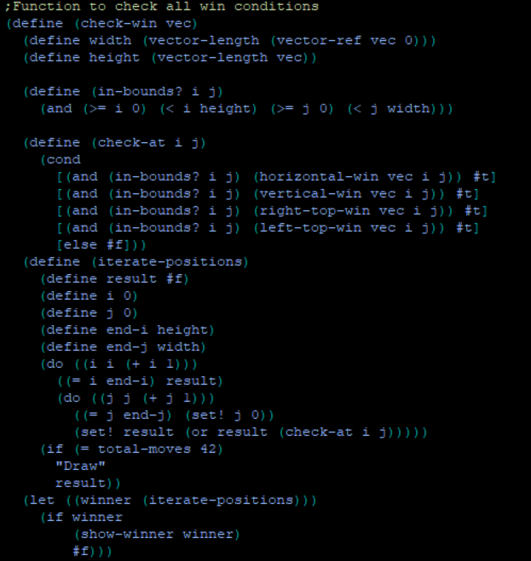After this, a win check is conducted through the button callback function. This function goes through the vector grid and checks all vectors for possible wins.

# Frame 3: Result Frame

Once the win check confirms a winning combination, it disables all buttons from further play. This is done by going through the vector button list and disabling each button. Then, the check calls a function called show-winner and sends in the value of winner. If winner is #t, it pulls the last player and displays the player’s number in the result frame. If the value of winner is ‘draw’, then it just displays draw as no player won the game after filling the board.

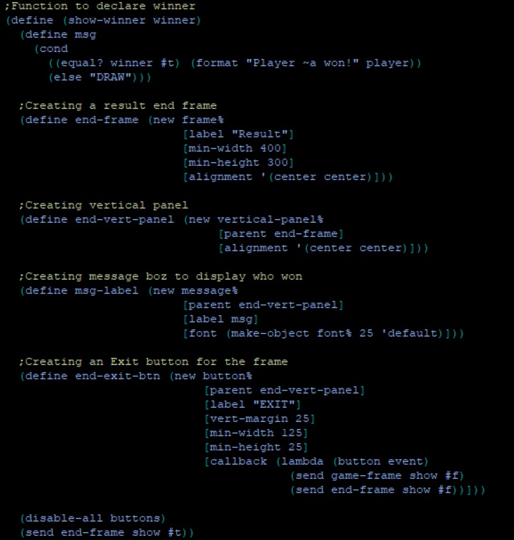

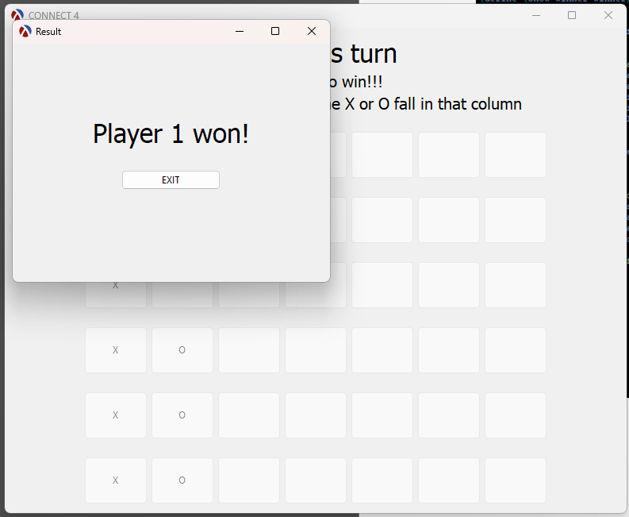

After this, the players can exit the game to finish it off.