Lab 2 (NCC)

Question 1.

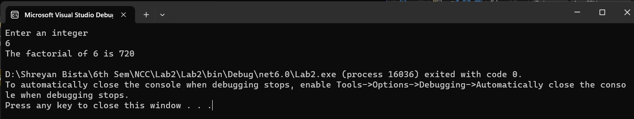

Question 2:

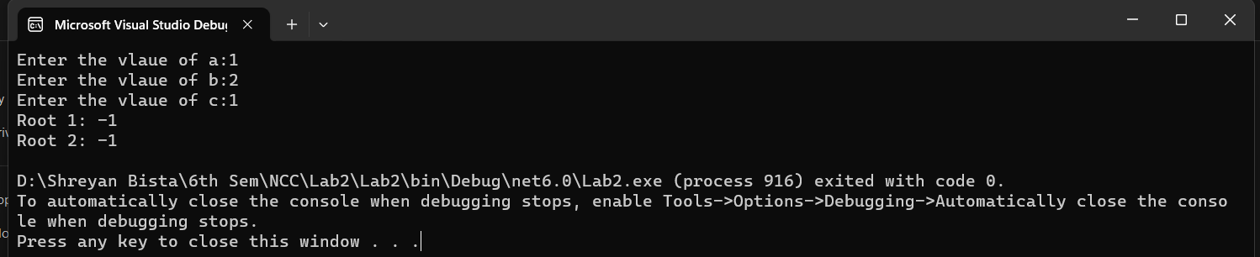

Question 3:

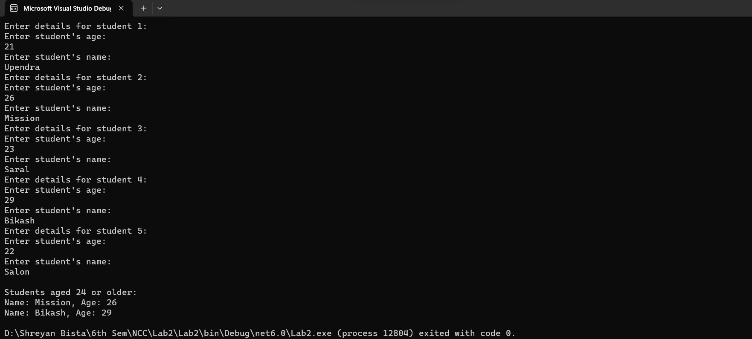

Question 4:

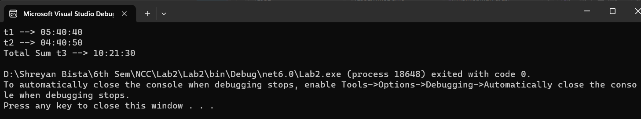

Question 5:

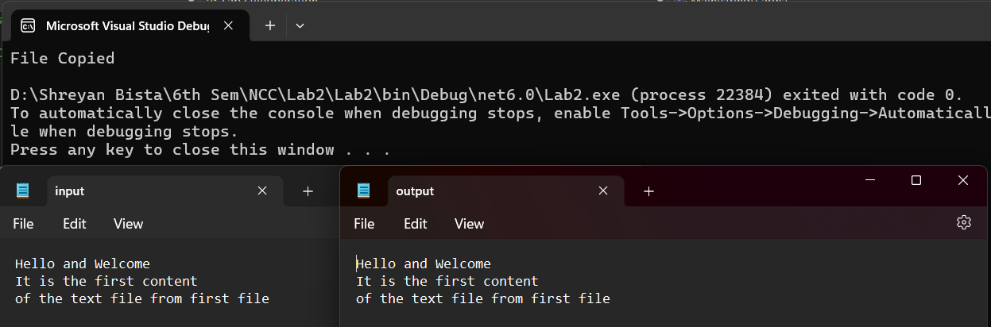

Question 6:

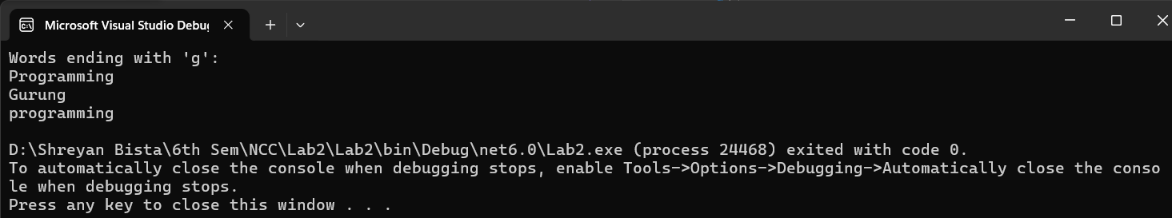

Question 7:

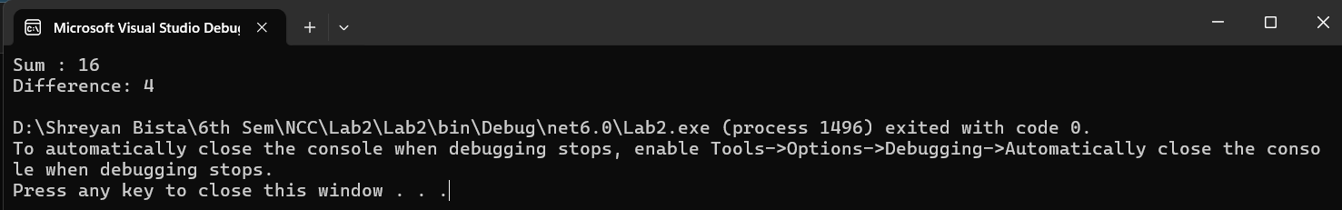

Question 8:

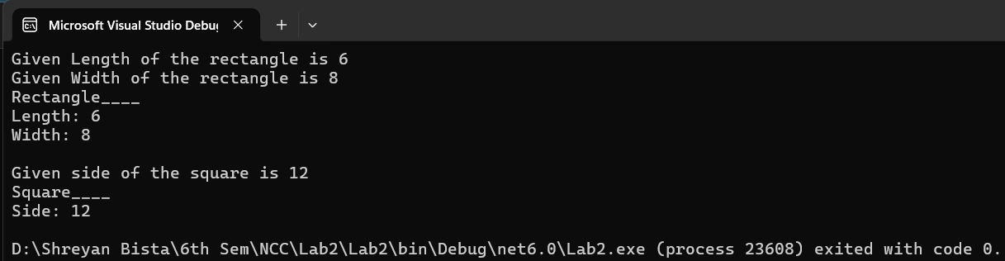

Question 9:

Question10:

Question 11: