VIETNAMESE – GERMAN UNIVERSITY
FACULTY OF ENGINEERING
COMPUTER SCIENCE DEPARTMENT

JAVA PROJECT REPORT
BOOK MANAGEMENT SYSTEM

Module 61CSE215: Object Oriented Programming in JAVA

- Đoàn Lê Gia Bảo - 10423008
- Nguyễn Văn Công - 10423020

Lecturer: Dr. Tran Hong Ngoc

VGU, WS2025

Abbreviation

OOP Object-Oriented Programming
MySQL My Structured Query Language
PC Personal Computer
CPU Central Processing Unit
RAM Random-Access Memory
JDBC Java Database Connectivity

List of Figures
Figure 1: Show the relationship among classes………………………………………… 10
Figure 2: The Definition of abstract class Person………………………………….…… 17
Figure 3: The Definition of abstract class Person, and inherited classes……...……. 18-19
Figure 4: The Overloading & Overriding methods in classes..................................... 20-21
Figure 5: LoginSystem...................................................................................................... 23
Figure 6: BookstoreAdminApp, Book Panel.................................................................... 23
Figure 7: Staff Panel........................................................ ................................................ 24

List of Tables

Table 1: Show all the user roles………………………………………………………...... 6
Table 2: Show all the objects…………………………………………………………... 6-8
Table 3: Show all the classes…………………………………………………………... 8-9
Table 4: Show the detailed classes………..………………………………………… 10-13
Table 5: Show the abstract classes………..………………………………………… 13-14
Table 6: Show data access control table………..………………………………………. 15
Table 7: Show the method access control table………..……………………………. 15-16
Table 8: MySQL Database………..…………………………………………………….. 22

Table of Contents
I. INTRODUCTION/BUSINESS REQUIREMENT 7
II. CLASS ANALYSIS 8
1. Objects 8
2. Classes 9
III. CLASS DESIGN 11
1. Classes 11
2. Some OOP techniques 15
Overloading method: 15
Overriding method: 15
Inheritance 15
IV. Package Design 16
V. Interface Design 16
VI. Access Control 16
Table X1: Data Access Control Table 16
Table X2: Method Access Control Table 17
VII. Encapsulation vs Inheritance vs Polymorphism 17
1. Encapsulation 18
2. Inheritance 18
3. Polymorphism 18
VIII. Experiment 18
1. Environment and Tools 18
2. Project functions 18
3. Database 18
4. GUI 18
IX. Conclusion 19

- INTRODUCTION/BUSINESS REQUIREMENT

In this project, we investigate the business functions of the Book Management System, and provide a desktop application supporting users (librarians or bookshop staff) in book management.

The system objective is to simplify the process of managing book information, tracking borrowers, and maintaining a structured and organized database, It helps reduce manual errors, improve accessibility of information, and enhance productivity for book management operations.

The full source code for this project is available at: OurProjectGithubLink

This project provides the basic functions for the users as follows:
- Input book information
- Search and view the status of books
- Manage customers
- Manage borrowing and buying
User roles
Role | Description
Admin | Has full control over the system. Can view/purchase/borrow/add/update/remove books, view staff and customers.
Librarian | Can view/purchase/borrow/add/update/remove the book information.
Customer | Can view/purchase/borrow the list of available books
Table 1: Show all the user roles
- CLASS ANALYSIS

- Objects
No | Object Name | State | Behaviours
1 | A00 – System Admin | username – “admin”  password – “admin123”  role – “ADMIN” | camManageStaff(), canManageBooks(),  viewBooks(),  borrow(),  paid()
2 | L00 – Librarian | username – “library”  password – “library123”  role – “LIBRARIAN” | canMangeBooks(),  viewBooks(),  borrow(),  paid()
3 | M00 - Customer | username – “member”  password – “member123”  role – “MEMBER” | viewBooks(),  paid(),  borrow()
4 | B00 – Book | title – “Feynmann’s Lectures”  author – “Richard Feynmann”  numAvailable – 3  price – 3.0 | getTitle(),  canBorrow(),  getAuthor(),  getPrice(),  getNumAvailable(),  setTitle(),  setAuthor(),  setPrice(),  setNumAvailable(),  displayInfo()
5 | B01 – Book | title – “Principia Mathematica”  author – “Issac Newton”  numAvailable – 4  price – 3.0 | getTitle(),  canBorrow(),  getAuthor(),  getPrice(),  getNumAvailable(),  setTitle(),  setAuthor(),  setPrice(),  setNumAvailable(),  displayInfo()
6 | B02 – Book | title – Myth of Sisphus  author – Albert Camus  numAvailable – 5  price – 2.0 | getTitle(),  canBorrow(),  getAuthor(),  getPrice(),  getNumAvailable(),  setTitle(),  setAuthor(),  setPrice(),  setNumAvailable(),  displayInfo()
Table 2: Show all the objects

- Classes
No | Class Name | Objects | Attributes | Methods
1 | Person (abstract) | (base for Admin, Librarian, Member) | username, password, role | getUsername(), getPassword(), getRole(), canManageBooks(), canManageStaff(), viewBooks(),  borrow(),  paid()
2 | Admin | A00 - System Admin |  | canMangeBooks(), canManageStaff()
3 | Librarian | L00 – Librarian |  | canMangeBooks(), canManageStaff(),
4 | Member | M00 – Member |  | canMangeBooks(), canManageStaff(),
5 | LibraryItem | (base for Book and Magazine) |  | getTitle(),  getNumAvailable(),  setTitle(),  setNumAvailable()  displayInfo()
6 | Book | B00 | title, author, numAvailable, price | getTitle(),  canBorrow(),  getAuthor(),  getPrice(),  getNumAvailable(),  setTitle(),  setAuthor(),  setPrice(),  setNumAvailable(),  displayInfo()
7 | Magazine | MA00 | title, author, numAvailable, price | getTitle(),  canBorrow(),  getAuthor(),  getPrice(),  getNumAvailable(),  setTitle(),  setAuthor(),  setPrice(),  setNumAvailable(),  displayInfo()
Table 3: Show all the classes

- CLASS DESIGN

- Classes
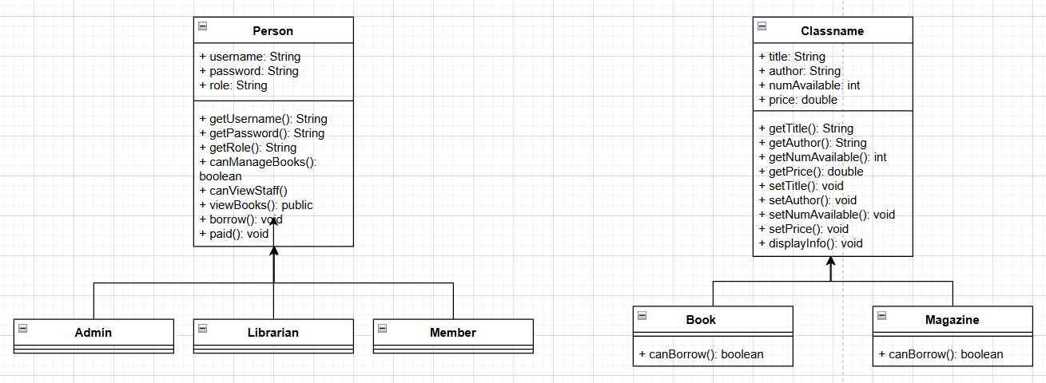
Figure 1: Show the relationship among classes

No | Class | Instance Variable | Methods | Description
1 | Person | - private String username  - private String password  - private String role | - public String getUsername()  - public String getPassword()  - public String getRole()  - public abstract boolean canManageBooks()  - public abstract boolean canViewStaff()  - public void viewBooks()  - public void borrow()  - public void paid() | This class is used as abstract class and is inherited by Admin, Librarian, Member classes
2 | Admin |  | - public boolean canManageBooks()  - public boolean canViewStaff() | This class is used for viewing staff information and viewing/adding/updating/deleting library items
3 | Librarian |  | - public boolean canManageBooks()  - public boolean canViewStaff() | This class is used for viewing/adding/updating/deleting library items
4 | Member |  | - public boolean canManageBooks()  - public boolean canViewStaff() | This class is used for viewing/buying/borrowing the book
5 | LibraryItem | - protected String title  - protected String author  - protected int numAvailable  - protected double price | - public abstract String getTitle()  - public abstract String getAuthor()  - public abstract int getNumAvailable()  - public abstract int getPrice()  - abstract void setTitle()  - abstract void setAuthor()  - abstract void setAuthor()  - abstract void setPrice()  - public abstract void displayInfo() | This class is used as abstract class and is inherited by Book and Magazine classes
6 | Book |  | - public boolean canBorrow()  - public String getTitle()  - public String getAuthor()  - public int getNumAvailable()  - public int getPrice()  - void setTitle()  - void setAuthor()  - void setAuthor()  - void setPrice()  - public void displayInfo() | This class is used to store the information of the book
7 | Magazine |  | - public boolean canBorrow()  - public String getTitle()  - public String getAuthor()  - public int getNumAvailable()  - public int getPrice()  - void setTitle()  - void setAuthor()  - void setAuthor()  - void setPrice()  public void displayInfo() | This class is used to store the information of the magazine
Table 4: Show the detailed classes

- Abstract classes
No | Abstract Class | Abstract Methods | Concrete Methods | Decription
1 | Person | public canManageBooks(),  public canManageStaff() | public getUsername(),  public getPassword(),  public getRole()  public viewBooks()  public borrow()  public paid() | This class is an abstract class that is used by subclasses Admin, Librarian, and Member.
2 | LibraryItem | public getTitle(),  public getNumAvailable(),  public setTitle(),  default setNumAvailable(),  public displayInfo() |  | This class is an abstract class that is used by subclasses Book and Magazine.
Table 5: Show the abstract classes
- Some OOP techniques

Overloading method:
- viewBooks() method in abstract class Person
- Contrucstors in LibraryItem, Book, and Magazine classes

Overriding method:
- canMangeBooks() and canManageStaff() methods in class Admin
- canMangeBooks() and canManageStaff() methods in class Librarian
- canMangeBooks() and canManageStaff() methods in class Member
Inheritance
- We defined Person class as abstract to contain all common fields (username, password, and role) and common behaviors (getUsername(), getPassword(), getRole(), canManageBooks(), canManageStaff(), viewBooks(), borrow(), paid()).
- The Admin, Librarian and Member classes inherit all public and protected attributes and methods from Person class.
- We defined LibraryItem as abstract to contain all common behaviors (getTitle(), getNumAvailable(), setTitle(), setNumAvailable(), displayInfo()).
- The Book and Magazine classes inherit all public and protected methods from LibraryItem class.
- Package Design
- We use 2 packages, including models and GUI:
  - Model package contains all classes (Person, Admin, Librarian, Member, LibraryItem, Book, and Magazine).
  - GUI package contains GUI class (BookstoreAdminApp, and LoginSystem)

- Interface Design
- LoginSystem for handling login, validating and determine user type (Admin, Librarian, Member)
- BookstoreAdminApp for book management and staff viewing based on user type

- Access Control

Table X1: Data Access Control Table
No | Data | Class | Modifier | Description
1 | username | Person | private | The username for log-in process
2 | password | Person | private | The password for log-in process
3 | role | Person | private | The role for the logged-in account (ADMIN/LIBRARIAN/MEMBER)
4 | title | LibraryItem | protected | The title of a book/magazine
5 | author | LibraryItem | protected | The author of a book/magazine
6 | numAvailable | LibraryItem | protected | The number of the book/magazines are available
7 | price | LibraryItem | protected | The price of a book/magazine
Table 6: Show data access control table

Table X2: Method Access Control Table
No | Method | Class | Modifier | Description
1 | getUsername() | Person | public | Obtain the username of the account
2 | getPassword() | Person | public | Obtain the password of the account
3 | getRole() | Person | public | Obtain the role of the account
4 | canManageBooks() | Person, Admin, Librarian, Member | public | Be the boolean method to check the account can manage books/magazine or not
5 | canViewStaff() | Person, Admin, Librarian, Member | public | Be the boolean method to check the account can view or not
6 | viewBooks() | Person, Admin, Librarian, Member | public | View the books/magazine available
7 | paid() | Member | public | Customer is paid to the chosen book
8 | borrow() | Member | public | Customer borrow the chosen book
9 | getTitle() | LibraryItem, Book, Magazine | public | Obtain the title of the book/magazine
10 | getAuthor() | LibraryItem, Book, Magazine | public | Obtain the author of the book/magazine
11 | getNumAvailable() | LibraryItem, Book, Magazine | public | Obtain the number of books/magazines are available
12 | getPrice() | LibraryItem, Book, Magazine | public | Obtain the price of the book/magazine
13 | setTitle() | LibraryItem, Book, Magazine | default | Update the title of the book/magazine
14 | setAuthor() | LibraryItem, Book, Magazine | default | Update the author of the book/magazine
15 | setNumAvailable() | LibraryItem, Book, Magazine | default | Update the number of books/magazines available
16 | setPrice() | LibraryItem, Book, Magazine | default | Update the price of the book/magazine
17 | displayInfo() | LibraryItem, Book, Magazine | public | Display the information of the book/magazine
18 | canBorrow() | Books, Magazine | public | Check whether the book/magazine available or not
Table 7: Show the method access control table

- Encapsulation vs Inheritance vs Polymorphism
- Encapsulation

Encapsulation means hiding internal data and only allowing few specific methods to access or modify these data.
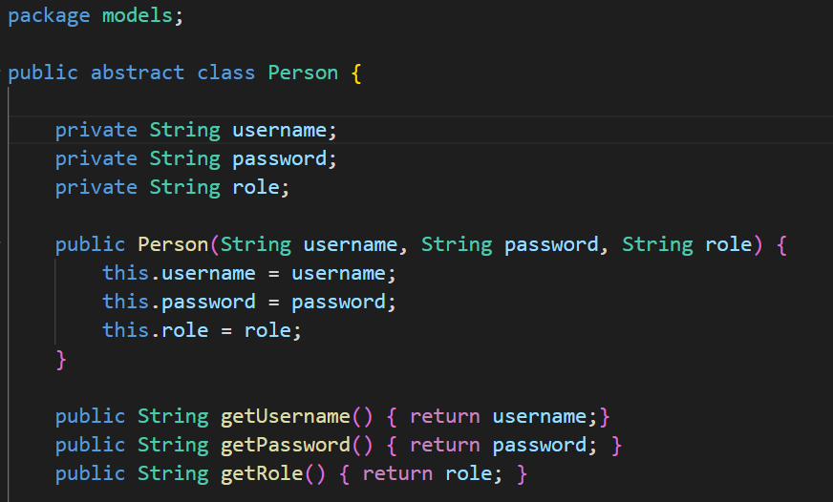

Figure 2: The Definition of abstract class Person

Important data (username, password, and role) cannot be accessed directly from outside.

- Inheritance
Inheritance allows one class to inherit attributes and methods from another class.
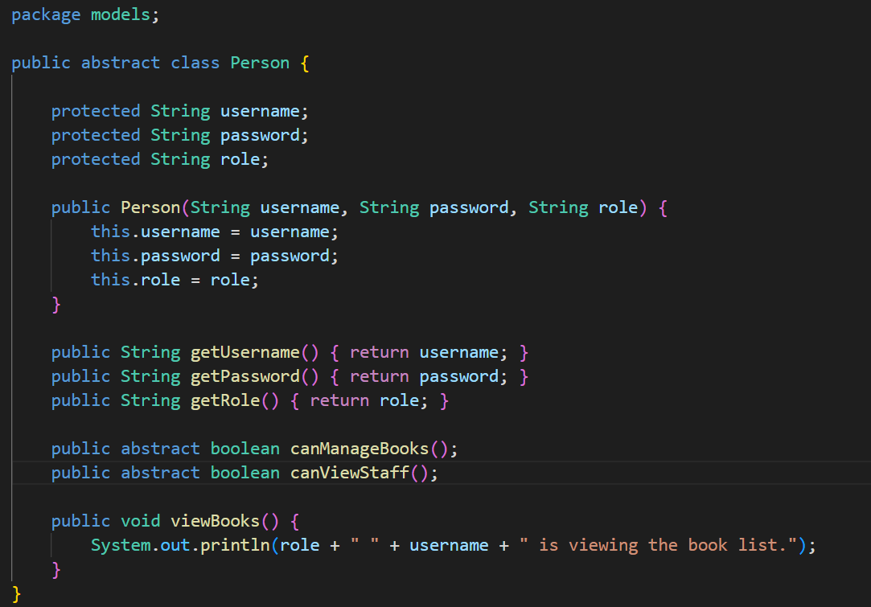
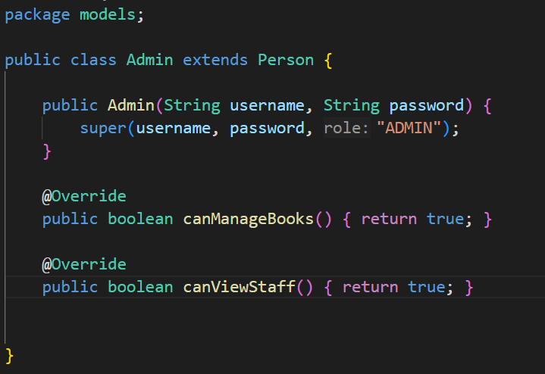
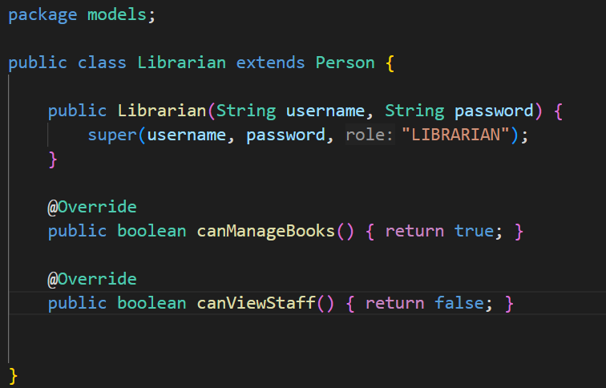
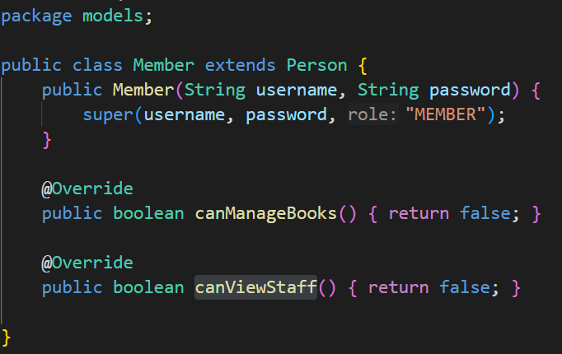
Figure 3: The Definition of abstract class Person, and inherited classes (Admin, Librarian, and Member)
Admin, Librarian, and Member inherit common attributes (username, password, and role) and methods (getUsername(), getPassword(), …)
- Polymorphism
Polymorphism allows different classes to provides different implementations of the same method.
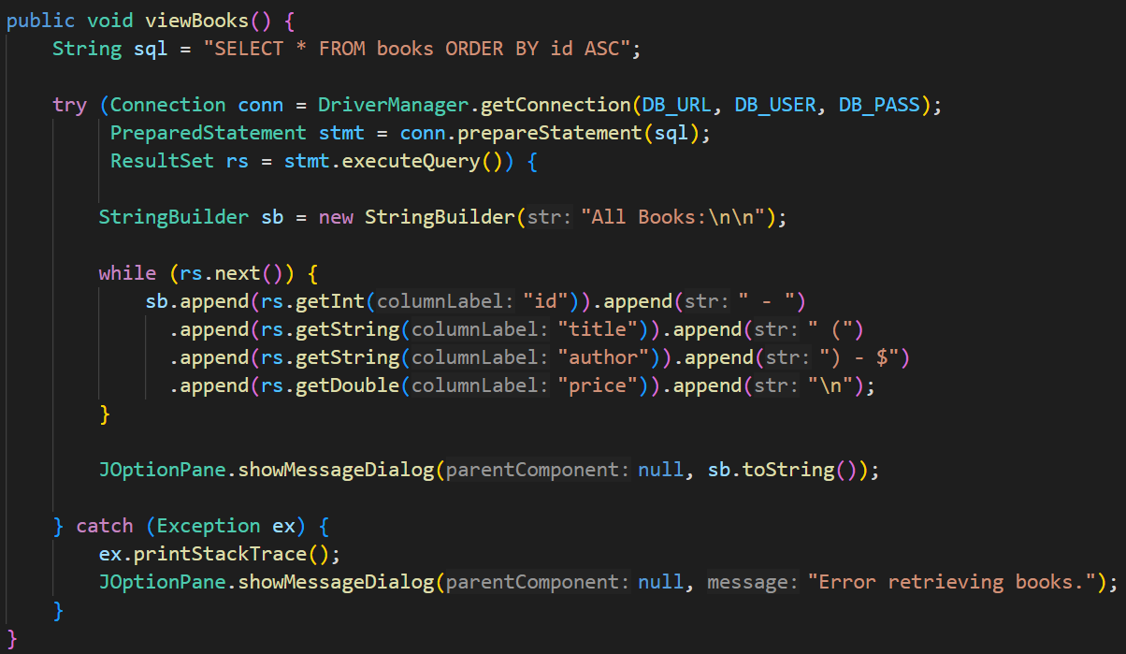
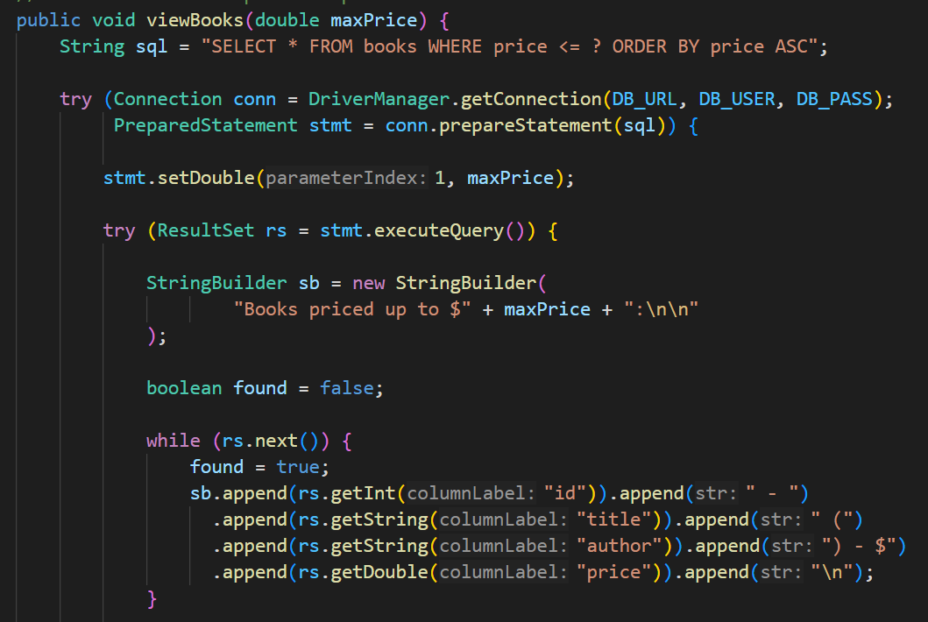
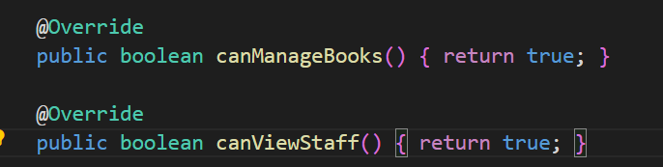
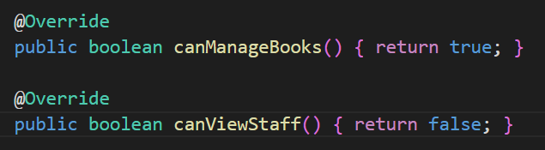
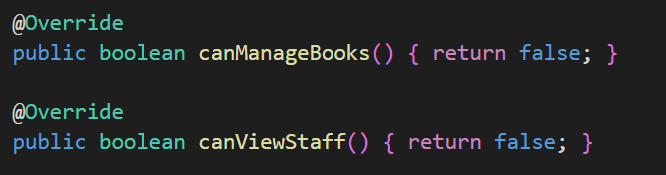
Figure 4: The Overloading & Overriding methods in Admin, Librarian, and Member classes

The same method name (canMangeBooks() and canViewStaff()), but different outputs

- Experiment
- Environment and Tools

- Environment:
- 1 PC (8 CPU cores, 1 RAM)
- Tools:
- MySQL server
- JDBC
- Java Swing library

- Project functions
- List and describe a bit the functions of the project
- There are 3 types of user (Admin, Librarian, Member):
- Admin can manage books and view staff without restriction
- Librarian can only manage books
- Member can only view books
- Everyone can view books and filter by price
- User is prompted a login screen and need to enter the correct credentials in order to continue
- Database

Books

ID | Title | Author | Price | Quantity | Type

Staff

ID | Name | Role
Table 8: MySQL Database

- GUI

Order | Name
1 | LoginSystem
2 | BookstoreAdminApp

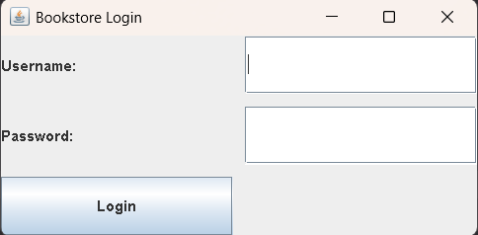
Figure 5: LoginSystem

User need to enter the right credentials and press the login button in order to transition to BookstoreAdminApp

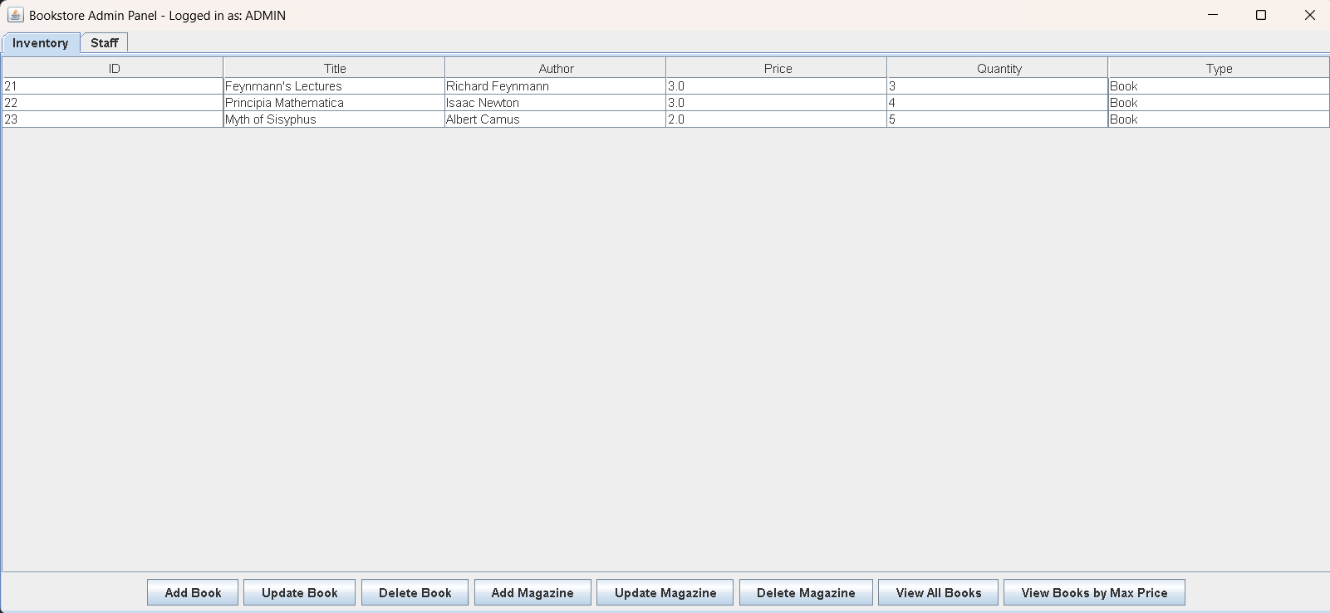Figure 6: BookstoreAdminApp, Book Panel

On this BookstoreAdminApp screen, you can interact with books or magazines:
- Add, update or delete a book in the by pressing “Add Book”, “Update Book”, “Delete Book” buttons
Ex: Select “Feynmann’s Lectures” and press “Update Book” to modify its value
- Add, update or delete a magazine in the database by pressing “Add Magazine”, “Update Magazine”, “Delete Magazine” buttons
Ex: Press “Add Magazine” to add a new entry of type Magazine
- Press “View All Books” or “View Books by Max Price” to view all the items or view all items up to a certain price in the database
Ex: View all the books up to 2$
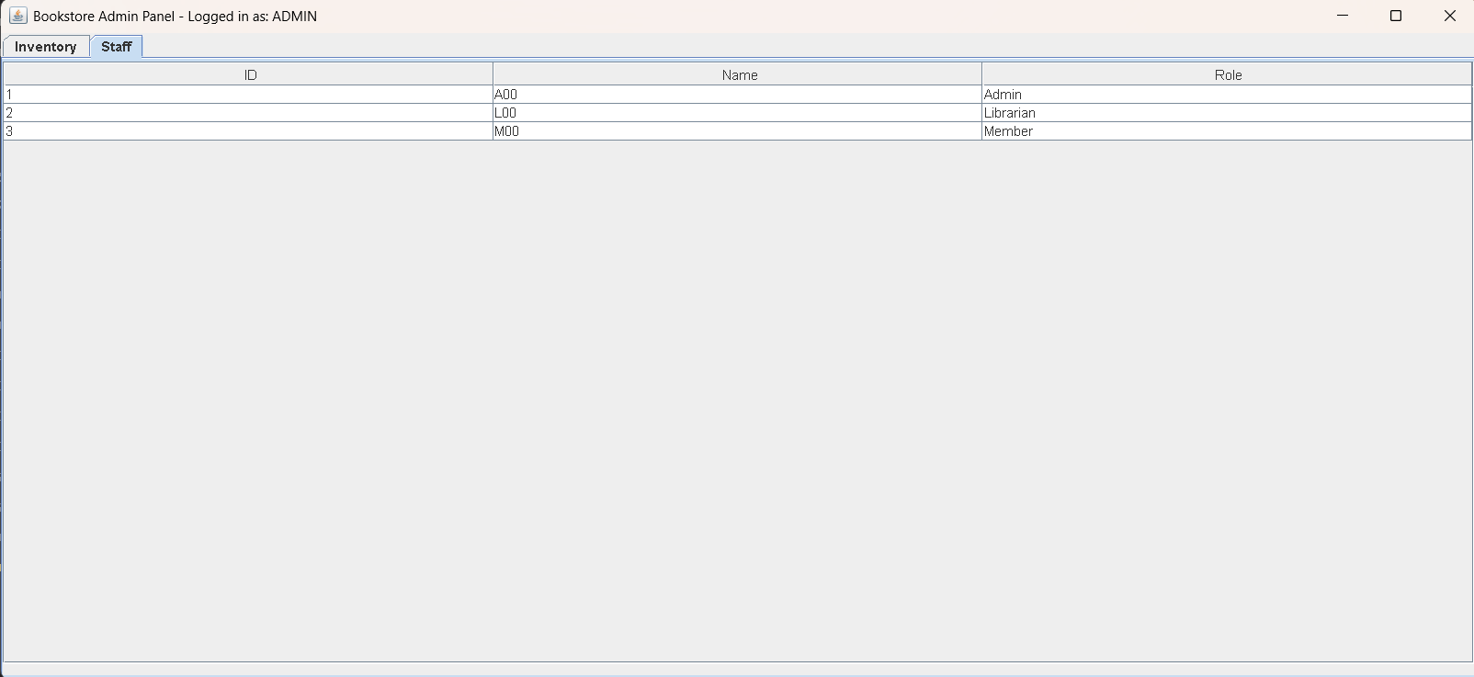
Figure 7: Staff Panel

As admin, you can switch to “Staff” panel in order to view all the staff information

- Conclusion
Pros and Cons
Feature | Pros | Cons
Design | Make use of abstract classes (Person, and LibraryItem), which promotes code reusability and maintainability. | less diversity in the attributes and methods of classes
Access Control | Protect sensitive data (username, password, and role) against directly modify from outside. | Cannot track which staff/member view/purchase/add/update/remove
User Interface | Provides a functional and user-friendly LoginSystem and Dashboard application. | Display many buttons or unnecessary buttons which can make user confused

We rate the project ourselves at around 9.0/10.0. Because The project successfully met all requirements and applied all core OOP principles in Java. Deductions are mainly come from the current simplicity of the GUI and the lack of diversity of classes.

DUTY ROSTER

ID | Task | In Charge | Start | End | State | Note
1 | Requirements Analysis & Class Design | Bao & Cong | 01-Nov | 05-Nov | Done | Completed Class Analysis and Design tables
2 | MySQL Database Setup | Nguyen Van Cong | 06-Nov | 08-Nov | Done | Created the Books and Staff tables
3 | Core Model Classes | Doan Le Gia Bao | 06-Nov | 12-Nov | Done | Implemented Person, LibraryItem, Admin, Librarian, Member, Book, Magazine classes
4 | GUI Development | Doan Le Gia Bao | 13-Nov | 15-Nov | Done | Completed the login interface
5 | GUI Development: BookstoreAdminApp | Nguyen Van Cong | 16-Nov | 20-Nov | Done | Completed the main management interface (Book & Staff Panels)
6 | JDBC Connection & Data Integration | Nguyen Van Cong | 21-Nov | 24-Nov | Done | Ensured the application could connect to and manage data in MySQL database
7 | Report Writing | Bao & Cong | 25-Nov | 29-Nov | Done | Writing and final review of the report

REFERENCE

- Java database connectivity with MySQL, Geeksforgeeks, 2025, https://www.geeksforgeeks.org/java/java-database-connectivity-with-mysql/
- Java Swing tutorial, TutorialsPoint,
https://www.tutorialspoint.com/swing/index.htm

