**New Business, Toronto Location Recommendations**

Trevor Birchall

August, 2019

**1.0 BACKGROUND**

With millions of citizens, Toronto has been growing at an ever-changing rate. This python program recommends new business locations based to the type of business, and your desired criteria.

**1.2 Problem**

Data that is needed to determine where a new business should open includes, other close similar businesses, population, population density, and average income. This project is able to look at all these factors and give a list and map of suggested locations.

**2.0** **Data Collecting**

The following are the sources of data necessary for our explorative analysis

1. Scrapping Toronto demographic data from Wikipedia

<https://en.wikipedia.org/wiki/Demographics_of_Toronto_neighbourhoods>

1. Toronto Neighbourhood location data retrieved using Forusquare API
2. Toronto Venue Data will be retrieved using FoursquareAPI.

**2.1 Data Preparing**

Once the Toronto demographic data was scraped, I needed to remove the unimportant columns. After this I got rid of any rows/neighborhoods that I couldn’t accurately get longitude and latitude data for. These were mostly smaller subregions in Toronto. With that I then created a longitude and latitude data frame using GeoPy. Then merged it with the original data fame using the neighborhood column to line them up. From this I then pulled data from foursquare or the venues in each neighborhood. Compiling all this information gave us an accurate count on the number of venues, and information about each Neighborhood. This is the data that I used to predict areas where it would be good to open a specific business.

**3.0 Methodology**

The data I used had several interesting attributes that could influence the decision to open a business. We can see potential competitors, number of businesses in an area, population of an area, population density, and average income of an area. These can all influence the location of a future business. The data frame itself has 163 rows, that contain each neighborhood in Toronto. It also includes 317 unique business in Toronto. Before we suggest a location for the business, we can take a look at the popularity of different business, and number of potential competitors. We can see that there are many Coffee Shops in Toronto and this might be a good type business to avoid. We can also look at types of business that don’t have many competitors or other business. These could be good untapped markets that are worth looking into. On this about this Foursquare data to keep in mind is that the business type can vary. So, a venue may be listed as a concert hall, but also be a theater, or labeled differently like “automotive shop” and “Auto Garage”. Also, some venues may not be listed on Foursquare. We can see the number of each type of venue in the chart on Github labeled “Number_of_Business.png”.

<https://github.com/TBirchall/Coursera_Capstone/blob/master/Number_of_Business.png>

We can also wee the top 10 most popular business types.

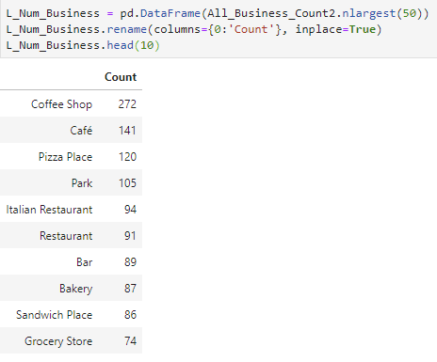

And the lowest business types.

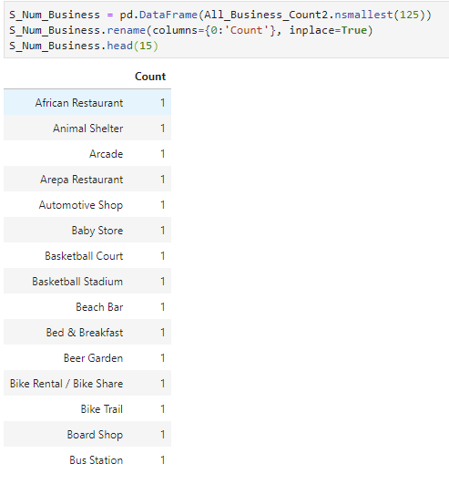

**4.0 Recommendation**

Once we have our data frame constructed, the rest is easy. Now we give the user the ability enters the business type of their choice, the focus of the search, and the number of recommendations they would like to see. The system will create a data frame of the top neighborhoods, and their information

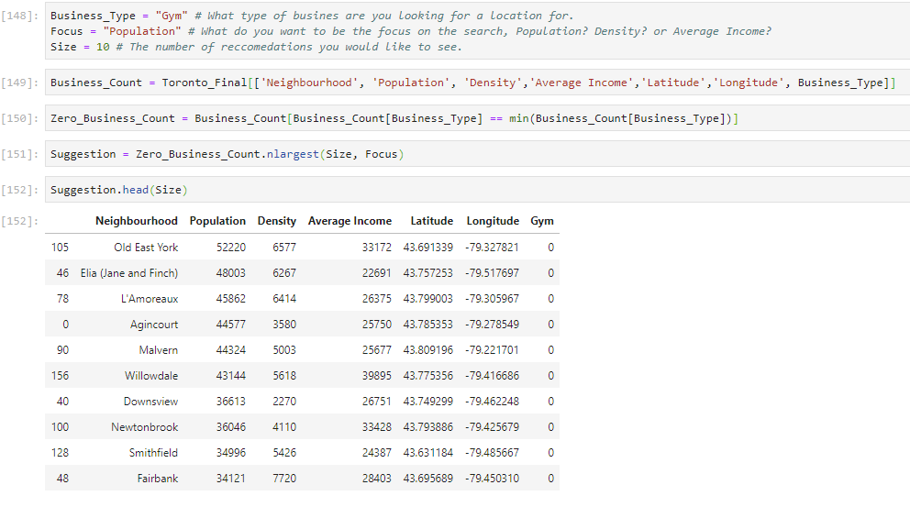

Next the system will create a map and highlight the top choice.

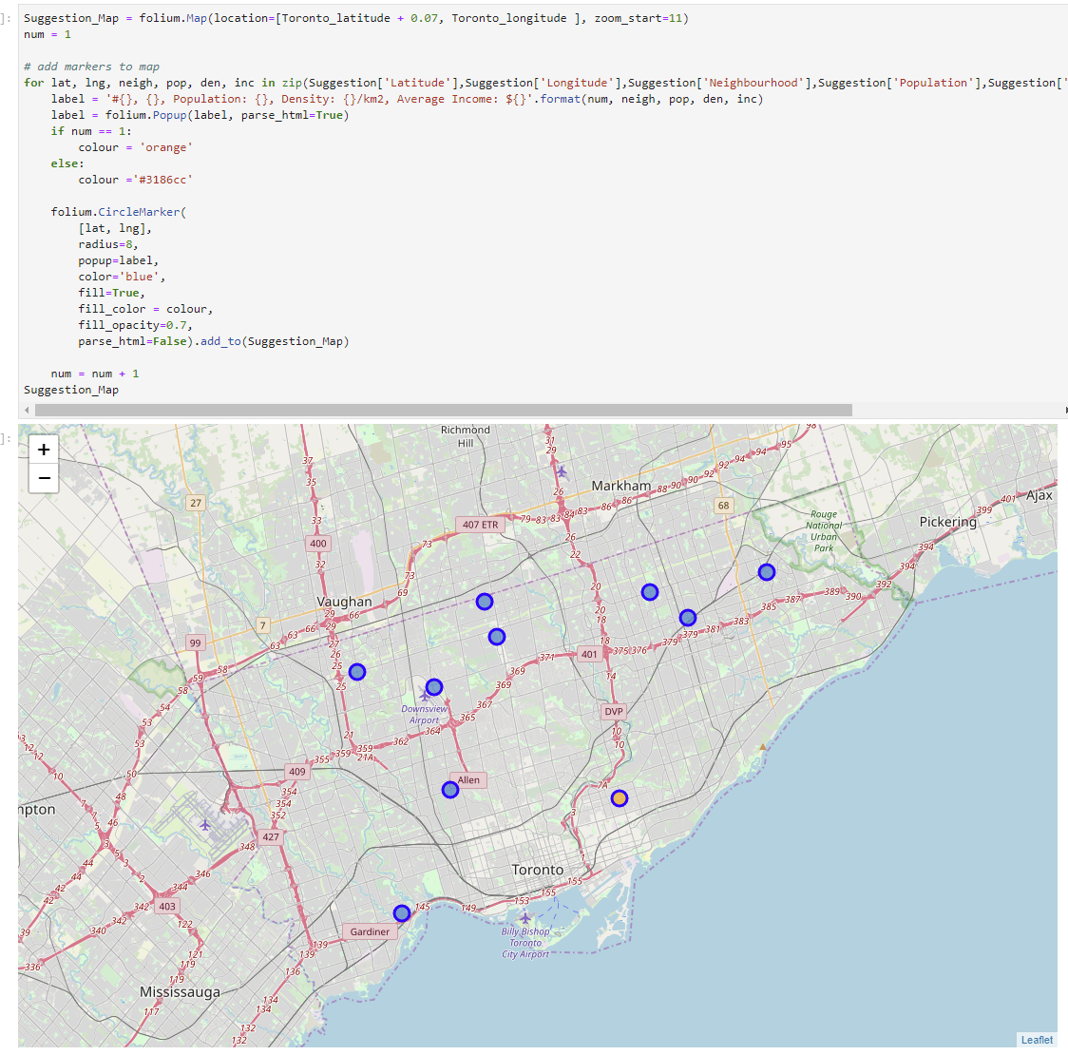

I didn’t feel the need to use cluster, as we were able to achieve the same result without it, using much simpler code.

**5.0 Conclusion**

Toronto is a large city and has many distinct neighborhoods, and types of business. This simple recommender system that uses demographic data, and the Foursquare API can simply inform the user on the best locations for a business type. Regardless of the type of business, or the criteria or number of recommendations needed. However, when using the system, the user must be aware of the downsides of the Foursquare API. That being, that the business type can vary. So, a venue may be listed as a concert hall, but also be a theater, or labeled differently like “automotive shop” and “Auto Garage”. Also, some venues may not be listed on Foursquare.

towns list with and median residential rental prices