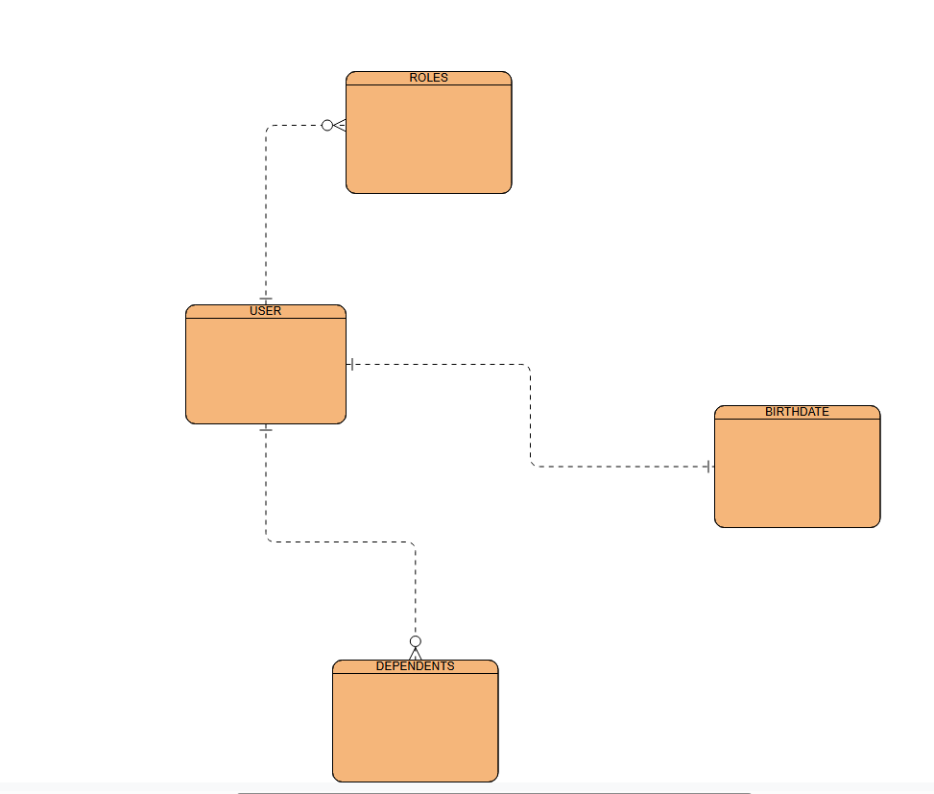

{

"user_id": "TBlatt98",

"name": "Tyson",

"birthdate": "1998-07-01",

"roles": ["Admin", "Engineer"],

"dependents": [

{ "name": "Lynne Blatter", "relationship": "Mom" },

{ "name": "Gary Blatter", "relationship": "Dad" }

]

}