NAME:TINA BORUNDIA

BATCH:C3

ROLL NO:65

PRACTICAL:4

AIM: Design a calculator to perform basic mathematical operations using JavaScript. Add two buttons : Clear , +/- (to represent positive and negative numbers).

CODE:

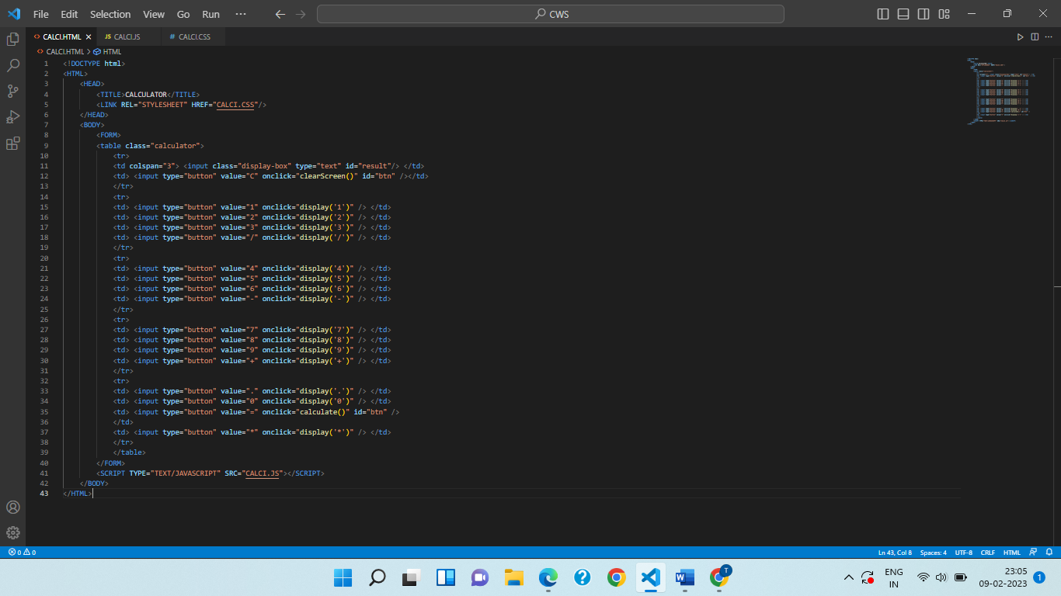

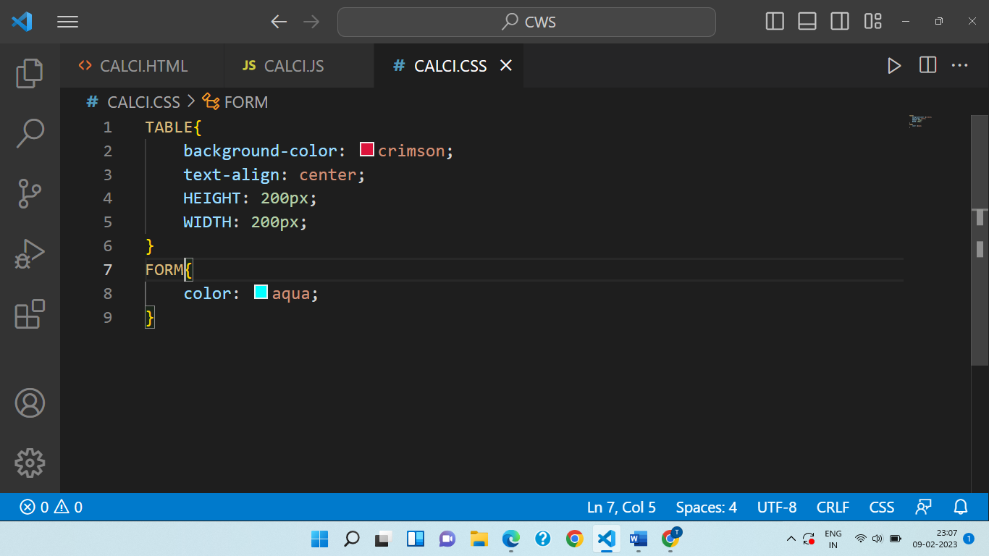

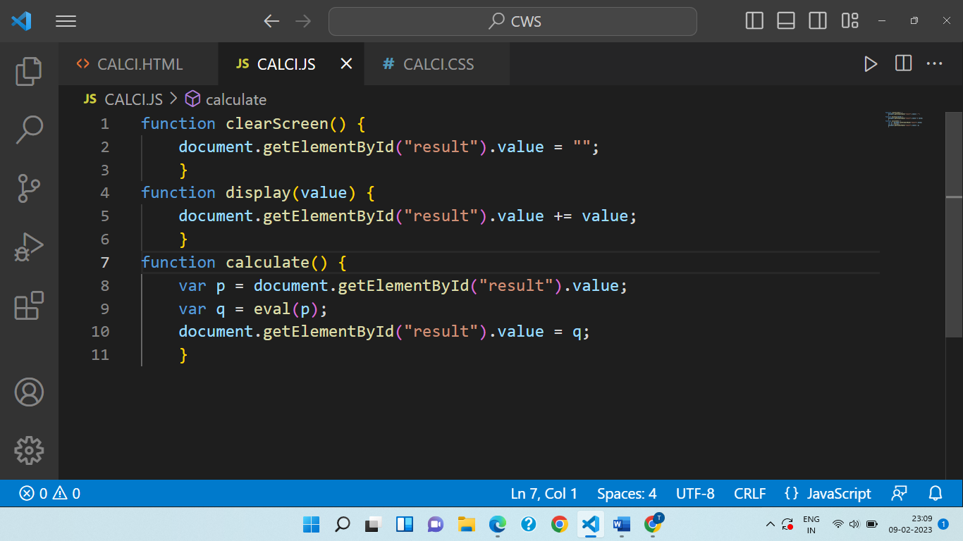

OUTPUT:

